# Shoe Glamour Point of Sale System



An Undergraduate Major Project

Presented to

Institute of Computing

University of Southeastern Philippines

Bo. Obrero, Davao City

In partial fulfilment   
of the course requirement in   
IC 310  
Application Systems Development

**Nancy Selgas Mozo**  
Instructor

**Espeña, Syralynn**

**Majadas, Cherry Pearl**

**Umbay, Jhon Danielle**Proponents

December 19, 2017

# Table of Contents

Shoe Glamour Point of Sale System 1

Table of Contents 2

**CHAPTER 1: INTRODUCTION** 3

A. Rationale 3

B. Project Context 4

C. Purpose, Description, and Significance 4

D. Objectives 5

E. Scope and Limitations 5

F. Review of Related Literatures/Systems 6

CHAPTER 2: METHODOLOGY 8

A. Methodology Used 8

B. Technical Background and/or Conceptual Framework 9

CHAPTER 3: RESULTS AND DISCUSSION 25

A. Results 25

B. Discussion 25

C. Recommendation 25

D. Conclusion 25

Appendices 27

A. Curriculum Vitae 27

B. Certificate of Completion 30

C. Code Snippets 31

D. Users Manual 33

E. Evaluation Tool 41

F. Other relevant documents 48

# 

# **CHAPTER 1: INTRODUCTION**

In the world of business, sales and inventory report has one of the biggest roles in the field of this industry. Recording data from past to present will calculate every statement and will help in monitoring the status of the business. Manual data recording of sales and inventory data are now a thing of the past. Indeed, the world is now inconceivable without computers. Billions of important data can be stored and handily retrieved because of database technologies that exist today. Precious time should be properly manage in order to do all the things that the boutique or business has. Monitoring and managing the sales and inventory is a hard task for the administrator.

As the world moves further and faster into a thriving technological age, the researchers conduct a system. A Point of Sale System for an apparel store has been created by CS students to make the system of the business easy to manage and monitor. It calculates the sales for the day, month and year. Inventory system programs now on the market that lets you track the usage, monitor changes in unit costs, calculate it when you need to reorder, and analyze inventory levels in item-by item basis. It can even control inventory right at the cash register with point of sale. with an automated Point of Sale and inventory, business rely on computers to do task that were once performed manually, such as inventory check and product sales.

The best thing of having a computerized POS system in a boutique business is: as new stocks arrive and as it is sold, it keeps the stocks level current and updated, hence making it easier to identify which items are selling and which item are not.

## A. Rationale

1. **Existing System**

Shoe Glamour records their stocks and sales in a manual process. They used pen and paper to record transactions. The cashier or owner literally writes down the customer’s order in a common printed receipt used also by the store or shop without computerized system. They provide receipt, but it is exclusive only for Jansport bags for the reason that, it is the only product that has a warranty. They used the receipt as a proof of purchased for that product for the warranty limit of the product. Also, they record their sold items and supplied items inconsistently that can give them inaccurate details and also, time consuming. They used a record notebook as the main storage of the boutique inventory and sales report, and it will cause problems such as data redundancy, data lost and data integrity because anyone can easily access the company’s master list. They record sales report and make an inventory, whenever they wants.

1. **Proposed System**

The proposed system, Point of Sale is really a big help to the store. The proposed system can provide cashiering transaction that can automatically record the transactions of sales. The system can update the inventory consistently and accurately. Also, the owner can monitor the store’s stocks and can supervise the progress of the business. This system can add, update, and view products as well as employees. It also secures their records unlike using pen and paper system. This system is updated every time the items are sold, therefore the availability of the products is identified and this will help the company to order in advance for the stocks.

## B. Project Context

Shoe Glamour is an apparel store owned by Ms. Cherry Ann Codilla. It is located at Gempesaw St. Uyanguren, Davao City. The store sells footwear, bags, clothes, accessories, and other fashionable items. The store has only one boutique in Davao City. However, they still join bazaars within the city. Until now, they still have many customers, even if there are many competitors near them. Despite of their competitiveness in the business industry, Shoe Glamour still lacks on innovative technology. Whenever a customer asks for a specific item or product, they still have to look on their display area or in the stock room to check if they still have stocks. Then, if the product is still available they’ll scan the record notebook of their current product list to know its price. Employee will write down the order details in the record book and manually computes using calculators, it takes minutes to do the cashiering. When new items or stocks arrived, the owner will list down the quantity of the items they order. The store has no real time monitoring on their current stocks. They just rely on the products they display.

Shoe Glamour records their stocks and sales manually with the use of record notebook. According to the owner, there are times also that they didn’t bother to record their sold items or to list down their stocks, this kind of manual system result to inaccurate details. The pen and paper based system of the shoe glamour make slow to its transaction. This also gives them a hard time to monitor the progress of their business. Therefore, the researchers come up to an idea to propose a POS that will automate the process of the said boutique sales and give admin a reliable inventory storing of products and stocks. The system can help them to record the stocks and sales accurately. The system will also be a computerized solution to the different problem i.e. (unreliable records due to erroneous or unreadable handwriting and loss of records) encountered because of its pen and paper based system. The researchers want to develop a customized Points of Sale System that will solve the problems encountered by Shoe Glamour in its business processes. The system will help to lessen the time and effort of the cashier and admin on storing, retrieving and monitoring records of business. The system’s database is more secure and reliable than the traditional paper and pen system that may lead to loss of records and provides the employee an easy way of managing records. The users can access the system through their username and password. Cashier accounts should be created by the Admin. Admin account is used to access the system.

## C. Purpose, Description, and Significance

The researchers hoped that the findings of the study will be beneficial to Shoe Glamour management. This study may serve as a valuable reference of the other students to make a better development of business on various managing techniques and services for business.

The researchers develop a system that would provide greater benefits and ease of the use to the admin and cashier of Shoe Glamour. The developed system will be a big help especially in the sales transaction and monitoring of the business. It will also speed up the processes and will help the users by saving their time and effort on processing transaction for the day. Also, it will help the owner to supervise or to monitor the progress of the business.

The developed system will give functions such as searching through list of products from inventory and automatic computing of its price and total value based on the quantity being sold. The admin can add, update, read, delete products in the inventory and also, add stocks to the products when receiving the stocks.

The system can create accounts to be used by the employee using the features of it. The system will generate sales report to be viewed by the admin of the business along with the inventory and transaction record of the system to have a data transparency between the management of Shoe Glamour.

## D. Objectives

1. **General objectives:**

The objectives of the proponents are first, to provide a Point of Sale System to Shoe Glamour Boutique which can help their services to become faster and more efficient. Through an authomated recording of sales and inventory, the client don’t need to manually write their records about their incoming stocks and the client don’t need to compute for the total sales as the system automatically produces the total sales for the selected dates.

1. **Specific Objective:**

The Point of Sale System has two types of users. The admin type and staff type. The admin can add new products. The admin can also change the product details and add product quantity if ever there’s a need to update. While the staff can only view products and the stocks as they are not allowed to manage the inventory. Both types of users can manage the Cashiering System and both of them can look for the sales on a selected date. The system also provide user restriction functions for system security so that unregistered users can’t access and alter any data in the Point of Sale System. Moreover, other goals of the proponents are to retrieve customers’ transaction data easily; to prevent loss of those transaction data and lastly, to check the acquired total sales on a specific date.

## E. Scope and Limitations

The study primarily aimed to design a Point of Sale System for Shoe Glamour. The system focuses on the business processes of boutique which includes; Point of Sale System, user management, and inventory management.

The scope of the system are as stated: the system provided a function that can add, change, view products as well as the registered users of the system.The developed system automatically computes the orders of the customer, receive the customer payment and display the change. It also provides a monitoring of inventory of the store which can display the list of products and their respective prices. It can display the receipt of the transaction and it can print the receipt. It automatically computes the sales of the specific time also.

The limitation of the system is that the system does not support barcode scanning and does not accept payments through credit card. It can only be accessed offline and has no backup. It does not cover reservation of product and not responsible of any human error.

## F. Review of Related Literatures/Systems

Nowadays, most businesses have been improved their service as well as their retail management system. From pen-and-paper system, it develops to a computer-based that can actually perform calculation of sales and inventory faster and more efficient compared to a manual process of recording and listing down of sales and stocks. Though, there are still stores that use the pen-and-paper system in recording their sales and stocks.

#### **History**

Ahead of this modern management system, stores and other retail businesses use an electronic cash register. It is controlled with proprietary software and has limited function and communication capability.

##### *IBM 3650 and 3660*

In 1973, IBM 3650 and 3660 store systems were released by the IBM. Basically, a mainframe computer was used as a controller of the store. It could store up to 128 3650/3660 point of sale registers. IBM 3650 and 3660 was the very first commercial use of remote initialization, peer-to-peer communication, simultaneous backup of LAN or local area network, and client-server technology. Eventually, IBM 3650 and 3660 was installed in Pathmark stores in New Jersey and Dilliard’s department stores by mid 1974.

##### *McDonald’s Point of Sale Device*

In 1974, one of the microprocessor-controlled cash register systems was built by William Brobeck and Associates. It was built for the McDonald’s Restaurants. Intel 8008 was used for this system. All station in McDonald’s had its own cash register. The device displayed the complete order of the customer. Any order could be processed at the same time. It could calculate the billing as well as the sales tax. This helped the McDonald’s precise and very expedient for the staffs and crews. This also provides the owner with the check on the amount of that should be in the cash box.

##### **Foreign**

Walmart is an American multinational retail corporation that manages as a chain of hypermarkets, discount department stores, and grocery stores. It was founded in Arkansas, United States. Just like any large companies, Walmart also uses custom software for their point of sale system. Their system is customized only for their specific needs. They use a system based on SUSE Linux Enterprise Point of Service (SLEPOS). SLEPOS has features that helped Walmart to generate an advance technology which is needed to manage one of most intricate and competitive supply chains in the world. The key features of the system are such as follows – graphical user interface for creating and managing images, centralized administration tools, and easy installation process.

Apple Inc. is an American multinational technology company founded in California, United States. Apple designs, develops, and sells consumer electronics, computer software, and online services. Unlike a traditional POS, Apple stores use the EasyPay touch system as their point of sale. Using the iPhone camera, customers can scan the bar code of the item(s) they want to purchase and checkout using the Apple app. For the non-iPhone users, they can approach an employee to complete their transaction using the handheld IOS device. Employees of Apple have used this system on iPod touch devices since 2009. EasyPay touch system has smoothen the progress of in-store checkout procedures in the world. Customers are not required to wait in the line at a cash register, instead the staff or the server of the store will come to the customer together with the portable device. This kind of POS system provides efficiency to the customers for there is no designated area to complete their transaction. This means, they can purchase the product from anywhere in the store.

##### **Local**

Mang Inasal is a barbeque food restaurant chain. It was established in Ilo-Ilo City, Philippines in 2003. As one of the fastest growing restaurants here in the Philippines, Mang Inasal uses computer based system for their cashiering and inventory system. In over 300 franchises of Mang Inasal across the Philippines, they use the ALDO software powered by e-POS Plus. E-POS Plus allows retail companies to control every feature of store and chain management. This also provides customer tracking, inventory management, comprehensive reporting tools, and seamless integration with leading financial applications.

# CHAPTER 2: METHODOLOGY

## Methodology Used

MAINTENANCE

PRODUCTIONIZING

ITERATIONS TO THE FIRST RELEASE

PLANNING

EXPLORATION

**AGILE Framework**

For the past few weeks, the proponents of this study have been busy for brainstorming, planning, and creating the proposed system – Point of Sale System. In developing a system, there is a methodology or conceptual framework we have to follow in order to produce an effective system. Among all the frameworks available, the proponents chose AGILE. AGILE has five phases – the exploration, planning, and iterations to the first release, productionizing, and maintenance.

1. **Exploration**

As the proponents are in the phase of exploration, they identify first the main business problem of the prospected client. They look for the issue that made the transaction and service of the store incompetent. Through exploring, they discovered the style or process of recording of inventory and sales of the chosen store. The proponents had identified that Shoe Glamour is using pen-and-paper based when it comes to their inventory.

1. **Planning**

In this phase, the proponents are already aware about the main problem they have to resolve. Each of them shares ideas and thoughts that can be use in solving the issue. The identified problem was the manual process of recording sales and inventory of the apparel store. According to the store’s owner, they barely list down their sales and incoming supplies. In addition, they don’t usually provide receipt for their customers except for those who buy Jansport backpack since it is the only product that has a 1-year warranty. With this kind of system, the proponents come up to an idea to develop a point of sale system that will record their sales and stocks automatically. Also, the proposed system can provide actual receipts for the customers.

1. **Iterations to the first release**

As for this period, there is no much comparison since they have no existing web based system. However, the client has a manual system which is a pen-and-paper base. The proposed system gives automated calculation of sales and displays list of stock accurately contrast to their existing manual system.

1. **Productionizing**

In this phase, the proponents started to develop the system after all the plans they made. Initially, they created database that will serve as the storage of the data to be used. After creating database, they list down the functions and buttons that will be utilized on the system. Then, they started to code the backend of the system. While doing the backend, the frontend or the design of the system was also processed. As the backend and the frontend of the system were done, they were joined together to produce the actual system for the client.

1. **Maintenance**

As of now, there is no agreement between the proponents and the client about implementing and using the system. Therefore, the developers are not liable and have no responsibility for safeguarding and upgrading the system that was developed for the client.

## Technical Background and/or Conceptual Framework

1. **Requirements Specification**

|  |  |
| --- | --- |
| Php | Language used in connecting to the database and to configure the values on the database. |
| XAMPP | An open source cross-platform web server solution stack package. It serves as the server of the system. |
| Bootstrap | Is an open source toolkit for developing with HTML, CSS and JS. It gives color in our pages. It makes the system nice, neat, and accessible to the user. Used to make the Front end (design) of the system. |
| Visual studio code | Test is a proprietary cross-platform source code editor that supports many programming languages and markup languages and functions can be added by user with plugins, typically community built and maintained under free-software licenses. It help us to code because we enjoyed the different color of its functions. The color of its background is nice in the eyes of the user. The files can be viewed at the left side of the editor, which is easy to locate, compare to notepad++. |
| Web browser(Google Chrome) | Needed to display and run the system. It combines with the front end (Bootstrap) to open the HTML file. Used to make the Front end nice to eyes of the user. |
| Agile Method | The agile is one of the rapid ways of developing software. It is also one of the main types of an incremental model where different results of different phases were merged together and send for thorough testing. After that, these results are used for application development. Because of the incremental model, the small software produces with quick phases. Also, it is cooperative because the developers and clients are working frequently together with good communication. It is straightforward due to its good documentation, simple, and easy to learn. It is also well adaptive in nature. At any time, changes can be made easily without difficulty. Developers have used Agile Approach as a framework in this project for the application need to be developed quickly in response to a dynamic environment. The agile framework is also a type of incremental model. The software is developed in incremental, rapid cycle. It is used for time- critical applications. |
| Font awesome | This library is used for icons to make the site beautiful. |

1. **Analysis**

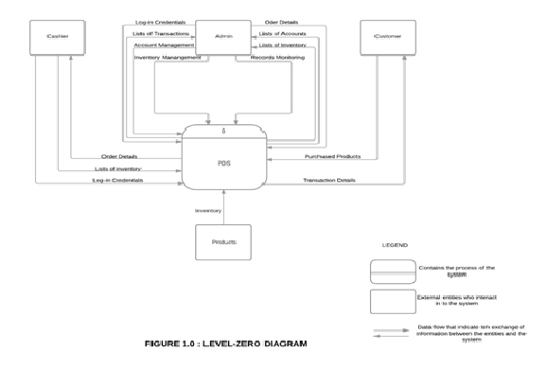

1. **DFD**

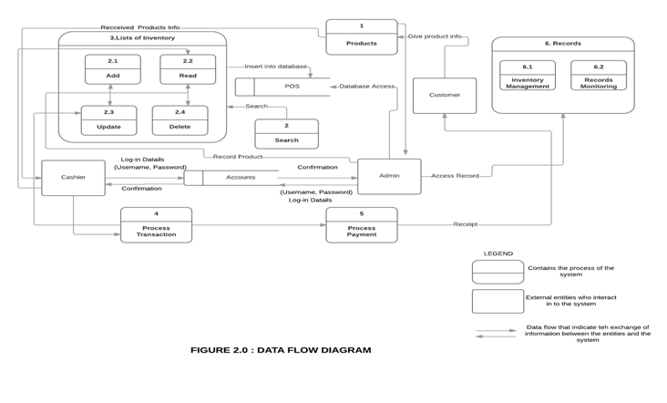

1. **ERD**

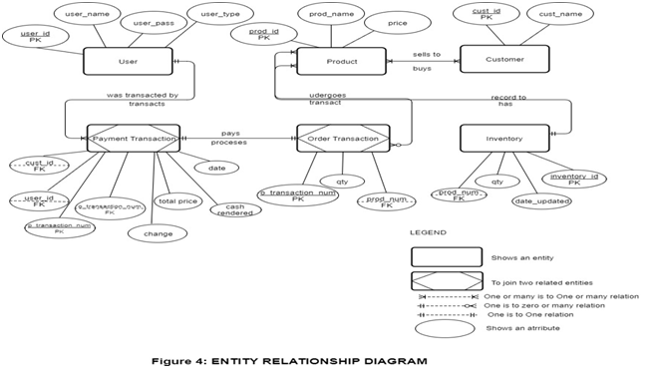

1. **Use Case**

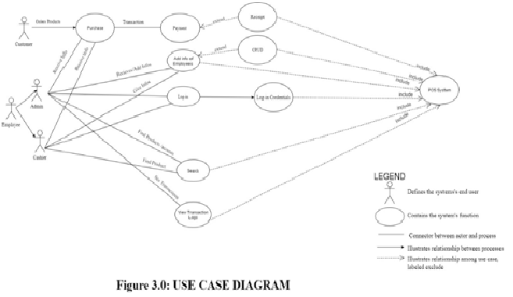

1. **Design**

In the design phase, the proponents worked together to create the models for the user interface, database and application architecture of the system based on the identified requirments. The developers made sure to meet the standard in creating a user-friendly interface and user experience.(Screenshot per page)

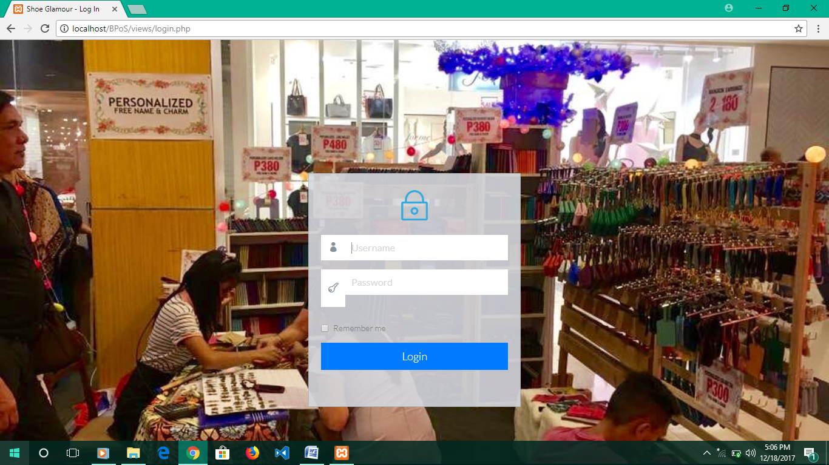

---Log in page---

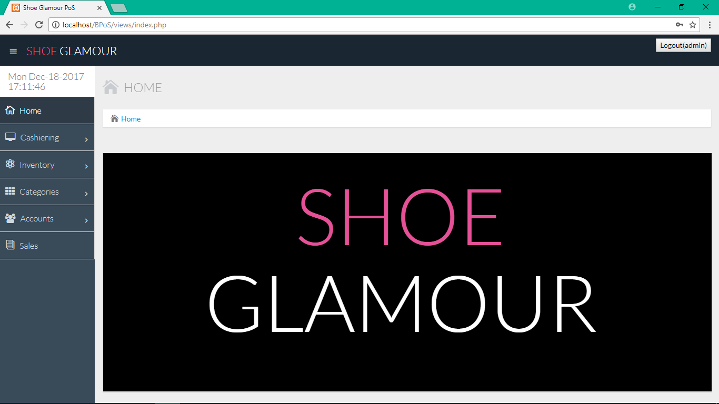

---Home Page---

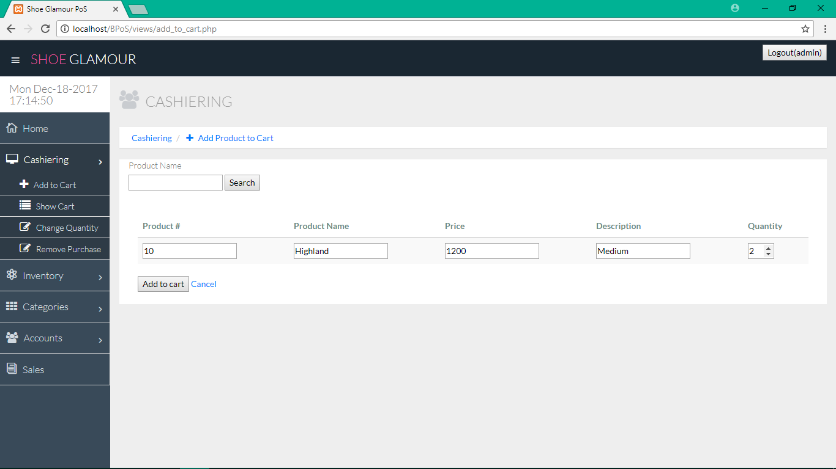---Add to Cart---

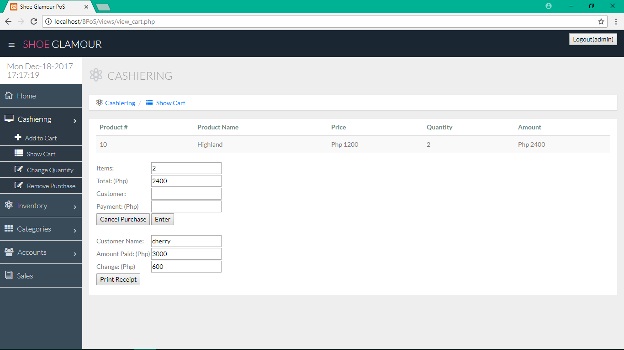

Show Cart---

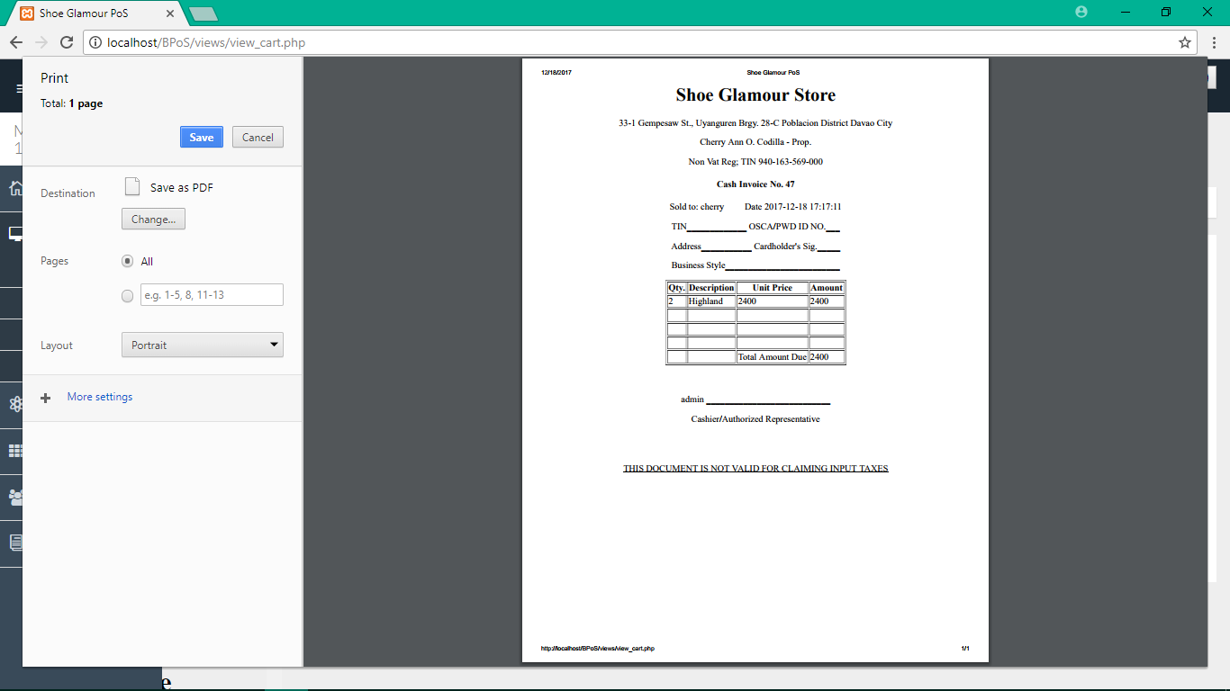

--

---Printed Receipt---

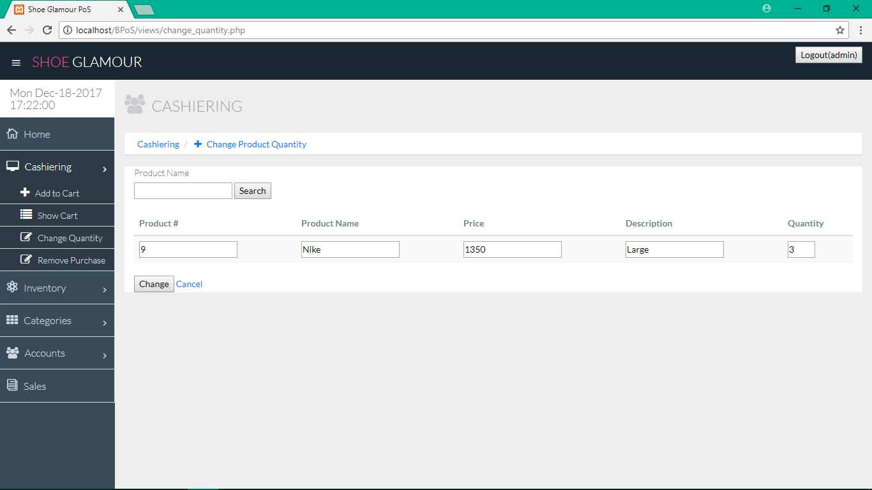---Change quantity---

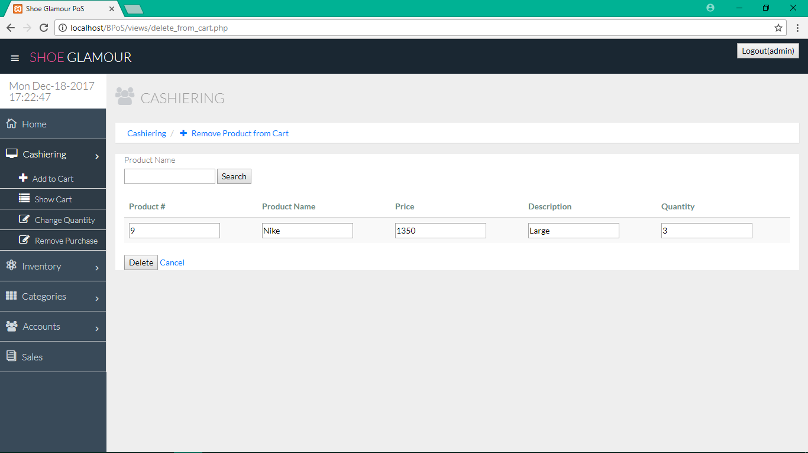

---Remove Product From Cart---

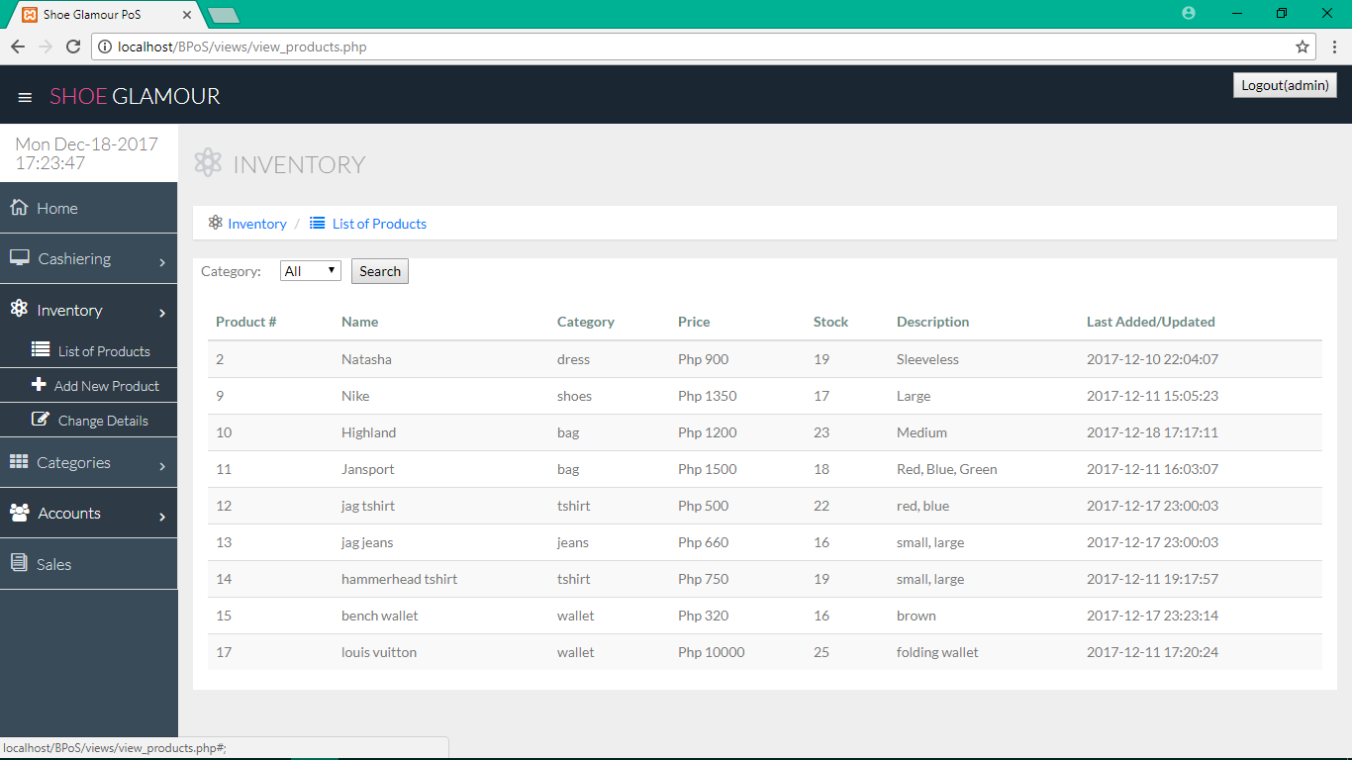

---View Product---

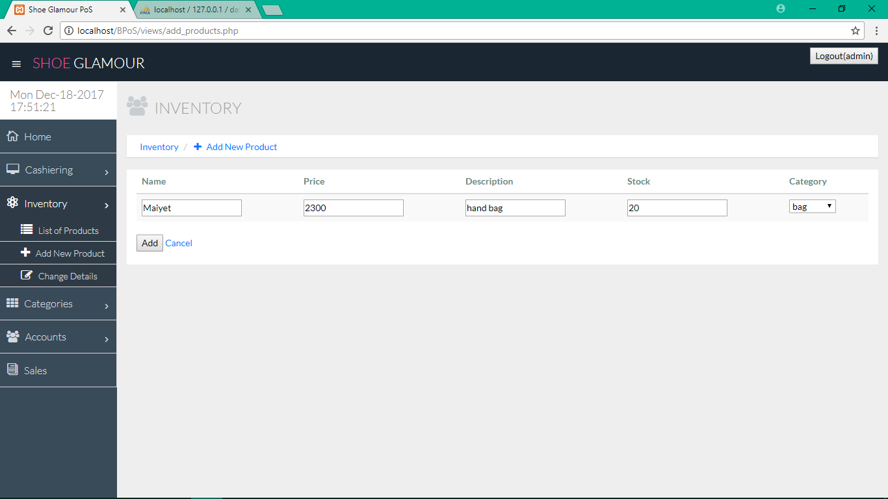

----Add Product----

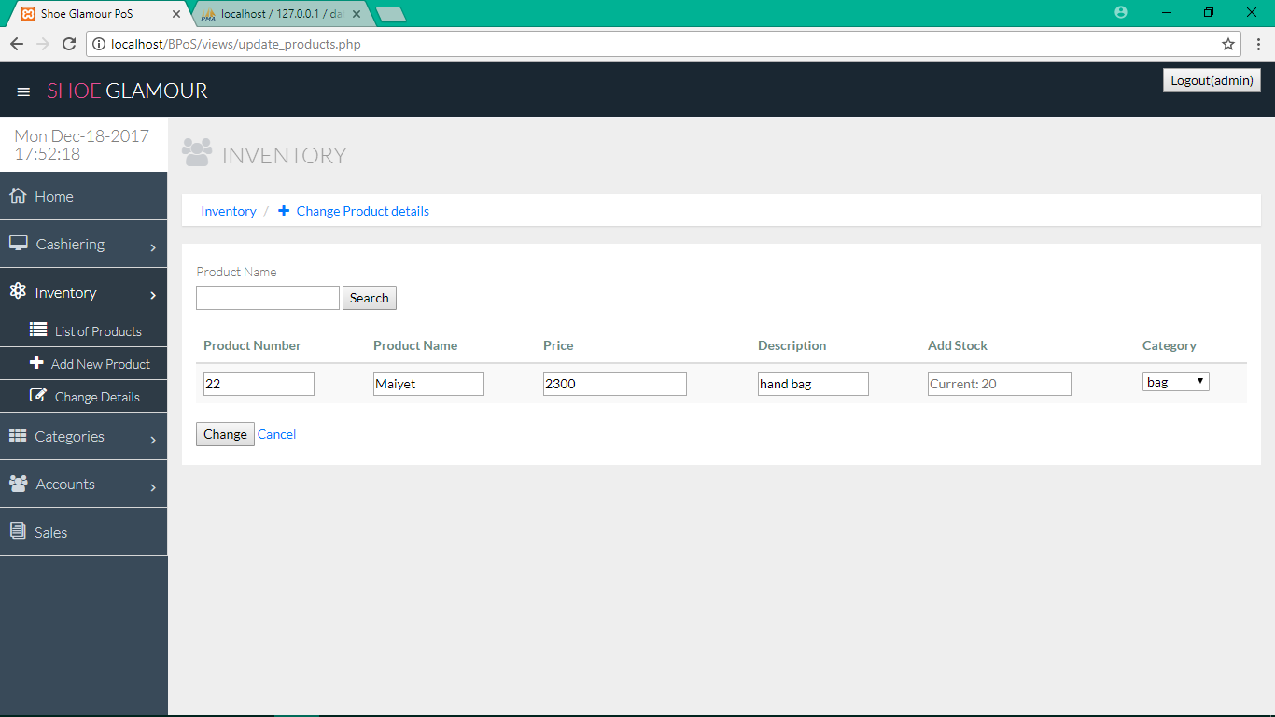

----Change Product Details----

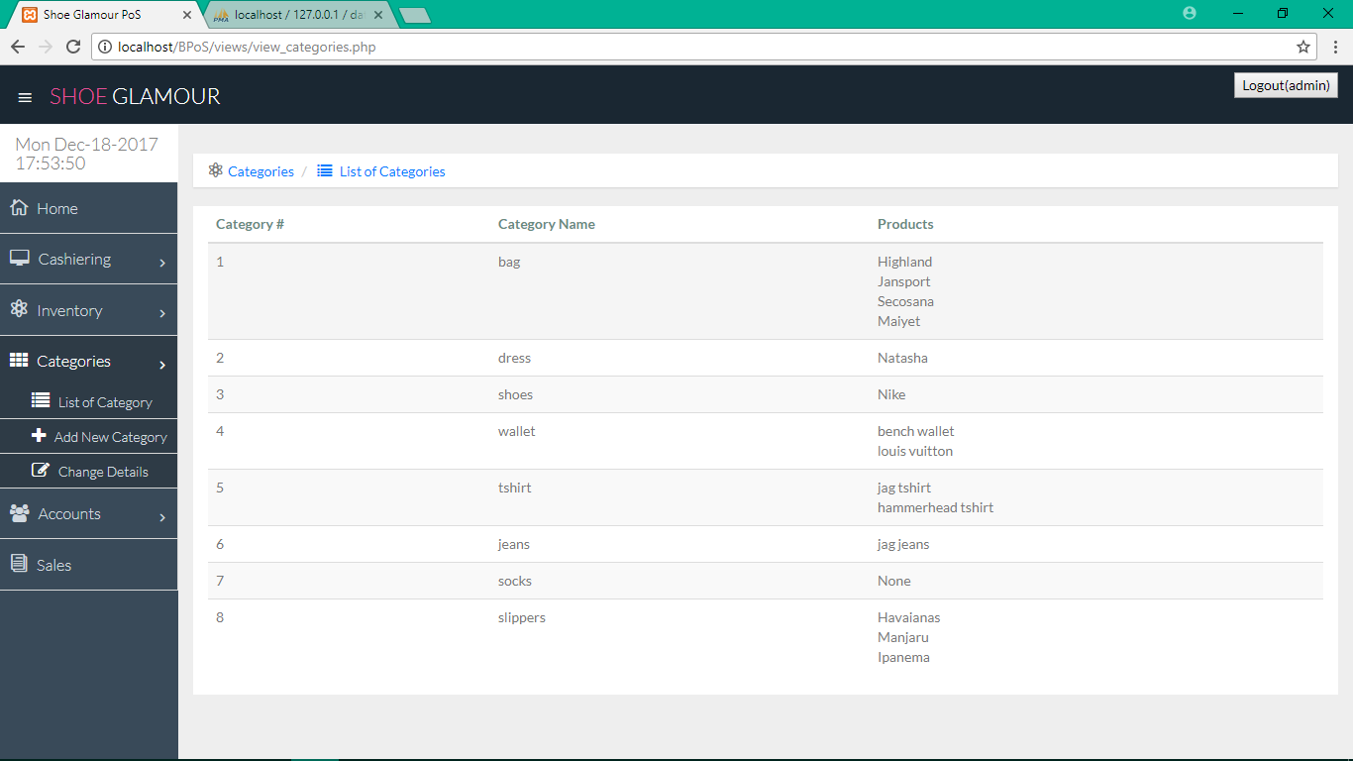

----View Categories----

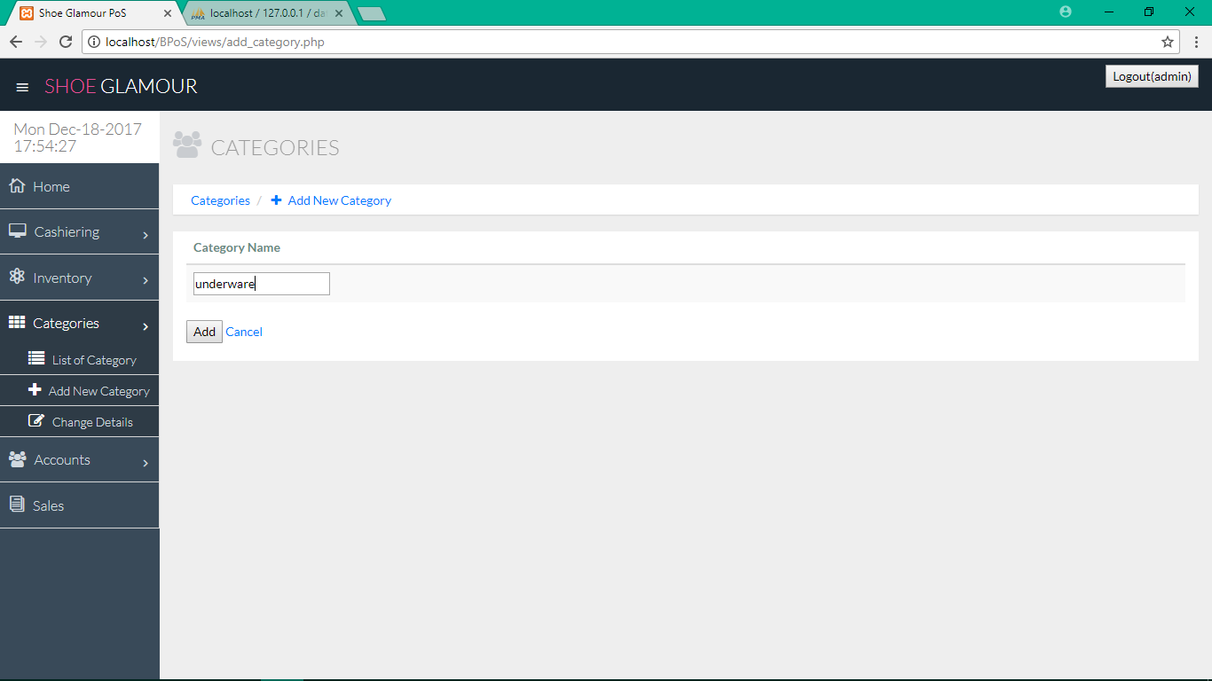

----Add Category----

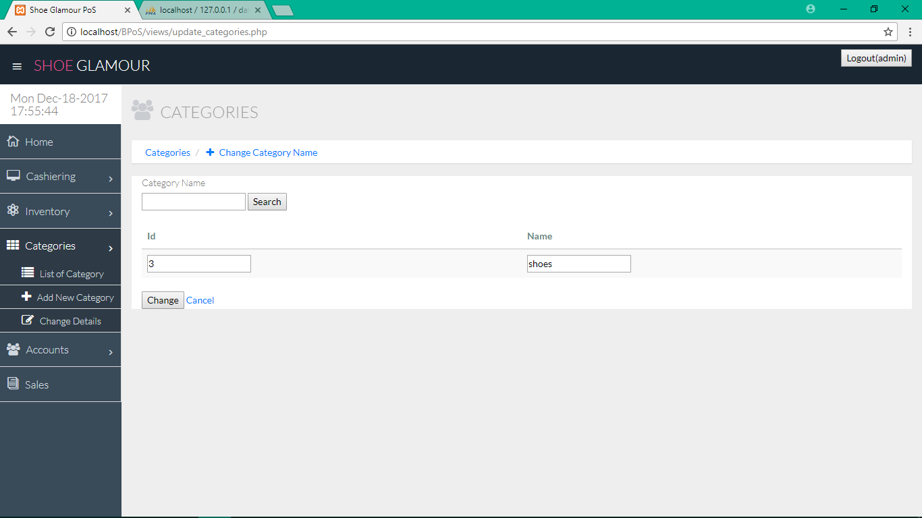

----Change Category Name----

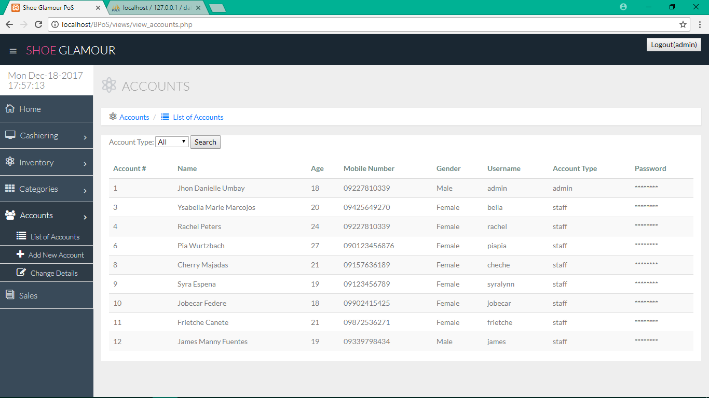

----View All Users----

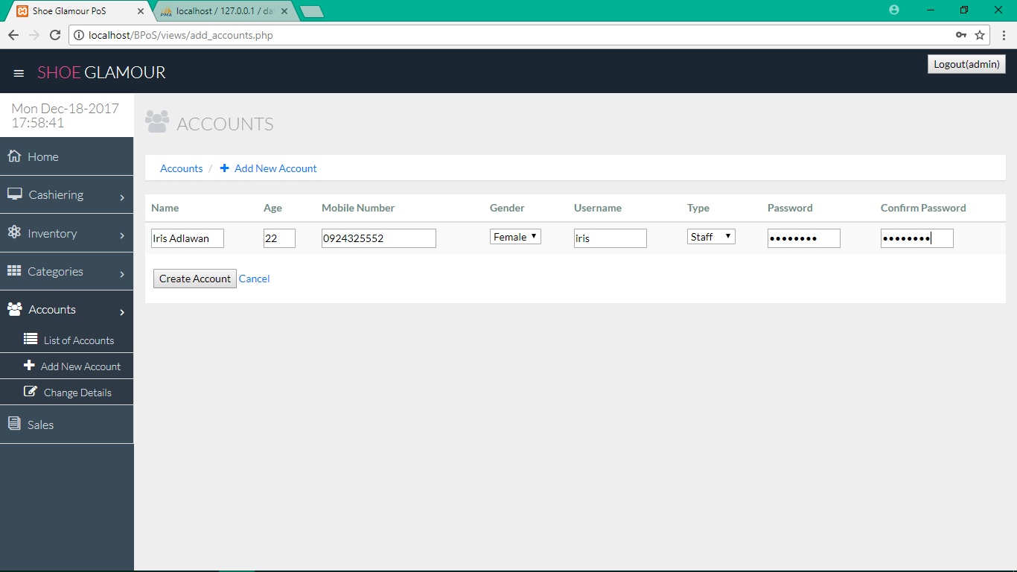

----Add New Account----

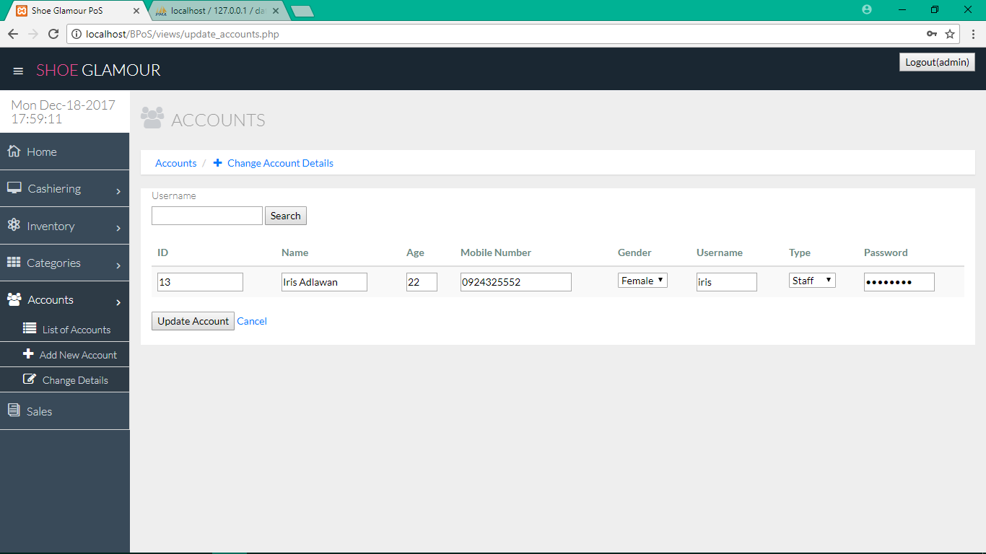

----Change Account Details----

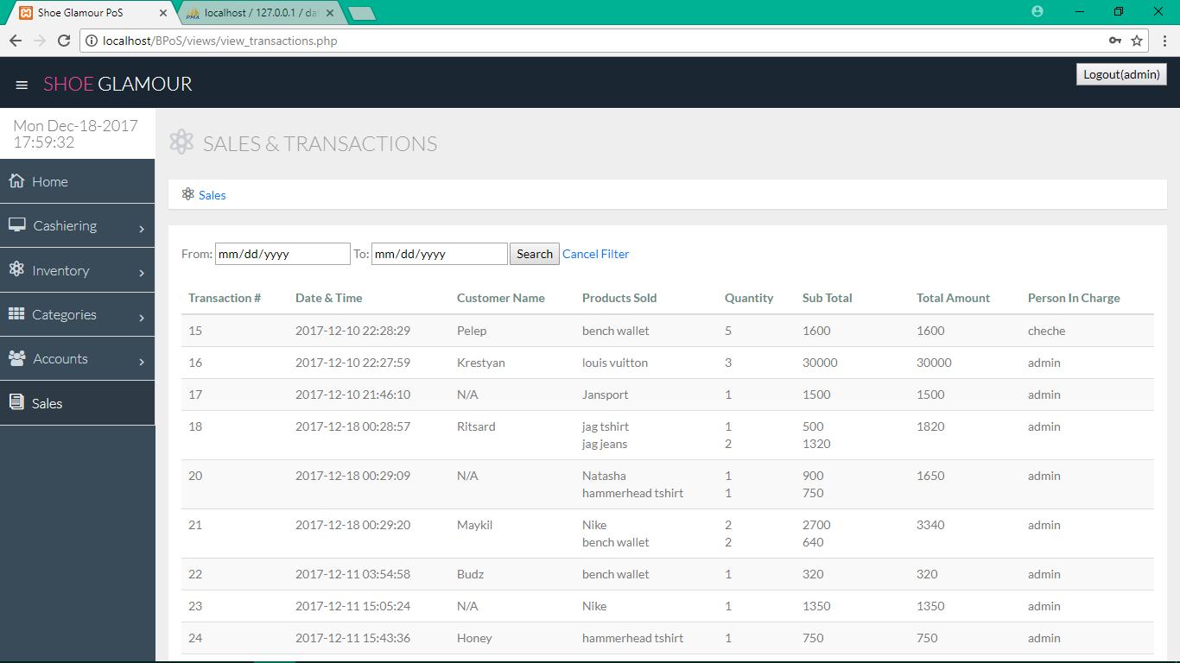

----List of Sales and Transactions----

1. **Development**

|  |  |  |  |
| --- | --- | --- | --- |
| **TASK** | **DATE/ START** | **DATE/FINISH** | **ROLE** |
| Project Proposal letter | Oct 13, 2017 | Oct 19, 2017 | All Members |
| Interview the client/ Consultation | Oct 13, 2017 | Oct 19,2017 | All Members |
| Brain storming | Oct 20, 2017 | Oct 24, 2017 | All Members |
| Making Diagram | Oct 25, 2017 | Oct 31, 2017 | Espeña,Syralynn  Majadas, Cherry Pearl |
| Checking Diagram | Nov 1, 2017 | Nov 3, 2017 | All Members |
| Remaking the Diagrams | Nov 10, 2017 | Nov 24 , 2017 | Syralynn Espeña & Cherry Pearl Majadas |
| Functionality, Queries, & Features | Nov 6, 2017 | Nov 13, 2017 | All Members |
| Back-end Making | Nov 13, 2017 | Dec 12, 2017 | Jhon Danielle Umbay |
| Front-end Making | Nov 13, 2017 | Nov 27, 2017 | Espeña, Syralynn |
| Rechecking the diagrams with Chapter 1 documents | Dec 5, 2017 | Dec 12, 2017 | All Members |
| Documentation | Dec 5, 2017 | Dec 18, 2017 | Espeña, Syralynn  Majadas, Cherry Pearl |

1. **Testing**

In order to evaluate the system performance and credibility, the system was tested on its usability and graphical capabilities using our own personal computers. System testing is performed on the entire system in the context of a set of requirements. It tests not only the design, but also the behavior and even the believed expectations of the customer. The proponents also tested the security capabilities of the system that would avoid sql injection and cross-site scripting. In addition, client-side validation and server-side validation were also tested if it can handle wrong inputs and how does it react to that incorrect input.

1. **Work Plan**

|  |  |
| --- | --- |
| Week 1 (Oct 13-19,2017) | In this week, the proponents make a proposal letter and get signed by the System Analysis Design Instructor , Dean, and proceed to the client.To proposed our project and to have authorization. |
| Week 2 (Oct 20 – 24 ,2017) | During this week, the proponents do brain storming.Planning took place and schedules were laid out. Deciding on what other functions fit to the problem of our client. |
| Week 3 (Oct 25 - 31, 2017) | This Seven days,the proponents do the Diagrams (Level 0, DFD, ERD, and Use Case) to illustrate the relationship inside the system and their database. The Functionalities and features were defined and drafted using a prototype. |
| Week 4 (Nov1-3 2017) | In this week,diagrams were check by the SAD instructor. |
| Week 5 ( Nov 6-13, 2017)  Week 6 (Nov 13-20, 2017)  Week 7 ( Nov 20-27, 2017)  Week 8 ( Nov 27- Dec 4, 2017) | In the four weeks, the proponents create the back end, front end, and the documentation of the system. |
| Week 9 (Dec 5-12 , 2017) | In these days, the proponents re-create the four Diagrams and checked by the SAD instructor. |
| Week 10 (Dec 13- 18, 2017) | In this last week, the proponents finished the last chapter of the documents and re-checked the functionalities of the system. |

# CHAPTER 3: RESULTS AND DISCUSSION

## Results

The proponents created a Point of Sale System for Shoe Glamour Boutique. It started with an empty inventory and empty sales data. Since the boutique includes only the owner and her assistants, the created system of the proponents have two types of users. The admin type and staff type. The owner use the admin account type and her assistants use the staff account type. The admin adds new products. The admin also change the product details and add product quantity if ever there’s a need to update. While the staffs only view products and the stocks as they are not allowed to manage the inventory. The owner allows her assistant to also manage the cashiering system so both types of users manage the Cashiering System and both of them look for the sales on a selected date. The system has user restriction functions for system security and unregistered users can’t access or alter any data in the Point of Sale System. The transaction data and sales data were automatically recorded and stored on the database.

## Discussion

After all the brainstorming, planning, sharing of thoughts, developing, and testing the system, the proponents have been successfully developed and done the system. The proponents concluded that the specific needs of the apparel store, Shoe Glamour, were meet. The system developed by the proponents has cashiering, sales and inventory management, and can produce receipts for the customers. The proponents believe that these functions can help the store a lot for an efficient and fast transaction and service. In contrast with their pen-and-paper-based system, the proposed P.o.S system can improve the progress of the store.

## Recommendation

Some recommendation is to add a functionality where the users can view the daily, weekly, monthly and yearly sales report. This add – on will help the owner to monitor the different changes in her sales on a timely basis. She can check if there is an increase or decrease on the demand of a product and adjusts the needs of the supply of that product. Given that her business is comprised of apparels, bags, shoes and other fashion-related products, knowing the amount of sales in a specific time will give her an insight of what products are in-demand in that times of a year.

## Conclusion

Due to slow transactions, the use of the developed system is increasing. The developed system for Shoe Glamour Boutique has been designed to achieve maximum efficiency and reduce the time taken to handle transactions. It is designed to replace the existing manual record system thereby reducing time taken for calculations and for storing data. The system uses bootstrap as front end and php language as a backend for the database. The system is strong enough to stand regressive daily operations under conditions where the database is maintained and cleared over a certain span of time. The implementation of the system in the said boutique will considerably reduce data entry, time and also provide readily calculated reports. Based on what happen yesterday, the developers went to the client and explained the user manual, and based on the reaction of the client to the system, the proponents concluded that the system met the needs and wants of their ongoing business environment.

**Referrences**

* <https://www.expertmarket.com/What-Point-Of-Sale-System-Does-Walmart-Use>
* https://en.wikipedia.org/wiki/Walmart
* <https://www.expertmarket.com/What-Point-Of-Sale-System-Does-Apple-Use>
* https://en.wikipedia.org/wiki/Apple_Inc.
* <https://en.wikipedia.org/wiki/Mang_Inasal>
* www.eposplus.net/
* https://www.usability.gov/how-to-and-tools/methods/system-usability-scale.html
* John Brooke, Redhatch Consulting Ltd., United Kingdom

# **Appendices**

## Curriculum Vitae

**Student Curriculum Vitae**

|  |
| --- |
| C:\xampp\htdocs\BPoS\views\img\sy.jpg |

**Name:** Syralynn A. Espeña **Age:** 19 **Sex:** Female

**Birthday:** February 8, 1998 **Religion:**Roman Catholic

**Height:** 5’’2’ **Weight:** 40 kg

**Citizenship:** Filipino **Civil Status:** Single

**Place of Birth:** Caloocan City

**Address:** Brgy. 76-A Purok 2 Bucana, Davao City

**Father’s Name:** Jessica A. Espeña **Occupation:** Driver

**Mother’s Name:** Ricky J. Espeña **Occupation:**Self-employed

**Educational Background:**

**Elementary:** Tandang Sora Integrated School

**Secondary:** Davao City National High School

**Tertiary:** University of Southeastern Philippines

**Student Curriculum Vitae**

**_____________________________________________________________________**



**Name:** Cherry Pearl F. Majadas **Age:** 19 **Sex:** Female

**Birthday:** August 30, 1998 **Religion:**Roman Catholic

**Height:** 5’’1’ **Weight:** 42 kg

**Citizenship:** Filipino **Civil Status:** Single

**Place of Birth:** Santa Cruz Davao del Sur

**Address:** Santa Cruz Davao del Sur

**Father’s Name:** Primitivo Majadas Sr. (deceased)

**Mother’s Name:** Sonia Majadas **Occupation:** Housewife

**Educational Background:**

**Elementary:** Santa Cruz Central Elementary School

**Secondary:** St. Marys Academy of Santa Cruz Inc.

**Tertiary:** University of Southeastern Philippines

**Student Curriculum Vitae**

_____________________________________________________________________

**Name:** Jhon Danielle L. Umbay **Age:** 20 **Sex:** Male

**Birthday:** August 30, 1998 **Religion:**Roman Catholic

**Height:** 5’’4’ **Weight:** 49 kg

**Citizenship:** Filipino **Civil Status:** Single

**Place of Birth:** Davao City

**Address:** Panacan, Davao City

**Father’s Name:** Danilo S. Umbay **Occupation:**Radio Operator

**Mother’s Name:** Oliva L. Umbay **Occupation:** Self-employed

**Educational Background:**

**Elementary:** Vicente Hizon Sr. Elementary School

**Secondary:** Francisco Bangoy National High School

**Tertiary:** University of Southeastern Philippines

## Certificate of Completion



## Code Snippets

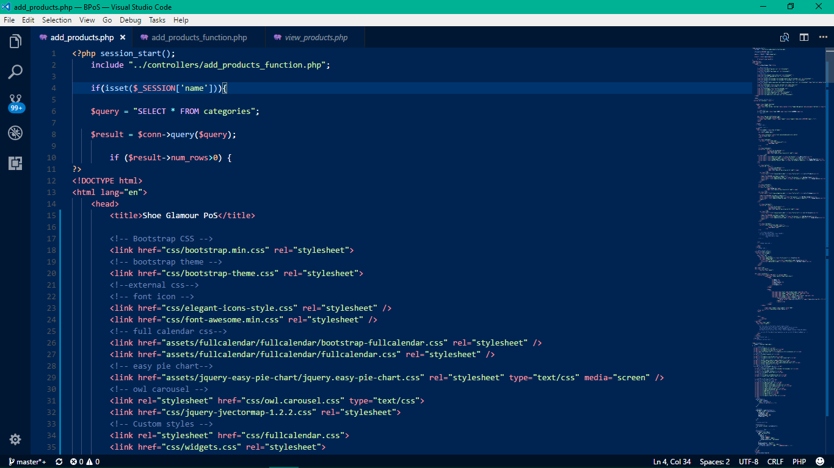

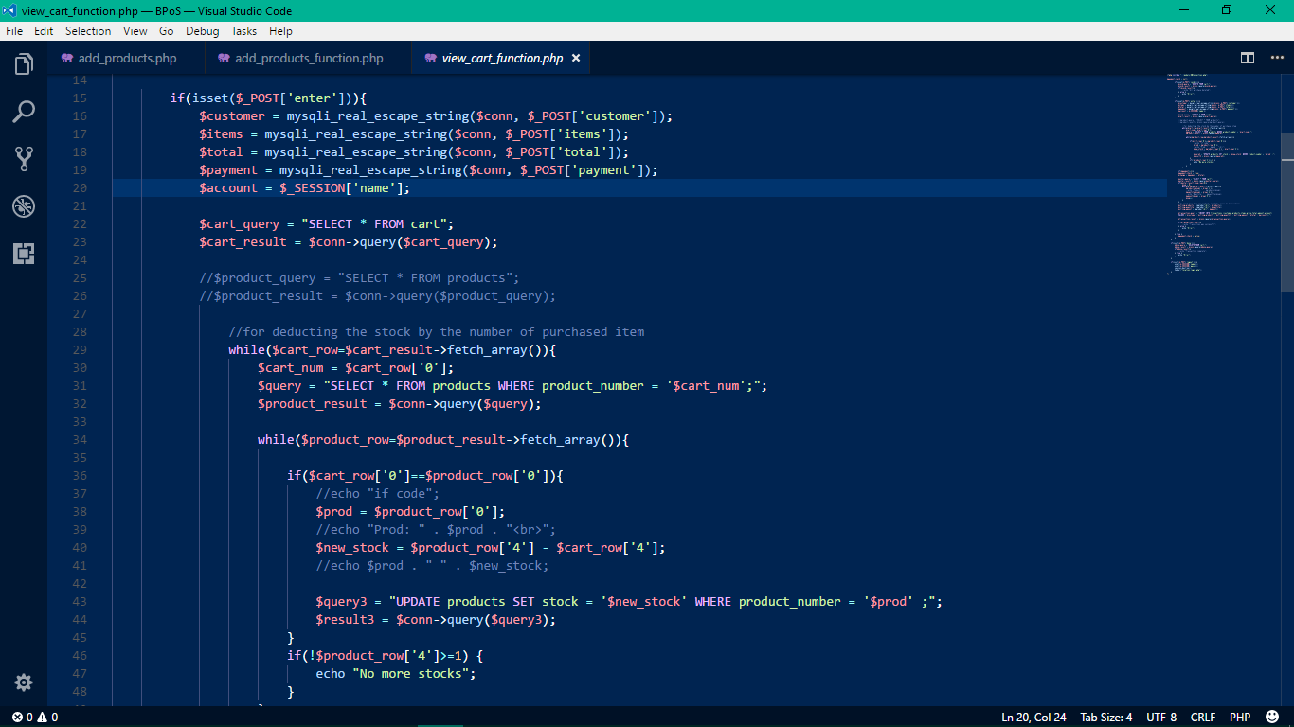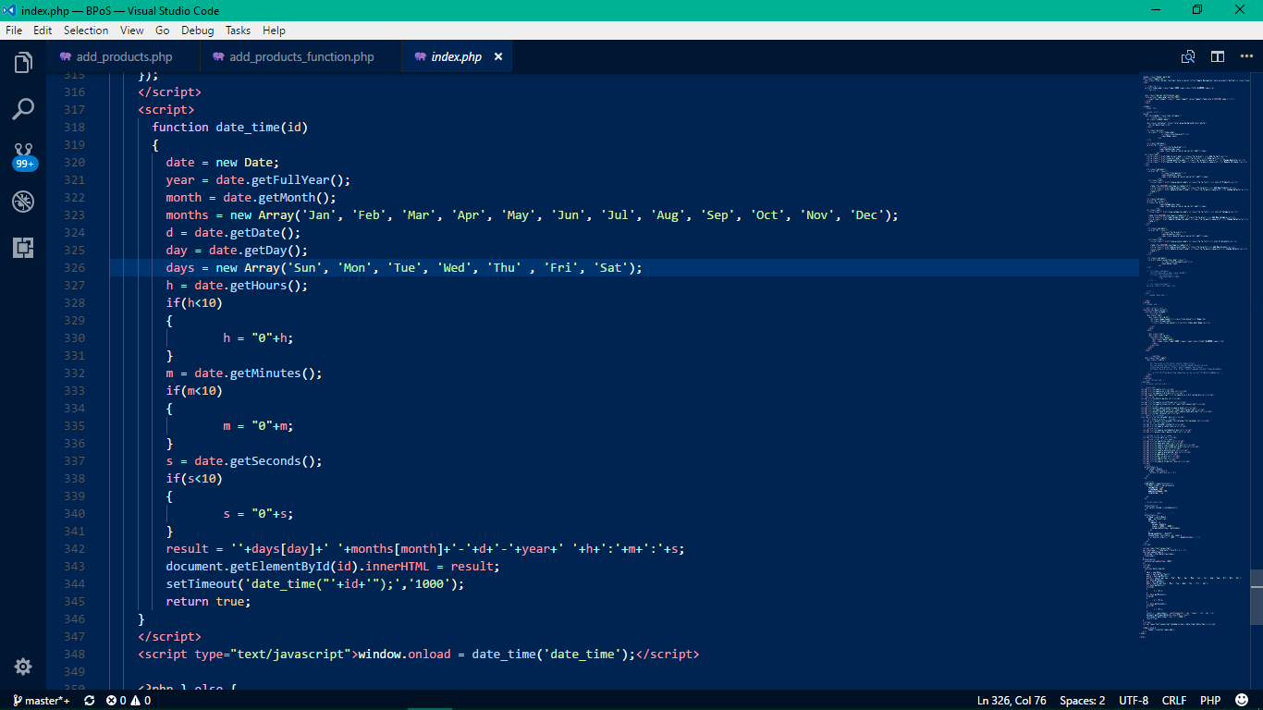

## Users Manual



---Log in page---



---Home Page---



---Add to Cart---



---Show Cart---



---Printed Receipt---



---Change quantity---



---Remove Product From Cart---



---View Product---



----Add Product----



----Change Product Details----



----View Categories----



----Add Category----



----Change Category Name----



----View All Users----



----Add New Account----



----Change Account Details----



----List of Sales and Transactions----

## Evaluation Tool

To evaluate the effectiveness and efficiency of the Point of Sale System, the proponents used the System Usability Scale(SUS) as a tool to find out if the system is user-friendly and if the functionalities were easy to use or to be understood. There are ten questions provided for the respondents and each question tackles about the user experience of the respondent when he or she used the system. Below is the result of the System Usability Scale from five random respondents. To calculate the SUS score, first add all the score contributions from each item. For items 1,3,5,7,and 9 the score contribution is the scale position minus 1. For items 2,4,6,8 and 10, the contribution is 5 minus the scale position. After that, multiply the sum of the scores by 2.5 to get the overall value of SUS.

Name: N/A

|  |  |  |  |  |  |  |
| --- | --- | --- | --- | --- | --- | --- |
|  | Strongly Disagree(1) | 2 | 3 | 4 | Strongly Agree(5) |  |
| 1. I think that I would like to use this system frequently |  |  |  | X |  |  |
| 2. I found the system unnecessarily complex |  | X |  |  |  |  |
| 3. I thought the system was easy to use |  | X |  |  |  |  |
| 4. I think that I would need the support of a technical person to be able to use this system |  | X |  |  |  |  |
| 5. I found the various functions in this system were well integrated |  |  |  | X |  |  |
| 6. I thought there was too much inconsistency in this system |  | X |  |  |  |  |
| 7. I would imagine that most people would learn to use this system very quickly |  |  |  | X |  |  |
| 8. I found the system very cumbersome to use |  | X |  |  |  |  |
| 9. I felt very confident using the system |  |  |  | X |  |  |
| 10. I needed to learn a lot of things before I could get going with this system | X |  |  |  |  |  |
|  |  |  |  |  | Total Score | 29 x 2.5 |
|  |  |  |  |  | SUS Score | 72.5 |

Name: N/A

|  |  |  |  |  |  |  |
| --- | --- | --- | --- | --- | --- | --- |
|  | Strongly Disagree(1) | 2 | 3 | 4 | Strongly Agree(5) |  |
| 1. I think that I would like to use this system frequently |  |  |  |  | X |  |
| 2. I found the system unnecessarily complex |  | X |  |  |  |  |
| 3. I thought the system was easy to use | X |  |  |  |  |  |
| 4. I think that I would need the support of a technical person to be able to use this system |  |  | X |  |  |  |
| 5. I found the various functions in this system were well integrated |  |  |  | X |  |  |
| 6. I thought there was too much inconsistency in this system | X |  |  |  |  |  |
| 7. I would imagine that most people would learn to use this system very quickly |  |  |  | X |  |  |
| 8. I found the system very cumbersome to use |  | X |  |  |  |  |
| 9. I felt very confident using the system |  |  |  |  | X |  |
| 10. I needed to learn a lot of things before I could get going with this system |  | X |  |  |  |  |
|  |  |  |  |  | Total Score | 29 x 2.5 |
|  |  |  |  |  | SUS Score | 72.5 |

Name:N/A

|  |  |  |  |  |  |  |
| --- | --- | --- | --- | --- | --- | --- |
|  | Strongly Disagree(1) | 2 | 3 | 4 | Strongly Agree(5) |  |
| 1. I think that I would like to  use this system frequently |  |  |  | X |  |  |
| 2. I found the system unnecessarily  complex | X |  |  |  |  |  |
| 3. I thought the system was easy  to use |  | X |  |  |  |  |
| 4. I think that I would need the  support of a technical person to  be able to use this system |  | X |  |  |  |  |
| 5. I found the various functions in  this system were well integrated |  |  | X |  |  |  |
| 6. I thought there was too much  inconsistency in this system |  | X |  |  |  |  |
| 7. I would imagine that most people  would learn to use this system  very quickly |  |  | X |  |  |  |
| 8. I found the system very  cumbersome to use |  | X |  |  |  |  |
| 9. I felt very confident using the  System |  |  |  | X |  |  |
| 10. I needed to learn a lot of  things before I could get going  with this system | X |  |  |  |  |  |
|  |  |  |  |  | Total Score | 28 x 2.5 |
|  |  |  |  |  | SUS Score | 70 |

Name:N/A

|  |  |  |  |  |  |  |
| --- | --- | --- | --- | --- | --- | --- |
|  | Strongly Disagree(1) | 2 | 3 | 4 | Strongly Agree(5) |  |
| 1. I think that I would like to use this system frequently |  |  |  | X |  |  |
| 2. I found the system unnecessarily complex |  |  | X |  |  |  |
| 3. I thought the system was easy  to use |  | X |  |  |  |  |
| 4. I think that I would need the  support of a technical person to  be able to use this system |  |  | X |  |  |  |
| 5. I found the various functions in  this system were well integrated |  |  |  | X |  |  |
| 6. I thought there was too much  inconsistency in this system |  | X |  |  |  |  |
| 7. I would imagine that most people  would learn to use this system  very quickly |  |  |  | X |  |  |
| 8. I found the system very  cumbersome to use | X |  |  |  |  |  |
| 9. I felt very confident using the  system |  |  | X |  |  |  |
| 10. I needed to learn a lot of  things before I could get going  with this system |  | X |  |  |  |  |
|  |  |  |  |  | Total Score | 26 x2.5 |
|  |  |  |  |  | SUS Score | 65 |

Name:N/A

|  |  |  |  |  |  |  |
| --- | --- | --- | --- | --- | --- | --- |
|  | Strongly Disagree(1) | 2 | 3 | 4 | Strongly Agree(5) |  |
| 1. I think that I would like to  use this system frequently |  |  | X |  |  |  |
| 2. I found the system unnecessarily  complex |  | X |  |  |  |  |
| 3. I thought the system was easy  to use | X |  |  |  |  |  |
| 4. I think that I would need the  support of a technical person to  be able to use this system |  | X |  |  |  |  |
| 5. I found the various functions in  this system were well integrated |  |  |  | X |  |  |
| 6. I thought there was too much  inconsistency in this system |  | X |  |  |  |  |
| 7. I would imagine that most people  would learn to use this system  very quickly |  |  | X |  |  |  |
| 8. I found the system very  cumbersome to use |  | X |  |  |  |  |
| 9. I felt very confident using the  system |  |  |  | X |  |  |
| 10. I needed to learn a lot of  things before I could get going  with this system | X |  |  |  |  |  |
|  |  |  |  |  | Total Score | 25 x 2.5 |
|  |  |  |  |  | SUS Score | 62.5 |

Based on the result of the SUS, the proponent found out that three of the respondents have scores above 68 which indicates above average and the remaining two respondents have scores below 68 that indicates below average. This means that there are more respondents who consider the system efficient and user-friendly than those who don’t. Though it can be considered as a positive result, the proponents still find the need for some improvement of the system based also on the result of System Usability Scale.

## Other relevant documents

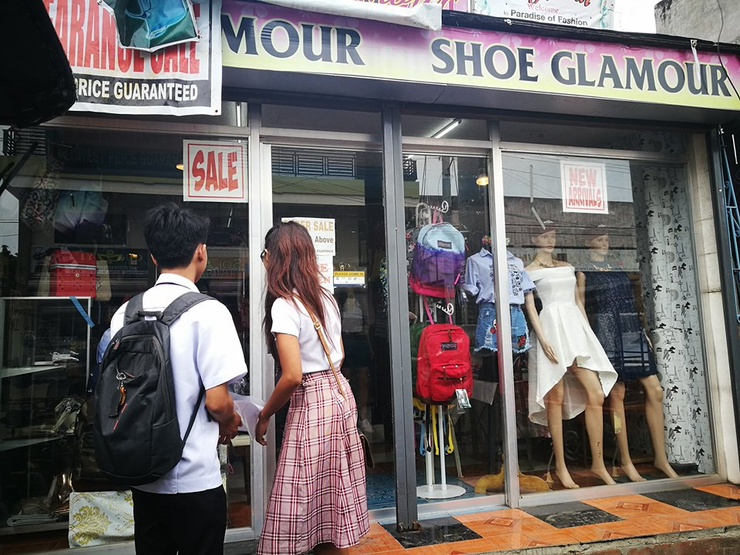

Signing the Proposal letter

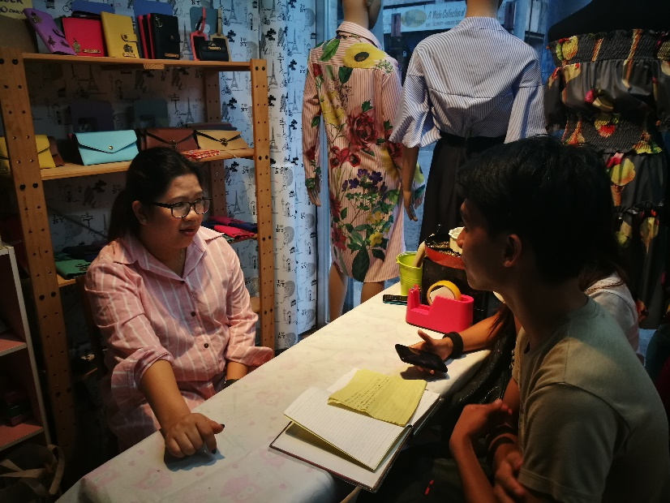

**1st** interview with the Owner

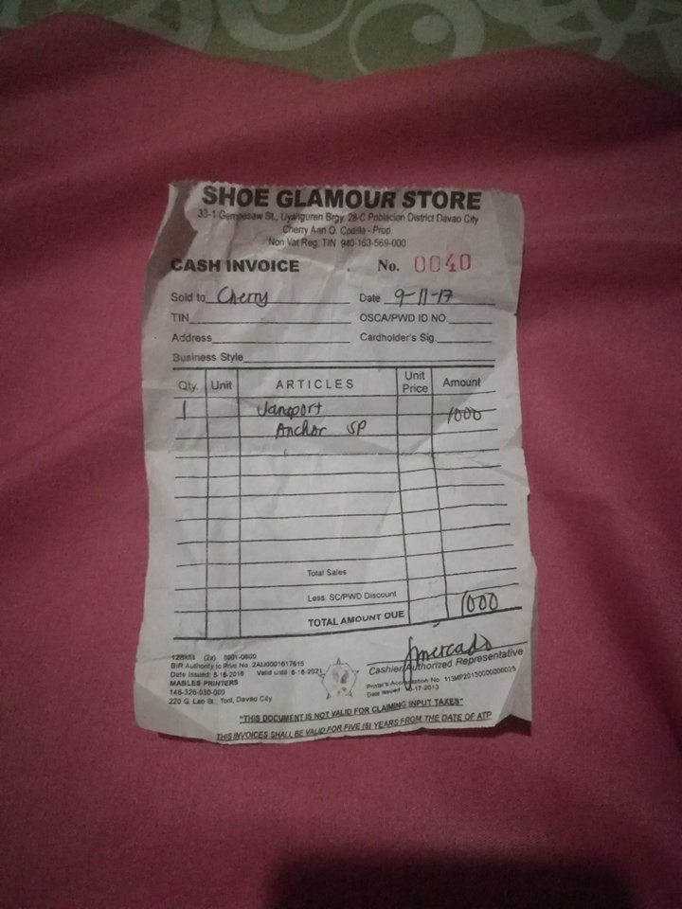

Sample receipt for manual process

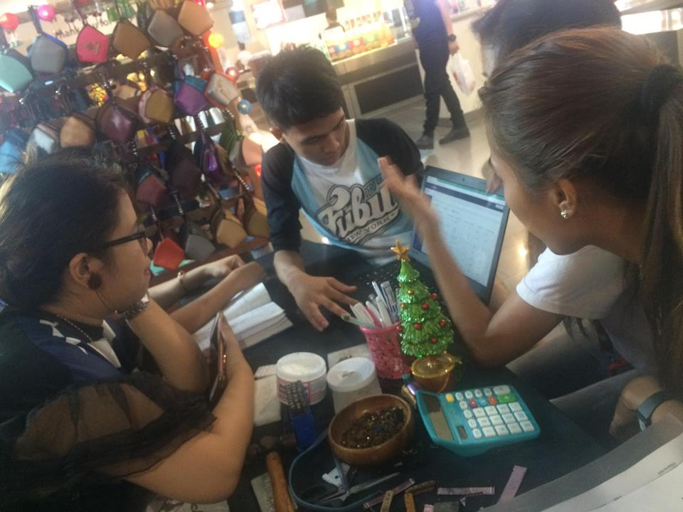

Last meet with the owner. Presentation of the proponents’ developed system.