Fatima Jinnah Women University

*Department of Software Engineering*



*---------------------------------------------------------------------------------------------------------------------------------------*

ASSIGNMENT#01

***Report***

**SUBJECT: CLOUD COMPUTING**

**SUBMITTED TO: SIR WAQAS SALEEM**

**SUBMITTED BY: UMBER QASIM**

**REGISTRATION NO: 2023-BSE-066**

**CLASS: BSSE V-B**

***Task#01:***

Run Gitea in Codespace and Create an Initial Repo.

***Answer:***

1. **Set up Gitea:**

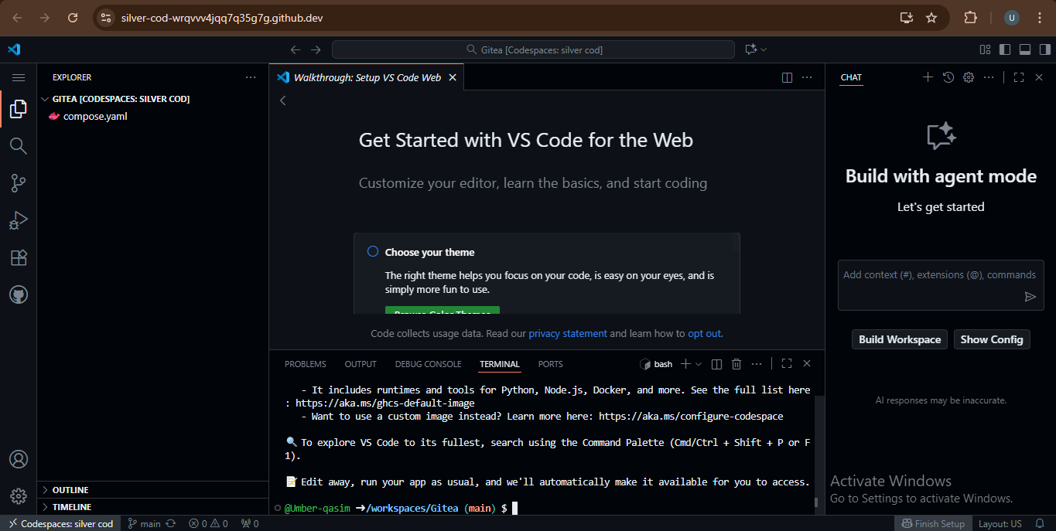

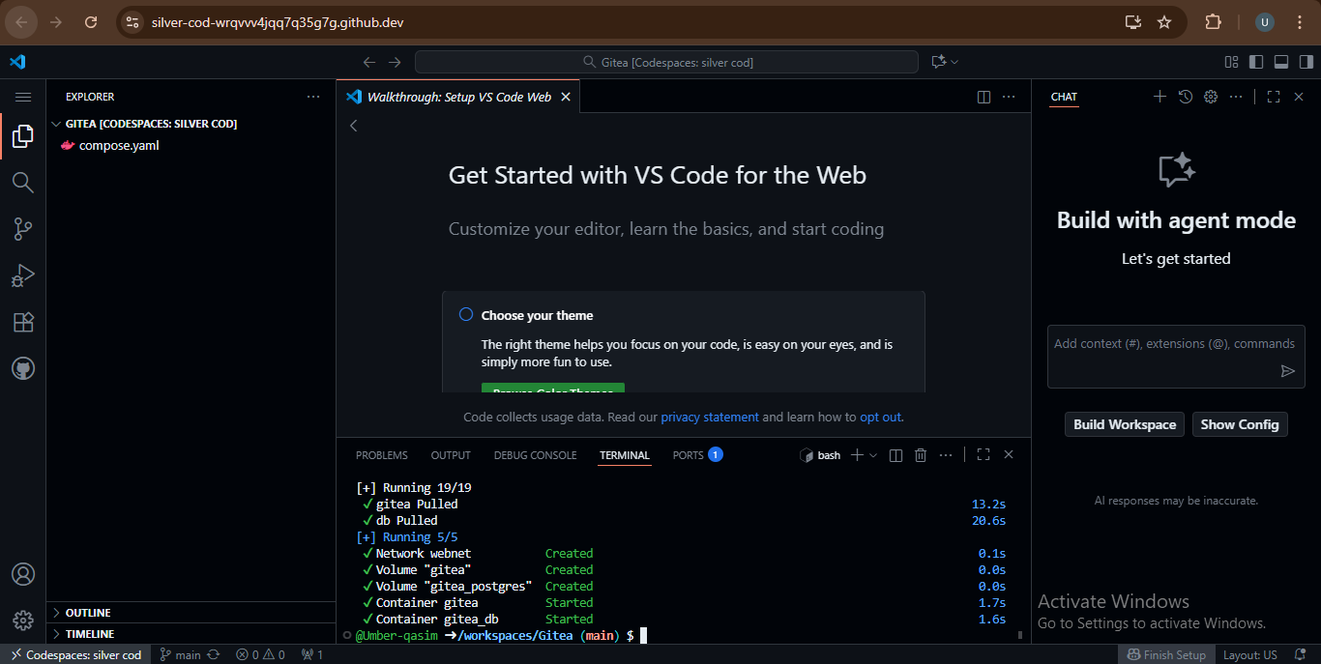

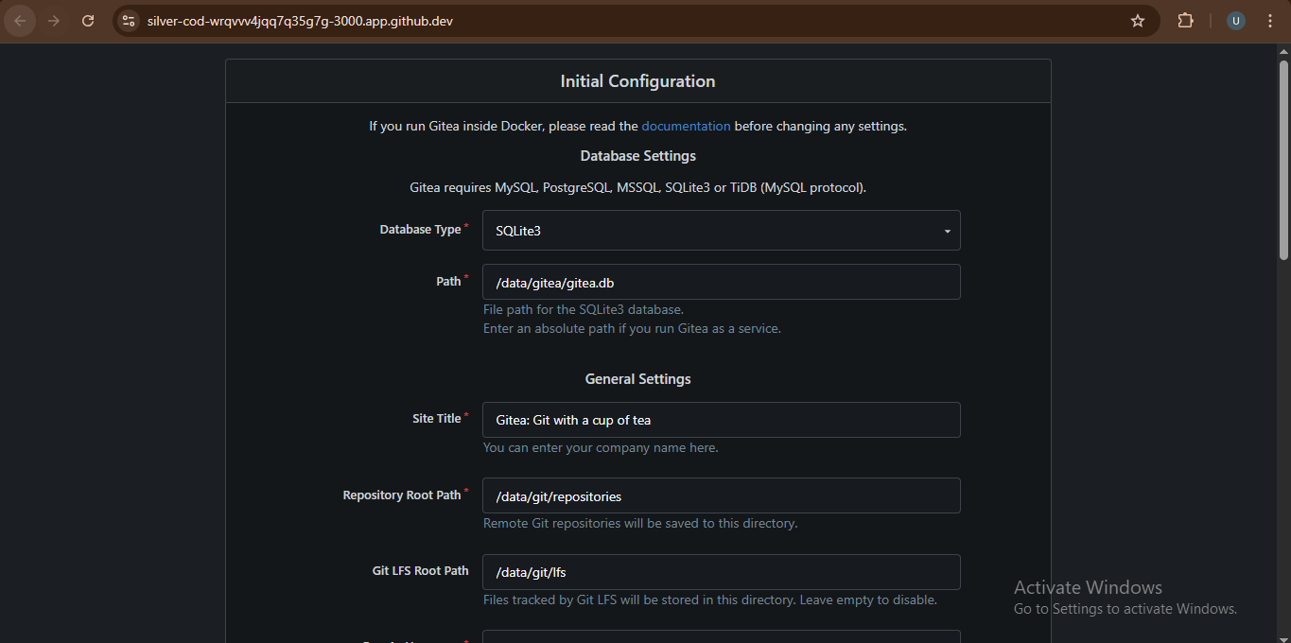

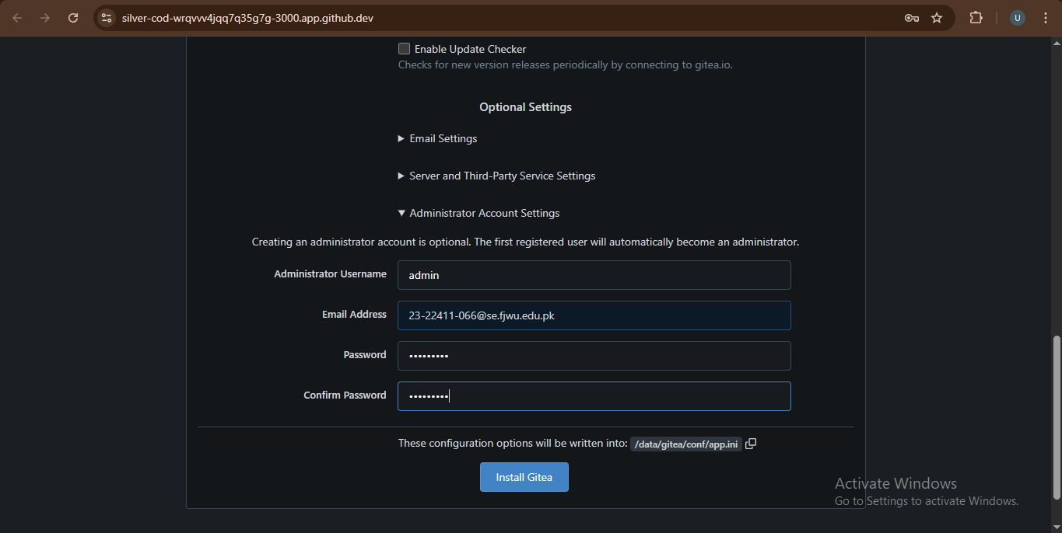

1. **Create a Repository:**

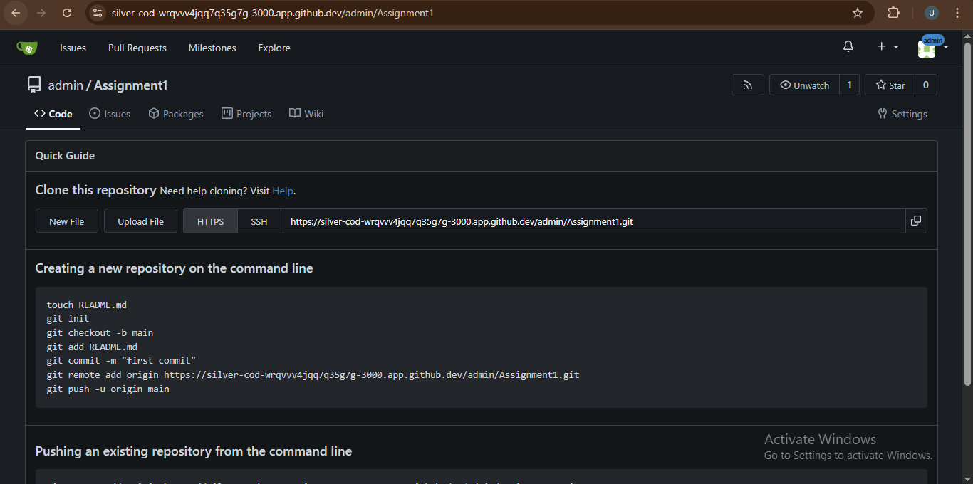

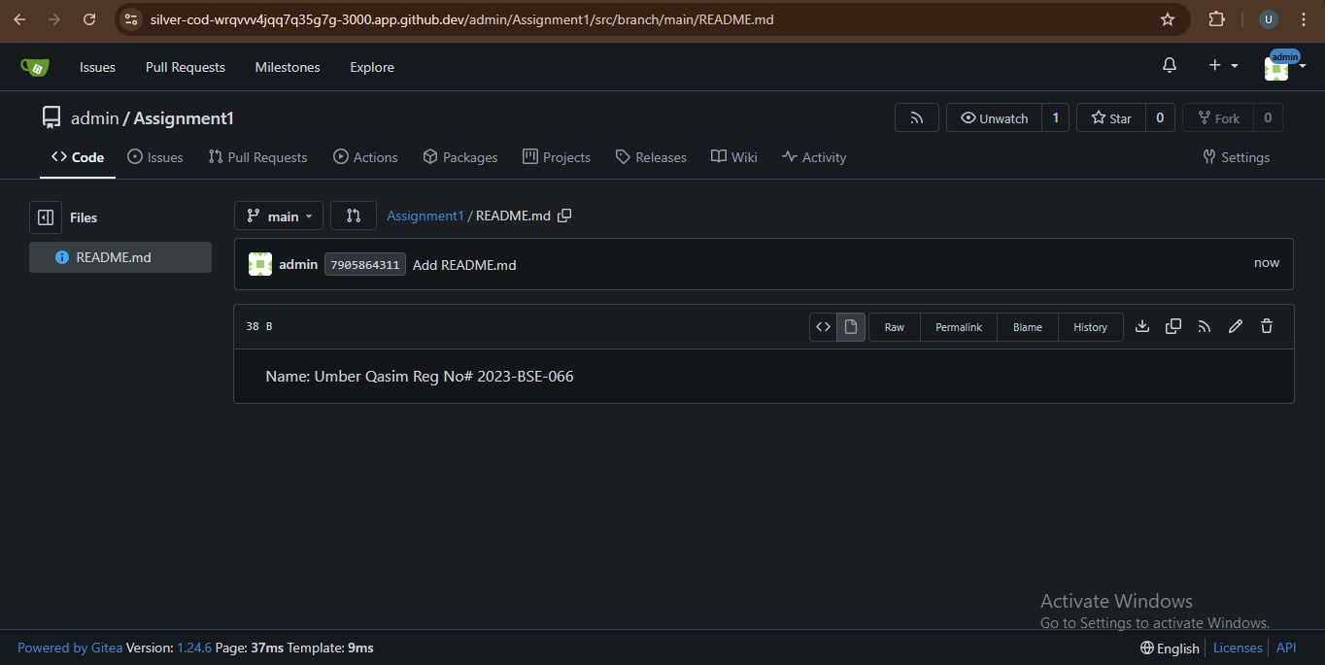

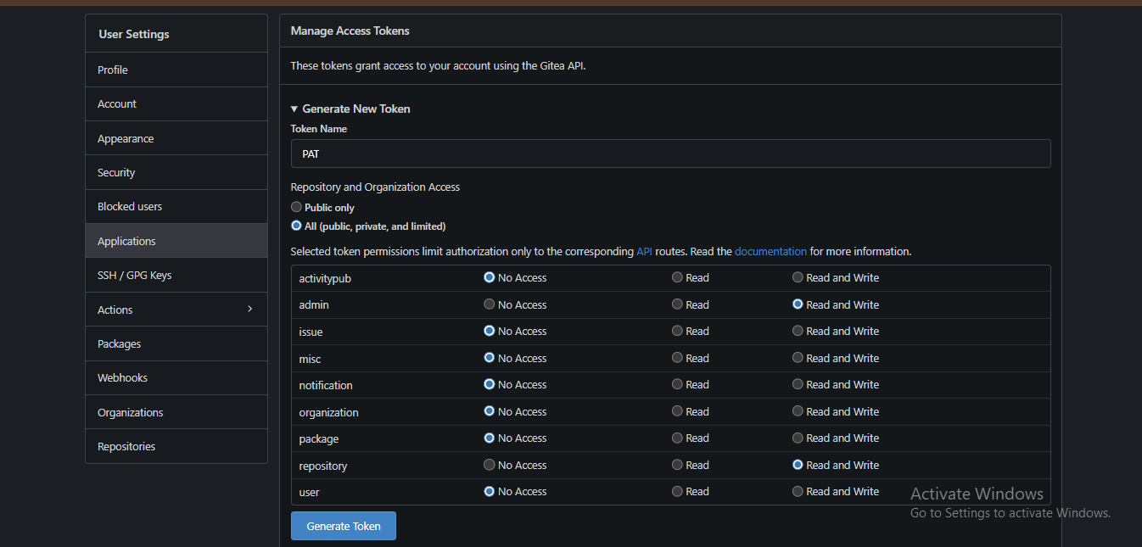

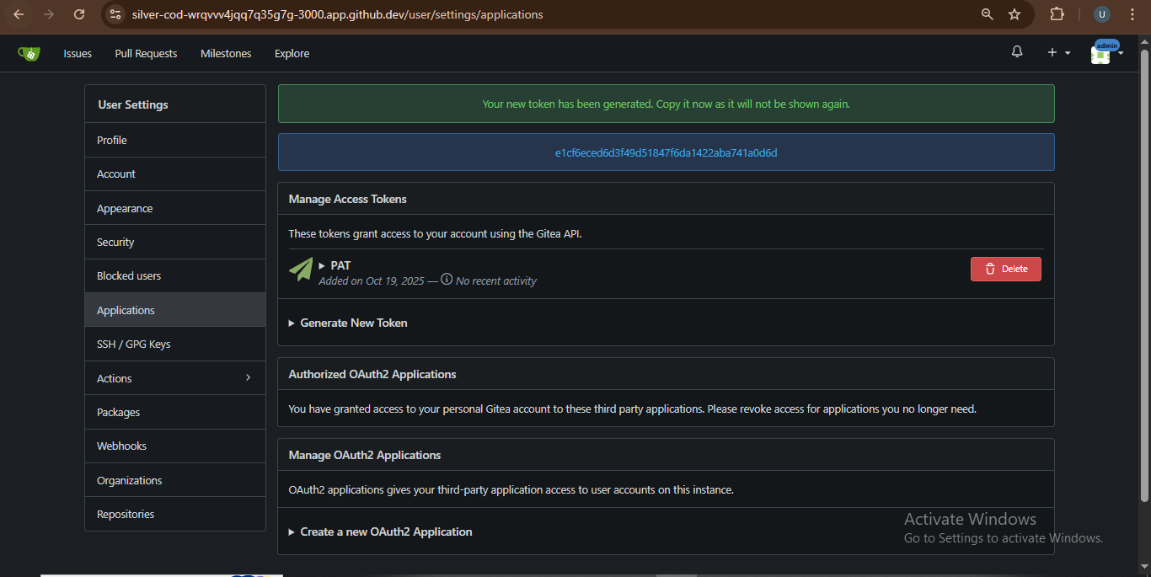

1. **Add Remote Repo:**

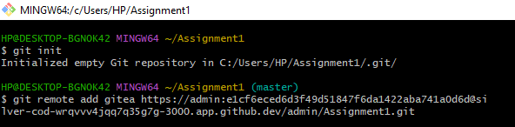

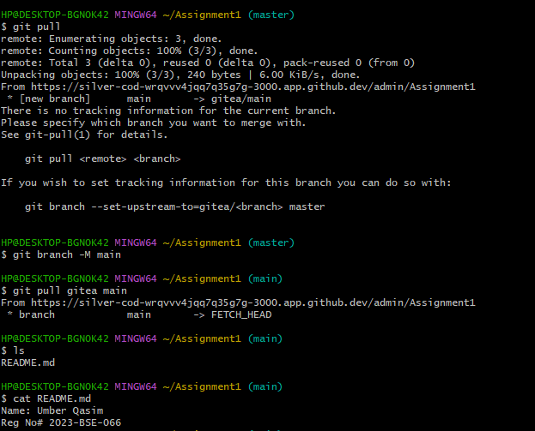

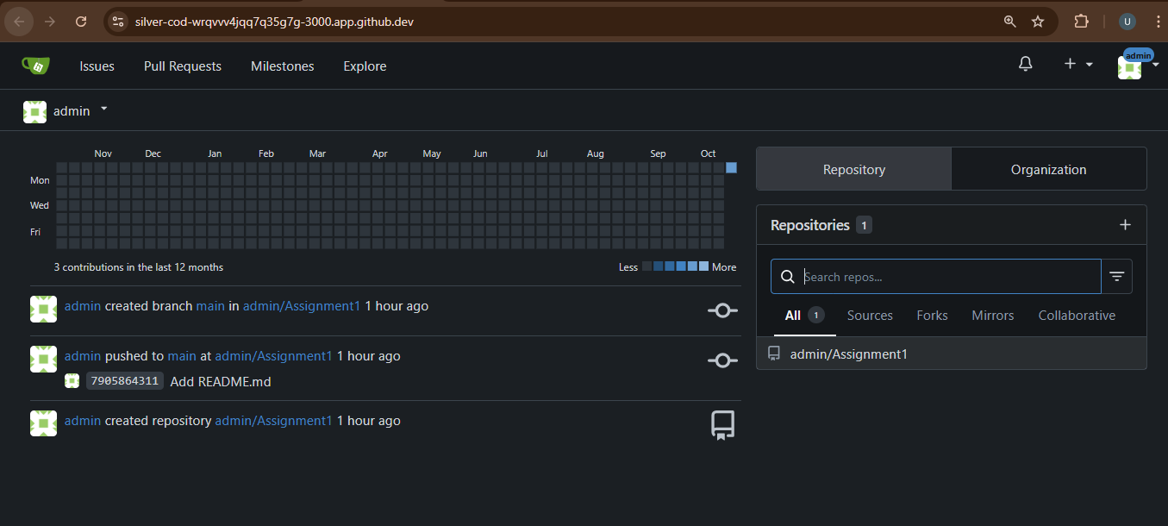

***Task#02:***

Mirror README.md from Gitea to GitHub.

***Answer:***

1. **Create GitHub Repository:**

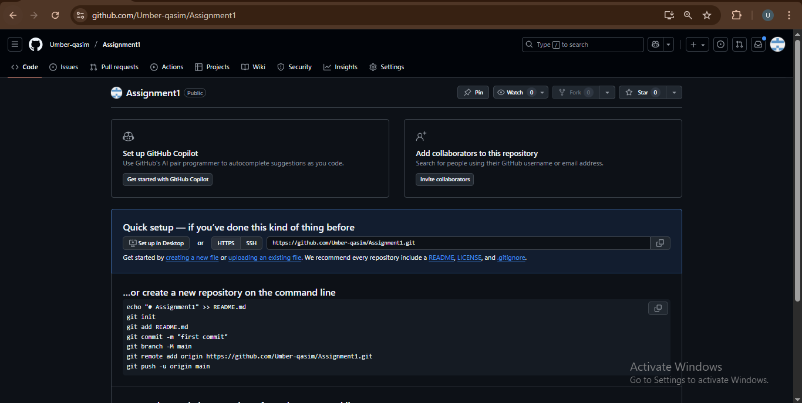

1. **Add GitHub as a Second Remote then Push the README.md File to GitHub and Verify Remotes:**

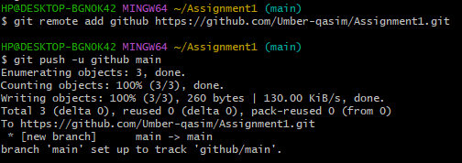

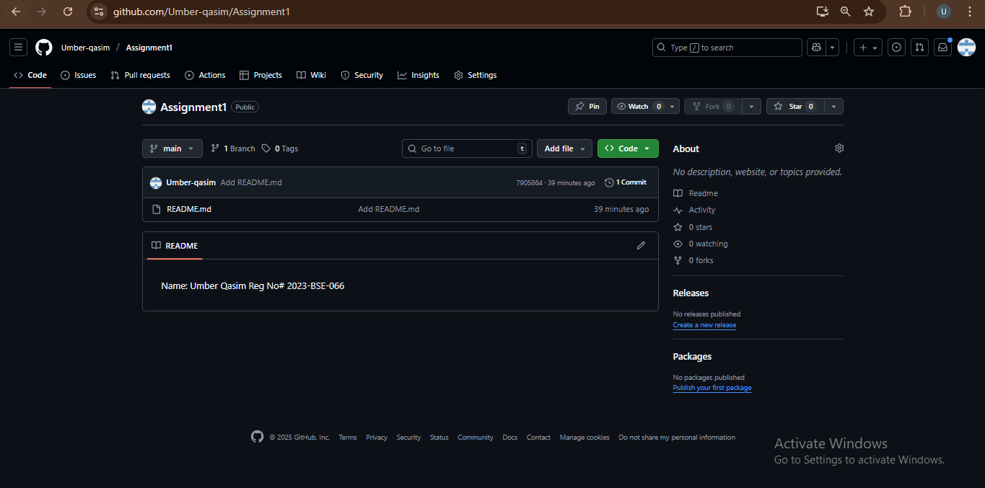



***Task#03:***

Use Git LFS for Large Files.

***Answer:***

1. **Install Git LFS:**

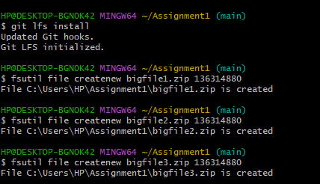

1. **Add Large Files:**

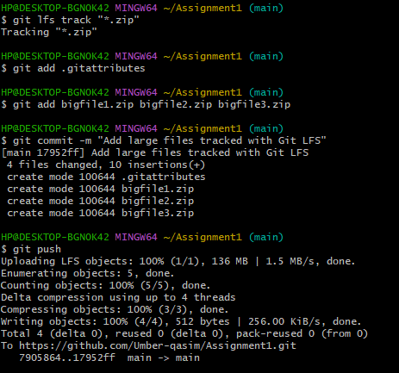

1. **Reference in Assignment Repo:**

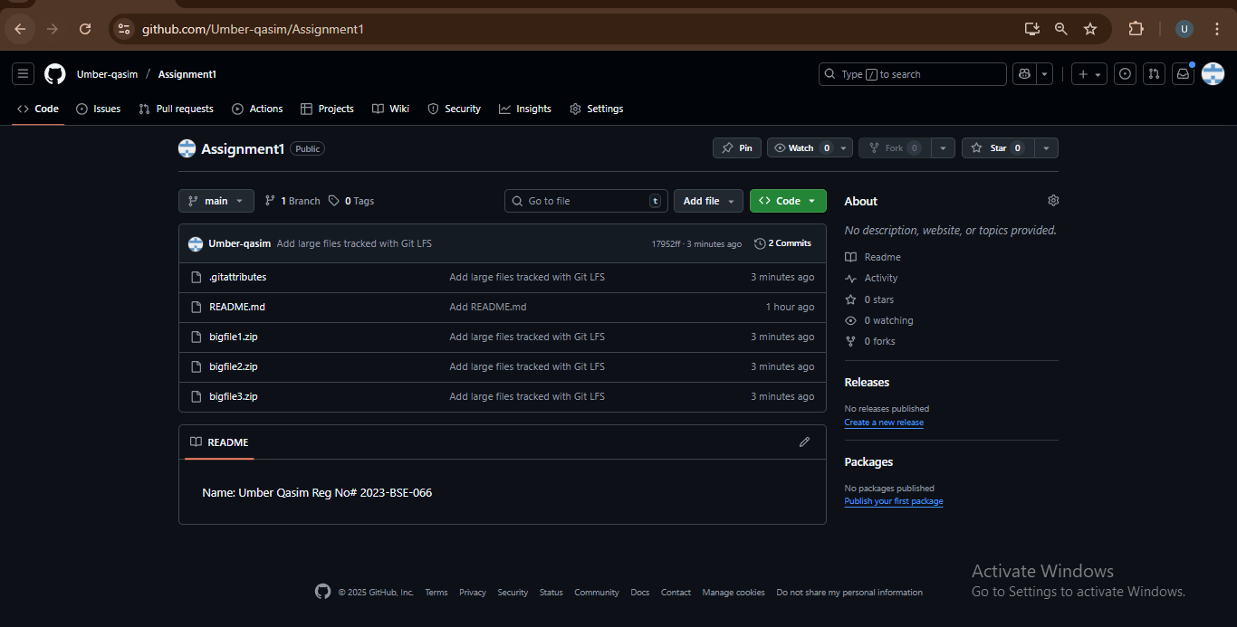

***Task#04:***

Create Portfolio/CV with GitHub Pages.

***Answer:***

1. **Create a new repository for GitHub Pages:**

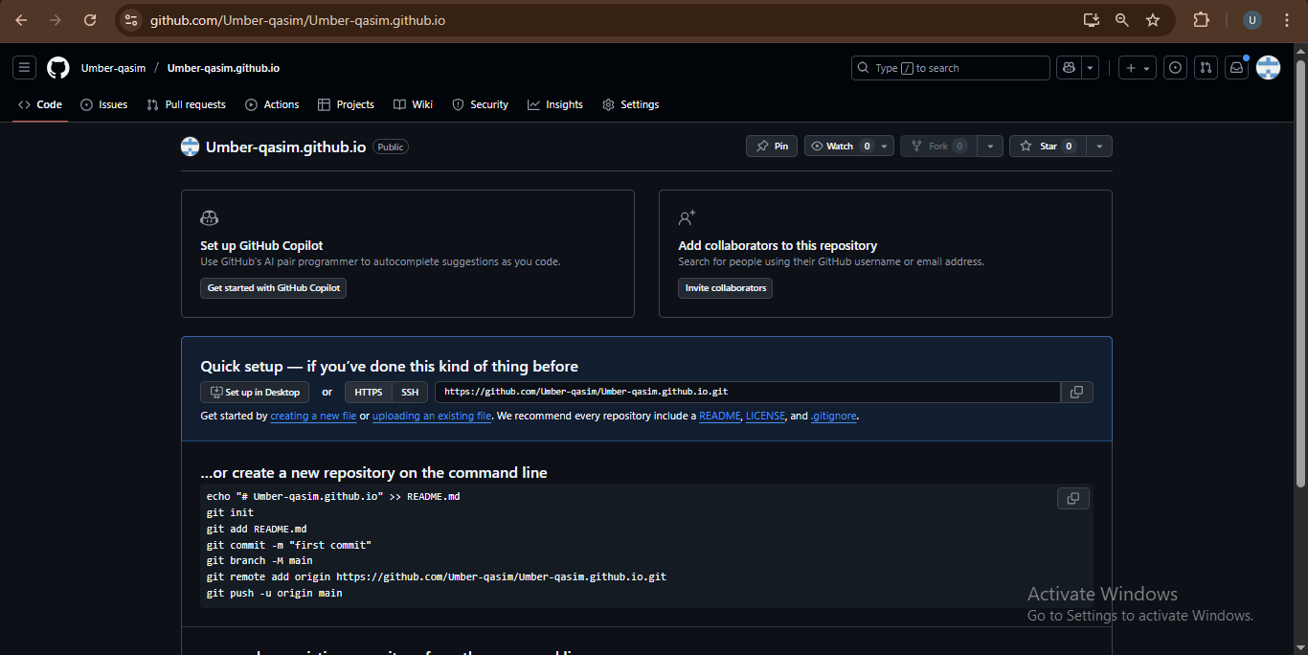

1. **Design Your Portfolio/CV:**

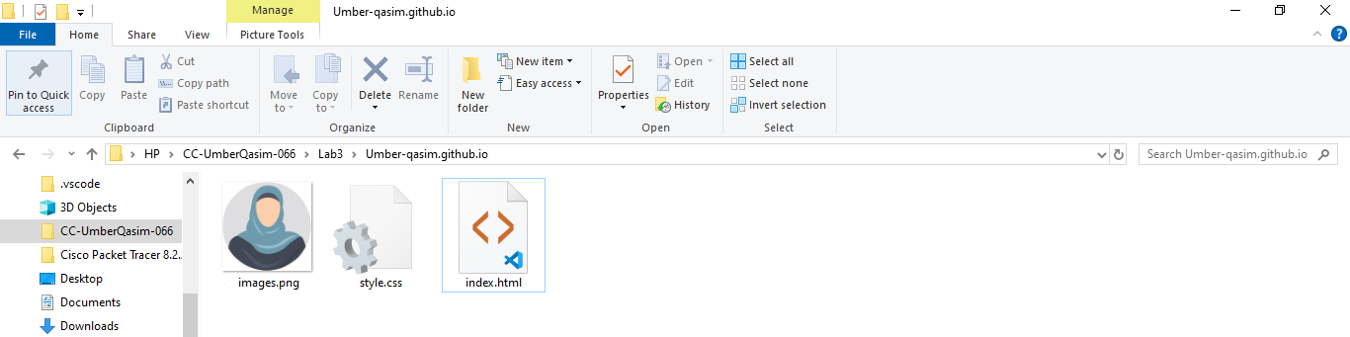

1. **Publish with GitHub Pages:**

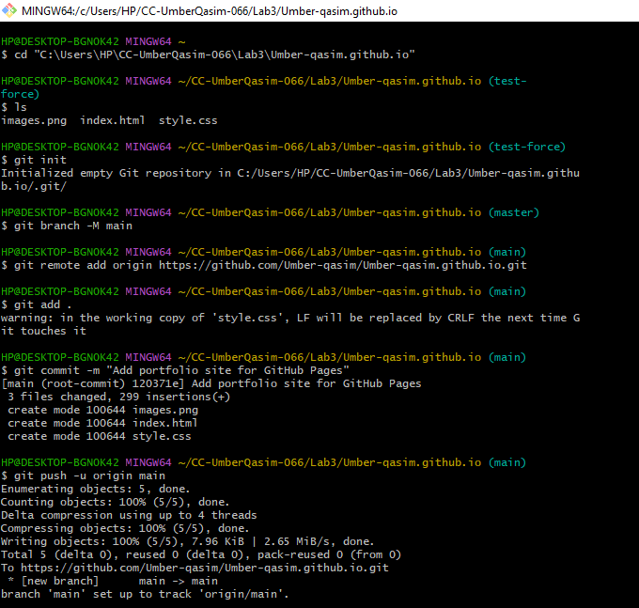

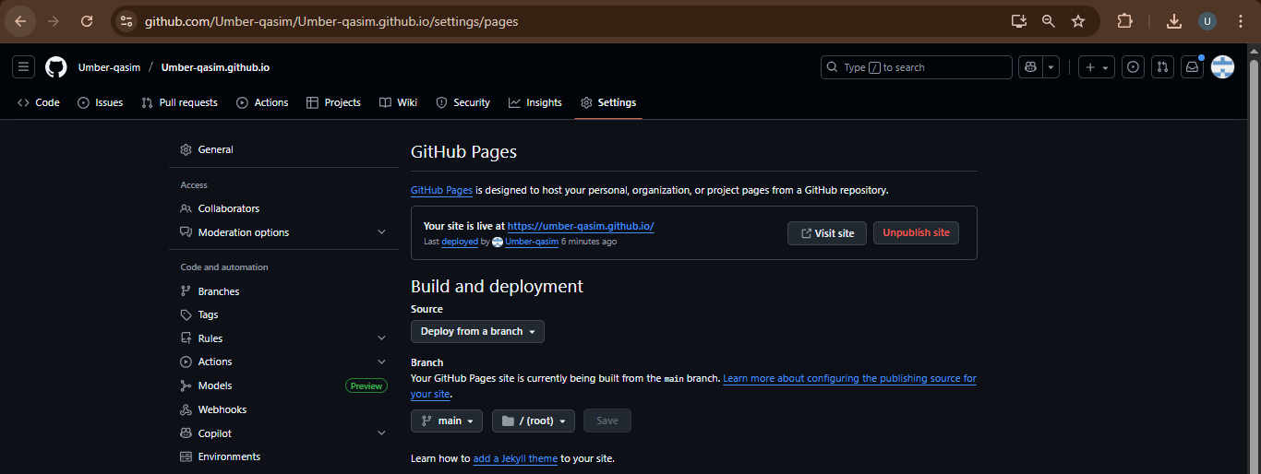

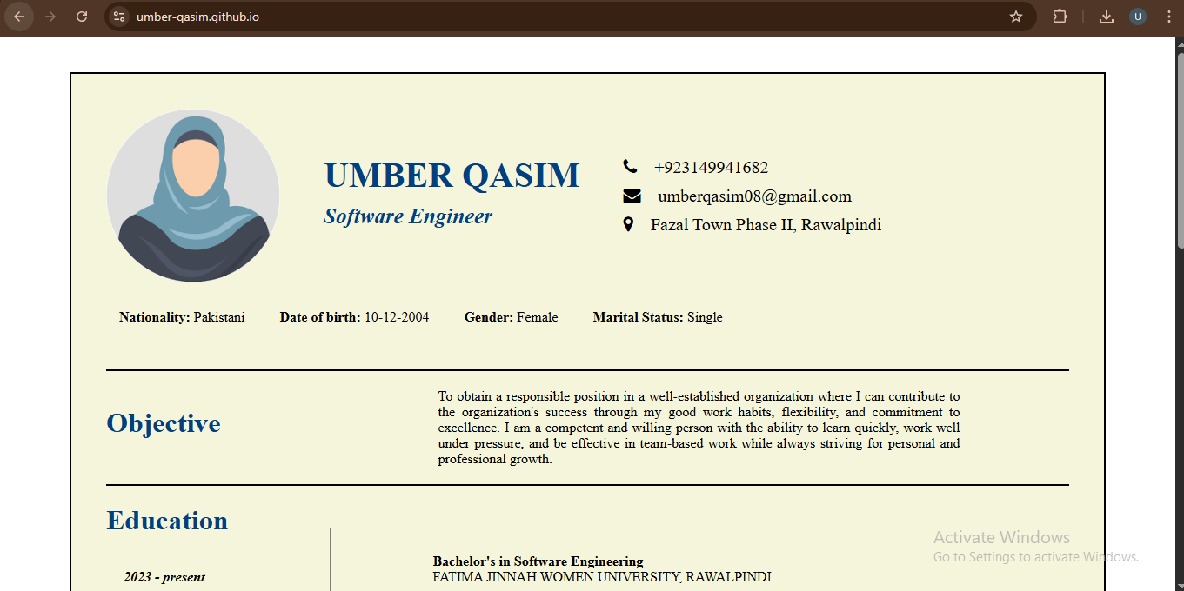

**Submission Checklist:**

***Screenshot of your Gitea repository (showing README listing names & roll numbers)***



***GitHub assignment1 repo link With README and large files***

**https://github.com/Umber-qasim/Assignment1**

***Screenshot or output of git remote -v showing both remotes***

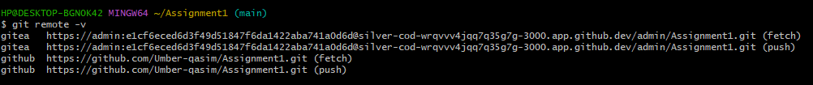

***GitHub Pages link to your CV/portfolio***

**https://umber-qasim.github.io/**