Fatima Jinnah Women University

*Department of Software Engineering*



*---------------------------------------------------------------------------------------------------------------------------------------*

LAB #03

**SUBJECT: CLOUD COMPUTING**

**SUBMITTED TO: SIR MUHAMMAD SHOAIB**

**SUBMITTED BY: UMBER QASIM**

**REGISTRATION NO: 2023-BSE-066**

**CLASS: BSSE V-B**

***Working with Git History, Stashing, and Reverting Commits***

**Task#01: Handling Local and Remote Commit Conflicts (Pull vs Pull --rebase)**

*Remote edit on GitHub*

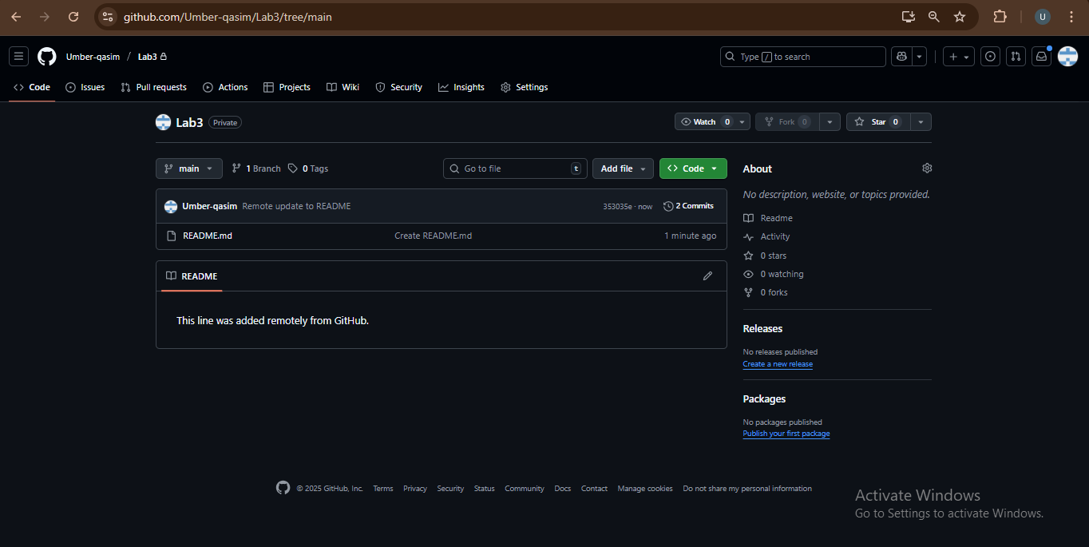

*Make a local change*

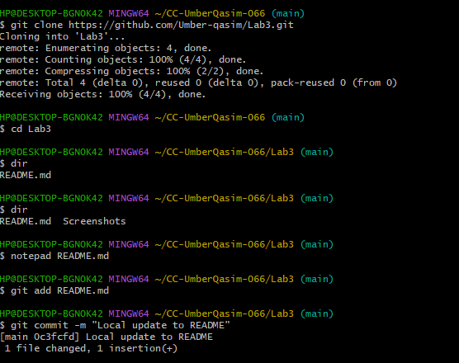

*This time it was pushed successfully so we try again:*

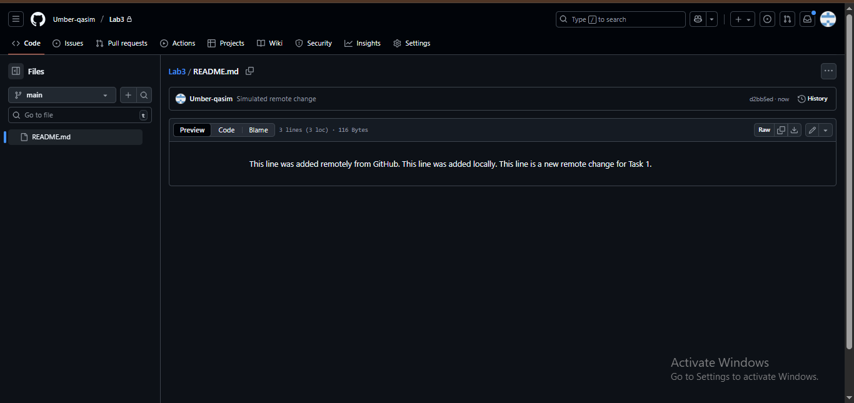

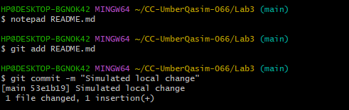

*Try pushing local change*

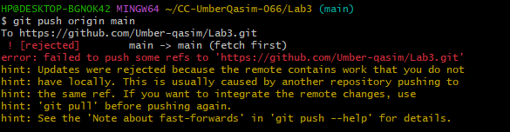

*Pull with merge*

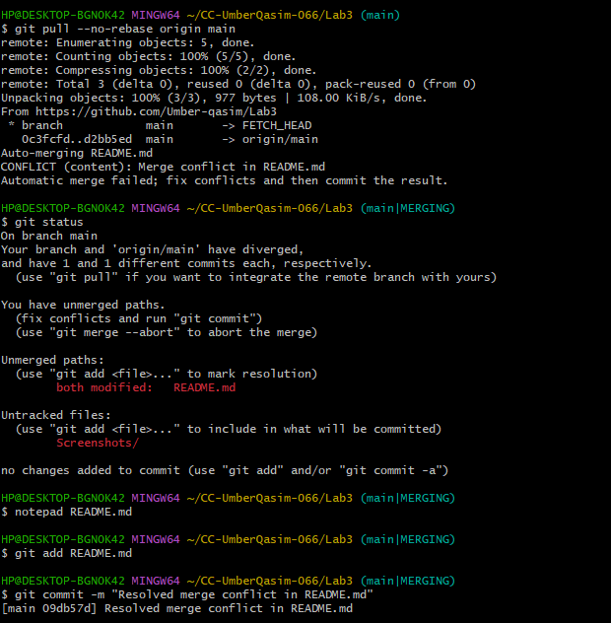

*Push after merge*

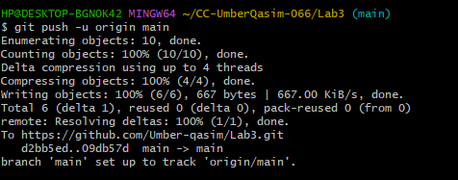

*Rebase practice*

**Make another remote edit** on GitHub README.md

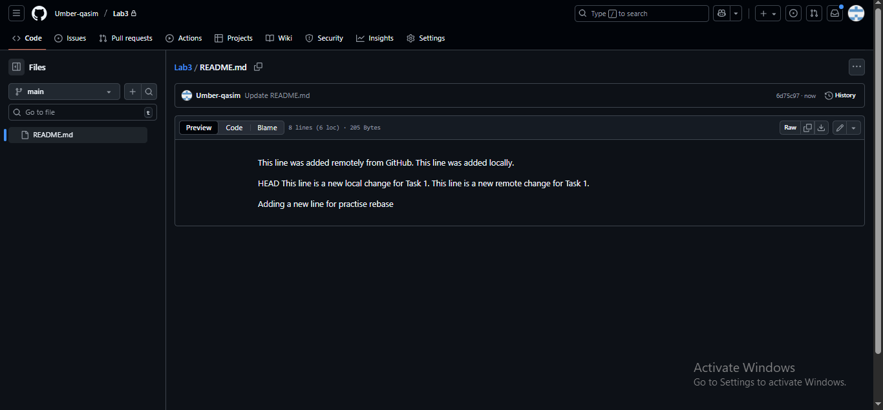

*Same as locally*

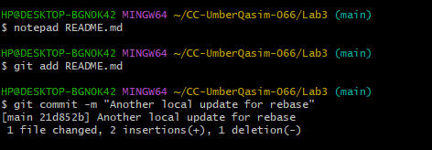

*Pull with rebase*

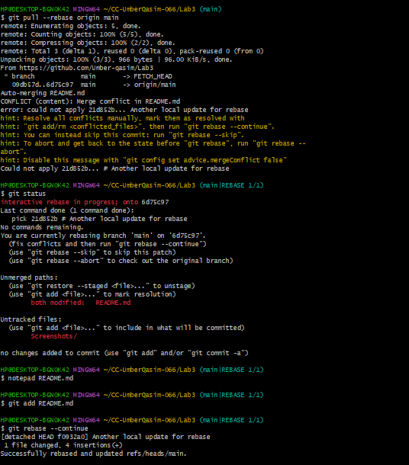

*Push after rebase*

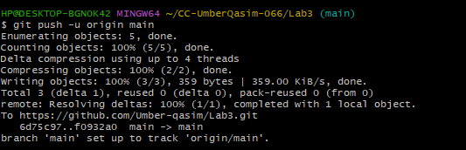

**Task#02: Creating and Resolving Merge Conflicts Manually**

*Remote conflicting edit (GitHub)*

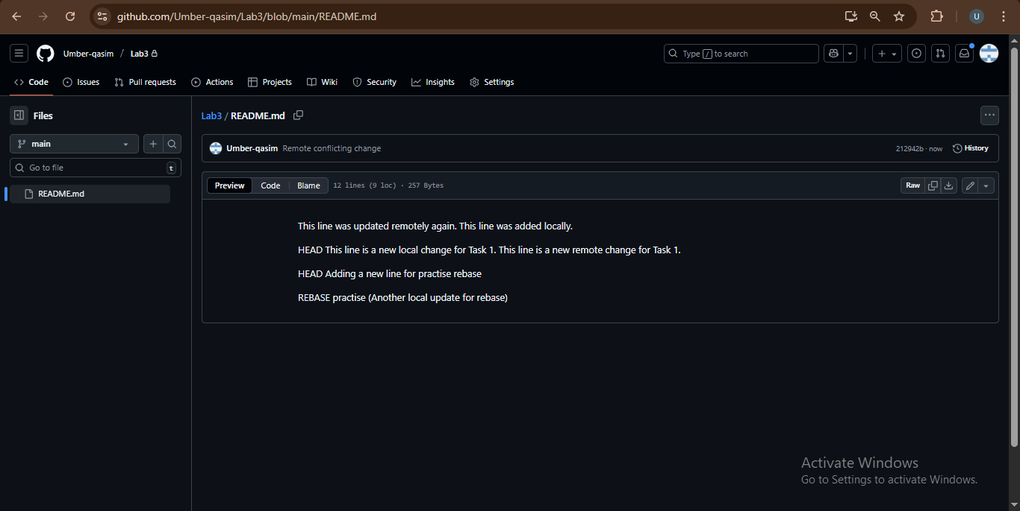

*Local conflicting edit*

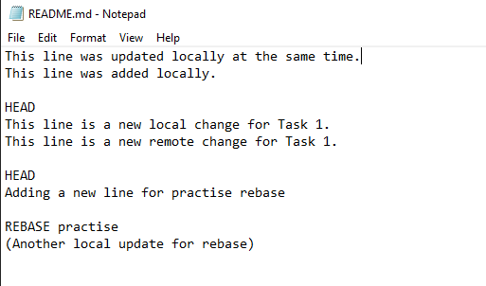

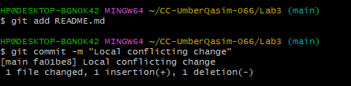

*Try to push*

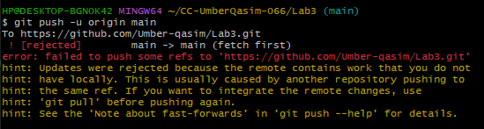

*Pull with rebase*

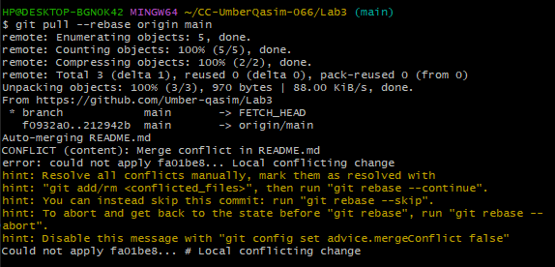

*Resolve conflict manually*

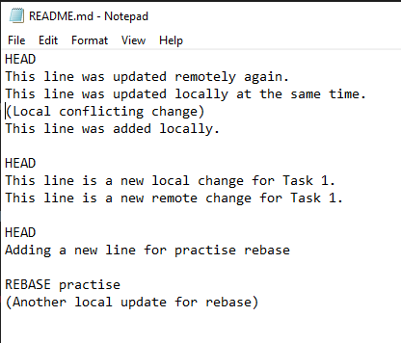

*Mark conflict as resolved & continue rebase*

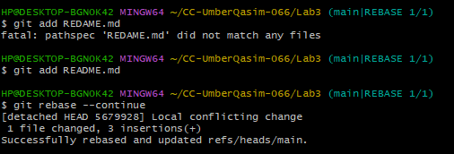

*Push after resolving conflict*

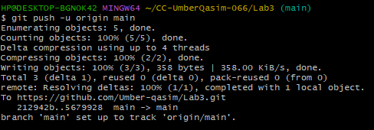

**Task#03: Managing Ignored Files with. gitignore and Removing Tracked Files**

*Create a folder textfiles with three text files inside it*

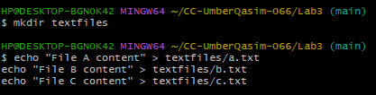

*Stage and commit the new directory*

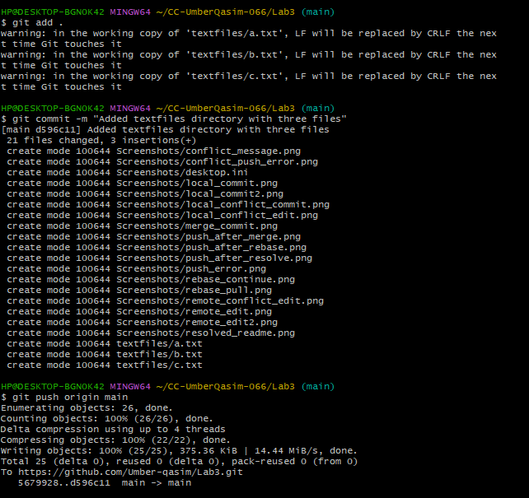

*Create a .gitignore file to ignore textfiles*



*Stage & commit .gitignore*

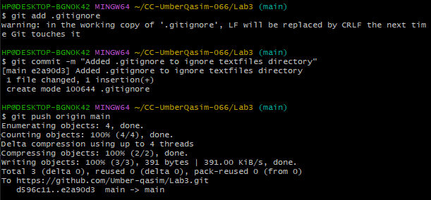

*Check repo on GitHub*

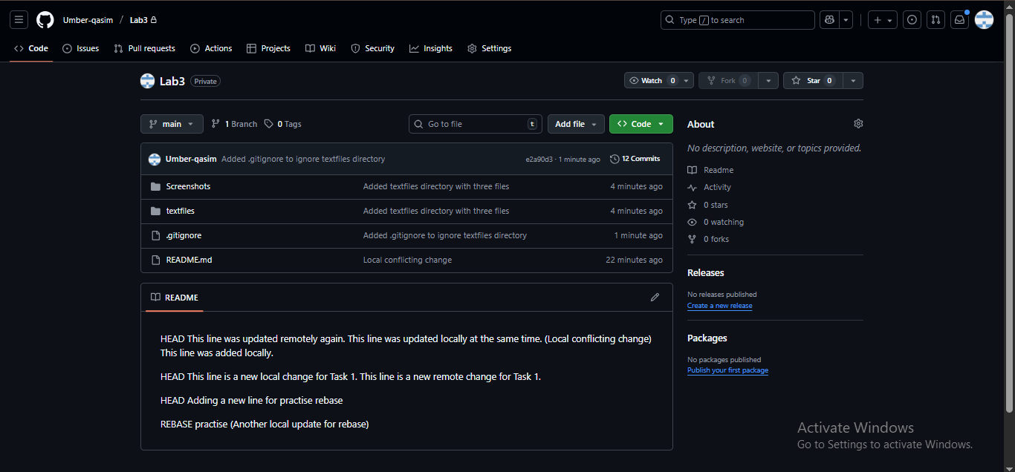

Reason: **Git already tracked the files before .gitignore**

*Remove tracked files but keep locally*

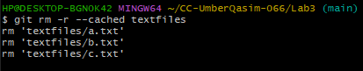

*Commit & push changes*

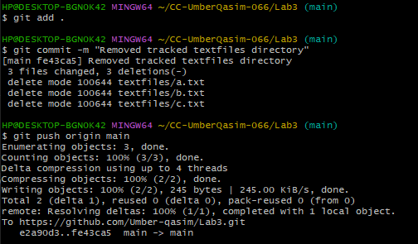

*Check GitHub repo*

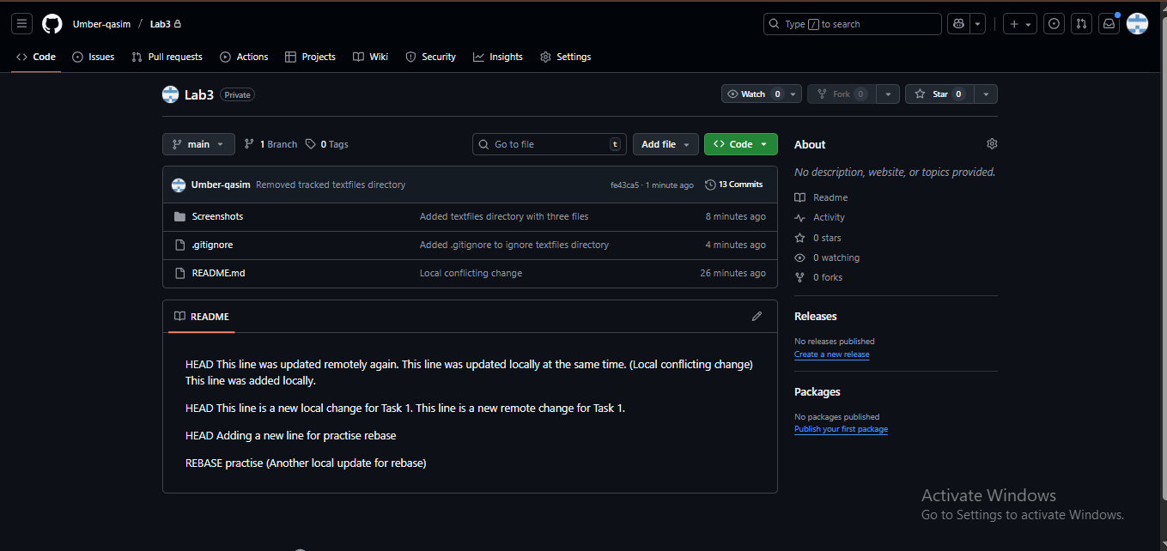

**Task#04: Create Temporary Changes and Use git stash**

*Create a new branch feature-branch then modify README.md and commit*

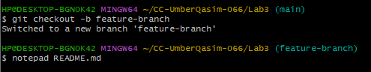

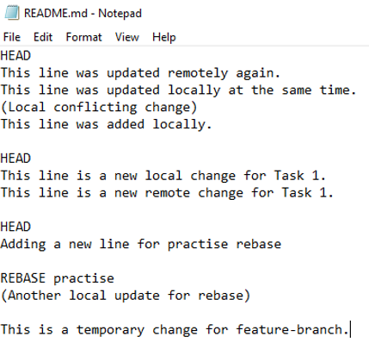

*Stage & commit:*

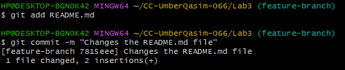

*Make new uncommitted changes*



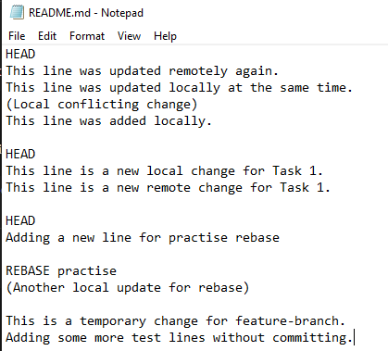

*Try switching branch*

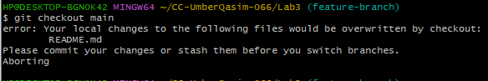

*Stash your changes*

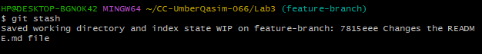

*Switch branch (now it works)*

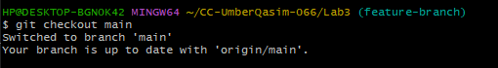

*Return to feature-branch*



*Check working directory status*

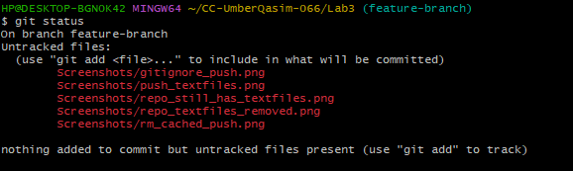

*Restore stashed changes*

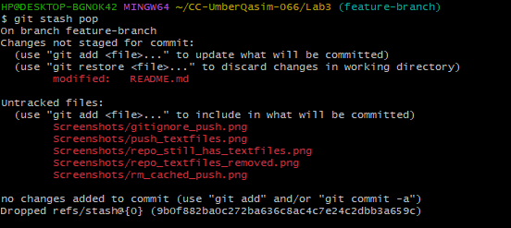

**Task#05: Checkout a Specific Commit Using git log**

*View commit history*

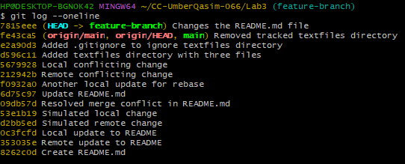

Copy any **previous commit hash**

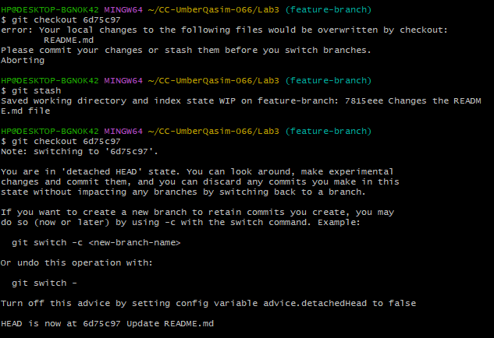

*Return to main branch*

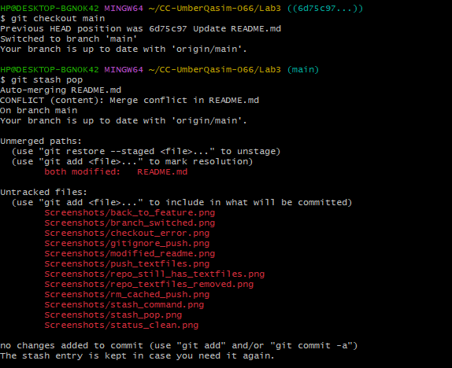

**Task#06: Resetting Commits (Soft vs Hard Reset) (With Verification Steps)**

*Add a new line in any file and commit it*

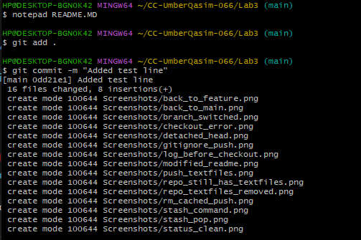

*Add another change and commit again*

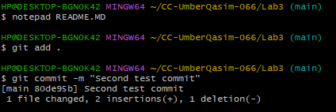

*View commit history before reset*

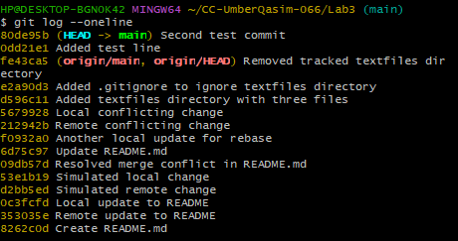

*Confirm both changes are in the file*

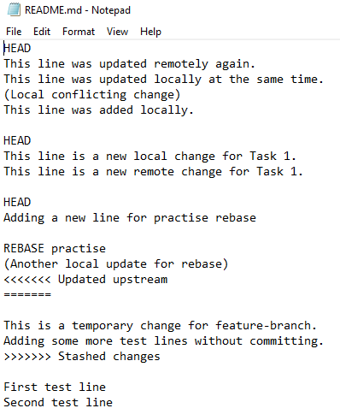

*Perform a soft reset*

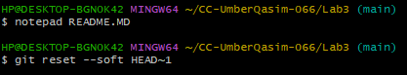

*Check commit history again*

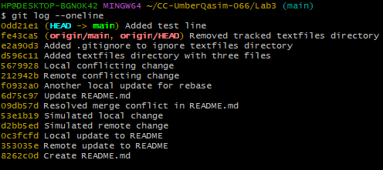

*Check file content after soft reset*

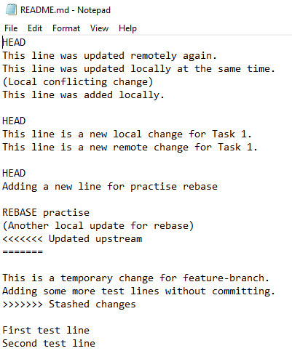

*Check git status*

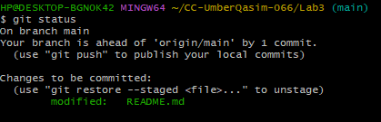

*If it shows staged changes, you can re-commit:*

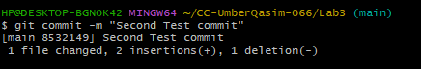

*Perform a hard reset*



*Check commit history again*

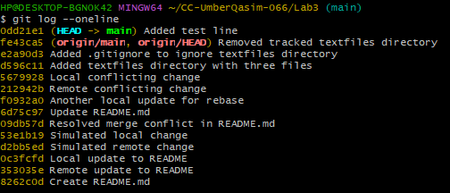

*Open file again*

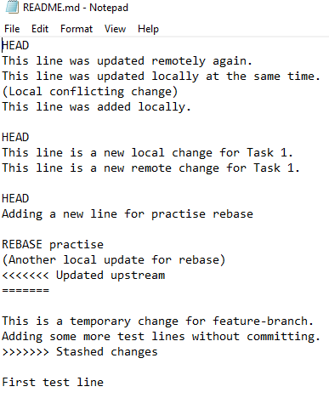

*Check git status*

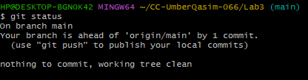

**Task#07: Amending the Last Commit**

Amending the Last Commit

**Make a small change in README.md file and Stage & commit normally**

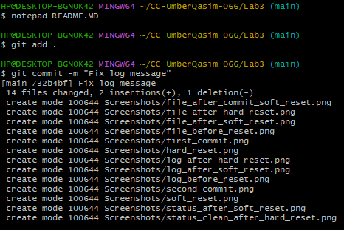

Move back to the same file and add another new line then Stage the new change and amend your last commit

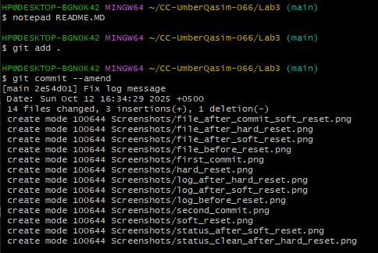

**Amended commit is complete and active**.



**Task#08: Reverting a Commit (Safe Undo on Remote Branch)**

Make a new file and commit it

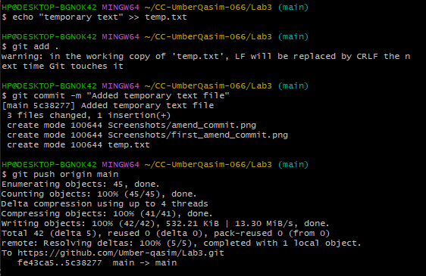

Check commit history

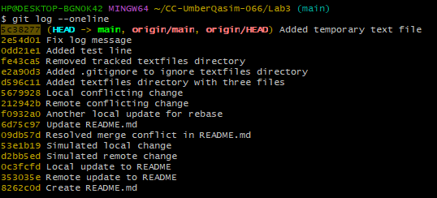

Revert that commit

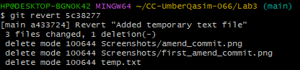

Push the revert commit

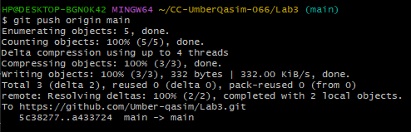

**Task#09: Force Push (With Caution)**

Create a new branch



Make a small change

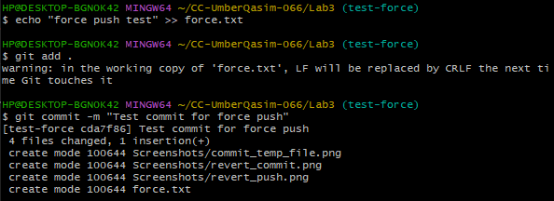

Push your new branch

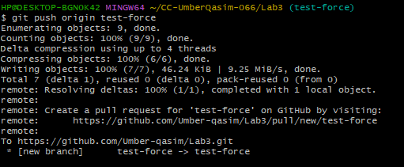

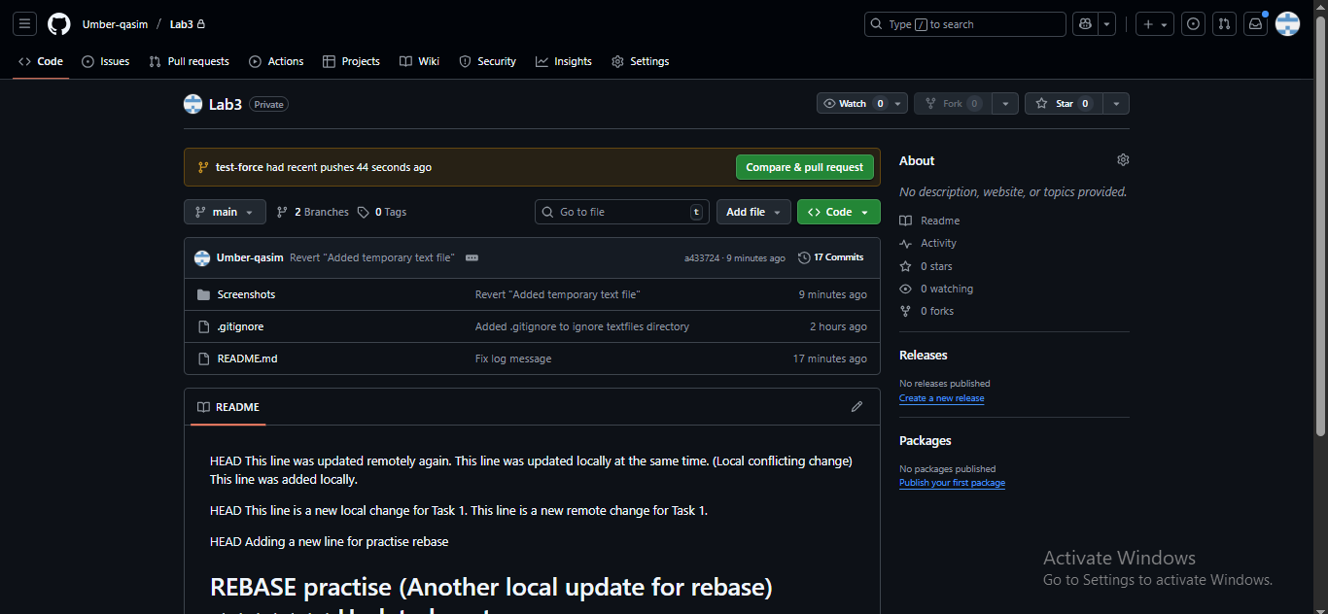

Perform a hard reset



Try normal push

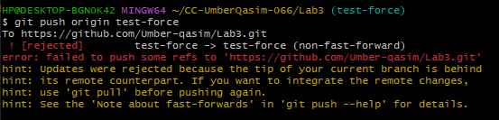

Force push

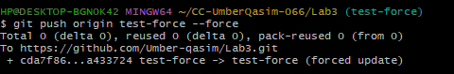

**Task#10: Running Gitea in GitHub Codespaces via Docker Compose**

Fork the Repository

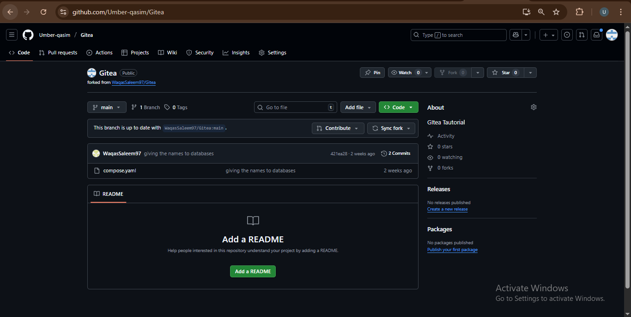

Open the Forked Repo in GitHub Codespaces

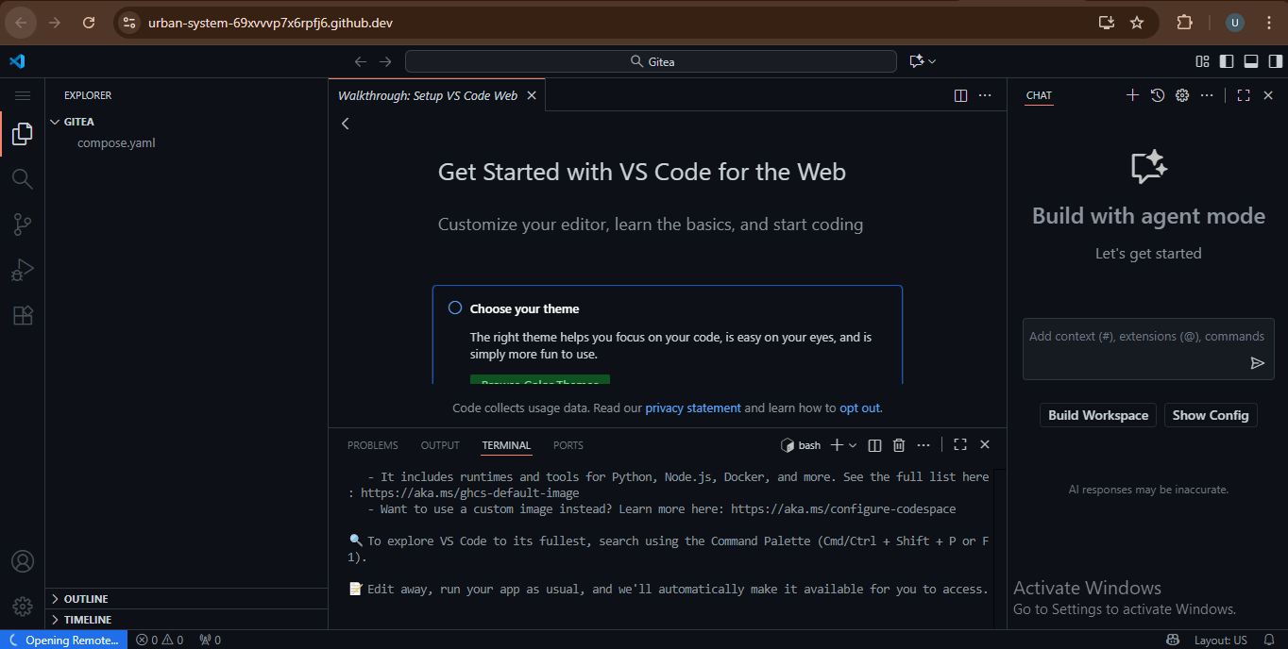

Start Gitea with Docker Compose

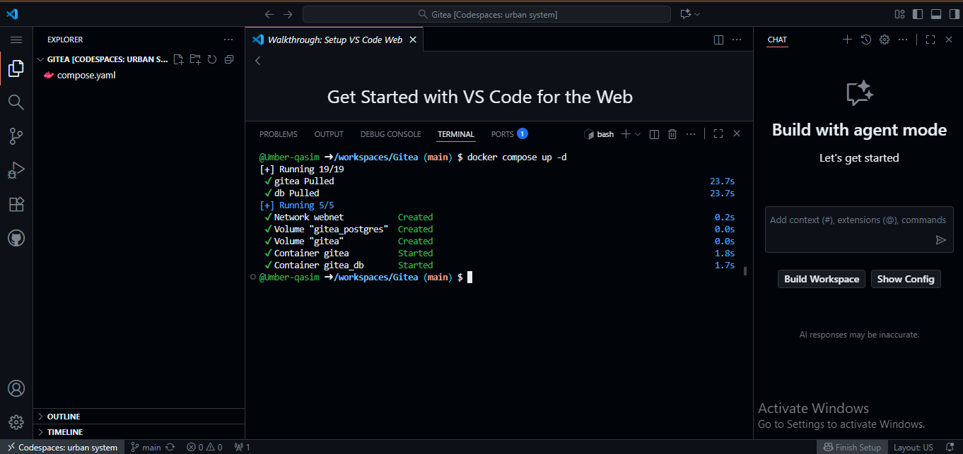

Access Gitea Web Interface

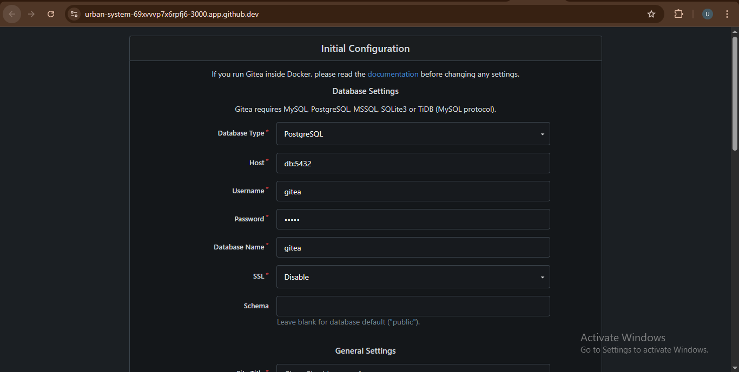

Install Gitea

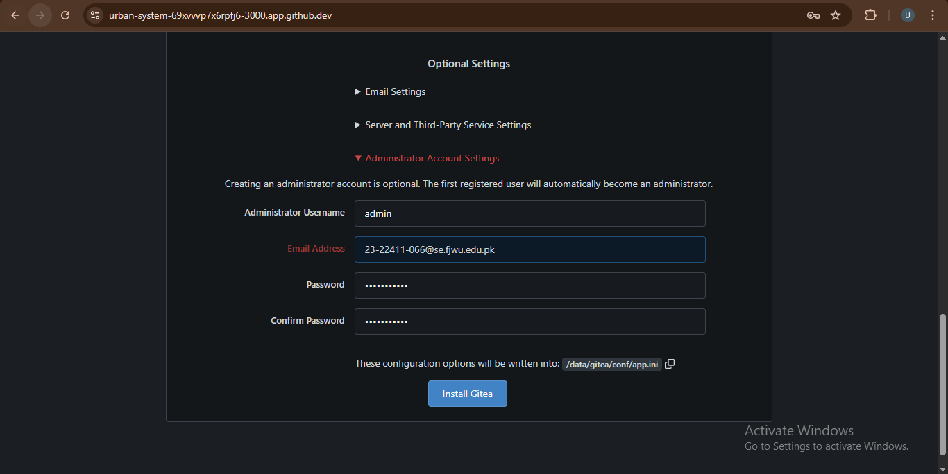

Log In

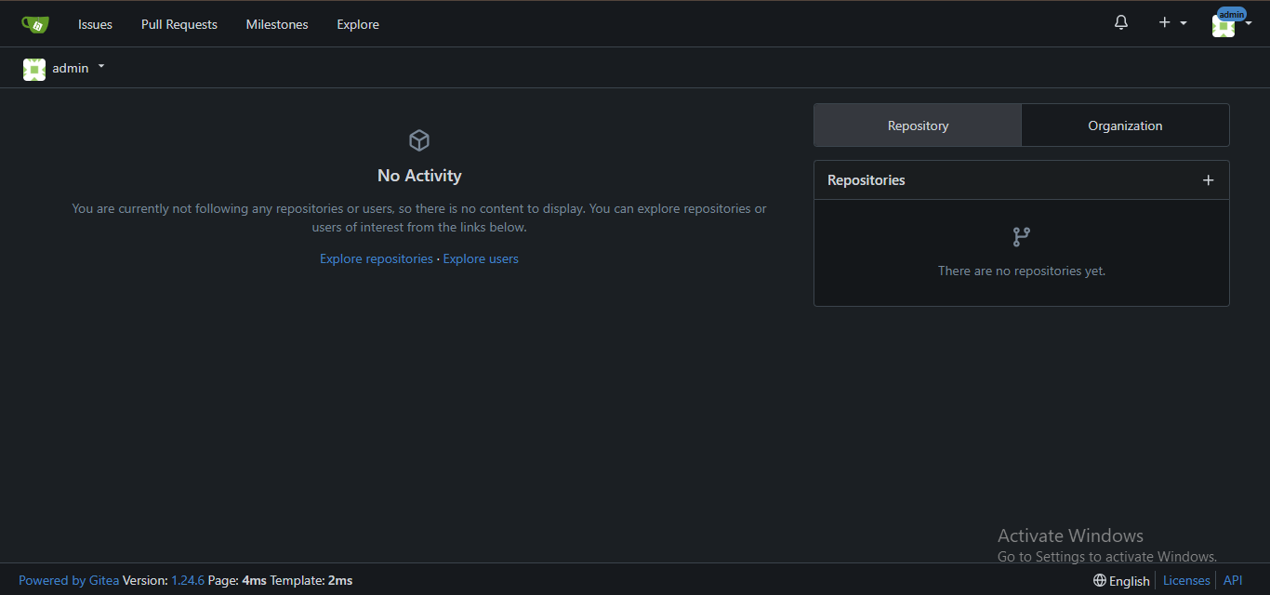

Create a New Repository

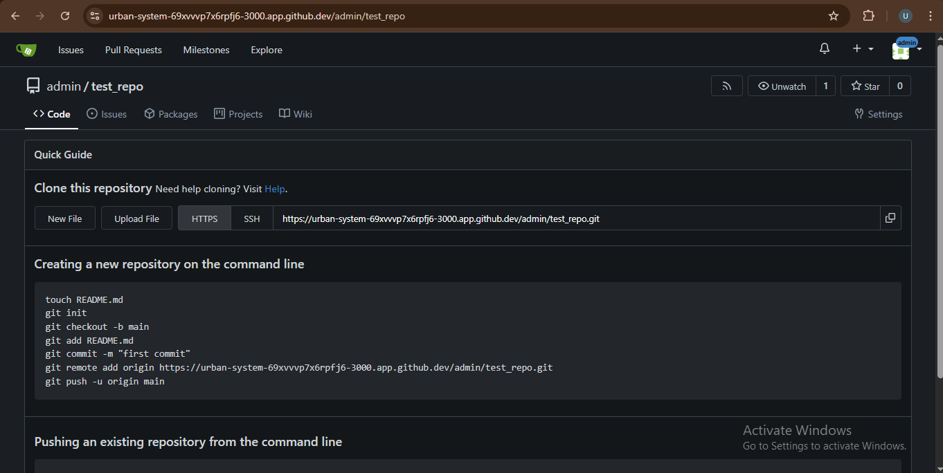

**Task#11: Creating a GitHub Pages Portfolio Site**

Create a GitHub Pages Repository

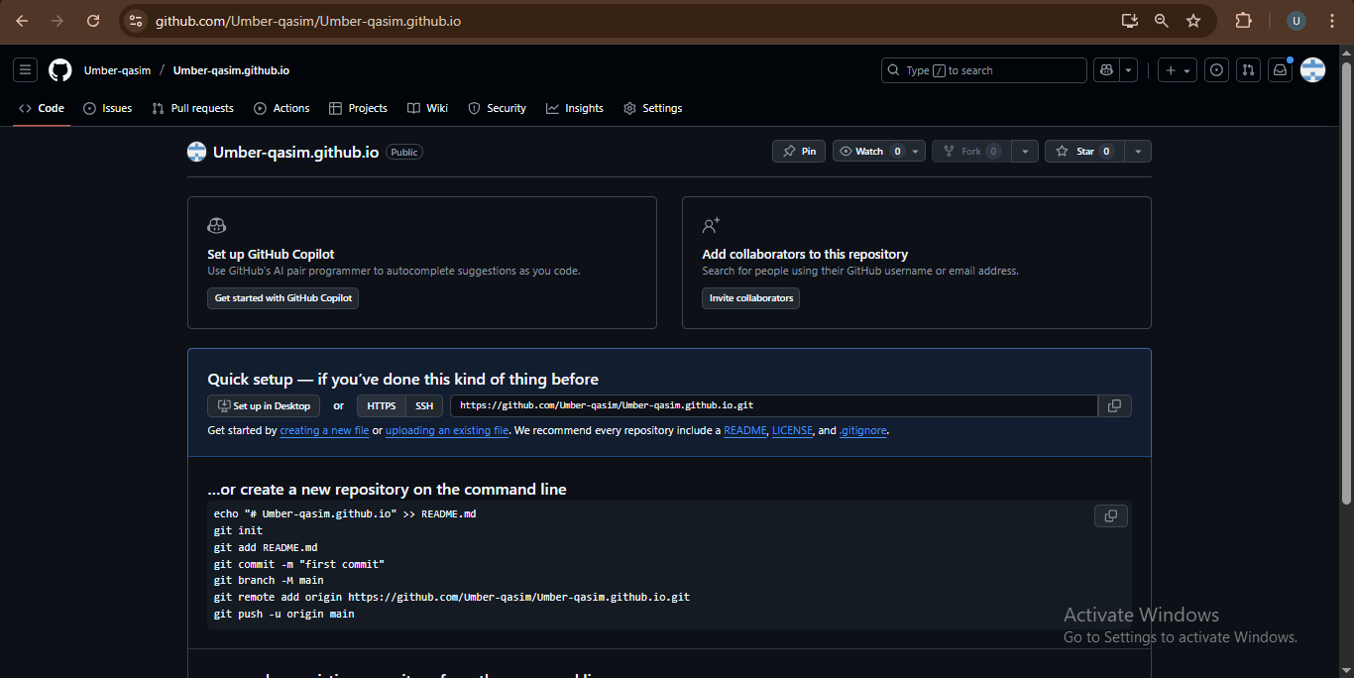

Add Static Website Code

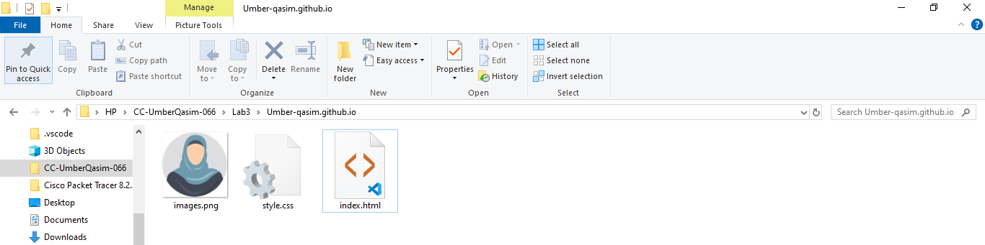

Push the Files to GitHub

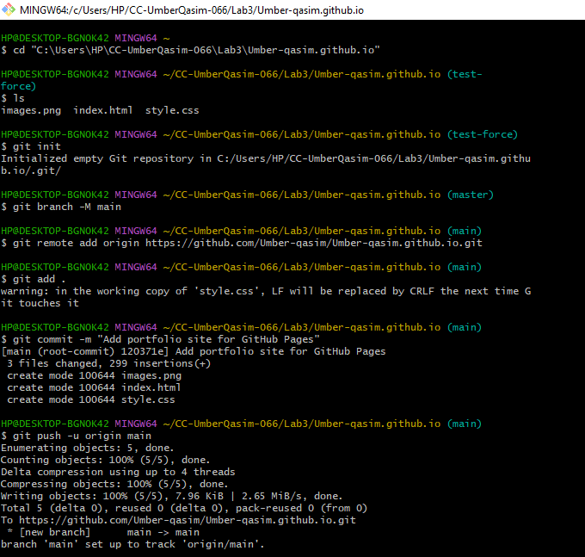

Check GitHub Pages Settings

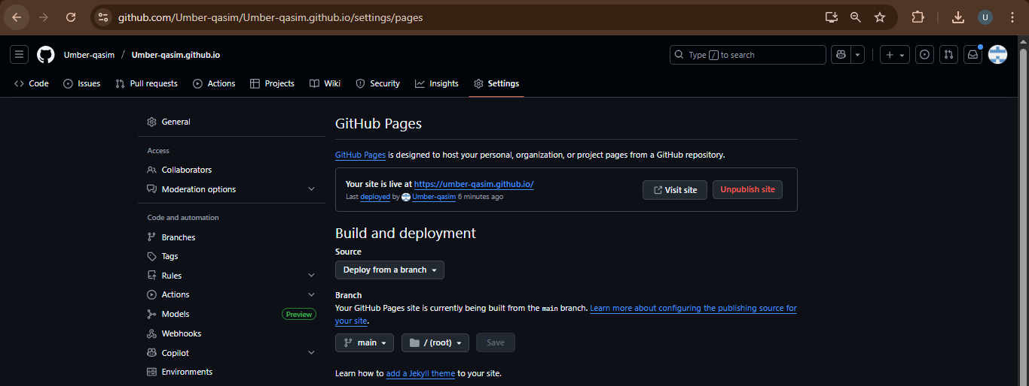

Visit Your Live Site

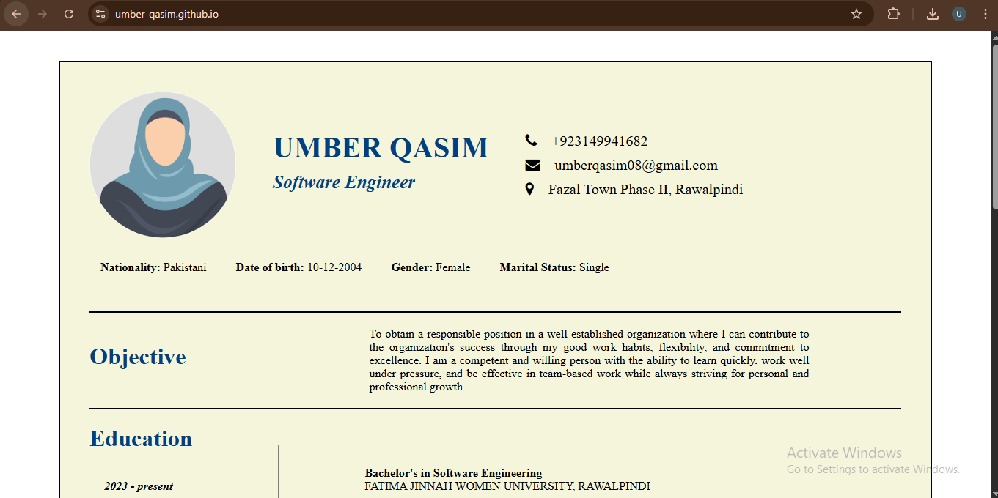

**Exam Evaluation Questions**

1. **Local vs Remote Conflict Resolution**

Make a Remote Edit on GitHub

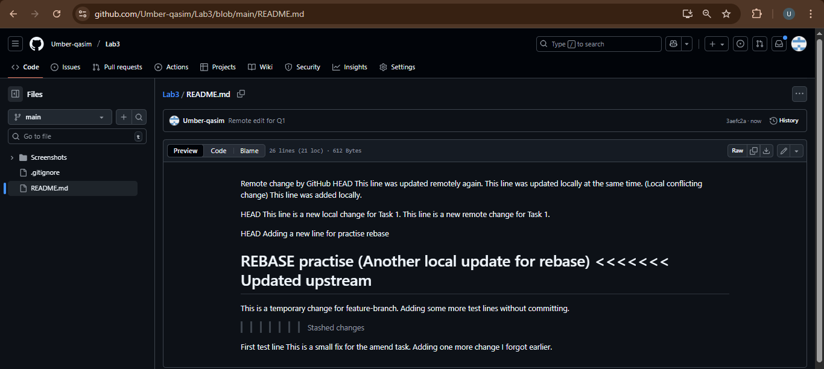

Make a Local Edit (to create a conflict)

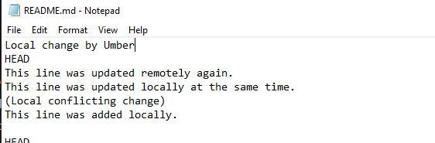

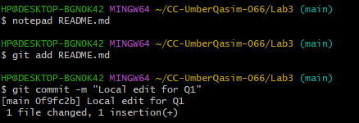

Try to Push

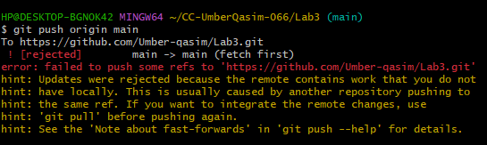

Resolve Conflict using git pull (Merge)

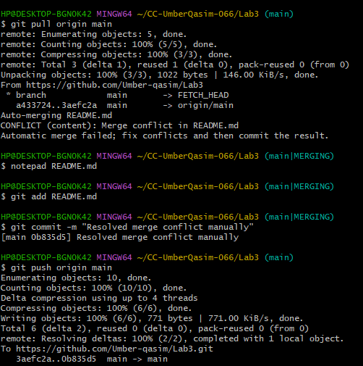

REBASE resolution

**Perform same work as above till push command**

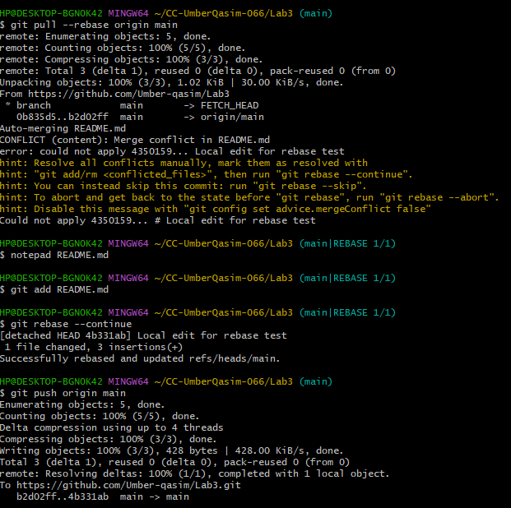

1. **Manual Merge Conflict Handling**

Remote change (on GitHub)

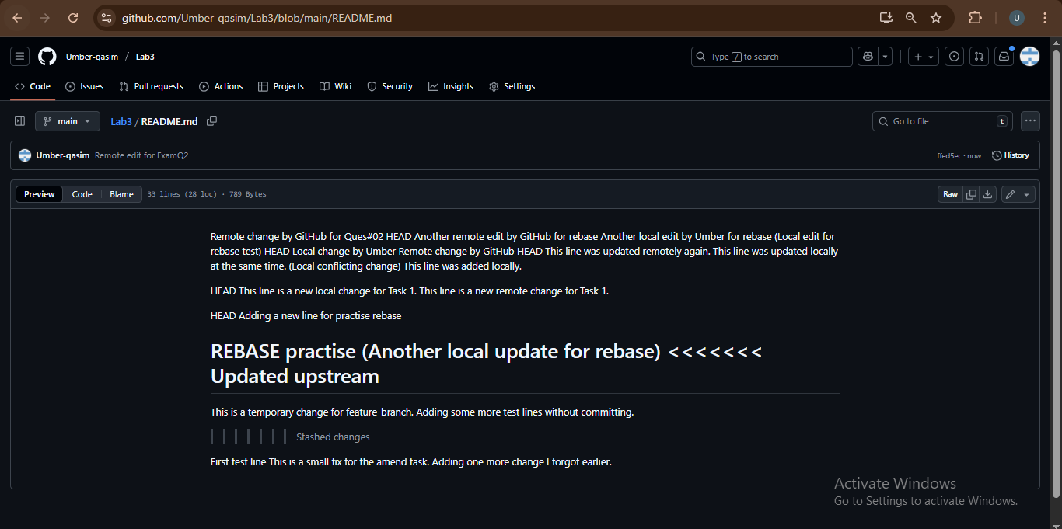

Local change (on your PC)

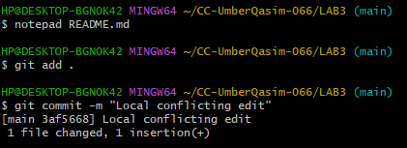

Push and see conflict

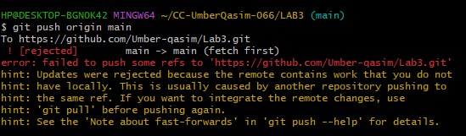

Pull with rebase

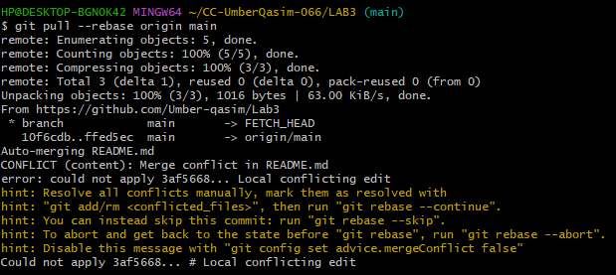

Resolve conflict manually

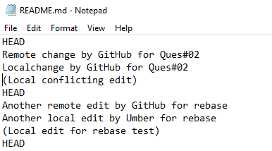

Mark as resolved and finish rebase

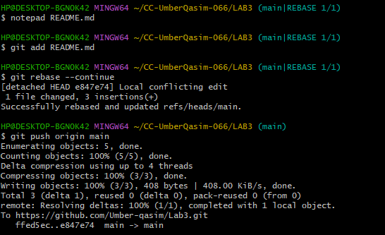

1. **Managing Ignored and Tracked Files**

Create folder and files

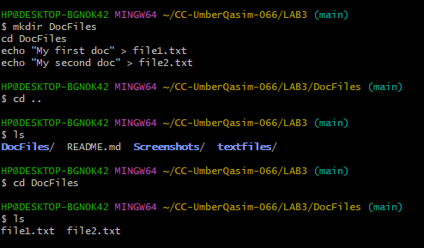

Add, commit, push (to GitHub)

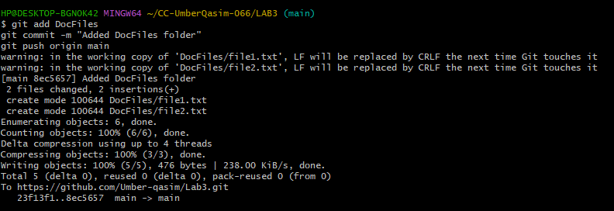

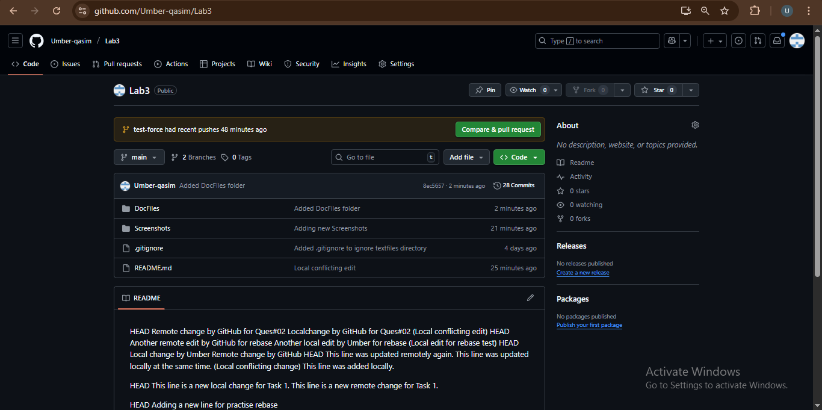

Add to .gitignore

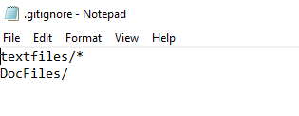

Commit and push .gitignore

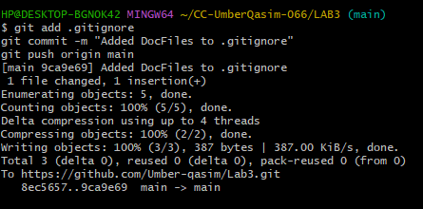

Remove folder from Git tracking

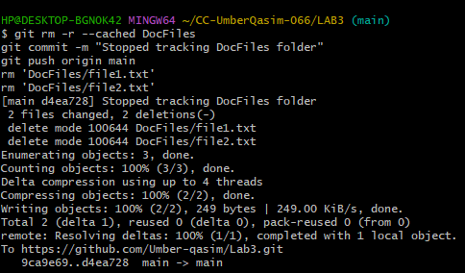

Verify

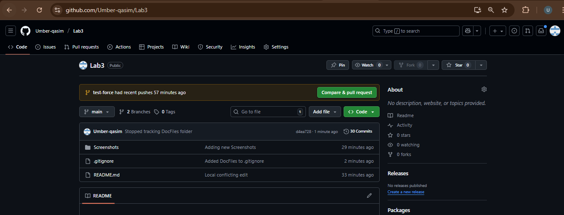

1. **Commit History Manipulation and Recovery**

*Add a new line in any file and commit it*



*Add another change and commit again*



*View commit history before reset*



*Confirm both changes are in the file*



*Perform a soft reset*



*Check commit history again*



*Check file content after soft reset*



*Check git status*



*If it shows staged changes, you can re-commit:*



*Perform a hard reset*



*Check commit history again*



*Open file again*



*Check git status*

