Phase Pharmer
Software Design Document

v1.0

Chris Mabon

15 May 2019

Contents

Section 1 - Project
1.1 Project
1.2 Description
1.3 Revision History

Section 2 - Design
2.1 Overview
2.2 System Behavior
2.3 Logical View

Section 3 - Functionality
3.1 User Interaction
3.2 GUI Layout

Section 1 - Project

1.1 Project
Phase Pharmer
https://github.com/chrismabon/PhasePharmer

1.2 Description
A mushroom farming tool for Project: Gorgon (an excellent MMORPG)

1.3 Revision History

Section 2 - Design

2.1 Overview
Phase Pharmer is a web app that calculates the current phase of the moon using Node.js and Lune. It provides useful fungal growth information for avid mushroom farmers and novices alike.

2.2 Design Goals
- Minimal complexity of design
- Must be portable between browsers and operating systems
- Allow for later addition of new features as project develops

2.3 System Behavior
Web app displays the moon phase for the current day, as well as additional phase information such as time until next phase. The app also shows mushroom farming information depending on the phase and box the user has selected.

2.4 Logical View
The phase is calculated using the Lune module for Node.js runtime. Phase and mushroom farming information aggregated and displayed in the web app.

3.1 User Interaction Overview
Current phase and time until next phase are displayed to the top left of the page. The phase selection drop-down is the first item on the toolbar (left to right) and allows the user to change selected phases. Upon updating the selected phase, the app populates the area down near the middle-bottom with information about mushrooms that grow robustly for that phase (red), or just adequately (grey).

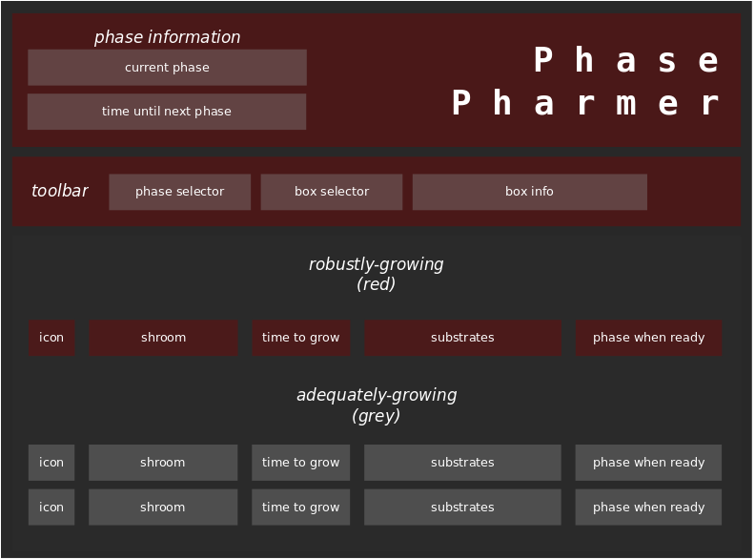
3.2 GUI Layout

