Phase Pharmer
Software Design Document

v1.1

Umbra Aeterna Labs

9 August 2019

Contents

Section 1 - Project
1.1 Project
1.2 Description
1.3 Revision History

Section 2 - Design
2.1 Overview
2.2 System Behavior
2.3 Logical View

Section 3 - Functionality
3.1 User Interaction
3.2 GUI Layout

Section 1 - Project

1.1 Project
Phase Pharmer
https://github.com/umbra-aeterna-labs/PhasePharmer

1.2 Description
A mushroom farming tool for Project: Gorgon (an excellent MMORPG)

1.3 Revision History

Section 2 - Design

2.1 Overview
Phase Pharmer is a web app that calculates the current phase of the moon. It provides useful fungal growth information for avid mushroom farmers and novices alike. It also keeps track of planted box timers.

2.2 Design Goals
- Must be portable between browsers and operating systems
- Allow for later addition of new features as project develops

2.3 System Behavior
Web app displays the moon phase for the current day, as well as additional phase information such as time until next phase. The app also shows mushroom farming information depending on the phase and box the user has selected. The display section can be toggled to show either mushroom information or box timers.

2.4 Logical View
App runs as a JavaScript file within a simple HTML web page. Moon phase is calculated using the current time in the Project: Gorgon server timezone. Box timers are saved in local web browser storage.

3.1 User Interaction Overview
Current phase and time until next phase are displayed to the top left of the page. The phase selection drop-down is the first item on the toolbar (left to right) and allows the user to change selected phases. Upon updating the selected phase, the app populates the area down near the middle-bottom with information about mushrooms that grow robustly for that phase (red), or just adequately (grey).
Upon clicking the toggle button, the display changes from mushroom and phase info to box timers. The user may then select a mushroom to grow, select the correct box type being used, and click the set button to start the timer from that moment. The timer takes into account the type of mushroom and the currently-selected box. If a time is entered into the time left box in the form of "h:m:s" (enter without quotes), where h = hours left, m = minutes left, and s = seconds left on the box.

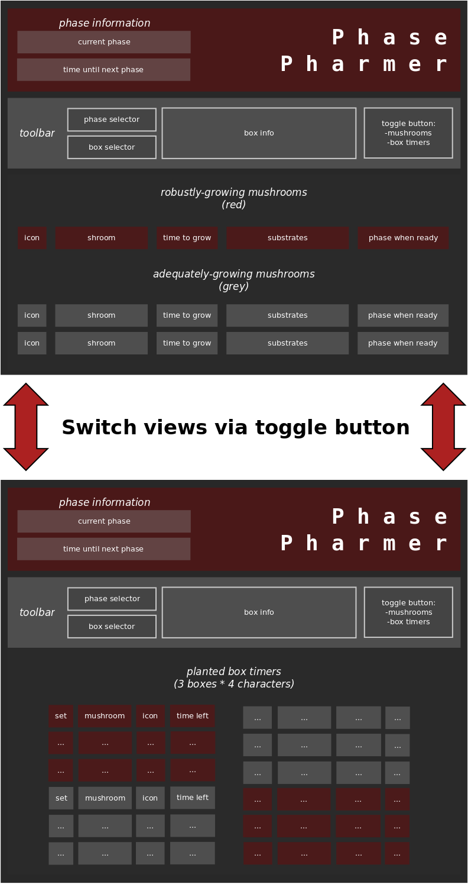
3.2 GUI Layout

