CS/SE 2630 - Object-Oriented Programming & Data Structures II S17 Clifton

Program 3: Bot wars on Android – Version 4
2a. Changed from growable array to fixed-sized array
2b. Reduced required Move complexity
3a. Added more setup instructions, including SVN
3b. Changed SVN requirement (#3).
4a. Added instruction for using the Math library.
Due Date: March 28, Finished Demonstration no later than 4:00 PM
Grace Date: March 30, Finished Demonstration no later than 4:00 PM
Points: 30

You are going to create a Bot War Android App. You will work in groups of 3. I expect all will do about the same amount of work and contribute approximately equally. Those that do significantly less will get lower grades.

I gave this program last semester. You are NOT allowed to reuse any code from last semester, even your own if you are repeating this course. I will ask questions to make sure all understand what you did and you can expect to lose points if you do not understand. I saved all the projects from last semester and will have no tolerance for those that cheat by taking things from last semester.

Besides the program, the other requirements are:

- Test Bed Main: None for this program
- Work Plan: None for this program. Get used to your group. Next program will require a plan.
- SVN and Dinger: You must periodically check your project into SVN via Visual Studio. However, the Dinger will not be turned on for this program.
You will points (and probably a lot of time) for unnecessary files checked in and not enough files checked in.
- Time Logs: You must enter your time into CSSE Hub. Each entry must have a comment and details specifying what you worked on. If you sat and watched as your other group members worked, you cannot count that as working! You must use punch-in and punch-out. If you forget, then you can manually enter the time. However, I expect the number of manual entries to be small. You will lose up to 5 points for non-compliance or lack of detail or too many manual entries.
- Code Review: There will be a 10-point lab associated with this program. The details of that lab will be in a separate document.
- Demonstration: You will be demonstrating in my office before the Grace Date. Sign up for a half-hour demonstration time before the Grace Date using the instructions on my web page. You must have the project checked out to your K group share folder (and tested running from there) prior to coming up to demo. You must be 100% done when you come to demo.

Setup:

The setup for this program is quite extensive. We will be using native C++ for Android, which unfortunately has practically no “tools”. Everything, including Buttons, Text, etc., have to be created “by hand” using OpenGL. We have a graphics course that covers OpenGL but this course is a prerequisite for that course. Therefore, I will be providing the OpenGL parts. I made up very crude classes for these things this summer. They get the job done but aren’t all that pretty!

- Choose File -> New Project and select:
Installed -> Templates -> Visual C++ -> Cross Platform -> Android -> Native Activity Application
Choose your group K share for the Location and choose a name like Prog3.
Make sure “Create Directory for solution” is unchecked.

- After creating the project, use File Explorer and check to see where it put the Prog3.sln file. If it is above the Prog3 folder, do the steps in "Solution file in the wrong place?" below before proceeding to the next step. When I tried in Ullrich 206, I had to do the extra steps - all of them.
- After the project is created, change the platform from x86 to ARM (in the top menu bar). The Solution Explorer should look like (except yours will be called Prog3 instead of Prog3_2):

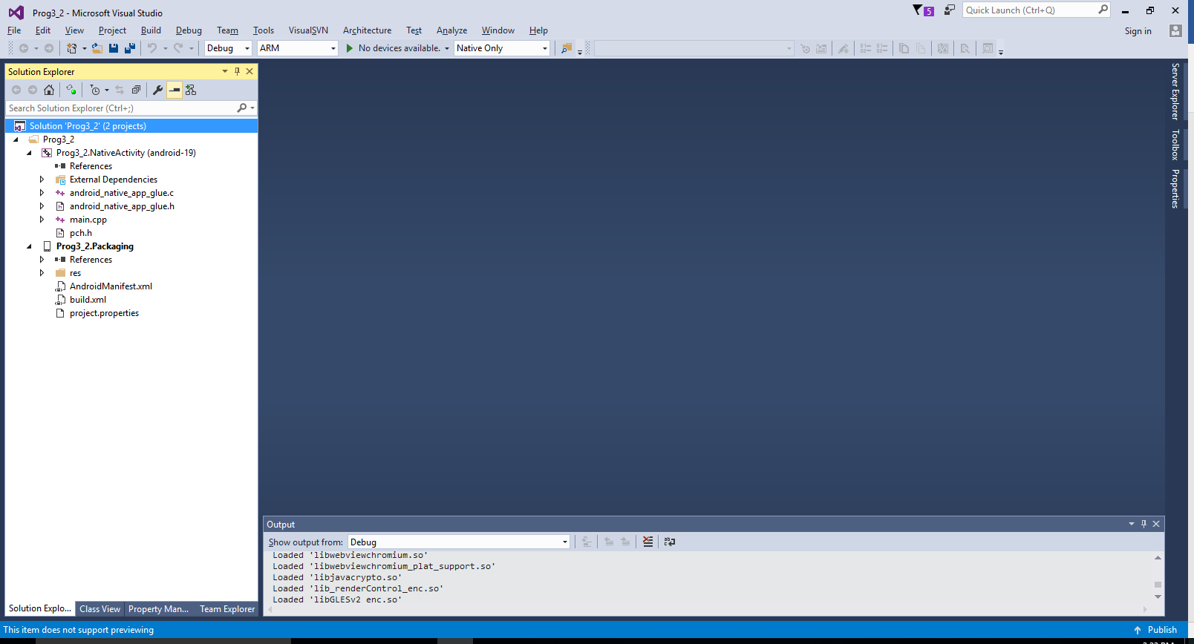

- Build the program. It should build without errors.
- Do Tools -> Android -> Android Emulation Manager (or below the menu bar, where it says "No Devices Available", select Android Virtual Device Manager).
- On the Android Virtual tab, Click Create and fill it out such as the figure below, and click OK. There are no spaces in the name. You can experiment with other choices once you get this running. Note that "Use Host GPU" must be checked.

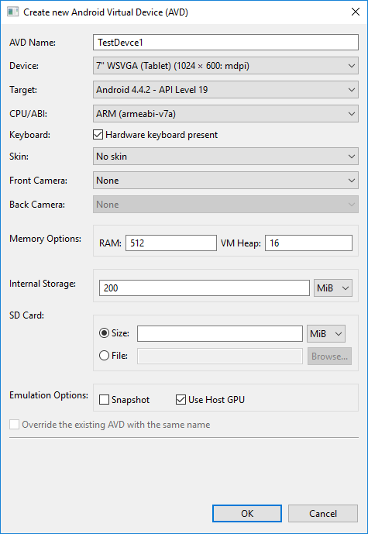

- When it goes back to the AVD Manager, select the Virtual Device you just created and click “Start”.
- When the pop-up appears, click Launch. It takes a painfully long time to launch.
- Go back to Visual Studio. You should see the TestDevice1 appear as the emulator (on the top menu bar).
- Click: Debug -> Start Debugging. It gives a nasty warning that ARM debugging is unreliable. The ARM emulator might not work as well as expected, but at least it works somewhat, which is more than I could get the x64 to do! So just click OK.
- Switch to the TestDevice1 emulator and you should see the App running. You can click on various places and watch the colors change. The colors also change without clicking.
- Click Debug -> Stop Debugging
- Do the steps from Lab1 to submit your solution to SVN. However, when I did it in ULR 206, it said that none of the files were checked in. That's OK. At least the Solution is associated with the repository. The next step should fix that.
- Do a Visual SVN commit. The files that should be checked in should have a check mark by them. It should look like below. At this time, don't add in any other files except these.

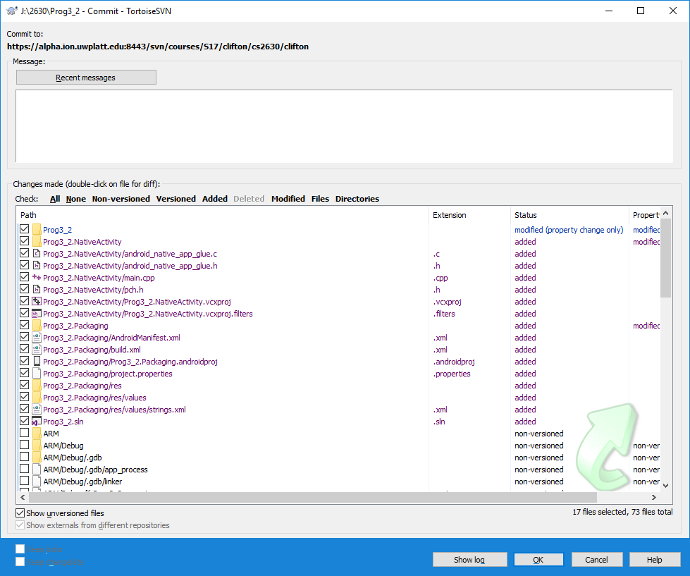

- After committing these files, open the Tortoise SVN Repo-Browser to see if everything looks OK in the repository. Below are some screenshots of how it should look (however, you should only be able to see yours and not the others):

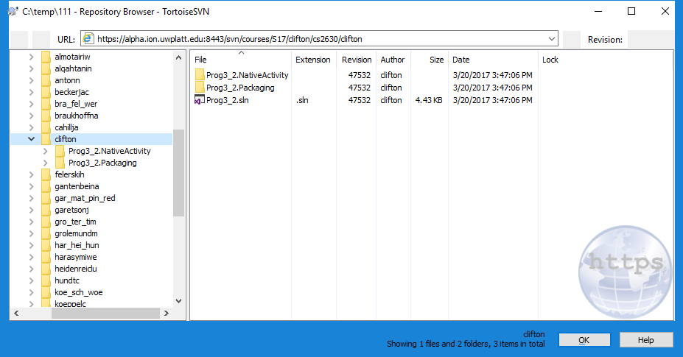

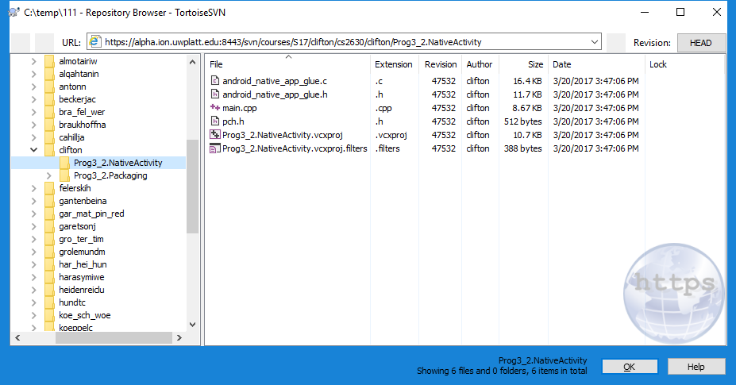

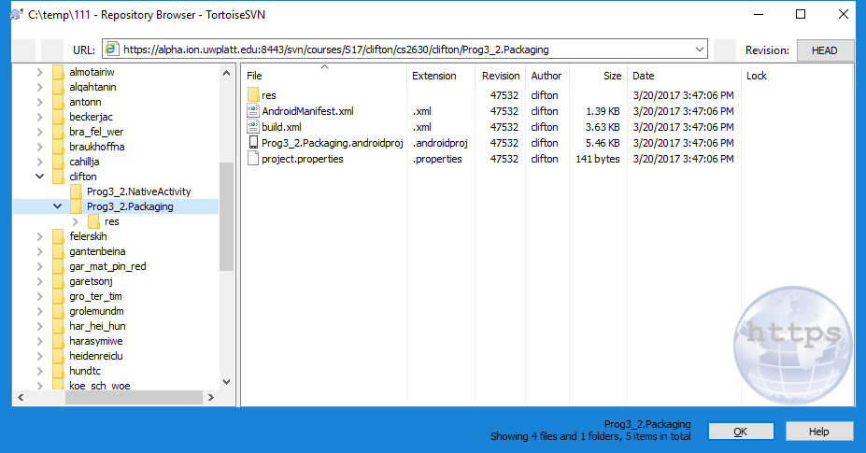

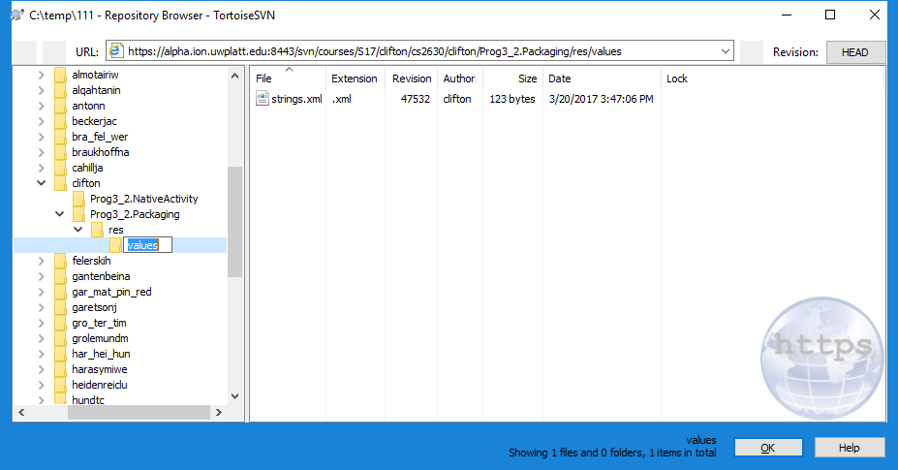

There shouldn't be any other files in there.

- If anything is wrong, start over!
- Close Visual Studio. Go to a different folder (or better yet, a different folder on a different computer). Check out the repository. Double-click the solution to open it up, and Build it. If it can't build or anything else is wrong, start over!
- At this point, you should have a good solution and project checked into SVN. If you are careful, it should never get messed up. If it does, start over (saving any files you changed, of course)!
- You will modify this running App to produce the Bot Wars App.
- The only other files that should be added to the SVN are the CPP and H files you create, the CPP & H files I gave you, and the BMP files you create. These should be added on the commits.
- If you get a message about not finding the java exe (I did at home), try adding C:\Program Files\Java\jre1.8.0_91\bin to path. This worked for me.
- Sometimes I got the error "fatal error rc1015: cannot open include file 'winres.h'". It appears to be related to Prog3.NativeActivity.rc, which sometimes gets added to the project (not sure why, perhaps I was doing something wrong). In any case, I could "fix" it by removing Prog3.NativeActivity.rc from the project.
- Any other issues, let me know right away.

Solution File in the Wrong Place?

If the Prog3.sln file is in the folder above Prog3, then do the following before proceeding to the next step in the instructions above:
- In Visual Studio, in the Solution Explorer, click the Solution (at the top of Solution Explorer) to highlight it, then do File -> “Save Prog3.sln as”, and save it into Prog3 folder.
- Exit Visual Studio and check to see that Prog3.sln is in your Prog3 folder using File Explorer.
- In File Explorer, select the View tab and check “File name Extensions” and “Hidden Items” in the Show/Hide portion of the menu.
- In the folder above Prog3, delete the following:
  - Prog3.sln file
  - Prog3.VC.db file
  - .vs folder
  - If there happens to be ARM, ipch, and x86 and/or x64 folders up there, delete them also.
- Go to the Prog3 folder and double-click Prog3.sln to open it. You would think everything should be OK. However, in ULR 206, it couldn't find the projects. I was able to fix it by right-clicking on the Solution in the Solution Explorer and selecting Resolve Errors. Then it should be able to find the projects. I tried it in ULR 206 and it worked fine. If this doesn’t work for you, let me know right away.

Program Overview:

A VBot (Virtual Bot) is a little creature that moves around on the screen. When VBots meet, they do battle. Each VBot puts a given amount of energy into the battle. Winners are rewarded and losers are penalized. I will provide an abstract base class, called VBot. You will be making at least three descendant classes. Furthermore, you need to make a VBot List class to handle them. VBots will be added via button clicks. You must display the number of Bots created and the number destroyed.

Below is a screen shot of what mine currently looks like on the Emulator. Envision that on each update, each Bot moves on the screen. Updates are many times a second, so they move fairly smoothly. The Buttons are simply labeled 1, 2, and 3. Pressing a button adds a Bot of that type. The numbers below the Buttons are the numbers of each type of Bot that were created and destroyed. For example, for Bot type 1, 13 were created and 4 destroyed. The reasons that you can't see all the Bots on the screen are: Some Bots are on top of each other, and at the moment I took the screen shot, some have just gone off the screen and will reappear somewhere else on the screen in the next refresh cycle.

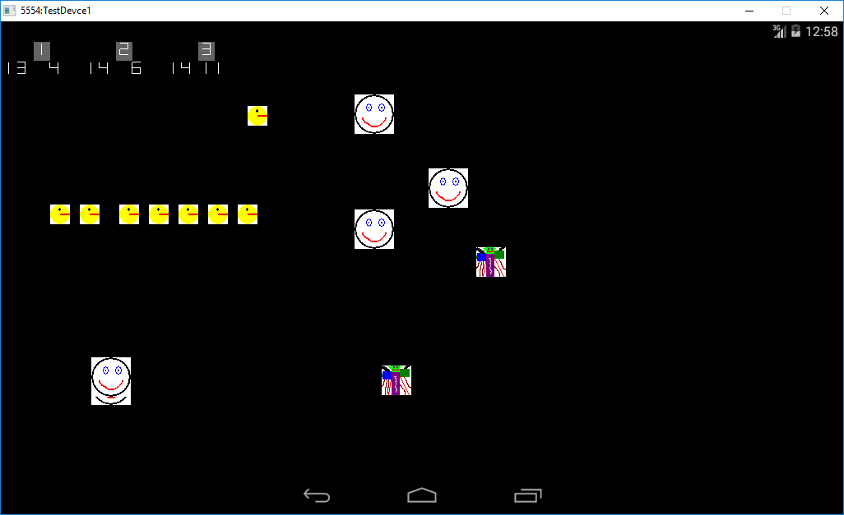

Some requirements and hints. They assume you named your project Prog3.

- You will use button clicks to create the VBots. Right after you create a Vbot, you need to call its InitGraphics method. It is like a delayed part of the constructor or the second part of the constructor.
- The buttons must have a scale factor between 1.5 and 2.5. -3 if they don't.
- You MUST implement the VBot list as an array of VBOT pointers. -10 if you don't. You must set the size to 200. Don't Add if the list is full.
- You must display the number of Bots created and the number destroyed.
- "Randomize" where you put them to start with when a button is clicked. You can use an algorithm you make up or #include <cstdlib> and properly use the rand function.
- Add all source files and the BMP files to the Prog3.NativeActivity folder. Do all the "TODO's" in all the files I provide.
- Enable Exceptions: In Solution Explorer, right click on Prog3.NativeActivity and select Properties. Then under Configuration Properties -> C/C++ -> Code Generation, set “Enable C++ Exceptions” to Yes.
- I modified the main.cpp to remove most of their App and set up for ours. I put "TODO" in all the places where you need (or could) to add something.
- I have provided an IntegerDisplay class that class that allows you to display integers anywhere in any color and scaled to any size. I left a small piece for you to finish just to make you understand some of that file. It is a non-OpenGl part and is marked with "TODO". It is a singleton class and you use it as: IntegerDisplay::Instance()->DisplayIntAt(....
- I have provided a GL_Button class that allows you to place buttons anywhere. You can set their foreground and background color and can scale them. An integer is used as their caption. I didn’t want to make a StringDisplay class and make all the characters. Making the integers was enough work.
- You must use the VBot.h and VBot.cpp I have provided.
- You must make three classes that inherit from the virtual VBot class (four for groups of four). Each group member must write one descendant class, on their own. I assume you will have significantly (algorithmically) different movement (Move) and fighting strategy (EnergyToFightWith) methods. Also, the movement methods must have some amount of complexity. I require at least 15 lines of code, not counting the braces. Try to be clever. Come up with neat patterns! When you demo, I will ask you what motivated you for your movement pattern and Battle strategy. I will ask you to explain exactly what you did and why you did it. I don't want you copying these from anywhere or expect a 0. Also, each member will create their own BMP file. The BMP files must be added to the project and checked into SVN. You can do that by "check"ing them when you do a commit.

Note: I assume you will use Paint to create a VBot and not take one from somewhere else. I also assume you will make your own clever movement and not take it from somebody else. If you did the VBot program last semester and are retaking this course this semester, you cannot use the same VBot or movement you did last semester: -6 if you do.

- You must make separate CPP and H files for each of the VBot descendants. Also, the BotList must have its own CPP and H files. You can only have one-line or two-line inline bodies in the H files you create.
- You can create your VBot bitmaps in Paint. You must create a BMP file. You can experiment with the height and width in pixels. I suggest you don’t make them too big. After you have created them, you need to run my ConvertBotData program that converts the BMP to a CPP file. Add the created CPP files to your project. The BMP file must have the same filename as your class name.
- You can and probably should add extra member data to the derived VBot classes. For example, you can keep track of the energy since the last movement and if it changed, jump somewhere out of the way.
- Main.cpp must make polymorphic use of VBots and must use the VBot list. Obviously you must "new" the different bots, but other than that, you can only use the methods in the VBot and the VBot List.
- In the engine_draw_frame function in main.cpp (which redraws on each screen update), you will call BotList methods to move all the bots, do all the battles, and draw all the bots. In addition, you will update Created/Destroyed displays, draw the buttons, etc. Everything needs to be drawn since each update starts as an empty screen.
- When checking for battles, you will need to do a double for-loop through all the bots in the list, checking each i, j pair. But make sure that you don't check a) i,i b) both i,j and j,i
- Make sure dead bots don't participate in battle.
- When deleting dead bots from the list, make sure you delete the higher indexed ones first. Please understand why this is - I may ask when you come to demo.
- The file pch.h is automatically (implicitly) included in all cpp files that are part of the project. You can open it and see what is there.
- The PGR line length restriction is changed from 74 columns to 120 columns.
- To Display the number of Bots Created and Destroyed, you need to add statics to each descendant Bot class so you can get a count for each. In the private section, add static int data members such as numCreated and numDestroyed. In the constructor, increment numCreated, and in the destructor, increment numDestroyed. Make public static methods such as NumCreated and NumDestroyed that return the values of each. Also make a static ResetCounters method for each that resets the counters back to 0. You will call the ResetCounters methods in the engine_init_display of main.cpp to reset them. This is necessary since if you switch Apps and then switch back, all the Heap memory gets lost, so you also need to reset all non-heap based variables. Putting the numCreated and numDestroyed static data members in the class in the H file only declares them. You need to define them in the descendant Bot CPP files and do it as follows (pick better names than Bot1, Bot2, …):
int Bot1::numCreated = 0;
Then if you want to display the total number created in main, do something like:
int numCreated = Bot1::NumCreated() + Bot2::NumCreated() + …
IntegerDisplay::Instance()->DisplayIntAt(20, 50, numCreated);
Note that these are statics, so don't have anything to do with Polymorphism, so they aren't violating #14 above.

I will give up to 5 points of extra credit for "extras" you add (on an "as it strikes me" basis) provided that you DEMONSTRATE BEFORE THE DUE DATE TIME. Note that I generally don't give extra credit for just doing more of what you already have to do. For example, if you make 4 or 5 Bot types instead of 3, that would not give you any extra credit. Two fixed extra credit item you can choose are:
  - 3 points: Make buttons to speed up and slow down the movement.
  - 2 points: Separate “Created, Destroyed” displays for each of the 3 Bots.

Extra Work for Groups of 4:
- Must do 4 descendant Bots, one for each person. As for groups of 3, each must do their own.
- Must do Extra Credit a) but won't get Extra Credit for it.

To put the program on your Android device varies depending on the device. When you come to demo, we'll put it on a Samsung Galaxy Tab E (9.6" display). The steps I need to do to get it on there are:

- Enable developer options: Under Settings -> About Device, tap on the "Build Number" 7 times (strange but true). You only need to do this once to Enable Developer Options.
- Under Settings -> Developer Options, turn on Developer Options and turn USB Debugging on (only need to do once). There are other options you may want to turn on, but these are the minimum needed.
- Connect the device to your Computer (via USB).
- It will ask if you want to allow access to the device. Press OK.
- It will ask if you want to allow USB debugging. You can check "Always allow from this Computer" if you want. Then click OK.
- The device should now appear under the Menu (where the emulator used to be, assuming you shut down the emulator).
- Do Debug -> Start Without Debugging and it should load like it did on the Emulator except you can't debug it. I couldn't find any options that allowed me to debug from Visual Studio.

Using the Math Library:

You must first include cmath:
#include <cmath>
It is in namespace std, so you either need:
using namespace std;
or use the scope resolution operator: std::
Next, you also need to add in the linker option (see below).
Just add an m (which stands for Math library) to the end of the linker options already there (separated with a semicolon).

