《嵌入式LInux应用程序可开发》

班级：软件153班
姓名：肖丁剑
学号：153266

实验要求：
- 在Linux系统下编写完成。
- 创建一个服务器和若干个客户端。
- 用户可以通过客户端输入文字并且向服务器发送消息。
- 服务器端接收到客户端发送的数据，将用户输入的内容在服务器上打印出来，并将原内容返回客户端。
- 在服务器端和客户机端要综合运用多进程/多线程的编程知识实现并发处理，并且要在进程和线程之间采用相应的同步/互斥机制，实现其通信过程。
- 最终采用makefile文件的形式予以实现。
- 服务器与客户端的具体内容可以自由发挥，充分体现自身的原创精神即可。注意：一定要有具体的实现的源代码和实现的过程和结果截图。
实验内容：
- 编写源代码
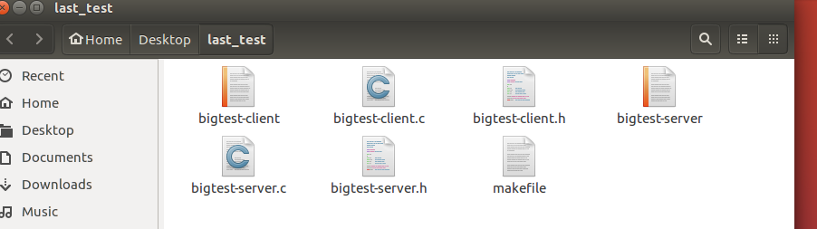
图一 所有文件总览
- bigtest-server源代码如下：
#include<stdio.h>
#include<stdlib.h>
#include<string.h>
#include<unistd.h>
#include<sys/socket.h>
#include<netinet/in.h>
#include<arpa/inet.h>
int main(int argc,char*argv[])
{
unsigned short port=8080;//localhost port
//create tcp socket
int sockfd=socket(AF_INET,SOCK_STREAM,0);
if(sockfd<0)
{
perror("socket");
exit(-1);
}
//config localhost web infomation
struct sockaddr_in my_addr;
bzero(&my_addr,sizeof(my_addr));//clean
my_addr.sin_family=AF_INET;//IPv4
my_addr.sin_port=htons(port);//port
my_addr.sin_addr.s_addr=htonl(INADDR_ANY);//ip
printf("socket id is %d\n",sockfd);
//bind
int err_log=bind(sockfd,(struct sockaddr*)&my_addr,sizeof(my_addr));
if(err_log!=0)
{
perror("binding");
close(sockfd);
exit(-1);
}
else
printf("bind success!\n");
//listen,socket change to be passivity
err_log=listen(sockfd,10);
if(err_log!=0)
{
perror("listen");
close(sockfd);
exit(-1);
}
printf("listening...\n");
while(1)//main circulation,waiting for the connection of client
{
char cli_ip[INET_ADDRSTRLEN]={0};
struct sockaddr_in client_addr;
socklen_t cliaddr_len=sizeof(client_addr);
//remove the connection that the client has completed
int connfd=accept(sockfd,(struct sockaddr*)&client_addr,&cliaddr_len);
if(connfd<0)
{
perror("accept");
close(sockfd);
exit(-1);
}
pid_t pid=fork();
if(pid<0){
perror("fork");
_exit(-1);
}else if(pid==0){//the child process receives the client's information and returns it tothe client
close(sockfd); //close the listening socket,which is inherited from the parent process
char recv_buf[1024]={0};
int recv_len=0;
//print the server's ip and port
memset(cli_ip,0,sizeof(cli_ip));//clear
inet_ntop(AF_INET,&client_addr.sin_addr,cli_ip,INET_ADDRSTRLEN);
printf("-----------------------------------\n");
printf("client ip=%s,port=%d\n",cli_ip,ntohs(client_addr.sin_port));
//receive data
while((recv_len=recv(connfd,recv_buf,sizeof(recv_buf),0))>0)
{
printf("recv_buf:%s\n",recv_buf);//printf data
send(connfd,recv_buf,recv_len,0);//send data to client
}
printf("client closed");
close(connfd);//shut down the socket which has been connected
exit(0);
}else if(pid>0){ //father fork
close(connfd);//shut down the socket which has been connected
}
}
close(sockfd);
return 0;
}
- bigtest-client源代码如下：
#include<stdio.h>
#include<stdlib.h>
#include<errno.h>
#include<string.h>
#include<netdb.h>
#include<sys/types.h>
#include<netinet/in.h>
#include<sys/socket.h>
#define PORT 8080
#define BUFFER_SIZE 1024
int main(int argc,char *argv[])
{
int sockfd,sendbytes;
char buf[BUFFER_SIZE];
struct hostent *host;
struct sockaddr_in serv_addr;

if(argc<3)
{
fprintf(stderr,"USAGE:./client Hostname(or ip address)Text\n");
exit(1);
}
if((host=gethostbyname(argv[1]))==NULL)
{
perror("gethostbyname");
exit(1);
}
memset(buf,0,sizeof(buf));
sprintf(buf,"%s",argv[2]);

if((sockfd=socket(AF_INET,SOCK_STREAM,0))==-1)
{
perror("socket");
exit(1);
}
serv_addr.sin_family=AF_INET;
serv_addr.sin_port=htons(PORT);
serv_addr.sin_addr=*((struct in_addr *)host->h_addr);
bzero(&(serv_addr.sin_zero),8);

if(connect(sockfd,(struct sockaddr *)&serv_addr,sizeof(struct sockaddr))==-1)
{
perror("connect");
exit(1);
}
if((sendbytes=send(sockfd,buf,strlen(buf),0))==-1)
{
perror("send");
exit(1);
}
close(sockfd);
exit(0);
}

- 分别用.c文件保存源代码的代码部分，.h文件保存头文件部分，用makefile进行编译

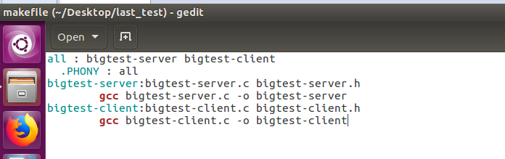
图二 makefile文件内容

目标文件

图三 编译后的目标文件

- 输入指令并运行（服务器主机ip地址为：192.168.2.67）
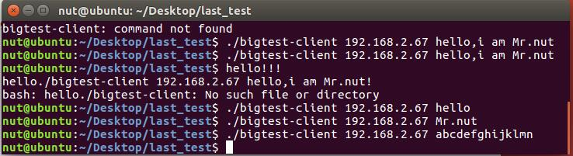
图四 客户端发送数据

两端发送以及接收的内容

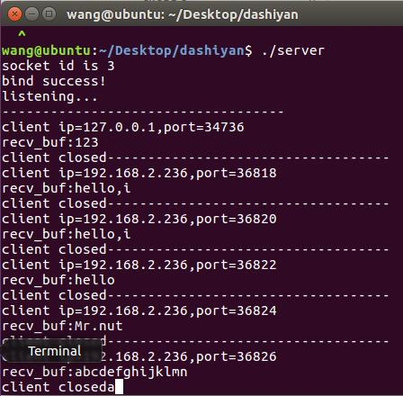
图五 服务器接收数据

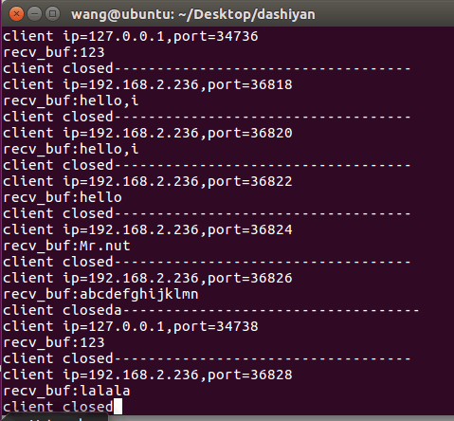
多个客户端以及他们各自发送的消息
图六 多个客户端并发发送消息
拓展实现：实现服务端对客户端的回复，在客户端可查看回复内容
服务器端源代码：
Sem_com.h文件内容：

/* sem_com.h */
#ifndef SEM_COM_H
#define SEM_COM_H
#include <sys/ipc.h>
#include <sys/sem.h>
union semun
{
int val;
struct semid_ds *buf;
unsigned short *array;
};

int init_sem(int sem_id, int init_value)
{
union semun sem_union;
sem_union.val = init_value;
if (semctl(sem_id, 0, SETVAL, sem_union) == -1)
{
perror("Initialize semaphore");
return -1;
}
return 0;
}

int del_sem(int sem_id)
{
union semun sem_union;
if (semctl(sem_id, 0, IPC_RMID, sem_union) == -1)
{
perror("Delete semaphore");
return -1;
}
}

int sem_p(int sem_id)
{
struct sembuf sem_b;
sem_b.sem_num = 0; /*id*/
sem_b.sem_op = -1; /* P operation*/
sem_b.sem_flg = SEM_UNDO;

if (semop(sem_id, &sem_b, 1) == -1) /*1:first struct*/
{
perror("P operation");
return -1;
}
return 0;
}

int sem_v(int sem_id)
{
struct sembuf sem_b;

sem_b.sem_num = 0; /* id */
sem_b.sem_op = 1; /* V operation */
sem_b.sem_flg = SEM_UNDO; /* It's tracks be follow, to automatical free for it*/

if (semop(sem_id, &sem_b, 1) == -1)
{
perror("V operation");
return -1;
}
return 0;
}
#endif /* SEM_COM_H */

Server.h文件内容
#include<stdio.h>
#include<stdlib.h>
#include<string.h>
#include<unistd.h>
#include<sys/socket.h>
#include<netinet/in.h>
#include<arpa/inet.h>
#include<sys/types.h>
#include<sys/ipc.h>
#include<sys/shm.h>
#include<semaphore.h>
#define BUFFER_SIZE 1024

Server.c文件内容
#include "server.h"
#include "sem_com.h"
int main(int argc,char*argv[])
{
int sendbytes;
char send_buf[BUFFER_SIZE];
unsigned short port=8080;//localhost port
//create a singnal
int sem_id=semget(ftok(".",'a'),1,0666|IPC_CREAT);
init_sem(sem_id,1);
//create tcp socket
int sockfd=socket(AF_INET,SOCK_STREAM,0);
if(sockfd<0)
{
perror("socket");
exit(-1);
}
//config localhost web infomation
struct sockaddr_in my_addr;
bzero(&my_addr,sizeof(my_addr));//clean
my_addr.sin_family=AF_INET;//IPv4
my_addr.sin_port=htons(port);//port
my_addr.sin_addr.s_addr=htonl(INADDR_ANY);//ip
printf("socket id is %d\n",sockfd);
//bind
int err_log=bind(sockfd,(struct sockaddr*)&my_addr,sizeof(my_addr));
if(err_log!=0)
{
perror("binding");
close(sockfd);
exit(-1);
}
else
printf("bind success!\n");
//listen,socket change to be passivity
err_log=listen(sockfd,10);
if(err_log!=0)
{
perror("listen");
close(sockfd);
exit(-1);
}
printf("listening...\n");
while(1)//main circulation,waiting for the connection of client
{
char cli_ip[INET_ADDRSTRLEN]={0};
struct sockaddr_in client_addr;
socklen_t cliaddr_len=sizeof(client_addr);
sem_p(sem_id);
//remove the connection that the client has completed
int connfd=accept(sockfd,(struct sockaddr*)&client_addr,&cliaddr_len);
if(connfd<0)
{
perror("accept");
close(sockfd);
exit(-1);
}
pid_t pid=fork();
sem_v(sem_id);
if(pid<0){
perror("fork");
_exit(-1);
}else if(pid==0){
//the child process receives the client's information and returns it tothe client
close(sockfd); //close the listening socket,which is inherited from the parent process
char recv_buf[1024]={0};
int recv_len=0;
//print the server's ip and port
memset(cli_ip,0,sizeof(cli_ip));//clear
inet_ntop(AF_INET,&client_addr.sin_addr,cli_ip,INET_ADDRSTRLEN);
printf("-----------------------------------\n");
//printf("client ip=%s,port=%d\n",cli_ip,ntohs(client_addr.sin_port));
//receive data
while((recv_len=recv(connfd,recv_buf,sizeof(recv_buf),0))>0&&strncmp(recv_buf,"quit",4)!=0)
{
printf("%s:%s",cli_ip,recv_buf);//printf data
memset(recv_buf,0,sizeof(recv_buf));
printf("reply to %s:\n",cli_ip);
memset(send_buf,0,sizeof(send_buf));
read(STDIN_FILENO,send_buf,sizeof(send_buf));
if((sendbytes=send(connfd,send_buf,strlen(send_buf),0))==-1)
{
perror("send");
}
//send(connfd,recv_buf,recv_len,0);//send data to client
}
printf("%s client closed\n",cli_ip);
close(connfd);//shut down the socket which has been connected
exit(0);
}else if(pid>0){ //father fork
close(connfd);//shut down the socket which has been connected
}
}
close(sockfd);
return 0;
}
客户端源代码：
Client.c文件内容
#include "client.h"
int main(int argc,char *argv[])
{
int sockfd,sendbytes;
char buf[BUFFER_SIZE],recv_buf[BUFFER_SIZE];
struct hostent *host;
struct sockaddr_in serv_addr;

if(argc<2)
{
fprintf(stderr,"USAGE:./client Hostname(or ip address)Text\n");
exit(1);
}
printf("you are chatting with %s!(you can end the chat by typing \"quit\")\n",argv[1]);
//read(STDIN_FILENO,hostbuf,sizeof(hostbuf));
if((host=gethostbyname(argv[1]))==NULL)
{
perror("gethostbyname");
exit(1);
}

if((sockfd=socket(AF_INET,SOCK_STREAM,0))==-1)
{
perror("socket");
exit(1);
}
serv_addr.sin_family=AF_INET;
serv_addr.sin_port=htons(PORT);
serv_addr.sin_addr=*((struct in_addr *)host->h_addr);
bzero(&(serv_addr.sin_zero),8);

if(connect(sockfd,(struct sockaddr *)&serv_addr,sizeof(struct sockaddr))==-1)
{
perror("connect");
exit(1);
}
do
{
printf("send to %s:\n",argv[1]);
memset(buf,0,sizeof(buf));
read(STDIN_FILENO,buf,sizeof(buf));
if((sendbytes=send(sockfd,buf,strlen(buf),0))==-1)
{
perror("send");
exit(1);
}
memset(recv_buf,0,sizeof(recv_buf));
if(recv(sockfd,recv_buf,sizeof(recv_buf),0)>0)
{
printf("%s:%s",argv[1],recv_buf);
}
}while(strncmp(buf,"quit",4)!=0);
close(sockfd);
exit(0);
}
运行结果：
发送的消息
客户端
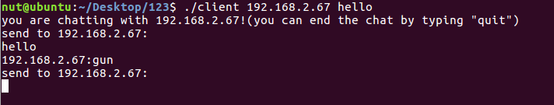
图七 客户端发送并接收信息
接收到服务器的消息
服务器
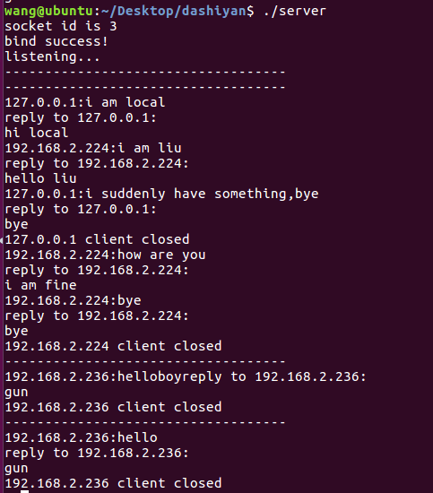
服务器接收的客户端发来的消息
图八 服务器接收并发送信息
服务器回复的消息

