实验三 共享内存
- 实验目的
通过编写共享内存实验，读者可以进一步了解使用共享内存的具体步骤，同时也进一步加深对共享内存的理解。在本实验中，采用信号量作为同步机制完善两个进程（“生产者”和“消费者”）之间的通信。其功能类似于“消息队列”中的实例
- 实验内容
利用共享内存实现文件的打开和读写操作
- 实验步骤
流程图
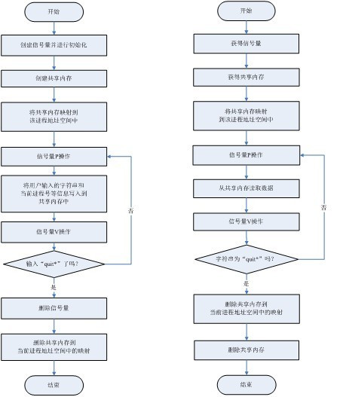
①编写代码
Shm_com.h源代码如下：
/* shm_com.h */
#ifndef SHM_COM_H
#define SHM_COM_H
#include <unistd.h>
#include <stdlib.h>
#include <stdio.h>
#include <string.h>
#include <sys/types.h>
#include <sys/ipc.h>
#include <sys/shm.h>
#define SHM_BUFF_SZ 2048
struct shm_buff
{
int pid;
char buffer[SHM_BUFF_SZ];
};

producer.c源代码如下：
/* producer.c */
#include "shm_com.h"
#include "sem_com.h"
#include <signal.h>
int ignore_signal(void)
{
signal(SIGINT, SIG_IGN);
signal(SIGSTOP, SIG_IGN);
signal(SIGQUIT, SIG_IGN);
return 0;
}
int main()
{
void *shared_memory = NULL;
struct shm_buff *shm_buff_inst;
char buffer[BUFSIZ];
int shmid, semid;
ignore_signal();
semid = semget(ftok(".", 'a'), 1, 0666|IPC_CREAT);
init_sem(semid, 1);/* ³õÊŒÖµÎª1 */
shmid = shmget(ftok(".", 'b'), sizeof(struct shm_buff), 0666|IPC_CREAT);
if (shmid == -1)
{
perror("shmget failed");
del_sem(semid);
exit(1);
}
shared_memory = shmat(shmid, (void*)0, 0);
if (shared_memory == (void*)-1)
{
perror("shmat");
del_sem(semid);
exit(1);
}
printf("Memory attached at %X\n", (int)shared_memory);
shm_buff_inst = (struct shm_buff *)shared_memory;
do
{
sem_p(semid);
printf("Enter some text to the shared memory(enter 'quit' to exit):");
if (fgets(shm_buff_inst->buffer, SHM_BUFF_SZ, stdin) == NULL)
{
perror("fgets");
sem_v(semid);
break;
}
shm_buff_inst->pid = getpid();
sem_v(semid);
} while(strncmp(shm_buff_inst->buffer, "quit", 4) != 0);
del_sem(semid);
if (shmdt(shared_memory) == 1)
{
perror("shmdt");
exit(1);
}
exit(0);
}

Customer.c源代码如下：
/* customer.c */
#include "shm_com.h"
#include "sem_com.h"
int main()
{
void *shared_memory = NULL;
struct shm_buff *shm_buff_inst;
int shmid, semid;
semid = semget(ftok(".", 'a'), 1, 0666);
if (semid == -1)
{
perror("Producer is'nt exist");
exit(1);
}
shmid = shmget(ftok(".", 'b'), sizeof(struct shm_buff), 0666|IPC_CREAT);
if (shmid == -1)
{
perror("shmget");
exit(1);
}
shared_memory = shmat(shmid, (void*)0, 0);
if (shared_memory == (void*)-1)
{
perror("shmat");
exit(1);
}
printf("Memory attached at %X\n", (int)shared_memory);
shm_buff_inst = (struct shm_buff *)shared_memory;
do
{
sem_p(semid);
printf("Shared memory was written by process %d :%s", shm_buff_inst->pid, shm_buff_inst->buffer);
if (strncmp(shm_buff_inst->buffer, "quit", 4) == 0)
{
break;
}
shm_buff_inst->pid = 0;
memset(shm_buff_inst->buffer, 0, SHM_BUFF_SZ);
sem_v(semid);

} while(1);
if (shmdt(shared_memory) == -1)
{
perror("shmdt");
exit(1);
}
if (shmctl(shmid, IPC_RMID, NULL) == -1)
{
perror("shmctl(IPC_RMID)");
exit(1);
}
exit(0);
}
Make file文件源代码如下：
EXEC1 = producer
EXEC2 = customer
OBJS1 = producer.o sem_com.o
OBJS2 = customer.o sem_com.o
HEADERS = shm_com.h sem_com.h
CC = gcc
CFLAGS = -O2
all:${EXEC1} ${EXEC2}
${EXEC1} : ${OBJS1}
${CC} ${CFLAGS} ${LDFLAGS} -o $@ $^
${EXEC2} : ${OBJS2}
${CC} ${CFLAGS} ${LDFLAGS} -o $@ $^
${OBJS1} : ${HEADERS}
${OBJS2} : ${HEADERS}
.PHONY : clean
clean :
-rm -f ${OBJS1} ${EXEC1}
-rm -f ${OBJS2} ${EXEC2}

发送内容
②运行并查看结果
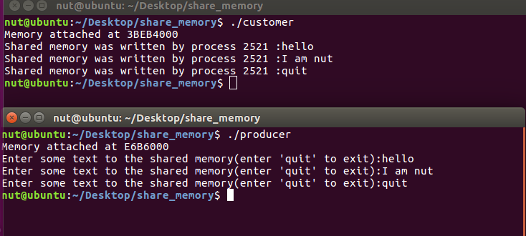
接收内容

