**HTML: Hyper text mark-up language:**

**Is Used for creating web pages which describe structure of web-page. It has ELEMENTS which tells browser how to display content.**

**<html> is root element**

**HTML Element:**

**Is component of html document that tells a web browser to structure and interpret a part of the html doc.**

**Web-browser:**

**Read doc and display them correctly.**

**Attributers provide additional information about HTML element.**

**<img> is element**

**<src,alt,width> is attribute**

**For Image:**

<img src="img_girl.jpg" width="500" height="600">

The required alt attribute for the <img> tag specifies an alternate text for an image

<img src="img_girl.jpg" alt="Girl with a jacket">

<img src="img_typo.jpg" alt="Girl with a jacket">

ALT let you know nature of image when image is not displayed.

**Style Attribute:**

The style attribute is used to add styles to an element, such as color, font, size, and more.

<p style="color:red;">This is a red paragraph.</p>

“link” put double quotes for attribute.

* All HTML elements can have **attributes**
* The href attribute of <a> specifies the URL of the page the link goes to
* The src attribute of <img> specifies the path to the image to be displayed
* The width and height attributes of <img> provide size information for images
* The alt attribute of <img> provides an alternate text for an image
* The style attribute is used to add styles to an element, such as color, font, size, and more
* The lang attribute of the <html> tag declares the language of the Web page
* The title attribute defines some extra information about an element

**Headings:**

Each HTML heading has a default size. However, you can specify the size for any heading with the style attribute, using the CSS font-size property:

<h1 style="font-size:60px;">Heading 1</h1>

**Paragraphs:**

The <hr> element is used to separate content (or define a change) in an HTML page:

The <hr> tag is an empty tag, which means that it has no end tag.

<p>This is<br>a paragraph<br>with line breaks.</p>

The text inside a <pre> element is displayed in a fixed-width font (usually Courier), and it preserves both spaces and line breaks: PRE for poems

**STYLE:**

<p style="color:red;">I am red</p>

<tagname style="property:value;">

Background:

<body style="background-color:powderblue;">

**Paragraph Background:**

<p style="background-color:tomato;">This is a paragraph.</p>

**Text Color:**

<h1 style="color:blue;">This is a heading</h1>

**Font style:**

<h1 style="font-family:Times In roman;">This is a heading</h1>

**Font Size:**

<h1 style="font-size:300%;">This is a heading</h1>

## Text Alignment:

<h1 style="text-align:center;">Centered Heading</h1>

* Use the style attribute for styling HTML elements
* Use background-color for background color
* Use color for text colors
* Use font-family for text fonts
* Use font-size for text sizes
* Use text-align for text alignment

**Formatting:**

* <b> - Bold text
* <strong> - Important text
* <i> - Italic text
* <em> - Emphasized text
* <mark> - Marked text/Highlighted text
* <small> - Smaller text
* <del> - Deleted text
* <ins> - Inserted text
* <sub> - Subscript text
* <sup> - Superscript text

**Tip:** A screen reader will pronounce the words in <em> with an emphasis, using verbal stress.

The HTML <mark> element defines text that should be marked or highlighted:

<p>Do not forget to buy <mark>milk</mark> today.</p>

**Used to cross words:**

<p>My favorite color is <del>blue</del> red.</p>

The HTML <ins> element defines a text that has been inserted into a document. Browsers will usually underline inserted text:

<p>My favorite color is <del>blue</del> <ins>red</ins>.</p>

**Sub is used to write H2O:**

<p>H<sub>2</sub>O</p>

<p>The <abbr title="World Health Organization">WHO</abbr> was founded in 1948.</p>

|  |  |
| --- | --- |
| [<abbr>](https://www.w3schools.com/tags/tag_abbr.asp) | Defines an abbreviation or acronym |
| [<address>](https://www.w3schools.com/tags/tag_address.asp) | Defines contact information for the author/owner of a document |
| [<bdo>](https://www.w3schools.com/tags/tag_bdo.asp) | Defines the text direction |
| [<blockquote>](https://www.w3schools.com/tags/tag_blockquote.asp) | Defines a section that is quoted from another source |
| [<cite>](https://www.w3schools.com/tags/tag_cite.asp) | Defines the title of a work |

**Add comments:**

<!-- Write your comments here -->

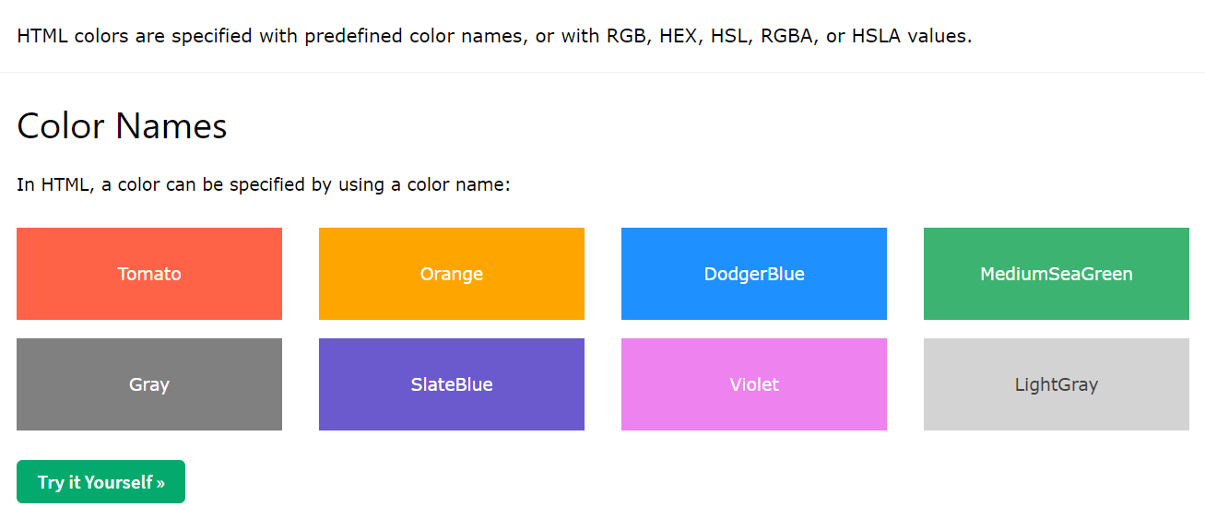

**To Set border color:**

<h1 style="border:2px solid Tomato;">Hello World</h1>

|  |  |
| --- | --- |
| [<link>](https://www.w3schools.com/tags/tag_link.asp) | Defines the relationship between a document and an external resource |

td stands for table data.

tr stands for table row.

th stands for table header.

<table style="width:100%">

<tr> write data in row

<th>Company</th> text in rows

<th>Contact</th>

<th>Country</th>

</tr>

<tr>

<td>Alfreds Futterkiste</td>

<td>Maria Anders</td>

<td>Germany</td>

</tr>

<tr>

<td>Centro comercial Moctezuma</td>

<td>Francisco Chang</td>

<td>Mexico</td>

</tr>

</table>

An unordered list starts with the <ul> tag. Each list item starts with the <li> tag.

An ordered list starts with the <ol> tag. Each list item starts with the <li> tag.

Here are the block-level elements in HTML:

[<address>](https://www.w3schools.com/tags/tag_address.asp)

[<article>](https://www.w3schools.com/tags/tag_article.asp)

[<aside>](https://www.w3schools.com/tags/tag_aside.asp)[<blockquote>](https://www.w3schools.com/tags/tag_blockquote.asp)[<canvas>](https://www.w3schools.com/tags/tag_canvas.asp)[<dd>](https://www.w3schools.com/tags/tag_dd.asp)[<div>](https://www.w3schools.com/tags/tag_div.asp)[<dl>](https://www.w3schools.com/tags/tag_dl.asp)[<dt>](https://www.w3schools.com/tags/tag_dt.asp)[<fieldset>](https://www.w3schools.com/tags/tag_fieldset.asp)[<figcaption>](https://www.w3schools.com/tags/tag_figcaption.asp)[<figure>](https://www.w3schools.com/tags/tag_figure.asp)[<footer>](https://www.w3schools.com/tags/tag_footer.asp)[<form>](https://www.w3schools.com/tags/tag_form.asp)[<h1>-<h6>](https://www.w3schools.com/tags/tag_hn.asp)[<header>](https://www.w3schools.com/tags/tag_header.asp)[<hr>](https://www.w3schools.com/tags/tag_hr.asp)[<li>](https://www.w3schools.com/tags/tag_li.asp)[<main>](https://www.w3schools.com/tags/tag_main.asp)[<nav>](https://www.w3schools.com/tags/tag_nav.asp)[<noscript>](https://www.w3schools.com/tags/tag_noscript.asp)[<ol>](https://www.w3schools.com/tags/tag_ol.asp)[<p>](https://www.w3schools.com/tags/tag_p.asp)[<pre>](https://www.w3schools.com/tags/tag_pre.asp)[<section>](https://www.w3schools.com/tags/tag_section.asp)[<table>](https://www.w3schools.com/tags/tag_table.asp) [<tfoot>](https://www.w3schools.com/tags/tag_tfoot.asp) [<ul>](https://www.w3schools.com/tags/tag_ul.asp) [<video>](https://www.w3schools.com/tags/tag_video.asp)

Here are the inline elements in HTML:

[<a>](https://www.w3schools.com/tags/tag_a.asp)[<abbr>](https://www.w3schools.com/tags/tag_abbr.asp)[<acronym>](https://www.w3schools.com/tags/tag_acronym.asp)[<b>](https://www.w3schools.com/tags/tag_b.asp)[<bdo>](https://www.w3schools.com/tags/tag_bdo.asp)[<big>](https://www.w3schools.com/tags/tag_big.asp)[<br>](https://www.w3schools.com/tags/tag_br.asp)[<button>](https://www.w3schools.com/tags/tag_button.asp)[<cite>](https://www.w3schools.com/tags/tag_cite.asp)[<code>](https://www.w3schools.com/tags/tag_code.asp)[<dfn>](https://www.w3schools.com/tags/tag_dfn.asp)[<em>](https://www.w3schools.com/tags/tag_em.asp)[<i>](https://www.w3schools.com/tags/tag_i.asp)[<img>](https://www.w3schools.com/tags/tag_img.asp)

[<input>](https://www.w3schools.com/tags/tag_input.asp)

[<kbd>](https://www.w3schools.com/tags/tag_kbd.asp)

[<label>](https://www.w3schools.com/tags/tag_label.asp)

[<map>](https://www.w3schools.com/tags/tag_map.asp)

[<object>](https://www.w3schools.com/tags/tag_object.asp)

[<output>](https://www.w3schools.com/tags/tag_output.asp)

[<q>](https://www.w3schools.com/tags/tag_q.asp)

[<samp>](https://www.w3schools.com/tags/tag_samp.asp)

[<script>](https://www.w3schools.com/tags/tag_script.asp)

[<select>](https://www.w3schools.com/tags/tag_select.asp)

[<small>](https://www.w3schools.com/tags/tag_small.asp)[<span>](https://www.w3schools.com/tags/tag_span.asp)[<strong>](https://www.w3schools.com/tags/tag_strong.asp)[<sub>](https://www.w3schools.com/tags/tag_sub.asp)[<sup>](https://www.w3schools.com/tags/tag_sup.asp)[<textarea>](https://www.w3schools.com/tags/tag_textarea.asp)[<time>](https://www.w3schools.com/tags/tag_time.asp)[<tt>](https://www.w3schools.com/tags/tag_tt.asp)[<var>](https://www.w3schools.com/tags/tag_var.asp)

The <span> element is an inline container used to mark up a part of a text, or a part of a document.

The <div> element is a block-level and is often used as a container for other HTML elements.

The HTML class attribute is used to specify a class for an HTML element.

A class name can be used by multiple HTML elements, while an id name must only be used by one HTML element within the page:

**CSS:**

* **Inline** - by using the style attribute inside HTML elements
* **Internal** - by using a <style> element in the <head> section
* **External** - by using a <link> element to link to an external CSS file

<!DOCTYPE html>

<html>

<head>

<style>

body {background-color: powderblue;}

h1 {color: blue;}

p {color: red;}

</style>

</head>

<body>

<h1>This is a heading</h1>

<p>This is a paragraph.</p>

**Inline:**

<h1 style="color:blue;">A Blue Heading</h1> Within line

An internal CSS is defined in the <head> section of an HTML page, within a <style> element.