Reports

1. Stock Buy from Companies Record

This report show the stocks of Medicine which are buy from a company

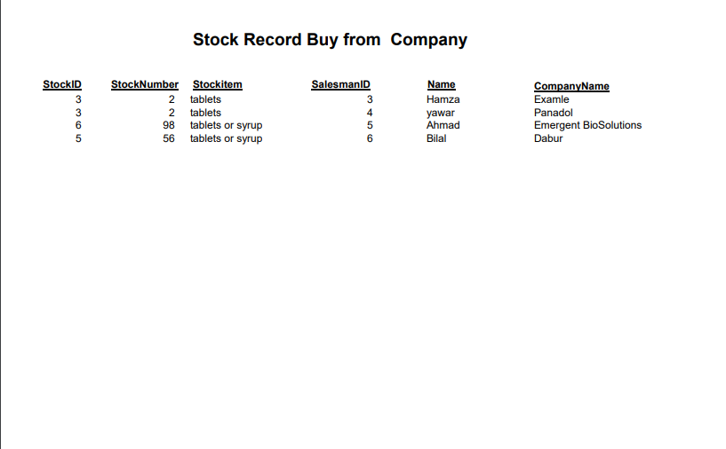

1. Attendance of Staff Per Day Report

This Report show the Attendance of staff per day

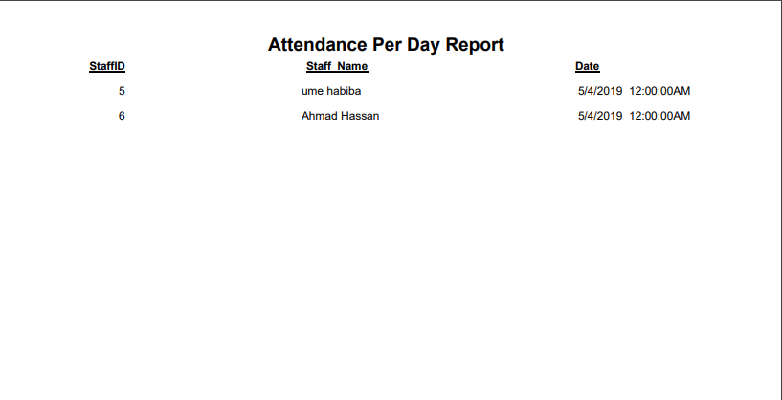

1. Attendance of Staff Per Month Report

This Report show the Attendance of the Staff per Month

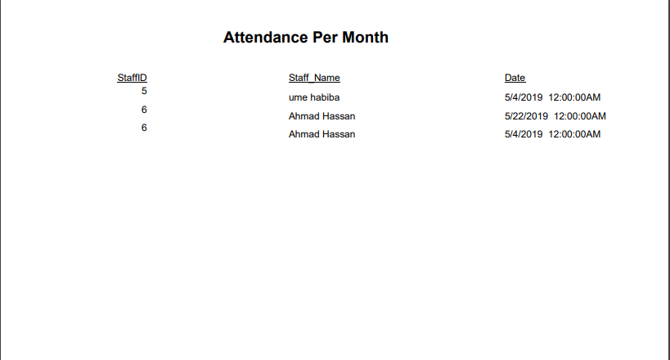

1. Medicine Sold Per Day Report

This Report show the Total sold Medicine per Day

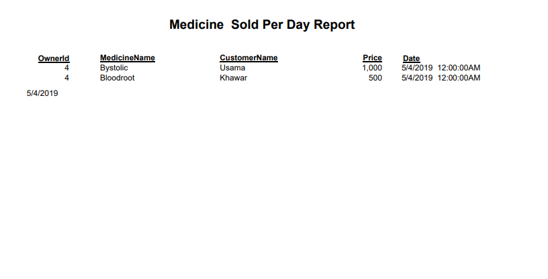

1. Medicine Sold Per Month Report

This Report Show the Medicinesold Report Per Month

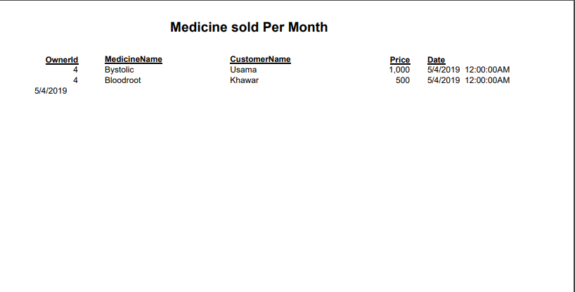

6.All Staff Report

This report Shows all data of Staffs Under specific Owner

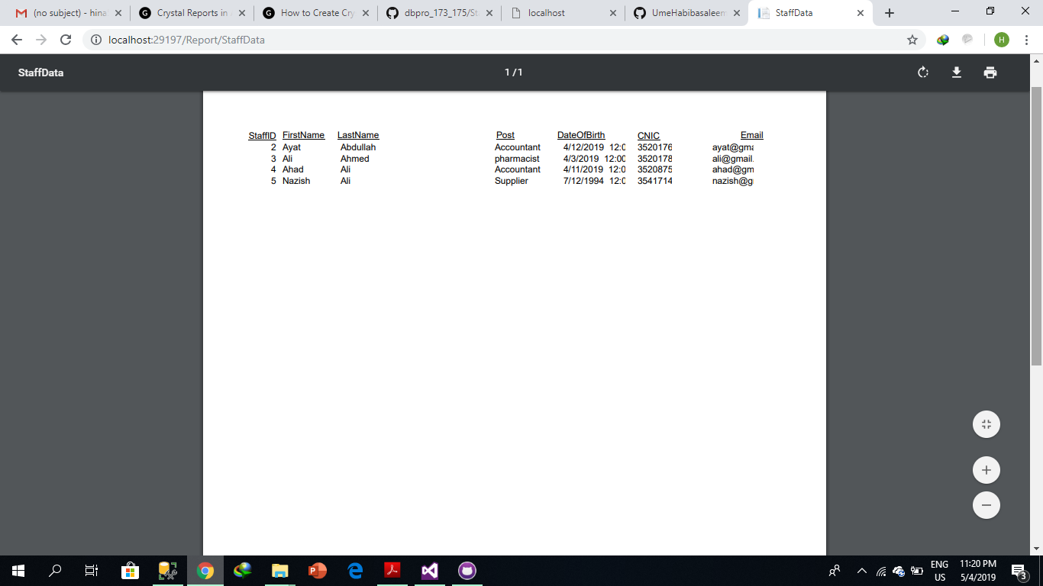

7.Post Wise Staff Report

Owner can see post wise Staff record

