**Abdul Rehman Abbasi ERP: 21772**

Get call:

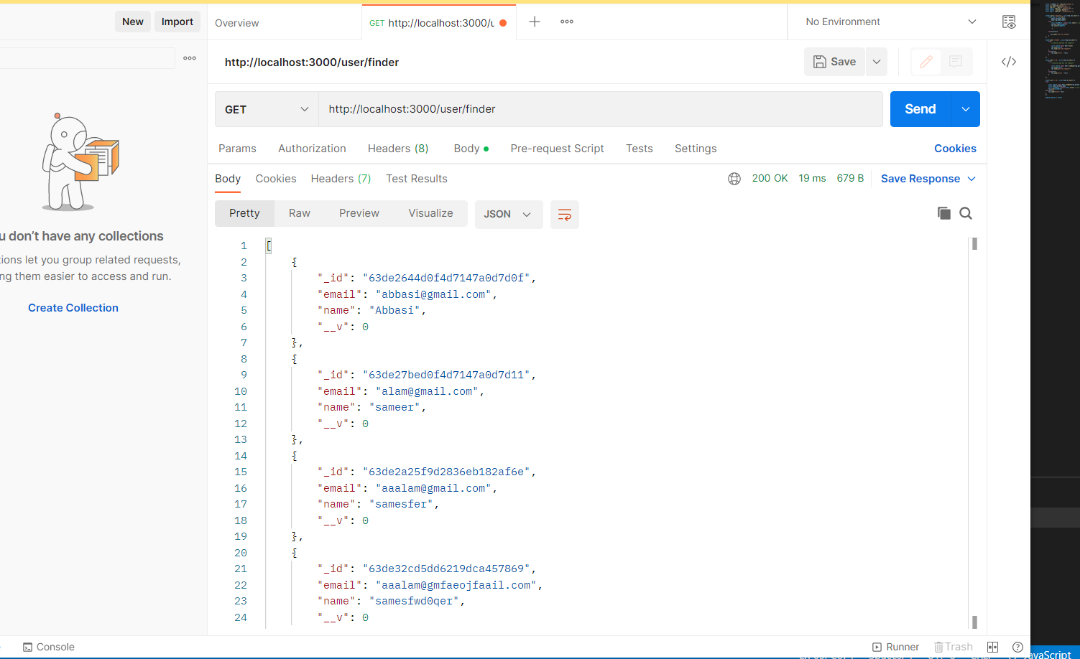

Post call:

Put call:

