Saved electric vehicle course

Saved electric vehicle course
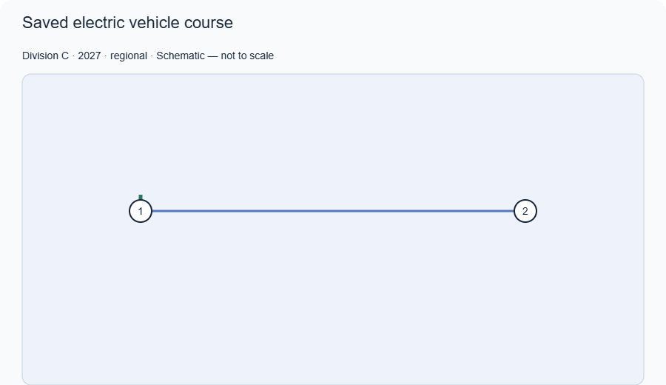
Practice schematic, not to scale. Match numbered markers to the course key and use the stated dimensions when building.

Course key
1. Start
2. Target

Dimensions and connections
1 → 2: 6.00 m

Setup parameters
Target time (s): Fixture value with units
Target distance (m): Fixture value with units
Water bottle position (m from start): Fixture value with units
Bottle line distance (m beyond target): Fixture value with units
Cups (yes/no): Fixture value with units
Cup positions and gap (cm): Fixture value with units
Track width and surface: Fixture value with units

Set it up
1. Measure the distance and mark the start and target.

Rule references
2027 course setup

