COMSATS university Islamabad

Abbottabad campus
Department of Computer Science

Database systems
Assignment#4  BCS-4(A+B) | Spring 2023  Total Marks = 30  Due Date: 4th July 2023

1.Examine the Patient Medication Form for the Wellmeadows Hospital case study (see Appendix B) shown in Figure.

(a) Identify the functional dependencies represented by the attributes shown in the form in Figure State
any assumptions that you make about the data and the attributes shown in this form.

Functional dependencies:

- Patient name determines the Patient's other information such as Full Name, Ward Number, and Bed Number.
- Drug Number determines the Drug's information such as Name, Description, and Dosage.
- Drug Number and
- Start Date determine the Units per Day and Finish Date.
- Drug Number, Start Date, and
- Units per Day determine the Method of Administration.

Assumptions made:

- Each patient has a unique Patient name.
- Each drug has a unique Drug Number.
- Start Date is the date when the medication begins.
- Finish Date is the date when the medication ends.
- Units per Day represents the number of units of the drug taken per day.

(b) Describe and illustrate the process of normalizing the attributes shown in Figure to produce a set of
well-designed 3NF relations.

Step 1: Identify the primary keys
- Create a relation for Patient:
- Patient (Patient name, Full Name, Ward Number, Bed Number)
  - Primary key: Patient name

Step 2: Remove the redundant attribute
- Remove the Full Name attribute from the Drug table since it can be derived from the Patient table.

Step 3: Create a separate relation for Drug
- Drug (Drug Number, Name, Description, Dosage, Method of Admin, Units per Day, Start Date, Finish Date)
- Primary key: Drug Number

Step 4: Create a separate relation for Ward

- Ward (Ward Number, Ward Name)
- Primary key: Ward Number

Step 5: Create a relation for Patient Medication

- Patient Medication (Patient name, Drug Number, Start Date, Finish Date)
- Primary key: (Patient name, Drug Number)

- Foreign key: Patient name references Patient (Patient name)
- Foreign key: Drug Number References Drug (Drug Number)

(c) Identify the primary, alternate, and foreign keys in your 3NF relations..

Primary Keys:

- Relation 1: Patient (Primary Key: Patient name)
- Relation 2: Ward (Primary Key: Ward Number)
- Relation 3: Drug (Primary Key: Drug Number)
- Relation 4: Prescription (Primary Key: Drug Number, Start Date; Foreign Key: Drug Number References Drug)

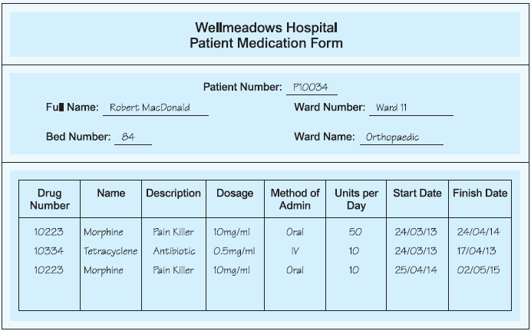

Question no 2

2. An agency called Instant Cover supplies part-time/temporary staff to hotels within Scotland. The table shown in Figure displays sample data, which lists the time spent by agency staff working at various hotels. The National Insurance Number (NIN) is unique for every member of staff.
- The table shown in Figure is susceptible to update anomalies. Provide examples of insertion, deletion,and update anomalies.
Insertion Anomaly:
If we want to add a new employee who hasn't worked at any hotel yet, we cannot do so without creating a duplicate entry for the hotel information. For example, if we want to add a new employee with NIN 1176, we would need to repeat the hotel information for that employee, resulting in redundancy..

Deletion Anomaly:
If we delete the last entry for employee NIN 1135, which has worked at two different hotels, we would lose information about the other hotel where the employee has worked. This can lead to data loss or incorrect information..

Update Anomaly:
If we want to update the hours worked by employee NIN 1135 at the first hotel, we would need to update multiple rows because the employee's information is repeated. This can lead to inconsistencies if the updates are not performed uniformly.

(b) Identify the functional dependencies represented by the attributes shown in the table of Figure State
any assumptions that you make about the data and the attributes shown in this table.

Functional dependencies
- NIN (National Insurance Number) uniquely determines eName (employee name).
- contractNo (contract number) determines hours worked.
- contractNo determines the location of the hotel (HLoc).
- hNo (hotel number) determines the location of the hotel (HLoc).

Assumptions made:
- NIN is a unique identifier for each member of staff.
- contractNo is unique for each contract.
- hNo is unique for each hotel.

(c) Describe and illustrate the process of normalizing the table shown in Figure to 3NF. Identify primary, alternate, and foreign keys in your relations.
(c) To normalize the table shown in Figure to 3NF, we can follow these steps:

- Remove the redundant data to eliminate update anomalies.
- Create separate tables for each set of related attributes, ensuring each table has a primary key.
- Identify and remove any partial dependencies, making sure each attribute depends on the entire primary key.
- Normalize further by identifying and removing any transitive dependencies.

Process of 3NF

1NF (First Normal Form):
Break the table into smaller tables, each with a single theme:
- Staff (NIN, eName)
- Contract (contractNo, hNo)
- Hotel (hNo, HLoc)
- Hours (NIN, contractNo, hours)

2NF (Second Normal Form):
Ensure that each non-key attribute is fully functionally dependent on the entire primary key:
- Staff (NIN, eName)
- Contract (contractNo, NIN, hNo)
- Hotel (hNo, HLoc)
- Hours (NIN, contractNo, hours)

3NF (Third Normal Form):
Ensure that there are no transitive dependencies where a non-key attribute depends on another non-key attribute:
  - Staff (NIN, eName)
  - Contract (contractNo, NIN)
  - Hotel (hNo, HLoc)
  - ContractHotel (contractNo, hNo)
  - Hours (NIN, contractNo, hours)

Primary, alternate, and foreign keys in the 3NF relations:

- Staff (Primary Key: NIN)
- Contract (Primary Key: contractNo; Foreign Key: NIN references Staff)
- Hotel (Primary Key: hNo)
- ContractHotel (Primary Key: contractNo, hNo; Foreign Keys: contractNo references Contract, hNo references Hotel)
- Hours (Primary Key: NIN, contractNo; Foreign Keys: NIN, contractNo references Contract)

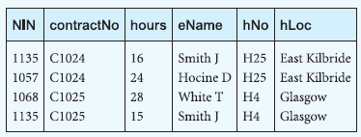

Question no 3

3. Students can lease university flats and some of the details of leases held by students for places in university flats are shown in Figure. A place number (placeNo) uniquely identifies each single room in all flats and is used when leasing a room to a student.

(a) Identify the functional dependencies that exist between the columns of the table in Figure and identify the primary key and any alternate key(s) (if present) for the table.

- leaseNo → BannerID, fName, IName, startDate, finishDate, flatNo, flatAddress
- BannerID → fName, IName
- placeNo → N/A (no other column is functionally dependent on placeNo)
- flatNo → flatAddress

The primary key for the table is leaseNo, and the alternate key is BannerID.

- Describe why the table in Figure is not in 3NF.
The table in Figure is not in 3NF because it contains transitive dependencies. Specifically, the functional dependency flatNo → flatAddress represents a transitive dependency. The flatNo column determines the flatAddress, but it is not part of the primary key.

- The table shown in Figure is susceptible to update anomalies. Provide examples of how insertion, deletion, and modification anomalies could occur on this table.
- Insertion Anomaly: If we want to add a new student who has not leased a room yet, we cannot insert their details into the table without providing a placeNo. This is because placeNo is part of the primary key, and without a room assignment, we cannot generate a unique placeNo.

- Deletion Anomaly: If we delete a row of a student who is the only one leasing a particular room (unique placeNo), we will lose information about that room. This can result in an incomplete representation of the university flats.

- Modification Anomaly: If we want to change the address of a flat, we would need to modify multiple rows in the table because the flat address is duplicated for every student occupying the same flat. This can lead to inconsistencies and redundancy in the data.

