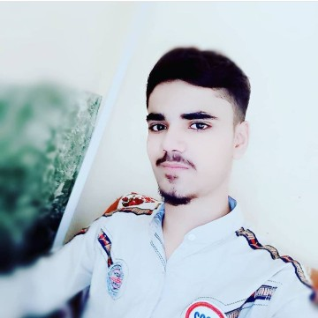 ***SUMMARY***

* *Reading*
* *Traveling*
* *Sports*

*HOBBIES*

* *Urdu*
* *English*

*LANGUAGES*

* *Web Developer*
* *Front end*
* *Back end*

endSSSSSSSSSSSSSSSSSSSSSSSSS

*SKILLS*

*Phone: 3220397933*

*Gmail:* [*rajau3567@gmail.com*](mailto:rajau3567@gmail.com)

*Address: karachi, pakistan*

MUHAMMAD UMER

*Efficient and knowledgeable coder with skills in HTML, CSS*

*And JavaScript programming languages.*

*Coordinated and collaborative team player with attention*

*to detail, graphic design skills, and ability to contribute to*

*code base improvement initiatives and UX improvement*

*projects.*

***EXPERIENCE***

* Proficient in JavaScript.
* Expert in HTML/CSS.
* Familiarity with RESTful APIs.
* Good communication and collaborating skills.

***EDUCATION***

***Government College FORMEN, Karachi,***

***Pakistan***

*Sep 2021 to Nov 2023*

*Pre-engineering* *completed*

***BANO QABIL institute, Karachi,***

***Pakistan***

*Dec 2023*

*Becoming a Web Developer*

***THE INNOVATIVE COMPUTER POINT***

***Institute, Karachi, Pakistan***

*Nov 2021 to Mar 2022*

CIT (Certificate Information Technology)