

**Computer Network (LAB)**

**Submitted by:**

Umer Aziz

**Roll No. :**

SU92-BSSEM-F22-186

**Section:** BSSE-5D

**Date:** 5/12/2024

**Final Project Documentation**

**Submitted to:**

Sir Rasik

**Catalog**

**Project Overview 4**

**Network Topology Overview 5**

Design Components: 5

Routers: 5

Switches: 5

Servers: 5

Devices: 5

**IP Addressing Scheme 6**

**Dynamic IP Pools for VLANs 7**

**Dynamic Routing Configuration 7**

ESteps for Configuring Dynamic Routing 7

Enable Routing Protocol on Each Router: 7

Router 1 Configuration: 7

· Router 3 Configuration: 8

**VLAN Configuration 8**

Steps for VLAN Configuration: 9

Define VLANs on the Switches: 9

**1. VLAN 10: Employees 9**

**2. VLAN 20: Guests 9**

**3. VLAN 30: Servers 9**

Assign VLANs to Ports: 9

**1. Ports connected to employee PCs: VLAN 10 9**

**2. Ports connected to guest PCs: VLAN 20 9**

Configure Trunk Ports: 10

Router-on-a-Stick Configuration (Inter-VLAN Routing): 10

**DHCP Configuration 11**

Steps for DHCP Configuration: 11

Access the DHCP Server: 11

**1. IP Address: 192.168.30.2 11**

**2. Subnet Mask: 255.255.255.0 11**

**3. Default Gateway: 192.168.30.1 11**

Enable the DHCP Service: 11

Configure DHCP Pools: 11

Pool Name: Employees 12

Pool Name: Guests 12

Pool Name: Servers 12

Enable DHCP Relay on Routers: 12

**DNS Configuration 13**

Steps for DNS Configuration: 13

Access the DNS Server: 13

**1. IP Address: 192.168.30.2 13**

**2. Subnet Mask: 255.255.255.0 13**

**3. Default Gateway: 192.168.30.1 13**

Enable DNS Service: 13

Configure DNS Records: 13

Configure DNS Server on Client Devices: 14

Test DNS Resolution: 14

Verify DNS Functionality: 14

**Configuring DNS in the Network 14**

**Configuring VLAN in the Network 15**

**Configuring DHCP in the Network 16**

**Configuring VLANs in the Network 17**

# Project Overview

#### ****Project Description****:

This project is an implementation of an e-commerce network infrastructure using Cisco Packet Tracer. The network is designed to support the operations of an e-commerce business by providing services like DNS for domain resolution, DHCP for dynamic IP address allocation, VLANs for network segmentation, and inter-network routing for communication between different parts of the network.

The infrastructure includes:

* **3 Routers** for interconnecting different parts of the network and managing routing.
* **6-8 Switches** to handle communication between devices within the same VLANs.
* **4 Servers** for DNS, DHCP, Web, and Email services.
* **30-40 PCs/devices** representing employees, customers, and guest users.
* **Wireless Access Points** for wireless connectivity.
* **Firewall** for network security.

#### ****Goals of the Project****:

1. **Dynamic IP Addressing**: Use DHCP to assign IPs to devices automatically.
2. **Network Segmentation**: Implement VLANs to divide the network into logical segments for security and efficient traffic management.
3. **Domain Name Resolution**: Configure DNS to resolve domain names to IP addresses for better usability.
4. **Inter-VLAN Routing**: Enable communication between VLANs using routers and dynamic routing protocols.
5. **Service Accessibility**: Ensure that web, email, and other services are accessible across the network.

#### ****Project Scope****:

The network will:

* Allow seamless communication between different departments (Employee, Guest, and Server VLANs).
* Provide secure wireless access to guests and employees.
* Enable dynamic routing between routers to optimize data transfer.
* Support DNS for converting domain names to IP addresses.
* Use VLANs to isolate sensitive data traffic from general traffic.

# Network Topology Overview

## Design Components:

The network topology is designed to ensure scalability, security, and efficiency. It includes the following key components:

## Routers:

* 1. **Router 1**: Connects to Switches 1 and 2, acting as the main router for the employee and server networks.
  2. **Router 2**: Connects to Switch 3 and serves as a bridge between Router 1 and Router 3.
  3. **Router 3**: Connects to Switch 4, managing the guest and external network.

## Switches:

* 1. **Switch 1**: Connected to Router 1, serves the Employee VLAN and DNS Server.
  2. **Switch 2**: Connected to Router 1 and Router 2, provides redundancy and connects to the DHCP Server.
  3. **Switch 3**: Connected to Router 2, hosts the Web Server and devices in the Server VLAN.
  4. **Switch 4**: Connected to Router 3, provides access to the Email Server and Guest VLAN.

## Servers:

* 1. **DNS Server**: Connected to Switch 1, resolves domain names to IP addresses.
  2. **DHCP Server**: Connected to Switch 2, assigns dynamic IPs to devices.
  3. **Web Server**: Connected to Switch 3, hosts the e-commerce platform.
  4. **Email Server**: Connected to Switch 4, handles email communication.

## Devices:

* 1. **30-40 PCs**: Represent employees, customers, and guest users. They are divided into VLANs based on their roles.
  2. **Wireless Access Points**: Provide wireless connectivity to guest and employee devices.

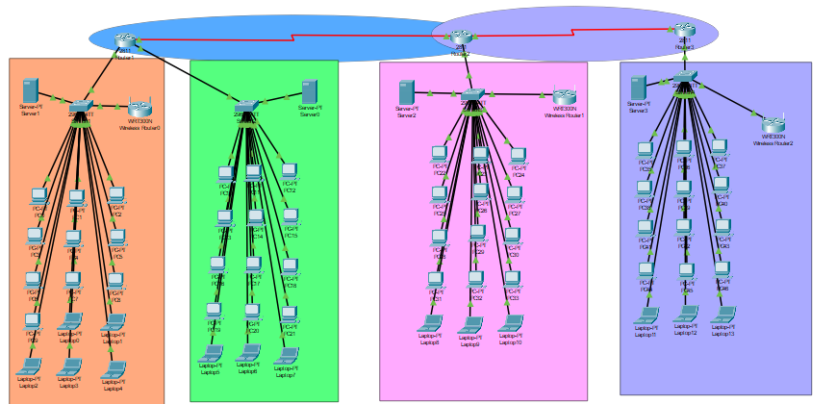

# IP Addressing Scheme

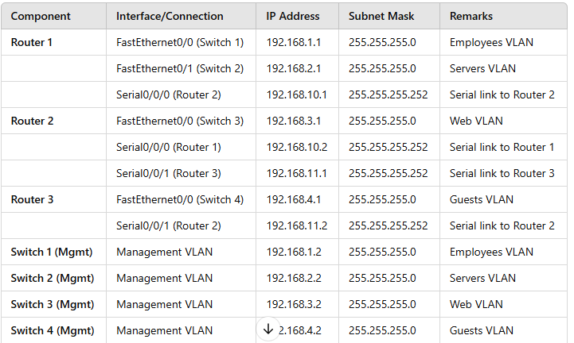

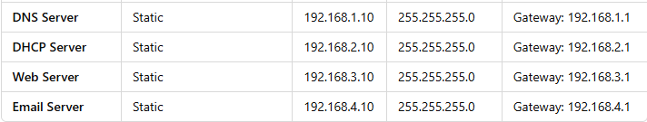

Here’s the **IP Addressing Scheme** presented in a **tabular format**:

# Dynamic IP Pools for VLANs

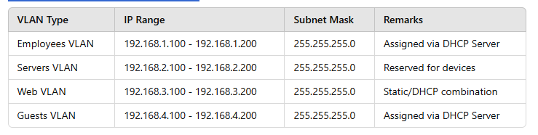

# Dynamic Routing Configuration

In this project, **dynamic routing** is implemented to enable communication between the three routers and ensure that each network can reach the others without manually configuring static routes.

## ****E****Steps for Configuring Dynamic Routing

## Enable Routing Protocol on Each Router:

* 1. Use **RIP Version 2** for compatibility and support for subnetting.

## Router 1 Configuration:

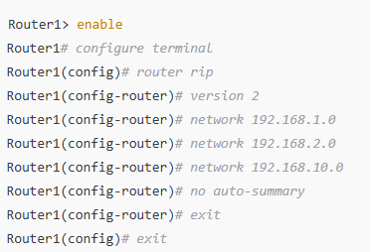

· Router 2 Configuration:

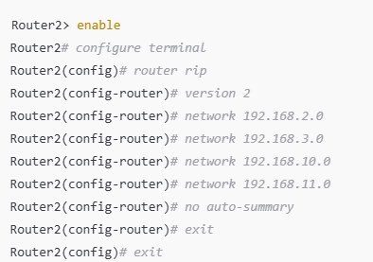

## · Router 3 Configuration:

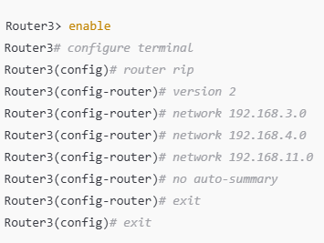

# VLAN Configuration

In this project, **VLANs (Virtual Local Area Networks)** are used to segment the network logically, improve security, and manage traffic efficiently. Each VLAN corresponds to a specific department or network type, such as employees, guests, or servers.

## Steps for VLAN Configuration:

## Define VLANs on the Switches:

* 1. Assign VLAN IDs to create logical separation.
  2. Example:
     1. VLAN 10: **Employees**
     2. VLAN 20: **Guests**
     3. VLAN 30: **Servers**

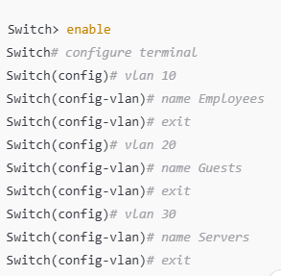

## Assign VLANs to Ports:

* 1. Assign specific switch ports to the VLANs based on their purpose.
  2. Example:
     1. Ports connected to employee PCs: VLAN 10
     2. Ports connected to guest PCs: VLAN 20
     3. 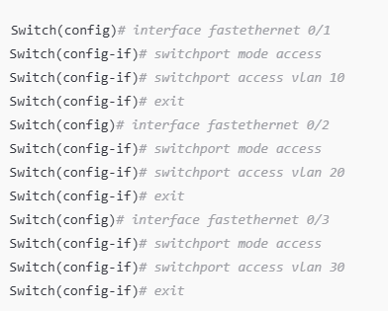Ports connected to servers: VLAN 30

## Configure Trunk Ports:

* 1. To allow VLAN traffic to pass between switches and routers, configure trunking on the ports connecting them.

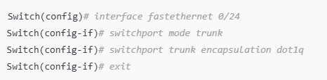

## Router-on-a-Stick Configuration (Inter-VLAN Routing):

* 1. Configure the router interface to route traffic between VLANs.
  2. Use subinterfaces for each VLAN on the router.

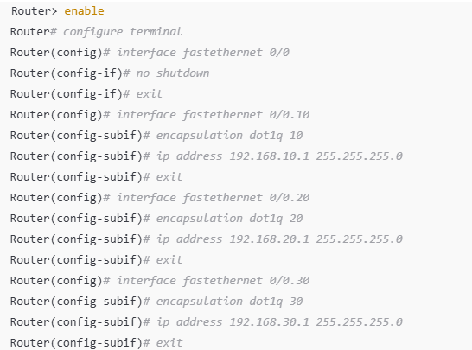

# DHCP Configuration

In this project, **DHCP (Dynamic Host Configuration Protocol)** is used to automatically assign IP addresses to devices within each VLAN. The DHCP service is configured on a dedicated server to simplify management and reduce router overhead.

## Steps for DHCP Configuration:

## Access the DHCP Server:

* 1. Click on the server in Cisco Packet Tracer.
  2. Go to the **Desktop tab** and select **IP Configuration**.
  3. Assign a static IP address to the server. For example:
     1. IP Address: **192.168.30.2**
     2. Subnet Mask: **255.255.255.0**
     3. Default Gateway: **192.168.30.1**

## Enable the DHCP Service:

* 1. Go to the **Services tab** on the server.
  2. Select **DHCP** from the list of services.
  3. Turn the DHCP service **ON**.

## Configure DHCP Pools:

* 1. Create a DHCP pool for each VLAN.

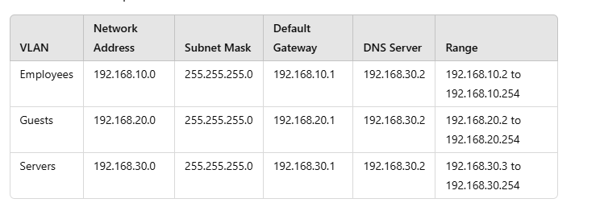

For each VLAN, add a new pool with the following details:

## Pool Name: Employees

* + Default Gateway: **192.168.10.1**
  + DNS Server: **192.168.30.2**
  + Start IP Address: **192.168.10.2**
  + Subnet Mask: **255.255.255.0**

## Pool Name: Guests

* + Default Gateway: **192.168.20.1**
  + DNS Server: **192.168.30.2**
  + Start IP Address: **192.168.20.2**
  + Subnet Mask: **255.255.255.0**

## Pool Name: Servers

* + Default Gateway: **192.168.30.1**
  + DNS Server: **192.168.30.2**
  + Start IP Address: **192.168.30.3**
  + Subnet Mask: **255.255.255.0**

## Enable DHCP Relay on Routers:

* Configure DHCP relay to forward DHCP requests to the DHCP server.

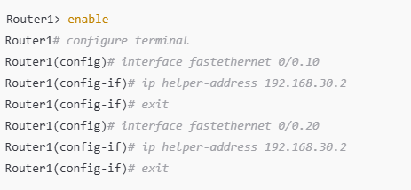

Repeat the same for **Router 2** and **Router 3**.

# DNS Configuration

In this project, **DNS (Domain Name System)** is used to allow users and devices to access network resources by name (e.g., webserver.local) instead of by IP address. The DNS server resolves domain names into IP addresses.

## Steps for DNS Configuration:

## Access the DNS Server:

* 1. Click on the **DNS Server** in Cisco Packet Tracer.
  2. Go to the **Desktop tab** and select **IP Configuration**.
  3. Assign a static IP to the DNS server. For example:
     1. IP Address: **192.168.30.2**
     2. Subnet Mask: **255.255.255.0**
     3. Default Gateway: **192.168.30.1**

## Enable DNS Service:

* 1. Go to the **Services tab**.
  2. Select **DNS** from the list of services.
  3. Enable the **DNS service** by clicking **ON**.

## Configure DNS Records:

**A Record (Address Record)**: This record maps a domain name to an IP address.

Add the following records for the domain names of the servers:

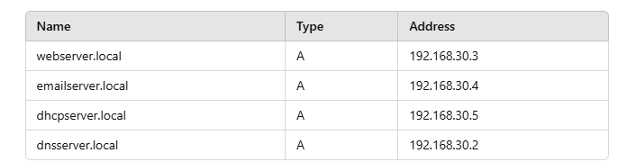

## Configure DNS Server on Client Devices:

* 1. On each **PC** or device, configure the **DNS server address**:
     1. Go to the **Desktop tab** and open **IP Configuration**.
     2. Set the **DNS Server** field to **192.168.30.2** (DNS Server IP).

## Test DNS Resolution:

* 1. On any PC, open the **Command Prompt** and try to **ping** the domain names:
     1. ping webserver.local
     2. ping emailserver.local
     3. ping dhcpserver.local
     4. ping dnsserver.local
  2. The PC should successfully resolve the domain names to the correct IP addresses.

## Verify DNS Functionality:

* 1. Ensure that devices within the network can resolve domain names to IP addresses correctly.

# Configuring DNS in the Network

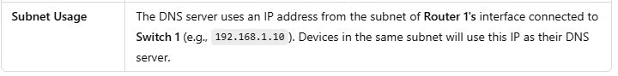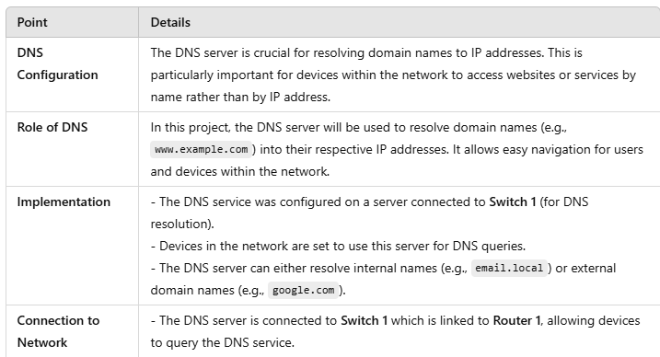

# Configuring VLAN in the Network

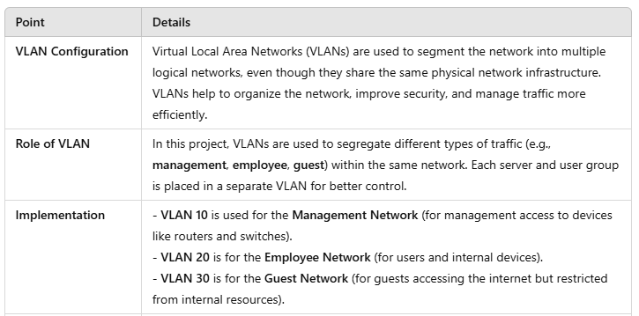

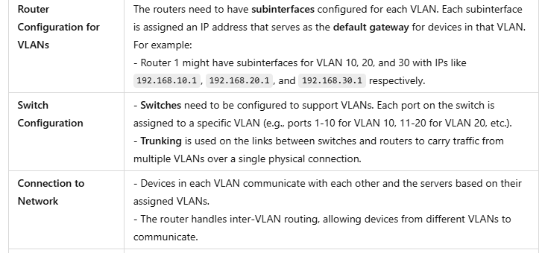

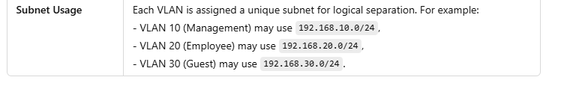

# Configuring DHCP in the Network

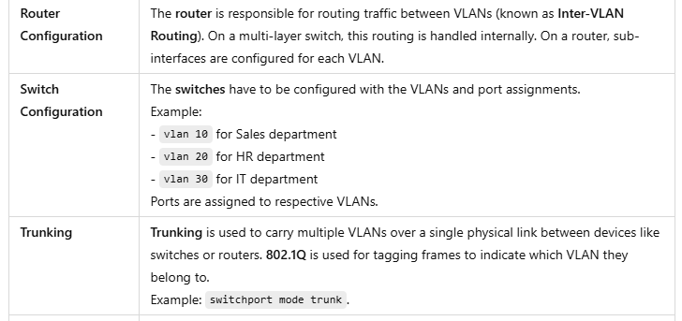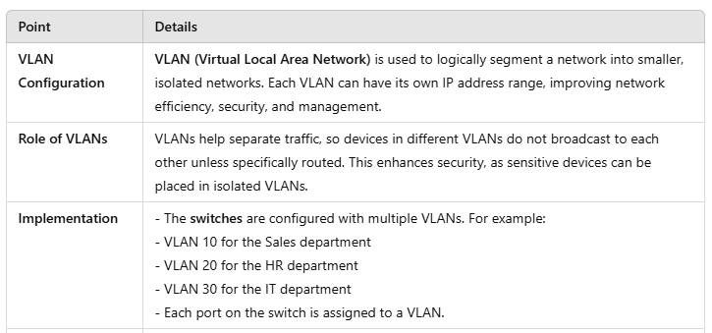

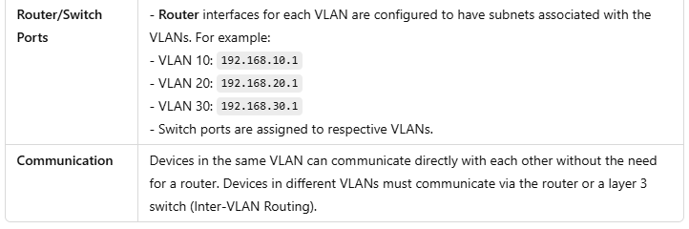



# Configuring VLANs in the Network

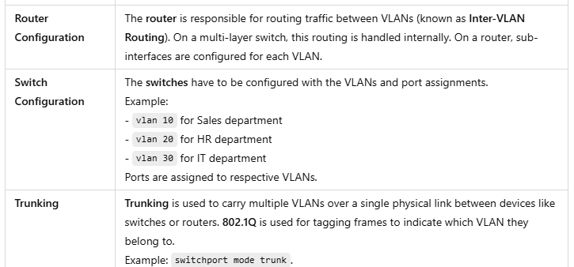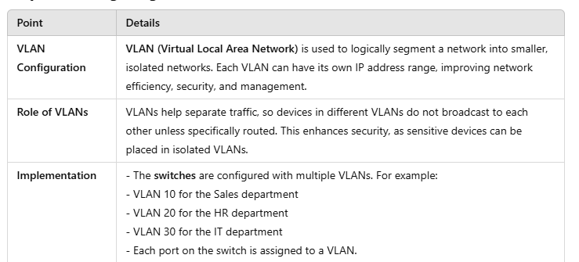

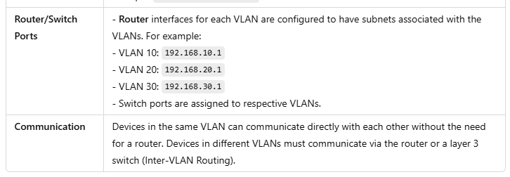

Configuring DNS (Domain Name System)

