Difference between SOAP and WSDL:

Simple Object Access Protocol (SOAP):
It is an XML based network protocol that is used for exchanging structured data between nodes. It works on top of application layer protocols like HTTP and SMTP for notations and transmission.
Web Services Description Language (WSDL):
It is XML based interface definition language that is used in describing the web service functionalities.
S.No. | SOAP | WSDL
1. | It is XML based messaging protocol. | It is XML based interface definition language.
2. | It consists of four layers in its architecture: Header, Body, Envelope and Fault. | It consists of three main elements in its architecture: Types, Binding and Operations
3. | It provides full support to most of the protocols like HTTP, SMTP, etc. | It does not support most of the protocols like SOAP.
4. | It is slower sometimes in performance in comparison to WSDL. | It is faster in performance in comparison to SOAP.
5. | It is simple than WSDL due to easy level of coding. | It is more complex as it has advanced level of coding.
6. | It provides high security as it has different layers of security. | While it is less secured as compared to SOAP.
7. | It is far good in extensibility than WSDL. | It is less extensible than SOAP.
8. | It provides support for almost all programming models. | It does not provide support for all programming models.
9. | To implement web services, it is used to exchange distinct and structured information in computer networks. | It is used to define different functionalities of web services.

Difference between Microservice and API:

Microservices:
Microservices Architecture is an architectural style that structures an application as a collection of small autonomous services modeled around a business domain. In a Microservice Architecture, each service is self-contained and implements a single business capability. It is a popular way where we build web applications now, for those reasons we outlined above.
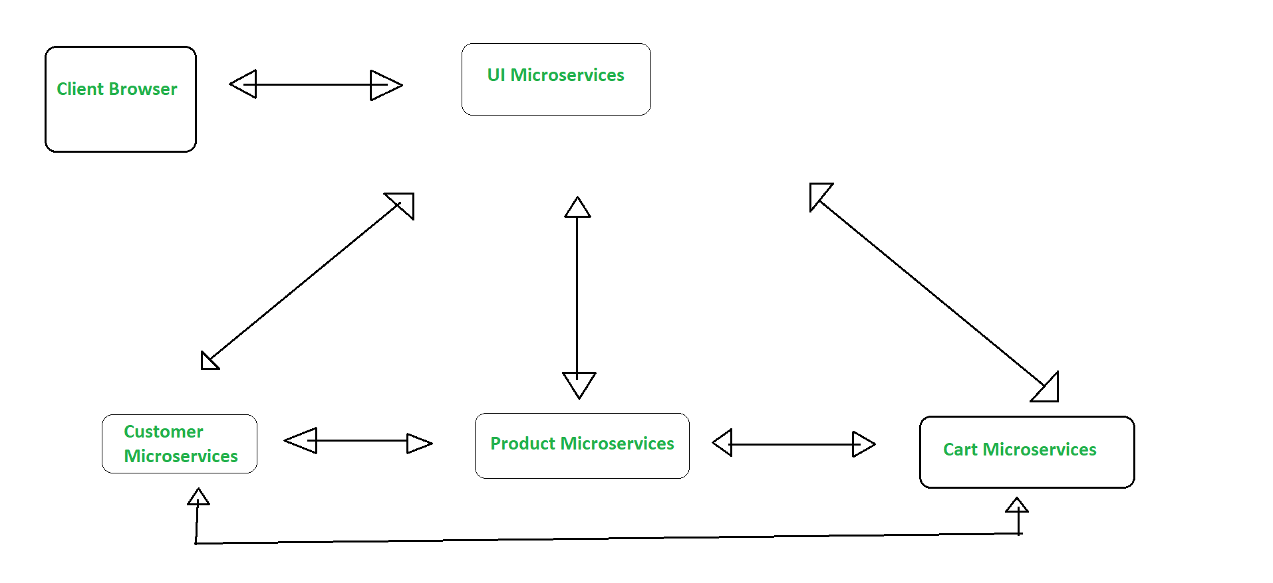
Application Program Interface (API):
Application Program Interface (API) is a way through which you can make sure two or more applications communicate with each other to process the client request.
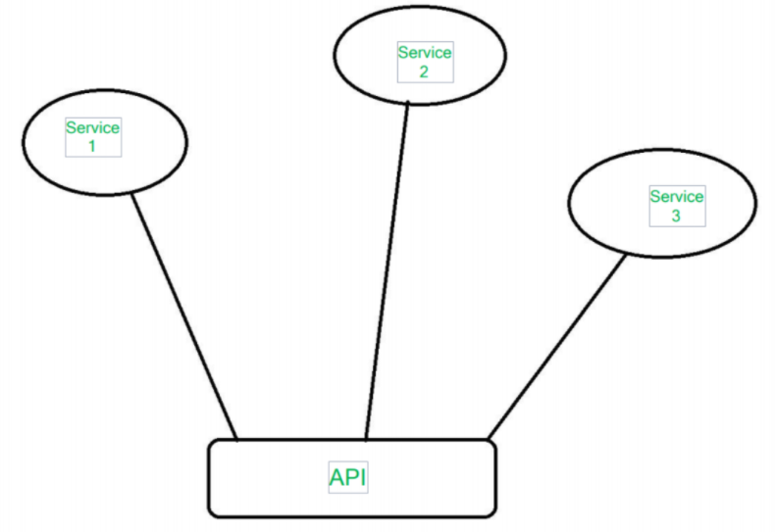

S.No. | MICROSERVICE | API
1 | Microservice are components. | APIs are interface.
2 | Microservices can be used to expose one or more APIs. | APIs is one of the means to build and expose microservices architecture.
3 | Not all Microservice components expose APIs. | API architecture and Microservices architecture is different.
4 | Microservices are small in size. | API is large in size with complex implementation cases.
5 | Microservices are quick to build. | APIs take longer time to build than Microservices.
6 | Easy and discrete connection of building blocks. | Highly formatted APIs.

