

CSDX 530 – DEEP LEARNING
Mini Project Report: Pneumonia Detection Using ResNet
PneumoScan AI – An Explainable Deep-Learning System for Chest X-ray Screening
Submitted by:
Umer Basith G – RRN: 230171601192
Vignesh A – RRN: 230171601195
B.Tech Artificial Intelligence & Data Science

Submitted to: Mrs. Mahalakshmi R
Assistant Professor / CSE

Table of Contents
1. Introduction to the Case Study 3
Objective 3
Problem Statement 3
Context 3
Project Team 3
2. Understanding of Tool Used and Techniques 4
3. Data Collection and Preprocessing 6
Chest X-ray Dataset 6
4. Analysis and Implementation 8
5. Results and Evaluation 20
Prediction Summary 20
Validation and Member Results 21
Performance Metrics 22
Explainability Results 22
Comparative Evaluation 23
6. Discussion 23
7. Future Recommendations 24
8. Conclusion 24
9. References 25

1. Introduction to the Case Study

Objective
This case study presents PneumoScan AI, a deep-learning system that detects pneumonia in paediatric chest X-ray images using deep residual networks (ResNet) [1]. The objective is to build the complete pipeline end-to-end – data preparation, transfer learning, model training, ensembling, calibration, explainability and deployment – and to evaluate it honestly on the official, independent test set of 624 X-rays [2], [3]. The project targets an accuracy of at least 95%, a very high sensitivity (so that children with pneumonia are not missed), a visual explanation for every prediction, and an easy-to-use offline web application for doctors, students and patients.

Problem Statement
Pneumonia is an infection in which the air sacs of the lungs fill with pus and fluid. It caused 740,180 deaths of children under five in 2019, 14% of all deaths in that age group [4]. The chest X-ray is the most common imaging test used to confirm it, but reading X-rays needs trained radiologists, and India has only about one radiologist per 100,000 people, mostly in cities [5]. Manual reading is slow, varies between readers, and films are usually read in the order they arrive, so an urgent case may wait behind routine ones. At the same time, many published deep-learning models are evaluated on re-split data, give no explanation, accept any image (even a photograph) and are never packaged as a usable tool. There is therefore a need for an accurate, explainable, honestly evaluated and easy-to-use system that gives a fast second opinion on a chest X-ray and helps prioritise patients, while leaving the final decision to a qualified doctor.

Context
Deep learning, and in particular convolutional neural networks (CNNs), learn image features directly from pixels. CheXNet, a 121-layer CNN, exceeded the average radiologist (F1 metric) for pneumonia on adult chest X-rays [6], and Kermany et al. showed that transfer learning from ImageNet can build an accurate paediatric pneumonia classifier from a few thousand X-rays [2]. ResNet made very deep networks trainable with identity skip connections [1], and Grad-CAM shows which image regions drove a CNN’s decision [7]. PneumoScan AI combines these techniques with probability calibration, an out-of-distribution check and a complete FastAPI + React application, and it runs fully offline on an ordinary laptop.

Project Team
Table 1. Team members
Name | Register Number (RRN) | Programme
Umer Basith G | 230171601192 | B.Tech AI & DS
Vignesh A | 230171601195 | B.Tech AI & DS

2. Understanding of Tool Used and Techniques

Overview of ResNet and the PneumoScan AI Pipeline
A Residual Network (ResNet) is a deep CNN built from residual blocks. Instead of learning a mapping H(x) directly, each block learns the residual F(x) = H(x) − x and adds its input back through an identity shortcut [1]:
$$y = F\left(x, \{W_{i}\}\right) + x$$
The shortcut gives gradients a direct path through the network, which solved the degradation problem of very deep plain networks and won ILSVRC 2015 [1]. PneumoScan AI fine-tunes three ImageNet-pretrained ResNets, combines them into an ensemble, calibrates the output into a trustworthy probability, explains each decision with Grad-CAM and refuses images that are not chest X-rays.
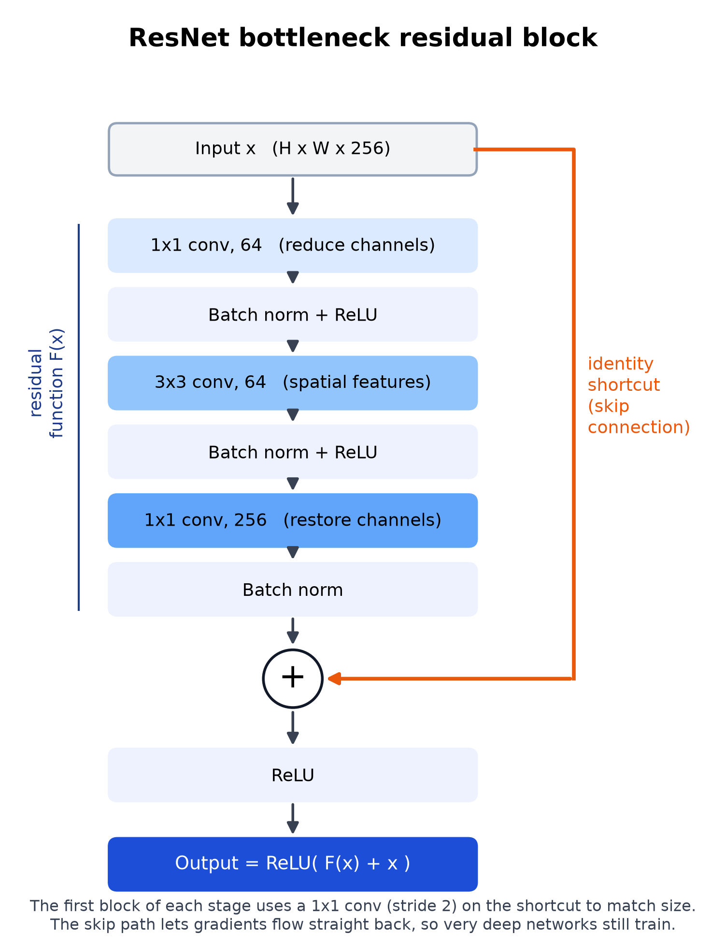
Figure 1. Bottleneck residual block with an identity shortcut (used in ResNet-50).

Core Techniques
- Residual Learning (ResNet-34 / ResNet-50): basic blocks (two 3×3 convolutions) in ResNet-34 and bottleneck blocks (1×1, 3×3, 1×1) in ResNet-50, with stages of 3, 4, 6 and 3 blocks.
- Transfer Learning: weights pretrained on ImageNet [13]; the 1000-class layer is replaced by Dropout(0.2) and a 2-class linear layer, and all layers are fine-tuned, the backbone at one third of the head’s learning rate.
- Weighted Cross-Entropy with Label Smoothing: class weights 1.94 (NORMAL) and 0.67 (PNEUMONIA) balance the 1 : 3 class ratio; label smoothing ε = 0.1 [14] prevents over-confidence.
- AdamW, Cosine Schedule, Mixed Precision and EMA: AdamW [15] with one warm-up epoch and cosine decay; fp16 automatic mixed precision [16] fits training into a 6 GB GPU; an exponential moving average of the weights gives a smoother final model.
- Ensemble with Test-Time Augmentation: three ResNets each score the X-ray and its mirror image; the six logit margins are averaged.
- Temperature Scaling and Youden’s J Threshold: the averaged margin is calibrated with a temperature T = 0.602 [17], and the decision threshold t = 0.0743 maximises Youden’s J [18]; both are fitted on validation data only.
- Grad-CAM Explainability: gradient-weighted class activation maps [7] from the last residual stage are averaged over the ensemble and overlaid on the X-ray.
- X-ray Gate (Out-of-Distribution Detection): colour, blank and size checks plus a Mahalanobis distance [19] with a Ledoit-Wolf covariance [20] on ResNet features reject photographs, documents and other non-X-ray images.
Table 2. Models used and their key features
Model Version | Key Features | Input Requirements
ResNet-50 @ 384 px (r50_384_s1) | Bottleneck blocks, 23.5 M parameters, ImageNet V2 weights, batch 24, seed 1 | 384 × 384 grayscale X-ray copied to 3 channels
ResNet-34 @ 384 px (r34_384_s2) | Basic blocks, 21.3 M parameters, ImageNet V1 weights, batch 32, seed 2 | 384 × 384 grayscale X-ray copied to 3 channels
ResNet-50 @ 448 px (r50_448_s3) | Higher input resolution for finer detail, batch 16, seed 3 | 448 × 448 grayscale X-ray copied to 3 channels
Final Ensemble (PneumoScan AI) | 3 members × 2 views averaged, temperature T = 0.602, threshold 0.0743, Grad-CAM, X-ray gate | Any frontal chest X-ray: JPG, PNG, BMP, WEBP, TIFF or DICOM, up to 25 MB

Methodological Advantages
- Analyses an X-ray in about 0.4 s on the GPU and about 1.25 s on a CPU-only laptop.
- Honest evaluation: every setting is chosen on validation data and the official test set was scored exactly once.
- Explainable: a Grad-CAM heat map for every prediction lets a doctor check the model’s reasoning.
- Safe input handling: non-X-ray images are rejected instead of receiving a meaningless diagnosis.
- Private and offline: runs on 127.0.0.1 without internet; patient data never leave the computer.
- Reproducible: fixed random seeds, logged training runs and a single command per pipeline step.

Technology Stack
Table 3. Technology stack of PneumoScan AI
Layer | Technology (version) | Purpose
Language | Python 3.11.9, TypeScript 5.8.3 | ML pipeline and back-end; front-end
Deep learning | PyTorch 2.11.0 + CUDA 12.8 [21], torchvision 0.26.0 | ResNet models, ImageNet weights, GPU training and inference
Machine learning / data | scikit-learn 1.9.1 [22], NumPy 2.4.6, SciPy 1.17.1, pandas 3.1.1 | Metrics, patient-level split, Ledoit-Wolf covariance, temperature fitting
Image processing | Pillow 13.0.0, OpenCV 5.0, pydicom 3.0.2 | Image decoding, colour maps, DICOM support
Visualisation | matplotlib 3.11.2, scikit-image 0.26.0 | Report figures; non-X-ray test images
Back-end | FastAPI 0.162.2, Uvicorn 0.54.0 | REST API and local web server
Database | SQLite (Python sqlite3) | Local scan history
PDF reports | ReportLab 5.1.0, uharfbuzz 0.57.0 | Patient reports, incl. Tamil / Hindi text
Front-end | React 19.1, Vite 7.3.7, Tailwind CSS 4.1.18, React Router 7.18.5, Motion 12.43, lucide-react 0.577 | User interface, routing, animation and icons
Testing | pytest 9.2.0, Playwright 1.64.1 (headless Chromium), ESLint 9.39.5 | Unit, API and end-to-end browser tests; code quality
Hardware | NVIDIA RTX 3050 Laptop GPU (6 GB), Intel Core i5-12450HX, 16 GB RAM, Windows 11 | Training, testing and the classroom demo

3. Data Collection and Preprocessing

Chest X-ray Dataset
The project uses the public paediatric chest X-ray dataset of Kermany et al. [2], [3], collected at Guangzhou Women and Children’s Medical Center from children aged 1–5 years and labelled by expert physicians. It is one of the most widely used benchmarks for pneumonia detection and comes with an official, independent test set. The archive was downloaded from Mendeley Data without any login and verified against its published SHA-256 hash.
Table 4. Summary of the dataset
Item | Value
Source | Mendeley Data, “Labeled OCT and Chest X-Ray Images for Classification”, v2, DOI 10.17632/rscbjbr9sj.2 (ChestXRay2017.zip, 1,235,512,464 bytes)
Licence | CC BY 4.0 (credit: Kermany et al., Cell, 2018)
Total images | 5,856 frontal chest X-rays (JPEG): 1,583 NORMAL and 4,273 PNEUMONIA
Official training set | 5,232 images: 1,349 NORMAL, 3,883 PNEUMONIA (2,538 bacterial, 1,345 viral)
Official test set | 624 images: 234 NORMAL, 390 PNEUMONIA (used once, for the final evaluation)
Image size | Median 1281 × 888 pixels; width 384–2916 pixels; 283 RGB-encoded grayscale files

Table 5. Preprocessing pipeline
Stage | Tool / Method | Purpose
Integrity check | SHA-256 hash (hashlib) | Make sure the download matches the published file
Count verification | ml/prepare_data.py | Exact official image counts per split and class
Patient-level split | StratifiedGroupKFold (7 folds, seed 42) | Validation set with no child shared with training
Grayscale conversion | Pillow (ITU-R 601 luma), DICOM min–max scaling, EXIF rotation | Uniform 8-bit input from any image mode
Canonical view + cache | Lanczos resize to 512 × 512 | Whole chest always visible; fast loading
Network input | Resize to 384 / 448, 3 channels, ImageNet mean / std | Match the pretrained ResNet backbones
Data augmentation | torchvision transforms v2 | Reduce over-fitting with realistic variation
Class balancing | Inverse-frequency loss weights w_c = N / (2 N_c) | Handle about 3 pneumonia images per normal image
Leakage checks | SHA-1 hashes, 64 × 64 thumbnail correlation | No shared patients or duplicates

Preprocessing and Augmentation Considerations
- Images are squashed, not cropped, to the square view so that no part of the lungs is ever cut off and the heat map maps back exactly onto the original image.
- Training augmentation: random resized crop (scale 0.75–1.0), horizontal flip, rotation ±10°, shift ±5%, brightness and contrast ±20%, Gaussian blur (p = 0.2) and sensor noise (σ = 0.02, p = 0.2).
- Vertical flips are not used, because an upside-down chest X-ray is not realistic.
- The same pre-processing code is used for training, evaluation and the web application, so the model always sees images in exactly the same way.
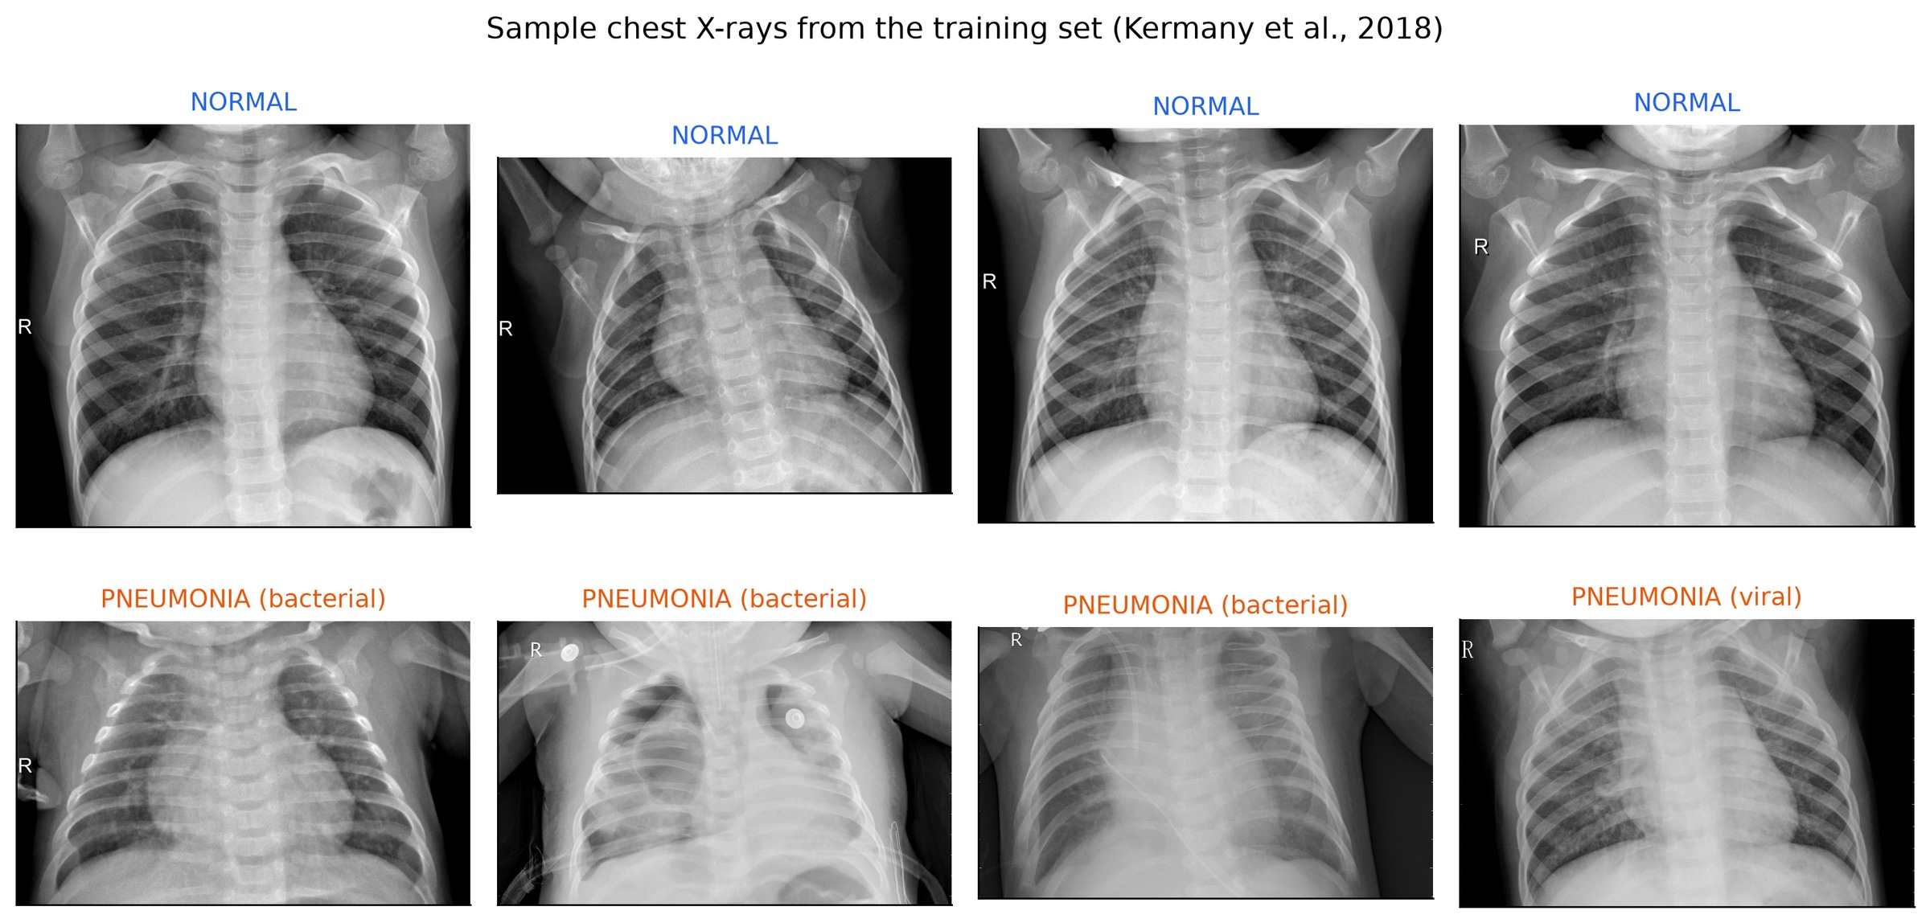
Figure 2. Sample training X-rays: NORMAL (top row) and PNEUMONIA (bottom row).

Data Quality Metrics
Table 6. Images and patients in each split
Split | NORMAL | PNEUMONIA | Total | Patients | Pneumonia share
Train | 1,157 | 3,328 | 4,485 | 2,272 | 74.2%
Validation | 192 | 555 | 747 | 378 | 74.3%
Test (official) | 234 | 390 | 624 | 404 | 62.5%
Total | 1,583 | 4,273 | 5,856 | – | 73.0%

Table 7. Leakage checks (run automatically by ml/prepare_data.py)
Check | Result
Patients in both training and validation | 0
Exact duplicate files between test and train / validation | 0
Near duplicates between test and train / validation (thumbnail correlation ≥ 0.99) | 0 (highest 0.968)

4. Analysis and Implementation

Step 1: Environment Setup and Parameter Configuration
- Framework: PyTorch 2.11.0 with CUDA 12.8 on an NVIDIA RTX 3050 (6 GB) laptop GPU.
- Backbones: torchvision ResNet-34 and ResNet-50 with ImageNet weights; 2-class head.
- Input resolution: 384 × 384 (two members) and 448 × 448 (one member).
- Loss: weighted cross-entropy (1.94 / 0.67) with label smoothing 0.1.
- Optimiser: AdamW, weight decay 0.01; learning rate 3 × 10⁻⁴ (head) and 1 × 10⁻⁴ (backbone).
- Schedule: 1 warm-up epoch, then per-step cosine decay; gradient clipping at norm 2.0.
- Precision: fp16 mixed precision; EMA of weights with decay 0.998.
- Epochs: up to 20, early stopping after 7 epochs without a better validation ROC-AUC.
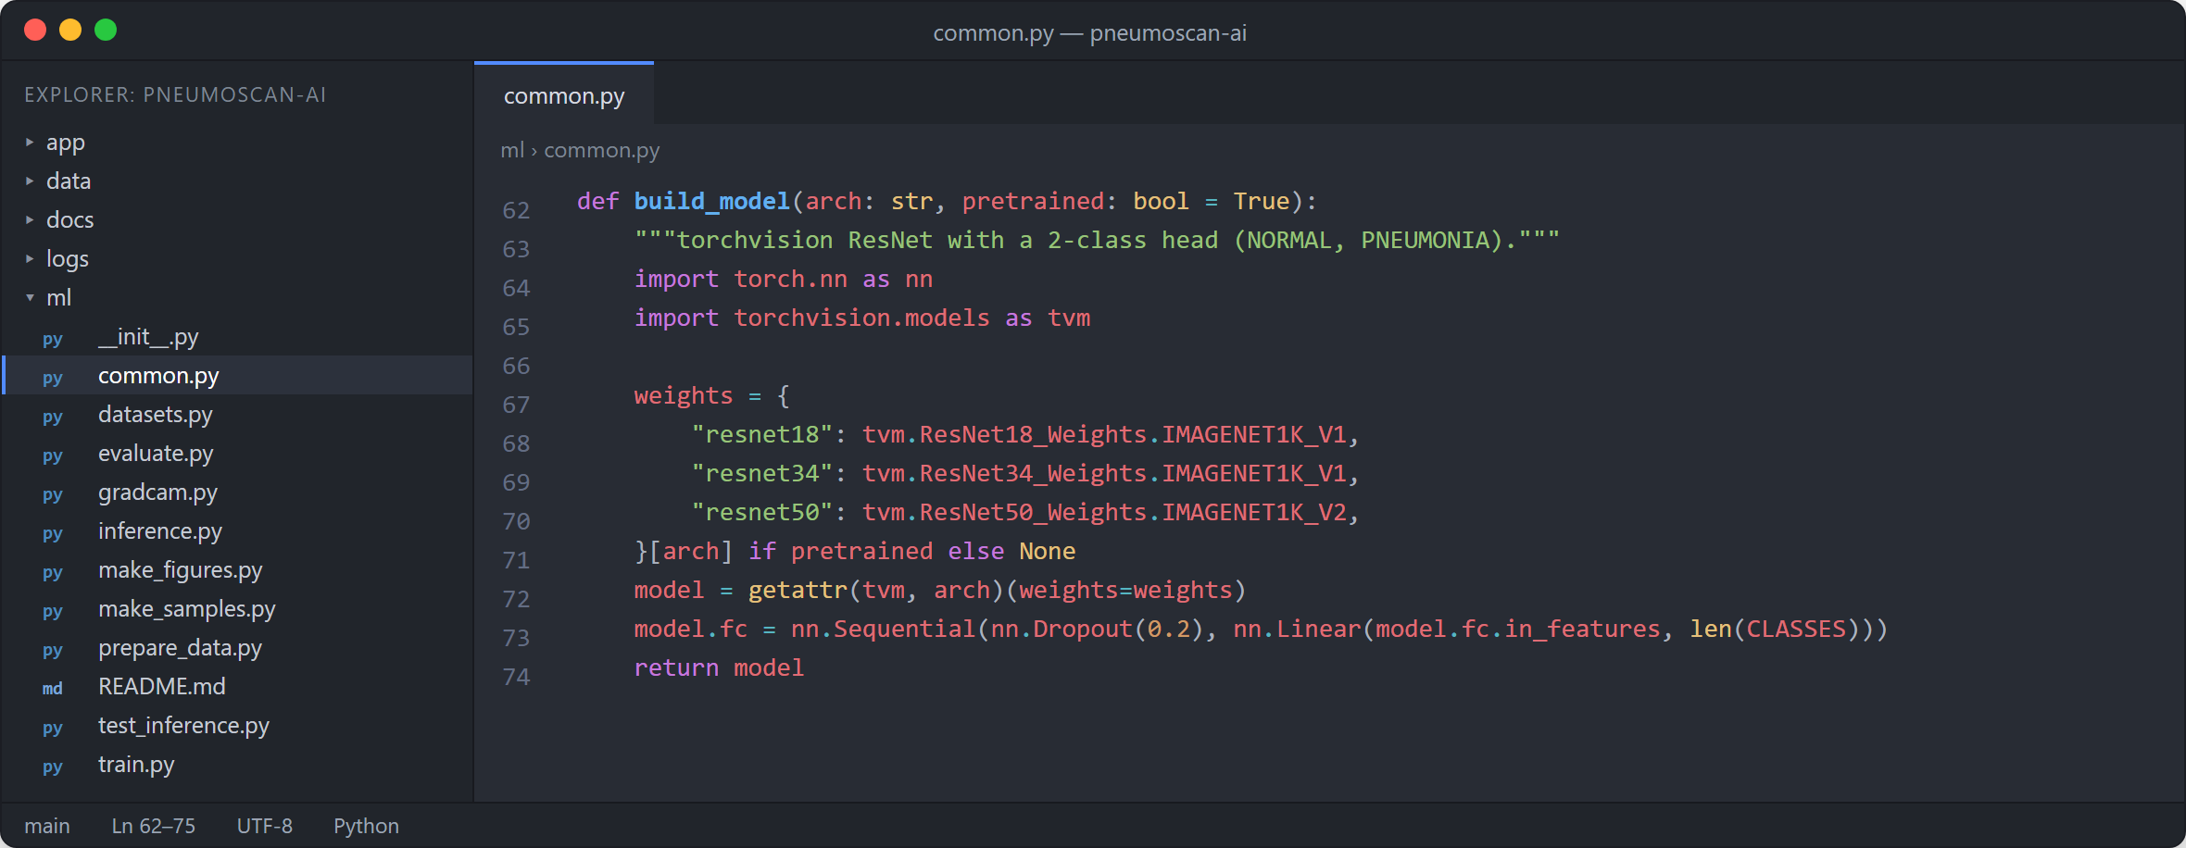
Figure 3. Building a ResNet with a two-class head (ml/common.py).

Step 2: Data Preparation Pipeline
The data preparation script verifies the dataset, builds the 512 × 512 cache, carves the patient-level validation split out of the training images only, and runs the leakage checks (Figure 4). The dataset module defines the training augmentation and the evaluation transform (Figure 5).
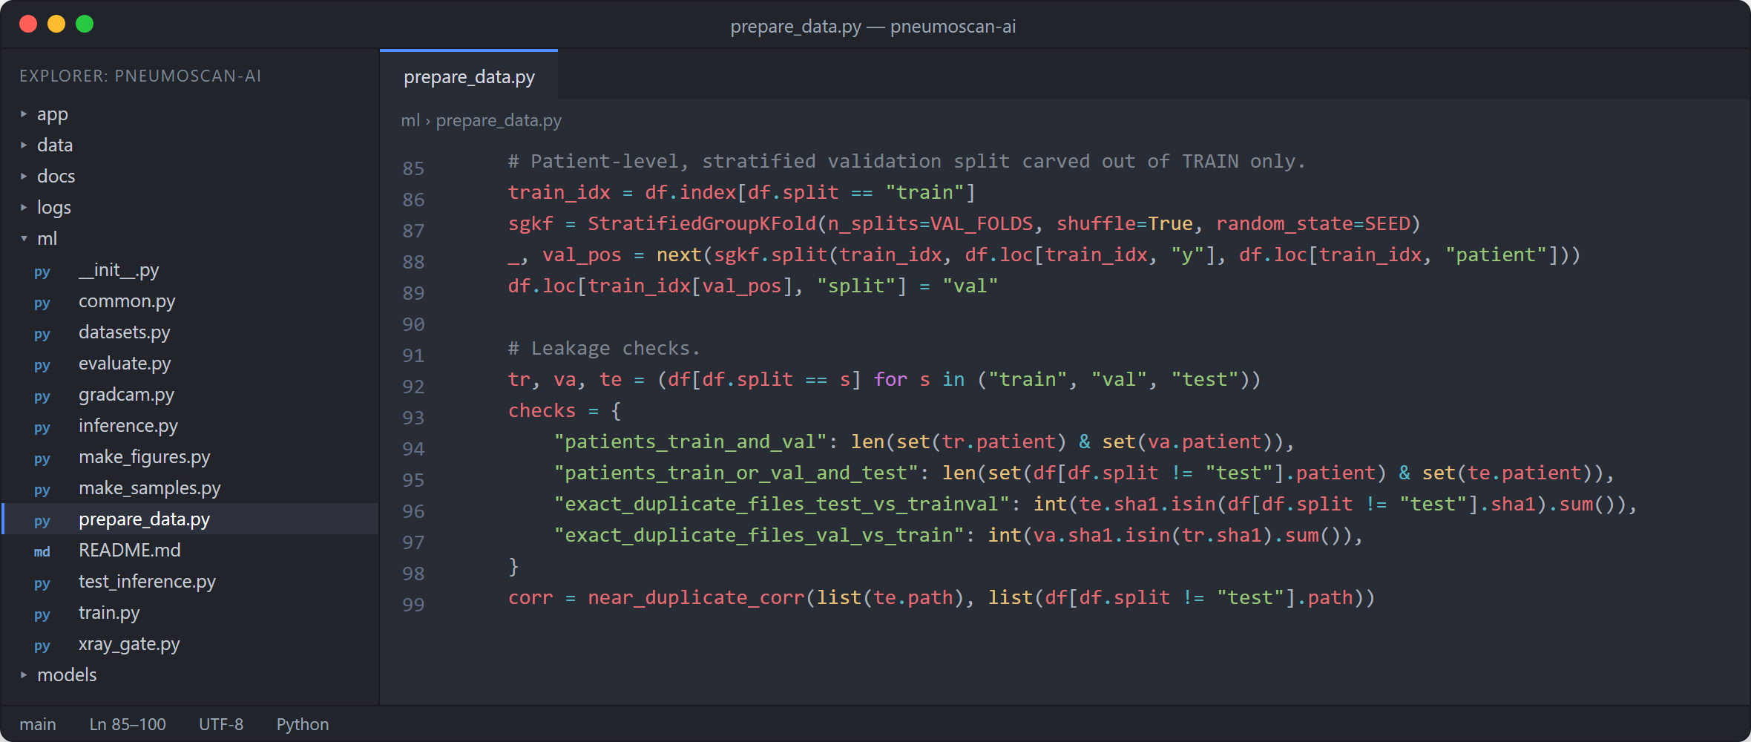
Figure 4. Patient-level stratified validation split and leakage checks (ml/prepare_data.py).
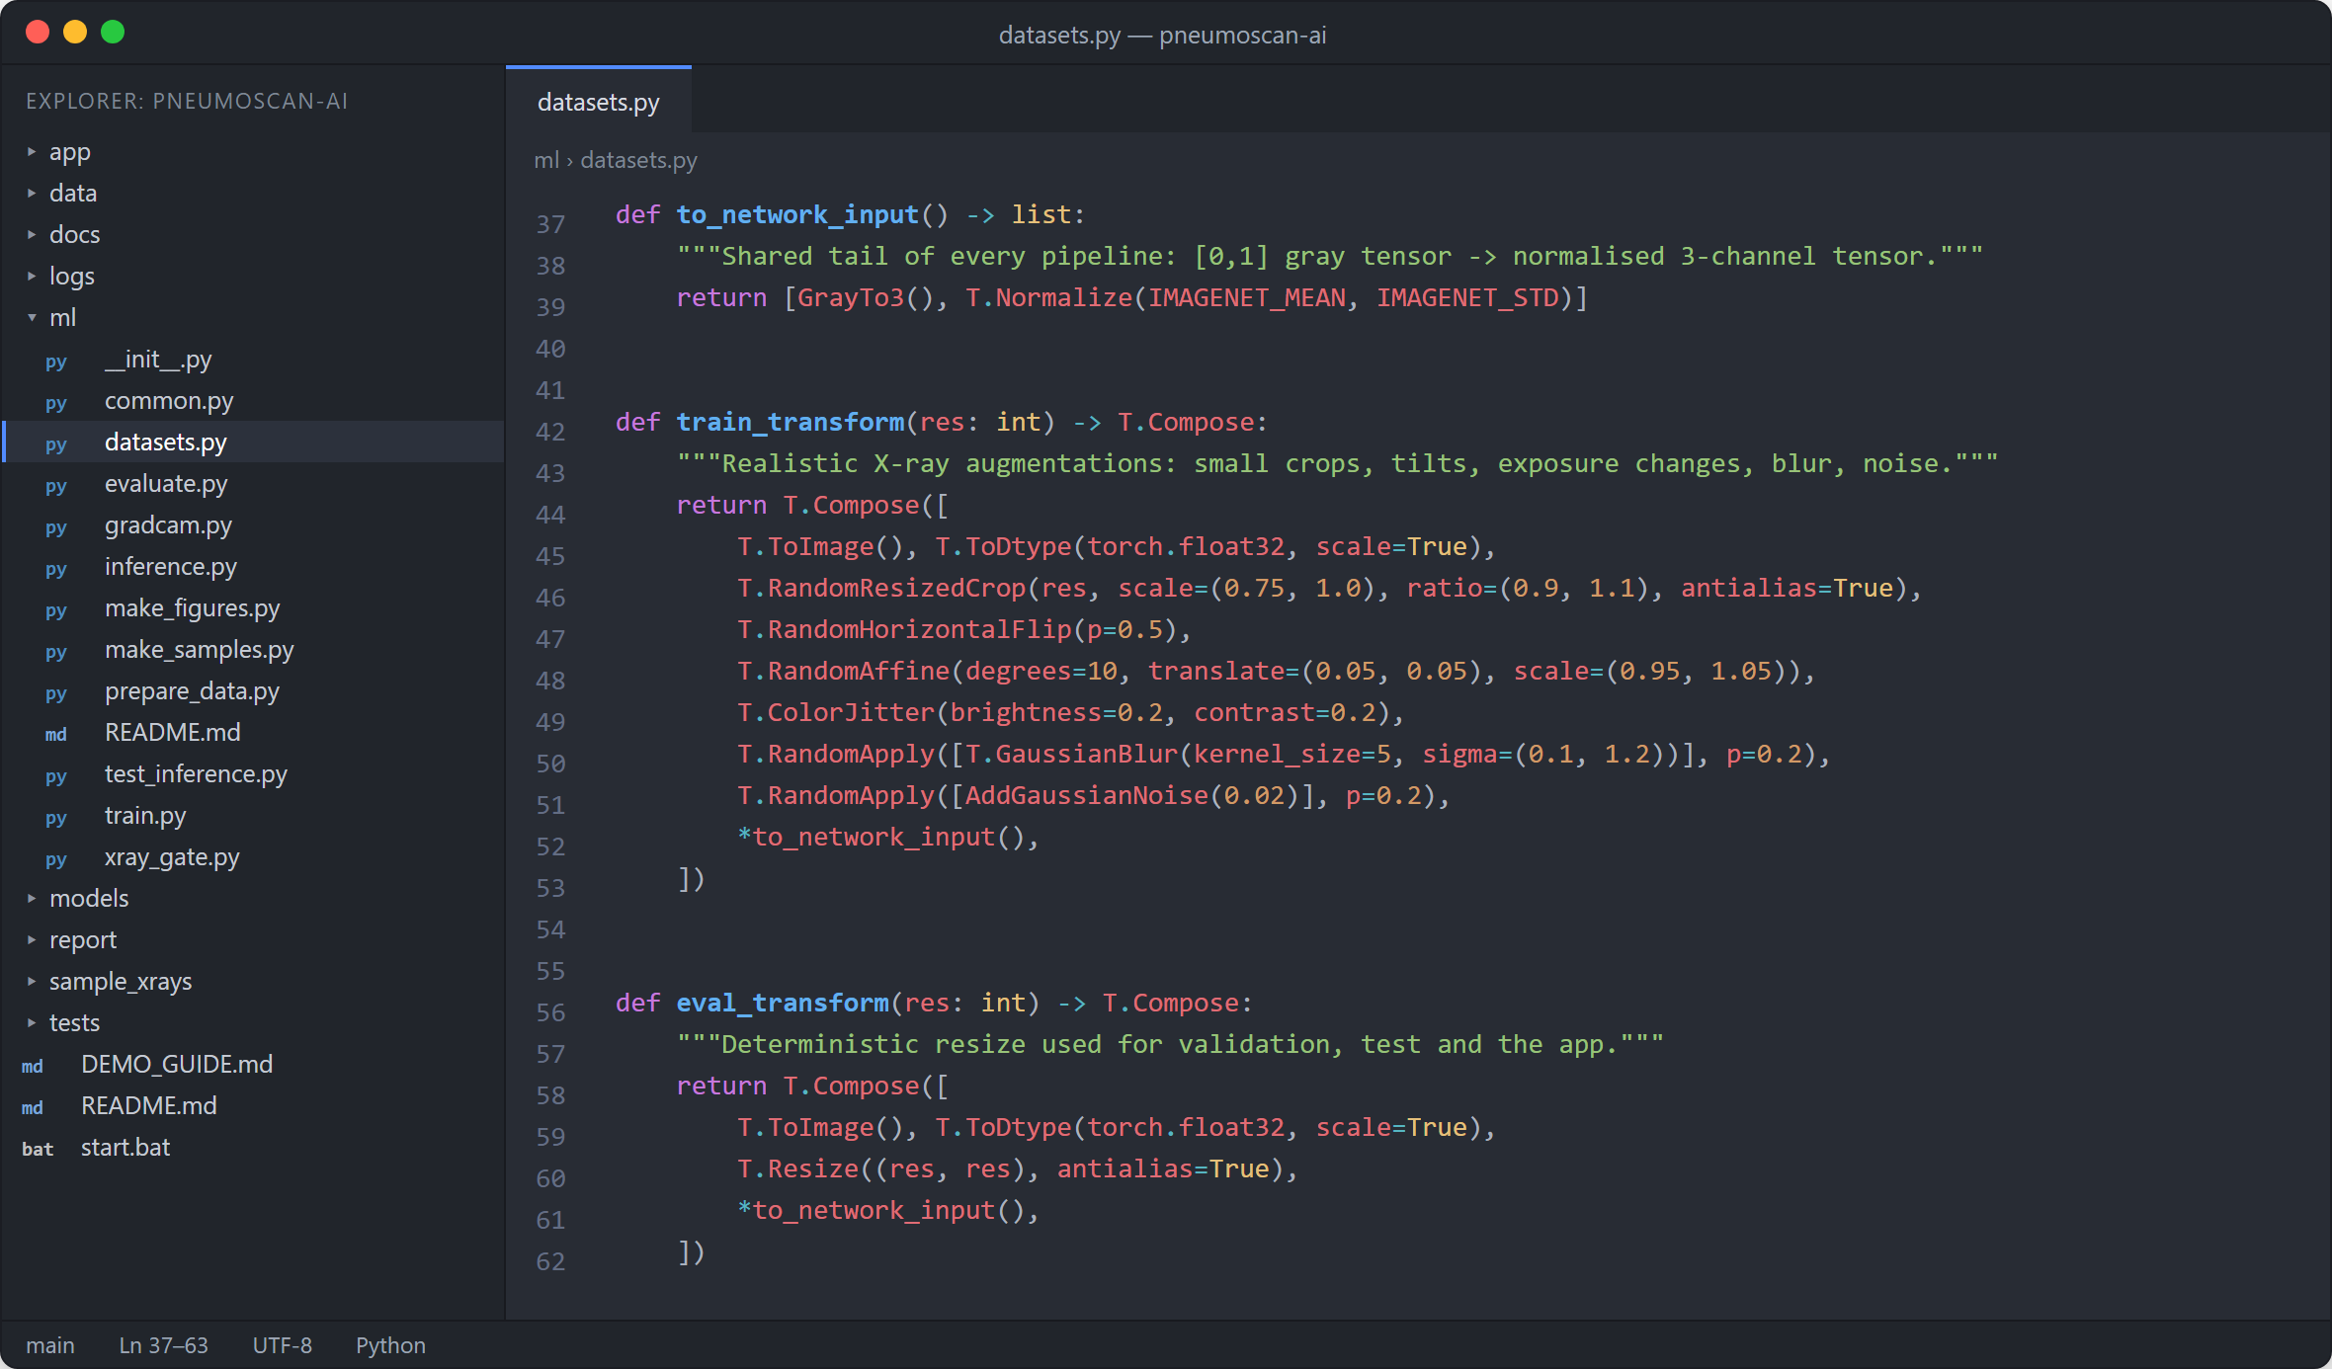
Figure 5. Training and evaluation transforms (ml/datasets.py).

Step 3: Training the ResNet Models
Each member is trained with one command. For every step the learning rate is set from the warm-up / cosine schedule, the forward pass runs in fp16, the scaled loss is back-propagated, gradients are clipped and the EMA weights are updated (Figure 6). After each epoch the EMA model is evaluated on the validation set and the best checkpoint is kept. Figure 7 is the real training log of the first member.
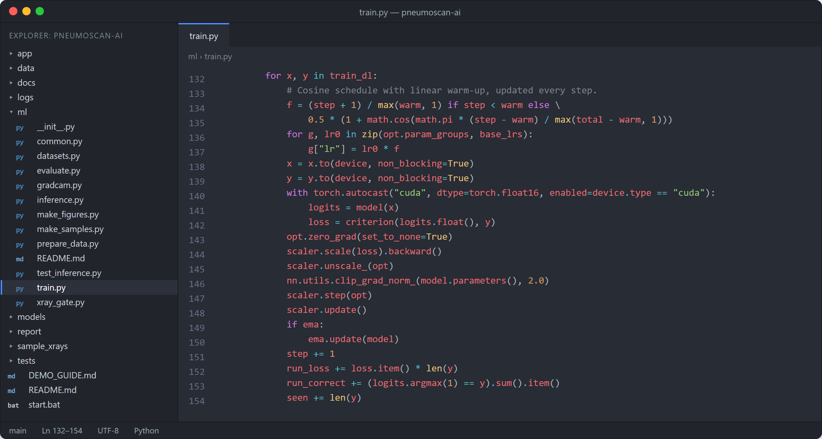
Figure 6. Core of the training loop (ml/train.py).
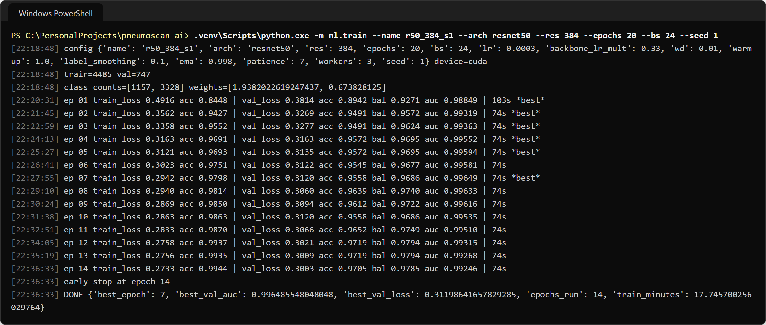
Figure 7. Execution of the training command for ResNet-50 @ 384 px (real log).
Table 8. Training runs on the RTX 3050 GPU (total training time 55.5 minutes)
Run | Model | Input | Epochs run | Best epoch | Time (min) | Best val AUC
r50_384_s1 | ResNet-50 | 384 | 14 | 7 | 17.7 | 0.9965
r34_384_s2 | ResNet-34 | 384 | 17 | 10 | 13.9 | 0.9971
r50_448_s3 | ResNet-50 | 448 | 14 | 7 | 23.9 | 0.9974

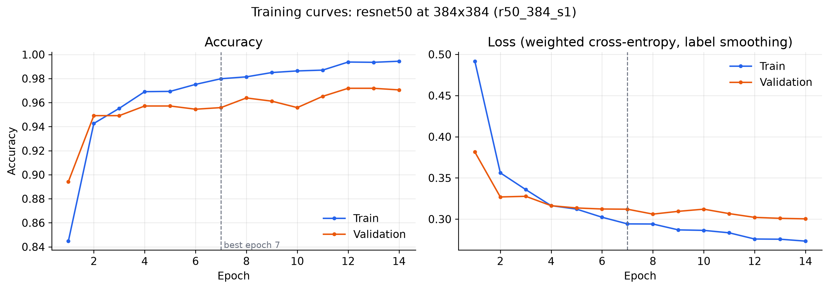
Figure 8. Training and validation curves of ResNet-50 @ 384 px.

Step 4: Ensemble, Calibration and Threshold Selection
For each member m and view v (original and mirror), the logit margin is z = ℓ_PNEUMONIA − ℓ_NORMAL. The six margins are averaged and calibrated with a temperature T fitted on the validation set, and the threshold t maximises Youden’s J on validation:
$$p = σ\left(\frac{\overline{z}}{T}\right), J\left(t\right) = Sensitivity\left(t\right) + Specificity\left(t\right) - 1$$
This gave T = 0.602 and t = 0.0743. A prediction is PNEUMONIA when p ≥ t, and the app also shows a risk level: Low (p < 0.037), Moderate (0.037 ≤ p < 0.537) or High (p ≥ 0.537).
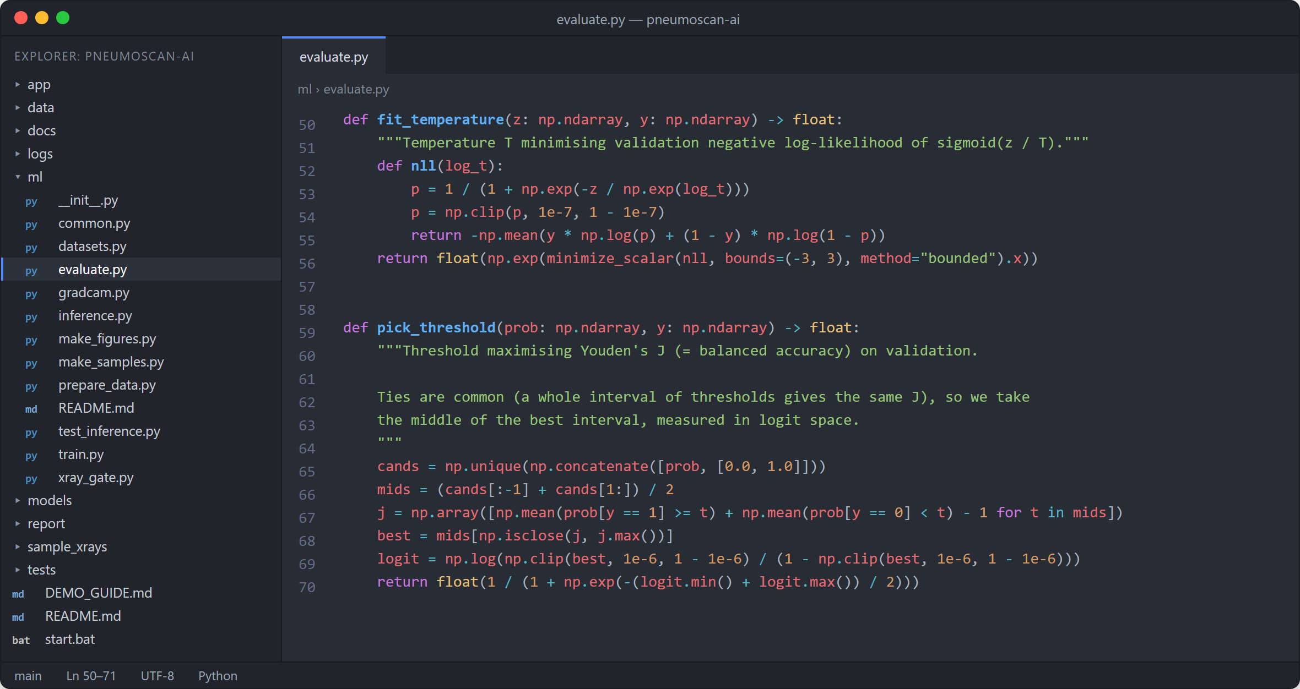
Figure 9. Temperature scaling and Youden-J threshold (ml/evaluate.py).

Step 5: Explainability (Grad-CAM) and the X-ray Gate
Grad-CAM weights each feature map A^k of layer4 by the average gradient of the class score and keeps the positive part [7]:
$$α_{k}^{c} = \frac{1}{Z}\sum_{i,j}{\frac{∂y^{c}}{∂A_{ij}^{k}}}, L^{c} = ReLU\left(\sum_{k}{α_{k}^{c} A^{k}}\right)$$
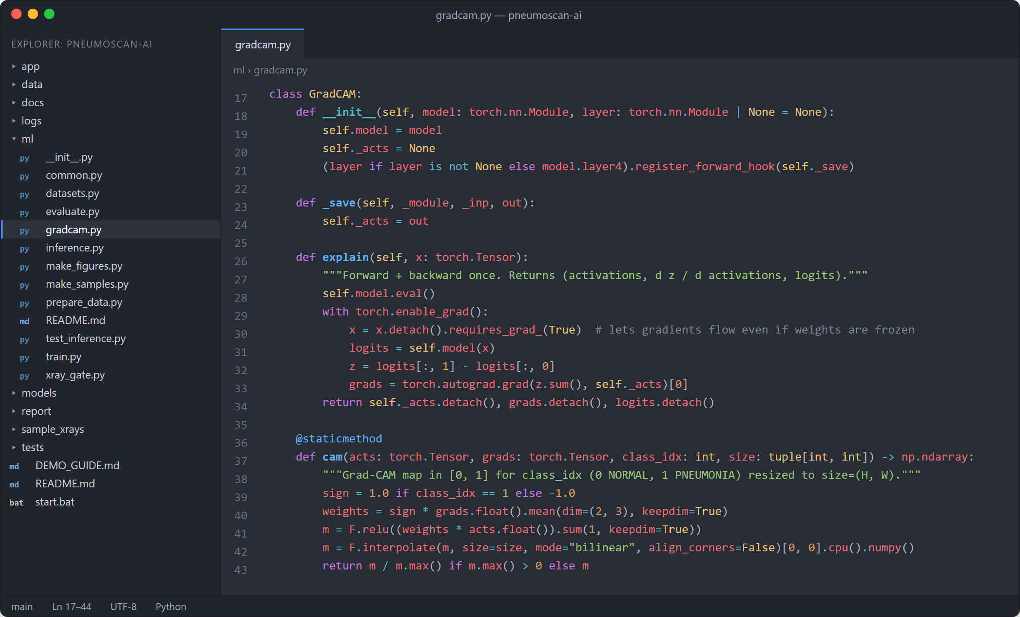
Figure 10. Grad-CAM for torchvision ResNets (ml/gradcam.py).
The X-ray gate compares the 2048 pooled ResNet-50 features of an image with those of the training X-rays using a Mahalanobis distance; the cut-off (66.04) is 1.15 × the 99.5th percentile of validation distances.
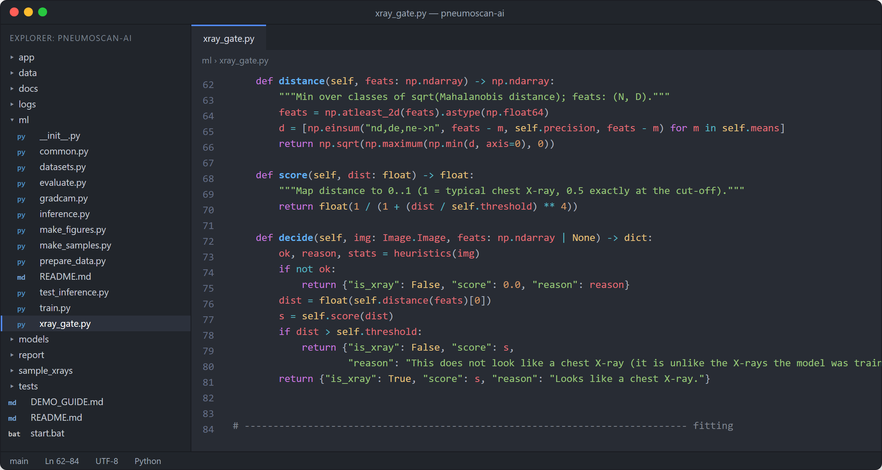
Figure 11. Distance, score and decision of the X-ray gate (ml/xray_gate.py).

Step 6: Inference Pipeline
The application uses one class, PneumoniaModel, which loads the three members once, checks the image with the X-ray gate, runs the ensemble with test-time augmentation and returns the label, calibrated probability, risk level and three aligned images (input, heat map and overlay). It can also be run from the command line (Figure 13).
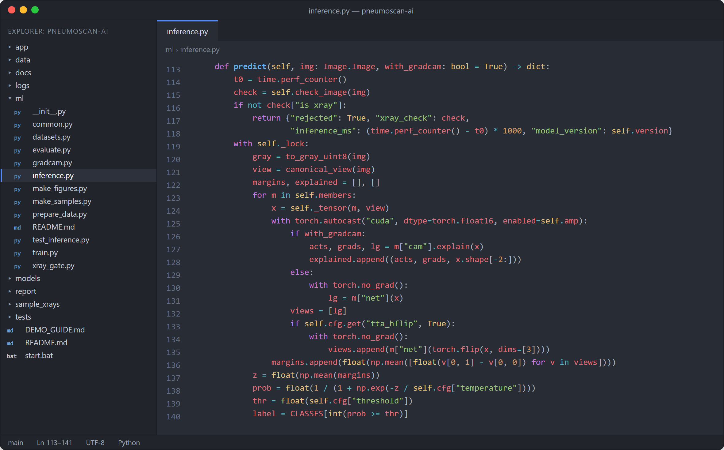
Figure 12. Ensemble decision inside PneumoniaModel.predict (ml/inference.py).
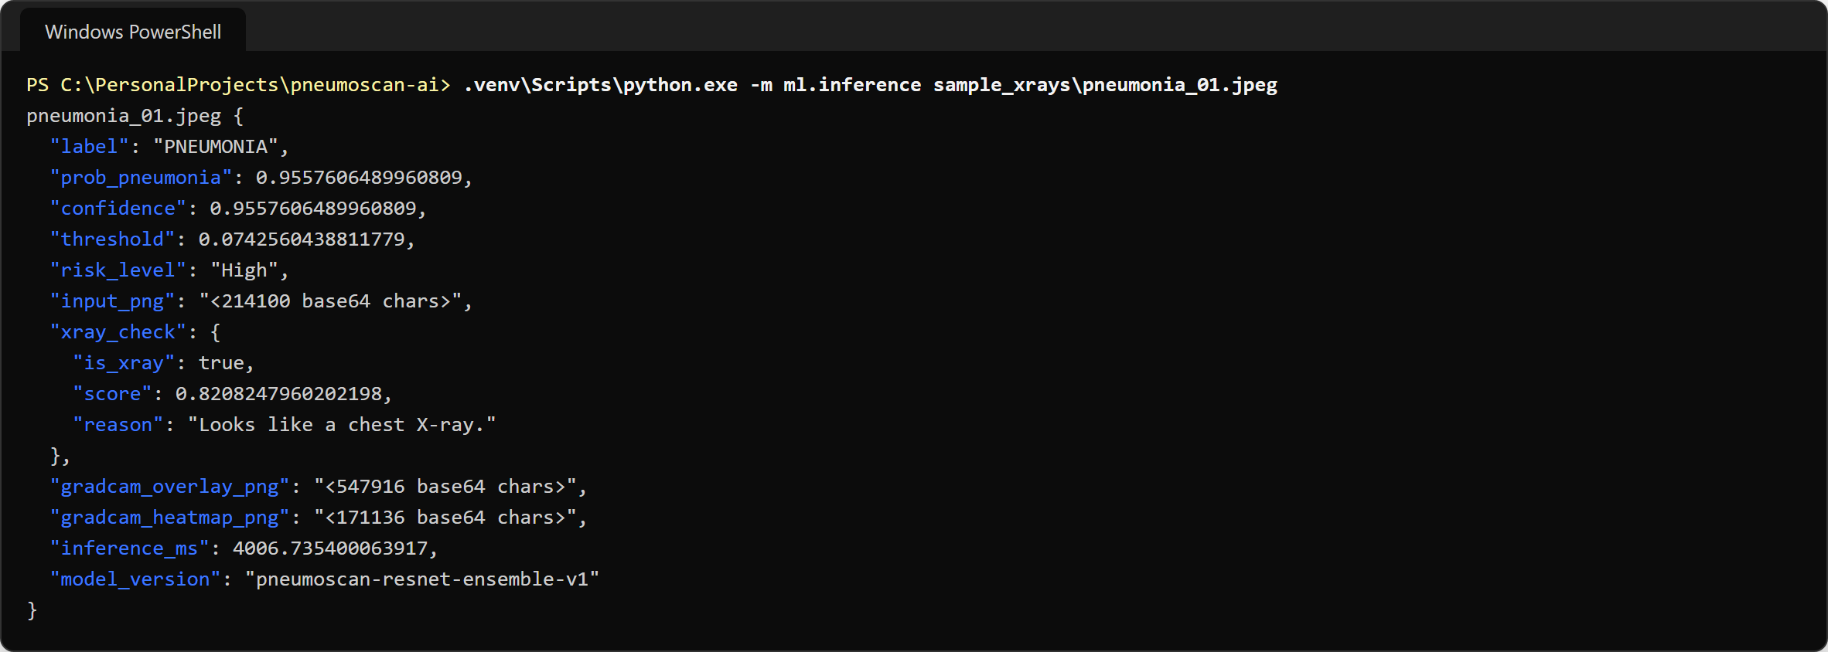
Figure 13. Running the inference module on a sample pneumonia X-ray (real output; images shown as base64 lengths).

Step 7: Web Application Development
The trained model is delivered as a three-layer offline web application (Figure 14): a React + TypeScript single-page front-end, a FastAPI back-end with a JSON REST API, and the model and data layer (X-ray gate, ResNet ensemble, Grad-CAM, SQLite history). The API is listed in Table 9.
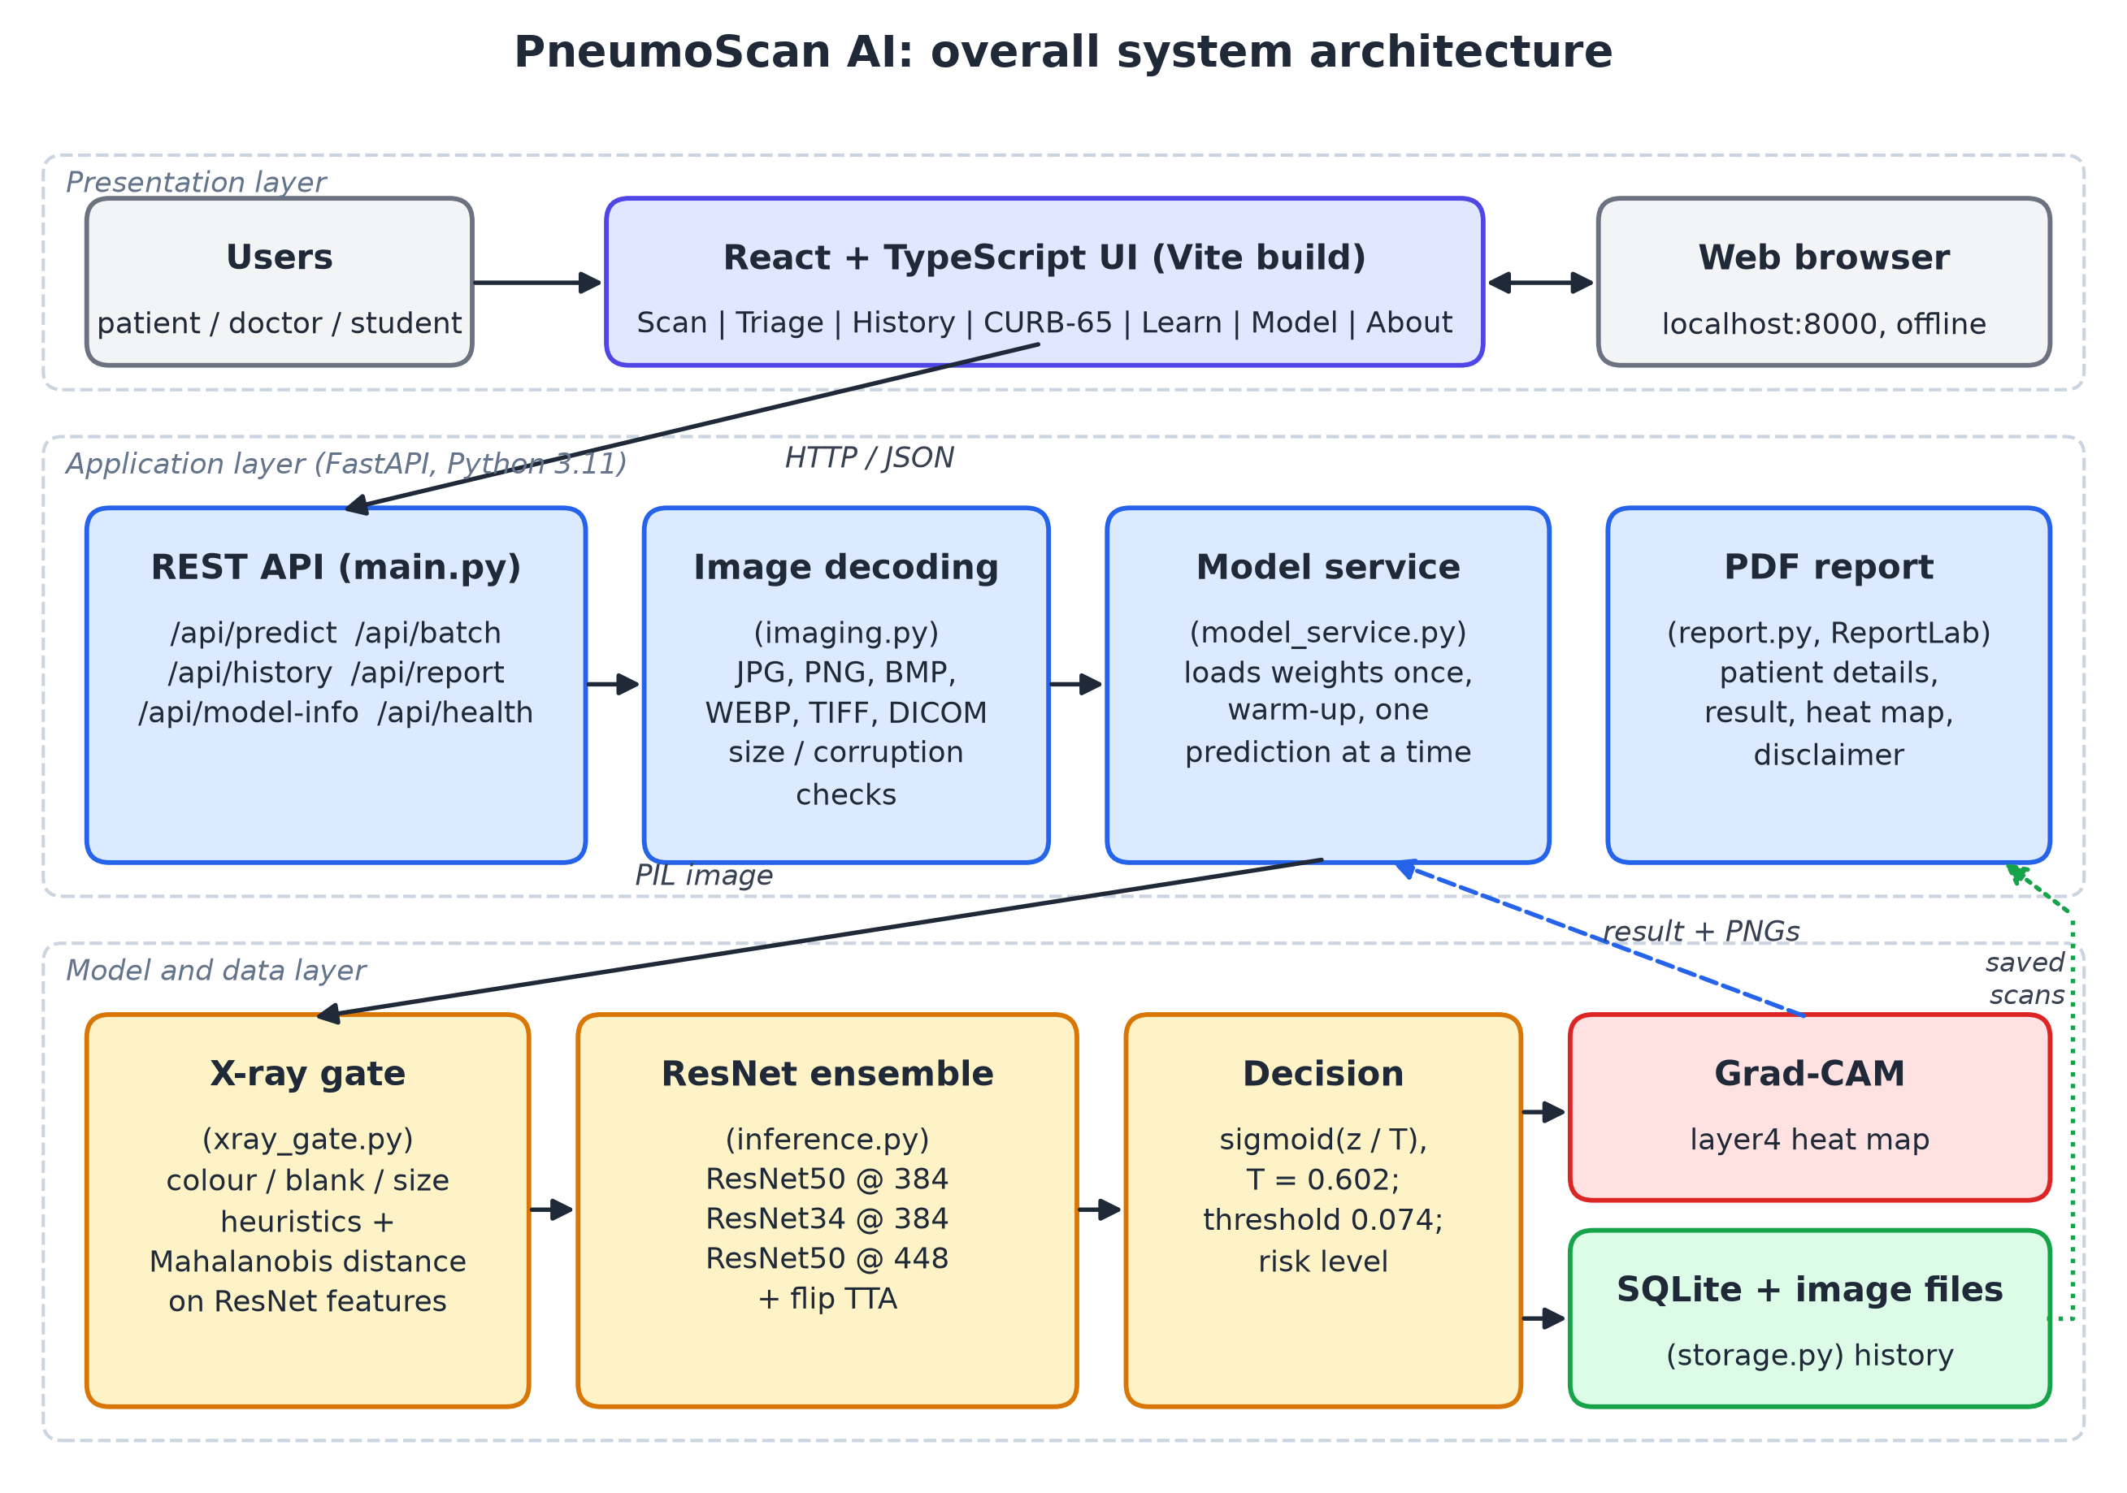
Figure 14. Overall system architecture of PneumoScan AI.
Table 9. REST API endpoints (app/backend/main.py)
Method | Path | Purpose
GET | /api/health | Status, model mode, device and model version
GET | /api/model-info | Test metrics, model card and figure URLs
POST | /api/predict | One X-ray (+ optional patient details) → result and saved scan
POST | /api/batch | Up to 50 X-rays → results sorted by pneumonia probability
GET | /api/history | Search, filter and page through saved scans
GET / PATCH / DELETE | /api/history/{id} | Read, edit (patient details, notes) or delete a scan
DELETE | /api/history | Clear all history
GET | /api/history/{id}/image/{kind} | Saved input, overlay, heat-map or thumbnail image
GET | /api/report/{id}.pdf | Patient PDF report
GET | /api/samples | Demo X-rays from the test split

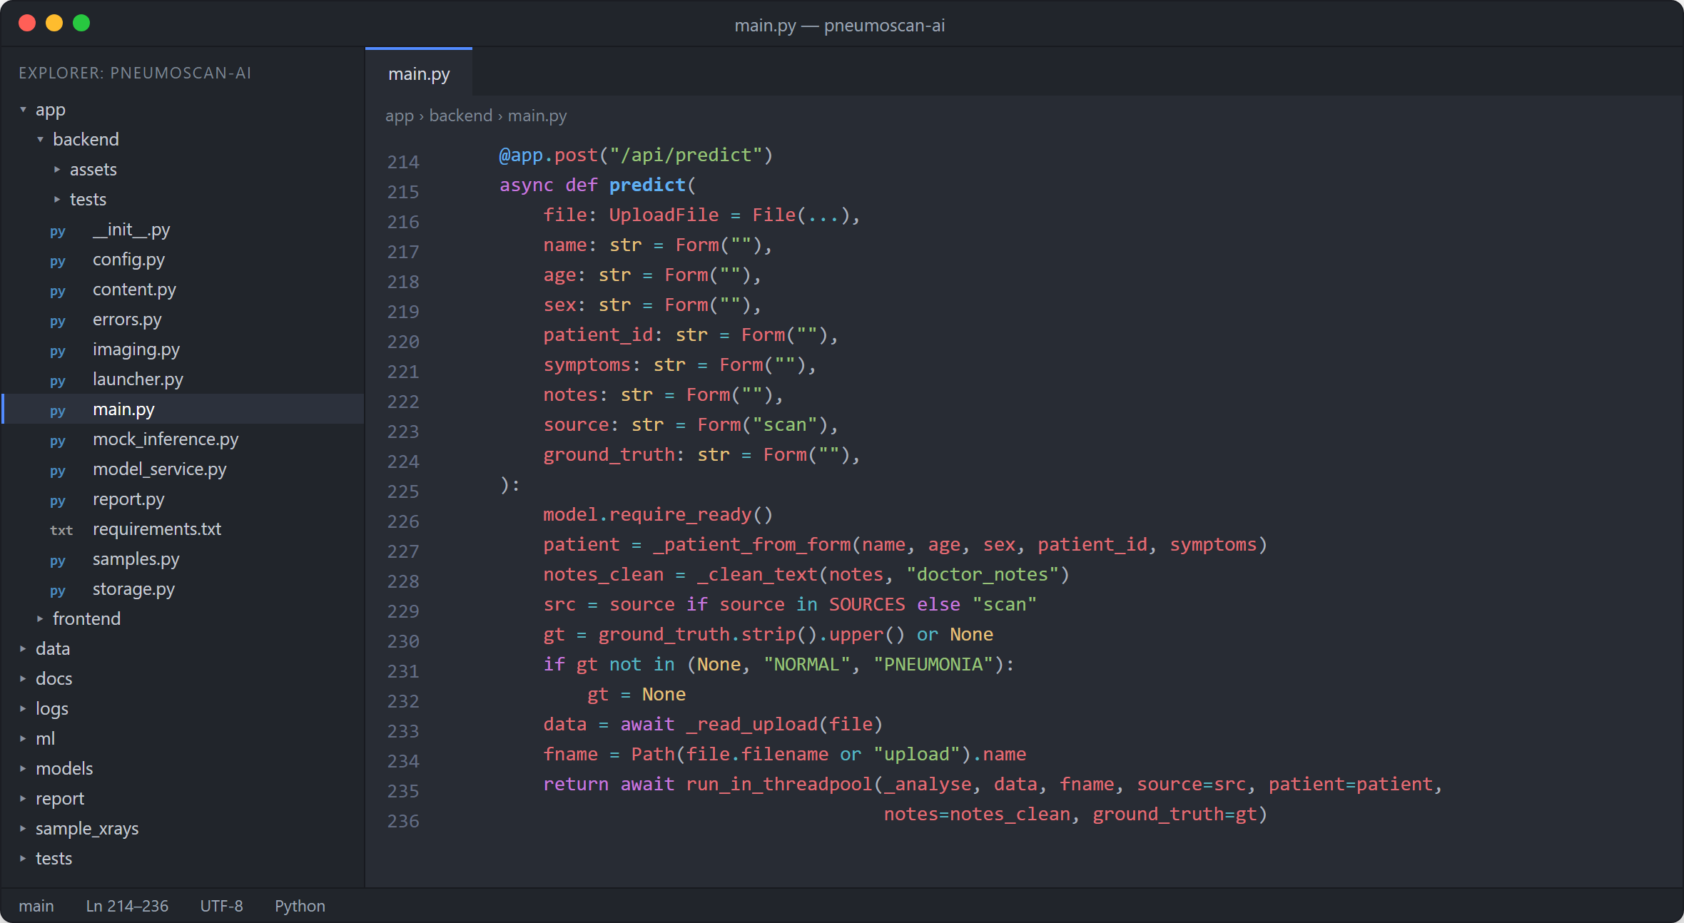
Figure 15. Prediction endpoint of the FastAPI back-end (app/backend/main.py).
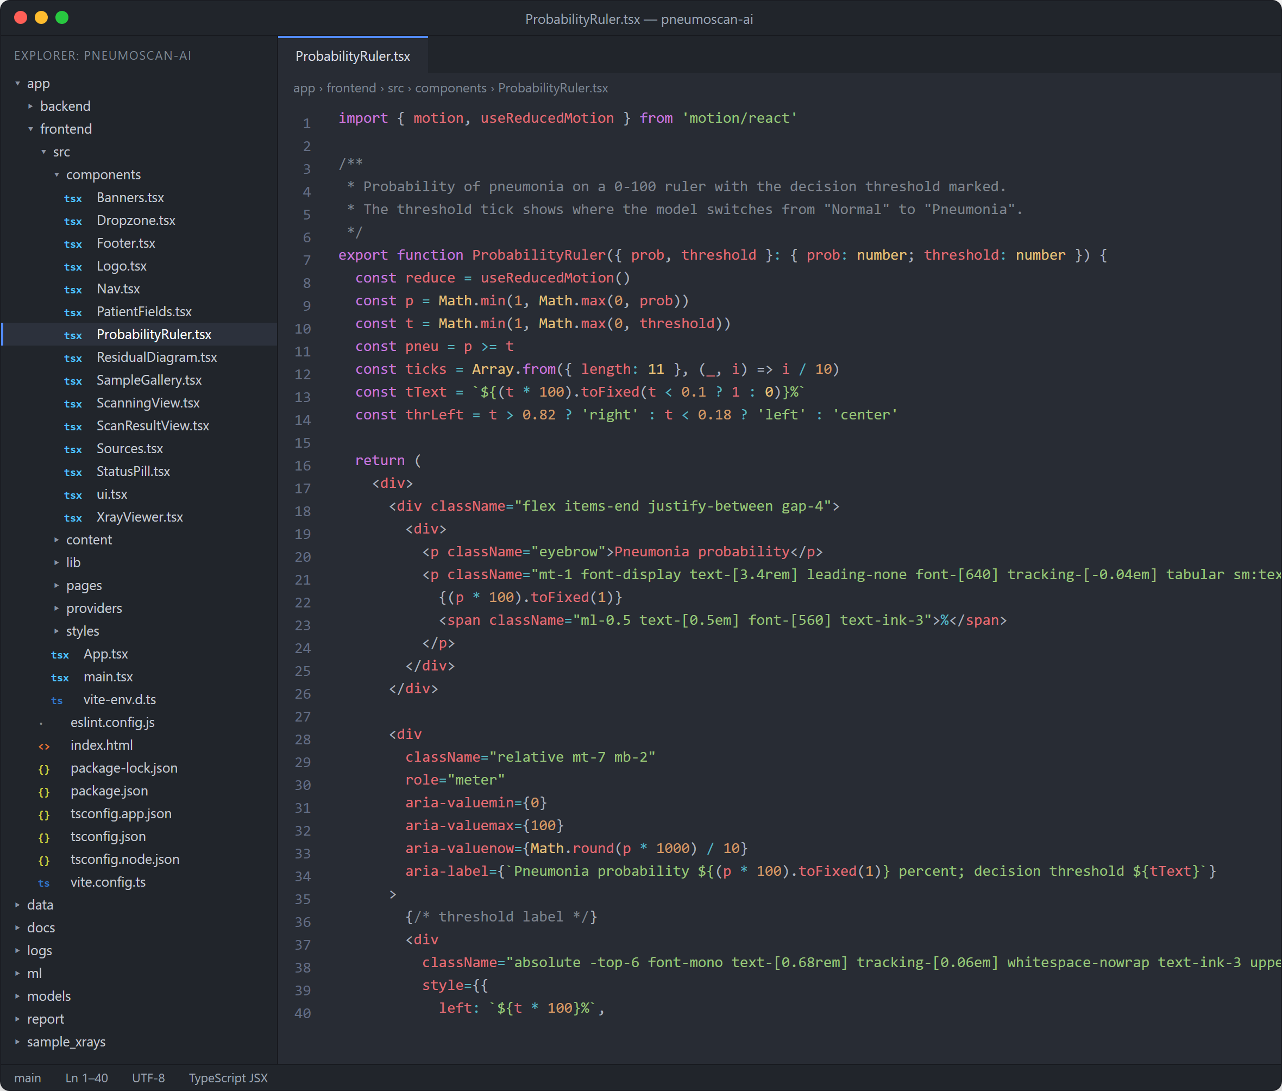
Figure 16. React component that draws the probability ruler with the decision threshold (ProbabilityRuler.tsx).
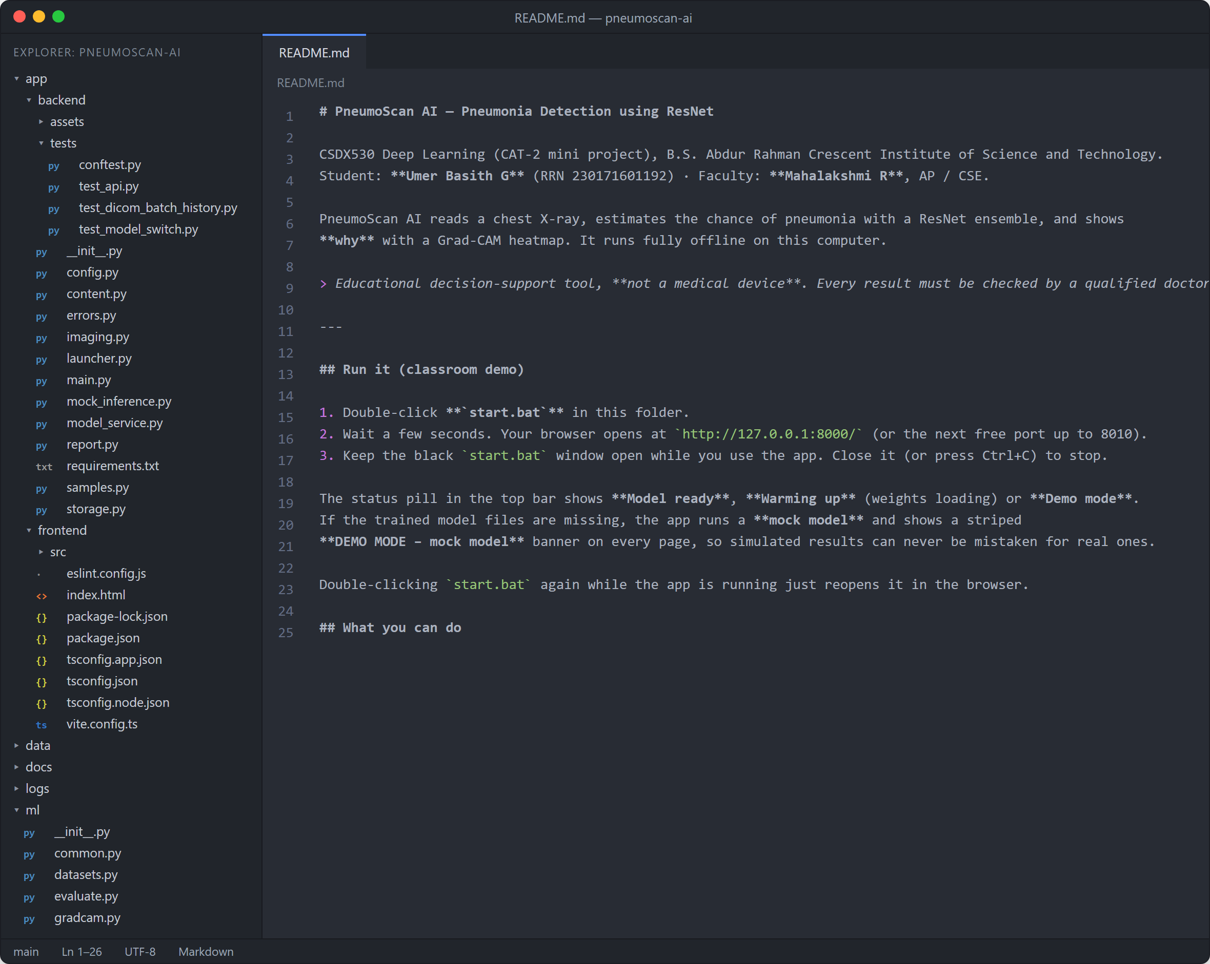
Figure 17. Project folder structure and README of the codebase.
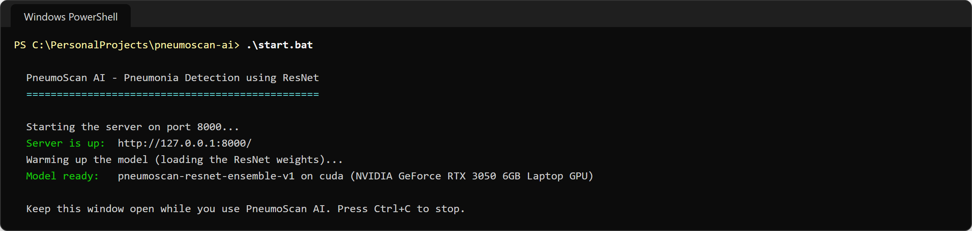
Figure 18. Starting the application with start.bat (real output).

Step 8: Testing and Validation
Because this is a healthcare tool, the system was tested at four levels and all 180 automated tests pass (Table 10). Figure 19 shows the real output of the model and back-end test suites.
Table 10. Automated tests
Level | Tests | What is checked
ML contract (ml/test_inference.py) | 24 | Result format, image sizes, every image mode, 16-bit DICOM, rejection of photographs, blank and noise images
Back-end (app/backend/tests) | 35 | Every API endpoint, bad and huge files, mixed batches, history create / read / update / delete, PDF reports
End-to-end (tests/) | 121 | Real model + headless browser: 12 demo X-rays, 40+ random test images, non-X-rays, path-traversal and script-injection attempts, Tamil and Hindi names in the PDF, 6 screen-size / theme combinations, server down and back
Front-end | – | ESLint and the TypeScript build: zero problems
Total | 180 | All passing

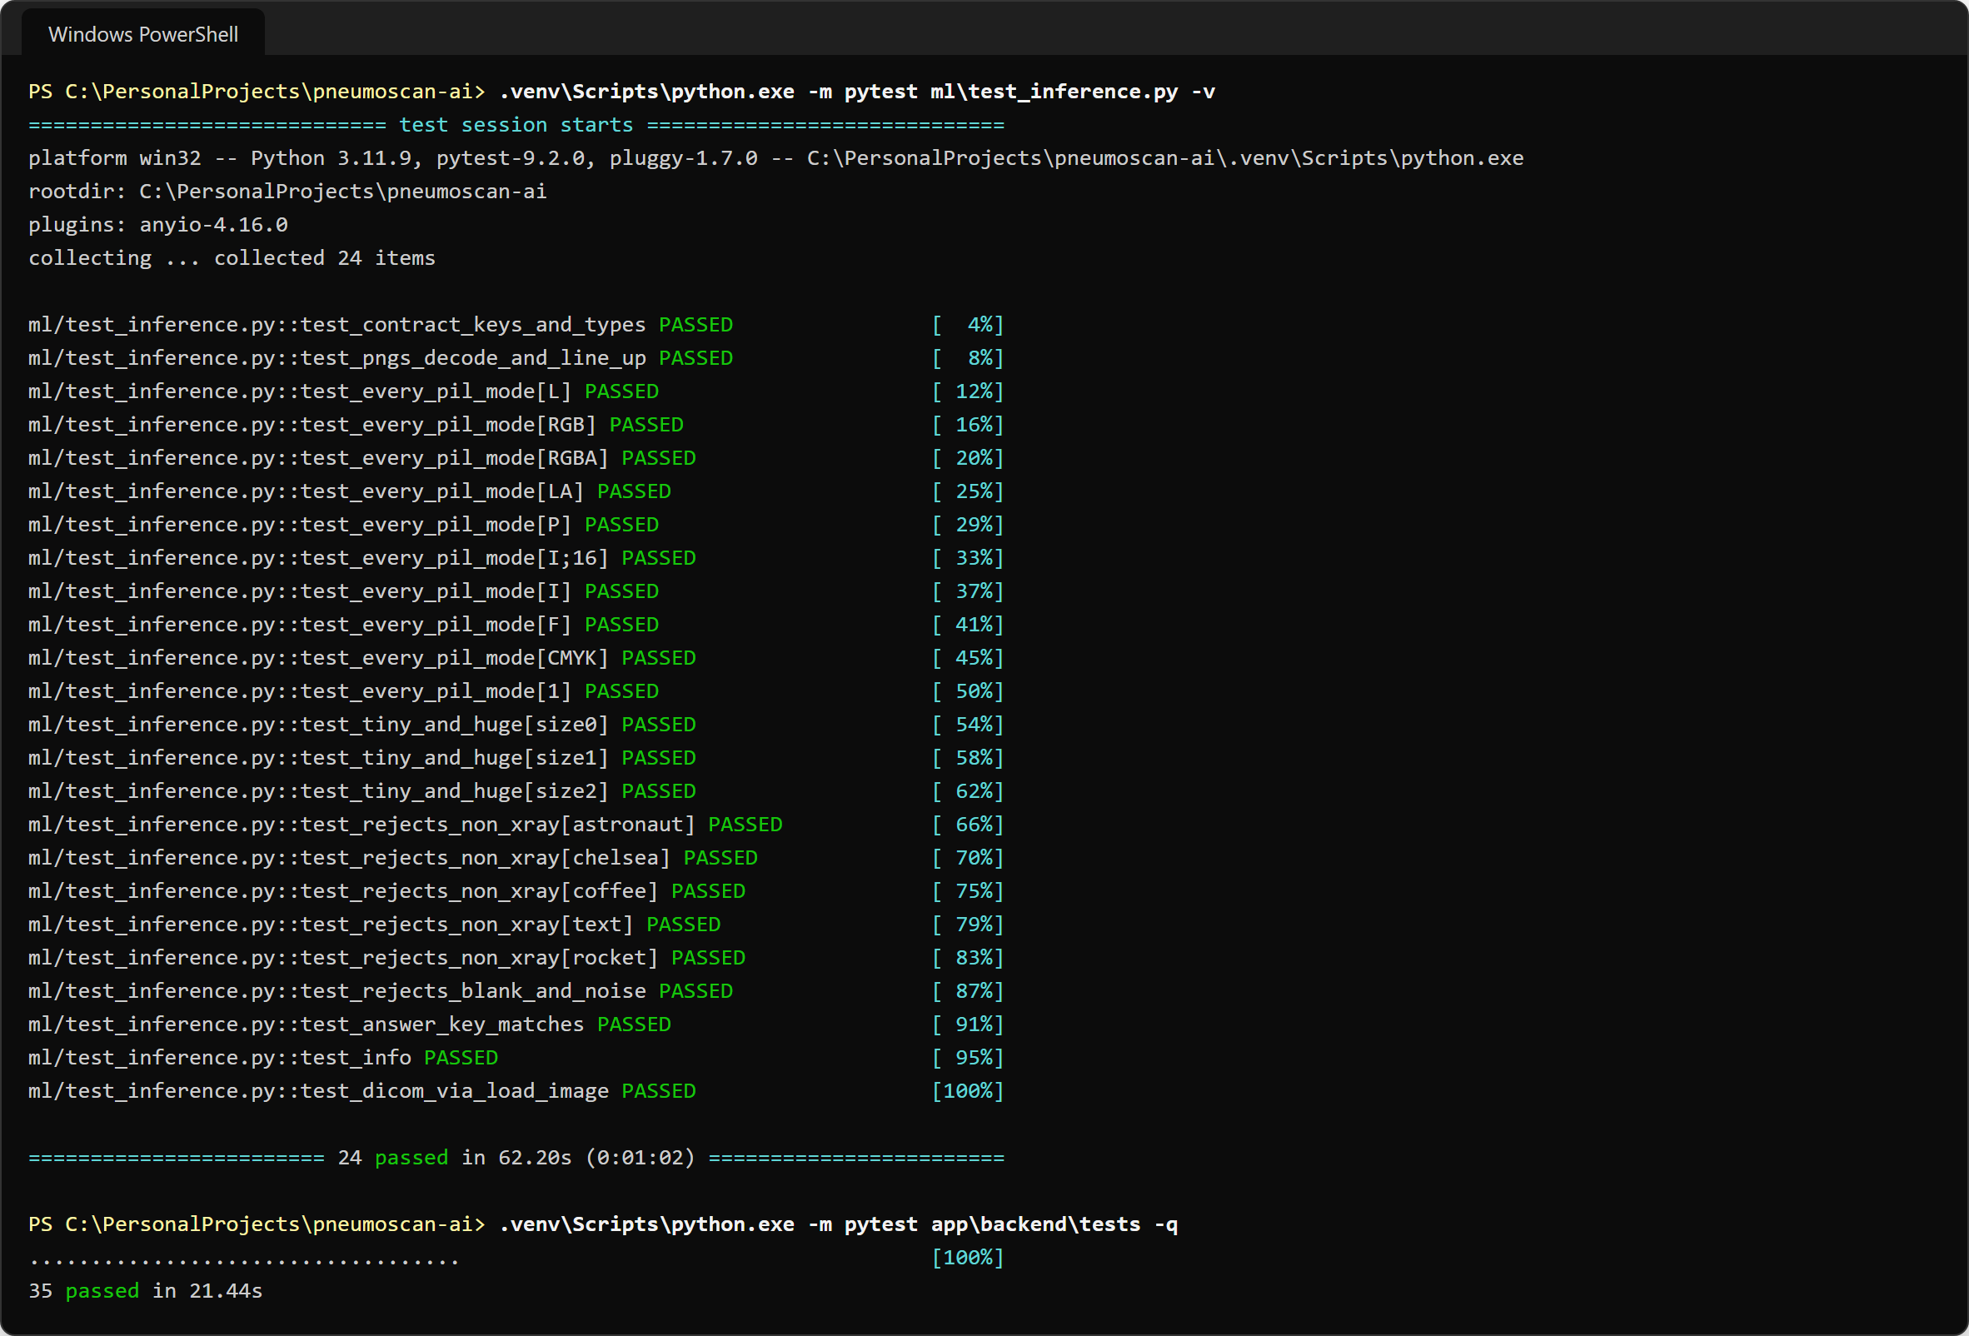
Figure 19. Model and back-end test suites passing (real output).

Step 9: Application Features
Table 11 lists every feature of the finished application, and Figures 20–27 show each screen, taken from the running application with the real trained model (patient details are fictitious demo data).
Table 11. Features of the PneumoScan AI application
Feature | What it does | Helps
Scan page | Drag-and-drop, browse or paste (Ctrl+V) an X-ray (JPG, PNG, BMP, WEBP, TIFF, DICOM, ≤ 25 MB) or pick a sample from the test set | Everyone
Result + risk level | Verdict, calibrated probability on a 0–100 ruler with the threshold, confidence, Low / Moderate / High risk, inference time | Doctors, students
Grad-CAM viewer | Original / Heat map / Side-by-side views, opacity slider, zoom and pan (mouse and keyboard) | Doctors, students
Explanation and next steps | Plain-English meaning of the result, recommended next steps and a responsible-AI disclaimer | Patients
Patient PDF report | One-click report with patient details, result, heat map, explanation and disclaimer; Tamil and Hindi names supported | Doctors, patients
X-ray gate | Turns away photographs, documents and blank images with a friendly reason; nothing is saved | Everyone (safety)
Triage queue | Up to 50 X-rays at once with per-file progress, sorted by probability, urgent flags, filters, CSV export | Doctors, hospitals
Scan history | Local SQLite history: search, filters, grid / list view, edit patient details and notes, re-download PDF, delete, clear all | Doctors
CURB-65 calculator | Adult severity score [8] (urea mmol/L or BUN mg/dL; CRB-65 without urea), 30-day mortality and care setting | Doctors
Learn page | Pneumonia explained simply: danger signs, symptoms, children (WHO), causes, prevention, home care, X-ray signs, with sources | Patients, families
Model page | Test accuracy, sensitivity, specificity, ROC-AUC, confusion matrix, figures, ResNet explainer, limitations | Students, teachers
About page | Project, course, tech stack, dataset credit and disclaimer | Everyone
Dark mode and phone layout | Light / dark themes remembered; responsive layout for phones and projectors | Everyone
Offline and private | Runs on 127.0.0.1 with bundled fonts; no internet needed; data stay on the computer | Hospitals, patients

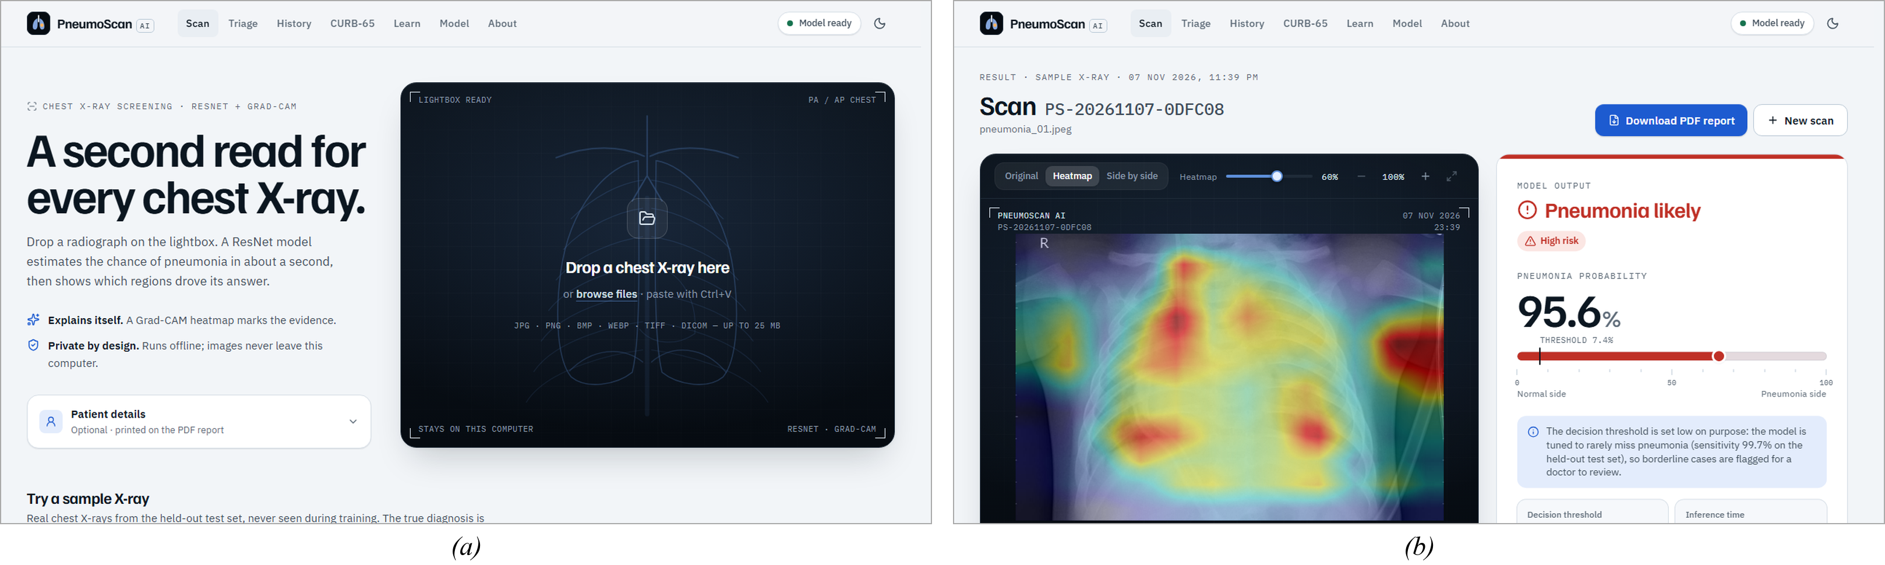
Figure 20. Scan page: (a) upload area, patient details and sample gallery; (b) analysis in progress.
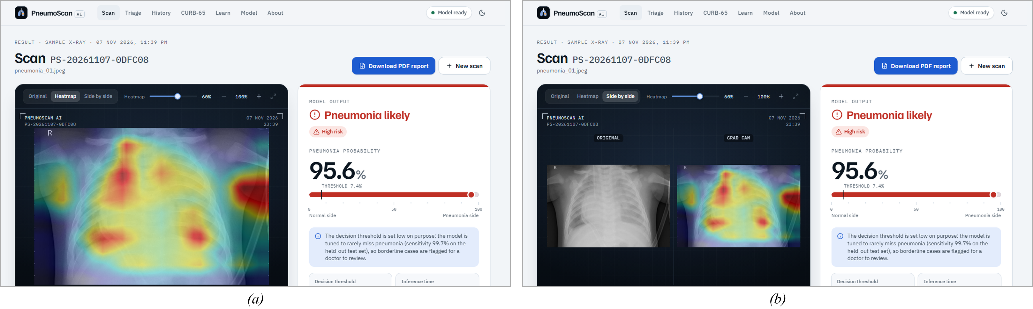
Figure 21. Result screen: (a) verdict, probability ruler, risk level and Grad-CAM heat map; (b) side-by-side view of the X-ray and the heat map.
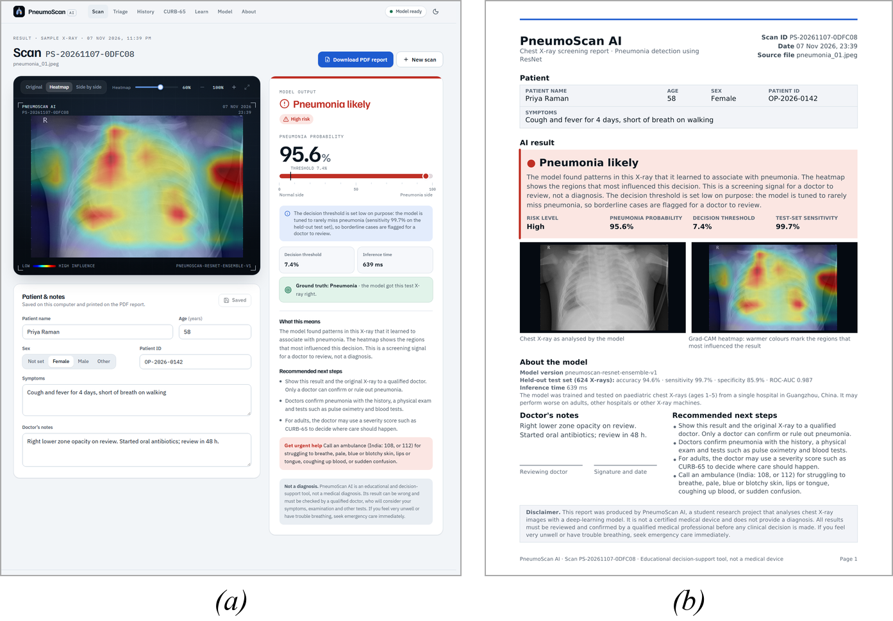
Figure 22. (a) Explanation, next steps and disclaimer below the result; (b) first page of the patient PDF report.
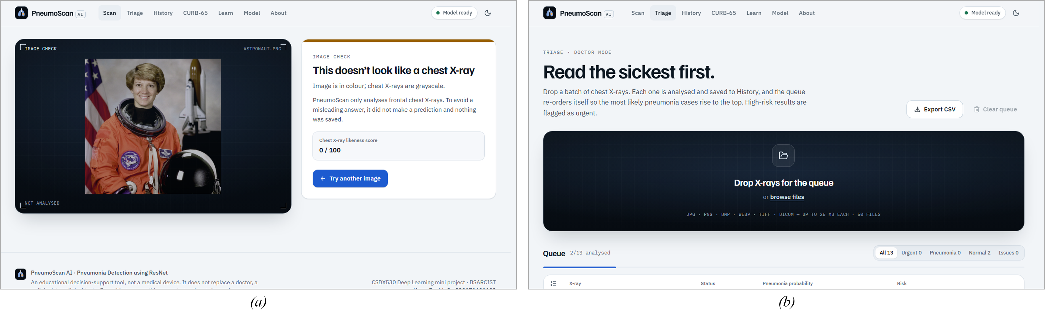
Figure 23. (a) A colour photograph rejected by the X-ray gate; (b) triage queue analysing several X-rays with per-file progress.
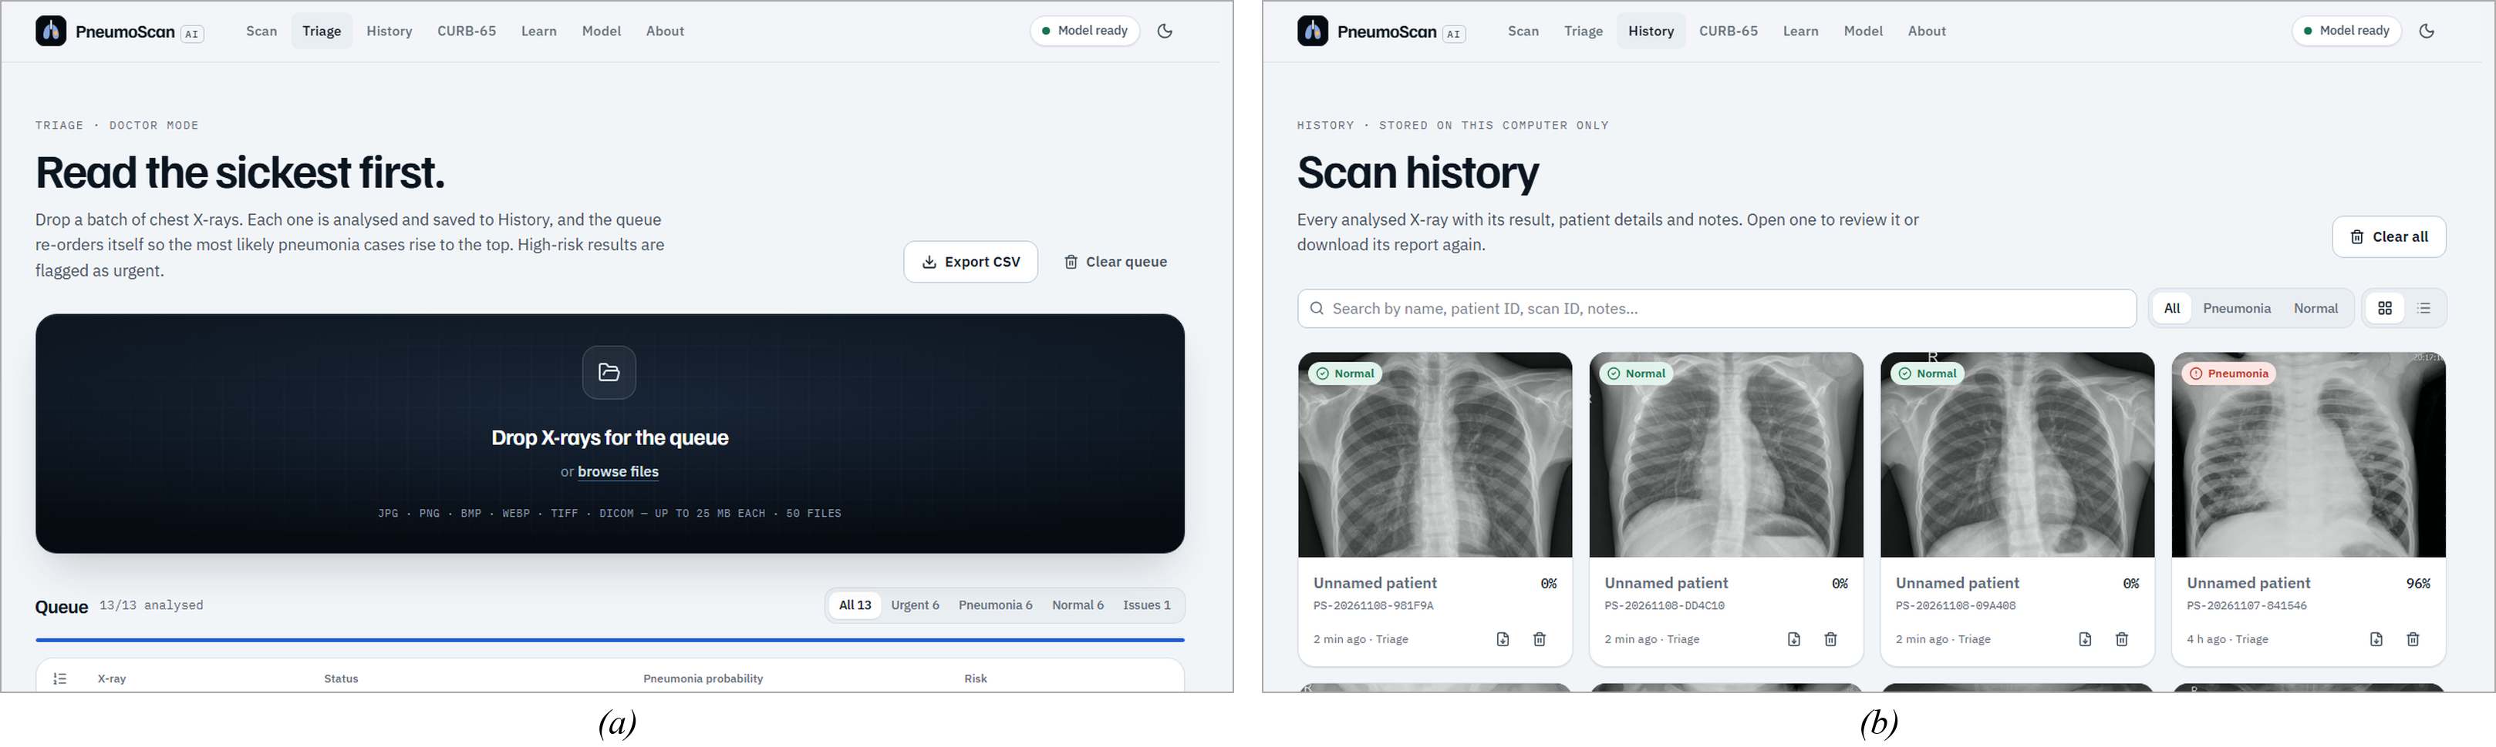
Figure 24. (a) Completed triage queue sorted by pneumonia probability with urgent flags; (b) scan history in grid view.
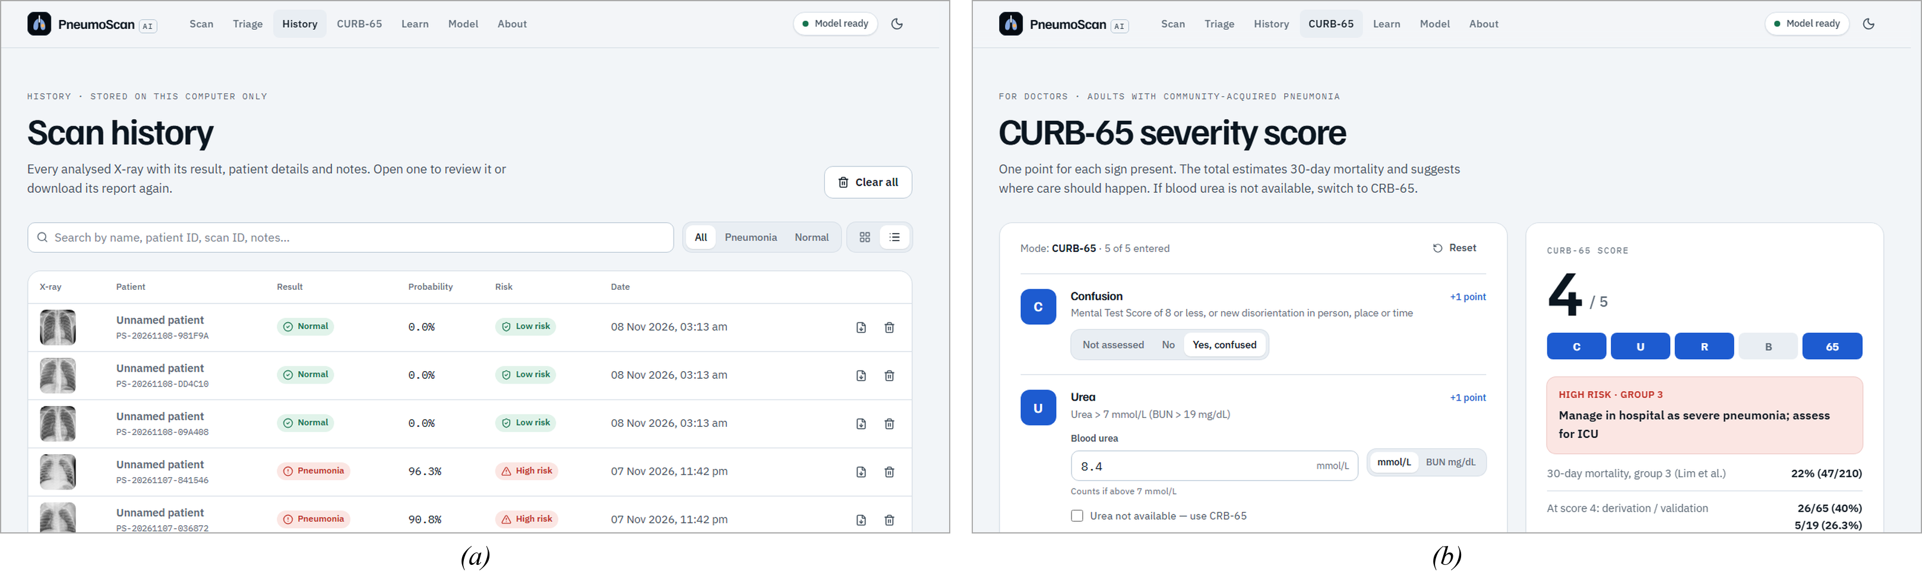
Figure 25. (a) Scan history in list view with search and filters; (b) CURB-65 severity calculator.
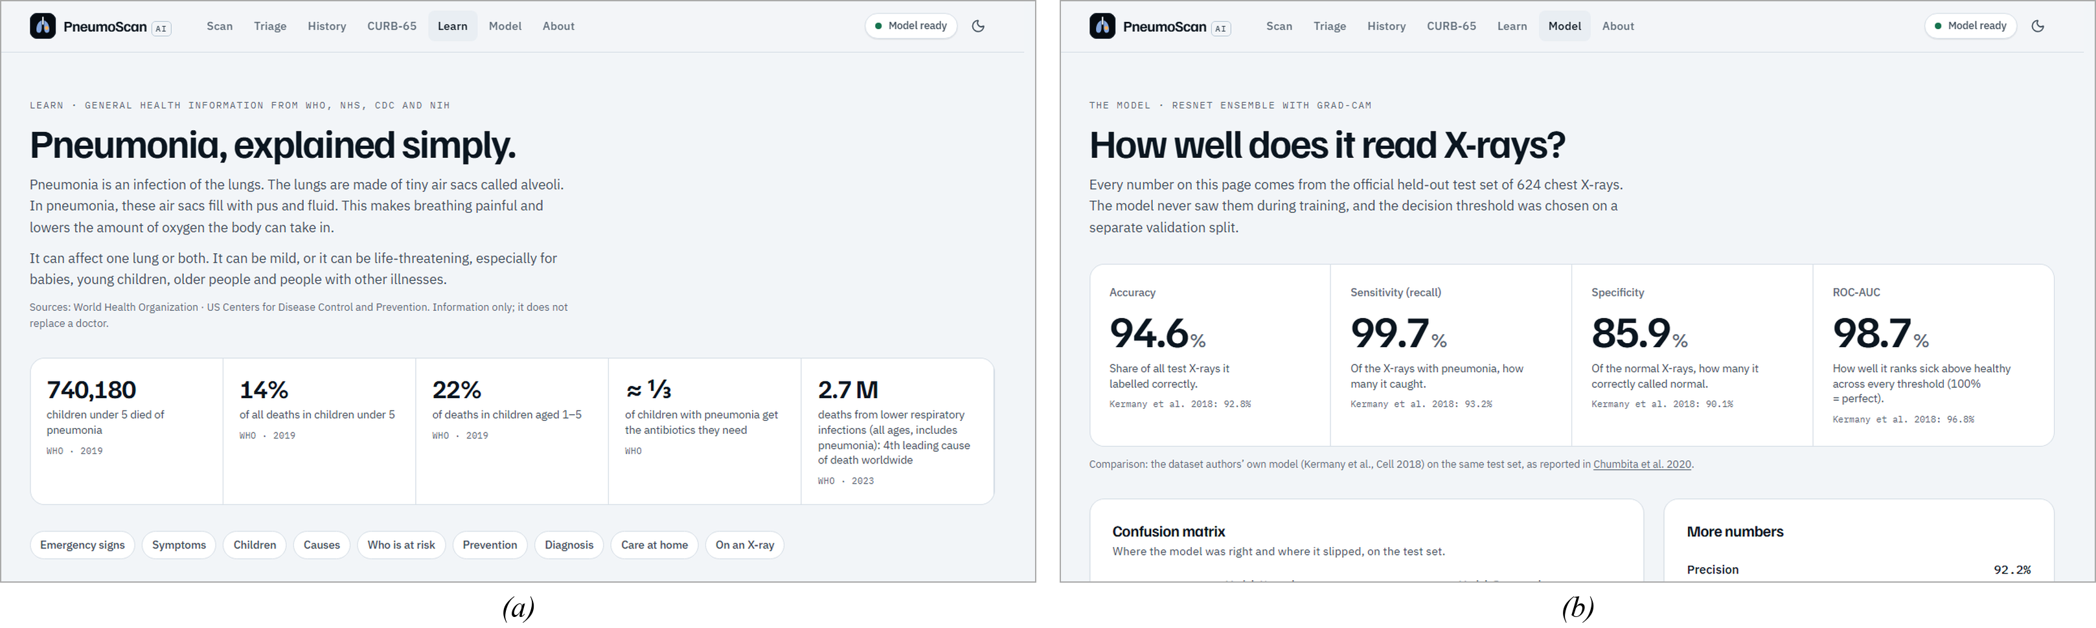
Figure 26. (a) Learn page with sourced health information; (b) Model page with test-set performance.
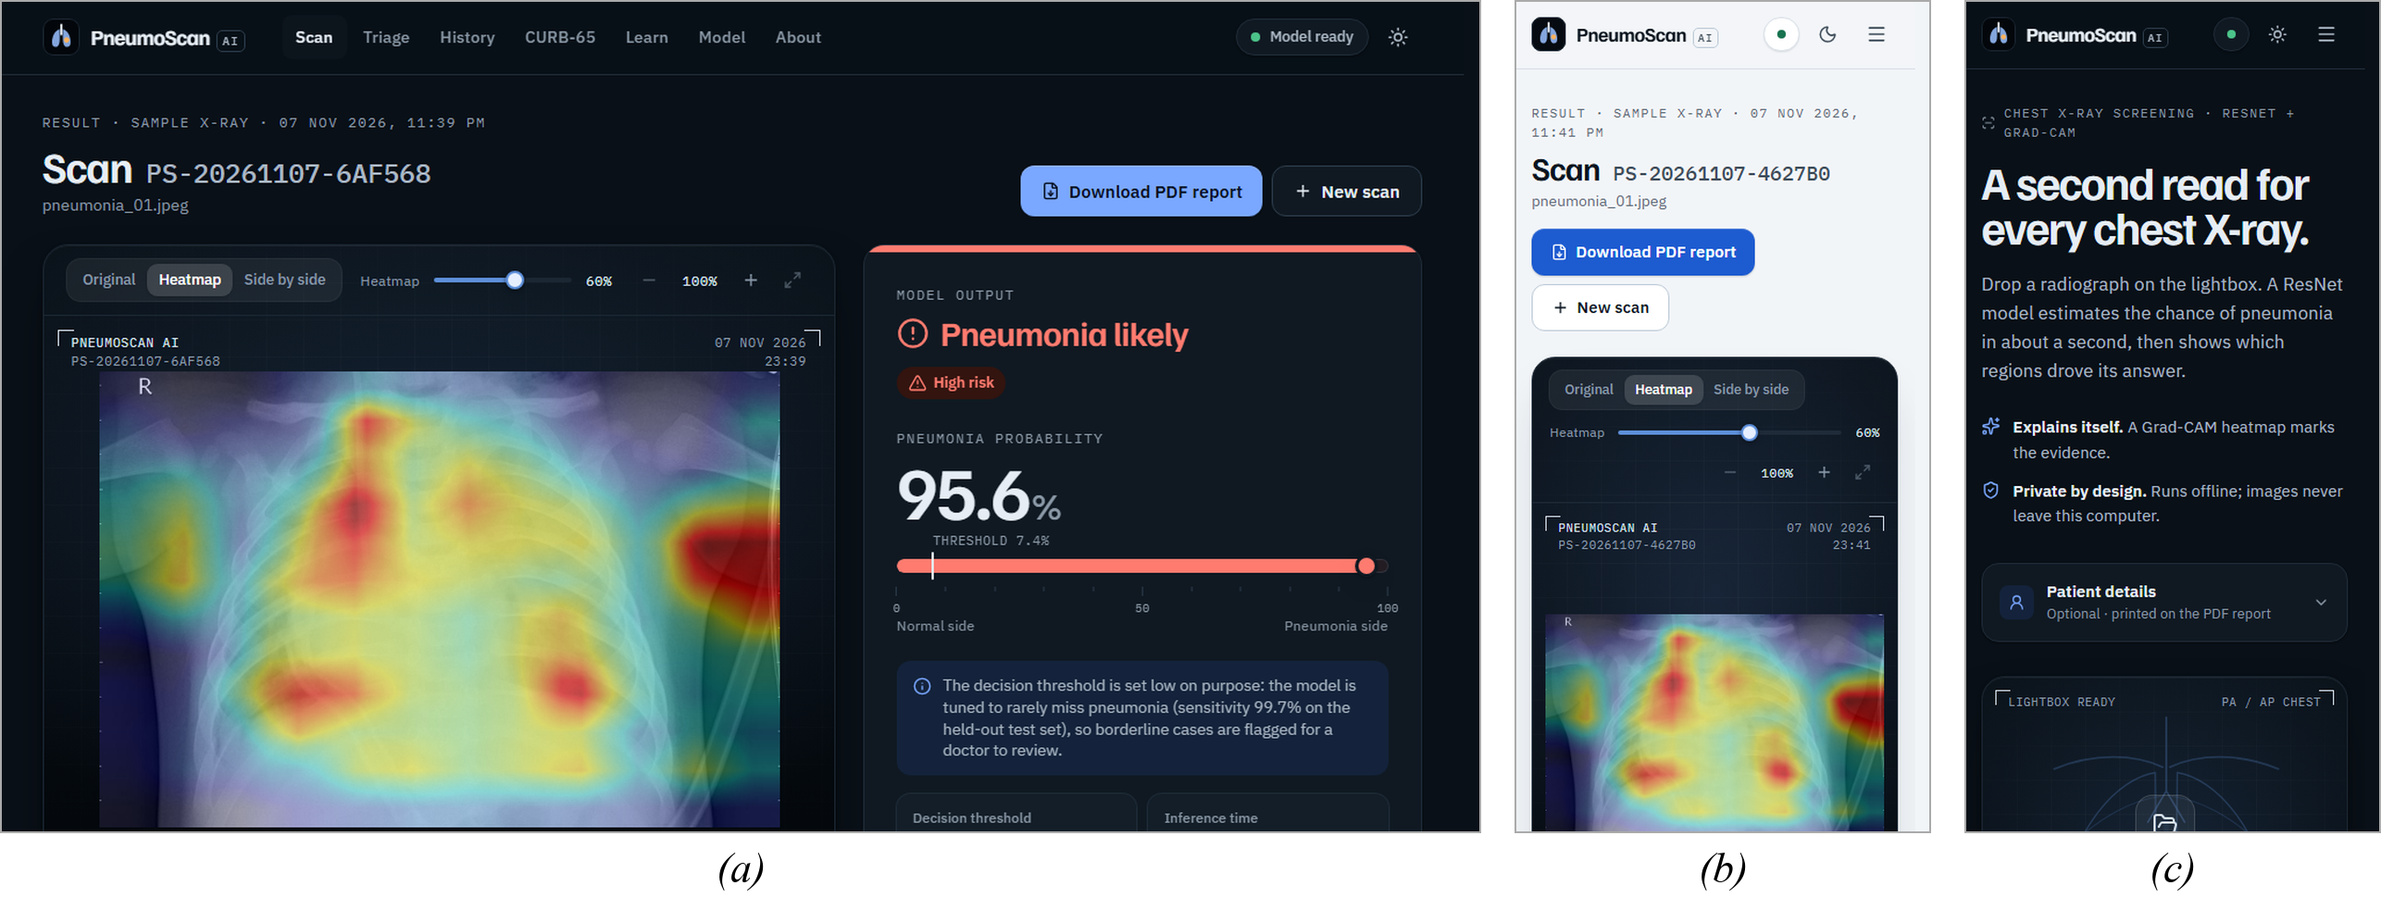
Figure 27. (a) Result screen in dark mode; (b) result and (c) scan page on a phone.

5. Results and Evaluation
All settings were fixed on the 747-image validation split; the final ensemble was then applied once to the official 624-image test set, and nothing was re-trained or re-thresholded afterwards.

Prediction Summary
Table 12. Final ensemble on the official test set (624 X-rays)
Metric | Value | Interpretation
Accuracy | 94.55% | 590 of 624 X-rays classified correctly
Sensitivity (Recall) | 99.74% | 389 of 390 pneumonia X-rays detected – only 1 missed
Specificity | 85.90% | 201 of 234 normal X-rays correctly cleared
Precision | 92.18% | Of all PNEUMONIA predictions, 92% were correct
F1-Score | 95.81% | Strong balance of precision and recall
ROC-AUC | 0.9867 | Excellent ranking of pneumonia above normal images
PR-AUC | 0.9898 | High precision across almost all recall levels
Balanced Accuracy | 92.82% | Average of sensitivity and specificity
Negative Predictive Value | 99.50% | A NORMAL result is almost always truly normal (201 / 202)

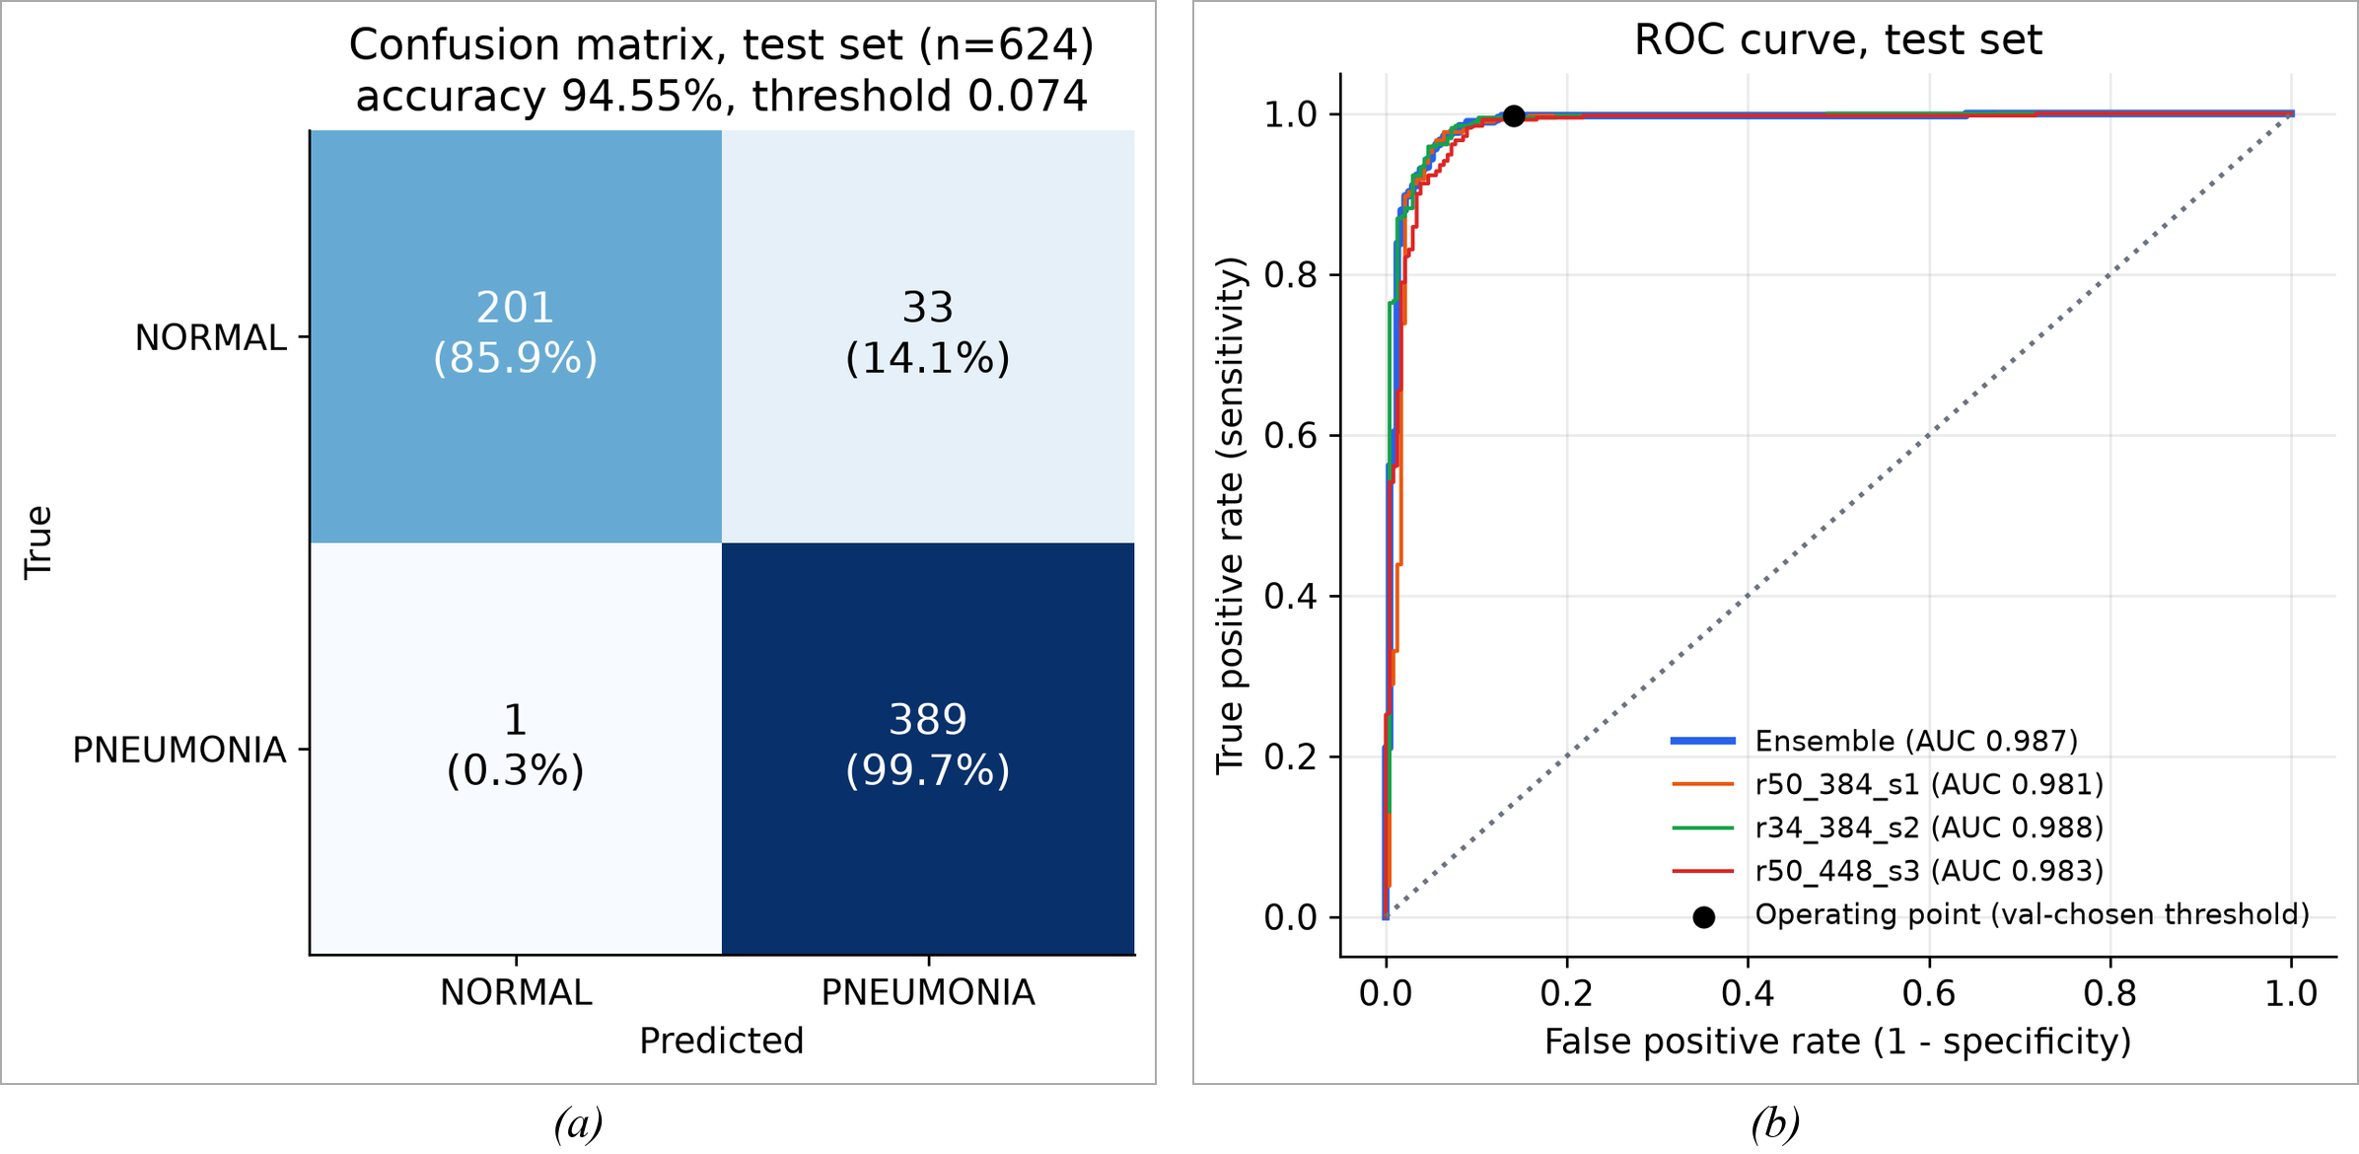
Figure 28. (a) Confusion matrix of the final ensemble; (b) ROC curves of the ensemble and its members on the test set.

Validation and Member Results
Table 13. Validation results (747 images; settings fitted on validation)
Model | T | Threshold | Accuracy | Sensitivity | Specificity | ROC-AUC
ResNet-50 @ 384 | 0.609 | 0.038 | 98.39% | 98.20% | 98.96% | 0.9974
ResNet-34 @ 384 | 0.612 | 0.067 | 98.13% | 97.66% | 99.48% | 0.9977
ResNet-50 @ 448 | 0.618 | 0.044 | 98.13% | 98.38% | 97.40% | 0.9972
Ensemble (final) | 0.602 | 0.074 | 98.39% | 98.20% | 98.96% | 0.9980

Table 14. Official test results of each member and the ensemble
Model | Accuracy | Precision | Sensitivity | Specificity | F1 | ROC-AUC
ResNet-50 @ 384 | 91.99% | 88.81% | 99.74% | 79.06% | 93.96% | 0.9811
ResNet-34 @ 384 | 94.87% | 92.82% | 99.49% | 87.18% | 96.04% | 0.9884
ResNet-50 @ 448 | 91.67% | 88.41% | 99.74% | 78.21% | 93.73% | 0.9828
Ensemble (final) | 94.55% | 92.18% | 99.74% | 85.90% | 95.81% | 0.9867

The ensemble clearly improved on the two ResNet-50 members. ResNet-34 alone scored slightly higher on the test set, but validation did not prefer it, and switching after seeing test results would be test-set tuning – so the pre-committed ensemble remains the reported model.

Performance Metrics
Table 15. Error rates and per-type sensitivity
Metric | Score
False Positive Rate | 14.10% (33 / 234)
False Negative Rate | 0.26% (1 / 390)
Sensitivity – bacterial pneumonia | 99.6% (241 / 242)
Sensitivity – viral pneumonia | 100% (148 / 148)

Table 16. X-ray gate and speed
Check | Result
Official test chest X-rays accepted by the gate | 620 / 624 (99.36%)
Non-X-ray images rejected (photographs, textures, documents, noise, plain colours) | 33 / 33
Grayscale copies of the colour images rejected | 16 / 16
Time per X-ray on GPU (3 ResNets × 2 views + Grad-CAM) | 376 ms (median)
Time per X-ray on CPU only | 1,248 ms (median)

Explainability Results
For correct predictions, the Grad-CAM maps mostly cover the lung fields (dense regions in pneumonia, broad areas of both lungs in normal X-rays). Some maps also highlight the burned-in “R” marker or text, a sign of partial shortcut learning that is reported honestly as a limitation [12].
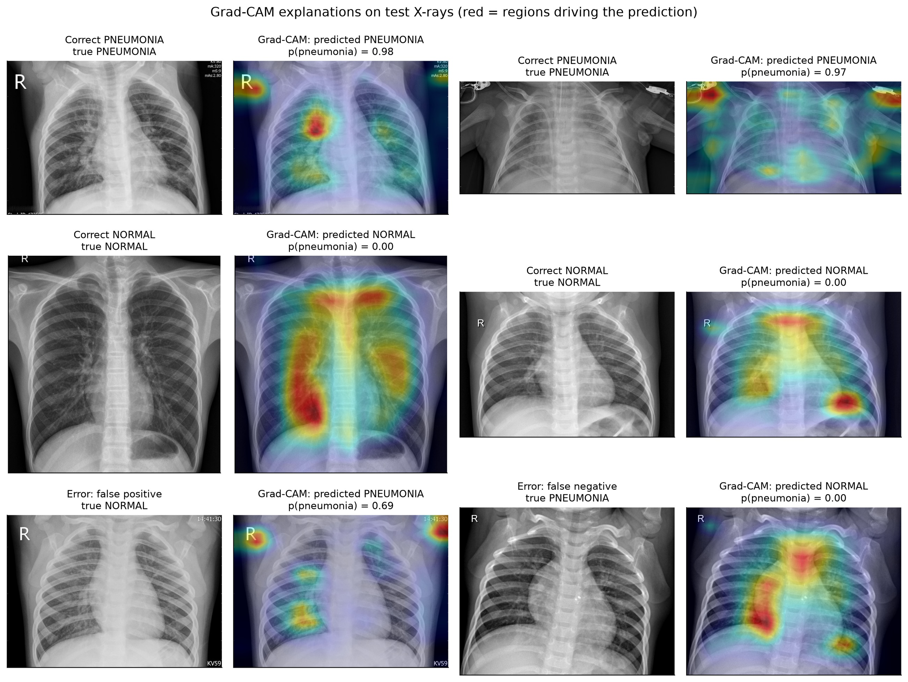
Figure 29. Grad-CAM explanations on test X-rays: correct pneumonia, correct normal, a false positive and the only false negative.

Comparative Evaluation
Table 17. Comparison with published results on the same official test set
Work | Model | Accuracy | Sensitivity | Other
Kermany et al. [2] | Inception-V3, transfer learning | 92.8% | 93.2% | AUC 0.968
Yang et al. [9] | ResNet-18 (224 px) | 86.4% | – | AUC 0.956
Yang et al. [9] | ResNet-50 (224 px) | 88.4% | – | AUC 0.962
Liang & Zheng [11] | Residual + dilated convolution | – | 96.7% | F1 92.7%
Chouhan et al. [10] | Ensemble of 5 CNNs (voting) | 96.4% | 99.62% | –
PneumoScan AI (ours) | Ensemble of 3 ResNets | 94.55% | 99.74% | AUC 0.987, F1 95.8%

PneumoScan AI is well above the published ResNet baselines (86.4–88.4%) and the dataset authors’ own Inception-V3 (92.8%), and its sensitivity of 99.74% is the highest in the table.

6. Discussion
The ResNet ensemble proved highly effective for pneumonia screening on paediatric chest X-rays. It missed only one of 390 pneumonia cases, and its ROC-AUC of 0.987 shows that it ranks pneumonia above normal images very reliably. The remaining errors are almost all normal X-rays flagged for review – the safer kind of error for a screening aid, which a doctor can quickly dismiss. The project target of 95% accuracy was missed by three images (94.55%). A threshold of 0.5 would have given 95.8%, but choosing it after seeing the test results would be tuning on the test set, so the honest, validation-chosen result is reported. The gap comes from the shift between the validation data (very clean normals) and the harder official test set, which is also seen in published work [2], [9].

Strengths Identified
- Very high sensitivity (99.74%) and negative predictive value (99.50%).
- Honest methodology: patient-level split, leakage checks and a single logged test evaluation.
- Explainable: Grad-CAM heat maps for every prediction.
- Safe: the X-ray gate rejected all 33 non-X-ray check images.
- Complete, tested product: offline web app with 14 features and 180 passing automated tests.
- Fast and affordable: about 0.4 s per X-ray on a laptop GPU; trained in under one hour.

Limitations Observed
- Trained and tested on X-rays of children aged 1–5 from one hospital; it may be less accurate on adults or other X-ray machines [12].
- Specificity of 85.9%: false alarms on normal X-rays are the main error.
- Some heat maps highlight the “R” marker or burned-in text (partial shortcut learning).
- Only two classes; it cannot tell bacterial from viral pneumonia or detect other lung diseases.
- A decision-support tool for education, not a certified medical device.

7. Future Recommendations
Table 18. Future improvements
Improvement Area | Suggested Method | Expected Benefit
Multi-centre data | Train and validate on larger adult and multi-hospital data, including Indian hospitals | Better generalisation to new patients and machines
Threshold on deployment-like data | Choose the threshold on a validation set from the target hospital | Higher specificity without losing sensitivity
Lung segmentation | Segment the lungs or mask burned-in text and markers before classification | Removes shortcut learning; more trustworthy heat maps
Multi-class diagnosis | Classify bacterial vs viral pneumonia and other chest findings | More useful clinical information
Clinical validation | Prospective study alongside radiologists | Real-world evidence of benefit
Hospital integration | Connect to PACS and teleconsultation services | Fits into existing hospital workflows
Mobile and regional languages | Lightweight mobile model and Tamil / Hindi interface for primary health centres | Reaches rural areas with few radiologists

8. Conclusion
This project built PneumoScan AI, a complete and explainable system that detects pneumonia in paediatric chest X-rays using an ensemble of three fine-tuned ResNets. Using transfer learning, class-weighted and label-smoothed training, mixed precision, test-time augmentation and temperature scaling, the system reached an accuracy of 94.55%, a sensitivity of 99.74%, a specificity of 85.90%, an F1-score of 95.81% and a ROC-AUC of 0.9867 on the official test set, which was scored only once. These results are well above the published ResNet baselines on the same images.
Beyond accuracy, the project delivers what a real user needs: Grad-CAM explanations, an X-ray gate that refuses invalid images, and an offline web application with patient PDF reports, a doctor’s triage queue, scan history, a CURB-65 calculator and sourced patient education, all verified by 180 automated tests. PneumoScan AI shows that a carefully and honestly evaluated deep-learning system can give fast, explainable support for pneumonia screening on ordinary hardware, while the final decision always stays with a qualified doctor.

9. References
1. K. He, X. Zhang, S. Ren, and J. Sun, “Deep residual learning for image recognition,” in Proc. IEEE Conf. Comput. Vis. Pattern Recognit. (CVPR), Las Vegas, NV, USA, 2016, pp. 770–778, doi: 10.1109/CVPR.2016.90.
2. D. S. Kermany et al., “Identifying medical diagnoses and treatable diseases by image-based deep learning,” Cell, vol. 172, no. 5, pp. 1122–1131.e9, Feb. 2018, doi: 10.1016/j.cell.2018.02.010.
3. D. Kermany, “Labeled optical coherence tomography (OCT) and chest X-ray images for classification,” Mendeley Data, v2, 2018, doi: 10.17632/rscbjbr9sj.2.
4. World Health Organization, “Pneumonia,” Fact sheet, Nov. 11, 2022. [Online]. Available: https://www.who.int/news-room/fact-sheets/detail/pneumonia
5. A. Chandramohan et al., “Teleradiology and technology innovations in radiology: status in India and its role in increasing access to primary health care,” Lancet Reg. Health Southeast Asia, vol. 23, Art. no. 100195, Apr. 2024, doi: 10.1016/j.lansea.2023.100195.
6. P. Rajpurkar et al., “CheXNet: Radiologist-level pneumonia detection on chest X-rays with deep learning,” arXiv:1711.05225, 2017. [Online]. Available: https://arxiv.org/abs/1711.05225
7. R. R. Selvaraju, M. Cogswell, A. Das, R. Vedantam, D. Parikh, and D. Batra, “Grad-CAM: Visual explanations from deep networks via gradient-based localization,” in Proc. IEEE Int. Conf. Comput. Vis. (ICCV), Venice, Italy, 2017, pp. 618–626, doi: 10.1109/ICCV.2017.74.
8. W. S. Lim et al., “Defining community acquired pneumonia severity on presentation to hospital: An international derivation and validation study,” Thorax, vol. 58, no. 5, pp. 377–382, May 2003, doi: 10.1136/thorax.58.5.377.
9. J. Yang et al., “MedMNIST v2 – A large-scale lightweight benchmark for 2D and 3D biomedical image classification,” Sci. Data, vol. 10, no. 1, Art. no. 41, Jan. 2023, doi: 10.1038/s41597-022-01721-8.
10. V. Chouhan et al., “A novel transfer learning based approach for pneumonia detection in chest X-ray images,” Appl. Sci., vol. 10, no. 2, Art. no. 559, Jan. 2020, doi: 10.3390/app10020559.
11. G. Liang and L. Zheng, “A transfer learning method with deep residual network for pediatric pneumonia diagnosis,” Comput. Methods Programs Biomed., vol. 187, Art. no. 104964, Apr. 2020, doi: 10.1016/j.cmpb.2019.06.023.
12. J. R. Zech, M. A. Badgeley, M. Liu, A. B. Costa, J. J. Titano, and E. K. Oermann, “Variable generalization performance of a deep learning model to detect pneumonia in chest radiographs: A cross-sectional study,” PLoS Med., vol. 15, no. 11, Art. no. e1002683, Nov. 2018, doi: 10.1371/journal.pmed.1002683.
13. J. Deng, W. Dong, R. Socher, L.-J. Li, K. Li, and L. Fei-Fei, “ImageNet: A large-scale hierarchical image database,” in Proc. IEEE Conf. Comput. Vis. Pattern Recognit. (CVPR), 2009, pp. 248–255.
14. C. Szegedy, V. Vanhoucke, S. Ioffe, J. Shlens, and Z. Wojna, “Rethinking the Inception architecture for computer vision,” in Proc. IEEE Conf. Comput. Vis. Pattern Recognit. (CVPR), 2016, pp. 2818–2826.
15. I. Loshchilov and F. Hutter, “Decoupled weight decay regularization,” in Proc. Int. Conf. Learn. Represent. (ICLR), 2019.
16. P. Micikevicius et al., “Mixed precision training,” in Proc. Int. Conf. Learn. Represent. (ICLR), 2018.
17. C. Guo, G. Pleiss, Y. Sun, and K. Q. Weinberger, “On calibration of modern neural networks,” in Proc. 34th Int. Conf. Mach. Learn. (ICML), 2017, pp. 1321–1330.
18. W. J. Youden, “Index for rating diagnostic tests,” Cancer, vol. 3, no. 1, pp. 32–35, 1950.
19. K. Lee, K. Lee, H. Lee, and J. Shin, “A simple unified framework for detecting out-of-distribution samples and adversarial attacks,” in Advances in Neural Information Processing Systems 31 (NeurIPS), 2018.
20. O. Ledoit and M. Wolf, “A well-conditioned estimator for large-dimensional covariance matrices,” J. Multivariate Anal., vol. 88, no. 2, pp. 365–411, 2004.
21. A. Paszke et al., “PyTorch: An imperative style, high-performance deep learning library,” in Advances in Neural Information Processing Systems 32 (NeurIPS), 2019, pp. 8024–8035.
22. F. Pedregosa et al., “Scikit-learn: Machine learning in Python,” J. Mach. Learn. Res., vol. 12, pp. 2825–2830, 2011.
23. R. Kundu, R. Das, Z. W. Geem, G.-T. Han, and R. Sarkar, “Pneumonia detection in chest X-ray images using an ensemble of deep learning models,” PLoS ONE, vol. 16, no. 9, Art. no. e0256630, Sep. 2021, doi: 10.1371/journal.pone.0256630.

