PNEUMONIA DETECTION
USING RESNET
PneumoScan AI: an explainable ResNet-ensemble system for chest X-ray screening

A MINI PROJECT REPORT
submitted for
CSDX530 – DEEP LEARNING
(CAT-2 Mini Project)
Submitted by
UMER BASITH G
Register Number: 230171601192
Under the guidance of
Mrs. Mahalakshmi R
Assistant Professor / CSE
Department of Computer Science and Engineering

DEPARTMENT OF COMPUTER SCIENCE AND ENGINEERING
B.S. ABDUR RAHMAN CRESCENT INSTITUTE OF SCIENCE AND TECHNOLOGY
Vandalur, Chennai
NOVEMBER 2026

ABSTRACT
Pneumonia is an infection of the lungs and a leading cause of death in young children; the World Health Organization reports 740,180 deaths of children under five in 2019 [14]. Chest X-ray imaging is the most frequently used method for diagnosing pneumonia [12], but reading X-rays needs trained radiologists, who are scarce in India [16]. This project presents PneumoScan AI, a decision-support system that classifies frontal chest X-ray images as NORMAL or PNEUMONIA using deep residual networks (ResNet) [1].
Three ImageNet-pretrained ResNets (ResNet-50 at 384 × 384 pixels, ResNet-34 at 384 × 384 and ResNet-50 at 448 × 448) are fine-tuned end-to-end with transfer learning on the public paediatric chest X-ray dataset of Kermany et al. [2], [17], using class-weighted cross-entropy with label smoothing, realistic data augmentation, mixed-precision training and an exponential moving average of the weights. The members are combined into an ensemble with horizontal-flip test-time augmentation, the output is calibrated by temperature scaling, and the decision threshold is chosen by Youden’s J statistic. All of these choices were made on a patient-level validation split carved out of the training data; the official independent test set of 624 images was scored exactly once.
On this test set the system achieves an accuracy of 94.55%, a sensitivity of 99.74% (only 1 of 390 pneumonia X-rays missed), a specificity of 85.90%, a precision of 92.18%, an F1-score of 95.81% and a ROC-AUC of 0.9867. The project target of 95% accuracy was missed by three images; the remaining errors are mainly normal X-rays flagged for review, which is the safer kind of error for a screening aid and matches the published behaviour of this test set. Grad-CAM heat maps [4] show the image regions behind each prediction, and an out-of-distribution gate turns away images that are not chest X-rays: it rejected all 33 non-X-ray check images (photographs, textures, documents and blank images) while accepting 620 of the 624 test X-rays.
The model is delivered through an offline web application built with FastAPI and React, offering single and batch (triage) scanning, patient PDF reports, local scan history, a CURB-65 severity calculator [5] and sourced patient education. The tool is intended for education and decision support only and does not replace a qualified doctor.
Keywords: pneumonia, chest X-ray, deep learning, ResNet, transfer learning, ensemble, Grad-CAM, explainable AI, medical decision support.

TABLE OF CONTENTS
ABSTRACT i
1 INTRODUCTION 1
2 LITERATURE SURVEY 3
3 SYSTEM ANALYSIS AND DESIGN 5
4 DATASET DETAILS 7
5 MODEL ARCHITECTURE AND METHODOLOGY 9
6 IMPLEMENTATION 13
7 RESULTS AND DISCUSSION 16
8 APPLICATION AND SCREENSHOTS 20
9 CONCLUSION AND FUTURE ENHANCEMENTS 25
REFERENCES 26

CHAPTER 1

INTRODUCTION

1.1 Background
Pneumonia is a form of acute respiratory infection in which the alveoli (the tiny air sacs of the lungs) fill with pus and fluid, making breathing painful and reducing the amount of oxygen the body can take in [14]. It can be caused by viruses, bacteria or fungi [14]. In children, Streptococcus pneumoniae is the most common bacterial cause and respiratory syncytial virus the most common viral cause [14]. Children younger than five years and adults aged 65 years or older are at increased risk, and people with a weakened immune system are at the greatest risk [19].
The disease burden is very large. Pneumonia caused 740,180 deaths of children under five in 2019, which is 14% of all deaths in that age group [14]. Across all ages, lower respiratory infections caused 2.7 million deaths in 2023, were the fourth leading cause of death worldwide and have remained the leading cause of death in low-income countries since around 2010 [15]. Pneumonia can be prevented by immunisation, adequate nutrition and cleaner indoor air, and pneumonia caused by bacteria can be treated with antibiotics [14], so early and correct diagnosis matters.

1.2 Role of the Chest X-ray
A doctor diagnoses pneumonia from the history, the physical examination (temperature, breathing rate, listening to the chest) and investigations. The chest X-ray (radiograph) is the most frequently used imaging test to confirm pneumonia [12]. On a frontal chest X-ray, pneumonia typically appears as consolidation: a white (opaque) area where the air in the alveoli has been replaced by fluid or pus. The World Health Organization standard for reading children’s chest radiographs counts alveolar consolidation or pleural effusion as the primary end-point for pneumonia [20]. Other signs include air bronchograms inside the opacity and loss of the normal sharp borders of the heart or diaphragm.

1.3 Problem Statement
Manual interpretation of chest X-rays for pneumonia is time-consuming, depends on the availability of trained radiologists, and is subject to variation between readers [12]. In India there are only about 20,500 registered radiologists, roughly one per 100,000 people [16]. There is a need for an accurate, explainable and easy-to-use automated system that can analyse a chest X-ray, indicate the likelihood of pneumonia, highlight the regions that influenced the decision and help to prioritise patients, while making clear that the final decision rests with a qualified doctor.

1.4 Objectives
- To build a deep-learning classifier based on the ResNet architecture that labels a frontal chest X-ray as NORMAL or PNEUMONIA.
- To reach a target accuracy of at least 95% on the official held-out test set of 624 images, and to report sensitivity, specificity, precision, F1-score and ROC-AUC honestly, whatever the outcome.
- To avoid any tuning on the test set by selecting every setting (epochs, ensemble, calibration and decision threshold) on a validation split drawn only from the training data.
- To provide a visual explanation of each prediction using Grad-CAM heat maps.
- To reject input images that are not chest X-rays.
- To develop an offline web application with single-image scanning, batch triage, patient PDF reports, scan history and a CURB-65 severity calculator.
- To present reliable, sourced health information about pneumonia for patients and families.

1.5 Scope
- Input: frontal chest X-ray images in JPG, PNG, BMP, WEBP, TIFF or DICOM format.
- Output: a two-class prediction (NORMAL / PNEUMONIA), a calibrated probability, a risk level (Low / Moderate / High), a Grad-CAM heat map and a downloadable PDF report.
- Data: the public paediatric chest X-ray dataset of Kermany et al. (children aged 1–5 years from one hospital in Guangzhou, China) [2], [17].
- Users: medical students (learning), doctors (second reader and triage aid) and patients (education).
- Out of scope: identifying the cause (bacterial or viral), detecting other lung diseases, validation on adults, and any use as a certified medical device.
CHAPTER 2

LITERATURE SURVEY

2.1 Introduction
This chapter reviews the work that this project builds on: the ResNet architecture, transfer learning for chest X-rays, ensembles of CNNs, explainability with Grad-CAM, generalisation across hospitals and the CURB-65 clinical score. Every paper was checked against PubMed, Crossref, arXiv or the open-access full text. An important observation is that several papers report very high accuracy (97–99%) on the Kermany data, but they re-split the images or used cross-validation instead of the official 624-image test set. Such numbers are not directly comparable with results on the official test set, and this is shown in the “Data / evaluation” column of Table 2.1.

2.2 Summary of the Literature
Table 2.1 summarises the reviewed works. Results marked “official test” use the same 624 test images as this project; the others use different evaluation data and are listed for context only.
Table 2.1: Summary of the literature survey
Ref. | Authors (year) | Model / method | Data / evaluation | Main result
[1] | He et al. (2016) | ResNet, up to 152 layers | ImageNet | 3.57% top-5 error (ensemble)
[2] | Kermany et al. (2018) | Inception-V3, transfer learning | Kermany, official test | Acc 92.8%, Sens 93.2%, Spec 90.1%, AUC 96.8% (as quoted in [18])
[3] | Rajpurkar et al. (2017) | DenseNet-121 (CheXNet) | ChestX-ray14 (adults) | F1 above average radiologist
[4] | Selvaraju et al. (2017) | Grad-CAM | ImageNet, VQA, captioning | Class-discriminative heat maps
[5] | Lim et al. (2003) | CURB-65 score | 1,068 adults with CAP | Mortality 1.5% / 9.2% / 22% by group
[6] | Yang et al. (2023) | ResNet-18 / ResNet-50 | PneumoniaMNIST, official test | ResNet-50 (224): Acc 88.4%, AUC 0.962
[7] | Stephen et al. (2019) | CNN from scratch | Re-split, validation | Val acc 93.73%
[8] | Chouhan et al. (2020) | 5-CNN ensemble (voting) | Guangzhou unseen test data | Acc 96.4%, recall 99.62%
[9] | Rahman et al. (2020) | AlexNet / ResNet-18 / DenseNet-201 / SqueezeNet | Own split, 5,247 images | Acc 98% (normal vs pneumonia)
[10] | Hashmi et al. (2020) | Weighted 5-CNN ensemble | Re-split (700 test) | Acc 98.43%, AUC 99.76%
[11] | Liang & Zheng (2020) | Residual + dilated convolution | Kermany test set | Recall 96.7%, F1 92.7%
[12] | Kundu et al. (2021) | GoogLeNet + ResNet-18 + DenseNet-121 | 5-fold cross-validation | Acc 98.81%
[13] | Zech et al. (2018) | CNN, multi-hospital | Internal vs external hospitals | AUC 0.931 internal vs 0.815 external

2.3 Research Gap
From the survey, the following gaps are identified:
- Most high-accuracy results use re-split data or cross-validation, so they do not show how a model behaves on the official, independent test set, which is known to be harder [2], [6].
- On the official test set, reported errors are dominated by normal X-rays called pneumonia (for example Kermany et al. report a specificity of 90.1% against a sensitivity of 93.2% [2]), which makes the choice of decision threshold critical; yet thresholds and model selection are rarely fixed on a separate validation split.
- Models can learn hospital-specific shortcuts and generalise poorly [13], so visual explanations and honest limitations are essential.
- Few works combine a ResNet ensemble, a validation-only threshold, Grad-CAM explanations, rejection of non-X-ray inputs and clinical tools (CURB-65, triage, patient reports) in one offline application for doctors and patients.
PneumoScan AI addresses these gaps with a patient-level validation split, a three-member ResNet ensemble whose every setting is chosen on validation, a single logged evaluation on the official test set, Grad-CAM explanations, an out-of-distribution X-ray gate and a complete offline application.
CHAPTER 3

SYSTEM ANALYSIS AND DESIGN

3.1 Proposed System
PneumoScan AI is an offline decision-support application that analyses a chest X-ray with an ensemble of ResNets and explains its output. Its main parts are:
1. Pre-processing: any image mode (8/16-bit, RGB, RGBA, DICOM) is converted to 8-bit grayscale, squashed to a square canonical view, resized to the network input size (384 or 448 pixels), replicated to three channels and normalised with ImageNet statistics.
2. X-ray gate: simple colour, blank and size checks plus an out-of-distribution distance (Mahalanobis distance [29] with a Ledoit-Wolf covariance [30]) on ResNet features reject images that are not chest X-rays.
3. Classification: three fine-tuned ResNets score the image and its mirror image; their logit margins are averaged, calibrated by temperature scaling and compared with a threshold chosen on validation data.
4. Explainability: Grad-CAM heat maps from the last residual stage of every member are averaged and overlaid on the X-ray.
5. Application: a FastAPI back-end and a React front-end provide scanning, batch triage, PDF reports, scan history, a CURB-65 calculator, a Learn page and a Model page, all running on the local computer.
Table 3.1 compares the existing approach with the proposed system.
Table 3.1: Comparison of the existing and proposed systems
Aspect | Existing system | Proposed system (PneumoScan AI)
Reading | Manual reading of every film by a specialist | Automatic second reading in about 0.4 s per image on the GPU
Availability | Depends on radiologist availability | Runs offline on an ordinary laptop (GPU or CPU)
Prioritisation | Usually first come, first served | Triage queue sorted by pneumonia probability, urgent cases flagged
Explanation | Not applicable / black-box models | Grad-CAM heat map for every prediction
Evaluation | Often re-split data or test-set tuning | All choices on validation; official test set scored once
Input check | Models accept any image | X-ray gate rejects photographs, documents and blanks
Reporting | Separate, manual | One-click patient PDF with heat map and disclaimer
Clinical context | Separate tools | Built-in CURB-65 calculator and sourced patient education

3.2 System Architecture
Figure 3.1 shows the overall architecture. It has three layers. The presentation layer is a React single-page application that runs in the browser. The application layer is a FastAPI server that exposes a JSON REST API, decodes and validates uploaded images, manages the model and builds PDF reports. The model and data layer contains the X-ray gate, the ResNet ensemble with calibration and threshold, Grad-CAM and the SQLite database with saved images.
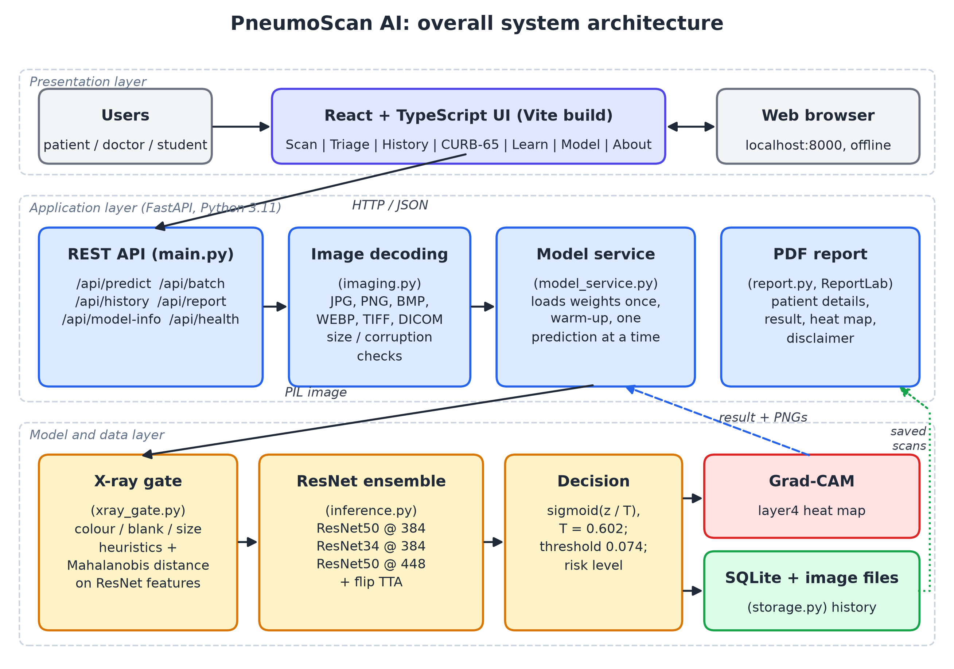
Figure 3.1: Overall system architecture of PneumoScan AI
CHAPTER 4

DATASET DETAILS

4.1 Source of the Dataset
The project uses the paediatric chest X-ray dataset released by Kermany et al. together with their Cell paper [2], [17]. The images were collected at Guangzhou Women and Children’s Medical Center from children aged one to five years, and the labels were assigned by expert physicians. The original release was downloaded from Mendeley Data without any login and its integrity was verified against the SHA-256 hash published by Mendeley. Table 4.1 summarises the dataset.
Table 4.1: Summary of the dataset
Item | Value
Name | Labeled Optical Coherence Tomography (OCT) and Chest X-Ray Images for Classification, Mendeley Data, version 2 (2018) [17]
Licence | CC BY 4.0 (credit: Kermany et al., Cell, 2018 [2])
Population | Paediatric patients (1–5 years), Guangzhou Women and Children’s Medical Center; frontal (anterior–posterior) chest X-rays
Official training set | 5,232 images: 1,349 NORMAL and 3,883 PNEUMONIA (2,538 bacterial and 1,345 viral by file name)
Official test set | 624 images: 234 NORMAL and 390 PNEUMONIA (matches the official release exactly)
Image size | Median 1281 × 888 pixels; width from 384 to 2916 pixels

4.2 Class Distribution and Split
The official test set is kept untouched until the final evaluation. A validation set was carved out of the official training folder with stratified group K-fold (seven folds, shuffled, random seed 42), grouping the images by patient so that no child appears in both training and validation. Patient identifiers were parsed from the file names. One fold (14.3% of the training images) became the validation set. Table 4.2 shows the resulting split. Automatic checks found no patient in both training and validation, and no exact or near-duplicate image shared between the test set and the training or validation images.
Table 4.2: Images and patients in each split
Split | NORMAL | PNEUMONIA | Total | Patients | Pneumonia share
Train | 1,157 | 3,328 | 4,485 | 2,272 | 74.2%
Validation | 192 | 555 | 747 | 378 | 74.3%
Test (official) | 234 | 390 | 624 | 404 | 62.5%
Total | 1,583 | 4,273 | 5,856 | – | 73.0%

4.3 Sample Images
Figure 4.1 shows typical training images. Normal X-rays show clear, dark lung fields with sharp borders of the heart and diaphragm, while pneumonia X-rays show hazy or dense white areas. Many images also contain burned-in text such as the “R” side marker and exposure values.
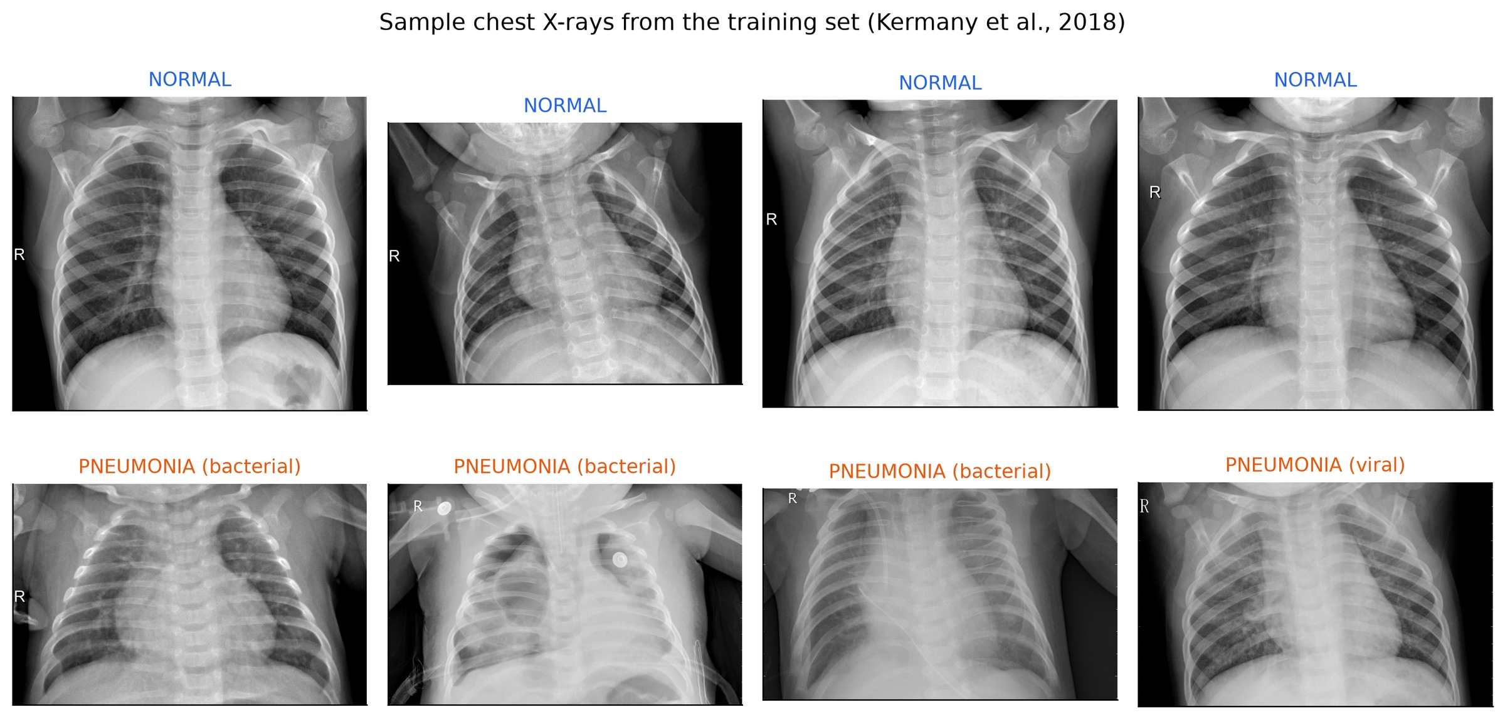
Figure 4.1: Sample training X-rays: four NORMAL (top) and four PNEUMONIA (bottom)

4.4 Pre-processing and Augmentation
The same pre-processing code (ml/common.py) is used for training, evaluation and the application, so the network always sees images in the same way. Every image is converted to 8-bit grayscale (16-bit DICOM images are rescaled and the EXIF orientation is applied), squashed to a 512 × 512 canonical view so that the whole chest is always visible, resized to the member’s input size (384 or 448 pixels), copied to three channels and normalised with the ImageNet mean and standard deviation, because the backbones were pretrained on colour ImageNet photographs [23].
To reduce over-fitting, each training image is randomly transformed every time it is used: a random crop (75–100% of the image), a left–right flip, a small rotation (±10°) and shift, brightness and contrast changes (±20%), slight blur and sensor noise. These imitate real differences between X-ray acquisitions; vertical flips are not used because an upside-down chest X-ray is not realistic. Because there are about three pneumonia images for every normal one, the loss is weighted by inverse class frequency, w_c = N / (2 N_c): 1.94 for NORMAL and 0.67 for PNEUMONIA.
CHAPTER 5

MODEL ARCHITECTURE AND METHODOLOGY

5.1 Residual Learning
Simply stacking more layers does not keep improving a plain CNN: deeper plain networks show higher training error than shallower ones (the degradation problem) [1]. A residual block lets a few layers learn a residual function F and adds the input x back through an identity shortcut (5.1). When the number of channels or the spatial size changes, a 1 × 1 projection W_s is used on the shortcut instead, y = F(x) + W_s x [1].
$$y = F\left(x, \{W_{i}\}\right) + x$$ | (5.1)

If the best mapping is close to the identity, the block only needs to push F towards zero, which is easy. During back-propagation the gradient also flows directly through the shortcut, so very deep networks remain trainable.

5.2 Basic and Bottleneck Blocks
ResNet-18 and ResNet-34 use the basic block: two 3 × 3 convolutions, each followed by batch normalisation, with ReLU after the first and after the addition. ResNet-50 uses the bottleneck block shown in Figure 5.1: a 1 × 1 convolution reduces the number of channels, a 3 × 3 convolution works on the reduced representation, and a second 1 × 1 convolution restores the channels (for example 256 → 64 → 64 → 256) before the shortcut is added. This keeps deep networks affordable.
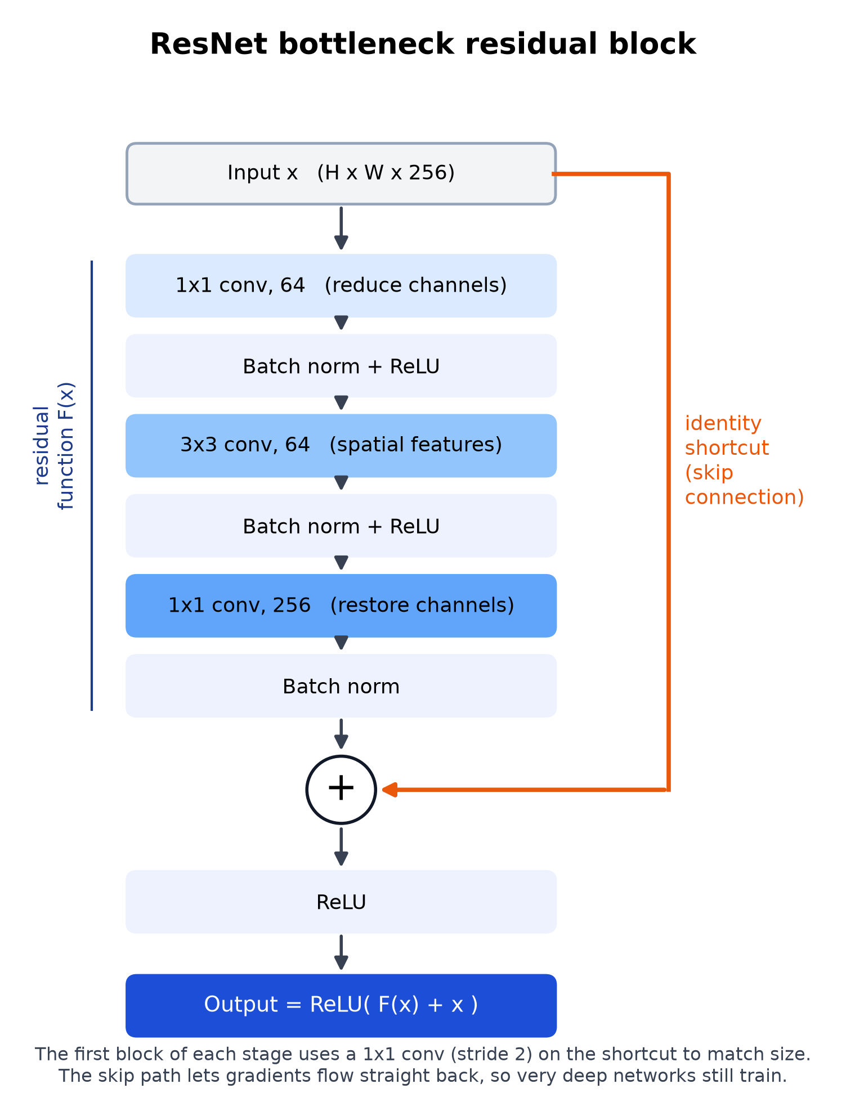
Figure 5.1: Bottleneck residual block with identity shortcut

5.3 ResNet-18, ResNet-34 and ResNet-50
All three depths share the same design: a 7 × 7 stride-2 convolution and a 3 × 3 max-pool, four residual stages (layer1 to layer4) with 64, 128, 256 and 512 base channels, global average pooling and a fully connected layer. They differ in the number and type of blocks: ResNet-18 uses 2, 2, 2, 2 basic blocks, ResNet-34 uses 3, 4, 6, 3 basic blocks and ResNet-50 uses 3, 4, 6, 3 bottleneck blocks, which end with 2048 channels instead of 512. With our two-class head, ResNet-34 has 21.3 million and ResNet-50 23.5 million parameters. The training code supports all three; the final ensemble uses ResNet-34 and ResNet-50.

5.4 Training Setup
Each network starts from ImageNet weights [23] (transfer learning). The 1000-class ImageNet layer is replaced by Dropout(0.2) and a two-class linear layer, and all layers are fine-tuned end-to-end, with the backbone learning three times more slowly than the new head. The loss (5.2) is cross-entropy with the class weights w_c of Section 4.4 and label smoothing ε = 0.1 [24], where q_c is the smoothed target. Training uses AdamW [25] with one warm-up epoch and a cosine learning-rate decay, automatic mixed precision [26] to fit the 6 GB GPU, and an exponential moving average (EMA) of the weights. After every epoch the validation ROC-AUC is computed; the best checkpoint is kept and training stops after 7 epochs without improvement (at most 20 epochs, batch size 16–32).
$$L = -\sum_{c=1}^{K}{w_{c} q_{c} log p_{c}}$$ | (5.2)

5.5 Ensemble, Calibration and Threshold
For each member and each view (the original image and its horizontal mirror), the logit margin z = ℓ_PNEUMONIA − ℓ_NORMAL is computed, and the six margins (3 members × 2 views) are averaged. Averaging models that make different mistakes reduces the variance of the prediction. Modern networks are often over-confident, so the averaged margin is divided by a temperature T fitted on the validation set (temperature scaling [27]; T = 0.602) and passed through a sigmoid to give a calibrated probability p = σ(z / T).
The decision threshold t is chosen on the validation set to maximise Youden’s J statistic [28] (5.3), which is equivalent to maximising balanced accuracy. When a whole interval of thresholds gives the same best J, the middle of the interval (in logit space) is taken. This rule was written into ml/evaluate.py before the test set was ever scored, and it gave t = 0.0743. An image is labelled PNEUMONIA when p ≥ t.
$$J\left(t\right) = Sensitivity\left(t\right) + Specificity\left(t\right) - 1$$ | (5.3)

Because the threshold is low, a PNEUMONIA label can come with a modest probability. The application therefore also reports a risk level whose bands are defined relative to t (Table 5.1).
Table 5.1: Risk levels derived from the calibrated probability p (t = 0.0743)
Risk level | Rule | Probability range | Meaning
Low | p < t / 2 | p < 0.037 | Normal side, well below the threshold
Moderate | t / 2 ≤ p < (1 + t) / 2 | 0.037 ≤ p < 0.537 | Borderline or possible pneumonia; see a doctor
High | p ≥ (1 + t) / 2 | p ≥ 0.537 | Pneumonia likely; prompt medical review

5.6 Grad-CAM Explanations
Grad-CAM [4] explains a prediction by finding which regions of the last convolutional feature maps increased the class score. Let A^k be the k-th feature map of layer4 (2048 maps of 12 × 12 for ResNet-50 at 384 px) and y^c the score for class c. The importance of each map is the spatial average of the gradient (5.4), where Z is the number of positions, and the heat map is the ReLU of the weighted sum of the maps (5.5).
$$α_{k}^{c} = \frac{1}{Z}\sum_{i}{\sum_{j}{\frac{∂y^{c}}{∂A_{ij}^{k}}}}$$ | (5.4)

$$L_{Grad-CAM}^{c} = ReLU\left(\sum_{k}{α_{k}^{c} A^{k}}\right)$$ | (5.5)

In this project the score for PNEUMONIA is the logit margin z, and the score for NORMAL is −z, so one backward pass gives the map for either class. The map for the ensemble’s final label is computed for every member, resized to the display image, averaged over the members and normalised to [0, 1]. It is drawn with a “jet” colour map (blue = low, red = high) whose transparency grows with importance, and overlaid on the X-ray at 60% opacity.

5.7 Complete Pipeline
Figure 5.2 shows the full pipeline with the output size of every ResNet-50 stage at 384 × 384 input. The X-ray is pre-processed, passed through three fine-tuned ResNets (each on the original and the mirrored image), the logit margins are averaged and calibrated, the threshold gives the decision, and Grad-CAM uses the layer4 activations and gradients to produce the heat map.
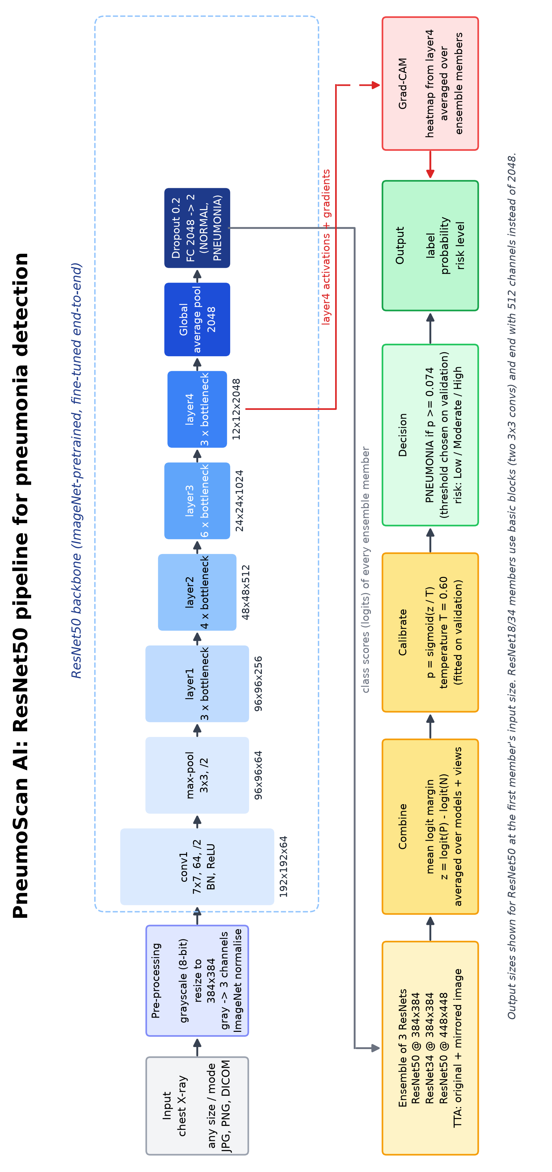
Figure 5.2: Architecture of the PneumoScan AI pipeline (ResNet-50 member shown; rotated to fit the page)
CHAPTER 6

IMPLEMENTATION

6.1 Development Environment
The project was developed and tested on a Windows 11 laptop with an NVIDIA GeForce RTX 3050 Laptop GPU (6 GB), an Intel Core i5-12450HX processor and 16 GB of RAM. Training the three ResNets took 55.5 minutes in total, and the finished application also runs without a GPU (about 1.25 s per X-ray). All software is free and open source: Python 3.11, PyTorch 2.11 with CUDA 12.8 [21] and torchvision for the ResNets, scikit-learn [22] for the metrics and the patient-level split, FastAPI for the back-end, SQLite for the scan history, ReportLab for the PDF reports, and React 19 with TypeScript, Vite and Tailwind CSS for the front-end. The code listings below are copied automatically from the project’s source files, so they match the submitted code exactly.

6.2 Building the Model
Listing 6.1 loads a torchvision ResNet with its ImageNet weights and replaces the 1000-class layer with a dropout layer and a two-class linear layer.
Listing 6.1: Building a ResNet with a two-class head (ml/common.py)
def build_model(arch: str, pretrained: bool = True):
"""torchvision ResNet with a 2-class head (NORMAL, PNEUMONIA)."""
import torch.nn as nn
import torchvision.models as tvm

weights = {
"resnet18": tvm.ResNet18_Weights.IMAGENET1K_V1,
"resnet34": tvm.ResNet34_Weights.IMAGENET1K_V1,
"resnet50": tvm.ResNet50_Weights.IMAGENET1K_V2,
}[arch] if pretrained else None
model = getattr(tvm, arch)(weights=weights)
model.fc = nn.Sequential(nn.Dropout(0.2), nn.Linear(model.fc.in_features, len(CLASSES)))
return model

6.3 Training Loop
Listing 6.2 is the core of ml/train.py. For every step the learning rate is set from the warm-up and cosine schedule, the forward pass runs under fp16 autocast, the scaled loss is back-propagated, gradients are clipped, the optimiser steps and the EMA copy of the weights is updated. After each epoch the EMA model is evaluated on validation, and the best checkpoint by validation ROC-AUC is saved.
Listing 6.2: One training epoch (ml/train.py, excerpt)
for x, y in train_dl:
# Cosine schedule with linear warm-up, updated every step.
f = (step + 1) / max(warm, 1) if step < warm else \
0.5 * (1 + math.cos(math.pi * (step - warm) / max(total - warm, 1)))
for g, lr0 in zip(opt.param_groups, base_lrs):
g["lr"] = lr0 * f
x = x.to(device, non_blocking=True)
y = y.to(device, non_blocking=True)
with torch.autocast("cuda", dtype=torch.float16, enabled=device.type == "cuda"):
logits = model(x)
loss = criterion(logits.float(), y)
opt.zero_grad(set_to_none=True)
scaler.scale(loss).backward()
scaler.unscale_(opt)
nn.utils.clip_grad_norm_(model.parameters(), 2.0)
scaler.step(opt)
scaler.update()
if ema:
ema.update(model)
step += 1
run_loss += loss.item() * len(y)
run_correct += (logits.argmax(1) == y).sum().item()
seen += len(y)

6.4 Inference API
The application uses a single class, PneumoniaModel (ml/inference.py), which loads the three members once, checks the image with the X-ray gate and returns the label, calibrated probability, risk level and three aligned PNG images (input, heat map and overlay). Listing 6.3 shows how the ensemble decision is made inside predict().
Listing 6.3: Ensemble decision inside PneumoniaModel.predict (ml/inference.py, excerpt)
margins, explained = [], []
for m in self.members:
x = self._tensor(m, view)
with torch.autocast("cuda", dtype=torch.float16, enabled=self.amp):
if with_gradcam:
acts, grads, lg = m["cam"].explain(x)
explained.append((acts, grads, x.shape[-2:]))
else:
with torch.no_grad():
lg = m["net"](x)
views = [lg]
if self.cfg.get("tta_hflip", True):
with torch.no_grad():
views.append(m["net"](torch.flip(x, dims=[3])))
margins.append(float(np.mean([float(v[0, 1] - v[0, 0]) for v in views])))
z = float(np.mean(margins))
prob = float(1 / (1 + np.exp(-z / self.cfg["temperature"])))
thr = float(self.cfg["threshold"])
label = CLASSES[int(prob >= thr)]

6.5 Back-end and Front-end
The back-end (app/backend/main.py) is a FastAPI server with a JSON REST API: POST /api/predict for one X-ray, POST /api/batch for up to 50 X-rays, /api/history for the saved scans and /api/report/{id}.pdf for the patient report. It also serves the built front-end, so the whole application runs from one local server. Listing 6.4 shows the prediction endpoint: the upload is size-checked, the patient fields are validated, and the heavy analysis runs in a worker thread so that the server stays responsive. The front-end is a React 19 single-page application written in TypeScript, styled with Tailwind CSS and built with Vite; all fonts are bundled, so nothing is loaded from the internet.
Listing 6.4: Prediction endpoint (app/backend/main.py, excerpt)
@app.post("/api/predict")
async def predict(
file: UploadFile = File(...),
name: str = Form(""),
age: str = Form(""),
sex: str = Form(""),
patient_id: str = Form(""),
symptoms: str = Form(""),
notes: str = Form(""),
source: str = Form("scan"),
ground_truth: str = Form(""),
):
model.require_ready()
patient = _patient_from_form(name, age, sex, patient_id, symptoms)
notes_clean = _clean_text(notes, "doctor_notes")
src = source if source in SOURCES else "scan"
gt = ground_truth.strip().upper() or None
if gt not in (None, "NORMAL", "PNEUMONIA"):
gt = None
data = await _read_upload(file)
fname = Path(file.filename or "upload").name
return await run_in_threadpool(_analyse, data, fname, source=src, patient=patient,
notes=notes_clean, ground_truth=gt)

6.6 Testing
Because this is a healthcare tool, the system was tested at four levels (Table 6.1), and all 180 automated tests pass.
Table 6.1: Automated tests (all passing)
Level | Tests | What is checked
ML contract (ml/test_inference.py) | 24 | Result format, image sizes, every image mode, 16-bit DICOM, rejection of photographs, blank and noise images
Back-end (app/backend/tests) | 35 | Every API endpoint, bad and huge files, mixed batches, history create / read / update / delete, PDF reports
End-to-end (tests/) | 121 | Real model + headless browser: 12 demo X-rays, 40+ random test images, non-X-rays, path-traversal and script-injection attempts, Tamil and Hindi names in the PDF, 6 screen-size / theme combinations, server down and back
Front-end | – | ESLint and the TypeScript build: zero problems
Total | 180 | All passing
CHAPTER 7

RESULTS AND DISCUSSION

7.1 Training Behaviour
All settings (epochs, ensemble members, test-time augmentation, temperature and threshold) were chosen on the 747-image validation split; the official 624-image test set was then scored once, and nothing was re-trained or re-thresholded afterwards. Table 7.1 summarises the three training runs. All runs converged within a few epochs: validation ROC-AUC exceeded 0.99 after the first or second epoch and peaked at epoch 7–10. Afterwards training accuracy kept rising towards 99% while validation AUC flattened or fell slightly, so early stopping ended each run between epochs 14 and 17. (Loss values stay around 0.3 because label smoothing prevents the loss from approaching zero.)
Table 7.1: Training runs on the RTX 3050 GPU
Run | Model | Input | Batch | Seed | Epochs run | Best epoch | Time (min) | Best val AUC*
r50_384_s1 | ResNet-50 | 384 | 24 | 1 | 14 | 7 | 17.7 | 0.9965
r34_384_s2 | ResNet-34 | 384 | 32 | 2 | 17 | 10 | 13.9 | 0.9971
r50_448_s3 | ResNet-50 | 448 | 16 | 3 | 14 | 7 | 23.9 | 0.9974
* Validation ROC-AUC of the EMA weights at the best epoch, single view, during training. Total training time 55.5 minutes.

7.2 Official Test Results
Table 7.2 reports the single evaluation on the official test set. The final ensemble reached an accuracy of 94.55% (590 of 624 images), a sensitivity of 99.74% (389 of 390 pneumonia X-rays detected), a specificity of 85.90%, a precision of 92.18%, an F1-score of 95.81%, a ROC-AUC of 0.9867 and a PR-AUC of 0.9898. By pneumonia type, the sensitivity was 99.6% for bacterial pneumonia (241 of 242) and 100% for viral pneumonia (148 of 148).
Table 7.2: Official test-set results (624 images; thresholds from validation)
Model | Accuracy | Precision | Sensitivity | Specificity | F1 | ROC-AUC | TN / FP / FN / TP
ResNet-50 @ 384 | 91.99% | 88.81% | 99.74% | 79.06% | 93.96% | 0.9811 | 185 / 49 / 1 / 389
ResNet-34 @ 384 | 94.87% | 92.82% | 99.49% | 87.18% | 96.04% | 0.9884 | 204 / 30 / 2 / 388
ResNet-50 @ 448 | 91.67% | 88.41% | 99.74% | 78.21% | 93.73% | 0.9828 | 183 / 51 / 1 / 389
Ensemble (final) | 94.55% | 92.18% | 99.74% | 85.90% | 95.81% | 0.9867 | 201 / 33 / 1 / 389

The ensemble improved clearly on the two ResNet-50 members (91.99% and 91.67%). The ResNet-34 member alone scored slightly higher on the test set (94.87%), but validation did not prefer it (balanced accuracy 98.57% versus 98.58%, AUC 0.9977 versus 0.9980). Switching to it after seeing the test results would be test-set tuning, so the pre-committed ensemble remains the reported model.

7.3 Confusion Matrix and ROC Curve
Figure 7.1 shows the confusion matrix of the final ensemble (left) and the ROC curves of the ensemble and its members (right). Of the 34 errors, 33 are false positives (normal X-rays labelled PNEUMONIA) and only one is a false negative (a missed pneumonia). The ROC curves rise steeply towards the top-left corner, with AUC values between 0.981 and 0.988, and the marked operating point of the ensemble sits at very high sensitivity, which reflects the low validation-chosen threshold.
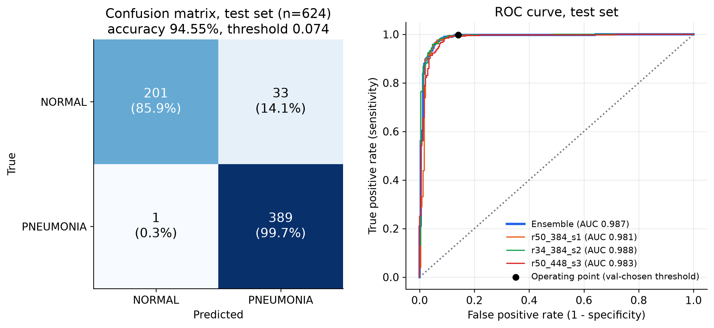
Figure 7.1: Confusion matrix (left) and ROC curves (right) on the official test set

7.4 Grad-CAM Explanations
Figure 7.2 shows Grad-CAM maps for two correctly detected pneumonia cases, two correctly classified normal cases, one false positive and the single false negative. For the correct predictions the heat maps mostly cover the lung fields: dense regions in the pneumonia cases, and broad areas of both lungs for the normal cases. However, some maps also highlight burned-in text, especially the “R” side marker in the upper corner and exposure values or time stamps. This indicates partial shortcut learning of hospital-specific image features, the same risk described by Zech et al. [13]. It is a likely contributor to errors on images acquired in a slightly different way and is listed as a limitation.
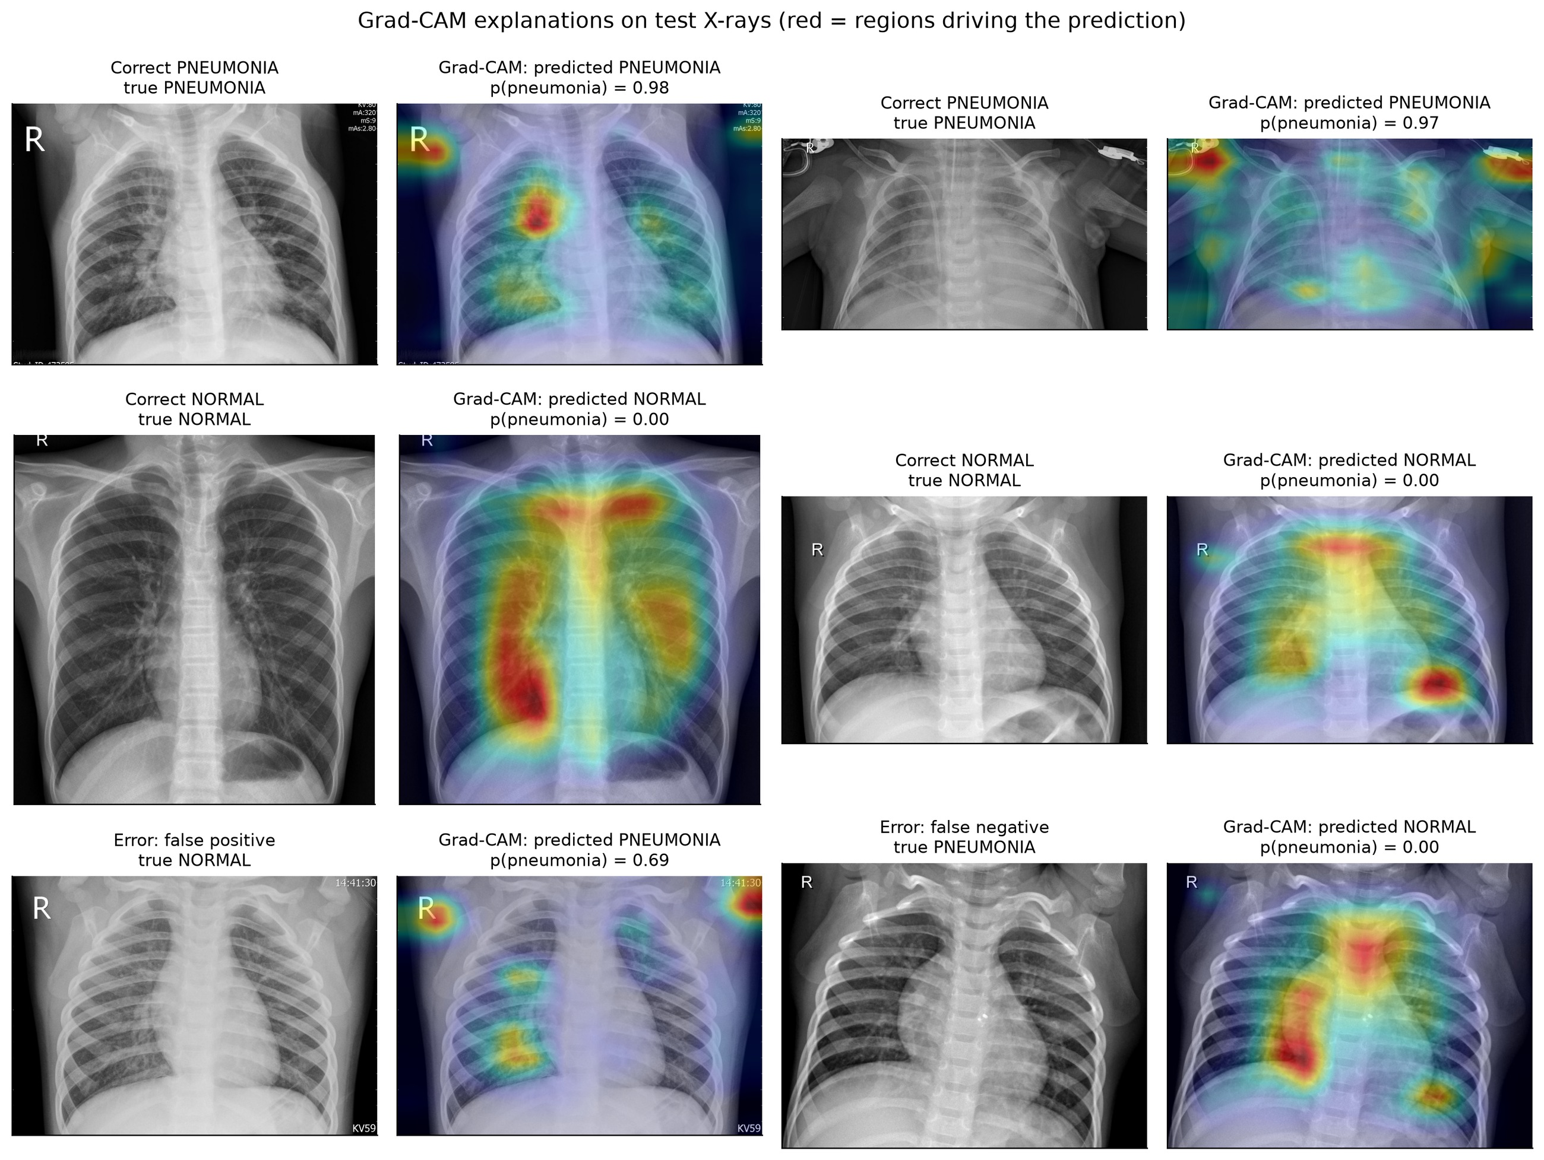
Figure 7.2: Grad-CAM explanations on test X-rays (red = regions driving the prediction)

7.5 Comparison with Published Work
Table 7.3 compares PneumoScan AI with published results that use the same official test set (Chapter 2). Results on re-split data or cross-validation (97–99%) are excluded because they are not comparable.
Table 7.3: Comparison with published results on the official Kermany test set
Work | Model | Accuracy | Sensitivity | Specificity | Other
Kermany et al. [2] | Inception-V3, transfer learning | 92.8% | 93.2% | 90.1% | AUC 0.968
Yang et al. [6] | ResNet-18, 28 px | 85.4% | – | – | AUC 0.944
Yang et al. [6] | ResNet-18, 224 px | 86.4% | – | – | AUC 0.956
Yang et al. [6] | ResNet-50, 224 px | 88.4% | – | – | AUC 0.962
Liang & Zheng [11] | Residual + dilated convolution | – | 96.7% | – | F1 92.7%
Chouhan et al. [8] | Ensemble of 5 CNNs (voting) | 96.4% | 99.62% | – | –
This work | Ensemble of 3 ResNets | 94.55% | 99.74% | 85.90% | AUC 0.9867, F1 95.81%
Sensitivity = recall for the PNEUMONIA class. “–” means not reported in the cited source. Chouhan et al. report results on “unseen data from the Guangzhou dataset” after training on the 5,232 training images.
PneumoScan AI is well above the published ResNet baselines on the same images (85.4–88.4%) and the dataset authors’ Inception-V3 (92.8%), and its sensitivity of 99.74% is the highest in the table. Only the five-CNN ensemble of Chouhan et al. reports a higher accuracy.

7.6 Discussion of the 95% Target
The objective was at least 95% accuracy on the official test set. The honest result is 94.55%, which is three images short of the target (95% of 624 is 593 correct images; the ensemble got 590). The result is nevertheless strong and clinically sensible:
- Only 1 of 390 pneumonia X-rays was missed (sensitivity 99.74%). For a screening and triage aid, missing pneumonia is the more dangerous error, and the validation-chosen threshold prioritises not missing it.
- Almost all errors are normal X-rays flagged for review, which a doctor can quickly dismiss. This matches the known behaviour of this test set in published work: Kermany et al. report lower specificity than sensitivity [2], the ResNet baselines of MedMNIST v2 have high AUC (0.944–0.962) but much lower accuracy (85.4–88.4%) [6], and the best published ensemble combines 96.4% accuracy with 99.62% recall, so its errors are also mostly false alarms [8].
- The evaluation is honest: the test set was scored once, with a threshold that was fixed on validation before the test set was touched.
For discussion only, a post-hoc analysis in the ML report shows how the same ensemble would have scored with other thresholds. With a threshold of 0.5 the test accuracy would have been 95.8% (sensitivity 98.7%, specificity 91.0%). This threshold was not adopted: choosing it after seeing the test results would be tuning on the test set, which would make the reported number optimistic and untrustworthy. The analysis is shown only to explain that the gap comes from where the threshold sits under the shift between the validation and test distributions. A future validation set that resembles the deployment data (for example from a different hospital) would allow a better threshold to be chosen honestly.
CHAPTER 8

APPLICATION AND SCREENSHOTS

8.1 Overview
The trained ensemble is delivered through an offline web application. A double-click on start.bat starts the server on the local computer and opens the browser; the status pill in the top bar changes to Model ready once the model is loaded. The navigation bar gives access to seven pages: Scan, Triage, History, CURB-65, Learn, Model and About. All screenshots were taken from the running application with the real trained model; the patient details are fictitious demo data.

8.2 Scan Page
The user drops a chest X-ray on the upload area, browses for a file or pastes an image (JPG, PNG, BMP, WEBP, TIFF or DICOM). Patient details are optional and are printed on the PDF report. A gallery of sample X-rays from the test set lets a teacher or student try the model at once (Figure 8.1).
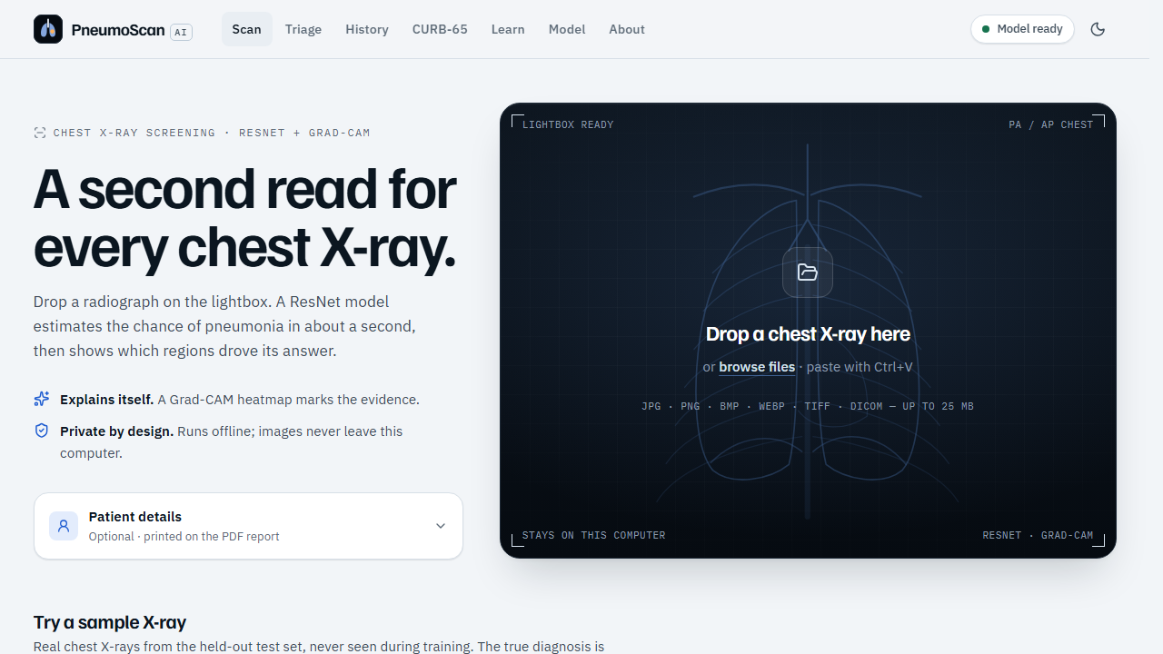
Figure 8.1: Scan page with the upload area and optional patient details

8.3 Result with Grad-CAM Heat Map
The result screen (Figure 8.2) shows the verdict, the calibrated pneumonia probability on a 0–100 ruler with the decision threshold marked, the confidence, the risk level and the inference time. The X-ray viewer shows the Grad-CAM heat map with an opacity slider, zoom, pan and a side-by-side view. Below the verdict the page gives a plain-English explanation, next steps and the disclaimer.
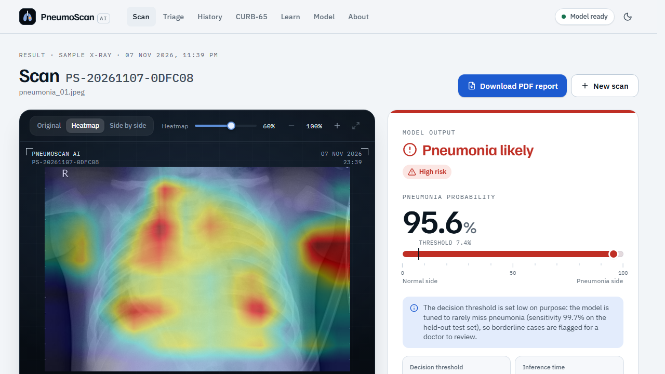
Figure 8.2: Result screen for a pneumonia X-ray with the Grad-CAM heat map

8.4 Rejection of Non-X-ray Images
If the image is not a chest X-ray, the X-ray gate turns it away with a friendly reason; no prediction is made and nothing is saved (Figure 8.3).
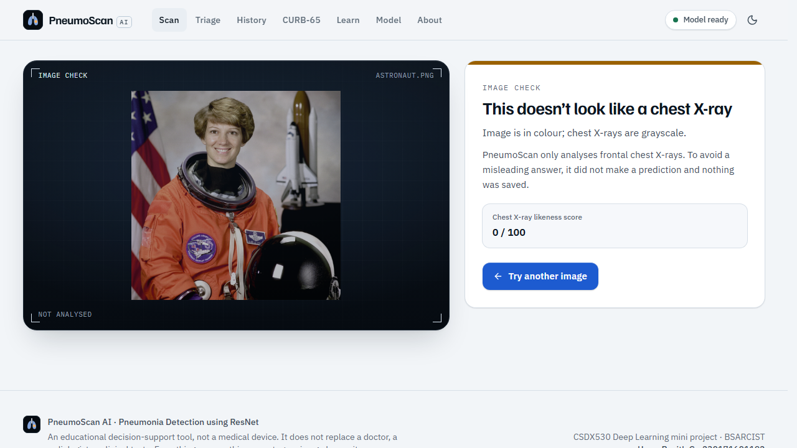
Figure 8.3: A colour photograph rejected by the X-ray gate

8.5 Patient PDF Report
A one-click PDF report (Figure 8.4) contains the patient details, the result with probability and risk level, the X-ray with its heat map, the explanation, next steps, the disclaimer and the model version. It is made on the local computer, so it works offline.
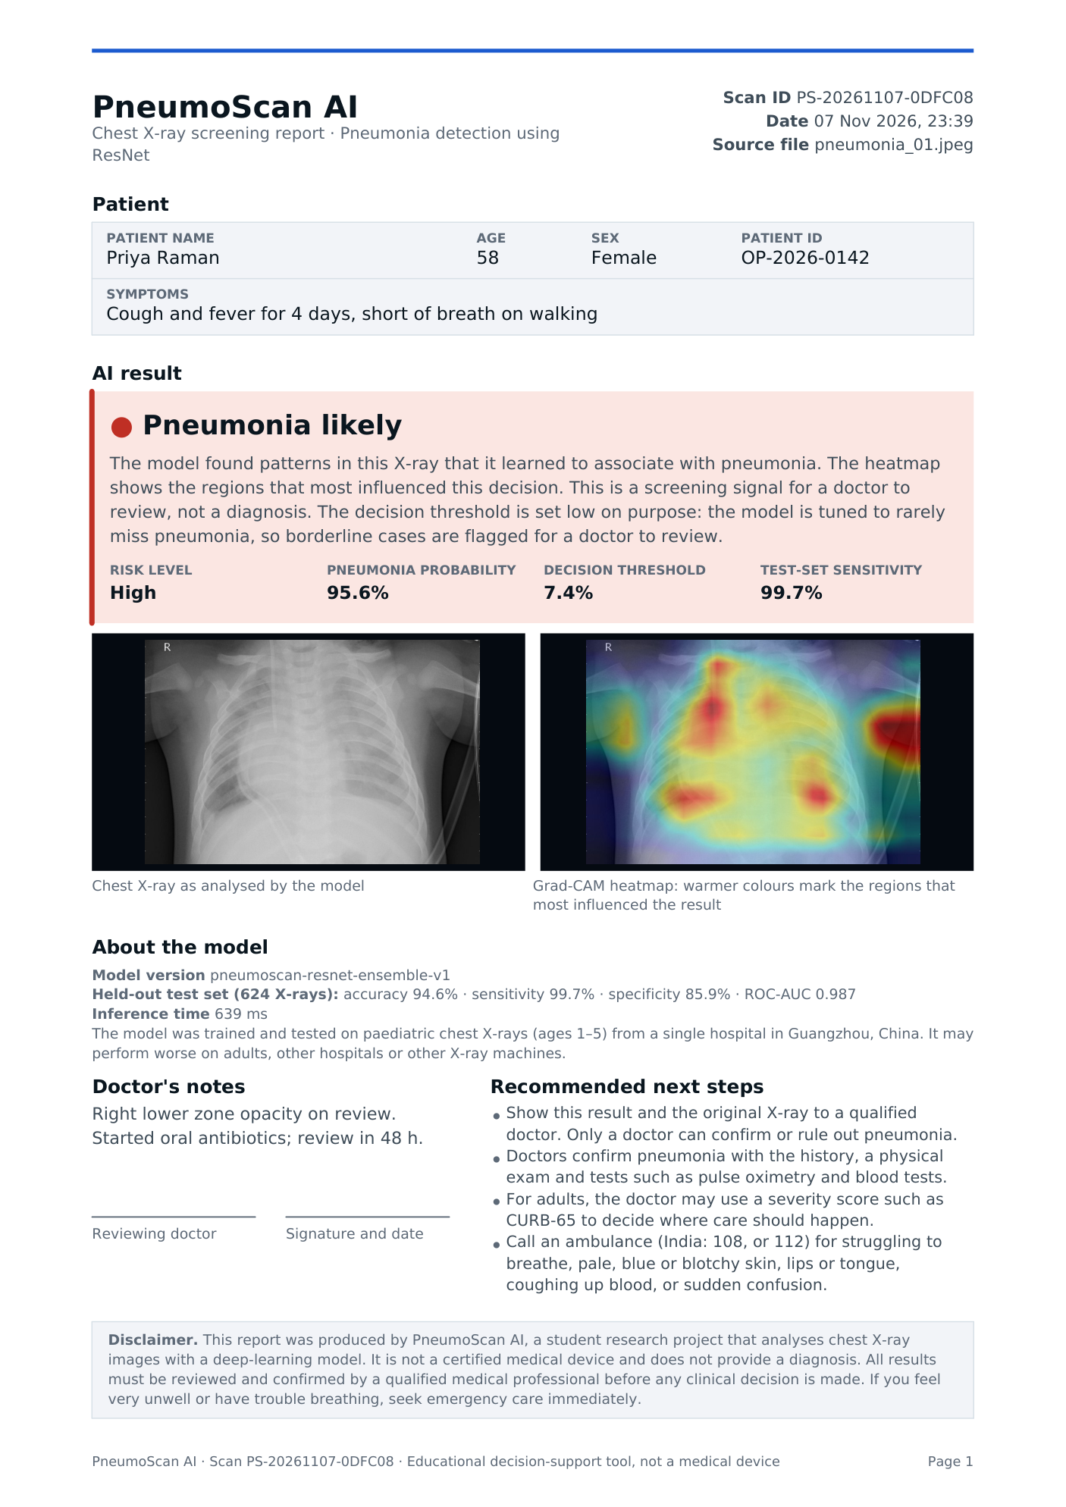
Figure 8.4: First page of a patient PDF report generated by the application

8.6 Triage Queue (Doctor Mode)
The Triage page accepts up to 50 X-rays at once. As results arrive, the queue re-orders itself so that the most likely pneumonia cases rise to the top, high-risk results are flagged as urgent, and the queue can be exported as CSV (Figure 8.5).
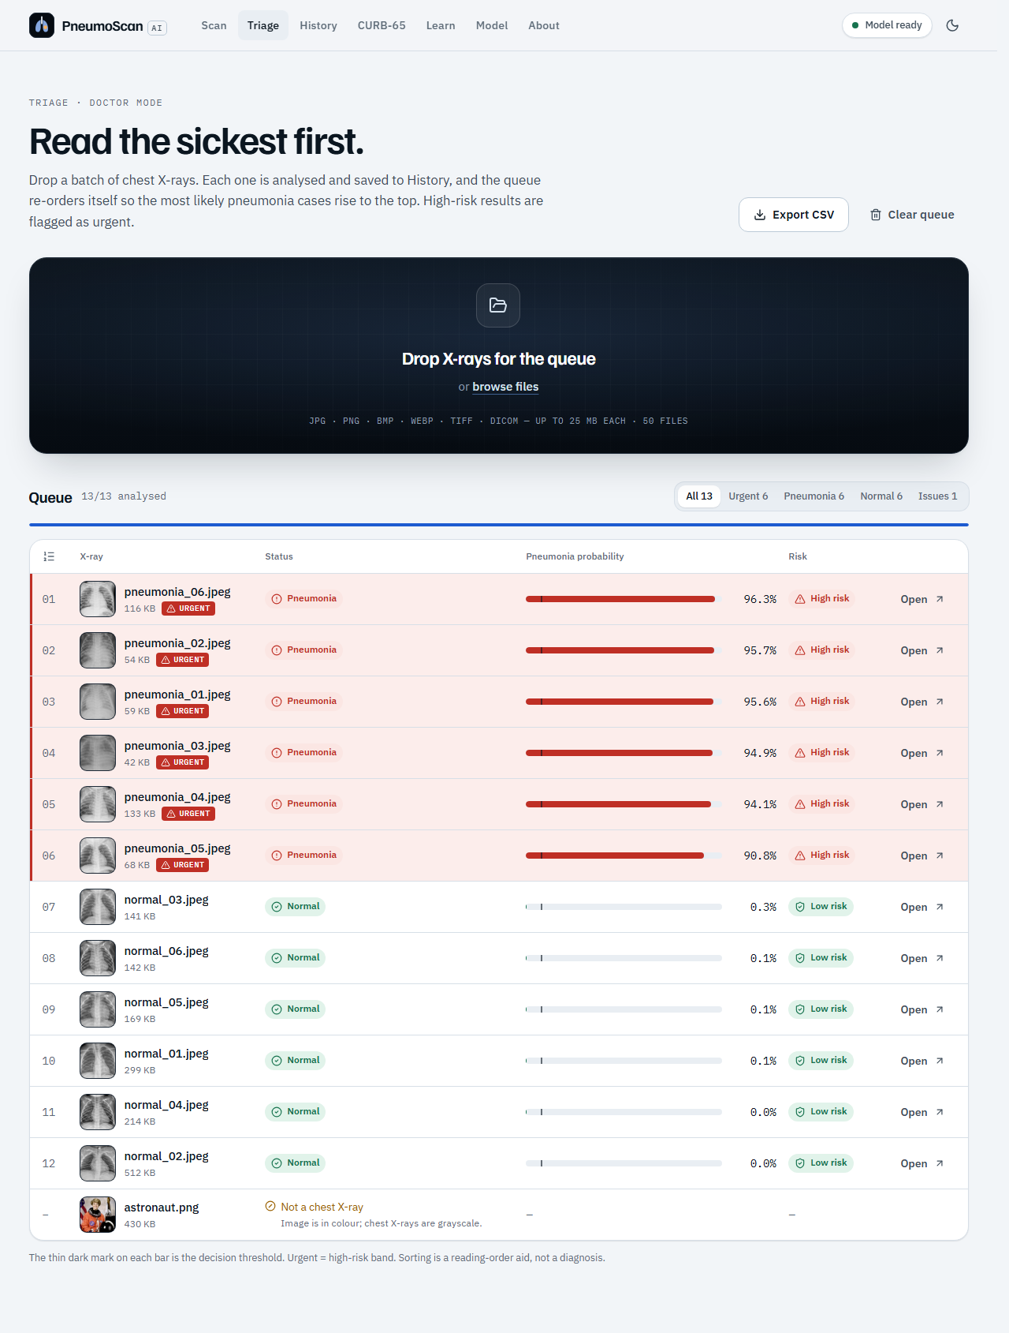
Figure 8.5: Completed triage queue sorted by pneumonia probability

8.7 CURB-65 Severity Calculator
For adults with pneumonia, the CURB-65 page (Figure 8.6) computes the standard severity score of Lim et al. [5] and shows the risk group, the 30-day mortality (1.5% for scores 0–1, 9.2% for 2 and 22% for 3–5) and the suggested care setting. Without a urea value it switches to CRB-65.
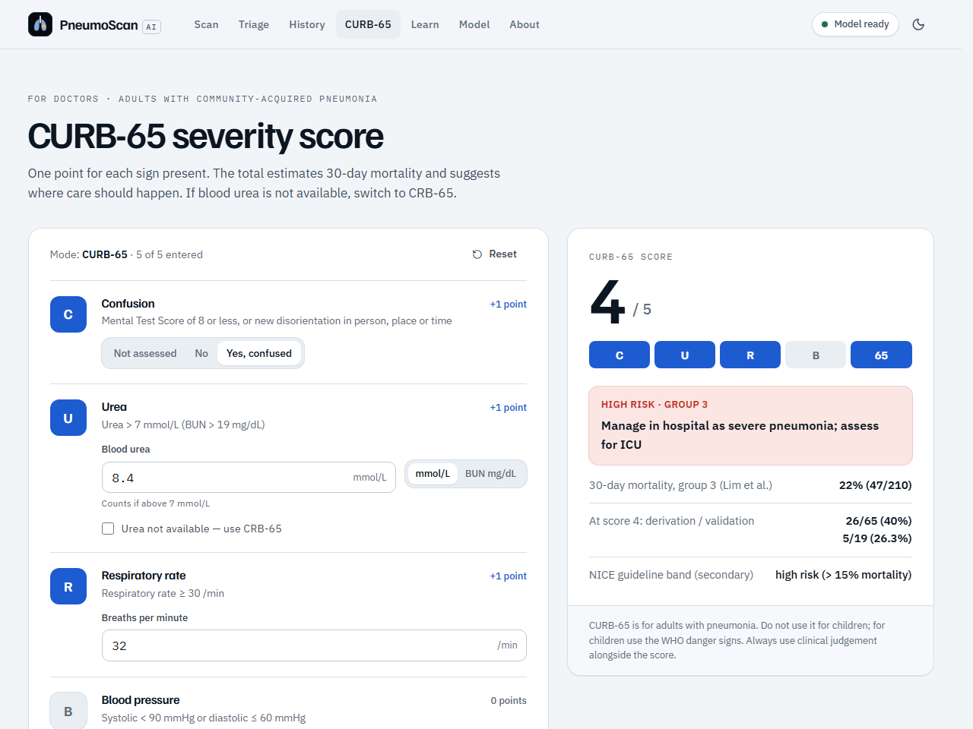
Figure 8.6: CURB-65 severity calculator (top part of the page)

8.8 Model Page
The Model page is designed for the classroom. It shows the official test accuracy, sensitivity, specificity and ROC-AUC, the confusion matrix, how ResNet’s skip connection works, the ensemble members, the dataset and the limitations. A Learn page with sourced health information (WHO, NHS, CDC) and an About page complete the application.
CHAPTER 9

CONCLUSION AND FUTURE ENHANCEMENTS

9.1 Conclusion
This project built PneumoScan AI, a complete and explainable system that detects pneumonia in children’s chest X-rays with an ensemble of three fine-tuned ResNets. Every setting was chosen on a patient-level validation split, and the official 624-image test set was scored only once. The system reached an accuracy of 94.55%, a sensitivity of 99.74% (one missed pneumonia out of 390), a specificity of 85.90% and a ROC-AUC of 0.9867: well above the published ResNet baselines on the same test set, although the 95% target was missed by three images. Grad-CAM heat maps explain each decision, non-X-ray images are rejected, and the offline application adds PDF reports, a triage queue, scan history and a CURB-65 calculator.

9.2 Limitations
- Trained and tested on X-rays of children aged 1–5 from one hospital; it may be less accurate on adults or other X-ray machines [13].
- Only two classes; it cannot tell bacterial from viral pneumonia or find other lung diseases.
- Most errors are false alarms on normal X-rays (specificity 85.9%), and some heat maps highlight the “R” marker or burned-in text.
- It is a student project for decision support, not a certified medical device.

9.3 Future Enhancements
- Train on larger, multi-centre and adult data, including Indian hospitals.
- Add lung segmentation or mask burned-in text so the model looks only at the lungs.
- Classify bacterial and viral pneumonia and other chest findings.
- A light mobile version for primary health centres, in regional languages.

REFERENCES
[1] K. He, X. Zhang, S. Ren, and J. Sun, “Deep residual learning for image recognition,” in Proc. IEEE Conf. Comput. Vis. Pattern Recognit. (CVPR), Las Vegas, NV, USA, 2016, pp. 770–778, doi: 10.1109/CVPR.2016.90.
[2] D. S. Kermany et al., “Identifying medical diagnoses and treatable diseases by image-based deep learning,” Cell, vol. 172, no. 5, pp. 1122–1131.e9, Feb. 2018, doi: 10.1016/j.cell.2018.02.010.
[3] P. Rajpurkar et al., “CheXNet: Radiologist-level pneumonia detection on chest X-rays with deep learning,” arXiv:1711.05225, 2017. [Online]. Available: https://arxiv.org/abs/1711.05225
[4] R. R. Selvaraju, M. Cogswell, A. Das, R. Vedantam, D. Parikh, and D. Batra, “Grad-CAM: Visual explanations from deep networks via gradient-based localization,” in Proc. IEEE Int. Conf. Comput. Vis. (ICCV), Venice, Italy, 2017, pp. 618–626, doi: 10.1109/ICCV.2017.74.
[5] W. S. Lim et al., “Defining community acquired pneumonia severity on presentation to hospital: An international derivation and validation study,” Thorax, vol. 58, no. 5, pp. 377–382, May 2003, doi: 10.1136/thorax.58.5.377.
[6] J. Yang et al., “MedMNIST v2 – A large-scale lightweight benchmark for 2D and 3D biomedical image classification,” Sci. Data, vol. 10, no. 1, Art. no. 41, Jan. 2023, doi: 10.1038/s41597-022-01721-8.
[7] O. Stephen, M. Sain, U. J. Maduh, and D.-U. Jeong, “An efficient deep learning approach to pneumonia classification in healthcare,” J. Healthc. Eng., vol. 2019, Art. no. 4180949, Mar. 2019, doi: 10.1155/2019/4180949.
[8] V. Chouhan et al., “A novel transfer learning based approach for pneumonia detection in chest X-ray images,” Appl. Sci., vol. 10, no. 2, Art. no. 559, Jan. 2020, doi: 10.3390/app10020559.
[9] T. Rahman et al., “Transfer learning with deep convolutional neural network (CNN) for pneumonia detection using chest X-ray,” Appl. Sci., vol. 10, no. 9, Art. no. 3233, May 2020, doi: 10.3390/app10093233.
[10] M. F. Hashmi, S. Katiyar, A. G. Keskar, N. D. Bokde, and Z. W. Geem, “Efficient pneumonia detection in chest X-ray images using deep transfer learning,” Diagnostics, vol. 10, no. 6, Art. no. 417, Jun. 2020, doi: 10.3390/diagnostics10060417.
[11] G. Liang and L. Zheng, “A transfer learning method with deep residual network for pediatric pneumonia diagnosis,” Comput. Methods Programs Biomed., vol. 187, Art. no. 104964, Apr. 2020, doi: 10.1016/j.cmpb.2019.06.023.
[12] R. Kundu, R. Das, Z. W. Geem, G.-T. Han, and R. Sarkar, “Pneumonia detection in chest X-ray images using an ensemble of deep learning models,” PLoS ONE, vol. 16, no. 9, Art. no. e0256630, Sep. 2021, doi: 10.1371/journal.pone.0256630.
[13] J. R. Zech, M. A. Badgeley, M. Liu, A. B. Costa, J. J. Titano, and E. K. Oermann, “Variable generalization performance of a deep learning model to detect pneumonia in chest radiographs: A cross-sectional study,” PLoS Med., vol. 15, no. 11, Art. no. e1002683, Nov. 2018, doi: 10.1371/journal.pmed.1002683.
[14] World Health Organization, “Pneumonia,” Fact sheet, Nov. 11, 2022. [Online]. Available: https://www.who.int/news-room/fact-sheets/detail/pneumonia
[15] World Health Organization, “The top 10 causes of death,” Fact sheet, Oct. 2, 2026. [Online]. Available: https://www.who.int/news-room/fact-sheets/detail/the-top-10-causes-of-death
[16] A. Chandramohan et al., “Teleradiology and technology innovations in radiology: status in India and its role in increasing access to primary health care,” Lancet Reg. Health Southeast Asia, vol. 23, Art. no. 100195, Apr. 2024, doi: 10.1016/j.lansea.2023.100195.
[17] D. Kermany, “Labeled optical coherence tomography (OCT) and chest X-ray images for classification,” Mendeley Data, v2, 2018, doi: 10.17632/rscbjbr9sj.2.
[18] M. Chumbita et al., “Can artificial intelligence improve the management of pneumonia,” J. Clin. Med., vol. 9, no. 1, Jan. 2020. [Online]. Available: https://pmc.ncbi.nlm.nih.gov/articles/PMC7019351/
[19] Centers for Disease Control and Prevention, “Risk factors for pneumonia,” Feb. 25, 2026. [Online]. Available: https://www.cdc.gov/pneumonia/risk-factors/index.html
[20] T. Cherian et al., “Standardized interpretation of paediatric chest radiographs for the diagnosis of pneumonia in epidemiological studies,” Bull. World Health Organ., vol. 83, no. 5, pp. 353–359, 2005. [Online]. Available: https://pmc.ncbi.nlm.nih.gov/articles/PMC2626240/
[21] A. Paszke et al., “PyTorch: An imperative style, high-performance deep learning library,” in Advances in Neural Information Processing Systems 32 (NeurIPS), 2019, pp. 8024–8035.
[22] F. Pedregosa et al., “Scikit-learn: Machine learning in Python,” J. Mach. Learn. Res., vol. 12, pp. 2825–2830, 2011.
[23] J. Deng, W. Dong, R. Socher, L.-J. Li, K. Li, and L. Fei-Fei, “ImageNet: A large-scale hierarchical image database,” in Proc. IEEE Conf. Comput. Vis. Pattern Recognit. (CVPR), 2009, pp. 248–255.
[24] C. Szegedy, V. Vanhoucke, S. Ioffe, J. Shlens, and Z. Wojna, “Rethinking the Inception architecture for computer vision,” in Proc. IEEE Conf. Comput. Vis. Pattern Recognit. (CVPR), 2016, pp. 2818–2826.
[25] I. Loshchilov and F. Hutter, “Decoupled weight decay regularization,” in Proc. Int. Conf. Learn. Represent. (ICLR), 2019.
[26] P. Micikevicius et al., “Mixed precision training,” in Proc. Int. Conf. Learn. Represent. (ICLR), 2018.
[27] C. Guo, G. Pleiss, Y. Sun, and K. Q. Weinberger, “On calibration of modern neural networks,” in Proc. 34th Int. Conf. Mach. Learn. (ICML), 2017, pp. 1321–1330.
[28] W. J. Youden, “Index for rating diagnostic tests,” Cancer, vol. 3, no. 1, pp. 32–35, 1950.
[29] K. Lee, K. Lee, H. Lee, and J. Shin, “A simple unified framework for detecting out-of-distribution samples and adversarial attacks,” in Advances in Neural Information Processing Systems 31 (NeurIPS), 2018.
[30] O. Ledoit and M. Wolf, “A well-conditioned estimator for large-dimensional covariance matrices,” J. Multivariate Anal., vol. 88, no. 2, pp. 365–411, 2004.

