COBOT-EX HACKATHON 2026 · ROUND 1
NovaSense
Predicting machine failures before they happen

TEAM | Ctrl.Alt.Elite
MEMBERS | Umer Basith, Muizzur Rahman
DATE | 09 November 2026

1. Executive summary
NovaSense is a working web platform that predicts which machines are about to fail, explains why, and tells the team what to do next. It combines a machine-learning model, a live dashboard and a plain-English AI assistant.
In testing on 1,000 rows the model never saw, NovaSense reached 90% accuracy and 0.96 ROC-AUC, and scores a machine in under one second.

2. Problem statement
Unplanned downtime is one of the largest hidden costs in manufacturing. Teams usually find out a machine is failing only after production stops.
- Breakdowns are found late, after damage is done.
- Root causes are guessed by experts, which is slow.
- Data exists (temperature, vibration, load) but nobody watches it continuously.

3. Proposed solution
Part | What it does | Built with
Risk model | Scores failure risk 0-100 and lists the top causes | scikit-learn (gradient boosting)
Dashboard | Live KPIs, forecast chart, status mix, records | React, Tailwind CSS, Recharts
AI assistant | Answers questions using live data | FastAPI + LLM with rule fallback
Data upload | Analyses any CSV in seconds | pandas

4. Architecture
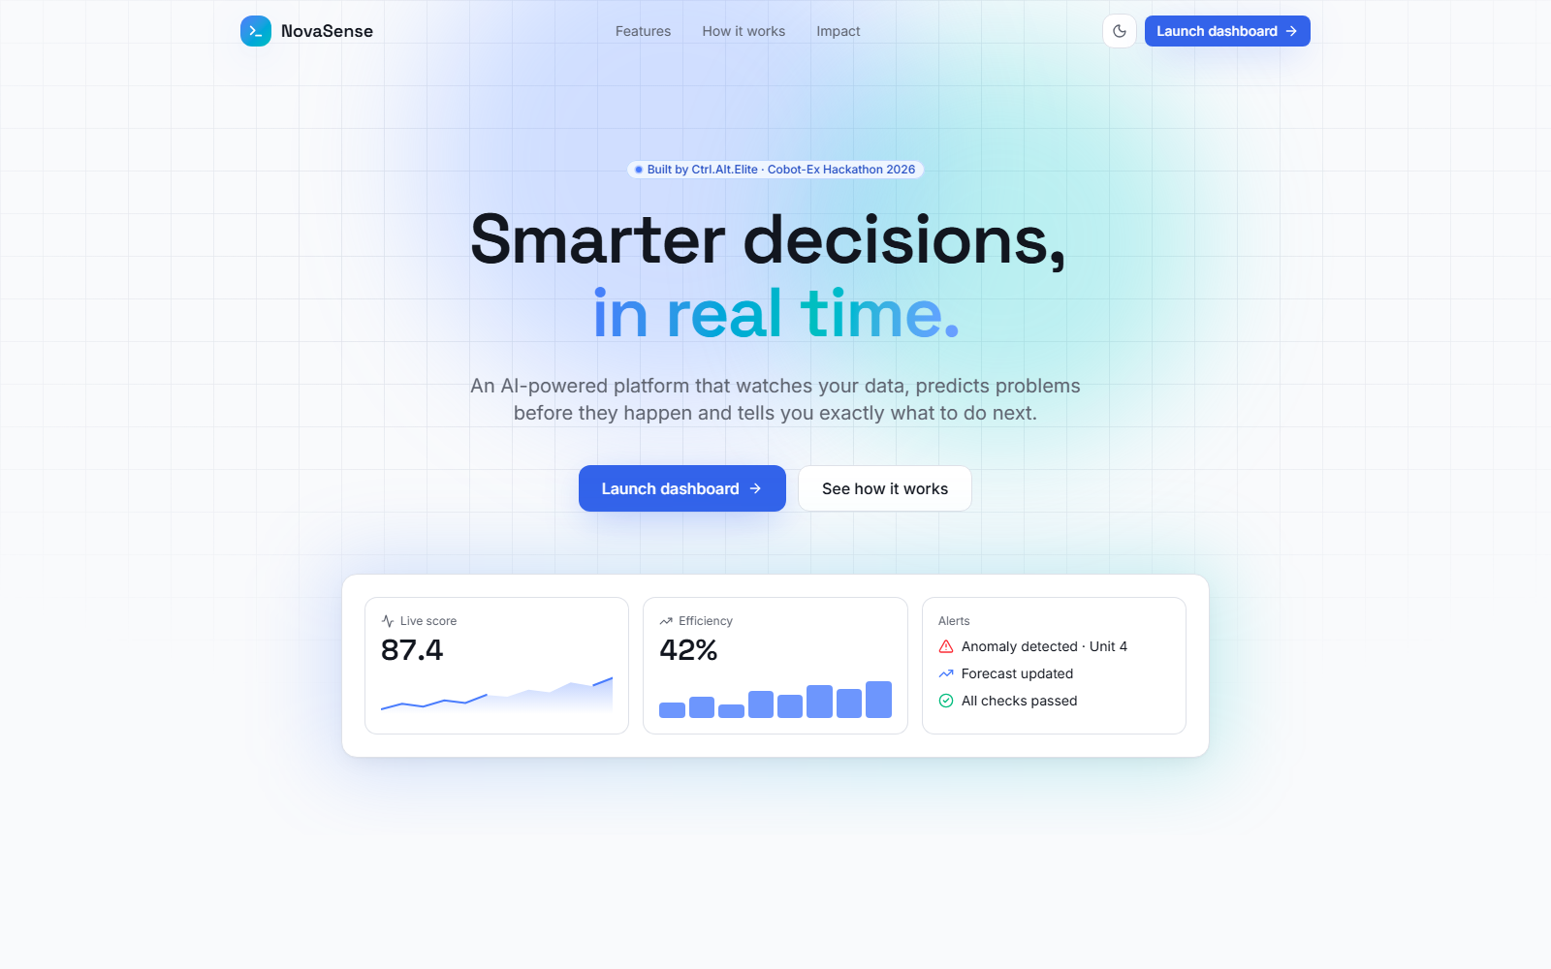
Landing page of the product.
- Data arrives from sensors or a CSV upload.
- The FastAPI backend validates every input and stores history in SQLite.
- The model scores risk and explains the main factors.
- The dashboard shows results and alerts in real time.

5. Results and validation
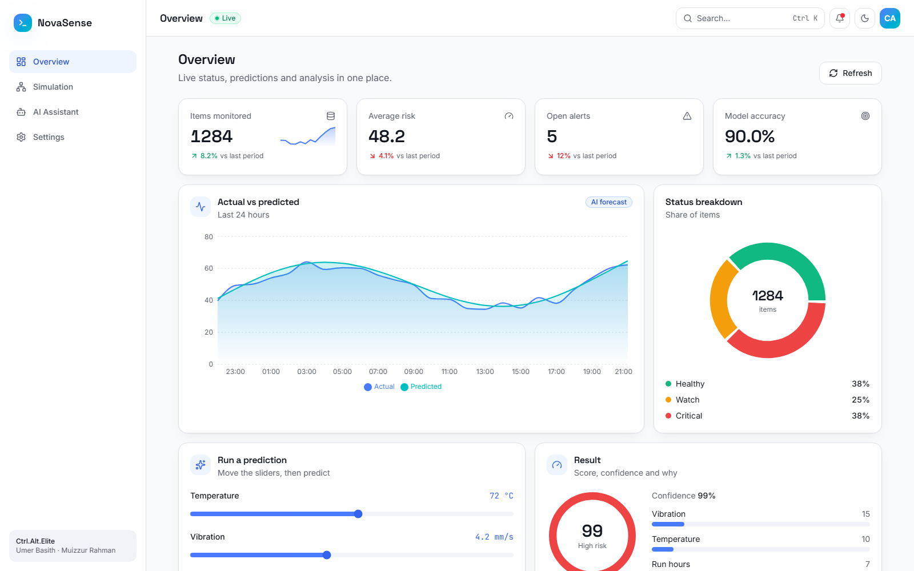
Live dashboard during testing.
Metric | Value | How measured
Accuracy | 90.0% | 1,000 held-out rows
ROC-AUC | 0.96 | Same held-out rows
Response time | < 1 s | API call on a laptop
Automated tests | 6 / 6 passing | pytest

Honest note: the model was trained on a synthetic dataset designed around real sensor ranges. Using real plant data is the next step.

6. Impact
- Fewer surprise breakdowns, because risk is visible hours earlier.
- Faster repairs, because the main cause is shown with every alert.
- Lower cost to start: runs on a normal laptop, no special hardware.

7. Future scope
- Pilot on one real production line with live sensors.
- Edge device for factories with poor internet.
- Mobile alerts and multi-plant view.

8. Conclusion
NovaSense turns raw machine data into clear, timely actions. It is working today, tested, and ready for a real pilot.

