**COAL (Lab) Project**

**Menu**

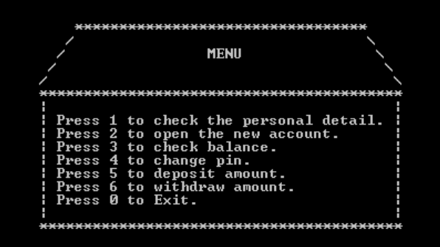

**Press ‘0’ to terminate**

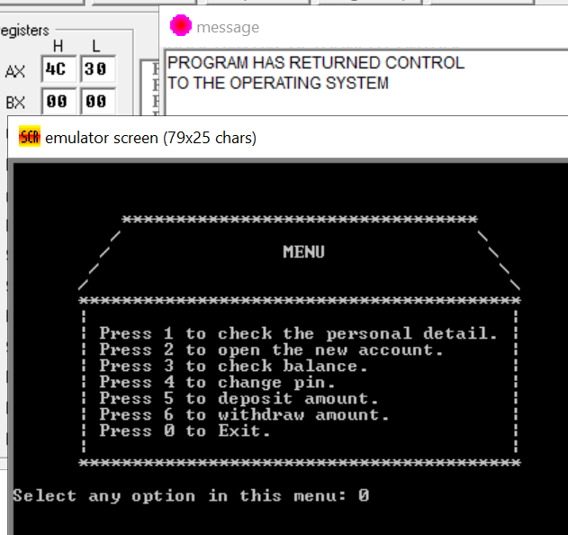

**If the user enter the wrong input, then**

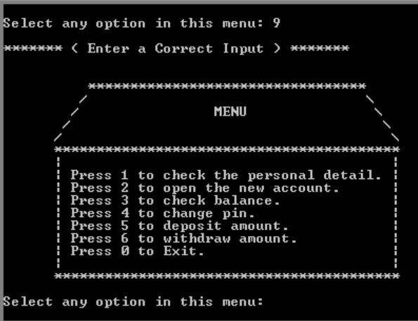

**If the user press 3 to check the balance, then**

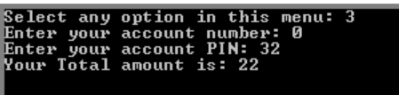

**If the user press 4 to change their PIN, then**

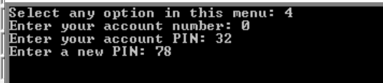

**If the user press 5 to deposit amount, then**

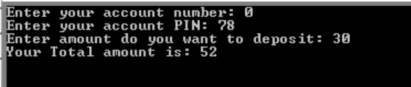

**If the user press 6 to withdraw amount, then**

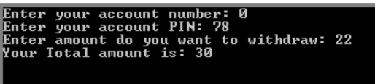

**If the user press 2 to open the new account, then**

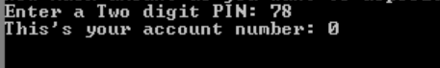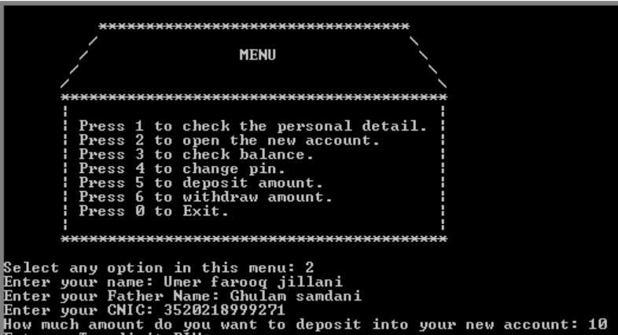

**If the user press 1 to check the personal details, then**

