**Project Overview**

**Project Title**

Comprehensive Apartment Management System

This project aims to create a **Comprehensive Apartment Management System** using SQL Server Management Studio to simplify property management.

The system will help manage projects, tenants, and landlords while automating tasks like rent tracking, utility bill management, and handling complaints.

It will also manage finances with vouchers, ledgers, and income sharing among owners. With features like real-time reports, notifications, and resource tracking, the system will make property management easier, faster, and more organized.

**Key Features of the Apartment Management System**

* **Project Management**

Create and assign projects with role-based access for users.

* **Tenant and Landlord Management**

Flexible rental agreements, automated rent cycles, and payment tracking.

* **Financial Management**

Generate vouchers, track payments, and maintain ledgers.

* **Utility Management**

Monitor utility bills, due dates, and payments with alerts.

* **Inventory Tracking**

Allocate and manage resources with repair, warranty, and disposal tracking.

* **Complaint Resolution**

Handle complaints, track progress, and notify users.

**Entities and attributes with data insert**

**Projects**

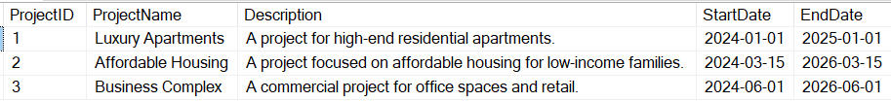

**Roles**

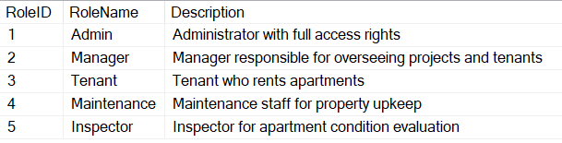

**Users**

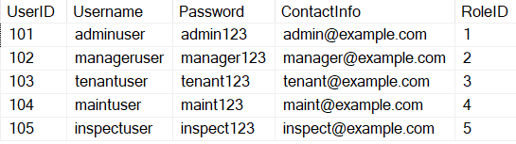

**Tenants**

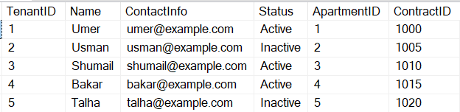

**Apartments**

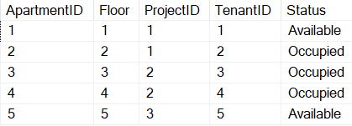

**Contracts**

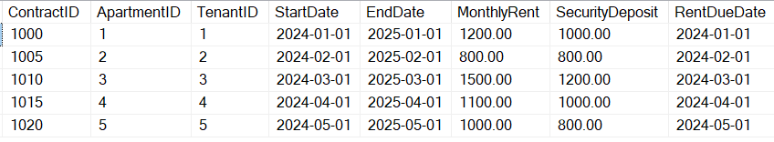

**Rent Payments**

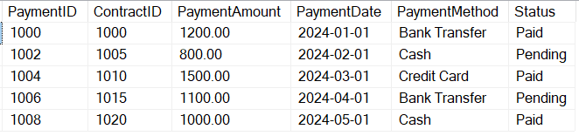

**Accounts**

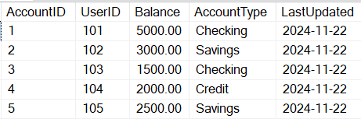

**Vouchers**

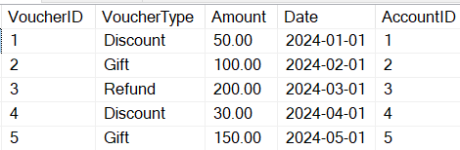

**Reports**

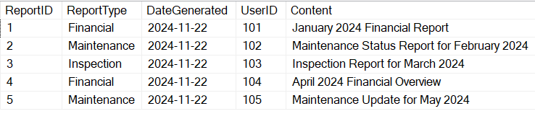

**Disbursements**

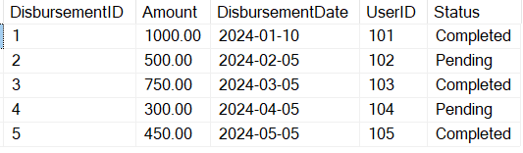

**Utility Bills**

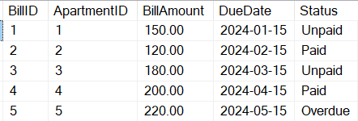

**Inventory**

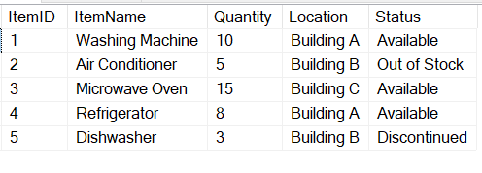

**Maintenance Requests**

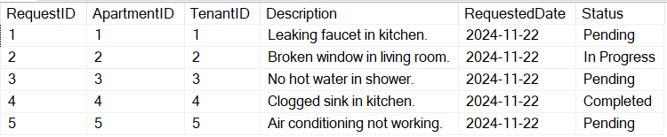

**Inspections**

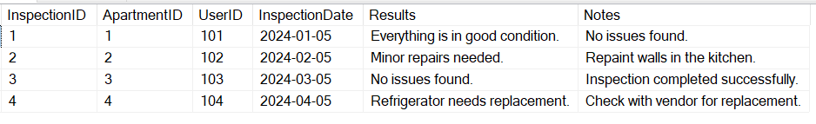

**Vendors**

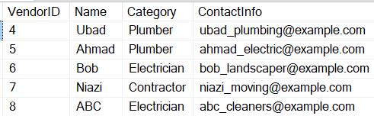

**Complaint Requests**

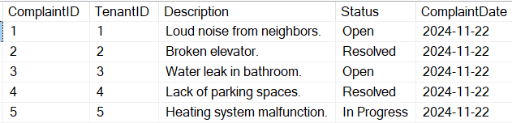

**Satisfaction Surveys**

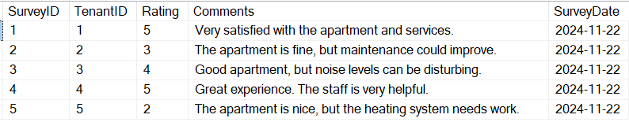

**VIEWS**

**Tenant Details with Apartment and Contract Information**

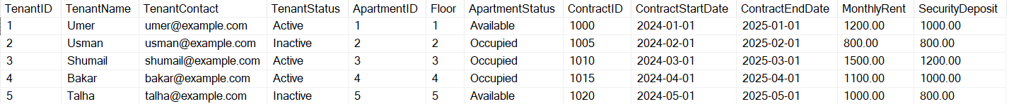

**Maintenance Requests by Apartment**

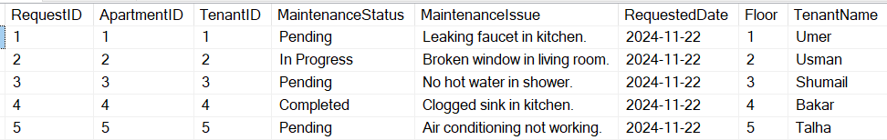

**Rent Payments with Contract Details**

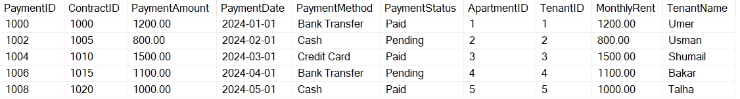

**Inspection Results**

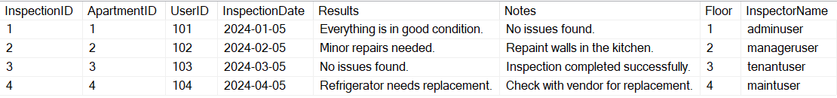

**Pending Utility Bills**

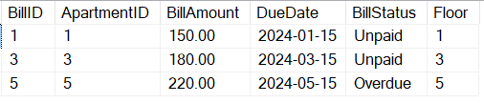

**Financial Reports by User**

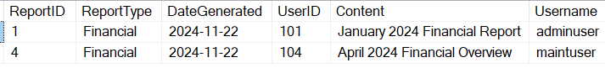

**Satisfaction Surveys with Tenant Details**

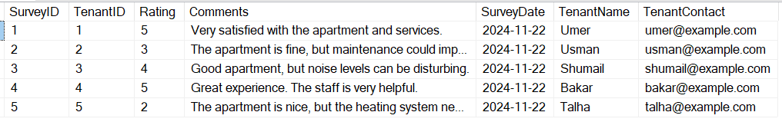

**Complaints with Tenant Information**

