Assignment 01

CY2001

Network and Cyber Security-I

Submitted by: Umer Farooq
Roll number: 22i-0518
Section: CY-A
Date: 17-9-2023

Table of Contents

• Introduction 3
• Software Tools & Description 3
Bit locker Manager: 3
Igor Ware Hasher: 3
Tor Browser: 4
1Password: 5
Hide’ N’ Send: 6
• Summary 7

Introduction
In the first part of this assignment, we were tasked to download various software which provided different security services. In the second part we were required to write a few simple encryption algorithms along with their decryption in the programming language of either C or C++. I chose c++ for this project.

Software Tools & Description

Bit locker Manager:
BitLocker is a built-in Windows encryption tool that is designed to protect entire volumes and thus ensuring data security. It prevents risks such as data theft from lost or stolen devices. Thus, this software ensures the confidentiality service through encryption.
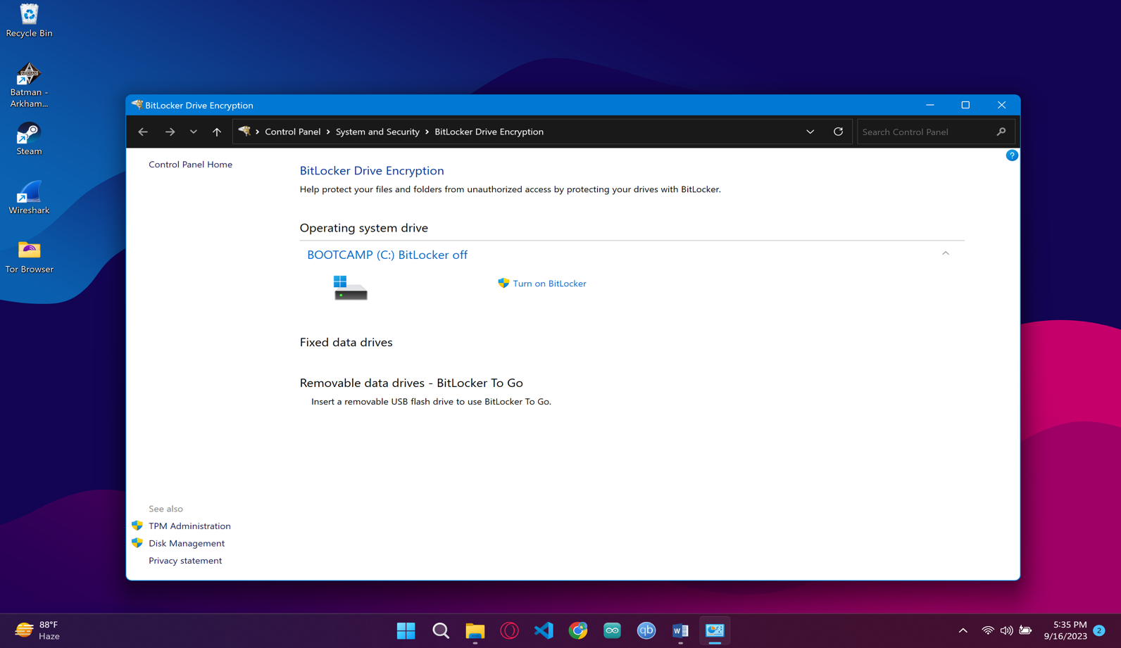

Igor Ware Hasher:
This tool allows users to generate checksums or hashes for files using algorithms such as SHA-1, MD5, and CRC32. These hash values serve as unique identifiers for files and can be used to verify the integrity and authenticity of the data within the files. Thus this software ensures the Integrity service.
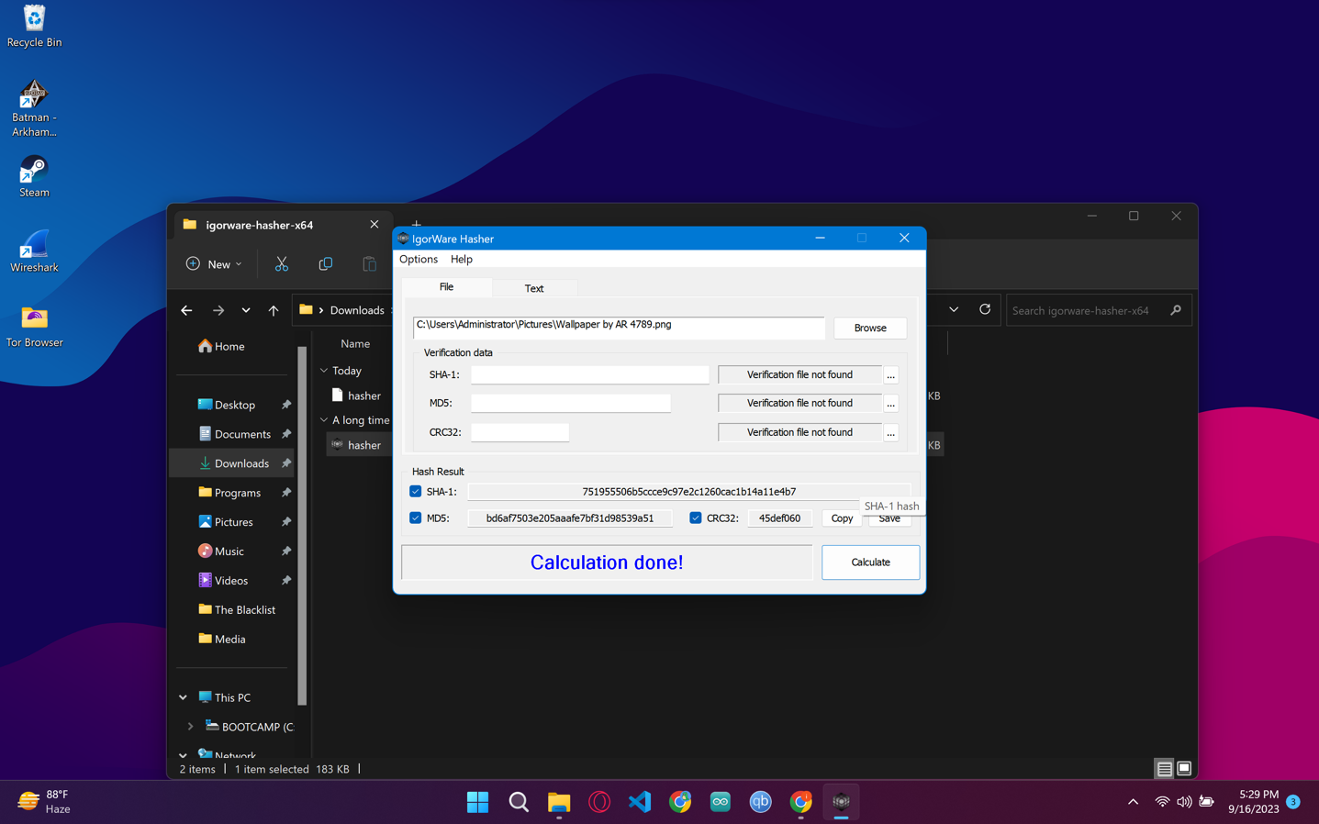

Tor Browser:
If you want to protect your privacy online then tor browser is perfect tool for you, tor browser hides your IP addresses and browsing activity by redirecting the web traffic through a series of different routers known as nodes. It is very secure and very difficult to track. Thus, this software ensures privacy.


1Password:
1Password is a popular password manager and digital vault application. It is designed to help users securely store and manage various sensitive information, primarily passwords for websites and online services, but also other important data like credit card details, software licenses, secure notes, and more. Thus, this software ensures the authentications service. Since it is a paid service I couldn’t install it, Sorry.
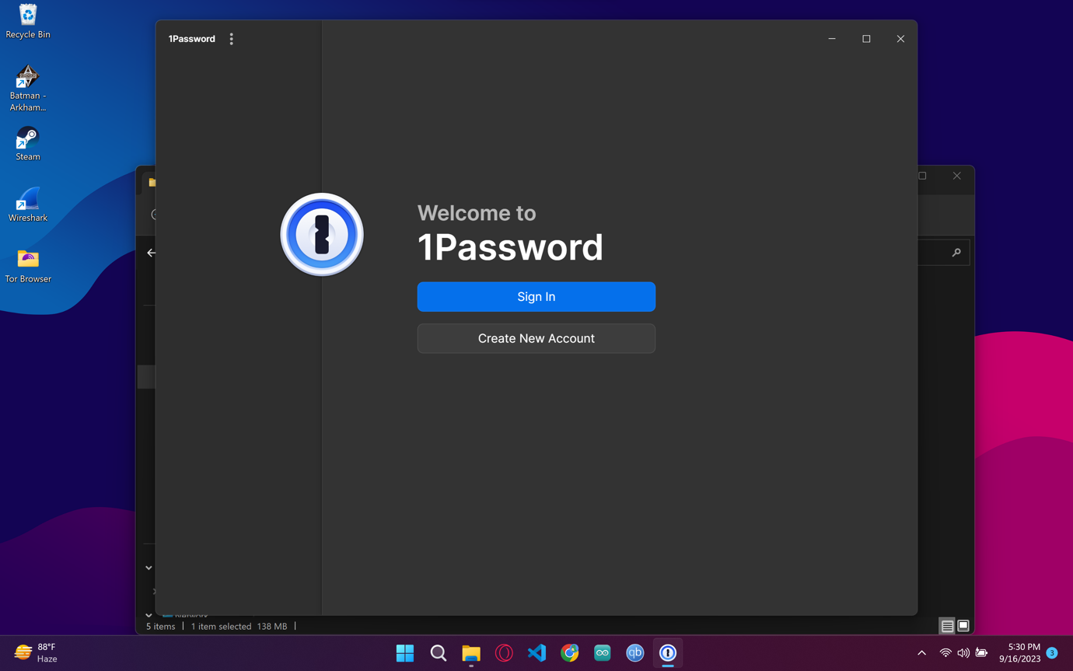

Hide’ N’ Send:
This is a steganography tool used for hiding and sending secret or concealed information within other files, such as images or audio. Steganography is a technique that involves hiding data within another medium in such a way that it's difficult for an observer to detect the hidden content. Thus, this software ensures confidentiality as well.
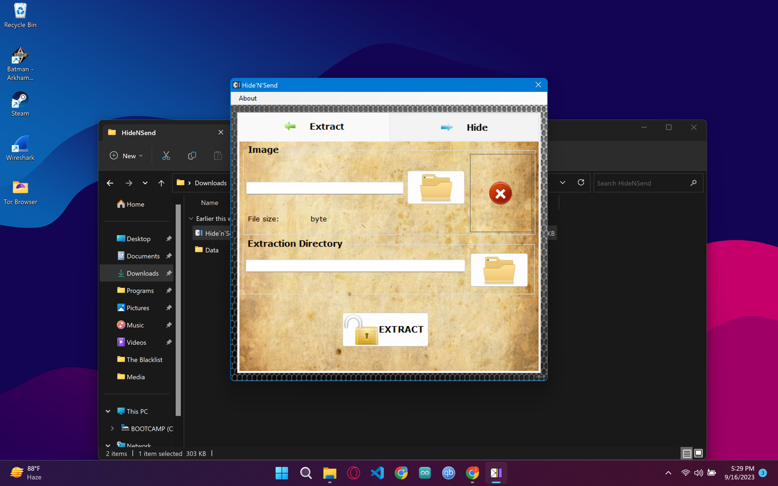

Wireshark:
Wireshark is a widely-used network protocol analyzer and packet capture tool. It allows users to capture, analyze, and inspect the data packets that flow over a computer network. Wireshark is primarily used for network troubleshooting, monitoring, analysis, and security auditing purposes. This is a very useful application for man in middle attack or the masquerading attack.
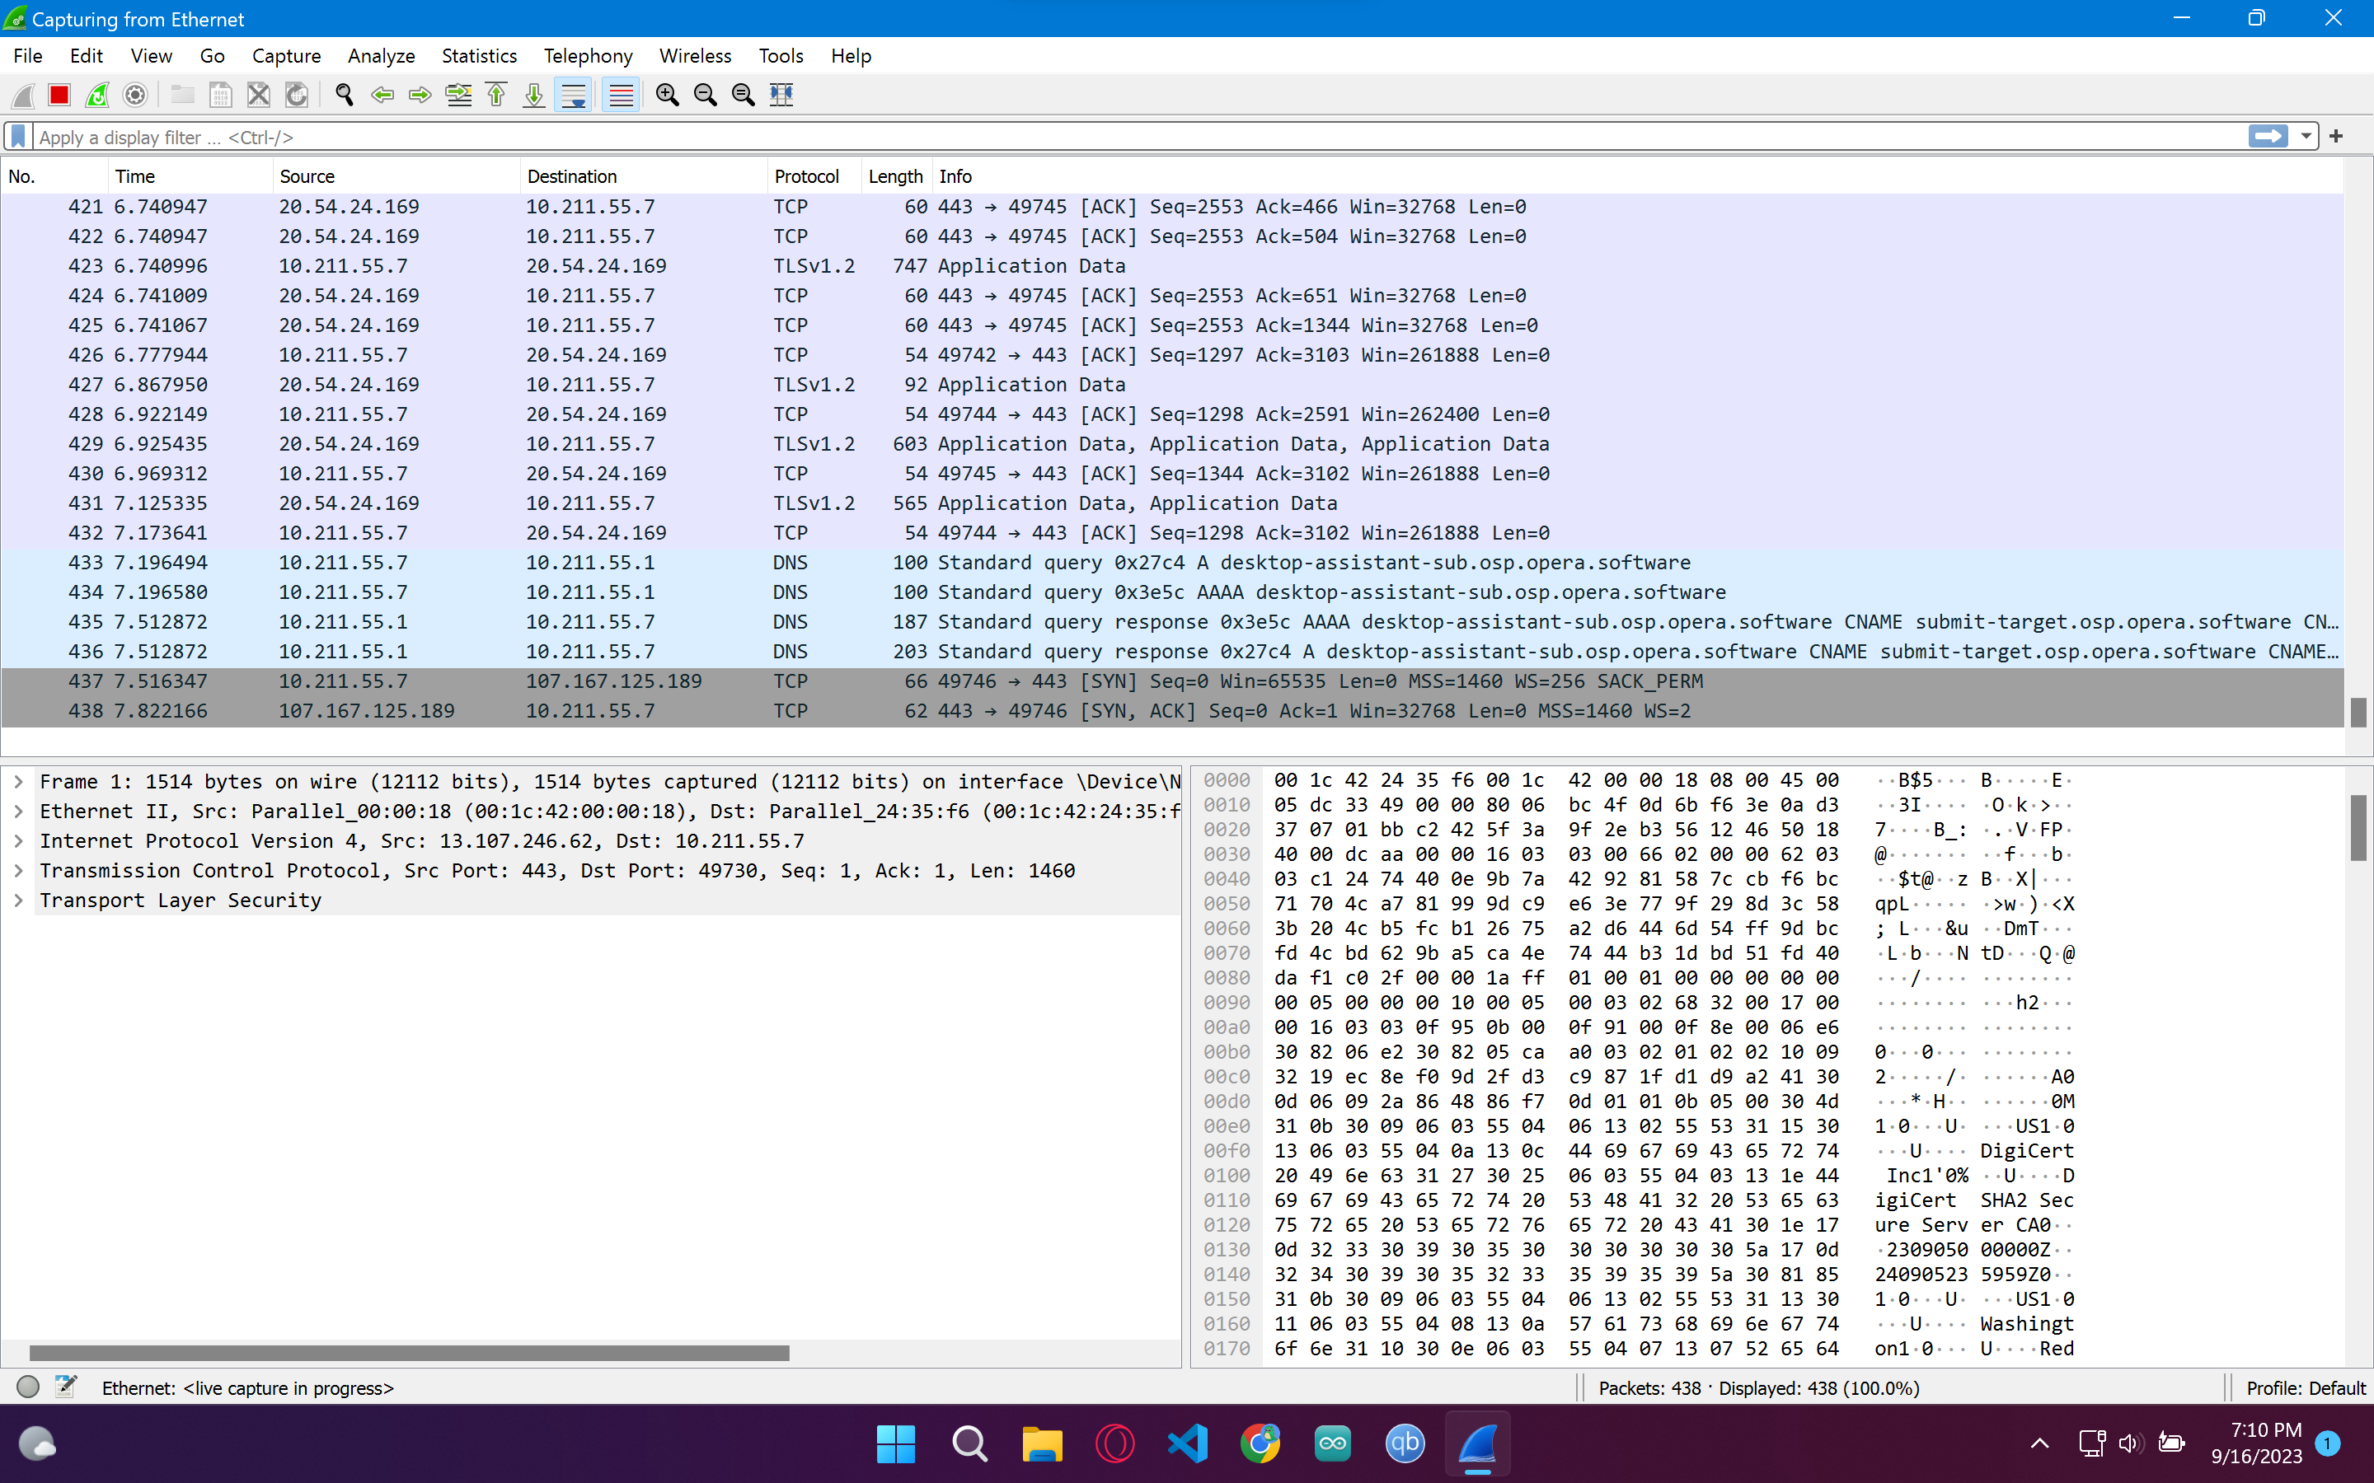

Summary
This assignment emphasized the significance of networks and cybersecurity. We explored essential topics like encryption, steganography, and different security services. This knowledge is vital in safeguarding data and systems against evolving cyber threats, ensuring a secure digital environment. This assignment truly challenged my intellect and problem-solving skill and I learned a lot during this assignment.

