**Software Requirement Engineering**

**Project**

**ZarB-e-Azab**



**Section:** ‘W3’

**Presented by:**

|  |  |
| --- | --- |
| **Registration No:** | **Name:** |
| 12003065264 | Fahad Khan |
| 12003065266 | M Umer Khalid |
|  |  |
|  |  |

|  |
| --- |
| School of Science and Technology |

University of Management & Technology

Contents

1. Introduction 5

1.1 Project Background and Rationale: 5

1.2 Responsibility: 5

1.3 Scope 5

1.4 Project Objectives 6

1.5 Project Deliverables 6

1.5.1 Phase 1. Project Initiation, Process Analysis, Technology. 6

1.5.2 Phase 2. Design and Development 6

1.5.3 Phase 3. Data Flow Design and Development 6

1.5.5 Phase 5. Post Implementation/Lessons Learned 7

1.6 Milestones 7

1.7 Business Case 7

2. Project Organization: 8

2.1 Organizational Structure: 8

2.2 Project Responsibilities: 9

3. Managerial Processes: 9

3.1 Assumptions: 9

3.1.1 Dependencies: 9

3.1.2 Constrains: 9

3.2 Risk Management: 9

3.3 Monitoring and Controlling Mechanism: 10

3.4 Quality plan: 10

3.5 Change Control Plan: 10

3.6 Staffing Plan: 10

4. Technical Processes: 10

4.1 System Documentation: 10

4.1.1 System Requirement Specification: 10

4.1.2 System Design: 11

4.1.3 Test Plan: 11

4.1.4 Installation plan: 11

4.1.5 Transition/ Cutover Plan: 11

4.1.6 Service Level Agreement: 11

4.1.7 Operations Manual: 11

Software Process Model (SPM): 11

4.1.8 User Manual: 12

4.1.9 Project Charter Plan: 12

4.1.10 Project Status and Tracking Report: 12

4.2 Project Support Function: 12

5. Work Break Down Structure, Scheduling and Budget: 13

5.1 Work Breakdown Structure (WBS): 13

Budget: 19

Scheduling: 19

Additional Components: 19

Appendices: 19

# Introduction

Our project title is “Zarb-e-Azb”. We are going to develop “Zarb-e-Azb” game in Unity and 3DS Max. The game will be desktop based. This is not a 3D game. The game we are developing is to give tribute to Pakistan’s Armed forces. This game simulates story of zarb-e-azab against terrorists in North Waziristan. In the game we will have three characters to provide variety in gameplay. Gameplay will include stealth, tactics as well as direct assaults in which player will have to cooperate with the team. There are different types of missions in the game as well e.g. collecting critical information, sabotage enemy air defense or destroy some arms cache. When the missions are accomplished a new mission is unlocked. Once unlocked, all missions will be available to be played anytime. This game will have stunning environments and effect that will place players in real war like situation. There will be different climatic conditions as well in the game, making missions more difficult to carry out

## 1.1 Project Background and Rationale:

We are going to develop “Zarb-e-Azb” game. There are also many games available which are same as this game like Counter Strike, COD and etc. But we are developing this game as per client’s requirement and also to give tribute to Pakistan’s Armed forces. There are also many other options available but we select this game because it is interesting and there is no need to perform elicitation process for this project. We just make the SRS time to time and then design and implement the game requirements in Unity and 3DS Max. We are developing this game as our semester project and final year project that is why we building it now

## 1.2 Responsibility:

|  |  |  |  |
| --- | --- | --- | --- |
| **Executive Sponsor:** |  | **Reviewers:** | **Fasiha Ashraf** |
| **Project Sponsor:** | Fasiha Ashraf |  |  |
| **Project Manager:** | Fahad khan |  |  |
| **Acceptors:** | Fasiha Ashraf |  |  |
|  |  |  |

## 1.3 Scope

Zarb-e-Azb will be both desktop based game. The application will be run on windows XP, 7, 8, 8.1. A PC is required. A good Graphic card is required. It will not be a 3D game. It will not be java compatible. It will develop in unity and 3DS Max. The project will be focused on level by level play. There will be maps in which one will have to complete some objectives in order to proceed to next level. Maps will not generate dynamically however enemy spawning will be random. We are working mainly with story, levels and animation. We have total three different missions in the game. There are different missions in the game like collecting critical information or destroy some arms cache We are working on our first missions in which there are sniper and assaults in which they have different targets to complete the mission. After the completion of our first map later on we will work on other missions to complete the whole game.

## 1.4 Project Objectives

Zarb-e-Azb requires you to make moves strategically. To be victorious you must figure out the best approach to end up the whole mission. When you have collect all the objectives you also have to face the enemies while collecting the objectives you just have to face it properly to finish the mission. There are total 3 different missions in the game. There are different missions in the game like collecting critical information or destroy some arms cache We are working on our first missions in which there are sniper and assaults in which they have different targets to complete the mission

## 1.5 Project Deliverables

### 1.5.1 Phase 1. Project Initiation, Process Analysis, Technology.

* In the initiation step of our project .We have started the project which is given by our client .First we have gather requirements from our client .According to our client .we have to develop game named as “Zarb-e-Azb”.
* After initiation we have to analyze the whole project and decide how to set our milestones. How to start that process, how to manage time, how to pass millstones achieve goals and how to finish this project.
* Our client required to build this whole project in “Unity and 3DS max “.

### 1.5.2 Phase 2. Design and Development

* In This phase we create the project component (e.g. Design Objects of man (enemy & army), movement of man, calculate score, ending conditions, loosing and winning conditions).
* Development of component’s supporting material (e.g. Creation of man (enemy & army), control movement of man, arranging of objects off maps, calculate score, ending conditions, loosing and winning conditions).

### 1.5.3 Phase 3. Data Flow Design and Development

* In this phase we have to create the game scenarios of game all possible scenarios creation. Check who the data flow, direction of data, interaction of user, compilation of code, interaction of code user and flow of data.
* After the data flow design development design, we are able to start the actual implementation of code and implementation of scenarios and data flow design.

#### 1.5.4 Phase 4. Partner Data Flow Installation

* After competition of phase 3 we have to recheck the pattern of the data flow.
* We also have to check cross platform installation, environment changing problems and their solutions.
* At last the installation of the final product.

### 1.5.5 Phase 5. Post Implementation/Lessons Learned

* After the complete installation and competition of the project we have to analyze the whole documentation and the phase of the project try to find out the hidden mistakes and hidden error in the implementation or code design and graphics.
* In the next step we try to resolve these errors and solve the problems in the installation of the game.

## 1.6 Milestones

First milestone was to select a project and give a brief introduction to the project weather this explanation fulfill the requirements needs or not. We were supposed to tell user its functional and non-functional requirements to understand it quickly. We were written the objectives of the project.

In the second milestone we have to plan the project that we have read in our chapter one. This milestone will cover our chapter no 1. Also in this milestone we have to discuss the introduction, project background, scope, objectives, deliverable etc.

## 1.7 Business Case

Our resource person give us a game project named “Zarb-e-Azb”. Financially we will earn no profit in this project, but in terms of education and grade we will earn absolute 10 bonus marks after implementing this game.

# Project Organization:

## 2.1 Organizational Structure:

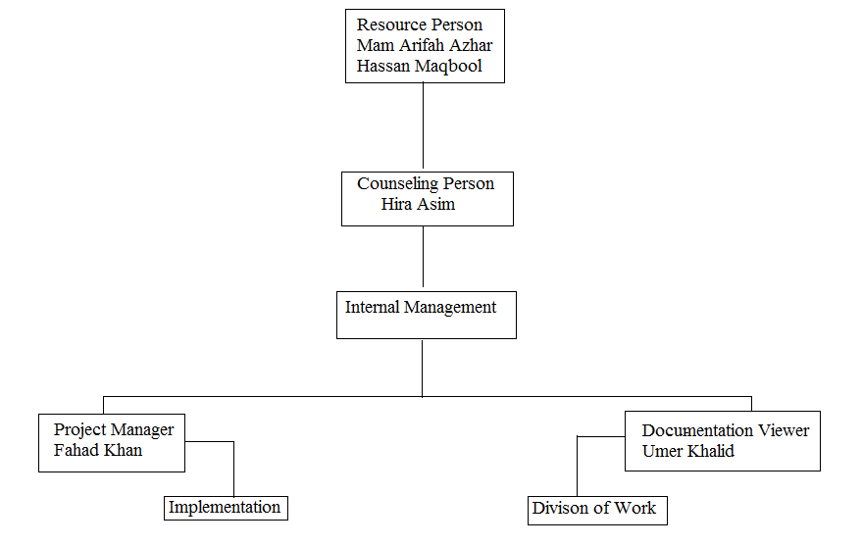

## 2.2 Project Responsibilities:

**Team Leader:** Umer Khalid

**Project Manager:** Fahad Khan

**Team Members:** Fahad Khan

Umer Khalid

**SE Supervisor:** Fasiha Ashraf

Hassan Maqbool

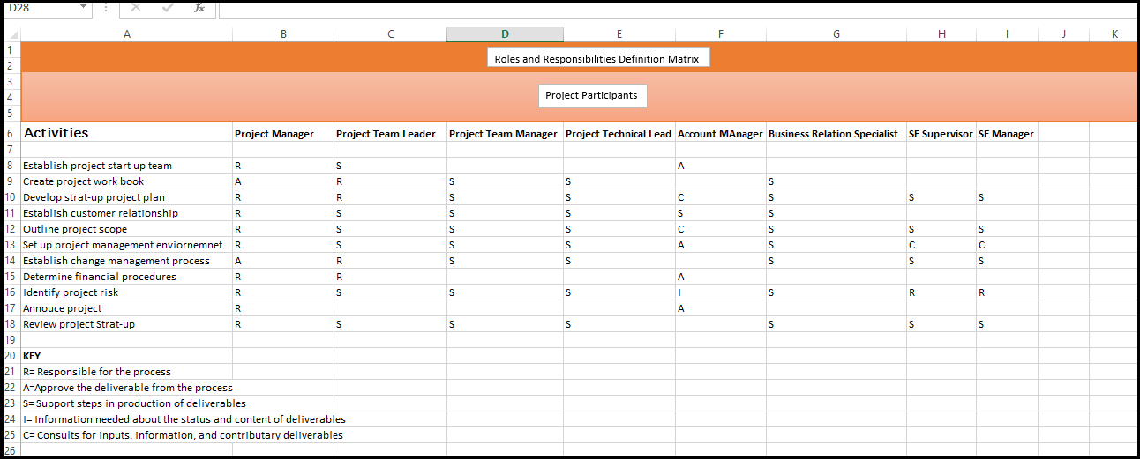

# Managerial Processes:

# 3.1 Assumptions:

**1.**  It is assume project will have VR support for immersive

### 3.1.1 Dependencies:

As our project is Unity so it is case sensitive. It is not language friendly. Unity is compulsory to play this game. A pc is required to play this game. Windows 7, 8 or 8.1 should be installed in your computer in order to play this game.

### 3.1.2 Constrains:

1. First Person shooter

2. Keeping in view others games in the market a constraint was put a that no incidence of black day will be simulated in the game

## 3.2 Risk Management:

* One group member cannot work properly so the task can submitted later instead of due date.
* Project portability can be effected if we does not provide proper environment to it.
* The game will not be tool instead of unity.
* Risk of losing budget.

By installing unity in a pc before deploying we can manage this risk. We can force or terrify by losing marks to our group member and motivate him to do this project actively. So by doing proper documentation we resolve the budgeting issue too. As our benefit was more than the cost and it is worthy that is we are continuing with this project.

## 3.3 Monitoring and Controlling Mechanism:

The estimated cost is 8000 to 10000 for the development of this game. It includes cost of whole project. Cost of proposal, scope, managerial process, risk management, technical process, WBS, scheduling and at the end implementation too. Through Gantt chart the project manager have allocated task. He defined the deadline of that task at the time of task allocation and elaboration.

Budget estimation is assumed by team manager itself.

## 3.4 Quality plan:

* Maps should be high definition.
* Theme of game can be attractive.
* Manipulate playing time should be correct.
* Manipulate score should be correct.
* Objectives should be cleared

## 3.5 Change Control Plan:

Any changing in the game can be accept at any time according to Mam Fasiha’s requirement. We save a backup of this in another folder.

## 3.6 Staffing Plan:

Number of required staff:

* At least 3 team members (students)
* person in development , 1 person documentation
* Project should be complete within 60 days.

All persons working on project are students and have low experience in each field.

# Technical Processes:

## 4.1 System Documentation:

### 4.1.1 System Requirement Specification:

It includes all the requirements of this project. Functional requirements like display map, display time, keep guns and objectives. It is includes nonfunctional requirements like unity in compulsory to play this game and windows 7, 8 is required. It includes use case and class diagrams. We make sequence diagrams of each function for this game.

### 4.1.2 System Design:

### 4.1.3 Test Plan:

There is no a large test plan is required for this game as it is a small project. Testing is done simultaneously while implementing this project. Bugs will be removed time to time.

### 4.1.4 Installation plan:

Yes installation is necessary to play this game. First of all, we are required to install unity on our machine. After this installation of unity installation is required then include package of this game in unity and enjoy the game. Without this installation the game will be play by user.

### 4.1.5 Transition/ Cutover Plan:

As we are not only doing implementation of this project but also documentation. We are doing documentation according to IEEE charter which gives the best way to make a detailed document of your project. This is our cutover plan. We can do any changing in our project at any time through this plan as per Hassan Maqbool requirement.

### 4.1.6 Service Level Agreement:

It defines the agreement between Hassan Maqbool and our team. We will deliver a completely developed game to Hassan Maqbool and he will give us good grade in this return.

### 4.1.7 Operations Manual:

The process model which we are going to implement is:

## Software Process Model (SPM):

The most suitable software process model for Zarb-e-Azab is **“V Model”** and **“Incremental Model”**. This is because:

* This game is a short project of maximum 2-3 months.
* Testing of every module will be done simultaneously while in the process of implementation of this project.
* Errors will be identified earlier in the process of implementation.
* The project will be completed in some increments.

These characteristics are more near to both V and agile model. Therefore, we select these process models for our project.

We are using the best programming practices for the development of this game. At the end we want seven absolute marks in reward.

### 4.1.8 User Manual:

This is only for guidance of user that how can he play this game? It defines the rules and regulations of the game.

* Use your stock.
* How to complete the objectives
* How to get to the target

### 4.1.9 Project Charter Plan:

* IEEE Charter
* **SRS:** Software Requirement Specification (not required for this game)
* **Planning:** Documentation, Process models applied like V model, Incremental model
* **Diagrams:** Sequence Diagrams
* **Implementation:** Unity

### 4.1.10 Project Status and Tracking Report:

It includes:

* Time (schedule)
* Cost (budget)
* Quality (deliverables)
* Resources (staff)
* Scope (objectives or activities)
* Risk (may include issues or challenges).

All these things are already defined above.

## 4.2 Project Support Function:

A project manager is responsible for providing project support function if needed. Supporting functions includes in project management are: planning, organizing, tracking, reviewing and leading. In this game IEEE charter is only the supporting function which is helping us in documentation of this project.

# Work Break Down Structure, Scheduling and Budget:

# 5.1 Work Breakdown Structure (WBS):

WBS of this game as shown below:

|  |  |
| --- | --- |
| **Data Category** | **Specifications** |
| Activity Number: | 01 |
| Activity Name: | Graphical User Interface **(GUI)** Design |
| Activity Description: | Create an interface where user can play the game. Make a proper GUI design of the game. |
| Estimated Duration: | 15 days |
| Resources Needed: | Computer, Compiler , Developer |
| Personnel: | Fahad and Umer |
| Skill: | Basic know of Unity |
| Tools: | Unity, 3DS Max |
| Travel: | Not required for this game |
| Work Products (i.e. Deliverables) | Phases (Specifications, Planning, Designing, Implementation) |
| Predecessors: | Project Selection |
| Successors: | Implementation |
| Completion Criteria: | Unity |
| Risks: | Portability effected if does not provided proper environment |
| Implementation: | Unity |
| Personnel Assignment: | Yes |
| Starting Date: | 1st February 2016 |
| Completion Date: | 14th February 2016 |
| Cost Budgeted: | 5000 |
| Costs Actual: | 2500 |
| Comments: | Yes the project is worthy as actual cost is less then budget cost |

|  |  |
| --- | --- |
| **Data Category** | **Specifications** |
| Activity Number: | 02 |
| Activity Name: | Design Mesh |
| Activity Description: | Design Army Man and Enemy which will be used in map |
| Estimated Duration: | 10 days |
| Resources Needed: | Computer, Compiler**,** Developer |
| Personnel: | Umer |
| Skill: | Basic know of 3DS Max |
| Tools: | 3DS Max |
| Travel: | Not required for this game |
| Work Products (i.e. Deliverables) | Phases (Specifications, Planning, Designing, Implementation) |
| Predecessors: | Project Selection |
| Successors: | Implementation |
| Completion Criteria: | 3DS Max |
| Risks: | Portability effected if does not provided proper environment |
| Implementation: | 3DS Max |
| Personnel Assignment: | Yes |
| Starting Date: | 10th February 2016 |
| Completion Date: | 17th February 2016 |
| Cost Budgeted: | 1300 |
| Costs Actual: | 2000 |
| Comments: | Yes the project is worthy as actual cost is less then budget cost |

|  |  |
| --- | --- |
| **Data Category** | **Specifications** |
| Activity Number: | 03 |
| Activity Name: | Mouse Handling and keyboard handling |
| Activity Description: | Make logic that user can play game through mouse and keyboard. He can move man through mouse and keyboard |
| Estimated Duration: | 10 days |
| Resources Needed: | Computer, Compiler , Developer |
| Personnel: | Fahad |
| Skill: | Basic know of Unity and 3DS Max |
| Tools: | Unity and 3DS Max |
| Travel: | Not required for this game |
| Work Products (i.e. Deliverables) | Phases (Specifications, Planning, Designing, Implementation) |
| Predecessors: | Project Selection |
| Successors: | Implementation |
| Completion Criteria: | Unity |
| Risks: | Portability effected if does not provided proper environment |
| Implementation: | Unity |
| Personnel Assignment: | Yes |
| Starting Date: | 15th February 2016 |
| Completion Date: | 24th February 2016 |
| Cost Budgeted: | 1800 |
| Costs Actual: | 2000 |
| Comments: | Yes the project is worthy as actual cost is less then budget cost |

|  |  |
| --- | --- |
| **Data Category** | **Specifications** |
| Activity Number: | 04 |
| Activity Name: | Logic to move objective to their foundations |
| Activity Description: | At the end of the game move all objectives to its foundation with sequence |
| Estimated Duration: | 7 Days |
| Resources Needed: | Computer, Compiler , Developer |
| Personnel: | Fahad and Wahab |
| Skill: | Basic know of Unity or 3DS Max |
| Tools: | Unity and 3DS Max |
| Travel: | Not required for this game |
| Work Products (i.e. Deliverables) | Phases (Specifications, Planning, Designing, Implementation) |
| Predecessors: | Project Selection |
| Successors: | Implementation |
| Completion Criteria: | Unity |
| Risks: | Cannot be suitable for other IDE, Portability effected if does not provided proper environment |
| Implementation: | Unity |
| Personnel Assignment: | Yes |
| Starting Date: | 28th February 2016 |
| Completion Date: | 6th March 2016 |
| Cost Budgeted: | 2000 |
| Costs Actual: | 1700 |
| Comments: | Yes the project is worthy as actual cost is less then budget cost |

|  |  |
| --- | --- |
| **Data Category** | **Specifications** |
| Activity Number: | 05 |
| Activity Name: | Compute time and final score |
| Activity Description: | At the end compute final score and total time of played game by user and display result of winning or losing game |
| Estimated Duration: | 3 days |
| Resources Needed: | Computer, Compiler , Developer |
| Personnel: | Fahad Wahab |
| Skill: | Basic know of Unity and 3DS Max |
| Tools: | Unity and 3DS Max |
| Travel: | Not required for this game |
| Work Products (i.e. Deliverables) | Phases (Specifications, Planning, Designing, Implementation) |
| Predecessors: | Project Selection |
| Successors: | Implementation |
| Completion Criteria: | Unity |
| Risks: | Portability effected if does not provided proper environment |
| Implementation: | Unity |
| Personnel Assignment: | Yes |
| Starting Date: | 10th March 2016 |
| Completion Date: | 13th March 2016 |
| Cost Budgeted: | 1000 |
| Costs Actual: | 600 |
| Comments: | Yes the project is worthy as actual cost is less then budget cost |

|  |  |
| --- | --- |
| **Data Category** | **Specifications** |
| Activity Number: | 06 |
| Activity Name: | Animation |
| Activity Description: | Build the animation of the mesh |
| Estimated Duration: | 1 Month |
| Resources Needed: | Computer, Compiler , Developer |
| Personnel: | Umer |
| Skill: | Basic know of Unity and 3DS Max |
| Tools: | Unity and 3DS Max |
| Travel: | Not required for this game |
| Work Products (i.e. Deliverables) | Phases (Specifications, Planning, Designing, Implementation) |
| Predecessors: | Project Selection |
| Successors: | Implementation |
| Completion Criteria: | Unity |
| Risks: | Portability effected if does not provided proper environment |
| Implementation: | Unity |
| Personnel Assignment: | Yes |
| Starting Date: | 15th March 2016 |
| Completion Date: | 15th April 2016 |
| Cost Budgeted: | 5000 |
| Costs Actual: | 4800 |
| Comments: | Yes the project is worthy as actual cost is less then budget cost |

Management of Zarb-e-Azb game

Testing Phase

Designing Phase

Implementation Phase

Proper checking of 3/3 grids

Map fragmentation for optimizing performance

Camp prefab

Camera affects bloom and grain

Plants and tree prefab

Objective has correctly done

Behavioral anomalies

Objective tracking system

Mechanism to ragdoll conversion

Villager Script

Ambient Lighting and performance boost through baking

Terrain construction

Villager and revel prefab

Vehicles and destroyed vehicles prefab

# Budget:

1. Electricity 5000/Month
2. Refreshment 150/Day
3. Travelling 100/Day

# Scheduling:

To schedule the whole project we are required Gantt chart. Through this chart project manager/ leader assigned task to other team members. It also specifies the starting and ending time of our project. Our game Zarb-e-Azb is going to complete within Ninty days as per Sir Hassan Maqbool requirement.

# Additional Components:

Additional components are referred to as components other than the basic components. They can be our plans. So according to game point of view this IEEE charter document can be considered as an additional component in this project. We can give a video tutorial of how to play this game. These all are includes additional components that are not necessary for this game but they support in the management of quality of this game.

# Appendices:

It includes the features which we want to add in our game but could not. We want to add login feature in this game so that user can resume his game after pause of two days. Login feature will save the email information of user so that it will secure his game. We want to give a video tutorial of how to play this game. These all are includes additional components that are not necessary for this game but they support in the management of quality of this game. But because of shortage of time we could not add them in our game.