**Lab Assignment 2**

**Example-1:**

Bad website design is given below with poor navigation and operations:

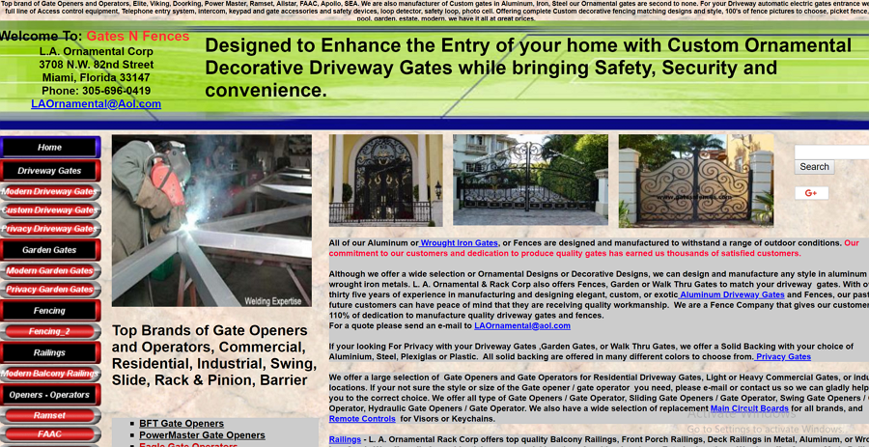

The navigation must be eye-catching and should often be at the top of the page. Do not try to design navigation like this site. It only makes the user more confused. The navigation content and the interactions also need to be clear, so do not use the horizontal scroll bar or other unusual animation design. If you do, you should at least give the user some hints to let them know how your site works. Below image shows how navigation should be placed.



**Example-2:**

Below is bad example of website with inconsistent style:



On this site, the text area uses contrasting colors and different font sizes to highlight the info. But the text on the second level also uses a highlight blue color, which in fact breaks the unity and balanced hierarchical interface. If you want to keep the page smooth and concise, then do not use too many elements of different styles. Unity is crucial to the overall beauty and fluency of the web interface, see it below:

