**ASSIGNMENT-1**

Name: Umer Khan Wazir, Yusra Fatima

Reg No: SP17-BCS-098, SP17-BCS-063

**Answer#1**

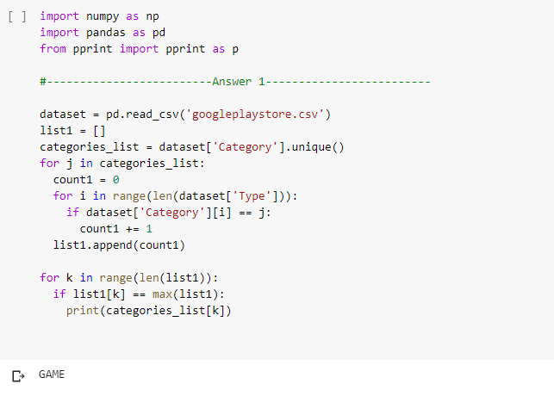

**Answer#2**

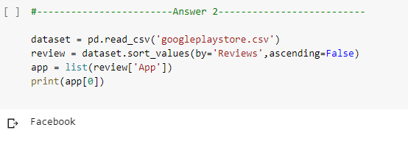

**Answer#3**

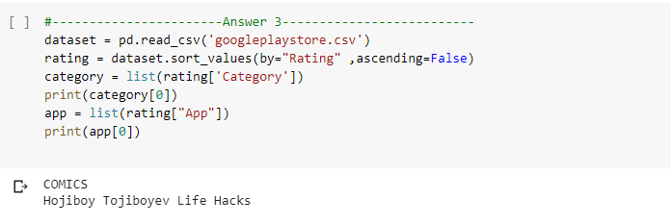

**Answer#4**

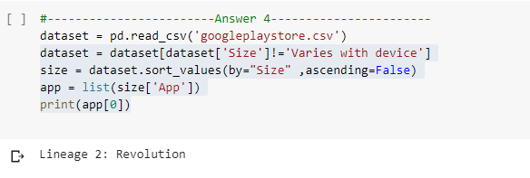

**Answer#6**

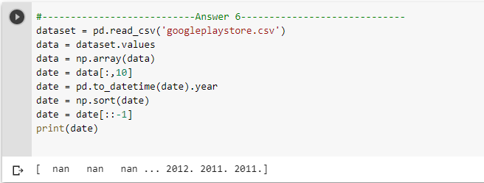

**Answer#7**

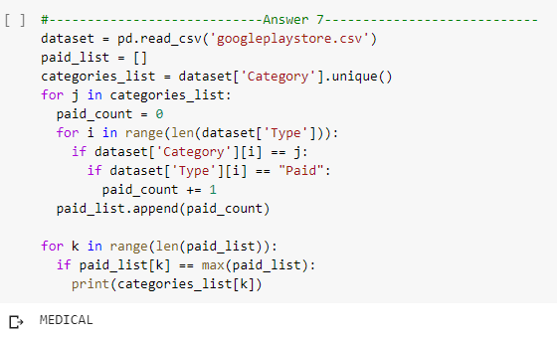

**Answer#8**

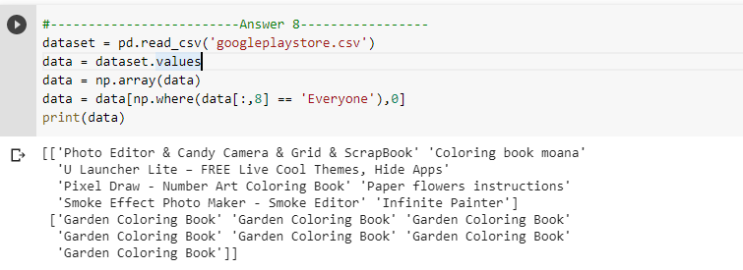

**Answer#9**

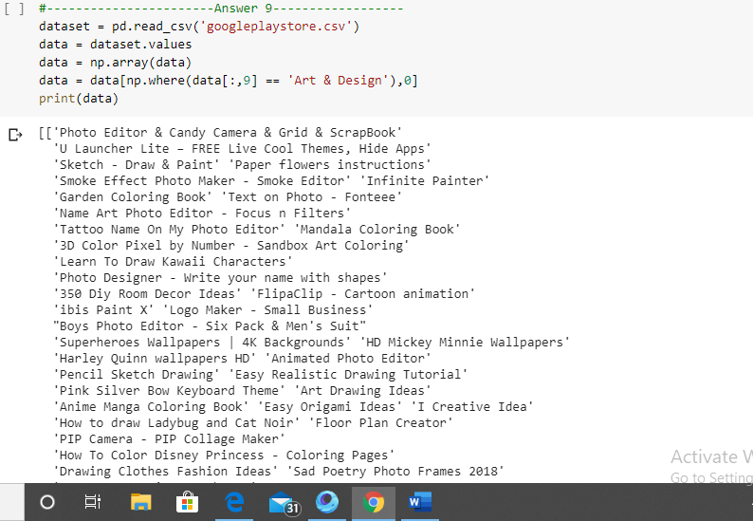

**Answer#10**

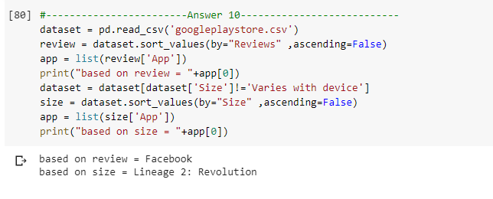

**Answer#11**

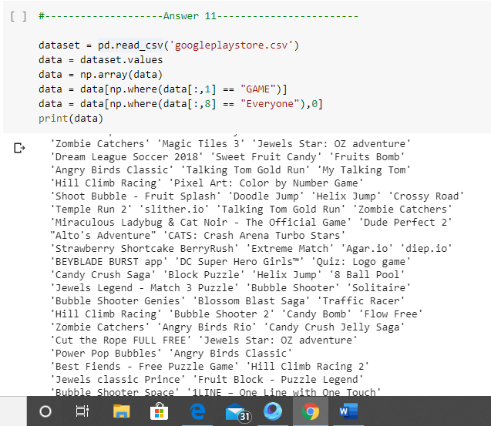

**Answer#12**

