|  |
| --- |
|  |
| <Project Name>  Specification and Design |
|  |

|  |
| --- |
| Version No: dd-mm-yyyy  Copy: uncontrolled |

Document Acceptance and Release Notice

This document is authorised for release once all signatures have been obtained.

|  |  |  |  |  |  |  |  |
| --- | --- | --- | --- | --- | --- | --- | --- |
| PREPARED: |  | Date: |  | / |  | / |  |
| (for acceptance) | <Name>  Project Manager, Student Group |  |  | | | | |
|  |  |  |  | | | | |
| ACCEPTED: |  | Date: |  | / |  | / |  |
| (for release) | Dr Paul Darbyshire  Project Sponsor, VIT |  |  | | | | |

Table of Contents

Executive Summary 7

Specification 7

System Description 7

Feasibility Analysis 7

Technical Feasibility 7

Economic Feasibility 7

Organizational Feasibility 8

Requirements Specification 8

Use Cases 9

Use Case Diagrams 9

Use Case Descriptions 9

Context Model 10

Design 10

Architectural Design 11

Database Structure 11

Interface Design 12

Sequence Diagrams 12

# 

# Executive Summary

We are using Google’s Dialogfow NLU model to build our chatbot which help us understanding human intention through its NLP. End user will interact with our chatbot integrated on the website get his response their coming from Dialogflow. Dialogflow took query of user, process it to detect what the user wants to ask and communicate with webhhook to get the user response and give response back to end user.

# Specification

## System Description

We are using Google’s Dialogflow NLU model to build our chatbot which help us communicating with end user through its NLP.

## Feasibility Analysis

### Technical Feasibility

This project is technically feasible because only one person is enough to manage whole project. Further we are using services of two most popular vendor i.e Heroku and Google so the downtime is almost negligible

### Economic Feasibility

Normally the paid plans of google Dialogflow and Heroku are feasible according to the use and also only one person is enough to handle the whole project. Initially we’ll go for free plans than after its growth to several hundreds users we’ll go paid plans

### Organizational Feasibility

The utility chatbot renders is upheld by its practical structure which is under the assessment of each financial specialist. Expenses acquired to keep up human assistance delegates are high when contrasted with that of manufacturing a bot. Introducing a chatbot requires a solitary huge venture beginning, and that adjusts through time, with unimportant upkeep consumption giving space to monstrous fund potential.

## Requirements Specification

### Functional

* API which takes user query to dialogflow and response back to use should up and running 24/7
* API which which takes response from webhook to dialoglow should be up and running 24/7
* No automatic upgradation in API response is tolerable

### Non-functional

## Use Cases

### Use Case Diagrams

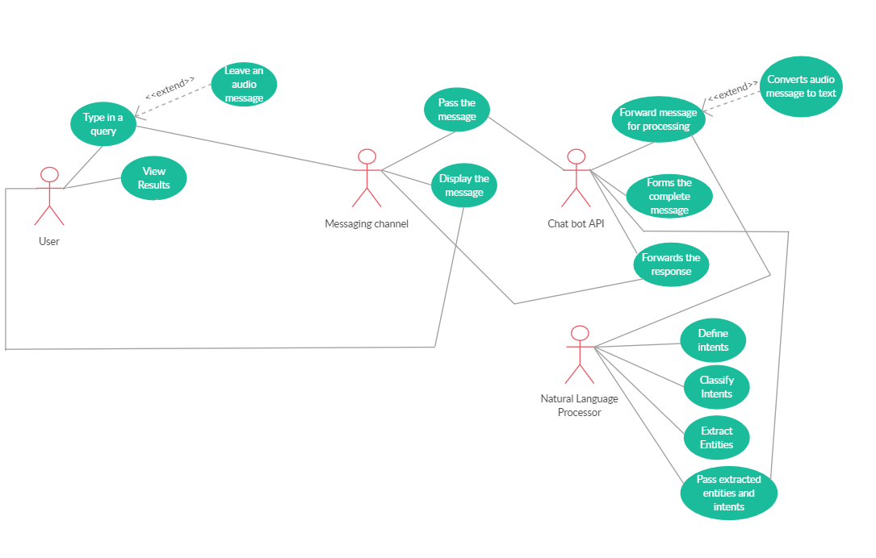

### Use Case Descriptions

This bot will be used as user will interact with bot with some simple interface available on the bottom right corner of the website where user can types his query after that that interface will pass the query message to Chatbot API. That chatbot api is responsible to pass that query message to Dialogflow platform where this message/query is processed to detect what user want to ask with provided training phrases in different intents with entities, if the intent is matched than its respective response will forward to chatbot API and from that API response will be displayed at that interface from where user types his query.

## Context Model

# Design

Product is designed as the end user will interact with Dialogflow agent. User will provides some sort intention by communicating with the agent. To detect every single intention we’ll provide vast number of similar phrases to dialogflow then dialogflow with its super strong and efficient Natural Language Understanding ( NLU ) algorithm help us by training its AI model according to our provided phrases. After a successful intention detection dialogflow looks for the response, if the response needs data from database or need to connect with external API’s we will be going for write a WEBHOOK that receives request from dialogflow then call external API’s , get data from database , do some calculations etc and last generate response back to dialogflow and dialogflow will give response to End User. Alternatively, if response doesn’t need to call external API or get data from database we can define response in dialogflow itself.

## Architectural Design

## Database Structure

Not needed now and if needed we’ll be going to use MongoDB ( NoSQL database ). Highly scalable and independent of defined schema

## Hardware Specification

## Interface Design

User Chatbot Interface

Chatbot Avatar

Explanation:

User visits the website he will notice the chatbot Avatar appearing at the bottom right corner of every webpage. When user clicks the avatar Chatbot User Interface opens for making communication between bot and user happen.

## 

## Sequence Diagrams

## State Diagram

