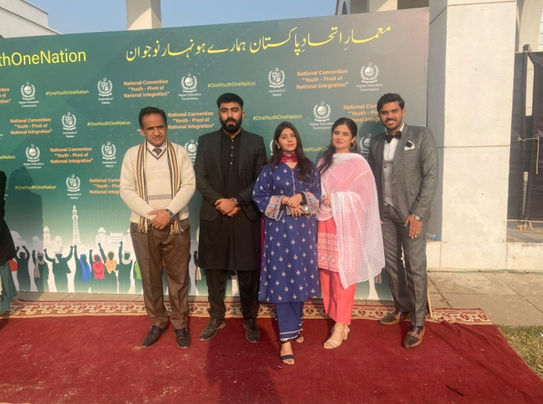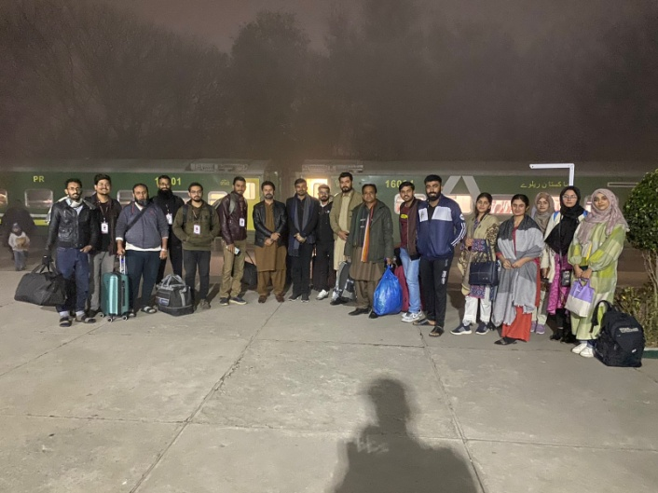

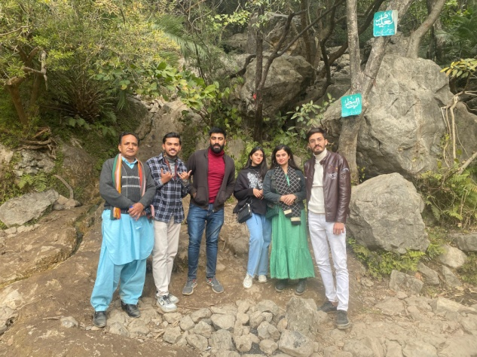

Higher Education Commission Pakistan organized a 2 days conference by the name of "Youth, Pivot of National Integration" at Jinnah Convention Center Islamabad on 23rd and 24th January 2024. Numerous delegations from various Institutions attended it under the motto of "One Youth- One Vision- One Nation".

A delegation of YPDC Chapter LUMHS comprising of President Mr. Moiz M. Sheikh, General Secretary Mr. M. Hashir Khan and members Miss Ayesha Sajid, Miss Maham Almani and Mr. M. Ali represented Liaquat University Of Medical and Health Sciences, Jamshoro.

1st day of The conference was full of knowledge and wisdom with Inspirational stories of successful youth followed by speeches of various intellectual and higher ranked personalities including Chairman Senate Mr. Sadiq Sanjrani and Chairman HEC Dr. Mukhtar Ahmed. For healthy entertainment, Music Gala night was also arranged in night at Pakistan National Arts Council, ISB where Federal Minister for National Heritage and Cultural Division, Mr. Syed Jamal Shah joined the ceremony.

2nd day of the conference was a Patriotic and Intellectual day. The conference was honoured by the presence of honourable Prime Minister of Pakistan, Mr. Anwar Ul Haq Kakar and Chief of the Army Staff, Gen. Syed Asim Muneer. They both spoke infront of the audience which was followed by healthy and democratic exchange of questions and answers between the PM, COAS and esteemed YOUTH of Pakistan. The students were given a laptop bag with some souvenirs as a token of appreciation.