**Prototype 1 - Main Page :**

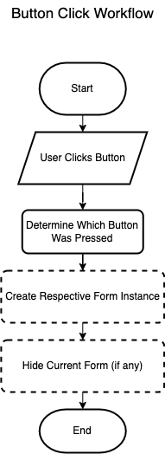

**Iteration 1**  
**Problem:** How to Map buttons so that they open a new form?  
**Solution:** Applying the function with the Click Keyword with the name of the button   
  
**Psuedocode:**  
**When button is clicked:**

**Create a new instance of the target form (e.g., PracticePage)**

**Show the target form**

**Hide the current form (optional)**  
  
**Iteration 2**

**Obstacle**: The Mock Test Page opening the Practice Page  
  
**Fix:** Refrence Wasnt Named Right Hence Causing the Practice Page to open Rather Than Mock test Page  
  
**Psuedocode:**

*FUNCTION Mock_test_Click(event sender, event args)*

*CREATE new instance of MockTest_Page called nextForm*

*DISPLAY nextForm (Show it on the screen)*

*HIDE the current form*

*END FUNCTION***Iteration 3**

**Update**: The Mock Test Page button now opens the Instruction form   
  
**Psuedocode:**

***FUNCTION Mock_test_Click(event sender, event args)***

***CREATE new instance of InstructionsForm called nextForm***

***DISPLAY nextForm (Show it on the screen)***

***HIDE the current form***

***END FUNCTION***

**Iteration 4**

**Update:** The New Progress_Page constructor in my new logic which will require a Dictionary<int, int> argument that contains the scores for each test. This dictionary keeps track of which tests have been attempted and their respective scores. I need to pass this dictionary when creating an instance of Progress_Page. In your MockTest_Page, Ialready have a testScores dictionary that tracks the scores for each test. So, I can pass that dictionary when calling the constructor.  
  
**Psuedocode:**  
***FUNCTION Progress_Click(event sender, event args)***

***RETRIEVE testScores dictionary from GlobalData***

***CREATE new instance of Progress_Page called nextForm, passing testScores as an argument***

***DISPLAY nextForm (Show it on the screen)***

***HIDE the current form***

***END FUNCTION*Prototype 2 - Practice Page**

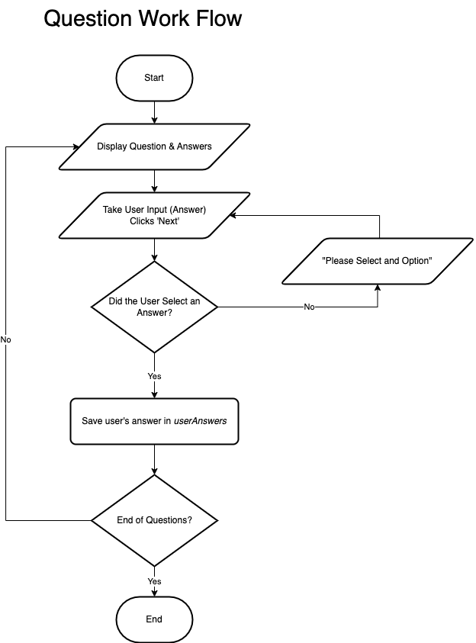

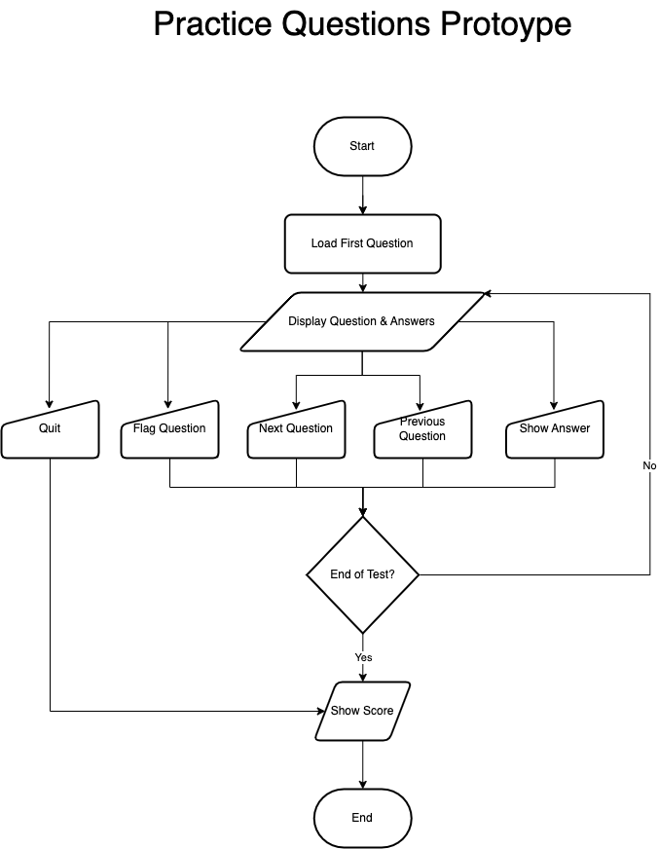

**Iteration 1**  
  
**Problem**: Tracker to track the question number you are on and iterating to the next question?  
  
**Psuedocode:**  
**Define a label to track the current question (trackerLabel)**

**Get the total number of questions from selectedTest.Questions.Count**

**If the current question index is equal to or greater than the total number of questions:**

**End the test or show results**

**Update the trackerLabel with the current question number:**

**trackerLabel.Text = "Question [currentQuestionIndex + 1] of [selectedTest.Questions.Count]"**

**For each option in the current question:**

**Create a radio button for the option**

**Set the radio button's text to the option text**

**Set the radio button's position and size**

**Add the radio button to the form's controls**

**Update the position for the next radio button**

**Iteration 2**

**Problem**: Need Buttons to navigate Between Questions but in a Smoother way ensuring the user doesn't navigate to a non-existent question.  
  
**Solution**: currentQuestionIndex Variable used to keeps track of the current question being displayed.This variable is updated when navigating between questions, ensuring the correct question from selectedTest.Questions is loaded.  
  
**Psuedocode:**  
**Define a variable to track the current question index (currentQuestionIndex)**

**For Next Button (moving forward):**

**Increment the currentQuestionIndex**

**Call LoadQuestion() to load the next question**

**Ensure currentQuestionIndex is less than the total number of questions**

**For Previous Button (moving backward):**

**If currentQuestionIndex is greater than 0:**

**Decrement the currentQuestionIndex**

**Call LoadQuestion() to load the previous question  
  
Problem**: Need To Show How Many Questions has the user gotten right? and what option is correct? How Will the scoring mechanism work?  
  
**Solution**: by comparing the selected option with the correct answer for each question.   
Each Question object has a property called CorrectOptionIndex, which stores the index of the correct option in the Options list.   
  
**Psuedocode**:   
**Define a variable to track the current question index (currentQuestionIndex)**

**For Next Button (moving forward):**

**Increment the currentQuestionIndex**

**Call LoadQuestion() to load the next question**

**Ensure currentQuestionIndex is less than the total number of questions**

**For Previous Button (moving backward):**

**If currentQuestionIndex is greater than 0:**

**Decrement the currentQuestionIndex**

**Call LoadQuestion() to load the previous question**  
  
  
**Iteration 3**  
**Problem:** How to Have Multiple Tests with different Questions?  
 **Solution:** Implementing multiple tests with different questions by organizing the questions into a List<Test> where each Test object contains its own set of questions.   
  
**Psuedocode:  
Define a Test class that holds a list of Question objects**

**Each Test object will have its own set of questions**

**Define a Question class that holds:**

**- The question text**

**- A list of possible answer options**

**- The index of the correct option**

**Create a List<Test> to manage multiple tests**

**Each Test object will contain a unique set of questions**  
  
**Problem:** How to store these tests?  
  
**Solution:** Bycreating Multiple like TestsA List<Test> is used to store multiple tests. Each Test in the list is initialized with a unique set of questions.  
  
**Psuedocode**:  
**Define a list to store multiple Test objects (tests)**

**For each Test:**

**Define a list of Question objects**

**For each Question in the Test:**

**Define the question text**

**Define a list of options**

**Define the correct answer's index**

**Add the Test to the list of tests**  
  
**Problem:** How to make the tests Random and Dynamic at the same time? Why To Choose Tests at Random?   
  
**Solution:** The test selection is made random using the Random class in the StartQuizButton_Click method

**Psuedocode:**   
**Define a method for starting the quiz (StartQuizButton_Click)**

**Initialize a Random object for generating random numbers**

**Select a random test from the list of tests using random.Next(tests.Count)**

**Set currentQuestionIndex to 0 (start from the first question)**

**Set score to 0 (reset score)  
  
Obstacle**: When the test is End and the Quiz is started by the User it shows me the final result of the test rather than starting a new one

**Fix**: The issue arises because the currentQuestionIndex and score variables are not reset after completing the first test. When you click the Start Test button again, the   
previous values persist, causing the program to skip to the score display.  
  
**Psuedocode:**  
  
**Define a method for starting the quiz (StartQuizButton_Click)**

**Reset test-specific variables:**

**- Set currentQuestionIndex to 0**

**- Set score to 0**

**Create a Random object for selecting a test**

**Randomly select a test from the list of tests using random.Next(tests.Count)**

**Initialize any components (e.g., timer) if needed**

**Load the first question of the selected test**

**Load the first question of the selected test  
  
Obstacle:** Facing the same test which the user has just attempted  
  
**Fix:** Change the random selection logic to ensure the user doesnt repeat the same test as the previous test they just did.  
previousTest variable is used to store the last selected test.  
  
**Psuedocode**:  
**Define a method for starting the quiz (StartQuizButton_Click)**

**Define a variable to store the previous test (previousTest)**

**Create a Random object for selecting a test**

**Repeat the following until a different test is selected:**

**- Randomly select a test from the list of tests**

**- If the selected test is the same as previousTest, repeat the selection**

**Store the selected test as previousTest**

**Load the first question of the selected test  
  
  
Problem:** showing the user What test They are attempting at the moment.  
  
**Solution:** To display the name or index of the current test, adding a label that updates whenever a new test is selected  
  
**Psuedocode:**  
**Define a label to display the current test name (testNameLabel)**

**Create a method to update the label when a new test is selected:**

**- Get the index of the selected test in the tests list**

**- Update testNameLabel to show the index (or name) of the current test**

**Add the label to the form to ensure it remains visible during the quiz**

**Whenever a new test is selected (in StartQuizButton_Click):**

**- Update the label with the test index or name**

**- Ensure testNameLabel is displayed on the form**

**Iteration 4  
Update:** Changing the logic of random Tests to user choice as this is a practice mode that logic is more suitable for mock test page  
Replacing the Start quiz class with StartTest   
  
**Psuedocode:**FUNCTION StartTest(testIndex)

SET selectedTest to the test at index testIndex in the tests list

SET currentQuestionIndex to 0

SET score to 0

UPDATE testNameLabel to display "Test (testIndex + 1)"

CALL LoadQuestion() to load the first question of the selected test

END FUNCTION

**Problem:** What if the user wants to quit the practice? And A Quit Button will help the user to quit at any given time?  
  
**Solution:** Add a Quit button which when clicked takes you to the initial screen   
  
**Psuedocode:**  
***FUNCTION Quit_Click(event sender, event args)***

***RESET selectedTest to null***

***RESET previousTest to null***

***RESET currentQuestionIndex to 0***

***RESET score to 0***

***CALL ShowIntroduction() to navigate back to the introduction screen***

***END FUNCTION***  
  
**Problem:** What if the user wants to see the answer to the question right there?  
  
**Solution:** Add a show answer button which highlights the correct answer in green.  
  
**Psuedocode:**  
***FUNCTION showAnswerButton_Click(event sender, event args)***

***IF selectedTest is null OR currentQuestionIndex is out of range for selectedTest.Questions***

***DISPLAY message: "No question loaded to show the answer."***

***RETURN from function***

***END IF***

***GET currentQuestion from selectedTest.Questions at currentQuestionIndex***

***GET correctOptionIndex from currentQuestion.CorrectOptionIndex***

***FOR EACH control in Controls***

***IF control is a RadioButton AND its Tag matches correctOptionIndex***

***SET the RadioButton's background color to Light Green***

***EXIT loop***

***END IF***

***END FOR***

***END FUNCTION }***

**Iteration 5**  
Problem: How to add pictorial Questions?  
Solution: Introduce picture box to display the picture,Set a proper location so it doesn’t comes over any button  
  
**Psuedocode:**  
***FUNCTION InitializeQuestionPictureBox()***

***CREATE a new PictureBox named questionPictureBox***

***SET SizeMode of questionPictureBox to Zoom***

***SET Size of questionPictureBox to 300x200***

***SET questionPictureBox.Visible to False (hidden by default)***

***SET Location of questionPictureBox to be centered horizontally and positioned at y=200***

***ADD questionPictureBox to the form's controls***

***END FUNCTION***Edit load questions function to display and show the picture if it exists  
**Psuedocode: *FUNCTION LoadQuestion()***

***IF currentQuestion has an associated image***

***SET questionPictureBox.Image to currentQuestion.Image***

***SET questionPictureBox.Visible to True (display the image)***

***ELSE***

***SET questionPictureBox.Visible to False (hide the image)***

***END IF***

***END FUNCTION*Prototype 3 - Mock Test Page**

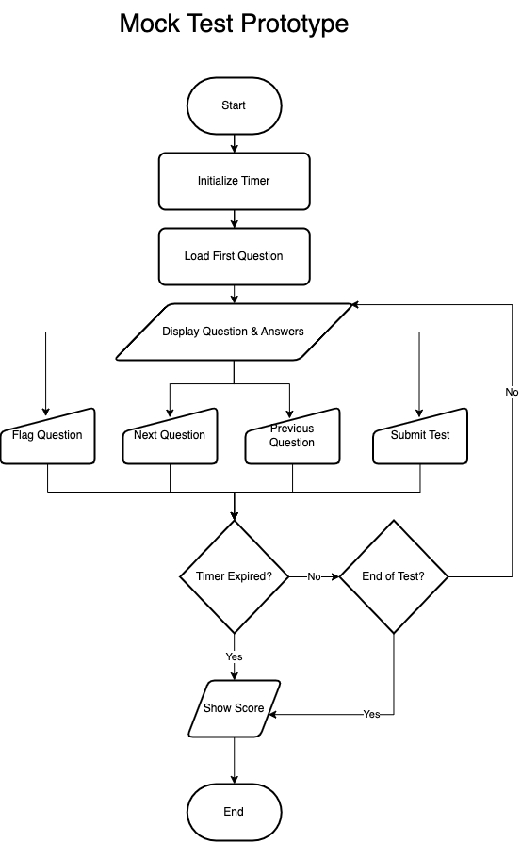

**Iteration 1**

Everything is the same as the practice page except there is a timer on  
  
**Problem**: How to Implement a CountDown?

**Solution:** The countdown timer can be implemented using a Initializating a Timer in the StartQuizButton_Click method.

**Psuedocode:  
  
Define a timer (quizTimer) for the countdown and a label (timerLabel) to display the time remaining.**

**Create the InitializeTimer method:**

**- Set the timer interval to 1000 milliseconds (1 second).**

**- Add a Tick event handler to update the countdown every second.**

**- Initialize the countdown time (e.g., 30 seconds).**

**- Start the timer and display the initial time on a label.**

**Create the Tick event handler (QuizTimer_Tick):**

**- Decrease the remaining time by 1 second.**

**- Update the label to show the new time.**

**- If time runs out, stop the timer and handle the end of the quiz.**

**Iteration 2**

**Problem:** How will the timer would be Updated? This timer should Stop the Test when the timer runs out:

**Solution:** The QuizTimer_Tick method is made which basically is triggered every second, thus updating the timeRemaining value and displaying the remaining time on the timerLabel. If the timer reaches zero, the test is stopped and the score is shown.  
  
**Psuedocode**:  
**Define a timer (quizTimer) for the countdown and a label (timerLabel) to display the remaining time.**

**Create the QuizTimer_Tick method:**

**- Decrease the time remaining by 1 second.**

**- If timeRemaining reaches 0, stop the timer and call ShowScore to display the final score.**

**- Otherwise, update the timer label to show the current remaining time.**

**Obstacle:** Severity Code Description Project File Line Suppression State Details Error (active) CS0104 'Timer' is an ambiguous reference between 'System.Windows.Forms.Timer' and 'System.Threading.Timer' WinFormsApp1 **Fix:** The error occurs because both System.Windows.Forms.Timer and System.Threading.Timer are referenced, and the compiler doesn't know which one to use. To resolve this ambiguity, I need to explicitly qualify the Timer class with its namespace.  
**private System.Windows.Forms.Timer quizTimer; // Timer object**

In the class of IntializeTimer we need to change the qualification  
 **Psuedocode:**

***FUNCTION InitializeTimer()***

***IF quizTimer is null***

***CREATE a new instance of System.Windows.Forms.Timer and assign it to quizTimer***

***SET quizTimer.Interval to 1000 milliseconds (1-second intervals)***

***ATTACH the QuizTimer_Tick event handler to quizTimer.Tick***

***END IF***

***END FUNCTION***

**Iteration 4**  
  
Update: Increase the Timer from 30 sec to 57 Minutes by changing the Initialize Timer Code  
**Psuedocode:**

***FUNCTION InitializeTimer()***

***IF quizTimer is null***

***CREATE a new instance of System.Windows.Forms.Timer and assign it to quizTimer***

***SET quizTimer.Interval to 1000 milliseconds (1-second intervals)***

***ATTACH the QuizTimer_Tick event handler to quizTimer.Tick***

***END IF***

***SET timeRemaining to 57 * 60 seconds (57 minutes)***

***CALL quizTimer.Start() to begin the countdown***

***END FUNCTION***

**Iteration 5:**

**Problem:** If a user wants to mark a question they dont understand how would they?  
  
**Solution**: I will introduce a "Flag" button that allows me to flag questions I want to know the answer to. These flagged questions will then be displayed on the progress page. I can flag and unflag questions as needed. Additionally, I will introduce a list to save the selected flagged questions for easy tracking.  
 ***private List<int> flaggedQuestions = new List<int>();***  
  
Make a new Class for it  
  
**Psuedocode:  
*DECLARE flaggedQuestions as a new List of integers  
FUNCTION Flag_Click(event sender, event args)***

***IF currentQuestionIndex exists in flaggedQuestions***

***REMOVE currentQuestionIndex from flaggedQuestions***

***SET flagButton.Text to "Flag"***

***ELSE***

***ADD currentQuestionIndex to flaggedQuestions***

***SET flagButton.Text to "Unflag"***

***END IF***

***END FUNCTION  
  
CLASS FlaggedQuestion***

***PROPERTY QuestionIndex AS integer***

***PROPERTY IsFlagged AS boolean***

***CONSTRUCTOR FlaggedQuestion(index)***

***SET QuestionIndex to index***

***SET IsFlagged to true***

***END CONSTRUCTOR***

***END CLASS***

**Problem:** when the user is flagging the question they are still forced to select an option to move ahead  
  
**Solution:** Change the Next Click Class to include an if which checks if the question is flagged or not

**Psuedocode:  
*FUNCTION Next_Click(event sender, event args)***

***IF currentQuestionIndex is in flaggedQuestions***

***INCREMENT currentQuestionIndex***

***CALL LoadQuestion() to load the next question***

***RETURN from function (skip the rest of the logic)***

***END IF***

***IF no option is selected for the current question***

***DISPLAY a message asking the user to select an answer***

***RETURN from function (do not proceed further)***

***END IF***

***INCREMENT currentQuestionIndex***

***CALL LoadQuestion() to load the next question***

***END FUNCTION***

**Update:** The Show screen also needs to show what questions the user has gotten right or wrong  
 **Problem:** Showing all of the questions without showing user choice

**Solution:** Make and implement a Dictionary which stores the users choice

**Psuedocode:  
*DECLARE a Dictionary called userAnswers***

***KEY: question index (int)***

***VALUE: selected answer (int)***

implement it in next click class so the users choice can be stored

**Psuedocode:  
*FUNCTION Next_Click(event sender, event args)***

***IF user has selected an option for the current question***

***userAnswers[currentQuestionIndex] = selectedOption***

***END IF***

***INCREMENT currentQuestionIndex***

***CALL LoadQuestion() to load the next question***

***END FUNCTION***

I will change the ShowScore class to incorporate all of the new changes by creating a loop that goes through all of the incorrect questions answered by me. In this loop, red will represent the user’s choice that was wrong, while green will represent the correct answer. This will provide a clear visual representation of the mistakes made and the correct answers.

**Psuedocode:  
*FUNCTION ShowScore()***

***CREATE a Label called reviewLabel***

***SET text to "Review of Incorrect Questions:"***

***SET font to Arial, size 10, bold***

***ADD reviewLabel to the scrollable panel***

***SET yPosition to the bottom of reviewLabel + 10***

***FOR each question in selectedTest***

***DECLARE userAnswer as -1 // Default value for no answer***

***DECLARE isCorrect as false***

***IF userAnswers contains the current question index***

***SET userAnswer to userAnswers[currentQuestionIndex]***

***SET isCorrect to (userAnswer == question.CorrectOptionIndex)***

***END IF***

***IF isCorrect***

***CONTINUE to the next question***

***END IF***

***CREATE a Label for the question***

***SET text to "Q{index + 1}: {question.Text}"***

***ADD question label to the scrollable panel***

***FOR each option in question.Options***

***CREATE a Label for the option***

***SET text to the option text***

***IF option index matches userAnswer***

***SET option label text color to Red***

***END IF***

***IF option index matches question.CorrectOptionIndex***

***SET option label text color to Green***

***END IF***

***ADD option label to the scrollable panel***

***UPDATE yPosition for next option***

***END FOR***

***UPDATE yPosition for spacing between questions***

***END FOR***

***END FUNCTION*Prototype 4 - Progress Page:**

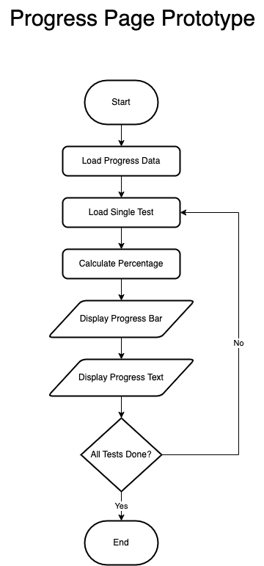

**Iteration 1:**

**Problem:** How can I track the progress of the user, including how many tests they have taken and their scores on those tests (graphically)? How will the score percentage be calculated?

**Solution:** To implement a graphical progress bar for the progress page, I can use the ProgressBar control in Windows Forms and a Label to display the score percentage. I can create a dynamic progress bar for each test, where the value of the progress bar reflects the user's score as a percentage. I will calculate the score percentage based on the number of correct answers (e.g., 10 questions per test, or adjust this to the actual number of questions in the test).

Next to each progress bar, a Score Display label will show the score percentage or indicate if the test has not been attempted. When navigating to the Progress_Page, I will pass a dictionary containing the scores for each test to ensure all progress is displayed correctly. **Psuedocode:**

***DECLARE a Dictionary called userAnswers***

***KEY: question index (int)***

***VALUE: selected answer (int)***

***FUNCTION Next_Click(event sender, event args)***

***// Check if the user has selected an answer***

***IF user has selected an option for the current question***

***// Store the user's answer in the userAnswers dictionary***

***userAnswers[currentQuestionIndex] = selectedOption***

***END IF***

***// Proceed to the next question logic (as usual)***

***INCREMENT currentQuestionIndex***

***CALL LoadQuestion() to load the next question***

***END FUNCTION***

***FUNCTION ShowScore()***

***// Create a label for reviewing incorrect answers***

***CREATE a Label called reviewLabel***

***SET text to "Review of Incorrect Questions:"***

***SET font to Arial, size 10, bold***

***ADD reviewLabel to the scrollable panel***

***// Set the starting position for displaying questions***

***SET yPosition to the bottom of reviewLabel + 10***

***// Loop through all the questions***

***FOR each question in selectedTest***

***DECLARE userAnswer as -1 // Default value for no answer***

***DECLARE isCorrect as false***

***// Check if the user has answered the question***

***IF userAnswers contains the current question index***

***SET userAnswer to userAnswers[currentQuestionIndex]***

***SET isCorrect to (userAnswer == question.CorrectOptionIndex)***

***END IF***

***// Skip displaying the correct answers***

***IF isCorrect***

***CONTINUE to the next question***

***END IF***

***// Display the question text***

***CREATE a Label for the question***

***SET text to "Q{index + 1}: {question.Text}"***

***ADD question label to the scrollable panel***

***// Display the options***

***FOR each option in question.Options***

***CREATE a Label for the option***

***SET text to the option text***

***// Highlight user's incorrect answer in red***

***IF option index matches userAnswer***

***SET option label text color to Red***

***END IF***

***// Highlight the correct answer in green***

***IF option index matches question.CorrectOptionIndex***

***SET option label text color to Green***

***END IF***

***ADD option label to the scrollable panel***

***UPDATE yPosition for next option***

***END FOR***

***// Add spacing between questions***

***UPDATE yPosition for spacing between questions***

***END FOR***

***END FUNCTION***

**Problem:** How to Integrate it with the Mock test page?  
  
**Solution:** To integrate with my MockTest_Page, updating the ShowScore method so it can save the score in a global object. Then, pass the scores to the Progress_Page.  
  
**Psuedocode:**  
***DEFINE a global dictionary: testScores***

***testScores = NEW Dictionary<int, int>()***  
***FUNCTION SaveScore(testNumber, score)***

***IF testScores does NOT contain key testNumber***

***testScores[testNumber] = score***

***END IF***

***END FUNCTION***

***FUNCTION ShowScore(testNumber, score)***

***SaveScore(testNumber, score)***

***DISPLAY score to the user***

***END FUNCTION***

***FUNCTION NavigateToProgressPage()***

***Progress_Page nextForm = NEW Progress_Page(testScores)***

***nextForm.Show()***

***CURRENT_PAGE.Hide()***

***END FUNCTION***

**Iteration 2:**

**Update**: To Dynamically calculate the progress bar based on the number of questions in the test  
  
**Psuedocode:**

***DEFINE a global dictionary: testQuestions***

***testQuestions = NEW Dictionary<int, int>()***

***testQuestions[1] = 10 // Test 1 has 10 questions***

***testQuestions[2] = 8 // Test 2 has 8 questions***

***testQuestions[3] = 12 // Test 3 has 12 questions***

***DEFINE a global dictionary: testScores***

***testScores = NEW Dictionary<int, int>()***

***FUNCTION DisplayProgressBar(testNumber, yPosition)***

***IF testScores contains key testNumber AND testQuestions contains key testNumber***

***scorePercentage = (testScores[testNumber] * 100) / testQuestions[testNumber]***

***ELSE***

***scorePercentage = 0***

***END IF***

***ProgressBar progressBar = NEW ProgressBar***

***progressBar.Minimum = 0***

***progressBar.Maximum = 100***

***progressBar.Value = scorePercentage***

***progressBar.Size = NEW Size(200, 20)***

***progressBar.Location = NEW Point(100, yPosition)***

***Controls.Add(progressBar)***

***END FUNCTION***  
  
**Problem:** The text next to the progress bar is 10%/20% it is being calculated by Multiplying the score by 10,Assuming that the number of question is 10  
the percentage should be calculated with the dynamic question logic now  
 ***Text = testScores.ContainsKey(testNumber)***

***? $"{testScores[testNumber] * 10}%"***

***: "Not Attempted",***

**Solution:** I can use a Label that dynamically calculates and displays the percentage based on the testScores and testQuestions.   
Calculate Percentage percentage is dynamically calculated now using the formula

**FUNCTION DisplayProgressBarWithPercentage(testNumber, yPosition)**

**IF testScores contains key testNumber AND testQuestions contains key testNumber**

**percentage = (testScores[testNumber] * 100) / testQuestions[testNumber]**

**ELSE**

**percentage = 0**

**END IF**

**ProgressBar progressBar = NEW ProgressBar**

**progressBar.Minimum = 0**

**progressBar.Maximum = 100**

**progressBar.Value = percentage**

**progressBar.Size = NEW Size(200, 20)**

**progressBar.Location = NEW Point(100, yPosition)**

**Label percentageLabel = NEW Label**

**percentageLabel.Text = testScores.ContainsKey(testNumber)**

**? $"{percentage}%"**

**: "Not Attempted"**

**percentageLabel.AutoSize = TRUE**

**percentageLabel.Location = NEW Point(310, yPosition) // Adjust X coordinate to position the label next to the progress bar**

**Controls.Add(progressBar)**

**Controls.Add(percentageLabel)**

**END FUNCTION**

**Iteration 3:**

**Update:** It only shows the progress of the mock test right now I want to change so that so it also shows the progress of practice page  
I have to add A variable to score practice score globally

**Psuedocode:**  
***CLASS GlobalData***

***STATIC Dictionary<int, int> TestScores = NEW Dictionary<int, int>()***

***// Key: Test number (integer)***

***// Value: Test score (integer)***

***STATIC Dictionary<int, int> PracticeScores = NEW Dictionary<int, int>()***

***// Key: Practice test number (integer)***

***// Value: Practice test score (integer)***

***END CLASS***I then have to store the scores aswell **Psuedocode:**

***FUNCTION ShowScore()***

***CALL Controls.Clear()***

***IF selectedTest IS NOT NULL THEN***

***SET testIndex = INDEX OF selectedTest IN tests + 1***

***GlobalData.PracticeScores[testIndex] = score***

***END IF***

***END FUNCTION***

I also changed the label to better identify the tests and show progress under  
**Psuedocode:**

***FUNCTION DisplayTestProgress()***

***CREATE Label mockProgressLabel***

***SET mockProgressLabel.Text TO "Mock Test Progress"***

***ADD mockProgressLabel TO form controls***

***FOR EACH testNumber IN testQuestions.Keys***

***CALL AddProgressRow("Test", testNumber, mockTestScores, REF yPosition)***

***END FOR***

***CREATE Label practiceProgressLabel***

***SET practiceProgressLabel.Text TO "Practice Test Progress"***

***ADD practiceProgressLabel TO form controls***

***FOR EACH testNumber IN testQuestions.Keys***

***CALL AddProgressRow("Test", testNumber, practiceTestScores, REF yPosition)***

***END FOR***

***END FUNCTION***

**Iteration 5:**

**Problem:** After adding the checkbox for completed topics, how can I track what the user has completed? And if they go back and complete it later, how will that be updated?

**Solution**: I will introduce a timer that checks what the user has selected to be completed. This timer will run every second. If the user hasn't completed any topics, it will display "None."  
add a timer and the topics completed  
  
**Psuedocode:**

***FUNCTION InitializeTopicsCompleted()***

***CREATE Label topicsCompletedLabel***

***SET topicsCompletedLabel.Text TO "Topics Completed: None"***

***SET topicsCompletedLabel.Font TO Arial, 12, Bold***

***SET topicsCompletedLabel.AutoSize TO True***

***SET topicsCompletedLabel.Location TO Point(20, yPosition) // Position based on yPosition***

***ADD topicsCompletedLabel TO form controls***

***CREATE Timer updateTimer***

***SET updateTimer.Interval TO 1000 // Update every 1 second***

***updateTimer.Tick += (s, e) => CALL UpdateTopicsCompleted()***

***updateTimer.Start()***

***END FUNCTION*Prototype 5 - Flagged Questions Page:  
Iteration 1:**  
For getting all the flagged questions and showing them on one page

**Psuedocode: *FUNCTION DisplayFlaggedQuestions()***

***FOR each questionIndex IN test.Value***

***SET question TO GlobalData.AllTests[test.Key - 1][questionIndex]***

***CREATE Label questionLabel***

***SET questionLabel.Text TO "Q: " + question.Text + "\nA: " + question.Options[question.CorrectOptionIndex]***

***SET questionLabel.Font TO Arial, 10, Regular***

***SET questionLabel.AutoSize TO True***

***SET questionLabel.Location TO Point(40, yPosition)***

***ADD questionLabel TO scrollablePanel.Controls***

***yPosition = yPosition + 50***

***END FOR***

***END FUNCTION***  
**Prototype 6 - Traffic Signs Page:**

**Iteration 1:**  
**Problem:** How to know what topics are completed by the user?  
**Solution:** I will add a checkbox under every topic so that when the user completes a topic, they can check it. This allows the user to track their progress and mark topics as completed.

**Psuedocode:**  
***DEFINE Global List CompletedTopics AS EMPTY LIST***

***FUNCTION Traffic_Signs_page()***

***CALL InitializeComponent()***

***END FUNCTION***

***FUNCTION Giving_Order_Complete_CheckedChanged(sender, e)***

***CALL UpdateCompletedTopics("Giving Orders", Giving_Order_Complete.Checked)***

***END FUNCTION***

***FUNCTION Warning_Signs_Complete_CheckedChanged(sender, e)***

***CALL UpdateCompletedTopics("Warning Signs", Warning_Signs_Complete.Checked)***

***END FUNCTION***

***FUNCTION Direction_Signs_Complete_CheckedChanged(sender, e)***

***CALL UpdateCompletedTopics("Direction Signs", Direction_Signs_Complete.Checked)***

***END FUNCTION***

***FUNCTION Information_Signs_Complete_CheckedChanged(sender, e)***

***CALL UpdateCompletedTopics("Information Signs", Information_Signs_Complete.Checked)***

***END FUNCTION***

***FUNCTION Road_Work_Complete_CheckedChanged(sender, e)***

***CALL UpdateCompletedTopics("Road Work Signs", Road_Work_Complete.Checked)***

***END FUNCTION***

***FUNCTION UpdateCompletedTopics(topic, isCompleted)***

***IF isCompleted IS TRUE***

***IF topic IS NOT IN CompletedTopics***

***ADD topic TO CompletedTopics***

***END IF***

***ELSE***

***REMOVE topic FROM CompletedTopics***

***END IF***

***END FUNCTION*Obstacle:** when the user goes back to the menu and open traffic page again the checkbox becomes empty  
  
**Solution:** The issue arises because the state of the checkboxes (whether they are checked or not) is not being preserved when navigating away from the Traffic_Signs_page and reopening it. This happens because each time the form is opened, a new instance of Traffic_Signs_page is created, and the checkboxes are reset to their default state (unchecked).

To fix this, I will store the state of the checkboxes (whether they are checked or unchecked) in a persistent location, such as a global variable, a file, or a database. When the Traffic_Signs_page is reopened, I can retrieve the saved state and update the checkboxes accordingly.  
 **Psuedocode:**  
***DEFINE Static Dictionary CheckboxStates AS DICTIONARY***

***{***

***"Giving Orders": FALSE,***

***"Warning Signs": FALSE,***

***"Direction Signs": FALSE,***

***"Information Signs": FALSE,***

***"Road Work Signs": FALSE***

***}***

***DEFINE Global List CompletedTopics AS EMPTY LIST***

***FUNCTION Traffic_Signs_page()***

***// Initialize page components***

***CALL InitializeComponent()***

***// Restore the checkbox states when the form loads***

***CALL RestoreCheckboxStates()***

***END FUNCTION***

***// Function to restore checkbox states***

***FUNCTION RestoreCheckboxStates()***

***// Restore each checkbox state from the static dictionary***

***SET Giving_Order_Complete.Checked = CheckboxStates["Giving Orders"]***

***SET Warning_Signs_Complete.Checked = CheckboxStates["Warning Signs"]***

***SET Direction_Signs_Complete.Checked = CheckboxStates["Direction Signs"]***

***SET Information_Signs_Complete.Checked = CheckboxStates["Information Signs"]***

***SET Road_Work_Complete.Checked = CheckboxStates["Road Work Signs"]***

***// Debug logging for validation***

***PRINT "Checkbox States Restored:"***

***FOR EACH entry IN CheckboxStates***

***PRINT entry.Key + ": " + entry.Value***

***END FOR***

***END FUNCTION***

***// Checkbox event handler to update the completed topics***

***FUNCTION UpdateCompletedTopics(topic, isCompleted)***

***IF isCompleted IS TRUE***

***IF topic IS NOT IN CompletedTopics***

***ADD topic TO CompletedTopics***

***END IF***

***ELSE***

***REMOVE topic FROM CompletedTopics***

***END IF***

***// Update the static dictionary with the checkbox state***

***SET CheckboxStates[topic] = isCompleted***

***// Debug logging for validation***

***PRINT "Updated Checkbox State: " + topic + " = " + isCompleted***

***END FUNCTION***

**Iteration 2:**

**Problem:** How to put pictures with text so the user can study signs from?  
  
**Solution:** I will add a new page under each topic so that the user can see what signs belong to that particular topic. When the user clicks on a topic, they will be directed to a page that displays all the relevant signs under that topic.

**Psuedocode**:  
***FUNCTION Orders_Signs_Click(sender, e)***

***CREATE nextForm AS new Orders_Signs()***

***CALL nextForm.Show()***

***CALL this.Hide()***

***END FUNCTION***

**Problem:** How to put pictures with text?  
  
**Solution:** Implementation of a datagrid with scroll wheel

**Psuedocode**:  
***FUNCTION InitializeGrid()***

***CREATE signsGridView AS new DataGridView()***

***SET signsGridView.Dock TO DockStyle.Fill***

***SET signsGridView.AutoSizeColumnsMode TO DataGridViewAutoSizeColumnsMode.Fill***

***SET signsGridView.RowTemplate.Height TO 100 // Adjust row height to fit images***

***SET signsGridView.AllowUserToAddRows TO false***

***SET signsGridView.ReadOnly TO true***

***CREATE imageColumn AS new DataGridViewImageColumn()***

***SET imageColumn.HeaderText TO "Sign Image"***

***SET imageColumn.Name TO "ImageColumn"***

***SET imageColumn.ImageLayout TO DataGridViewImageCellLayout.Zoom***

***ADD imageColumn TO signsGridView.Columns***

***CREATE infoColumn AS new DataGridViewTextBoxColumn()***

***SET infoColumn.HeaderText TO "Information"***

***SET infoColumn.Name TO "InfoColumn"***

***ADD infoColumn TO signsGridView.Columns***

***CALL AddSignRow(signsGridView, "Signs with red circles are mostly prohibitive.\r\nPlates below signs qualify their message.", "Blank.png")***

***CALL AddSignRow(signsGridView, "Entry to 20 mph zone", "Entry_to_20_mph_zone.png")***

***CALL AddSignRow(signsGridView, "End of 20 mph zone", "End_of_20_mph_zone.png")***

***IF signsGridView.Rows.Count > 1 THEN***

***SET signsGridView.Rows[0].DefaultCellStyle.Font TO new Font("Arial", 10, FontStyle.Bold)***

***ADD signsGridView TO Controls***

***END FUNCTION***

***FUNCTION AddSignRow(grid, info, imagePath)***

***CREATE appDirectory AS AppDomain.CurrentDomain.BaseDirectory***

***CREATE imageFullPath AS System.IO.Path.Combine(appDirectory, "Signs_Giving_Order", imagePath)***

***IF NOT System.IO.File.Exists(imageFullPath) THEN***

***THROW new System.IO.FileNotFoundException("Image file not found: " + imageFullPath)***

***CREATE signImage AS Image.FromFile(imageFullPath)***

***CALL grid.Rows.Add(signImage, info)***

***END FUNCTION*Prototype 7 - Settings Page:  
Iteration 1:  
  
Update:** Setting button to change the background colour of each form for user visibility  
 **Create a new Form Page of Settings   
  
Psuedocode:  
*FUNCTION Change_Color_Click(sender, e)***

***CREATE colorDialog AS new ColorDialog()***

***IF colorDialog.ShowDialog() == DialogResult.OK THEN***

***SET GlobalBackgroundColor TO colorDialog.Color***

***CALL MessageBox.Show("Background color updated. It will apply to all forms when they are reopened.",***

***"Settings",***

***MessageBoxButtons.OK,***

***MessageBoxIcon.Information)***

***END IF***

***END FUNCTION***

**Iteration 2:**

**Problem:** How can the user change the size of the font? **Solution:** Introduce a slider on the Settings Page So That The User can change the size of the font as well as choose if they want to make it bold/italic **Psuedocode:  
  
*FUNCTION FontSizeSlider_Scroll(sender, e)***

***SET GlobalFontSize TO fontSizes[fontSizeSlider.Value]***

***SET fontPreviewLabel.Font TO new Font("Arial", GlobalFontSize, GlobalFontStyle)***

***END FUNCTION***

***FUNCTION FontStyleCheckBox_CheckedChanged(sender, e)***

***SET fontStyle TO FontStyle.Regular***

***IF boldCheckBox.Checked THEN***

***fontStyle |= FontStyle.Bold***

***END IF***

***IF italicCheckBox.Checked THEN***

***fontStyle |= FontStyle.Italic***

***END IF***

***SET GlobalFontStyle TO fontStyle***

***SET fontPreviewLabel.Font TO new Font("Arial", GlobalFontSize, GlobalFontStyle)***

***CALL MessageBox.Show("Font style updated to " + GlobalFontStyle, "Settings", MessageBoxButtons.OK, MessageBoxIcon.Information)***

***END FUNCTION***