Lab # 4

Name:Umer farooq

CMS:229143

BSCS 7A

# Task 2:

Output: 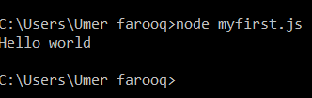

Task 3:code

exports.myDatetime = function(){

return Date();

};

# Task 4:

var dt = require('./myfirstmodule');

console.log(dt.myDatetime());

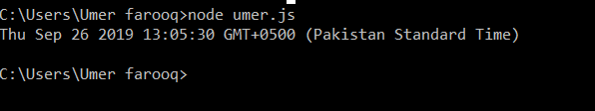

# Task 5 :

Code:

var http = require('http');

http.createServer(function(req,res){

res.write("Server created");

res.end();

}).listen(8080);

Output: 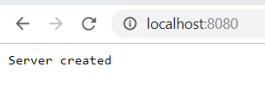

# Task 6:

Code: var http = require('http');

http.createServer(function(req,res){

res.writeHead(200, {'Content-type': 'text/html'});

res.write("Http header added");

res.end();

}).listen(8080);

Output:

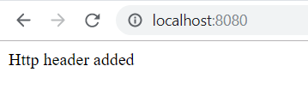

Task 7:

Read file: code

var http = require('http');

var fs = require('fs');

http.createServer(function(req,res){

fs.readFile('demofile.html',function(err,data){

res.writeHead(200, {'Content-type': 'text/html'});

res.write(data);

res.end();

});

}).listen(8080);

Html file:

<html>

<head>

<tittle> My name </tittle>

</head>

<body>

<p> My name is umer farooq </p>

</body>

</html>

Output :

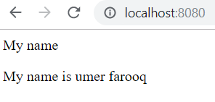

Task 8:

Code :

Append file:

var fs = require('fs');

fs.appendFile('newfile.txt','My new file',function(err){

if (err) throw err;

console.log('File is created');

});

Output:

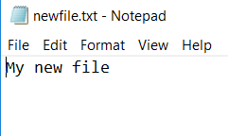



Open file:

Code:

var fs = require('fs');

fs.appendFile('newfile2.txt','w',function(err){

if (err) throw err;

console.log('File2 is created');

});

Output: 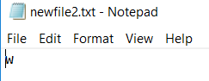



Code :

var fs = require('fs');

fs.writeFile('newfile3.txt','My 3rd file is created',function(err){

if (err) throw err;

console.log('File3 is created');

});

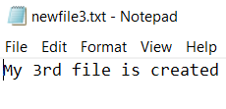



# Task 9:

Code:

var fs = require('fs');

fs.appendFile('newfile.txt','This is my text',function(err){

if (err) throw err;

console.log('File1 is created');

});

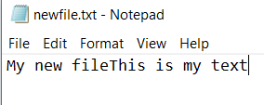

# Task 10:

Code: var fs = require('fs');

fs.writeFile('newfile3.txt','New content',function(err){

if (err) throw err;

console.log('File3 is changed');

});

Output:

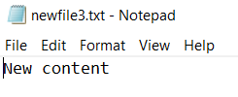

# Task 11:

Code:

var fs = require('fs');

fs.unlink('newfile2.txt',function(err){

if (err) throw err;

console.log('File2 is deleted');

});

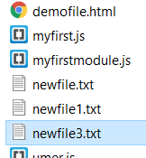



# Task 12:

Code: var fs = require('fs');

fs.rename('newfile1.txt','Myrenamedfile.txt',function(err){

if (err) throw err;

console.log('File1 is renamed');

});

Output: 

