Team Number: 1

Course: ET712 / SPRING 2018

Web Design Capstone Project

Case Domain: Online Pizza Ordering System

**TABLE OF CONTENTS:**

1. Introduction

1.1 Website Key features

1.2 Navigation structure

1.3 Target audience Market and Break-Even Analysis

2. **Goals**

2.1 P**lausibility**

3. Swot Analysis

**4.** Competitor websites

5. Resources

**5.1 Credits**

**1. Introduction**

We see a new site that easy to navigate but also easy to manage. Deep pages, but clear navigation. We need to highlight past ordering pizzas on phone for home delivery. The process seems easy to use but at times there is miscommunication. Our client QCCPIZZA have visual menu during a phone call and employee repeat again and again to the customer request.

**1.1 Website Key features**

All ages visitors to what our QCCPIZZA online tracking and menu choices, and how they can track pizza ordering status.

Online Platform:

1. MAC & PC browsers (chrome, IE, Firefox, Safari)

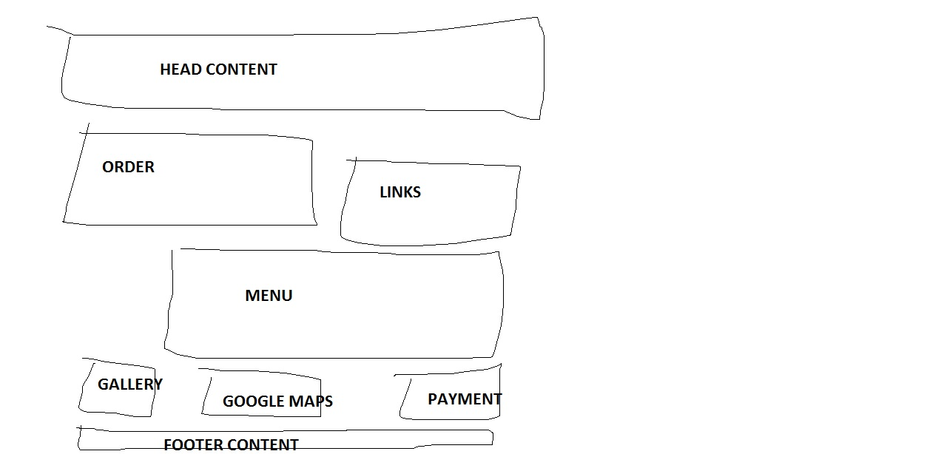

Mobile Platform:

1. IPhone, iPad, Android (Samsung).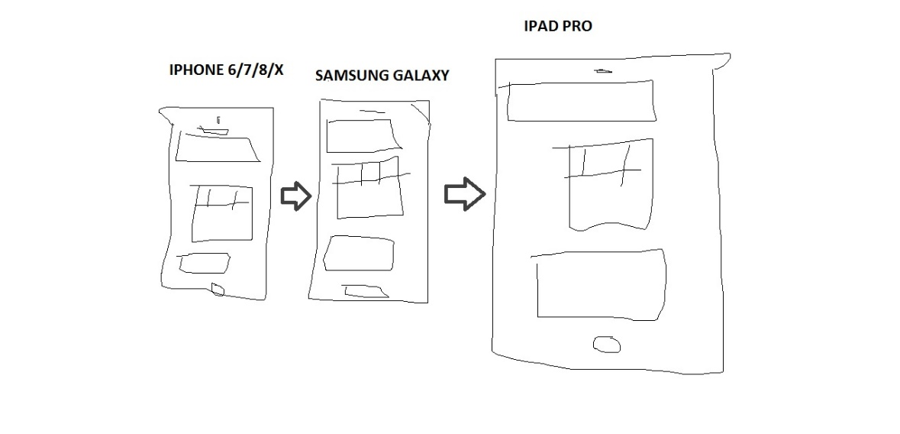

**QCCPIZZA Version 1.0**

1. Online Ordering cart
2. Menu Selection
3. Google Location Maps
4. Comments

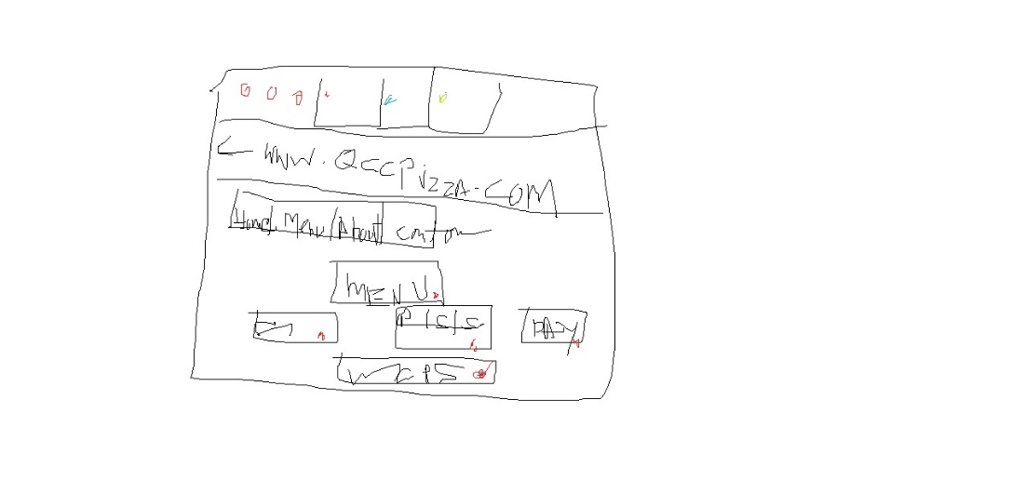

**QCCPIZZA Version 2.0 (coming soon)**

1. Tracking Pizza
2. Email confirmation

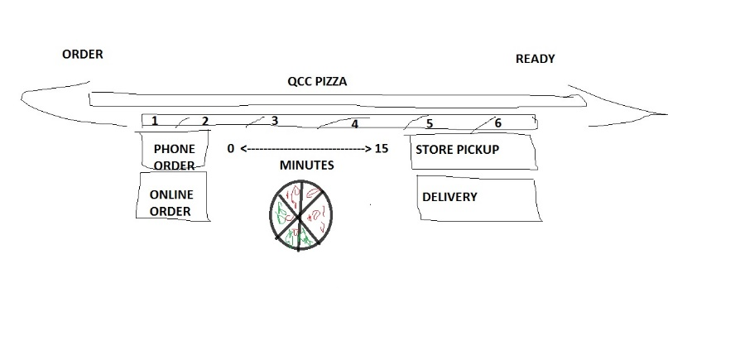

1.2 Navigation structure

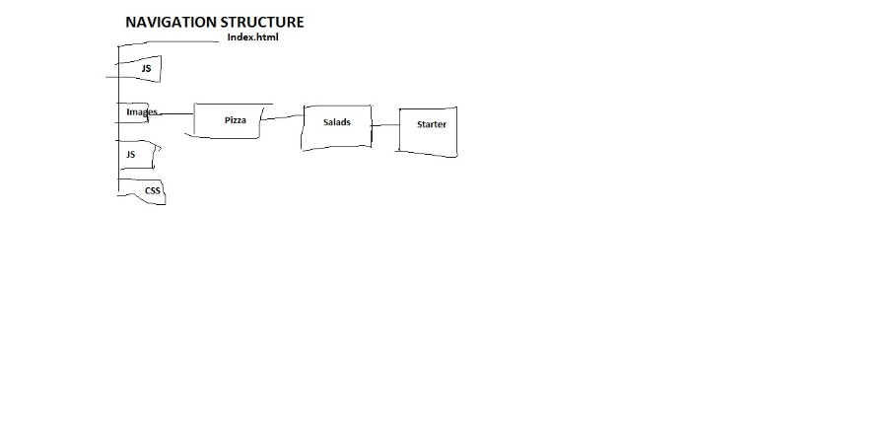

**1.3 Target audience Market and Break-Even Analysis**

The pizza industry experiencing a steady level of growth local and nationally. The operator continue have online market responsible for almost 58 percent of new pizza stores open, thus in Bayside, NY Zip code 11364 where QCC Pizza location. The locals consist of either upper-middle class retirees or lower-middle class middle-aged workers, both which enjoy quality pizza 1-2 times per month.

***WHO:*** All ages & groups

***WHAT:*** Online Pizza ordering system

***WHY:*** Online comfortable pizza ordering and reduce the purchasing time.

The break-even analysis works out to an annualized online average of 625 pizzas per month or $24000 in sales.

Total Revenue: $24000

Total Costs: $19400

Net Profit: $4600

|  |  |  |  |  |
| --- | --- | --- | --- | --- |
| **Units** | **Variable Costs** | **Total Costs** | **Total Revenue** | **Net Profit** |
| 0 | $0 | $5000 | $0 | -$5000 |
| 100 | $1200 | $6200 | $2000 | -$4200 |
| 200 | $2400 | $7400 | $4000 | -$3400 |
| 300 | $3600 | $8600 | $6000 | -$2600 |
| 400 | $4800 | $9800 | $8000 | -$1800 |
| 500 | $6000 | $11000 | $10000 | -$1000 |
| 600 | $7200 | $12200 | $12000 | -$200 |
| 700 | $8400 | $13400 | $14000 | $600 |
| 800 | $9600 | $14600 | $16000 | $1400 |
| 900 | $10800 | $15800 | $18000 | $2200 |
| 1000 | $12000 | $17000 | $20000 | $3000 |
| 1100 | $13200 | $18200 | $22000 | $3800 |
| 200 | $14400 | $19400 | $24000 | $4600 |

**2. Goals**

1. Be the premier online pizza delivery restaurant with quality menu items
2. First year revenues of $50,000
3. Expansion to second location and mobile vending carts within 12 months
4. Have a strong community involvement
5. Open additional locations in other neighboring towns
   1. **Plausibility**

The Netflix and Redbox movie growth prompt shortage of online pizza delivery at local neighborhood. In average with online pizza ordering system business had growth 40% year to year.

1. **Swot Analysis**

**4. Competitor websites**

Neighborhood Belmont Pizzeria hired second delivery driver. The pending online Belmont pizza ordering cart decrease revenue for Belmont Pizzeria’s.

Comments QCC PIZZA Owner:

Our online pizza ordering will increase business, “We’re just really excited to be doing online pizza ordering. This is a business that my family is mostly going to handle, and some great plans for the restaurant.”

**5. Resources**

**W3School**

<https://www.w3schools.com/>

**PEXELS**

<https://www.pexels.com/>

**Swot Problem Analysis**

<https://www.swotanalysis.com/>

**Getbootstrap**

<https://getbootstrap.com/>

**Breakeven Calculator**

<https://goodcalculators.com/break-even-calculator/>

**5.1 Credits**

Team lead:

Umer Farooq

Email: [umerfarooq02@gmail.com](mailto:umerfarooq02@gmail.com)

Member: Marc Crisostomo

Email:

Member: James Reyes

Email: