# Wireframes Documentation – AI-Powered Resume Tailor Web App

## Introduction

This document provides a visual comparison between the initial wireframe designs and the final implemented UI of the AI-Powered Resume Tailor Web App. The wireframes represent the early-stage conceptualization, while the final UI screenshots depict the actual working product deployed on Vercel.

## Wireframe Mockups

The following images showcase the initial wireframes created during the design phase of the project.

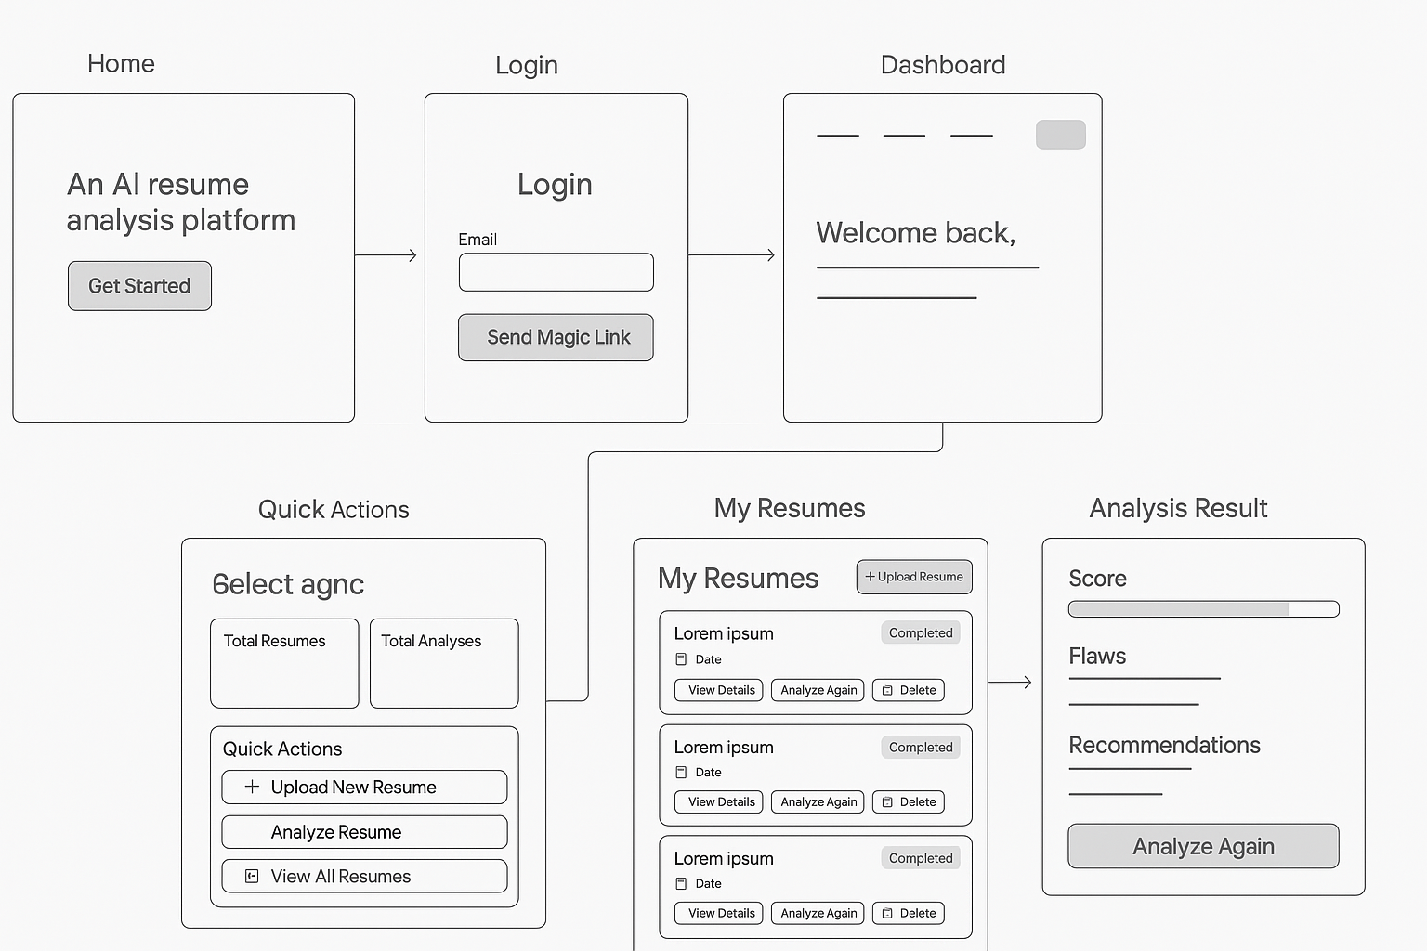

## Final Website UI Screenshots

Below are screenshots of the final deployed website, reflecting the implemented user interface and workflow.

**Home Page:**

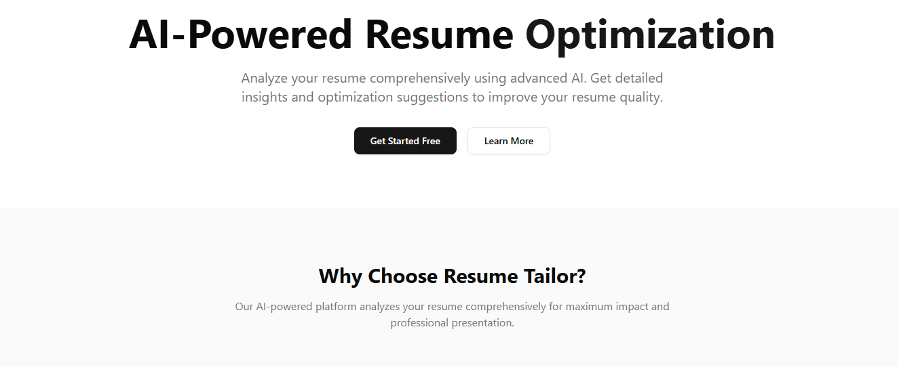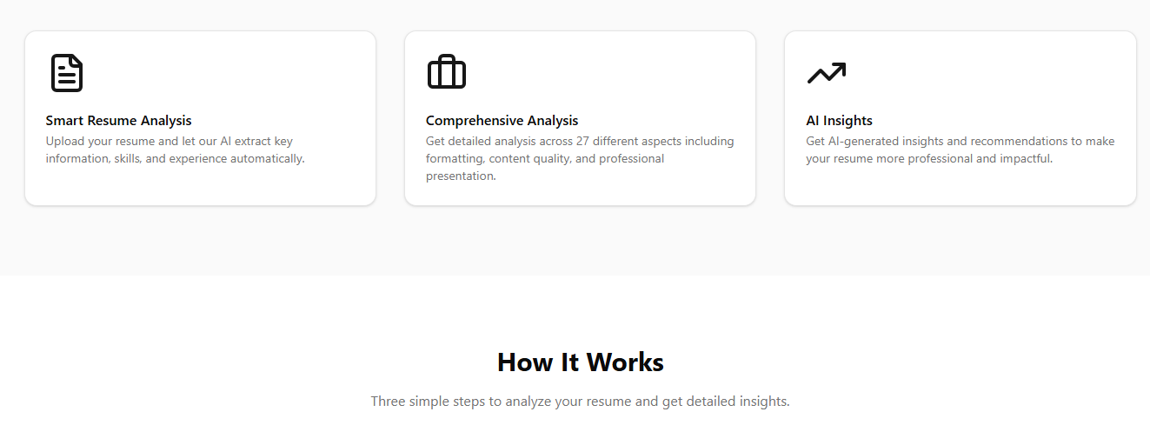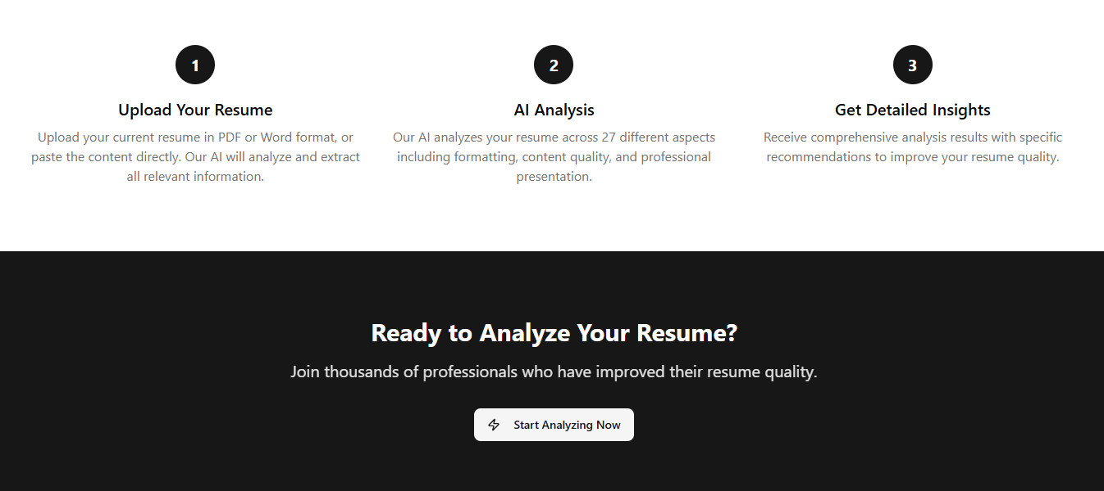

**Login Page:**

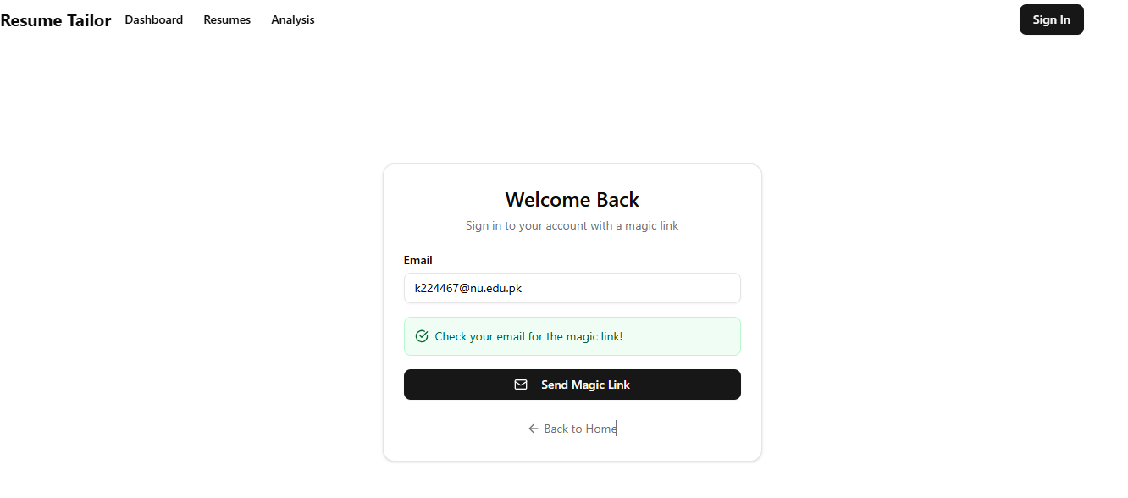

**Dashboard Page:**

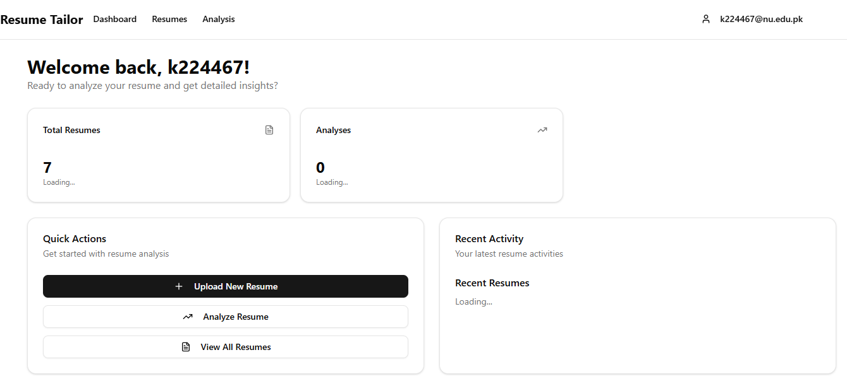

**Upload New Resume Page:**

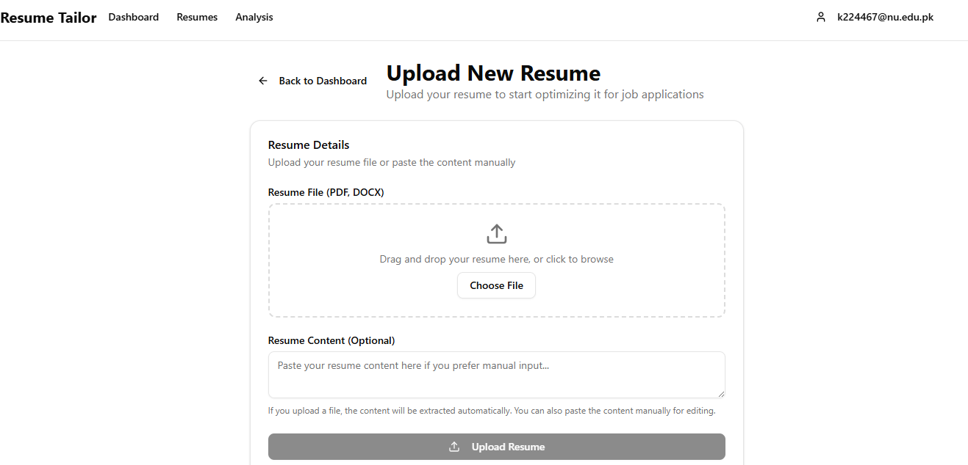

**Resume Analyze Page:**

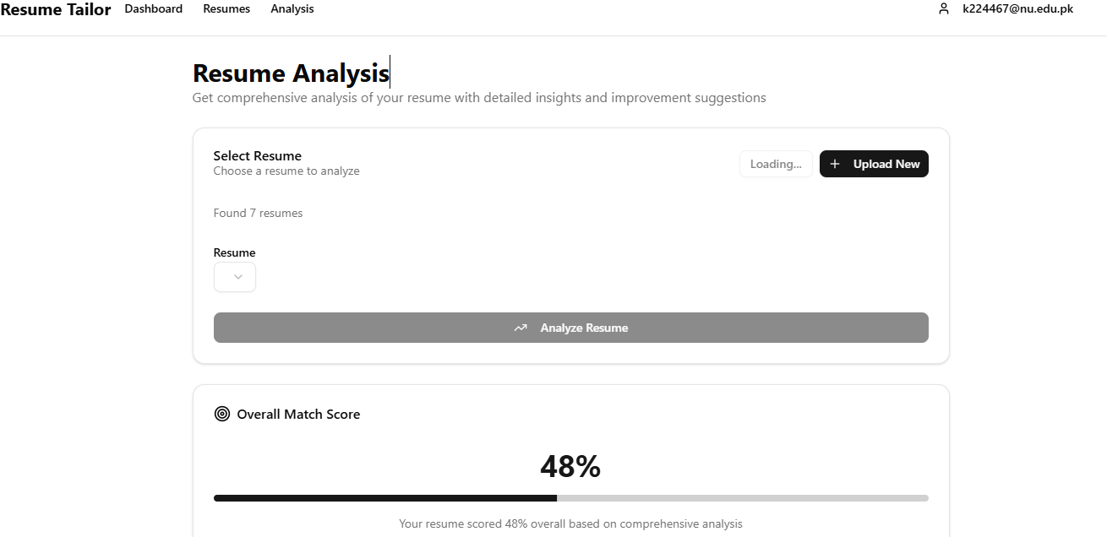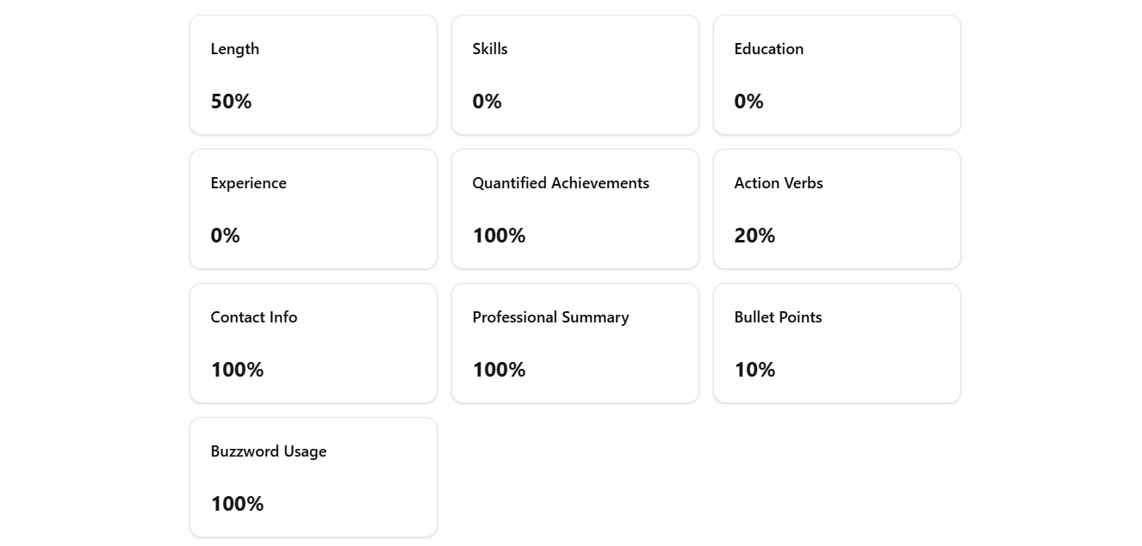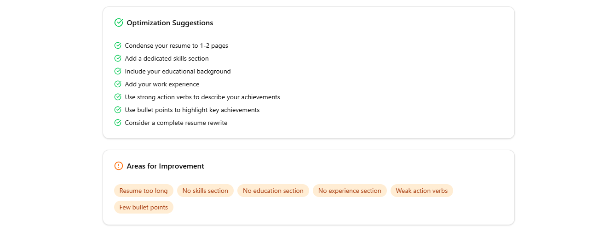

**Resume View Page:**

