**Introduction**

**Project Title:**

E-SHOPPER

**Project Definition:**

E-Shopper is a multilingual e-commerce website to make online shopping easier for online shoppers and also expand the market of shop owners.

**Project Description:**

This project is developed for three types of users and they are Visitors, Customers (Registered Member) and Online shop owners. The application consists of following main sections (inclusions)

* **VISITOR FEATURES**
* Multi Lingual (English, British English, Spanish, French,Chinese,Dutch, German, Portuguese, Japanese, Welsh,Italian, Hebrew,Korean,Russian, Hindu, Greek,Catalan, Irish, Turkish, Arabic,Afrikaans)
* View Home Banners or Slide Show Gallery
* Browse Products
* View Product Details
* View FAQs
* Become a Member through Registration process
* View Static Pages (Contact Us, About Us, Privacy Policy,Disclaimer, Terms & Conditions)
* Debit and Credit Card Payments with PayPal
* Coupons
* Live Chat Support
* Product Recommendations
* **REGISTERED MEMBER PANEL**
* Login to site
* Manage Account
* My Profile
* My Orders
* Newsletter
* Buy Product (Checkout)
* Logout
* **ONLINE SHOP OWNERS**
* Login
* Dashboard
* Administrator User Management
* Site Member (Customer) Management
* Product Management
* Banner Manager
* Order Manager
* Shipping Management
* FAQ Management
* Email Templates
* Static Page Content Management
* Location Management (Country/State/City)
* System Settings
* Logout

**Project Facilities:**

* + **E-commerce:** The act of doing business transactions over the Internet or similar technology.
  + **Brick-and-mortar store:** A conventional store with a physical presence.
  + **Brokerage site:** A type of Web site that brings buyers and sellers together to facilitate transactions between them; the site earns revenue in the form of commissions on sales made via the site.
  + **Digital wallet:** A program or online service that holds a buyer’s information (such as electronic payment, billing, and shipping information) that can be used to speed up online purchase transactions.
  + **Dot-com:** An Internet-only store with no physical presence.
  + **Meta tag:** A special HTML or XHTML tag containing information about a Web page that is added by the person creating the Web page and is used primarily by search sites.
  + **Online auction site:** A Web site where potential buyers bid on an item and, at the end of a set time period, the highest bidder buys the item as long as all bidding criteria (such as minimum selling price) have been met.
  + **Shopping cart software:** E-commerce software designed to add ordering capabilities to an existing Web site.
  + **Order:** This is a request to supply or deliver food booked by diners far in advance before due date and time.

**Tools Used:**

* **Hardware Requirements**

The minimum hardware requirement in develop this system are listed as below:

|  |  |
| --- | --- |
| Hardwar Description | Minimum Requirements |
| Processor | Intel Pentium D 3.4GHz / AMD Athlon II X2 250 u (Minimum)  Intel Core 2 Duo E4400 2.0GHz / AMD Athlon 64 X2 Dual Core 4600+ (Recommended) |
| Memory | 1 GB RAM Recommended, 256 MB RAM (Minimum) |
| Hard Disk Space | Up to 3 GB Recommended |
| Display | 65536 colours, set to at least 1024 X 768 Resolution |

* **Software Requirements**

The minimum software requirement in develop this system are listed as below:

|  |  |
| --- | --- |
| Software Description | Minimum Requirements |
| Operating System (OS) | All 32-bits Microsoft Windows  (95/98/2000/XP/7/8) |
| Web Browsers | Mozilla Firefox (15.0 & above), Internet  Explorer (8.0 & above), Google Chrome  (20.0 & above). |

**Software Requirement Specification**

1.1 **Current System**

**Ubuntu 22.10 Linux**

1.2 **Its Drawbacks**

Every research has challenges and this project is no exception and some of the limitations of this project are:

• The application will require internet connection and also the user must be a computer literate. The Owners has to incur debt in hosting their site online shop so that people can browse the site and place orders.

• The set back of the system is that the customers targeted are adults with access to computer systems and mobile phones with internet capabilities. People who cannot afford these resources cannot engage in shopping online.

• Time Constraint is also going to be a major challenge in developing this system. I will be doing everything possible to finish the project on time so as to submit the final work and documentation to my supervisor. Within this six (6) month of developing the system, there will be things that will happen along the way which will be inevitable. Going for lectures, writing mid-semester examinations, assignments and writing of examination will all interfere with the smooth development of this system and might cause delay in delivery of the final output.

• Because the system will be responsive, I need to acquire some tablets, android phones, laptops etc. during the system development in order to do the testing to see that it is actually working. All these hardware parts have to be either bought or borrowed from friends because I as the developer does not have most of the equipments.

1.3 **Proposed System and Its Features**

A System Requirements Specification (SRS) (also known as a Software Requirements Specification) is a document or set of documentation that describes the features and behavior of a system or software application. It includes a variety of elements that attempts to define the intended functionality required by the customer to satisfy their different users. What the software will do and how it will be expected to function is fully described under requirements specification. In addition to specifying how the system should behave, the specification also defines at a high-level the main business processes that will be supported, what simplifying assumptions have been made and what key performance parameters will need to be met by the system. It outlines functional and non- functional requirements and may include a set of use cases that describe user interactions that the system must provide. Requirements specification allows a thorough analysis of requirements before design can start hence, reducing later redesign.

**Overall Description**

2.1 **Product Perspective**

**Project Objectives:** The project objectives should be clearly defined at the outset of the project. This includes defining the goals, scope, deliverables, and timelines for the project.

**Project Management Methodology:** Choosing the right project management methodology can help ensure the project is executed effectively. This includes considering factors such as the project size, complexity, and team size.

**Project Schedule**: Developing a realistic project schedule is critical to ensure that the project is completed within the set timeline. This includes identifying the tasks and dependencies, estimating the duration of each task, and allocating resources accordingly.

**Risk Management:** Risk management involves identifying potential risks that could impact the project and developing strategies to mitigate those risks.

2.2 **Product BENEFICIARIES**

At the end of this project, I hope to have acquired some benefits for:

* Customers who do not understand the English language since the project has a feature that converts the content of the entire website to his/her desired language. It also offers them convenience to shop 24 hours a day and seven days a week without having to leave their homes or offices.
* Shop Owners are also huge beneficiaries of the system. Since they are able to explore other markets and countries by putting their shops on the electronic highway making people from different countries access the website and patronize their products or services without limiting them to only a physical location of their store. This also helps owners cut down cost because they don’t need to build, staff or maintain a store or print and distribute mail order catalogs. Automated order tracking and billing systems cut additional labor costs.
* I also perceive the following benefits after successful completion of the project:
* To have enhanced my programming skills since this project will expose me to the use of some new programming techniques.
* To have better insight as to what a software system documentation really entails and how to document properly.
* To have developed better working ethics including being time conscious as well as developing the right attitude towards team work.

2.3 **USER INTERFACE DESIGN**

User interface design or UI design generally refers to the visual layout of the elements that a user might interact with in a website, or technological product. This could be the control buttons of a radio, or the visual layout of a webpage. User interface designs must not only be attractive to potential users but must also be functional and created with users in mind. The goal of user interface design is to make the user's interaction as simple and efficient as possible, in terms of accomplishing user goals (user-cantered design). Good user interface design facilitates finishing the task at hand without drawing unnecessary attention to itself.

During the system development phase, several UI design features like input controls which includes text-boxes, radio buttons, check-boxes, date fields, drop-down lists etc. For example, when a customer wants to place an order, recommendations will be made on the products they select to help the customer order with ease. The use of navigation components such as pagination, search field, slider, icons, tags etc. will be used to make user interactions with the website easier. Information components like notifications, messages boxes, contact forms etc. will also be used to help the user get quick feedback's from the system.

The following best User interface design practices used in Software and website Development will be used in the user interface (UI) design for this project:

* + **Clarity:** The interface will be designed with the customer who willmake the orders in mind. The information content is conveyed quickly and accurately. The interface will be simple for the customer to navigate easily.

* + **Consistency:** A unique design, conformity with user's expectation in mind. The UI design elements that would beused in the system implementation will be consistent throughout the site. This will help the user to be familiar with certain UI elements so that they will not be using different elements for similar operations.
  + **Strategically use color and texture:** Direct attention would be drawn towards or redirected away from items using color, light, contrast, etc. The intention is to blend colors that will make the website nice and simple.
  + **Detectability:** Carefully consideration will be made on how to use typeface to help draw the user's attention towards information required. Different sizes, fonts, and arrangement of the text to help increase scan ability, legibility and readability of the user.

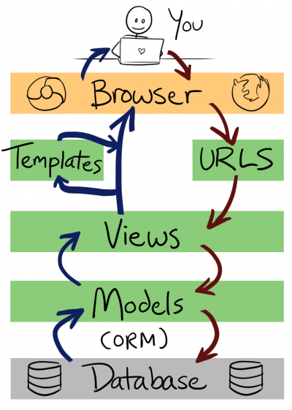

**System Features**

3.1 **Database-Storage**

3.1.1 **Description and Priority**

Database is any collection of data, or information, that is specially organized for rapid search and retrieval by a computer. Databases are structured to facilitate the storage, retrieval, modification, and deletion of data in conjunction with various data-processing operations. A database is stored as a file or a set of files on magnetic disk or tape, optical disk, or some other secondary storage device. The information in these files may be broken down into records, each of which consists of one or more fields. Fields are the basic units of data storage, and each field typically contains information pertaining to one aspect or attribute of the entity described by the database. Records are also organized into tables that include information about relationships between its various fields.

Database Design is a collection of processes that facilitate the designing, development, implementation and maintenance of enterprise data management systems. The main objectives of database designing are to produce logical and physical designs models of the proposed database system.

The logical model concentrates on the data requirements and the data to be stored independent of physical considerations. It does not concern itself with how the data will be stored or where it will be stored physically.

The physical data design model involves translating the logical design of the database onto physical media using hardware resources and software systems such as database management systems (DBMS).

A well-designed database gives access to up-to-date and accurate information. The Entity-Relationship (ER) model, Unified Modelling Language (UML), Relational Model (RM) among others are some of the models used by database designers. The Entity-Relationship (ER) model was used for our database design.

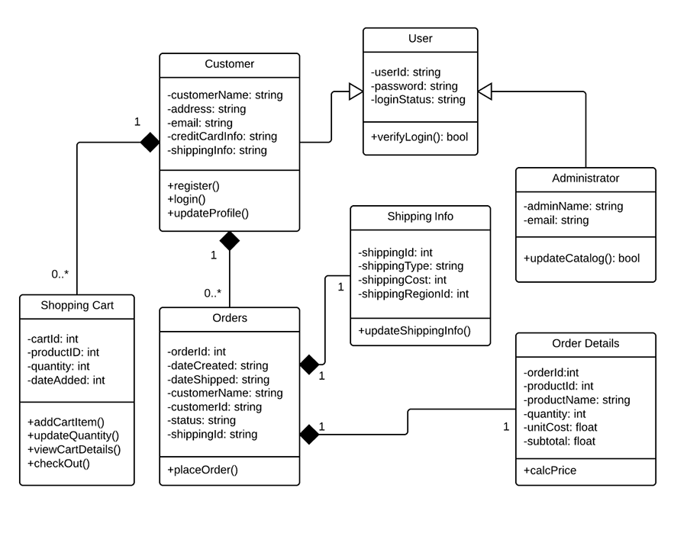

3.1.2 **ENTITY RELATIONSHIP MODEL**

An entity relationship diagram (ERD), also known as an entity relationship model, is a graphical representation of an information system that depicts the relationships among people, objects, places, concepts or events within that system. An ERD is a data modeling technique that can help define business processes and be used as the foundation for a relational database.

An ER diagram is a means of visualizing how the information a system produces is related. There are five main components of an ERD:

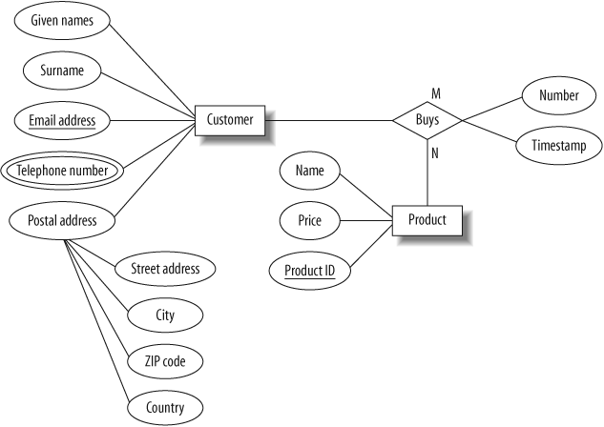

3.2.1 **User Interfaces**

As we mentioned in the previous chapter about how the user interface would be designed, below are the narrations and screenshots of the various user interfaces of the system.

Narration for Customers and Online Shoppers who will use the system

Once a user visits the e-shopper website, it takes them to the homepage of the website where they can choose a language of their choice before they start shopping. For example, when they choose Spanish, the website converts every text to Spanish . The user can then click on the shop in the menu bar and it takes them to shop page with a list of all book categories and the books listed. Once they select a particular book, it takes them to the book’s detail page where they can find detailed information about the book, they can also select the quantity of the book they want to buy and can write review on the book. The system also recommends other books people buy with the book the user has selected . Once the user selects the quantity of books they want to buy and add it to the cart, it takes them to the cart page where they see the total of their order, they can apply a coupon for discount and they can then click on the checkout button . The checkout takes them to the checkout page where they can fill in their shipping details and place their order . Once they place their order, the system sends them an email of the order and it takes them to the payment process page . When they click on the “Buy Now” on the payment process page, it sends them to the PayPal page to finalize the payment . PayPal sends them an email notification where the payment was successful or not and then redirects them to either the system’s successful or unsuccessful page respectively. PayPal also sends notification of the transaction to the system for the shop manger to know whether the shopper has paid for their order before they ship out the order.

Shoppers can register on the site to be customers by clicking on the Account button in the navigation bar. It sends them to “Register Account” page where they can register as regular customers. The system sends them an email with a link for them to activate their account. When they click on the link, it takes them to the “Login” page for them to login into the system. After a successful login, it takes them to their dashboard where they can create their profiles if they have none. Once they logout of the system, it takes them to “Logout” page.

Customers and Shoppers can contact customer service either through a “live chat” support or contact form on the “Contact Us” page. After they submit message successfully, it takes them to “Message sent” page indicating the message was sent successfully with a notification they will get a feedback soon.

* Narration for the Shop Manager who will use the system.

A shop manager will use the system to add, delete, modify categories, products and orders. The system will give them analytics of the number of people visiting the website every day. They can also see the number customers registered and can send newsletters to subscribers. The shop managers can also add coupons and create separate accounts for different users like marketers, sales managers, customer service and accounts managements.

The shop managers can navigate to the management page by visiting eshopper.com/shop-admin where they would be greeted by a “Login” page for them to login. Once they login, it takes them management dashboard which has different tabs for various tasks such as a tap for the analytics of the number of people visiting the website every day, also various tab for them to add, delete, modify categories, products, orders, coupons, approve reviews, and recent actions.

**GUI**

Below are screenshots of the various user interfaces of the system

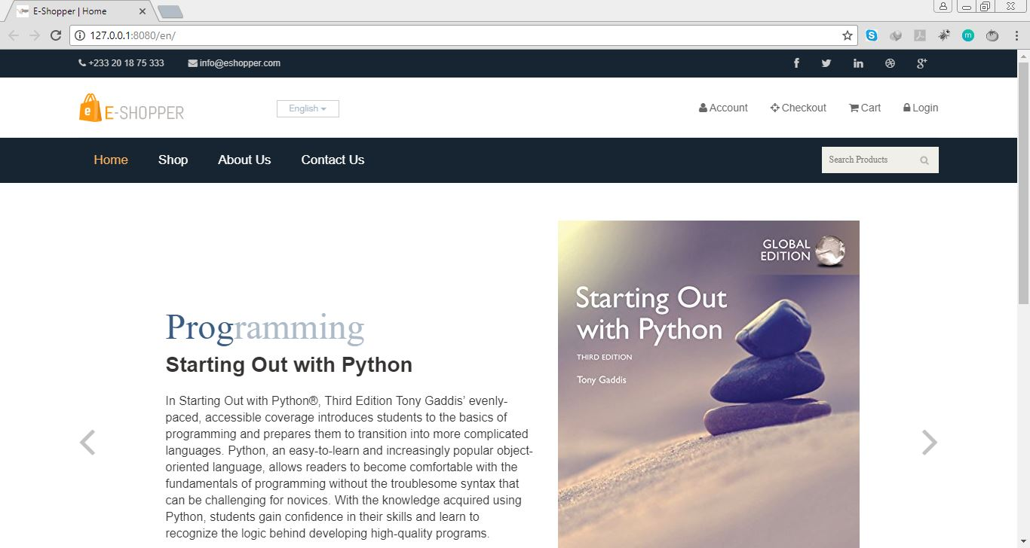

**Homepage of the application with a slideshow of some of the books sold.**

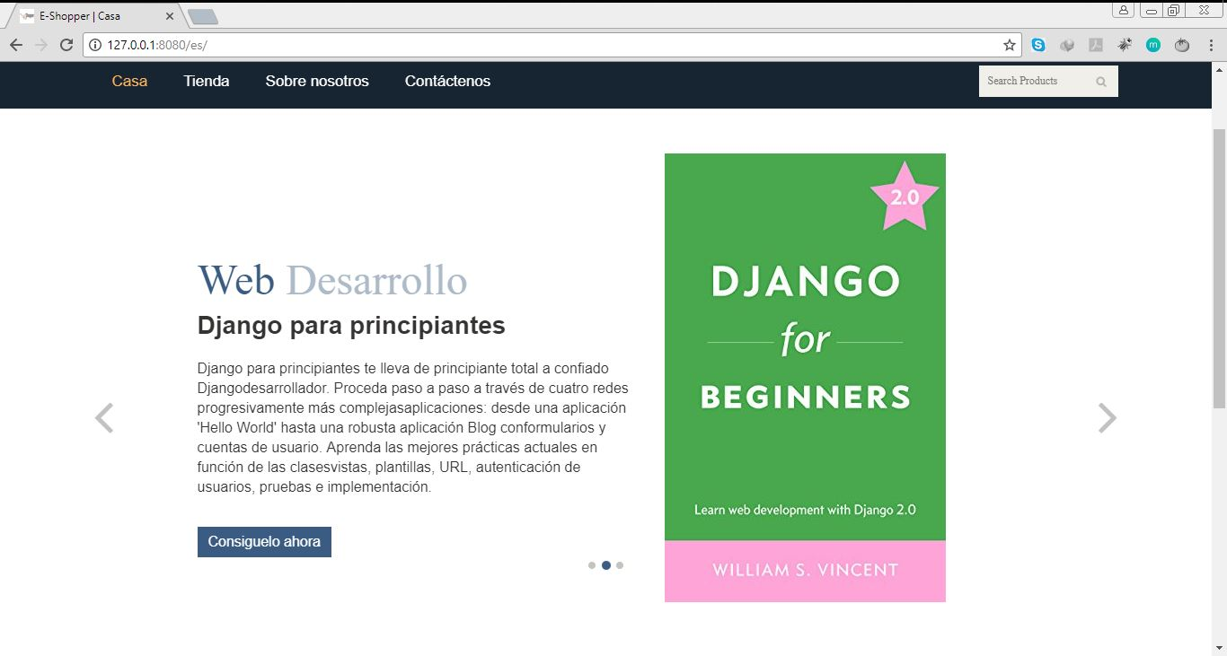

# **Homepage and URL after Spanish is selected.**

# **Shop or Product list page with Categories**

# **Product Detail Page**

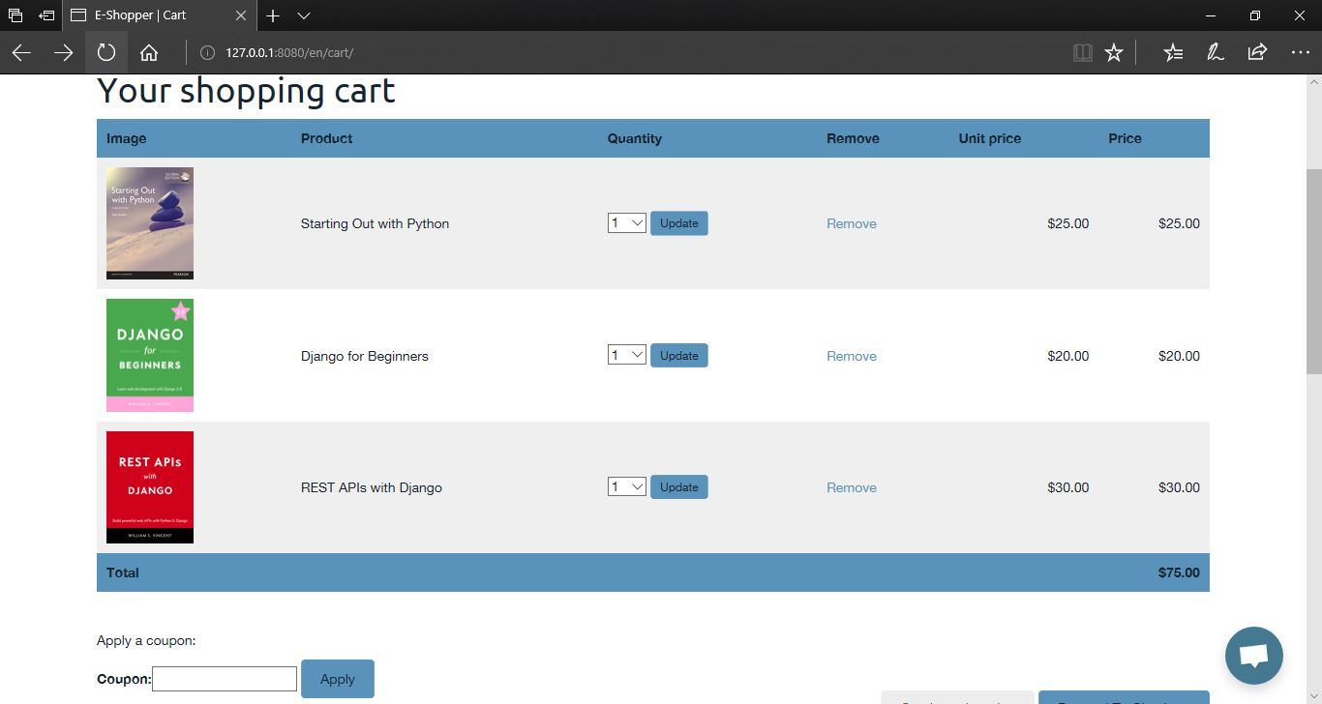**Cart Page**

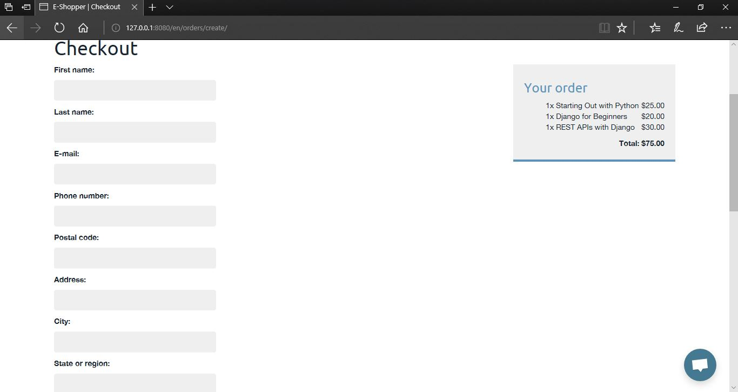

# **Checkout Page with cart.**

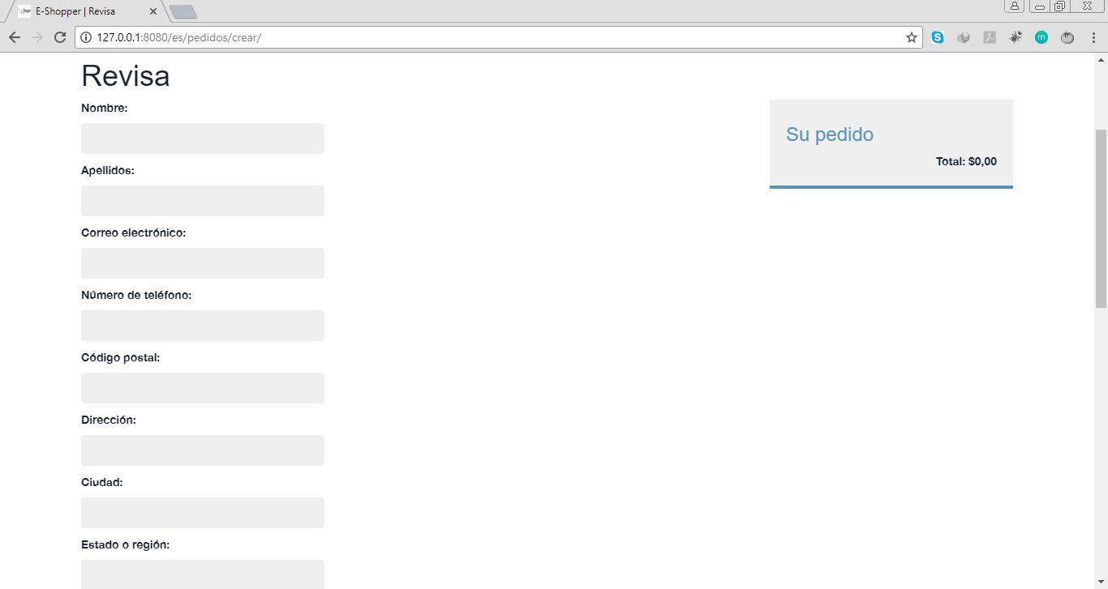

**Checkout Page with empty cart in Spanish.**

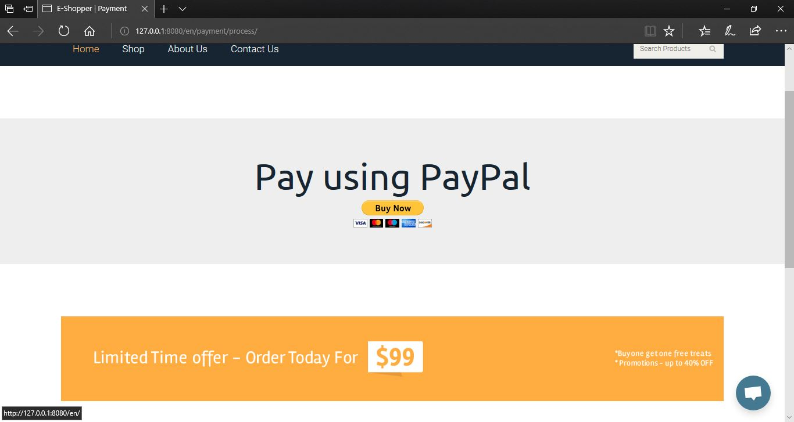**Proceed to Payment Page**

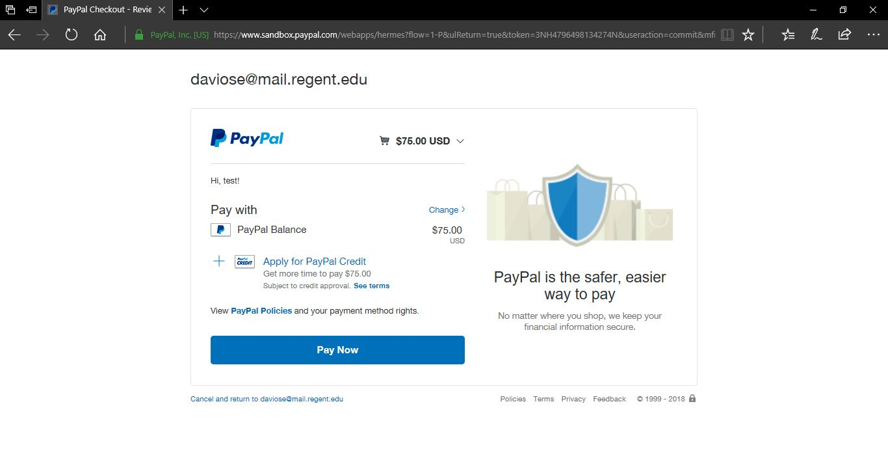

# **PayPal Payment page**

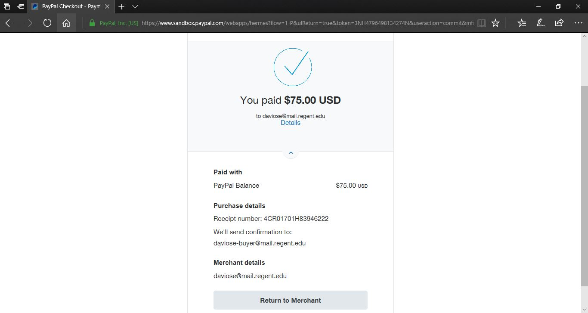**PayPal Successful Payment page**

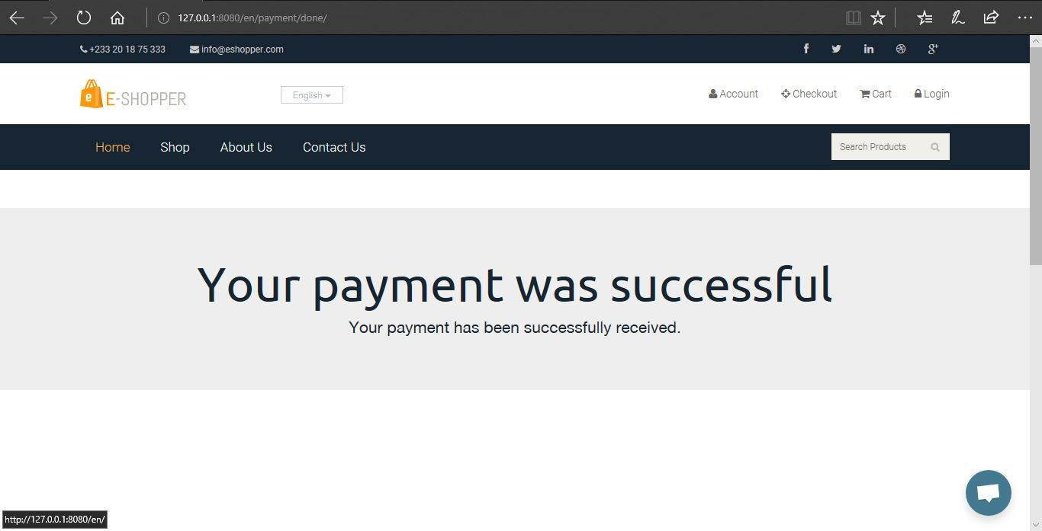

# **Successful Payment Page**

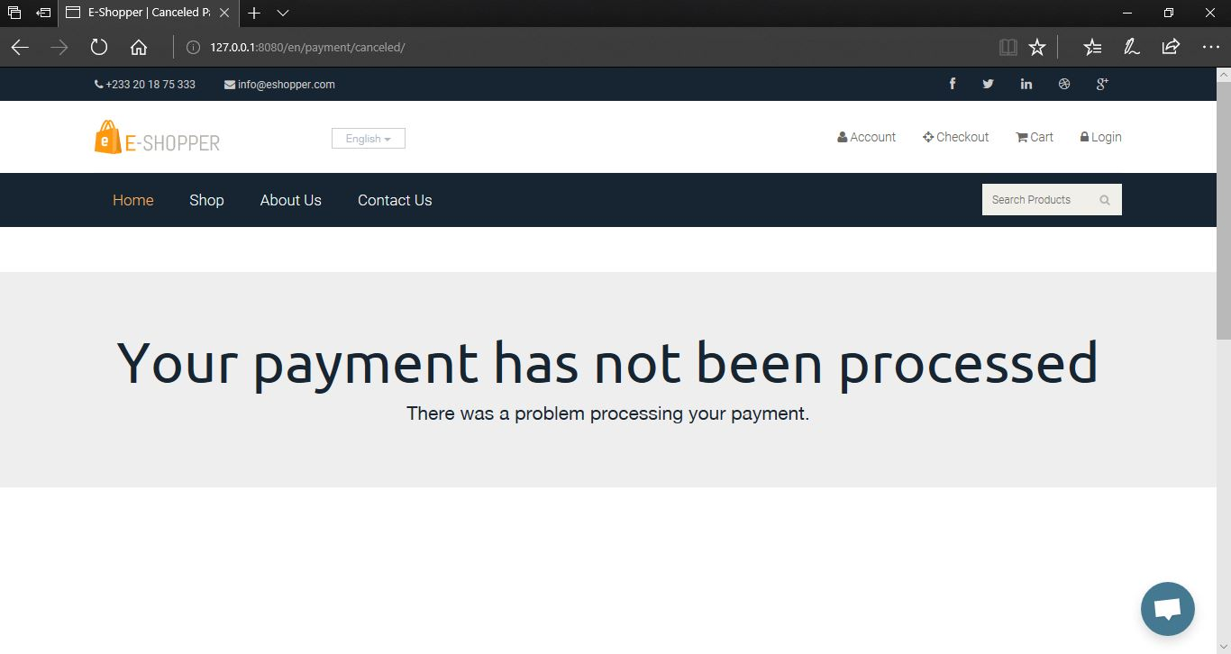

# **Cancelled or Unsuccessful Payment Page.**

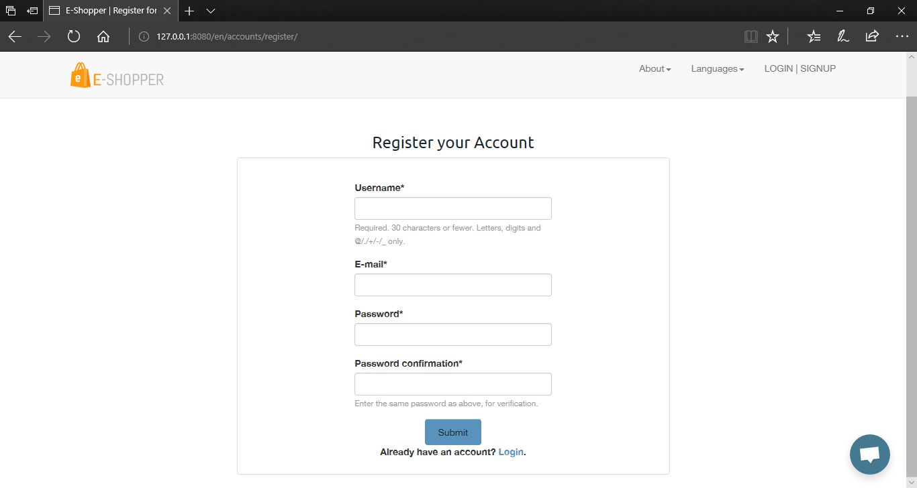

# **Customer Register Account Page**

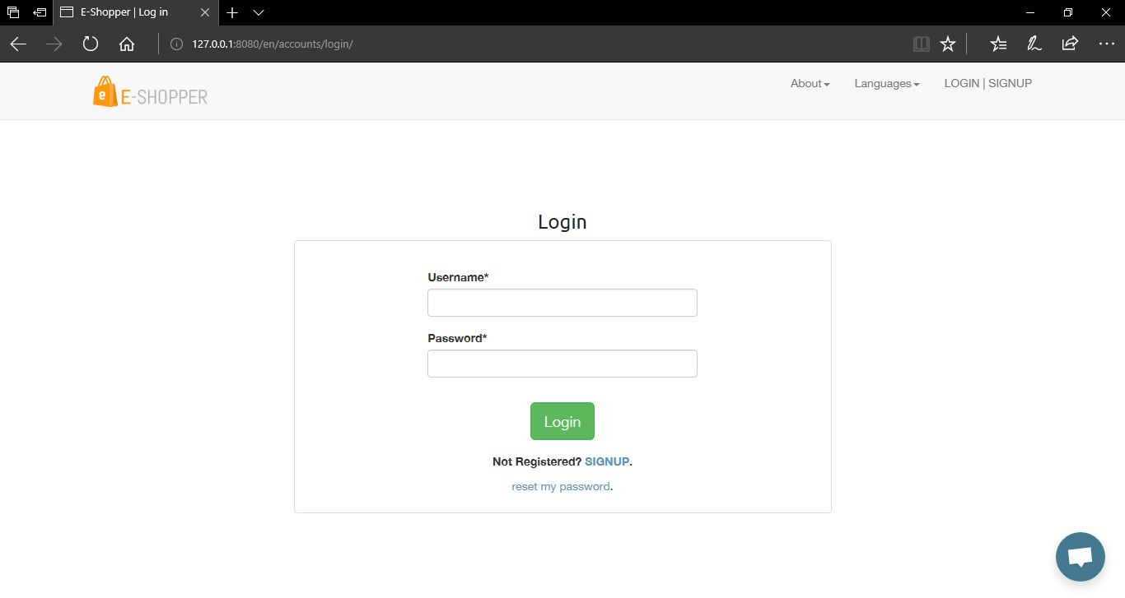**Customer Login Page**

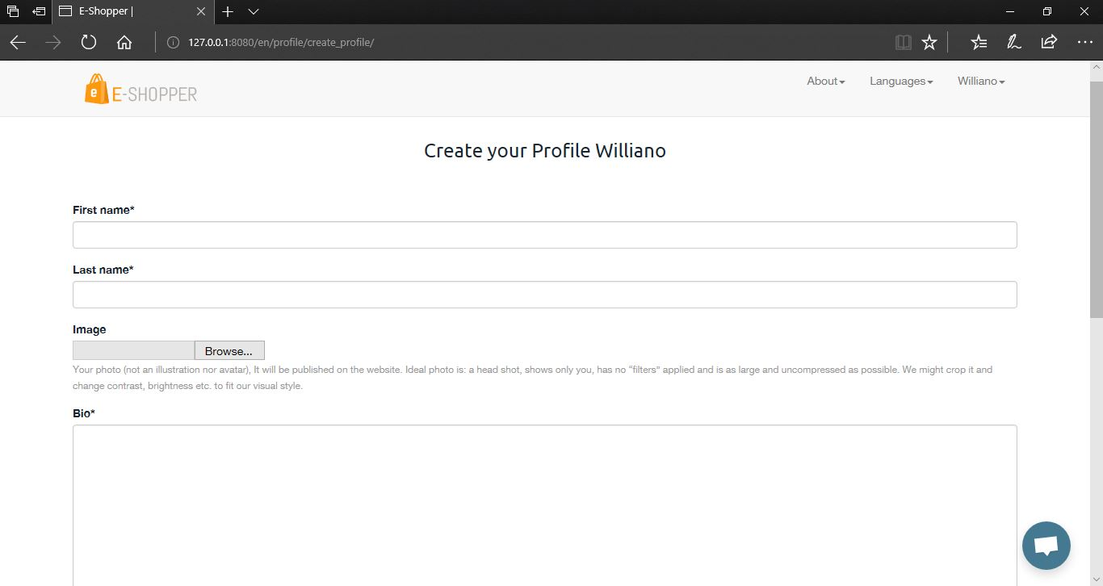**Customer Create Profile Page**

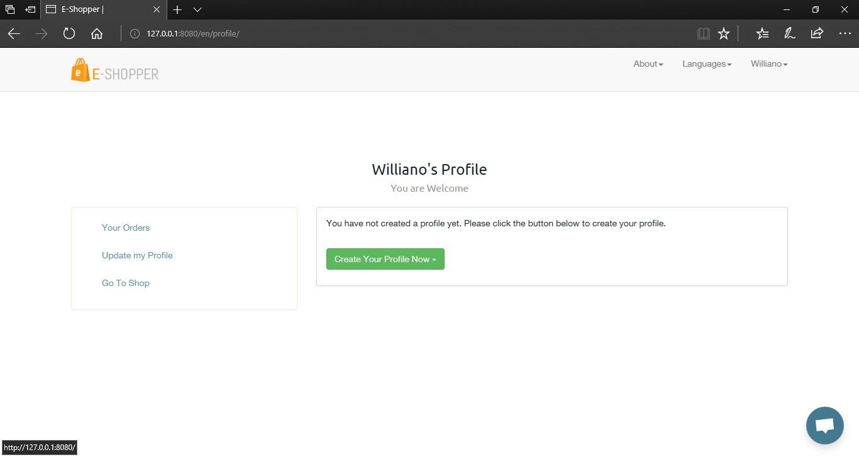**Customer Profile Dashboard**

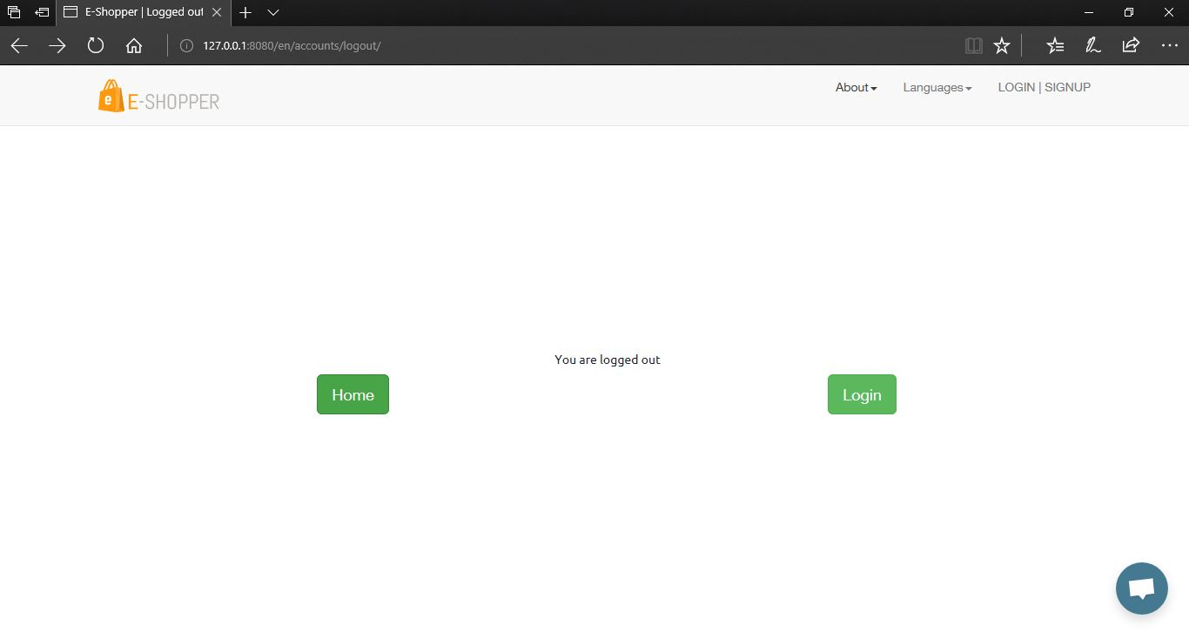**Customer Logout Page**

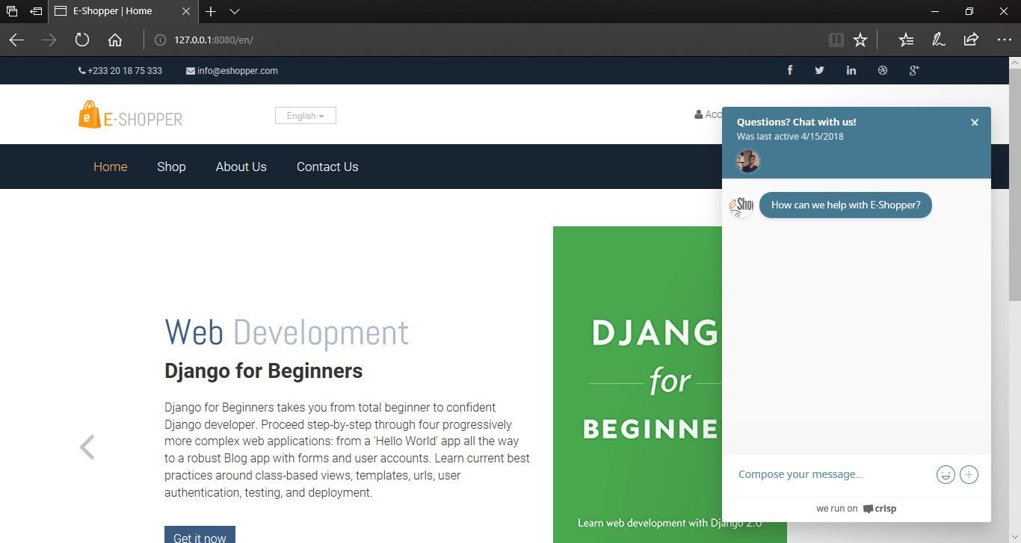**Live Chat Support**

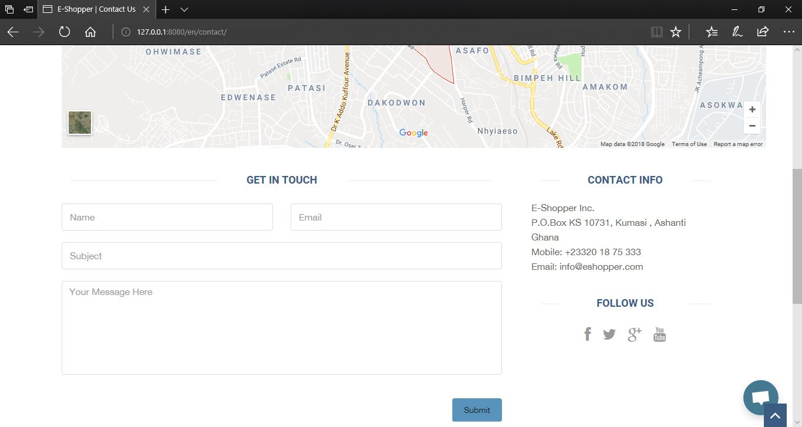 **Contact Us Page**

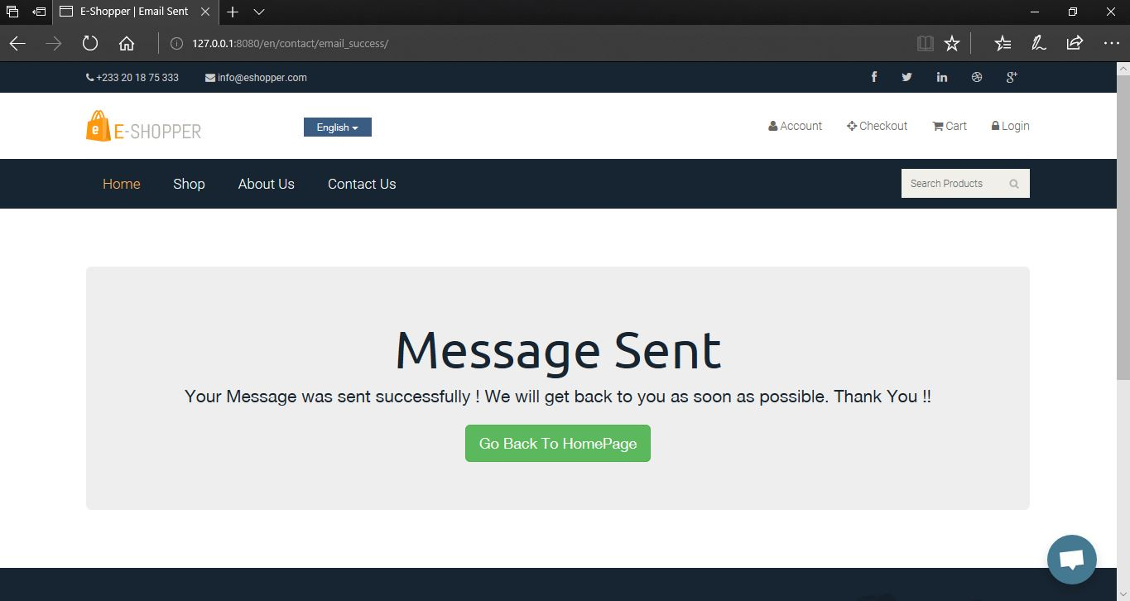**Successful Contact Us Message sent page**

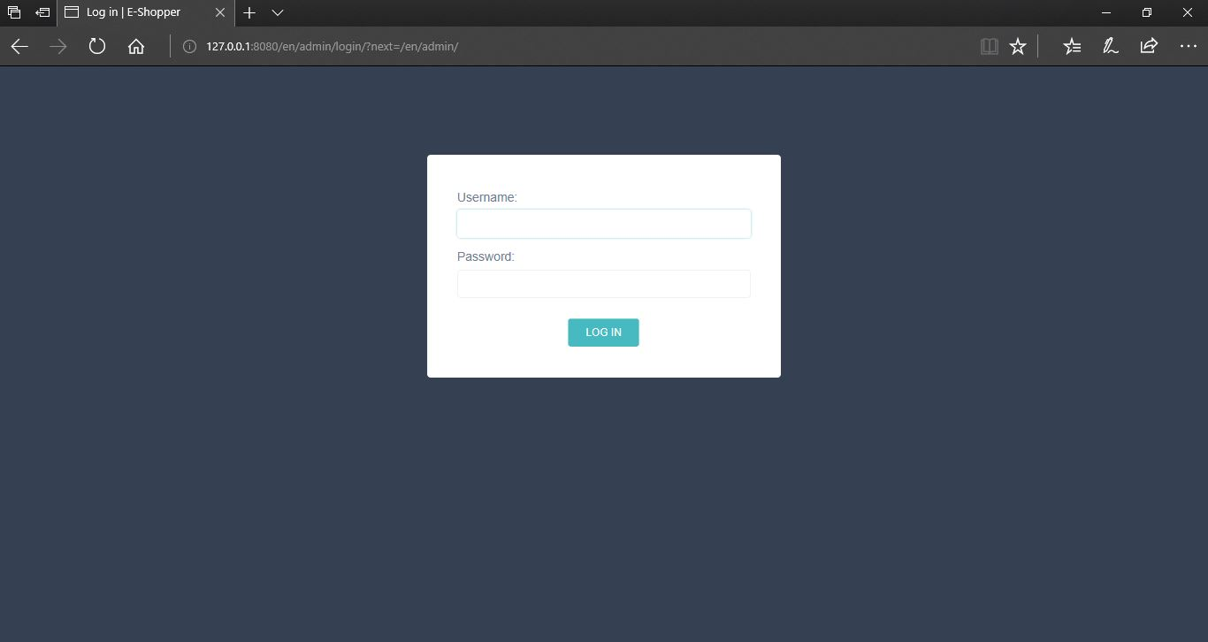

**Shop Owner or Manager Login Page**

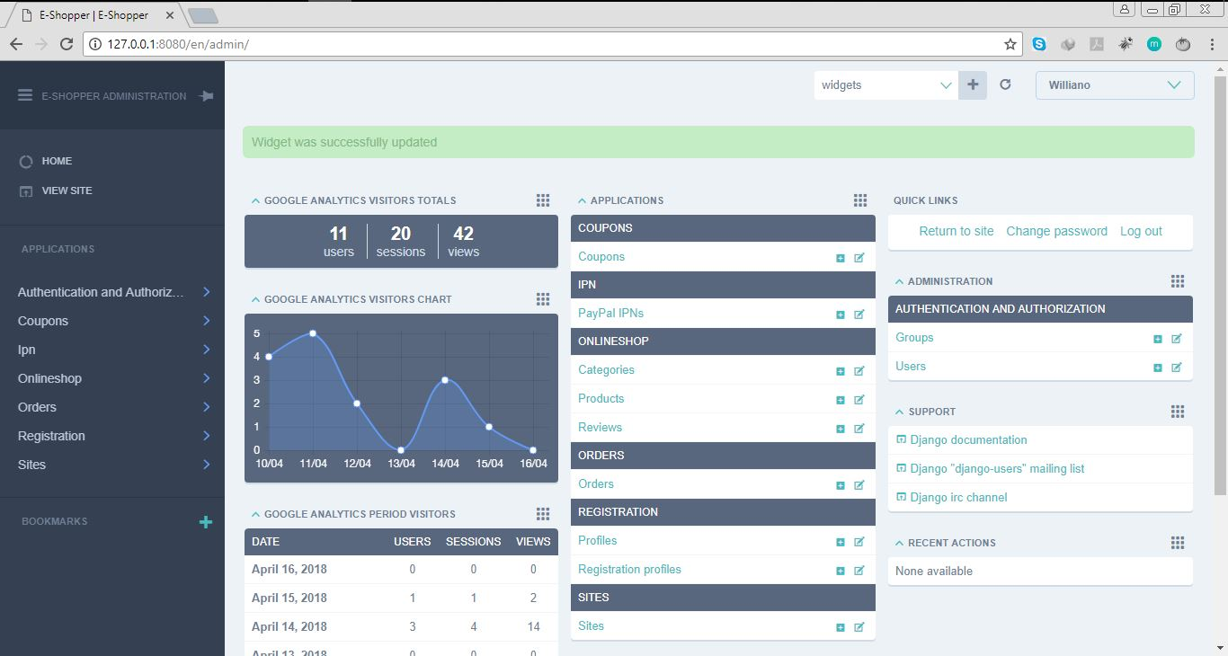

**Shop Manager or Owner Dashboard to accept orders, add products, add categories, add coupons with Analysis of people visiting the website**

## BACKGROUND TO THE STUDY

Ecommerce began to gain traction in the early nineties and has grown rapidly ever since. Ecommerce offers many advantages over traditional brick and mortar stores. Consumers can easily search for the products and services they are looking for. Online retailers, or e-tailers, are incredibly convenient, in that they are available twenty-four hours a day. Today, most brick and mortar retailers such as Walmart also have an ecommerce option. While an ecommerce consumer does not get the immediate gratification of having their purchase immediately in hand, they can place orders from the comfort of their own home without having to deal with the hustle and bustle of a shopping mall. Some stores offer a combination, allowing a customer to order their merchandise online, and pick it up almost immediately at their local store. E-tailer sites like Amazon paved the way for many others. Amazon is arguably one of the most successful e-tailer sites around. It began as an online bookstore with a primary focus on the customer experience. It was so successful that it did not take long before it expanded beyond the sale of books. Today, you can order almost anything from Amazon. They have also crossed over from strictly being an e-tailer to an e-tailer and subscription site with its Amazon Prime offering.

Online shopping remains the most popular type of e-commerce. Sellers create online or mobile stores which are similar to face-to-face retail shops. Buyers visit these stores, browse through items available, and if they like the items’ quality and price, they will select it, make payments online and the goods or services will be delivered to them. Currently, the global leader in this space is www.amazon.com, which does not only serve as a seller but also creates opportunity for others to use its platform to sell their goods and services.

## PROBLEM STATEMENT

A key role of e-commerce over brick-and-mortar retail is the ability to easily expand your business's geographical borders. But according to a PayPal report, U.S.-based small businesses could be doing a lot more to reach global online shoppers. Modern e-commerce websites are restricted to more often than not; to the language of the country the developers are from. In particular, e-commerce merchants aren't tailoring the shopping experience to local customers outside their home country: Only 19 percent translate their website copy from English, and less than half list foreign currency options on their sites. Global customers are much more likely to make purchases when product descriptions and prices are available in their native language/currency, PayPal found.

The E-commerce business in Ghana is growing at a fast pace and most of these Ghanaian online retailers face the same language barrier problem because they develop their online shops only in English. This limits the market share and customer base because Ghana is a diverse country with different people from different countries who speak different languages.

These problems are faced by Online Shoppers and it is my hope that by the end of this project, all these issues would be addressed and resolved.

**Back-end:**

This is a specialized subordinate process or a module that is not directly accessible by the user. This part of the application allows the administrator to interact with the software. This part of the software is where menu details that would be available to the user to place order is entered. Reports generation and basic managerial operations occur at the back-end. We usually refer to this part of the system as the server side of the software application.

**Front-end:**

In software development, front-end is that part of the software that the user interacts with in performing his or her functions. It usually consists of Graphical User Interface which makes it easy for users to either login, place food order, reserve a table etc. It is sometimes referred to as the client side of the application

**Responsive display:**

Is an approach to web design and development whereby websites and web applications respond to a screen size of the device on which they are being accessed. The response includes layout changes, rearrangement of content, and in some cases selective display or hiding of content elements. Using a responsive web design

**OVERVIEW OF E-COMMERCE AND ONLINE SHOPPING**

Before setting out a business, one needs to know his target audience or market. These business transactions occur either as business-to-business, business-to-consumer, consumer-to-consumer or consumer-to-business.

Business to consumer (B2C) is business or transactions conducted directly between a company and consumers who are the end-users of its products or services. The business-to-consumer as a business model differs significantly from the business-to-business model, which refers to commerce between two or more businesses. While most companies that sell directly to consumers can be referred to as B2C companies, the term became immensely popular during the dotcom boom of the late 1990s, when it was used mainly to refer to online retailers, as well as other companies that sold products and services to consumers through the internet.

**HIGHLIGHTS OF SIMILAR IMPLEMENTATIONS FROM VENDORS**

There are several implementations of online shops and I would like to highlight ten of them from different vendors and they are:

#### AMAZON

### WALMART

* JUMIA GHANA

### FLIPKART

### AZALIABOOKS

### ESHOPAFRICA

**DEVELOPMENT TOOLS**

In this project, a number of development tools would be used to complete this project. They are listed as follow

**PYTHON**

Is an interpreter, object-oriented, high-level programming language and a general-purpose programming with dynamic semantics and it will be used for the back-end. It incorporates modules, exceptions, dynamic typing, very high level dynamic data types, and classes. Python combines remarkable power with very clear syntax. It has interfaces too many systems call and libraries, as well as to various window systems, and is extensible in C or C++. It is also usable as an extension language for applications that need a programmable interface. Python is versatile. It runs websites and is used in many popular desktop applications on PCs and Macs. It can also be found in mobile applications and embedded in many devices. Python is also a popular scripting language for other applications. Python is portable, it runs on many Unix variants, on the Mac, and on PCs under MS-DOS, Windows, Windows NT, and OS/2.

**DJANGO**

Django is a high-level Python Web framework that encourages rapid development and clean, pragmatic design. Django is a free and open-source web framework which follows the model-view-template architectural pattern. Django is portable, it runs on many Unix variants, on the Mac, and on PCs under MS-DOS, Windows, Windows NT, and OS/2. The reasons why I chose Django for my project are:

* **Fast:** Django has been designed in a way to help the developers make an application as fast as possible. From idea, production to release, Django helps in making it both cost effective and efficient. Thus, it becomes an ideal solution for developers having a primary focus on deadlines.
* **Secure:** Django ensures that developers don’t commit any mistakes related to security. Some of the common mistakes include SQL injection, cross-site request forgery, clickjacking and cross-site scripting. To manage effectively usernames and passwords, the user authentication system is the key.
* **Scalable:** To meet the heaviest traffic demand, the benefits of Django framework can be seen. Therefore, the busiest sites such as Instagram, Bitbucket, Pinterest etc. use this medium to quickly meet the traffic demands.
* **Versatile:** Content management, scientific computing platforms, and even big organizations, all these aspects are very efficiently managed by the use of Django.
* **Actively Developed:** One of the biggest risks of open source is whether there is sufficient interest in the project for it to attract developer support in the long term. There is no such risk with Django, not only is the project over 12 years old, it has a long history of consistent releases and it continues to be supported by an active community and a large core team of voluntary contributors who maintain and improve the code base every day. The Django development team maintains a development roadmap on the Django Project website and have a solid track record of meeting roadmap milestones. The Django Project is also supported by an independent foundation, the Django Software Foundation, that is a registered non-profit in the US.

**HTML**

HTML (Hypertext Markup Language) is the code that is used to structure a web page and its content. HTML is used to specify whether a web content should be recognized as a paragraph, list, heading, link, image, multimedia player, form, or one of many other available elements or even a new element that you define. It is the globally accepted programming language for formatting web pages. It is mostly used by small and medium scale businesses that do not really need advanced functionality on their websites. HTML is free, supports all browsers on the client’s machine, easy to use and understand hence, the choice in building the structure of my web pages.

**CSS**

Cascading Style Sheets (CSS) is a stylesheet language used to describe the presentation of a document written in HTML or XML (including XML dialects such as SVG or XHTML). CSS describes how elements should be rendered on screen, on paper, in speech, or on other media. CSS is one of the core languages of the open web and is standardized across browsers according to the W3C (World Wide Web Consortium) specification.

**JAVASCRIPT**

JavaScript is a high-level, dynamic, weakly typed, prototype-based, multi-paradigm, and interpreted programming language. JavaScript is a full-fledged dynamic programming language that, when applied to an HTML document, can provide dynamic interactivity on websites. It would be used in conjunction with Django to ensure validation rules on the front-end of the websites.

**BOOTSTRAP**

Bootstrap is a free and open-source front-end web framework for designing websites and web applications. It contains HTML and CSS based design templates for typography, forms, buttons, navigation and other interface components, as well as optional JavaScript extensions. Unlike many web frameworks, it concerns itself with front-end development only. Bootstrap would be used to design the styling of the application alongside CSS. Bootstrap is important in the application for the following reasons:

**PHOTOSHOP**

Adobe Photoshop is the predominant photo editing and manipulation software on the market. Its uses ranges from full featured editing of large batches of photos to creating intricate digital paintings and drawings that mimic those done by hand. It is a graphic designing tool that enables picture manipulation and editing. Photoshop would be used to design user interfaces and the various images that would be required in developing the system.

**POSTGRESQL**

It is an object-relational database management system(ORDBMS) with an emphasis on extensibility and standards compliance. A fundamental characteristic of an object-relational database is support for user-defined objects and their behaviors including data types, functions, operators, domains and indexes. This makes PostgreSQL extremely flexible and robust. Among other things, complex data structures can be created, stored and retrieved. All the tables and records that would be required in the project would be designed and created with POSTGRESQL. My choice for POSTGRESQL is that it is easy to use, support is easily available on the internet, it is open source and hence inexpensive to get it, supports complex structures, it provides extensive data capacity and is trusted for its data integrity and finally it remains one of the most accepted industry standard database for developing web applications.

## SUMMARY

This chapter describes the software process model that was involved in the production of the application, which was the incremental development process model under the agile development as the methodology. It also spoke about the project methodologies where different methodologies were identified. It identified the main activities of the incremental approach as *Requirements*, *Design and Development, Testing* and *Implementation* and made it clear that the software would be released as a series of versions to the user until the final product is accepted.

The advantages and disadvantages of the incremental development over other process models were analyzed. Furthermore, Azaliabooks was identified my case study and briefly description of their operations. Lastly, a list of the development tools used to develop my project was also discussed. There was also a discussion of the Django framework and outlined strong reasons why it is used it to develop the application as well as the other tools such as Python,

PostgreSQL, HTML, CSS, Bootstrap, Adobe Photoshop, JavaScript Django Rest Framework and the Pycharm IDE.

**ACTIVITY DIAGRAM**

Activity diagrams are graphical representations of workflows of stepwise activities and actions with support for choice, iteration and concurrency. It describes the flow of control of the target system, such as the exploring complex business rules and operations, describing the use case also the business process. In the Unified Modelling Language, activity diagrams are intended to model both computational and organizational processes

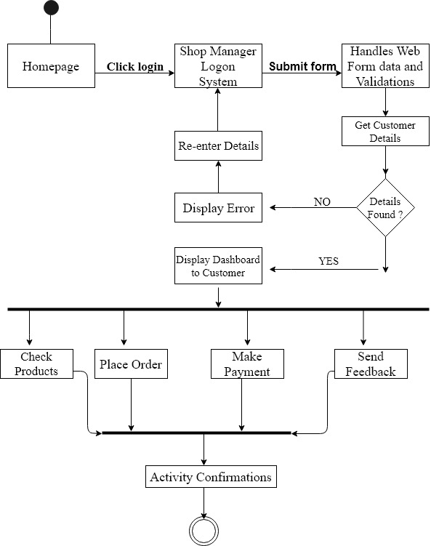

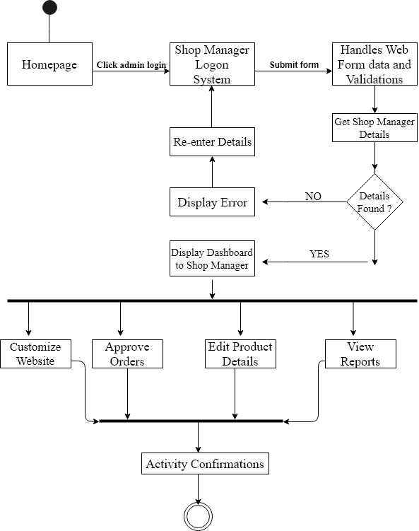

**CLASS DIAGRAM**

The class diagram is a central modelling technique that runs through nearly all object-oriented methods. This diagram describes the types of objects in the system and various kinds of static relationships which exist between them.

* **Relationships**

There are three principal kinds of relationships which are important:

* **Association** - represent relationships between instances of types (a person works for a company a company has a number of offices.
* **Inheritance** - the most obvious addition to ER diagrams for use in OO. It has an immediate correspondence to inheritance in OO design.
* **Aggregation** - Aggregation, a form of object composition in object-oriented design.

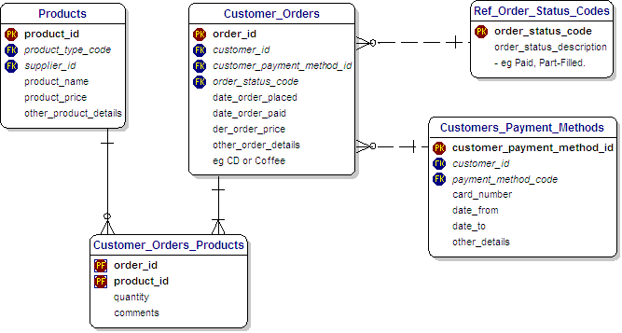

## **DEVELOPMENT METHODOLOGY**

In software engineering, a system development methodology refers to the framework that is used to structure, plan, and control the process of developing an information system. Software development methodologies define the processes we use to build software. These methodologies are also referred to as Software Development Process Models. Each methodology follows a series of steps unique to its type, to ensure success in the process of software development.

A software process is a set of related activities that leads to the production of a software product.

There are a lot of software processes but they all include four activities:

* Specification
* Development
* Validation
* Evolution

These are fundamental to software engineering. A wide variety of Software Development methodology has evolved over the years. Each of these methodologies has its own recognized strengths and weaknesses. The following are the most widely used methodologies for software development.

**Testing**

**WATERFALL METHOD**

The waterfall model is a sequential approach, where each fundamental activity of a process represented as a separate phase, arranged in linear order. This model requires planning and scheduling activities before starting working on them, it is plan-driven.

Plan-driven process is one in which all the activities are first planned, and then each progress is measured against the plan.

The Agile process on the other hand involves planning incrementally and it is much easier to change the processes to reflect a change in requirement.

### **INCREMENTAL METHOD**

The Incremental method of development is based on the idea of developing an initial implementation, exposing this model to user to receive feedback. This model evolves in the form of versions as the requirements change until an acceptable system has been developed.

### **SPIRAL METHOD**

The spiral model is a risk-driven method where the process is represented as spiral rather than a sequence of activities and it includes best features from the waterfall and prototyping models. In addition, it introduces a new component called: risk-assessment. Each loop in the spiral represents a phase, thus the first loop might be concerned with system feasibility. The next loop might be concerned with the requirements definition and the next with system design, and the like.

**Analysis**

**Goals**

**Increase Sales**: One of the primary goals for any e-commerce project is to increase sales. You can set a specific sales target, such as a percentage increase in revenue over a certain period of time, or a total dollar amount of sales to be reached.

**Improve Customer Experience**: E-commerce success depends heavily on providing a positive customer experience. To improve customer experience, you can set goals like reducing website load times, streamlining the checkout process, and implementing a user-friendly navigation menu.

**Optimize Mobile Experience:** More and more people are using mobile devices to make purchases online, so optimizing your website for mobile users is crucial. Setting goals to improve the mobile experience, such as reducing load times, simplifying navigation, and improving mobile checkout can help increase sales from mobile users.

**Objectives**

The main aim of the project is to develop a simple and easy-to-use online shopping system with the functionality of making the shop available in different languages for different people across the globe

In order to attain the general objective, the following list of specific objectives is set:

* To make buying easier for online shoppers by making the website available in different languages for them.
* To make selling easier by providing shop management with an effective and efficient system to handle client’s data and request.
* To help expand the market of shops and make it available to a worldwide audience.
* To provide customers access to discounts and special pricing.

## **SPECIFIC OBJECTIVES OF THE STUDY**

**Scope**

This project is developed for three types of users and they are Visitors, Customers (Registered Member) and Online shop owners. The application consists of following main sections (inclusions):

**VISITOR FEATURES**

* Multi Lingual (English, British English, Spanish, French, Chinese, Dutch, German,
* Hindu, Portuguese, Japanese, Welsh, Italian, Hebrew, Korean, Russian, Greek, Catalan,
* Irish, Turkish, Arabic, Afrikaans)
* View Home Banners or Slide Show Gallery
* Browse Products
* View Product Details
* View FAQs
* Become a Member through Registration process
* View Static Pages (Contact Us, About Us, Privacy Policy, Disclaimer, Terms & Conditions)
* Debit and Credit Card Payments with PayPal
* Coupons
* Live Chat Support
* Product Recommendations