**HTTP Request Response** :

Output:

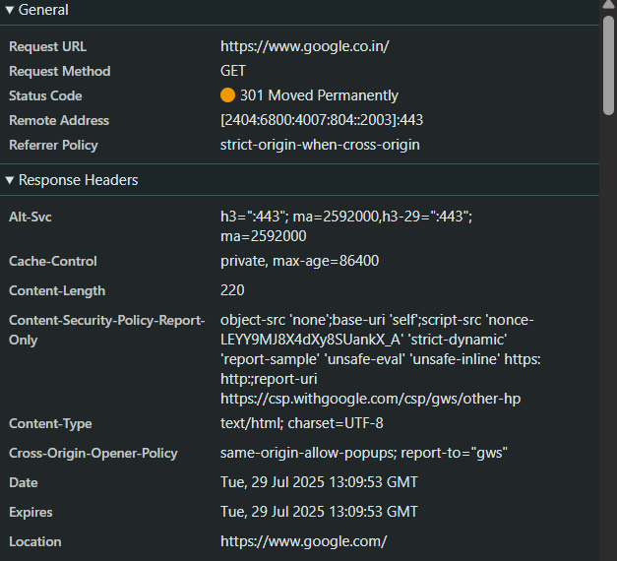

**Hello World RESTful Web Service** :

**HelloController.java:**

**package com.cognizant.springlearn.controller;**

**import org.slf4j.Logger;**

**import org.slf4j.LoggerFactory;**

**import org.springframework.web.bind.annotation.GetMapping;**

**import org.springframework.web.bind.annotation.RestController;**

**@RestController**

**public class HelloController {**

**private static final Logger LOGGER = LoggerFactory.getLogger(HelloController.class);**

**@GetMapping("/hello")**

**public String sayHello() {**

**LOGGER.info("START");**

**LOGGER.info("END");**

**return "Hello World!!";**

**}**

**}**

**SpringLearnApplication.java:**

**package com.cognizant.springlearn;**

**import org.springframework.boot.SpringApplication;**

**import org.springframework.boot.autoconfigure.SpringBootApplication;**

**@SpringBootApplication**

**public class SpringLearnApplication {**

**public static void main(String[] args) {**

**SpringApplication.run(SpringLearnApplication.class, args);**

**}**

**}**

**Pom.xml:**

**<project xmlns="http://maven.apache.org/POM/4.0.0"**

**xmlns:xsi="http://www.w3.org/2001/XMLSchema-instance"**

**xsi:schemaLocation="http://maven.apache.org/POM/4.0.0**

**http://maven.apache.org/xsd/maven-4.0.0.xsd">**

**<modelVersion>4.0.0</modelVersion>**

**<groupId>com.cognizant</groupId>**

**<artifactId>spring-learn</artifactId>**

**<version>0.0.1-SNAPSHOT</version>**

**<name>spring-learn</name>**

**<description>Part 2 - Hello REST Controller</description>**

**<packaging>jar</packaging>**

**<parent>**

**<groupId>org.springframework.boot</groupId>**

**<artifactId>spring-boot-starter-parent</artifactId>**

**<version>3.2.0</version> <!-- or latest -->**

**<relativePath/>**

**</parent>**

**<dependencies>**

**<!-- Spring Boot Starter Web -->**

**<dependency>**

**<groupId>org.springframework.boot</groupId>**

**<artifactId>spring-boot-starter-web</artifactId>**

**</dependency>**

**<!-- Spring Boot Starter Test -->**

**<dependency>**

**<groupId>org.springframework.boot</groupId>**

**<artifactId>spring-boot-starter-test</artifactId>**

**<scope>test</scope>**

**</dependency>**

**</dependencies>**

**<build>**

**<plugins>**

**<!-- Spring Boot plugin -->**

**<plugin>**

**<groupId>org.springframework.boot</groupId>**

**<artifactId>spring-boot-maven-plugin</artifactId>**

**</plugin>**

**</plugins>**

**</build>**

**</project>**

**Output:**

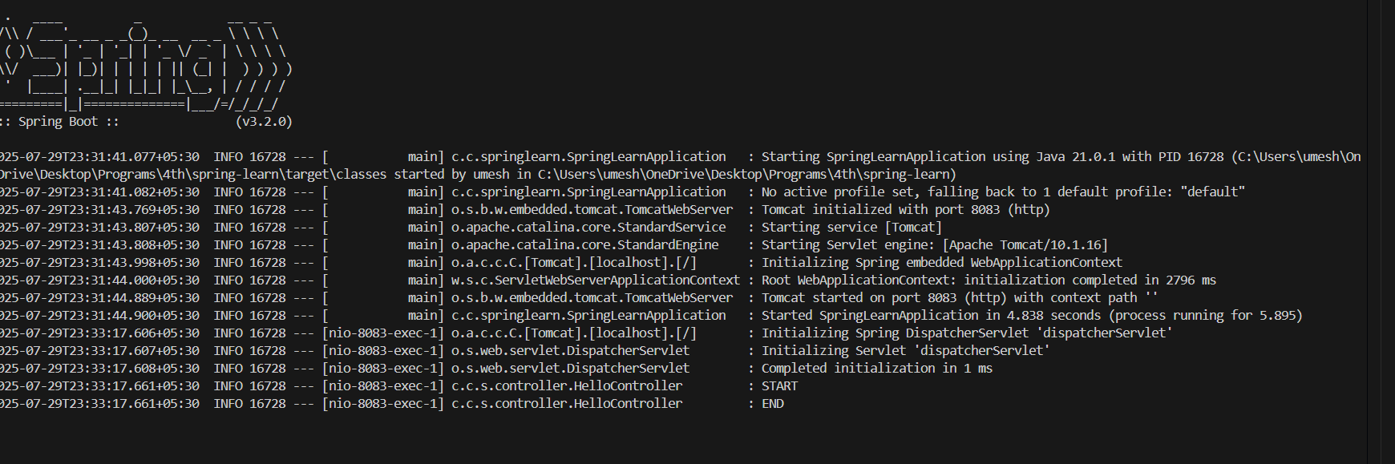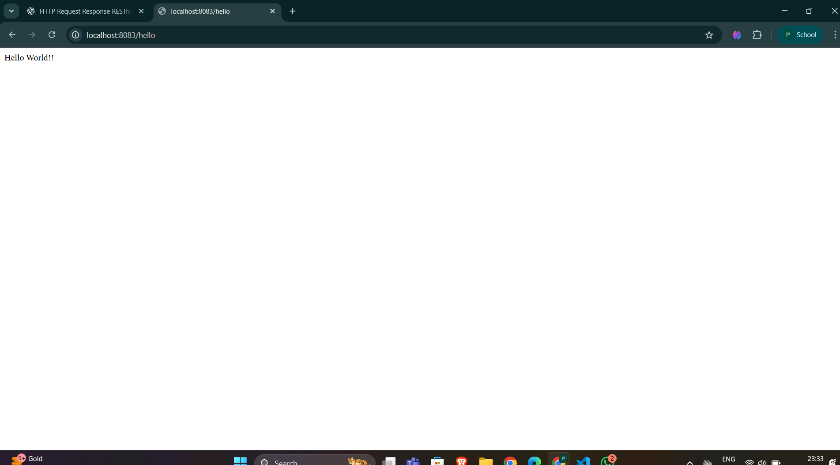

**REST - Country Web Service :**

**SpringLearnApplication.java:**

**package com.cognizant.springlearn;**

**import org.slf4j.Logger;**

**import org.slf4j.LoggerFactory;**

**import org.springframework.boot.SpringApplication;**

**import org.springframework.boot.autoconfigure.SpringBootApplication;**

**import org.springframework.context.ApplicationContext;**

**import org.springframework.context.support.ClassPathXmlApplicationContext;**

**import com.cognizant.springlearn.model.Country;**

**@SpringBootApplication**

**public class SpringLearnApplication {**

**private static final Logger LOGGER = LoggerFactory.getLogger(SpringLearnApplication.class);**

**public static void main(String[] args) {**

**SpringApplication.run(SpringLearnApplication.class, args);**

**LOGGER.info("START");**

**ApplicationContext context = new ClassPathXmlApplicationContext("country.xml");**

**Country country = (Country) context.getBean("country");**

**LOGGER.debug("Country: {}", country.toString());**

**LOGGER.info("END");**

**}**

**}**

**Country.xml:**

**<?xml version="1.0" encoding="UTF-8"?>**

**<beans xmlns="http://www.springframework.org/schema/beans"**

**xmlns:xsi="http://www.w3.org/2001/XMLSchema-instance"**

**xsi:schemaLocation="http://www.springframework.org/schema/beans**

**http://www.springframework.org/schema/beans/spring-beans.xsd">**

**<bean id="country" class="com.cognizant.springlearn.model.Country">**

**<property name="code" value="IN"/>**

**<property name="name" value="India"/>**

**</bean>**

**</beans>**

**Country.java:**

**package com.cognizant.springlearn.model;**

**import java.io.Serializable;**

**public class Country implements Serializable {**

**private String code;**

**private String name;**

**public Country() {**

**}**

**public Country(String code, String name) {**

**this.code = code;**

**this.name = name;**

**}**

**public String getCode() {**

**return code;**

**}**

**public void setCode(String code) {**

**this.code = code;**

**}**

**public String getName() {**

**return name;**

**}**

**public void setName(String name) {**

**this.name = name;**

**}**

**@Override**

**public String toString() {**

**return "Country [code=" + code + ", name=" + name + "]";**

**}**

**}**

**Output:**

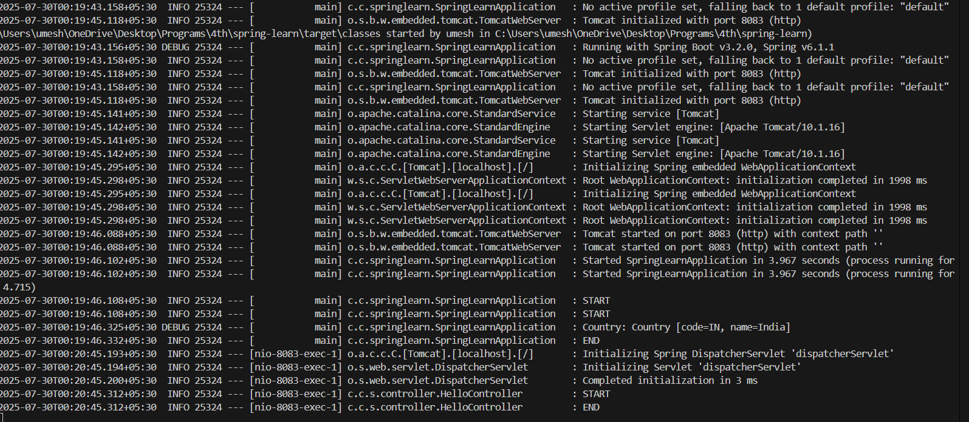

**REST - Get all countries :**

**Country.java:**

**package com.cognizant.springlearn.model;**

**public class Country {**

**private String code;**

**private String name;**

**public Country() {**

**}**

**public Country(String code, String name) {**

**this.code = code;**

**this.name = name;**

**}**

**public String getCode() {**

**return code;**

**}**

**public void setCode(String code) {**

**this.code = code;**

**}**

**public String getName() {**

**return name;**

**}**

**public void setName(String name) {**

**this.name = name;**

**}**

**}**

**SpringLearnApplication.java:**

**package com.cognizant.springlearn;**

**import org.springframework.boot.SpringApplication;**

**import org.springframework.boot.autoconfigure.SpringBootApplication;**

**@SpringBootApplication**

**public class SpringLearnApplication {**

**public static void main(String[] args) {**

**SpringApplication.run(SpringLearnApplication.class, args);**

**}**

**}**

**Country-list.xml:**

**<?xml version="1.0" encoding="UTF-8"?>**

**<beans xmlns="http://www.springframework.org/schema/beans"**

**xmlns:context="http://www.springframework.org/schema/context"**

**xmlns:xsi="http://www.w3.org/2001/XMLSchema-instance"**

**xsi:schemaLocation="http://www.springframework.org/schema/beans**

**https://www.springframework.org/schema/beans/spring-beans.xsd**

**http://www.springframework.org/schema/context**

**https://www.springframework.org/schema/context/spring-context.xsd">**

**<bean id="countryList" class="java.util.ArrayList">**

**<constructor-arg>**

**<list>**

**<bean class="com.cognizant.springlearn.model.Country">**

**<property name="code" value="IN"/>**

**<property name="name" value="India"/>**

**</bean>**

**<bean class="com.cognizant.springlearn.model.Country">**

**<property name="code" value="US"/>**

**<property name="name" value="United States"/>**

**</bean>**

**<bean class="com.cognizant.springlearn.model.Country">**

**<property name="code" value="CN"/>**

**<property name="name" value="China"/>**

**</bean>**

**</list>**

**</constructor-arg>**

**</bean>**

**</beans>**

**SpringLearnApplicationTest.java:**

**package com.cognizant.springlearn;**

**import org.junit.jupiter.api.Test;**

**import org.springframework.beans.factory.annotation.Autowired;**

**import org.springframework.boot.test.autoconfigure.web.servlet.AutoConfigureMockMvc;**

**import org.springframework.boot.test.context.SpringBootTest;**

**import org.springframework.test.web.servlet.MockMvc;**

**import static org.springframework.test.web.servlet.request.MockMvcRequestBuilders.get;**

**import static org.springframework.test.web.servlet.result.MockMvcResultMatchers.jsonPath;**

**import static org.springframework.test.web.servlet.result.MockMvcResultMatchers.status;**

**@SpringBootTest**

**@AutoConfigureMockMvc**

**class SpringLearnApplicationTests {**

**@Autowired**

**private MockMvc mockMvc;**

**@Test**

**void helloEndpointTest() throws Exception {**

**mockMvc.perform(get("/hello"))**

**.andExpect(status().isOk());**

**}**

**@Test**

**void countryEndpointTest() throws Exception {**

**mockMvc.perform(get("/countries/IN")).andExpect(status().isOk())**

**.andExpect(jsonPath("$.name").value("India"));**

**}**

**}**

**Output:**

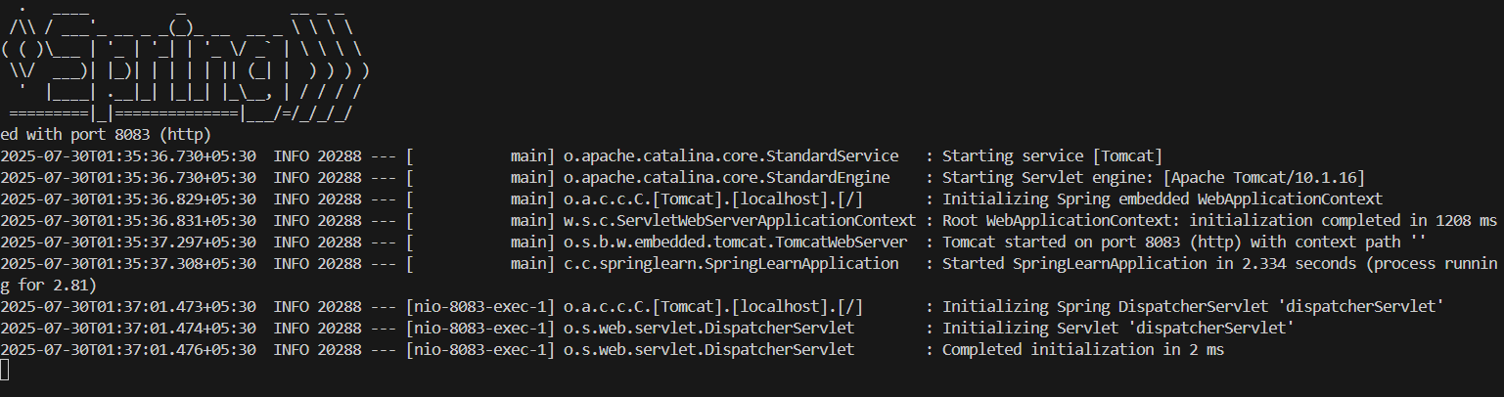

**REST - Get country based on country code**

**Country.java:**

**package com.cognizant.springlearn.model;**

**public class Country {**

**private String code;**

**private String name;**

**public Country() {**

**}**

**public Country(String code, String name) {**

**this.code = code;**

**this.name = name;**

**}**

**public String getCode() {**

**return code;**

**}**

**public void setCode(String code) {**

**this.code = code;**

**}**

**public String getName() {**

**return name;**

**}**

**public void setName(String name) {**

**this.name = name;**

**}**

**@Override**

**public String toString() {**

**return "Country [code=" + code + ", name=" + name + "]";**

**}**

**}**

**CountryController.java:**

**package com.cognizant.springlearn.controller;**

**import com.cognizant.springlearn.model.Country;**

**import com.cognizant.springlearn.service.CountryService;**

**import org.springframework.beans.factory.annotation.Autowired;**

**import org.springframework.web.bind.annotation.*;**

**@RestController**

**public class CountryController {**

**@Autowired**

**private CountryService countryService;**

**@GetMapping("/country/{code}")**

**public Country getCountry(@PathVariable String code) {**

**return countryService.getCountryByCode(code);**

**}**

**}**

**CountryService.java:**

**package com.cognizant.springlearn.controller;**

**import com.cognizant.springlearn.model.Country;**

**import com.cognizant.springlearn.service.CountryService;**

**import org.springframework.beans.factory.annotation.Autowired;**

**import org.springframework.web.bind.annotation.*;**

**@RestController**

**public class CountryController {**

**@Autowired**

**private CountryService countryService;**

**@GetMapping("/country/{code}")**

**public Country getCountry(@PathVariable String code) {**

**return countryService.getCountryByCode(code);**

**}**

**}**

**Output:**

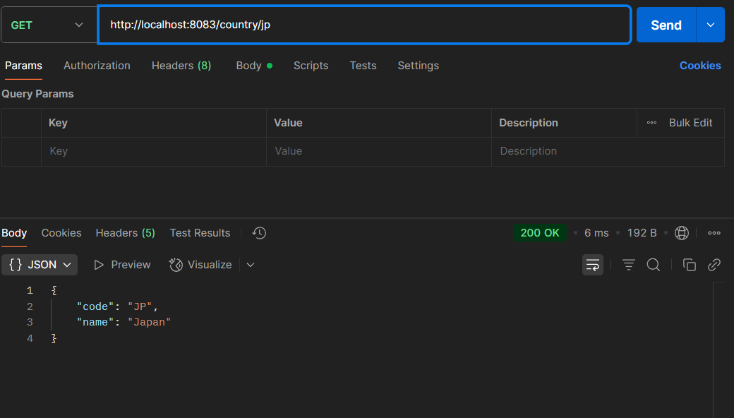

**REST - Get country exceptional scenario**

**CountryService.java:**

**package com.cognizant.springlearn.service;**

**import java.util.ArrayList;**

**import java.util.List;**

**import org.springframework.stereotype.Service;**

**import com.cognizant.springlearn.exception.CountryNotFoundException;**

**import com.cognizant.springlearn.model.Country;**

**import jakarta.annotation.PostConstruct;**

**@Service**

**public class CountryService {**

**private List<Country> countryList = new ArrayList<>();**

**@PostConstruct**

**public void init() {**

**countryList.add(new Country("IN", "India"));**

**countryList.add(new Country("US", "United States"));**

**countryList.add(new Country("JP", "Japan"));**

**}**

**public Country getCountryByCode(String code) {**

**return countryList.stream()**

**.filter(c -> c.getCode().equalsIgnoreCase(code))**

**.findFirst()**

**.orElseThrow(() -> new CountryNotFoundException(code));**

**}**

**}**

**CountryNotFoundExcepion.java:**

**package com.cognizant.springlearn.exception;**

**public class CountryNotFoundException extends RuntimeException {**

**public CountryNotFoundException(String code) {**

**super("Country with code '" + code + "' not found");**

**}**

**}**

**GlobalExceptionHandler.java:**

**package com.cognizant.springlearn.exception;**

**import org.springframework.http.HttpStatus;**

**import org.springframework.http.ResponseEntity;**

**import org.springframework.web.bind.annotation.ControllerAdvice;**

**import org.springframework.web.bind.annotation.ExceptionHandler;**

**@ControllerAdvice**

**public class GlobalExceptionHandler {**

**@ExceptionHandler(CountryNotFoundException.class)**

**public ResponseEntity<String> handleCountryNotFoundException(CountryNotFoundException ex) {**

**return new ResponseEntity<>(ex.getMessage(), HttpStatus.NOT_FOUND);**

**}**

**}**

**Output:**

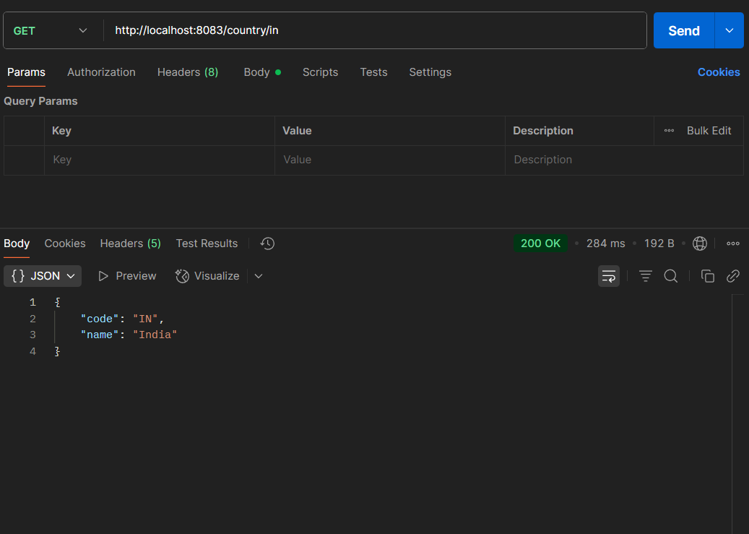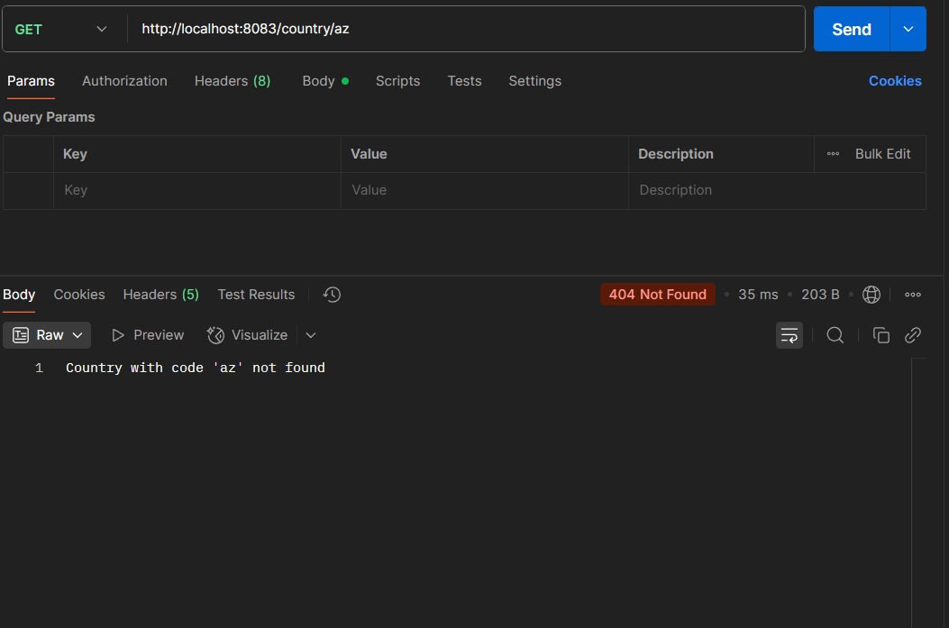

**MockMVC - Test get country service**

**SpringLearnApplicationTests.java:**

**package com.cognizant.springlearn;**

**import static org.junit.jupiter.api.Assertions.assertNotNull;**

**import org.junit.jupiter.api.Test;**

**import org.springframework.beans.factory.annotation.Autowired;**

**import org.springframework.boot.test.autoconfigure.web.servlet.AutoConfigureMockMvc;**

**import org.springframework.boot.test.context.SpringBootTest;**

**import org.springframework.test.web.servlet.MockMvc;**

**import org.springframework.test.web.servlet.ResultActions;**

**import static org.springframework.test.web.servlet.request.MockMvcRequestBuilders.get;**

**import static org.springframework.test.web.servlet.result.MockMvcResultMatchers.jsonPath;**

**import static org.springframework.test.web.servlet.result.MockMvcResultMatchers.status;**

**import com.cognizant.springlearn.controller.CountryController;**

**@SpringBootTest**

**@AutoConfigureMockMvc**

**public class SpringLearnApplicationTests {**

**@Autowired**

**private CountryController countryController;**

**@Autowired**

**private MockMvc mockMvc;**

**// 1. Test if controller is loaded**

**@Test**

**public void contextLoads() {**

**assertNotNull(countryController);**

**}**

**// 2. Test getCountry() success case**

**@Test**

**public void testGetCountry() throws Exception {**

**ResultActions actions = mockMvc.perform(get("/country"));**

**actions.andExpect(status().isOk());**

**actions.andExpect(jsonPath("$.code").value("IN"));**

**actions.andExpect(jsonPath("$.name").value("India"));**

**}**

**}**

**SpringLearnApplication.java:**

**package com.cognizant.springlearn;**

**import org.springframework.boot.SpringApplication;**

**import org.springframework.boot.autoconfigure.SpringBootApplication;**

**import org.springframework.context.ApplicationContext;**

**import org.springframework.context.support.ClassPathXmlApplicationContext;**

**@SpringBootApplication**

**public class SpringLearnApplication {**

**public static void main(String[] args) {**

**ApplicationContext context = new ClassPathXmlApplicationContext("spring.xml");**

**SpringApplication.run(SpringLearnApplication.class, args);**

**}**

**}**

**Output:**

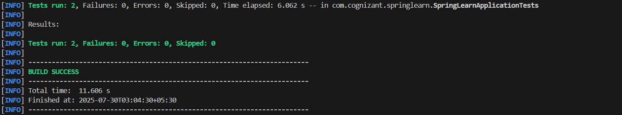

**MockMVC - Test get country service for exceptional scenario**

**SpringLearnApplication.java:**

**package com.cognizant.springlearn;**

**import org.springframework.boot.SpringApplication;**

**import org.springframework.boot.autoconfigure.SpringBootApplication;**

**@SpringBootApplication**

**public class SpringLearnApplication {**

**public static void main(String[] args) {**

**SpringApplication.run(SpringLearnApplication.class, args);**

**}**

**}**

**SpringLearnApplicationTest.java:**

**package com.cognizant.springlearn;**

**import static org.junit.jupiter.api.Assertions.assertNotNull;**

**import org.junit.jupiter.api.Test;**

**import org.springframework.beans.factory.annotation.Autowired;**

**import org.springframework.boot.test.autoconfigure.web.servlet.AutoConfigureMockMvc;**

**import org.springframework.boot.test.context.SpringBootTest;**

**import org.springframework.test.web.servlet.MockMvc;**

**import org.springframework.test.web.servlet.ResultActions;**

**import static org.springframework.test.web.servlet.request.MockMvcRequestBuilders.get;**

**import static org.springframework.test.web.servlet.result.MockMvcResultMatchers.jsonPath;**

**import static org.springframework.test.web.servlet.result.MockMvcResultMatchers.status;**

**import org.junit.jupiter.api.Test;**

**import static org.junit.jupiter.api.Assertions.*;**

**import com.cognizant.springlearn.controller.CountryController;**

**@SpringBootTest(classes = SpringLearnApplication.class)**

**@AutoConfigureMockMvc**

**public class SpringLearnApplicationTests {**

**@Autowired**

**private CountryController countryController;**

**@Autowired**

**private MockMvc mockMvc;**

**// 1. Test if controller is loaded**

**@Test**

**public void contextLoads() {**

**assertNotNull(countryController);**

**}**

**// 2. Test getCountry() success case**

**@Test**

**public void testGetCountryByCode() throws Exception {**

**ResultActions actions = mockMvc.perform(get("/countries/IN"));**

**actions.andExpect(status().isOk());**

**actions.andExpect(jsonPath("$.code").value("IN"));**

**actions.andExpect(jsonPath("$.name").value("India"));**

**}**

**}**

**RestExceptionHandler.java:**

**package com.cognizant.springlearn.service.exception;**

**import org.springframework.http.HttpStatus;**

**import org.springframework.http.ResponseEntity;**

**import org.springframework.web.bind.annotation.*;**

**@ControllerAdvice**

**public class RestExceptionHandler {**

**@ExceptionHandler(CountryNotFoundException.class)**

**public ResponseEntity<String> handleCountryNotFound(CountryNotFoundException ex) {**

**return new ResponseEntity<>(ex.getMessage(), HttpStatus.NOT_FOUND);**

**}**

**}**

**Output:**

