**Employee.xml:**

<?xml version="1.0" encoding="UTF-8"?>

<beans xmlns="http://www.springframework.org/schema/beans"

xmlns:xsi="http://www.w3.org/2001/XMLSchema-instance"

xsi:schemaLocation="http://www.springframework.org/schema/beans

https://www.springframework.org/schema/beans/spring-beans.xsd">

<!-- Department Beans -->

<bean id="department1" class="com.cognizant.springlearn.model.Department">

<property name="id" value="1" />

<property name="name" value="Human Resources" />

</bean>

<bean id="department2" class="com.cognizant.springlearn.model.Department">

<property name="id" value="2" />

<property name="name" value="IT" />

</bean>

<!-- Employee Beans -->

<bean id="employee1" class="com.cognizant.springlearn.model.Employee">

<property name="id" value="101" />

<property name="name" value="Alice" />

<property name="salary" value="50000" />

<property name="permanent" value="true" />

<property name="department" ref="department1" />

</bean>

<bean id="employee2" class="com.cognizant.springlearn.model.Employee">

<property name="id" value="102" />

<property name="name" value="Bob" />

<property name="salary" value="60000" />

<property name="permanent" value="false" />

<property name="department" ref="department2" />

</bean>

<!-- Add more employees if needed -->

<!-- List of Employees -->

<bean id="employeeList" class="java.util.ArrayList">

<constructor-arg>

<list>

<ref bean="employee1" />

<ref bean="employee2" />

</list>

</constructor-arg>

</bean>

</beans>

**Skill.java:**

package com.cognizant.springlearn.model;

public class Skill {

private int id;

private String name;

// Constructors

public Skill() {}

public Skill(int id, String name) {

this.id = id;

this.name = name;

}

// Getters and Setters

public int getId() {

return id;

}

public void setId(int id) {

this.id = id;

}

public String getName() {

return name;

}

public void setName(String name) {

this.name = name;

}

}

**Department.java:**

package com.cognizant.springlearn.model;

public class Department {

private int id;

private String name;

// Constructors

public Department() {}

public Department(int id, String name) {

this.id = id;

this.name = name;

}

// Getters and Setters

public int getId() {

return id;

}

public void setId(int id) {

this.id = id;

}

public String getName() {

return name;

}

public void setName(String name) {

this.name = name;

}

}

**Employee.java:**

package com.cognizant.springlearn.model;

import java.util.List;

public class Employee {

private int id;

private String name;

private double salary;

private boolean permanent;

private Department department;

private List<Skill> skills;

// Constructors

public Employee() {}

public Employee(int id, String name, double salary, boolean permanent, Department department, List<Skill> skills) {

this.id = id;

this.name = name;

this.salary = salary;

this.permanent = permanent;

this.department = department;

this.skills = skills;

}

// Getters and Setters

public int getId() {

return id;

}

public void setId(int id) {

this.id = id;

}

public String getName() {

return name;

}

public void setName(String name) {

this.name = name;

}

public double getSalary() {

return salary;

}

public void setSalary(double salary) {

this.salary = salary;

}

public boolean isPermanent() {

return permanent;

}

public void setPermanent(boolean permanent) {

this.permanent = permanent;

}

public Department getDepartment() {

return department;

}

public void setDepartment(Department department) {

this.department = department;

}

public List<Skill> getSkills() {

return skills;

}

public void setSkills(List<Skill> skills) {

this.skills = skills;

}

}

**Pom.xml:**

<project xmlns="http://maven.apache.org/POM/4.0.0"

xmlns:xsi="http://www.w3.org/2001/XMLSchema-instance"

xsi:schemaLocation="http://maven.apache.org/POM/4.0.0

http://maven.apache.org/xsd/maven-4.0.0.xsd">

<modelVersion>4.0.0</modelVersion>

<groupId>com.cognizant</groupId>

<artifactId>springlearn</artifactId>

<version>0.0.1-SNAPSHOT</version>

<packaging>jar</packaging>

<name>springlearn</name>

<description>Spring REST Application</description>

<parent>

<groupId>org.springframework.boot</groupId>

<artifactId>spring-boot-starter-parent</artifactId>

<version>3.1.2</version>

<relativePath/>

</parent>

<properties>

<java.version>21</java.version>

</properties>

<dependencies>

<!-- Spring Boot Web -->

<dependency>

<groupId>org.springframework.boot</groupId>

<artifactId>spring-boot-starter-web</artifactId>

</dependency>

<!-- Spring Boot Test (optional) -->

<dependency>

<groupId>org.springframework.boot</groupId>

<artifactId>spring-boot-starter-test</artifactId>

<scope>test</scope>

</dependency>

<!-- For Transactional -->

<dependency>

<groupId>org.springframework</groupId>

<artifactId>spring-tx</artifactId>

</dependency>

</dependencies>

<build>

<plugins>

<!-- Plugin to run Spring Boot app -->

<plugin>

<groupId>org.springframework.boot</groupId>

<artifactId>spring-boot-maven-plugin</artifactId>

</plugin>

</plugins>

</build>

</project>

**EmployeeDao.java:**

package com.cognizant.springlearn.dao;

import com.cognizant.springlearn.model.Employee;

import org.springframework.beans.factory.annotation.Autowired;

import org.springframework.context.ApplicationContext;

import org.springframework.stereotype.Repository;

import java.util.ArrayList;

@Repository

public class EmployeeDao {

private static ArrayList<Employee> EMPLOYEE_LIST;

// Constructor loads data from XML using Spring context

@Autowired

public EmployeeDao(ApplicationContext context) {

EMPLOYEE_LIST = (ArrayList<Employee>) context.getBean("employeeList");

}

public ArrayList<Employee> getAllEmployees() {

return EMPLOYEE_LIST;

}

}

**EmployeeService.java:**

package com.cognizant.springlearn.service;

import com.cognizant.springlearn.dao.EmployeeDao;

import com.cognizant.springlearn.model.Employee;

import org.springframework.beans.factory.annotation.Autowired;

import org.springframework.stereotype.Service;

import org.springframework.transaction.annotation.Transactional;

import java.util.List;

@Service

public class EmployeeService {

@Autowired

private EmployeeDao employeeDao;

@Transactional

public List<Employee> getAllEmployees() {

return employeeDao.getAllEmployees();

}

}

**EmployeeController.java:**

package com.cognizant.springlearn.controller;

import com.cognizant.springlearn.model.Employee;

import com.cognizant.springlearn.service.EmployeeService;

import org.springframework.beans.factory.annotation.Autowired;

import org.springframework.web.bind.annotation.*;

import java.util.List;

@RestController

public class EmployeeController {

@Autowired

private EmployeeService employeeService;

@GetMapping("/employees")

public List<Employee> getAllEmployees() {

return employeeService.getAllEmployees();

}

}

**SpringApplication.java:**

package com.cognizant.springlearn;

import org.springframework.boot.SpringApplication;

import org.springframework.boot.autoconfigure.SpringBootApplication;

import org.springframework.context.annotation.ImportResource;

@SpringBootApplication

@ImportResource("classpath:employee.xml") // Register XML beans

public class SpringlearnApplication {

public static void main(String[] args) {

SpringApplication.run(SpringlearnApplication.class, args);

}

}

**Output:**

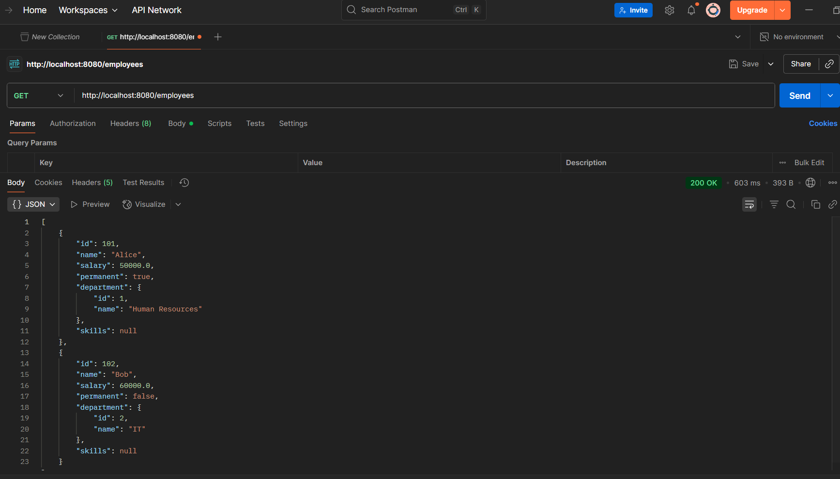

**EmployeeDao.java:**

package com.cognizant.springlearn.dao;

import com.cognizant.springlearn.model.Employee;

import org.springframework.beans.factory.annotation.Autowired;

import org.springframework.context.ApplicationContext;

import org.springframework.stereotype.Repository;

import java.util.ArrayList;

@Repository

public class EmployeeDao {

private static ArrayList<Employee> EMPLOYEE_LIST;

// Constructor loads data from XML using Spring context

@Autowired

public EmployeeDao(ApplicationContext context) {

EMPLOYEE_LIST = (ArrayList<Employee>) context.getBean("employeeList");

}

public ArrayList<Employee> getAllEmployees() {

return EMPLOYEE_LIST;

}

}

**DepartmentDao.java:**

package com.cognizant.springlearn.dao;

import com.cognizant.springlearn.model.Employee;

import org.springframework.beans.factory.annotation.Autowired;

import org.springframework.context.ApplicationContext;

import org.springframework.stereotype.Repository;

import java.util.ArrayList;

@Repository

public class EmployeeDao {

private static ArrayList<Employee> EMPLOYEE_LIST;

// Constructor loads data from XML using Spring context

@Autowired

public EmployeeDao(ApplicationContext context) {

EMPLOYEE_LIST = (ArrayList<Employee>) context.getBean("employeeList");

}

public ArrayList<Employee> getAllEmployees() {

return EMPLOYEE_LIST;

}

}

## **DepartmentService.java:**

package com.cognizant.springlearn.service;

import com.cognizant.springlearn.dao.DepartmentDao;

import com.cognizant.springlearn.model.Department;

import org.springframework.beans.factory.annotation.Autowired;

import org.springframework.stereotype.Service;

import java.util.List;

@Service

public class DepartmentService {

@Autowired

private DepartmentDao departmentDao;

public List<Department> getAllDepartments() {

return departmentDao.getAllDepartments();

}

}

**DepartmentController.java:**

package com.cognizant.springlearn.controller;

import com.cognizant.springlearn.model.Department;

import com.cognizant.springlearn.service.DepartmentService;

import org.springframework.beans.factory.annotation.Autowired;

import org.springframework.web.bind.annotation.*;

import java.util.List;

@RestController

public class DepartmentController {

@Autowired

private DepartmentService departmentService;

@GetMapping("/departments")

public List<Department> getAllDepartments() {

return departmentService.getAllDepartments();

}

}

