FrameWork :

Framework is a well organized structure of packages , one .xml file will take care of entire batch execution without any manual interaction is called framework

Framework contains collection of reusable components, that’s makes test-scripts development & execution is easier

Framework is a custom tool designed by framework developer , which contains lots reusable components, that’s automation test engineer life easy.

Framework contains 8 Framework

1. Batch-Runner(testing.xml)
2. Test-scripts
3. Generic Libraries
4. Page object Libraries
5. Test data
6. Reports
7. screenshots
8. Resources
9. Batch-Runner :

* Batch Runner is a testNG.xml , which is used to achieve batch execution
* In order to execute multiple test Scripts through batch , we should create testing.xml file & place all the test-NAME within xml file
* Through Batch-Runner we can also run the test in parallel & grouping execution
* Its brain of my framework , it’s a main file where we can the trigger the framework

1. Test-Scripts

* Components contains collection of testing test scripts
* All the test scripts are implemented using testNg Annotations, & its developed using generic & business libraries
* Every test test scripts will be maintained in module wise
* Its written by automation test engineer by taking a help of framework component , & developing test scripts will be easier because of framework resalable complements

1. Generic Libraries

* All the methods available in generic lib , can be used to any Application
* Its contains lots of reusable mtds

ExcelLib : its implemented using Apache POI , used get the data from ExcelSheet & properties File

* SampleListner : contains LISTNER implementation , which is used to get the

scrrenShot whenever test is getting failed

* WebDriverCommonLib : contains webdriver specific reusable mtds like waitforPageToLoad, waitForElement(). Select() ect …which can be used while developing testscripts
* BAseClass : it contains base config annotation , which is common for all the test like @beforesuite , @afterSuite, @beforeclass & afterclass, @beforemethod ,@afterMethod

@beforeClass : used to launch the browse

@afteClass : used to close the browser

@beforemethod : used to login to application

@afterMethd : used to logout from the application

@beforeSuite : used to connect to DataBase

@AfterSuite : used to disconnect to DataBase

1. Page Object repository Lib :

* Collection of webelemets xpath & business libraries
* Its implemented using POM[Page Object Model ] design pattern
* POM is java design pattern preferred by GOOGLE to devlop Page Object repository
* POM advanced technique to develop object repository , it’s a good way of storing web element in Organized structure

Repositoy is implemented using 2 design pattern

1. POM
2. Page Foctory

POM

* Repository is implemented using POm rules

1. Create a separate or dedicated java class , for each page in a application
2. As per the POM , object should identified & stored using @findBY & @findBys annotation
3. Page specific Action should be stored in specific Page class in Repository
4. All the Webelements in repository should be private ,& private webelment will not have Write access , but every Page class will have getters mtds to provide read access to test-scripts

How to create getters automatically

Place cursor inside the page class🡺 rightclick🡺select SOURCE🡺click on generate getters & setters

Page Factory : it’s an extended design pattern of POM , which is used execute all @findBy annotation on the browser, & initialize elements available in Page Class,

PAgeClassNAme objName = PageFoctory.initElements(driver, PAgeClassNAme .class)

5.Test data

* Contains collection test Data
* As per the automation rule test data should not hardcodes with-in test , so should place the data in ExcelSheet

2 types of Data

1. Test-script data : contains test scripts specific data, Every row is dedicated for one test
2. CommonData.properties File : contains global parameter which can be used in across the test-Scripts like

URL : used to run the test on different Environment

USerNAme/Password : run the test in different credentials

Browser : used the run the test in different browser

1. Reports

Whenever we run hundred of test-scripts through batch execution , reporting feature might be helpful the verify the status of the application & used to debug the test when it fails

Framework supports 2 type of reports

1. High level reports:

Verify the execution statues means (num test : PASS , num test: fail Num test:skips)

1. Low level reports

Low reports are implanted using “REporter” testng class , which is used for debug the testscripts when test is getting failed

Reporter class : is used to insert LOW reports in the HMTL report

1. screenshot :

* Contains collections of failed test case screenshot , which is taken by @Listener annotation

1. Resoucres :

Contains collection browser Server & automation related documents

**4 types of framework**

1. **Data driven framework**
2. **Moduler driver framework**
3. **Hybrid driven framework**
4. **KeyWord driven framework**
5. **Data driven framework**

Whenever App needs to be tested with huge amount of data , we do pre prefer data driven framework

* Read data from external recourse & run same test with different set of Data is called data driven framework
* In order to run same Test with multiple data we should have dedicated @dataProvider annotation for each test in class
* in data driven framework , we dedicated 1 Excel Sheet for One test

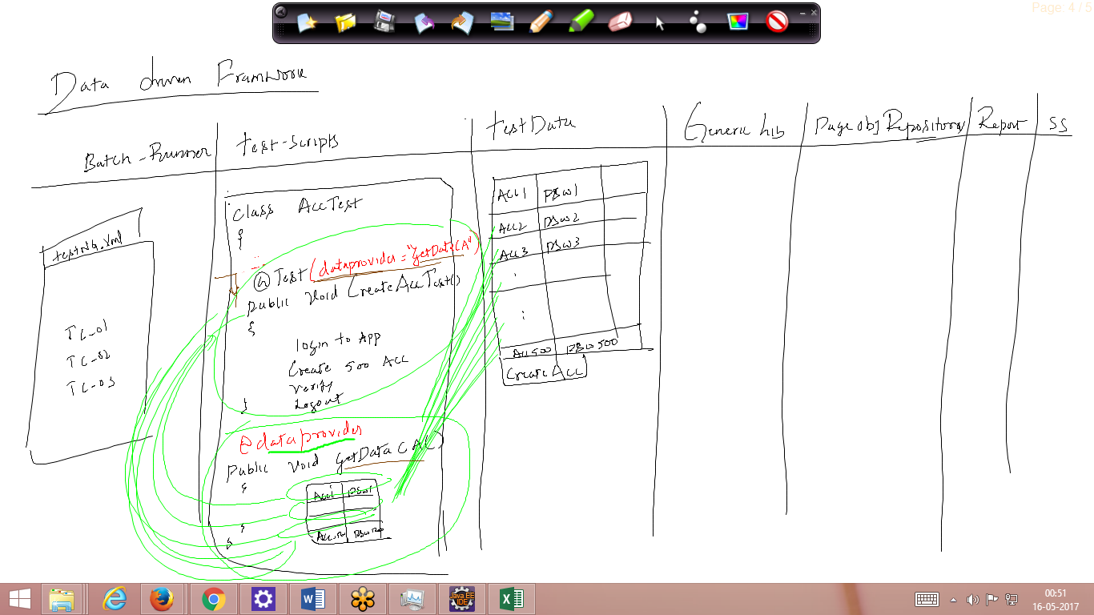

1. Modular driven framework

When Eever application contains lots of modules we prefer modular driven framework

* According to modular driver framework , every component should be maintained in module Wise
* Should be not used in real time , because maintain ace is difficult

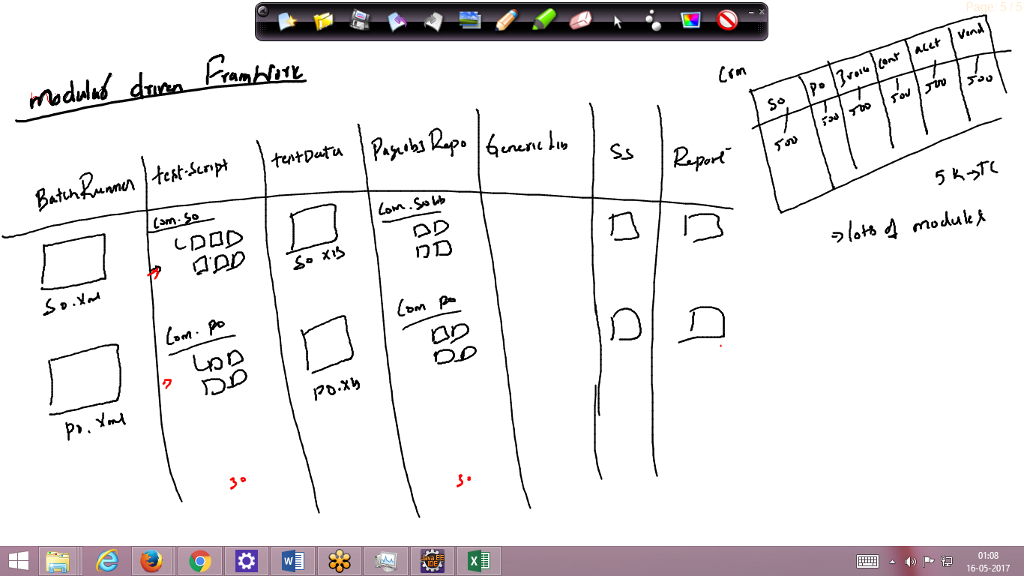

1. **Hybrid driven framework**

* Combination of Any Two framework is hybrid driven framework
* The framework which we have designed is a combination data driven + modular driven framework
* Nowadays most the company prefer Hybrid

1. KEyWordDriven framework

When ever test Engineer needs write test with less knowledge on automation tool & programing language we prefer KEyWordDriven

* As per the keyword test script will be written ExcelSheet in using KeyWord libraries

Eg : Selenium –IDE

