23CSE111

OBJECT ORIENTED PROGRAMMING

LAB MANUAL 

**Department of Computer and Science Engineering Amrita**

**School of Engineering**

**Amrita Vishwa Vidyapeetham, Amaravati Campus**

NAME:- C.Umesh Chandra Reddy.

ROLL.NO:-av.sc.u4cse24037

VERIFIED BY:-

|  |  |  |  |  |
| --- | --- | --- | --- | --- |
| S.NO | Programs | DATE | PG.NO | SIGNATURE |
| WEEK-1 |  | 27-01-2025 |  |  |
| 1. | Write the steps to download  and install Java. |  | 3 |  |
| 2. | Write a java program to print the message“Welcome to java programming”. |  | 6 |  |
| 3. | Write a java program that prints name, roll number and section of a student. |  | 7 |  |
|  |  |  |  |  |
| WEEK-2 |  | 03-02-2025 |  |  |
| 1. | Write a java program to calculate the area of a rectangle. |  |  |  |
| 2.a) | Write a program to convert temperature from Celsius to Fahrenheit . |  |  |  |
| 2.b) | Write a java program to convert temperature from Fahrenheit to Celsius. |  |  |  |
| 3. | Write a java program to calculate the simple interest. |  |  |  |
| 4. | Write a java program to find the largest of three numbers using ternary operator. |  |  |  |
| 5. | Write a java program to find the factorial of a number. |  |  |  |
|  |  |  |  |  |
| WEEK-3 |  | 11-02-2025 |  |  |
| 1. | Create a java program with following instructions  a )create a class with name car  b) Create 4 attributes name car color, car brand, fuel type, milage.  c) Create 3 methods named start, stop, services  d) Create 3objects named car1, car2, car3.  e) Create a constructor which should print “welcome to car garage” |  |  |  |
| 2. | Write a java program to create a class BackAccount with two methods deposit( ) and withdraw()  b) In deposit( ) whenever an amount is deposited it has to be updated with current amount  b) In withdraw( ) whenever an amount is withdrawn it has to be less than current amount else print “Insufficient funds” |  |  |  |
|  |  |  |  |  |
| WEEK-4 |  | 02-03-2025 |  |  |
| 1. | Write a java program with class named “Book”. The class should contain various attributes such as “Title of the book , author , year of publication “. It should also contain a constructor with parameters details of the book. i.e. “ Title of the book, author and year of publication”. Display the details of  two books by creating two objects. |  |  |  |
| 2. | To create a java program with class named Myclass with a staticvariable “Count” of “int type”, Initialized to 0 and a constant variable “pi” of type double initialized to 3.1415 as attributes of that class Now, define a constructor for “Myclass” that increments the “Count” variable each that an object of Myclass is created. Finally , print the final values of “Count” and “pi”variables. |  |  |  |
|  |  |  |  |  |
| WEEK-5 |  | 09-03-25 |  |  |
| 1. | Create a calc using the operations including add, sub, mul, div using multilevel inheritance and display the desired output |  |  |  |
| 2. | Creating a Rental Sysytem |  |  |  |
|  |  |  |  |  |
| WEEK-6 |  | 16-03-2025 |  |  |
| 1. | Write a java program to create a  Vehicle class with displayInfo()  method , overridden in Car subclass  to provide info about carcompany ,  model , price ,seating and petrol. |  |  |  |
| 2. | An automated admission system  that verifies student eligibility for  UG and PG with different criteria.  1.UG requires minimum of 60%  2.PG requires minimum of 70% |  |  |  |
| 3. | Create a calculator class with  overloaded methods to perform  additions  1.add two integers4  2.add two double values  3.add three integers |  |  |  |
| 4, | Create a shape class with method  calculateArea() that is overloaded  for different shapes (eg: square,  rectangle).Then create a subclass  Circle that overrides calculateArea()  method for Circle. |  |  |  |
|  |  |  |  |  |
|  |  |  |  |  |
|  |  |  |  |  |

WEEK:-1

1. Write the steps to download and install Java.

**Aim:** To download and install java.

**Procedure:**

i. Visit oracle.com website to download Java

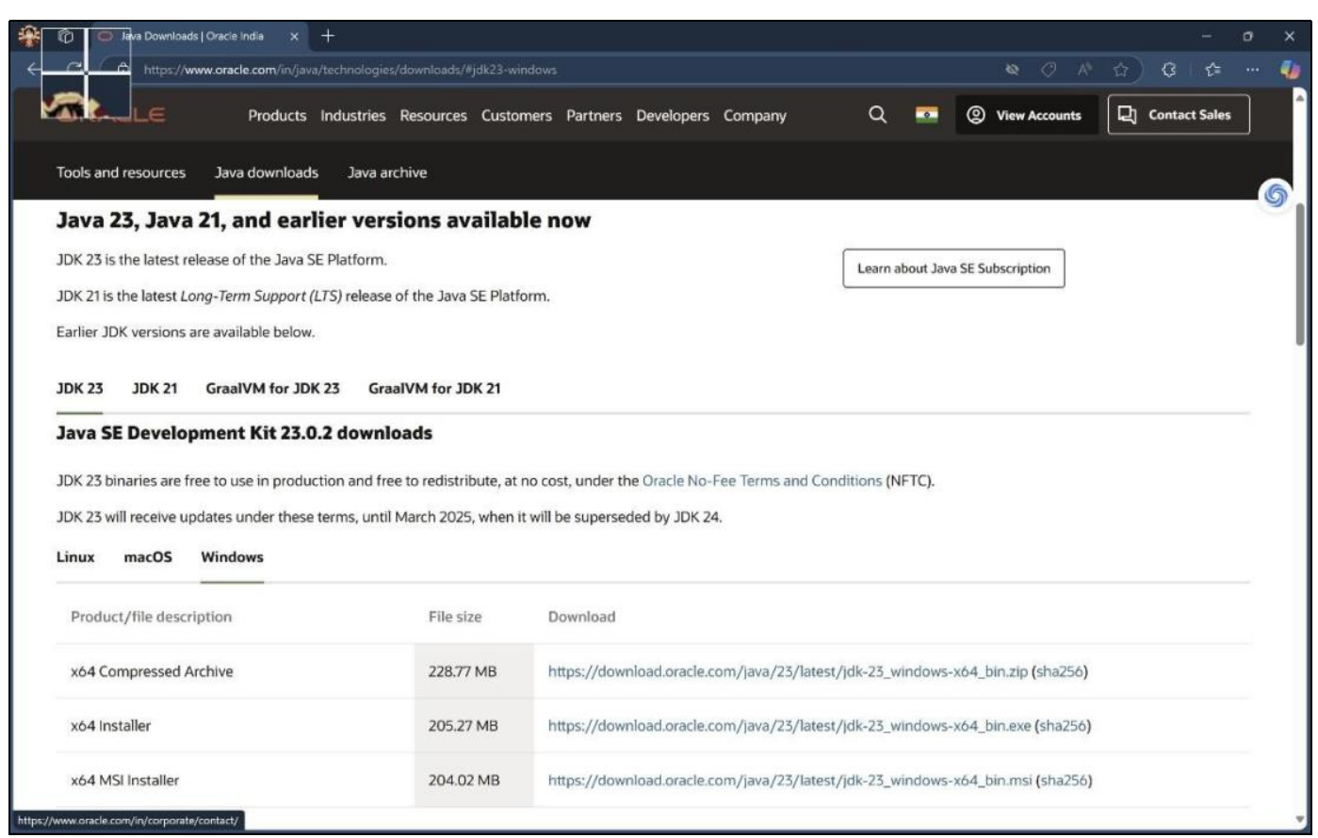

ii. Download the version which supports LTS (JDK 21) x64 installer for windows.



iii. Install and copy the path.

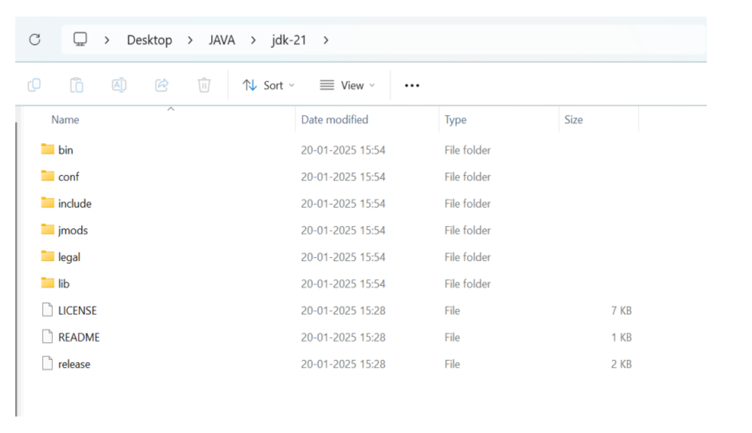

iv. Open environmental variables and add a new file with path.

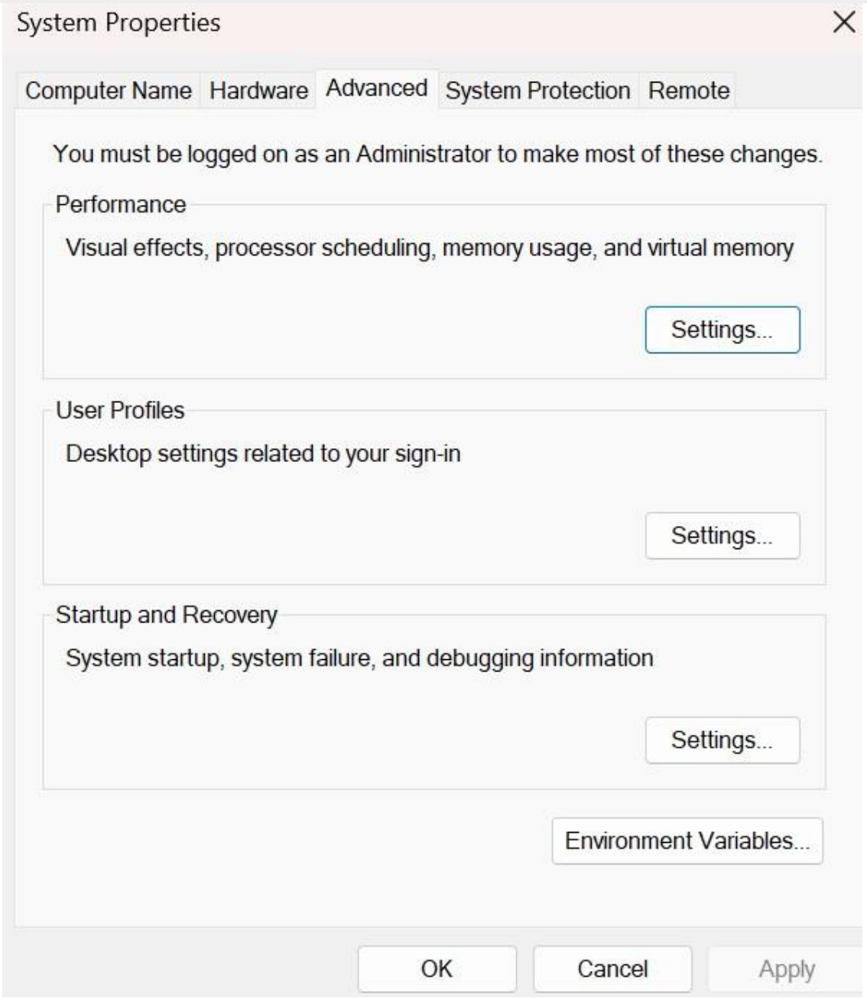

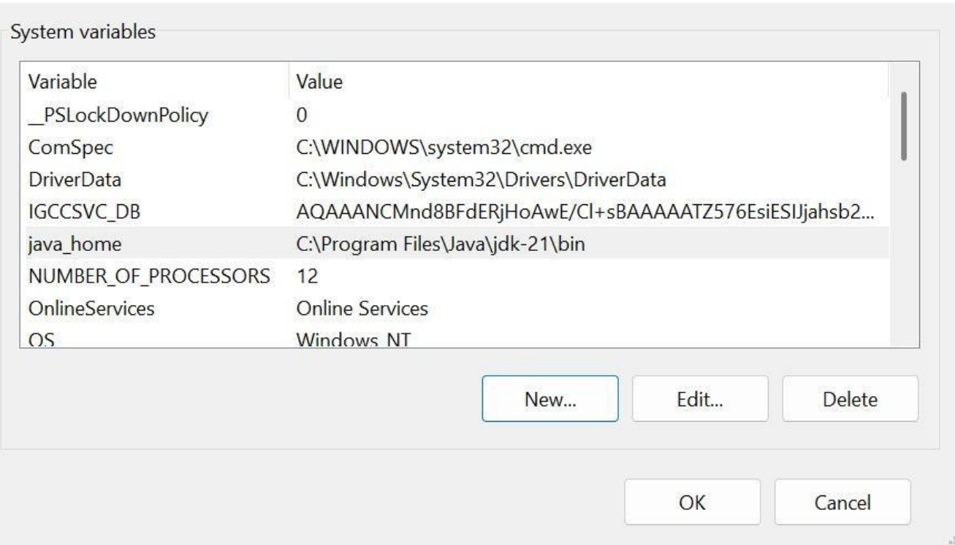

v. Verify java version in command window.

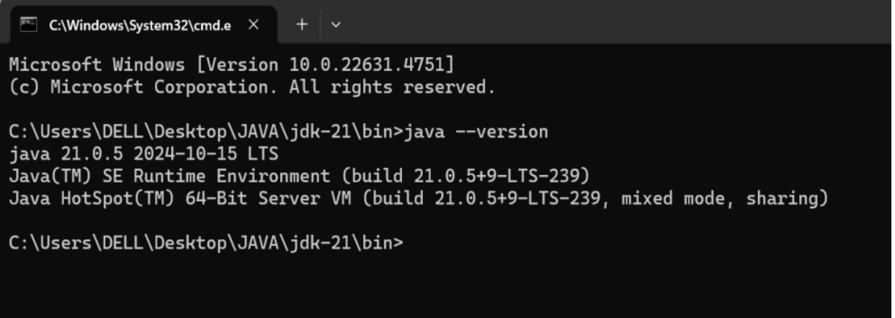

2. Write a java program to print the message “Welcome to java programming”.

CODE:

class ex1

{

public static void main(String[] args)

{

System.out.println("Welcome to java programming.");

}

}

OUTPUT:-

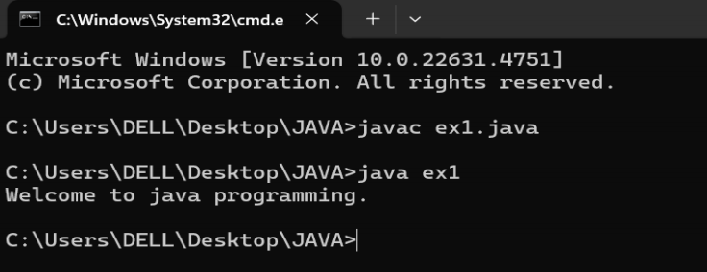

ERROR:-

|  |  |  |
| --- | --- | --- |
| S.NO | EXPECTED ERROR | REASON |
| 1. | ; | ; is expected at end |
| 2. | S | Capital S is expected for  String and System. |

3.Write a java program to print the name, roll number and section of a student.

**Code:**

class ex2{

public static void main(String[] args){

String name = "Umesh";

int rollNo = 24037;

String section = "A";

System.out.println("Student Information:");

System.out.println("Name:" + name);

System.out.println("Roll No:" + rollNo);

System.out.println("Section:" + section);

}

}

**Output:**

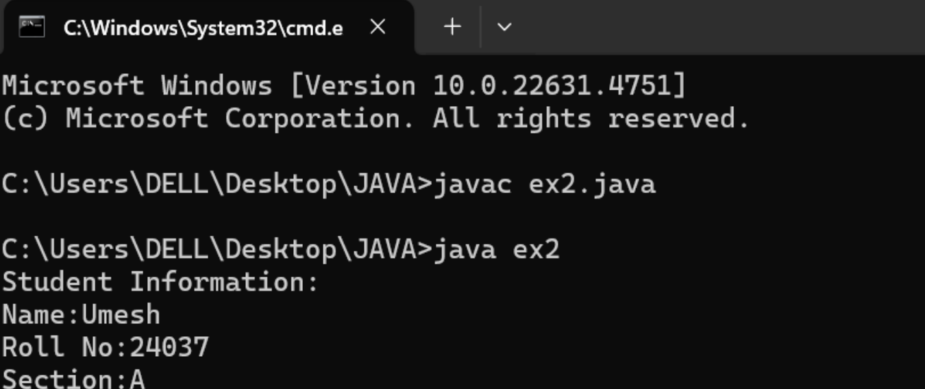ERROR:-

|  |  |  |
| --- | --- | --- |
| S.No | EXPECTED ERROR | REASON |
| 1. | S | Capital S is expected for  String and System. |

WEEK:-2

1. Write a java program to calculate the area of a rectangle.

**Code**:

import java.util.Scanner;

class rec{

public static void main(String[] args){

Scanner scan=new Scanner(System.in);

System.out.println("Enter length of rectangle:");

double l=scan.nextDouble();

System.out.println("Enter breadth of rectangle:");

double b=scan.nextDouble();

double a=l*b;

System.out.println("Area of rectangle is"+a);

}

}

OUTPUT:-

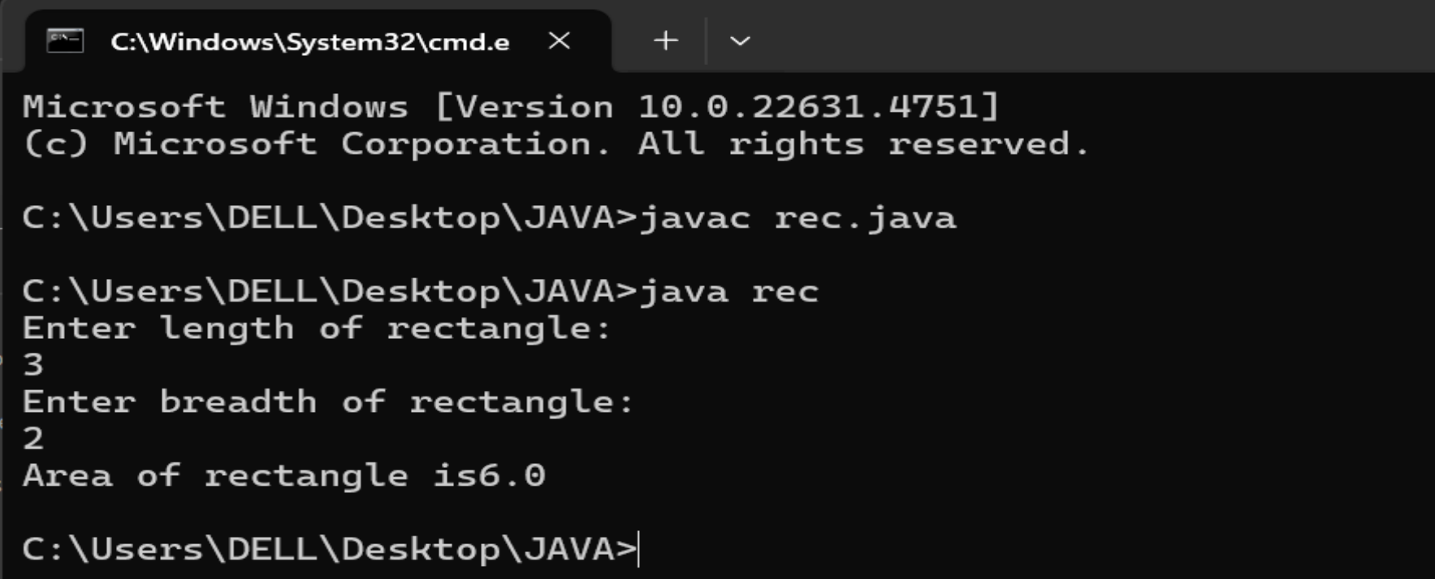

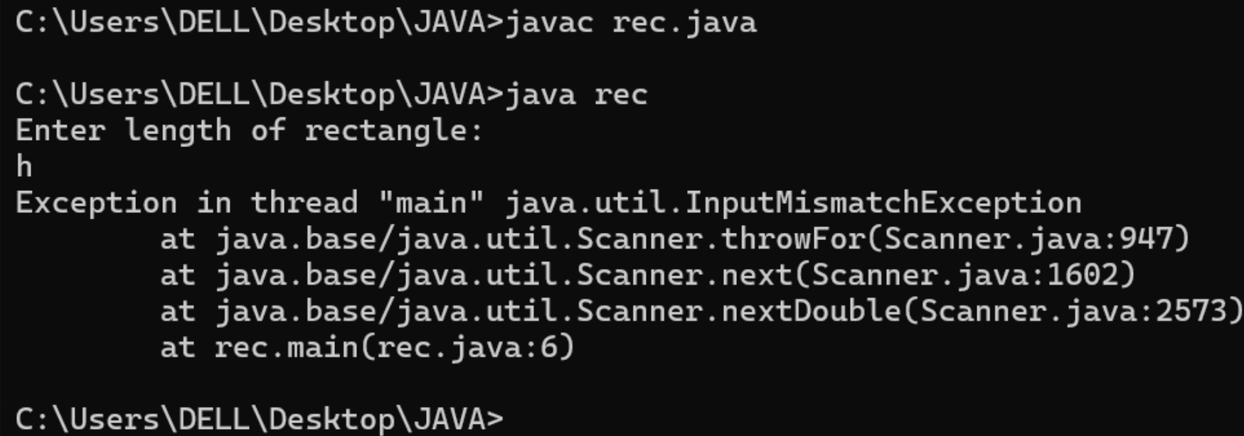

ERROR:-

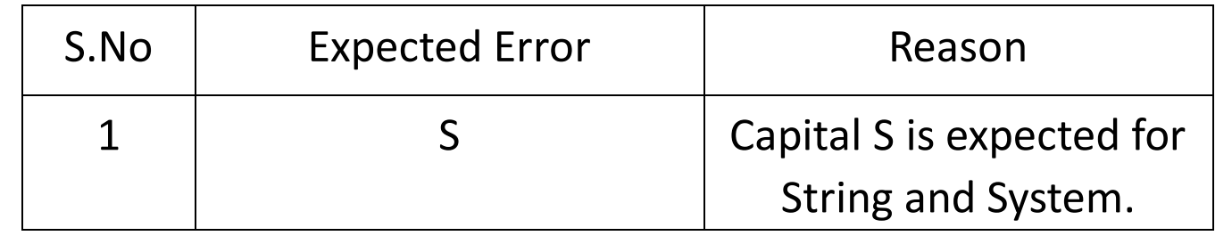

2a). Write a program to convert temperature from Fahrenheit to Celsius.

**Code**:

import java.util.Scanner;

class temp{

public static void main(String[] args){

Scanner scan=new Scanner(System.in);

System.out.println("Enter temperature in Fahrenheit:");

double f=scan.nextDouble();

double c=((f-32)/(1.8));

System.out.println("Temperature in celsius is"+c);

}

}

OUTPUT:-

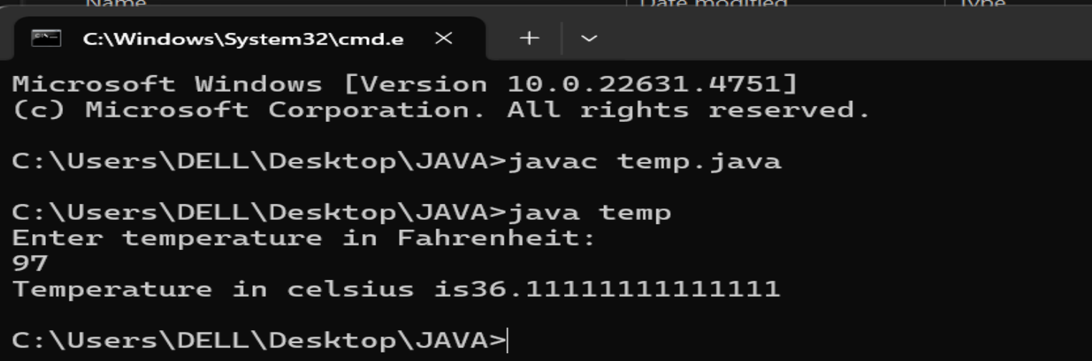

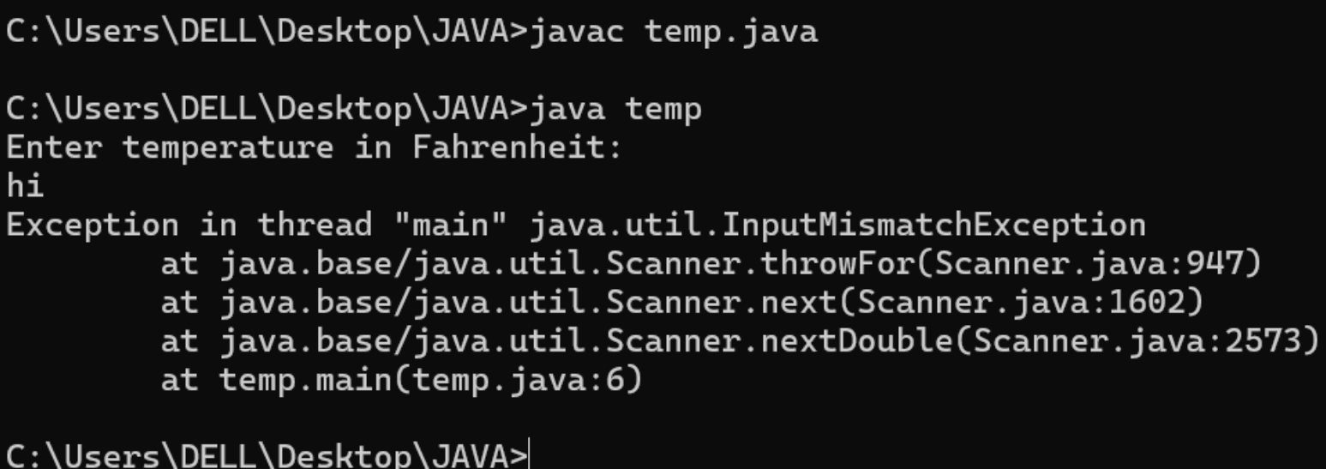

ERROR:-

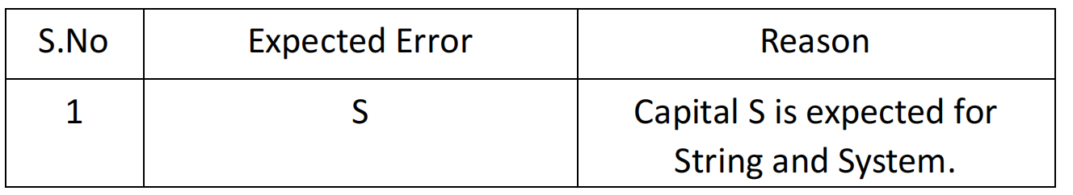

2b). Write a program to convert temperature from Celsius to Fahrenheit.

**Code**:

import java.util.Scanner;

class temp{

public static void main(String[] args){

Scanner scan=new Scanner(System.in);11

System.out.println("Enter temperature in celsius:");

double c=scan.nextDouble();

double f=(c*1.8)+32;

System.out.println("Temperature in Fahrenheit is"+f);

}

}

OUTPUT:-

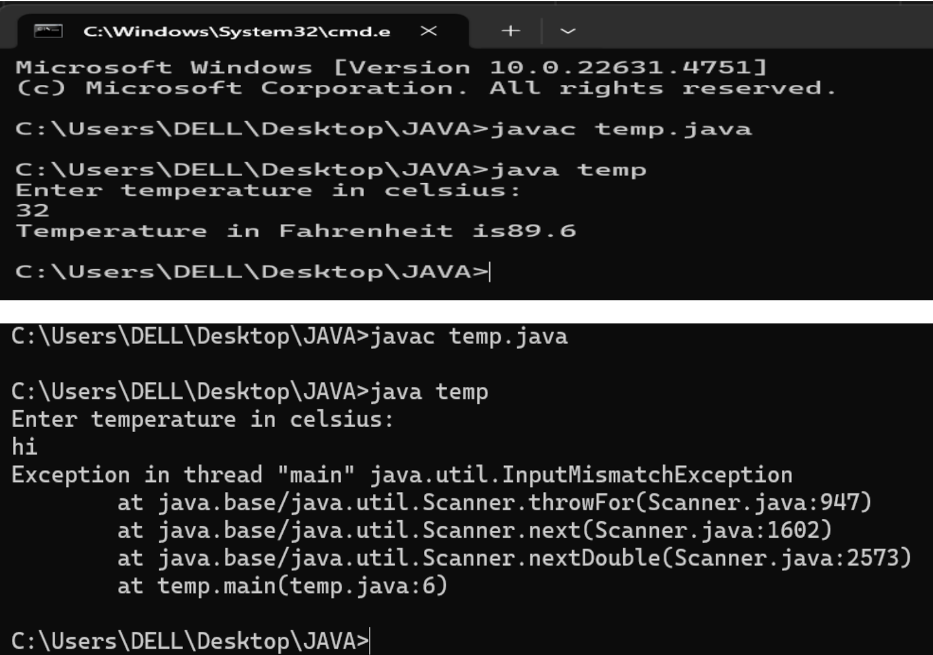

ERRORS:-

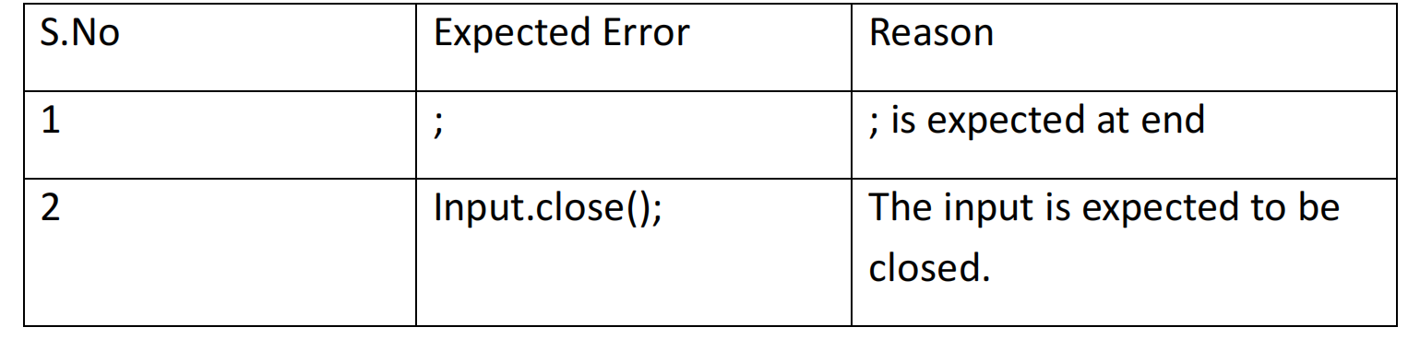

3)Write a java program to calculate the simple interest.

**Code**:

import java.util.Scanner;

public class si{

public static void main(String[] args){

Scanner input = new Scanner(System.in);

System.out.print("Enter principal amount : ");

int p = input.nextInt();

System.out.print("Enter rate of interest : ");

int r = input.nextInt();

System.out.print("Enter the time period : ");

int t = input.nextInt();

int SI = p*r*t/100;

System.out.print("The simple Interest is : " + SI);

input.close();

}

}

CODE:-

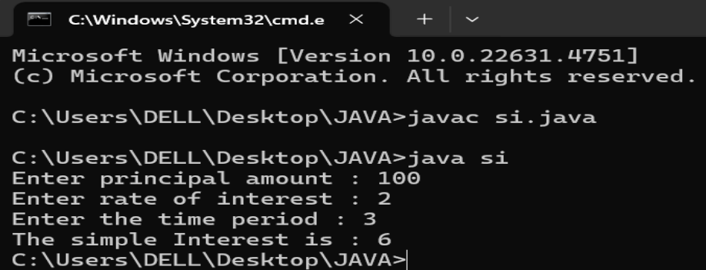

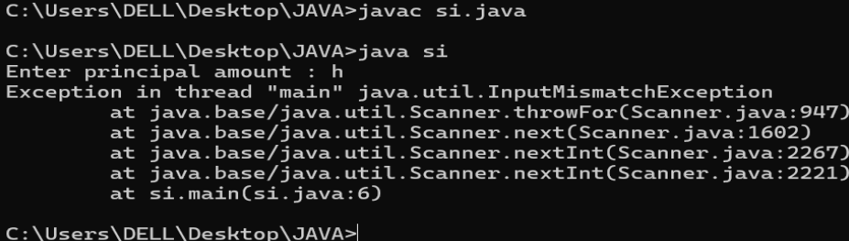

ERROR:-

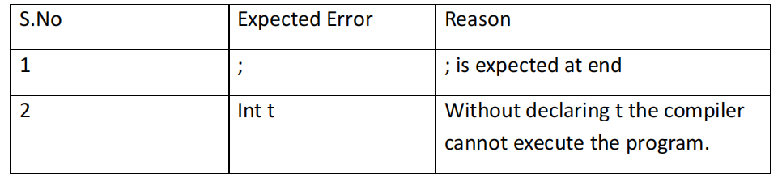4) Write a java program to find the largest of three numbers using ternary

operation.

**Code**:

import java.util.Scanner;

public class largest{

public static void main(String[] args){

Scanner input = new Scanner(System.in);

System.out.print("Enter number a : ");

int a = input.nextInt();

System.out.print("Enter number b : ");

int b = input.nextInt();

System.out.print("Enter number c : ");14

int c = input.nextInt();

int largest = (a>=b) ? ((a>=c ) ? a : c) : ((b >=c) ? b : c);

System.out.print("The largest number is : " + largest);

input.close();

}

}

CODE:-

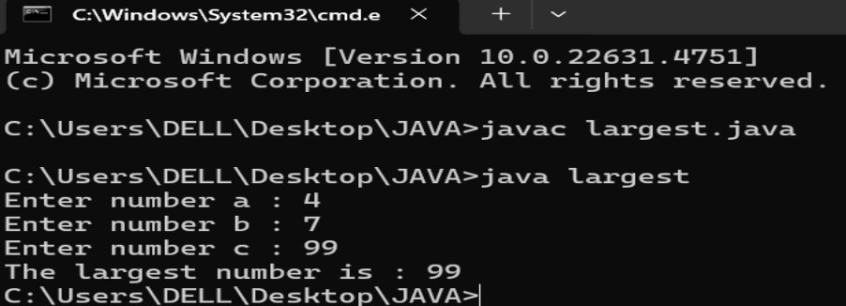ERRORS:-

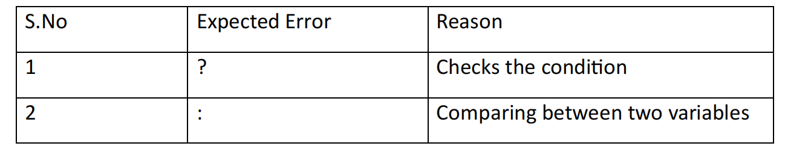5) Write a java program to find the factorial of a number

**Code**:

import java.util.Scanner;

public class fac{

public static void main(String[] args){15

Scanner input = new Scanner(System.in);

System.out.print("Enter the number n : ");

int n = input.nextInt();

int fac = 1;

for(int i = 2; i<=n;i++){

fac *= i;

}

System.out.println( "The factorial of the given number is :" + fac);

input.close();

}

}

OUTPUT:-

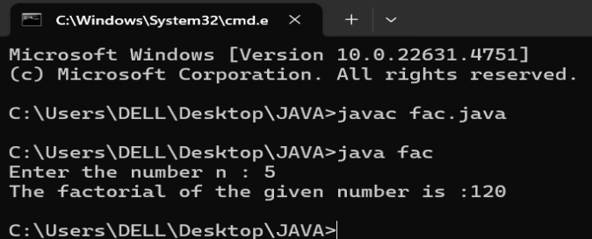ERRORS:-

|  |  |  |
| --- | --- | --- |
| S.no | EXPECTED ERROR | REASON |
| 1. | } | To close for loop |
| 2. | System.out.println | IF we place the print statement inside the for loop it will print the each i value every time but to print only the final value we must place it outside the for loop. |

WEEK:-3

1.Create the java program with the following instructions

i) Create a class with name Car

ii) Create 4 attributes named Car_Color , Car_brand, fuel_type,

mileage

iii) Create 3 method named Start( ) , Stop( ), Service( )

iv) Create 3 objects Car1 , Car2 , Car3

v) Create a constructor which should print “Welcome to Car Garage”

**Code:** public class car {

public String carColor;

private String carBrand;

private String fuelType;

public int mileage;

car(String carColor, String carBrand, String fuelType, int mileage) {

this.carColor = carColor;

this.carBrand = carBrand;

this.fuelType = fuelType;

this.mileage = mileage;

System.out.println(carColor + " " + carBrand + " " + fuelType + " " +

mileage);

}

public void Start() {

System.out.println("The car has just started");

}

public void Stop() {

System.out.println("The car has just stopped");

}

public void Service() {

System.out.println("The car is in good condition");

}

public static void main(String[] args) {

car car1 = new car(" orange", "Audi", "Petrol", 60);

car car2 = new car(" yellow", "BMW", "Diesel", 97);

car car3 = new car(" violet", " tata", "Petrol", 66);

car1.Start();

}

}

OUTPUT:-

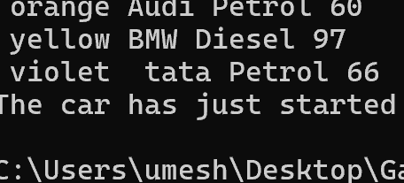

ERRORS:-

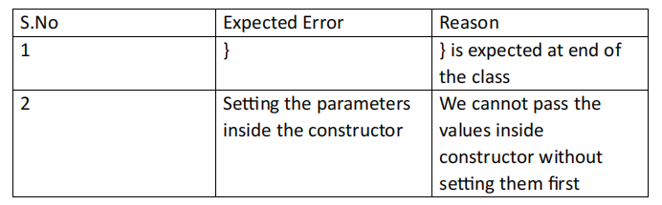CLASS:-

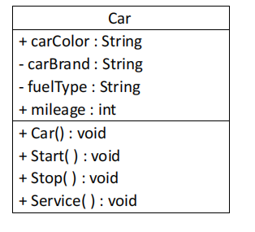

2.Write a java program to create a class BackAccount with two methods deposit( )

and withdraw( )

i) In deposit( ) whenever an amount is deposited it has to be updated with current amount

ii) In withdraw( ) whenever an amount is withdrawn it has to be less than current amount else print “Insufficient funds”

CODE:-

public class BankAccount {

private String Name;

private int AccNo, CurrBal;

public BankAccount(String Name, int AccNo, int CurrBal) {

this.Name = Name;

this.AccNo = AccNo;

this.CurrBal = CurrBal;

System.out.println("The customer is: " + this.Name);

}

public int deposit(int dAmt) {

CurrBal += dAmt;

return CurrBal;

}

public void withdraw(int wAmount) {

if (wAmount <= CurrBal) { // Allowing withdrawal if balance is equal

CurrBal -= wAmount;

System.out.println("Remaining Balance: " + CurrBal);

} else {

System.out.println("Insufficient funds");

}

}

public static void main(String[] args) {

BankAccount Umesh = new BankAccount("UMESH CHANDRA REDDY", 1500, 10000);

Umesh.withdraw(9000); // Should print "Insufficient funds"

Umesh.withdraw(5900); // Should print remaining balance

int FinalAmount = Umesh.deposit(5000);

System.out.println("Final Balance: " + FinalAmount);

}

}

OUTPUT:-

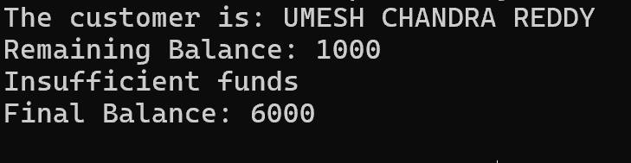

ERRORS:-

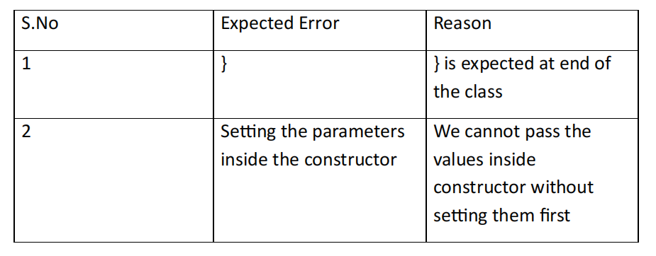CLASS:-

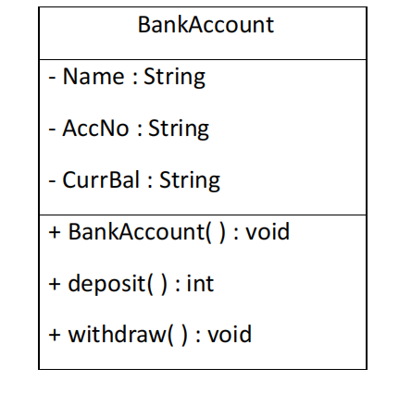

WEEK-4

1) Write a java program with class named “Book”. The class should contain various attributes such as “Title of the book , author , year of publication “. It should also contain a constructor with parameters details of the book. i.e. “ Title of the book, author and year of publication”. Display the details of two books by creating two objects.

**Code:**

import java.util.Scanner;

class book {

public String title;

public String author;

public int year;

book(String title, String author, int year) {

this.title = title;

this.author = author;

this.year = year;

}

public void display() {

System.out.println("Title of the book is: " + title);

System.out.println("Author of the book is: " + author);

System.out.println("Year of publishion of the book is: " + year);

}

public static void main(String[] args) {

Scanner scan = new Scanner(System.in);

System.out.println("Enter name of the book:");

String title = scan.nextLine();

System.out.println("Enter author of the book:");

String author = scan.nextLine();

System.out.println("Enter year of publishion of the book:");

int year = scan.nextInt();

book third = new book(title, author, year);

third.display();

book first = new book("The kill a mocking bird", "Harper Lee", 2005);

book second = new book("The alchemist", "Paulo Coelho", 1995);

first.display();

second.display();

}

}

OUTPUT:-

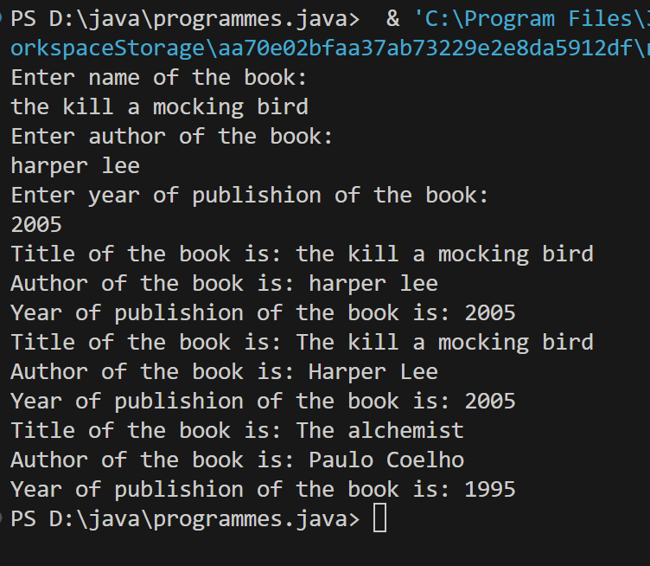

ERRORS:-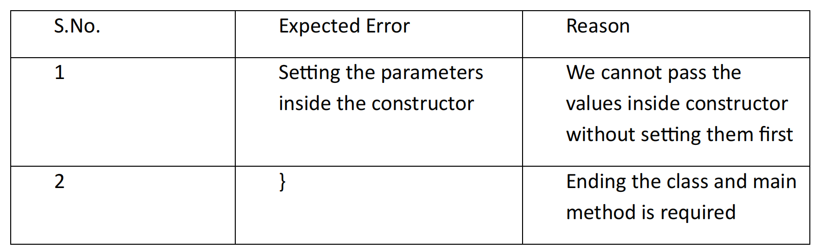

Class diagram:-

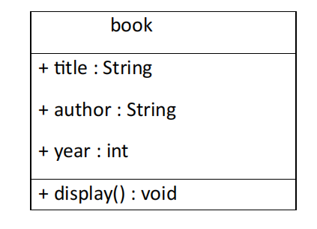

2) To create a java program with class named Myclass with a static

variable “Count” of “int type”, Initialized to 0 and a constant variable “pi” of type double initialized to 3.1415 as attributes of that class

Now, define a constructor for “Myclass” that increments the “Count”variable each that an object of Myclass is created. Finally ,print the final values of “Count” and “pi” variables.

**Code:**

class myclass {

static int count = 0;

final double pi = 3.1415;

myclass() {

count++;

}

void display() {

System.out.println("The value of pi is: " + pi);

}

public static void main(String[] args) {

myclass obj1 = new myclass();

myclass obj2 = new myclass();

myclass obj3 = new myclass();

int fc = count;

System.out.println("Total number of objects created is: " + fc);

obj1.display();

obj2.display();

obj3.display();

}

}

OUTPUT:-

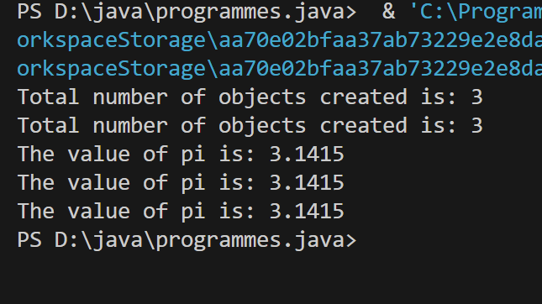

ERRORS:-

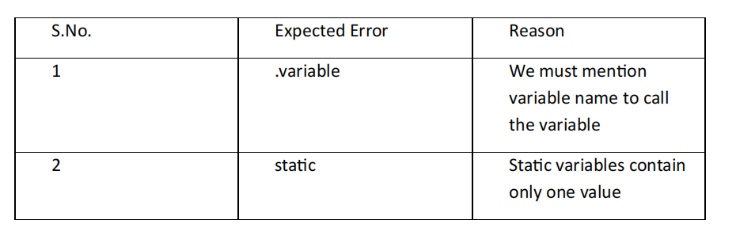

Class Diagram:

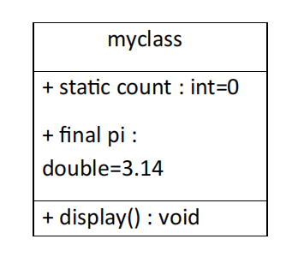

WEEK-5

1) Create a calc using the operations including add, sub, mul, div using multilevel inheritance and display the desired output.

CODE:-

class bcalc {

int a, b;

int sum, diff;

bcalc(int a, int b) {

this.a = a;

this.b = b;

}

public void add() {

diff = a - b;

sum = a + b;

System.out.println("Difference: " + diff);

System.out.println("Sum: " + sum);

}

}

class acalc extends bcalc {

int mul;

acalc(int a, int b) {

super(a, b);

}

public void mult() {

mul = a * b;

System.out.println("Multiplication: " + mul);

}

}

class aacalc extends acalc {

float div;

aacalc(int a, int b) {

super(a, b);

}

public void divi() {

if (b != 0) { // Check to avoid division by zero

div = (float) a / b;

System.out.println("Division: " + div);

} else {

System.out.println("Division by zero error!");

}

}

}

class ocalc {

public static void main(String[] args) {

aacalc c = new aacalc(10, 2);

c.divi();

c.mult();

c.add();

}

}

OUTPUT:-

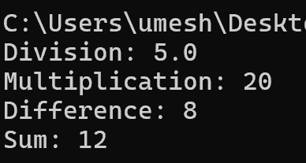

ERRORS:-

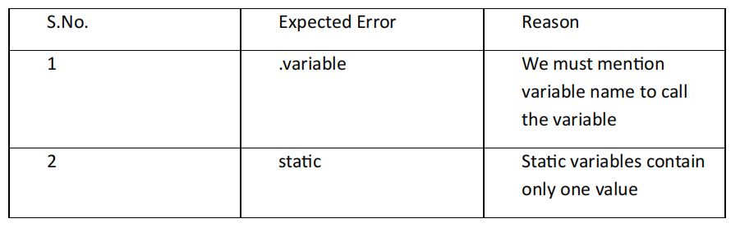CLASS DIAGRAM:-

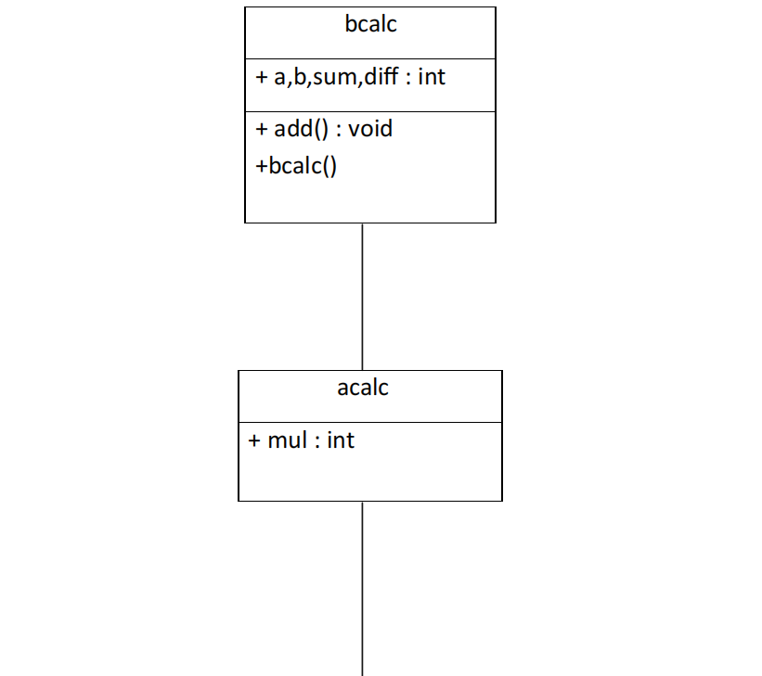

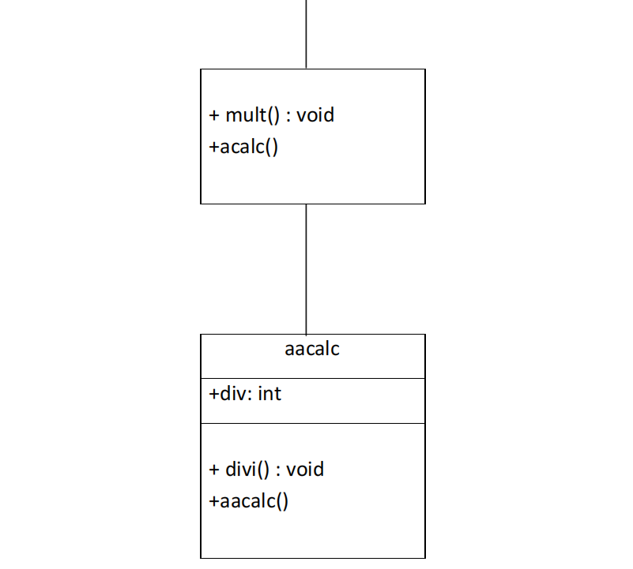

2) A vehicle rental company wants to develop a system that maintains information about different types of vehicles available for rent. The company rents out cars and bikes and they need a program to store details about each vehicle such as brand and speed cars should have an additional properties(attributes)- no.of doors , seating capacity bikes should have a property indicating whether they have gears or not the system should also include a function to display details about each vehicle and indicate when a vehicle is starting each class should have a constructor .

a) which oops concept is used in the above program ? Explain why it is useful in this scenario b)If the company decides to add a new type of vehicle truck how would u modify the above program

1) truck should include an additional property called capacity(in tons)

2)create a show truck details method() to display the trucks capacity

3)write a constructor for truck that initializes all the properties

c)Implement the truck class and update the main method to create the truck object and also create an object for car and bike subclass. Finally display its details

CODE:-

// Base class

class Vehicle {

String brand;

int speed;

Vehicle(String brand, int speed) {

this.brand = brand;

this.speed = speed;

}

void displayDetails() {

System.out.println("Brand: " + brand);

System.out.println("Speed: " + speed + " km/h");

}

void startVehicle() {

System.out.println(brand + " is starting...");

}

}

// Car subclass

class Car extends Vehicle {

int noOfDoors;

int seatingCapacity;

Car(String brand, int speed, int noOfDoors, int seatingCapacity) {

super(brand, speed);

this.noOfDoors = noOfDoors;

this.seatingCapacity = seatingCapacity;

}

@Override

void displayDetails() {

super.displayDetails();

System.out.println("Number of Doors: " + noOfDoors);

System.out.println("Seating Capacity: " + seatingCapacity);

}

}

// Bike subclass

class Bike extends Vehicle {

boolean hasGears;

Bike(String brand, int speed, boolean hasGears) {

super(brand, speed);

this.hasGears = hasGears;

}

@Override

void displayDetails() {

super.displayDetails();

System.out.println("Has Gears: " + (hasGears ? "Yes" : "No"));

}

}

// Truck subclass

class Truck extends Vehicle {

double capacity;

Truck(String brand, int speed, double capacity) {

super(brand, speed);

this.capacity = capacity;

}

void showTruckDetails() {

System.out.println("Truck Capacity: " + capacity + " tons");

}

@Override

void displayDetails() {

super.displayDetails();

showTruckDetails();

}

}

// Main class

public class VehicleRentalSystem {

public static void main(String[] args) {

Car car = new Car("audi", 158, 5, 3);

Bike bike = new Bike("tata", 520, true);

Truck truck = new Truck("benz", 100, 16.5);

System.out.println("Car Details:");

car.displayDetails();

car.startVehicle();

System.out.println();

System.out.println("Bike Details:");

bike.displayDetails();

bike.startVehicle();

System.out.println();

System.out.println("Truck Details:");

truck.displayDetails();

truck.startVehicle();

}}

OUTPUT:-

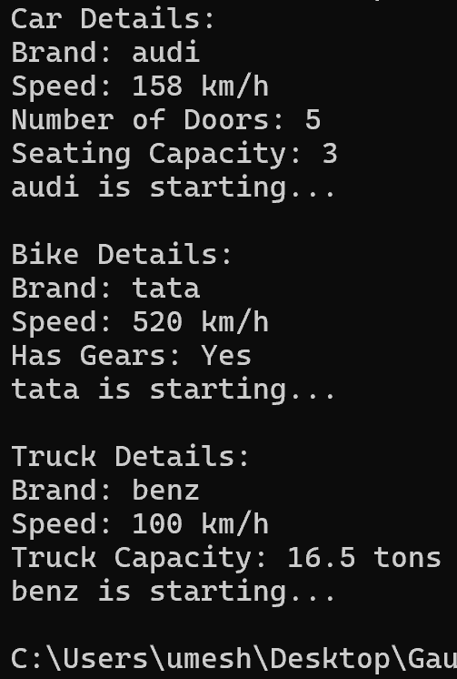

ERRORS:-

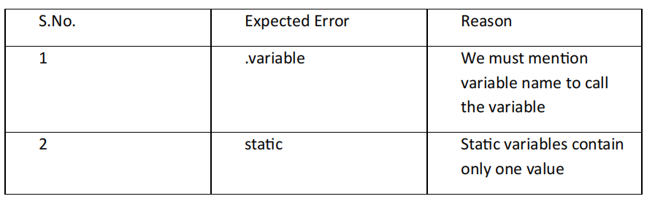CLASS DIAGRAM:_

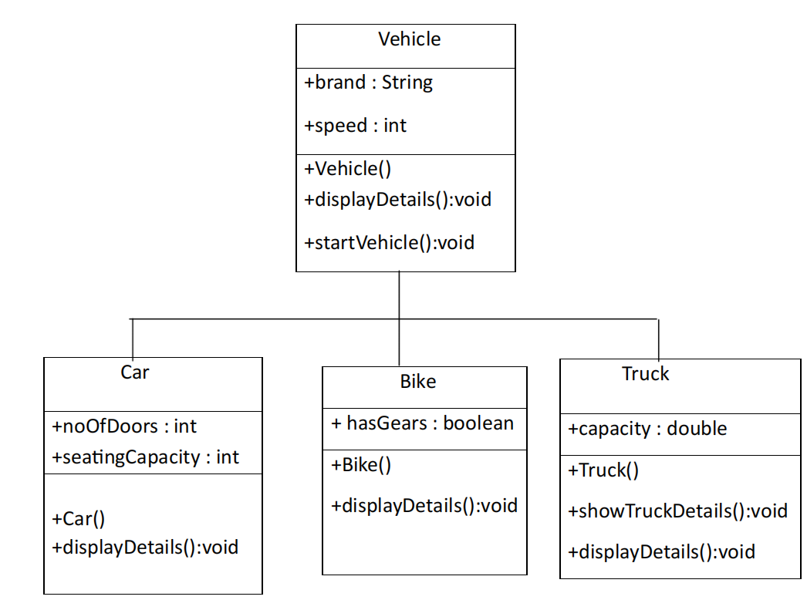

**WEEK-6**

1. Write a java program to create a Vehicle class with displayInfo() method overridden in Car subclass to provide info about carcompany , model , price,

seating and petrol.

CODE:-

class Vehicle{

public void displayInfo(String comp,String model,int price,int

seating,boolean petrol){

System.out.println("Details");

}

}

class car extends Vehicle{

public void displayInfo(String comp,String model,int price,int

seating,boolean petrol){

System.out.println("Car Details");

System.out.println("Car company:"+comp);

System.out.println("Car model:"+model);

System.out.println("Car seating:"+seating);

System.out.println("Car price:"+price);

System.out.println("Petrol:"+petrol);

}

}41

class maruti{

public static void main(String[] args){

car c=new car();

c.displayInfo("AUDI","200ec",2400000,8,true);

}

}

OUTPUT:-

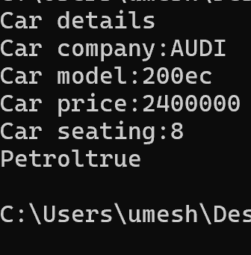

CLASS DIAGRAM:-

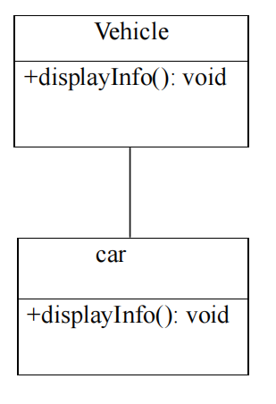

ERRORS:-

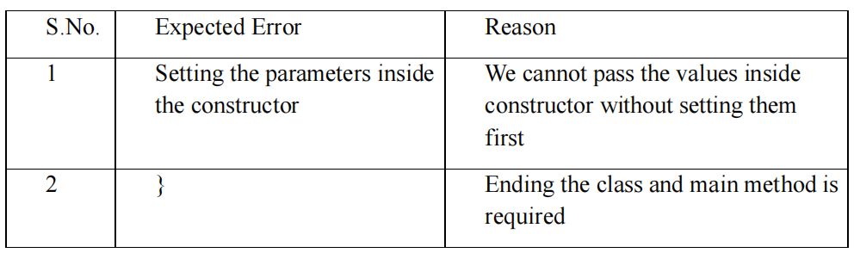

2. An automated admission system that verifies student eligibility for UG and PG with different criteria.

.UG requires minimum of 60%

.PG requires minimum of 70%

**CODE:**

class adm{

public void elg(float score){

System.out.println("Eligibility");

}

}

class ug extends adm{

public void elg(float score){

if(score>=60){

System.out.println("Eligible");

}

S.No.

Expected Error

Reason

1

Setting the parameters inside

the constructor

We cannot pass the values inside

constructor without setting them

first

2

}

Ending the class and main method is

required 43

else{

System.out.println("Not Eligible");

}

}

}

class pg extends adm{

public void elg(float score){

if(score>=70){

System.out.println("Eligible");

}

else{

System.out.println("Not Eligible");

}

}

}

class score{

public static void main(String[] args){

ug stu1=new ug();

pg stu2=new pg();

stu1.elg(89);

stu2.elg(70);

}

}

OUTPUT:-

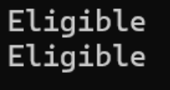

CLASS DIAGRAM:-

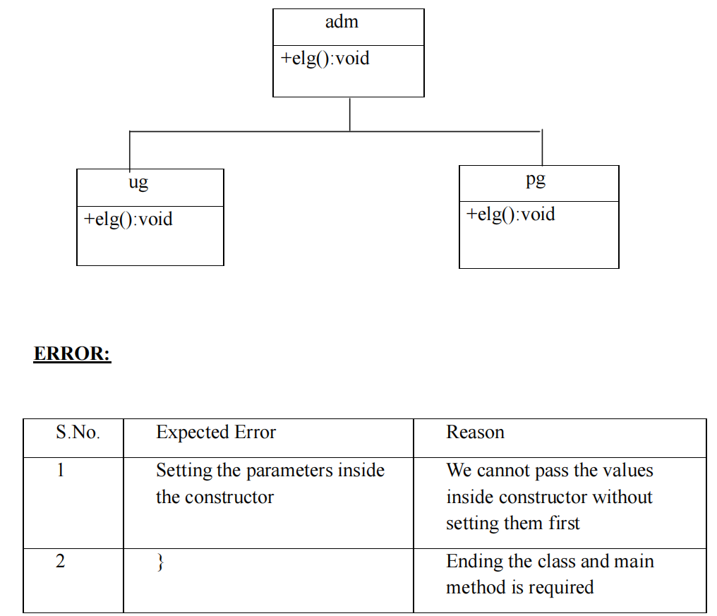

3.Create a calculator class with overloaded methods to perform additions

.add two integers

.add two double values

.add three integers

**CODE:**

class cal{

public int add(int a,int b){

return a+b;

}

public double add(double a, double b){

return a+b;

}

public int add(int a,int b,int c){

return a+b+c;

}

}

class ocal{

public static void main(String[] args){

cal c=new cal();

System.out.println(c.add(6,7));

System.out.println(c.add(5.5,7.7));

System.out.println(c.add(6,7,8));

}

}

OUTPUT:-

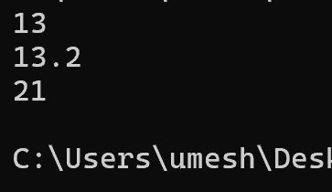

CLASS DIAGRAM:-

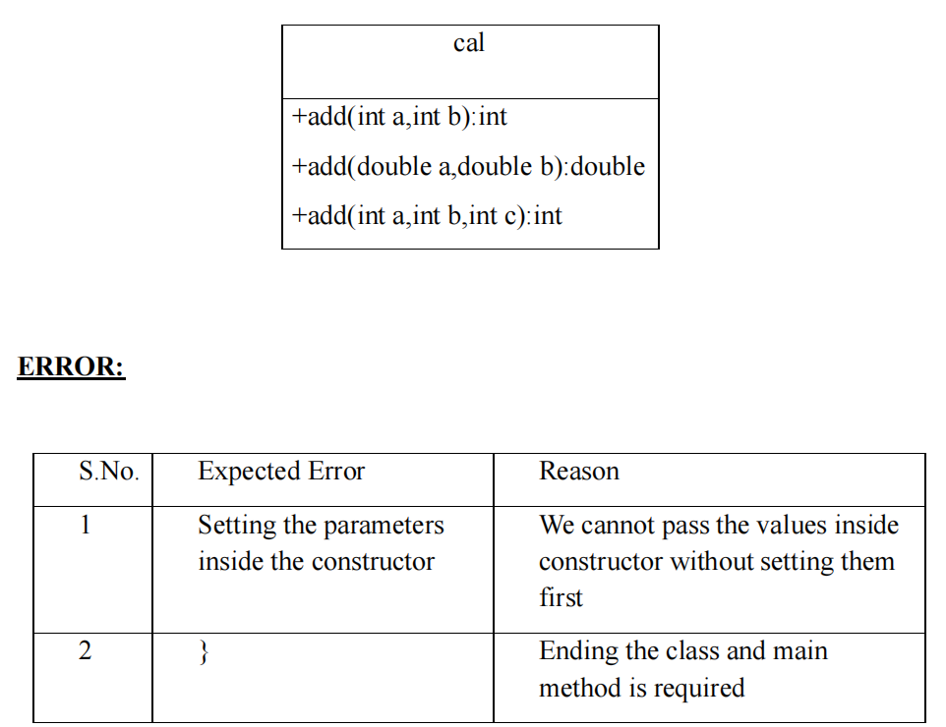

4. Create a shape class with method calculateArea() that is overloaded for different shapes (eg: square, rectangle).Then create a subclass Circle that overrides calculateArea() method for Circle.

**CODE:**

class shape{

public float calarea(float side){

return side*side;

}

public float calarea(float l,float b){

return l*b;

}

}

class circle extends shape{

public double calarea(double r){

return 3.14*r*r;

}

}

class s{

public static void main(String[] args){

circle c=new circle();

System.out.println(c.calarea(6));

}

}

OUTPUT:-

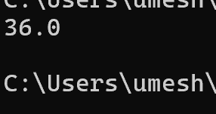

CLASS DIAGRAM:-

