**GUJARAT TECHNOLOGICAL UNIVERSITY**

Chandkheda, Ahmedabad

Affiliated





**BVM Engineering College**

A

Project Report

On

**Bluetooth based automatic door lock system**

Under subject of

DESIGN ENGINEERING – II-A

B. E. Semester – V

Electronics Engineering

Submitted by:

**Name of the student Enrollment No.**

1. Umesh Joshi 140070110023
2. Jaimin Puj 140070110022
3. Aditya Pitale 140070110002

Prof. Anita Bhatt  Dr. T.D. Pawar

(Faculty Guide)   (Head of the department)

Academic Year

(2016-2017)

**BVM Engineering College**

**VALLABH VIDYANAGAR**

**BVM ENGINEERING COLLEGE**

**VALLABH VIDYANAGAR**

**DEPARTMENT OF ELECTRONICS ENGINEERING**



**CERTIFICATE**

This is to certify that the design engineering canvases entitled “BLUETOOTH CONTROLED DOOR LOCK SYSTEM” has been carried out by Umesh Joshi (140070110023), Jaimin Puj (140070110022), Aditya Pitale (140070110002) under my guidance and supervision for the award of Degree of Bachelor of Engineering in Electronics Engineering (Semester-V) at BVM Engineering College, VallabhVidyanagar during the academic year 2016-17.

Date:

Guide: Head of Department:

PROF. ANITA BHATT DR. TANMAY PAWAR

ELECTRONICS Department, ELECTRONICS Department,

BVM. BVM.

**INDEX**

1. Introduction
2. Canvas
3. Feedback Analysis
4. Summary of Reaserch Paper
5. Summary of Design Thinking
6. Rough Prototype/ Schematic Plan

**ACKNOWLEDGMENT**

I have taken efforts in this project. However, it would not have been possible without the kind support and help of many individuals and organizations. I would like to extend my sincere thanks to all of them.

I am highly indebted to Anita Bhatt for their guidance and constant supervision as well as for providing necessary information regarding the project & also for their support in completing the project.

I would like to express my gratitude towards my parents & member of **BVM Enginineering College** for their kind co-operation and encouragement which help me in completion of this project.

I would like to express my special gratitude and thanks to industry persons for giving me such attention and time.

My thanks and appreciations also go to my colleague in developing the project and people who have willingly helped me out with their abilities.

**Chapter:1 INTRODUCTION**

**TEAM NAME: KWIK LOCK**

**TEAM MEMBERS:**

1. UMESH JOSHI

2. JAIMIN PUJ

3. ADITYA PITALE

**FACULTY GUIDE & MENTOR**

**PROF. ANITA BHATT**

**INTRODUCTION TO DOMAIN:-**

Our main goal is to create a framework between physical object and digital object by creating a server which will connect our home security system to a virtual world.

By creating an android based application which will connect to our locking system through serial port protocol based Bluetooth.

The Java development kit is used to create a interface between lock and android phone.

Android studio is the development program for our user interface. The microcontroller used to control door lock is Arduino Uno (ATMEGA 328p-pu).

The mechanism which is used to control movement of door lock is Servo Motor and L2LM329 is used to control current flow of Servo Motor.

A password will be set through the Android application through Bluetooth model HC-05.If the password will match, the control of the lock will be given to the user. If the password won’t match then access will be denied.

After matching the password, two functions will be provided to the user, which are, open door and close door. By using these virtual functions user will be able to rotate the motor.

A DC stepper motor will be used for the same purpose. When the user will use the open door function, the movement of the stepper motor will be 15 degrees clockwise and 15 degree anticlockwise when closed door function is used.

A 12 V battery will be used to drive the motor shaft. In case of emergencies, an extra set of keys will be provided to the user.

**Chapter:2 Canvas**

**AEIOU SHEET:**

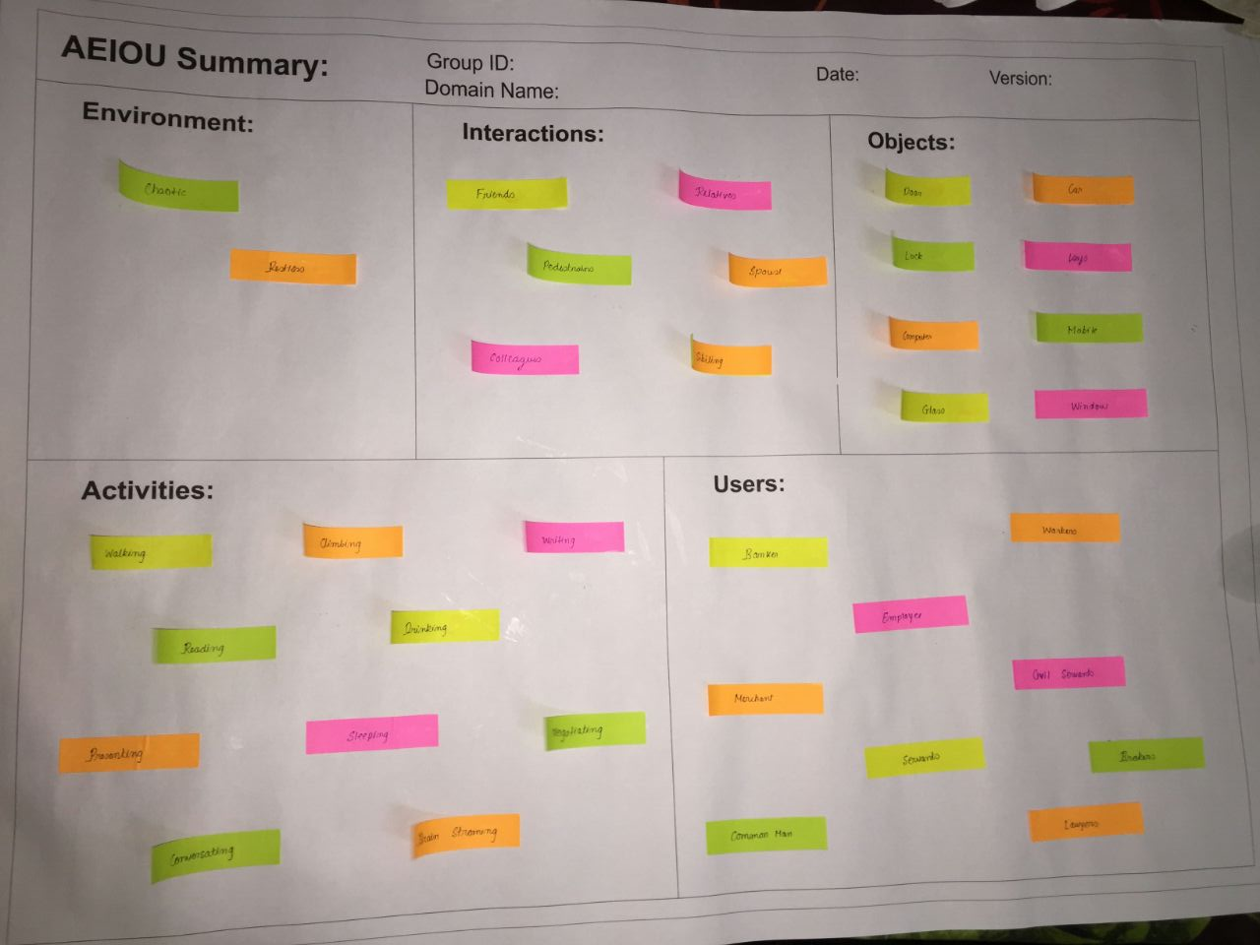

**EMPATH**Y **MAPPING:**

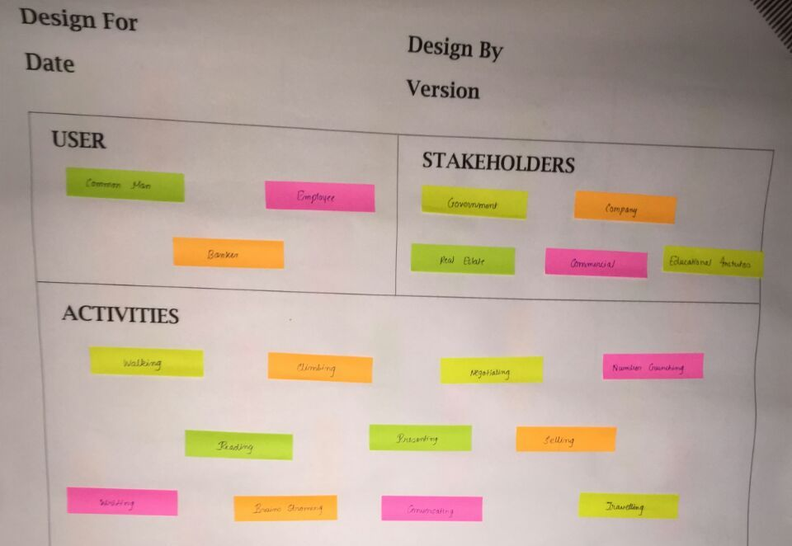

**IDEATION CANVAS:**

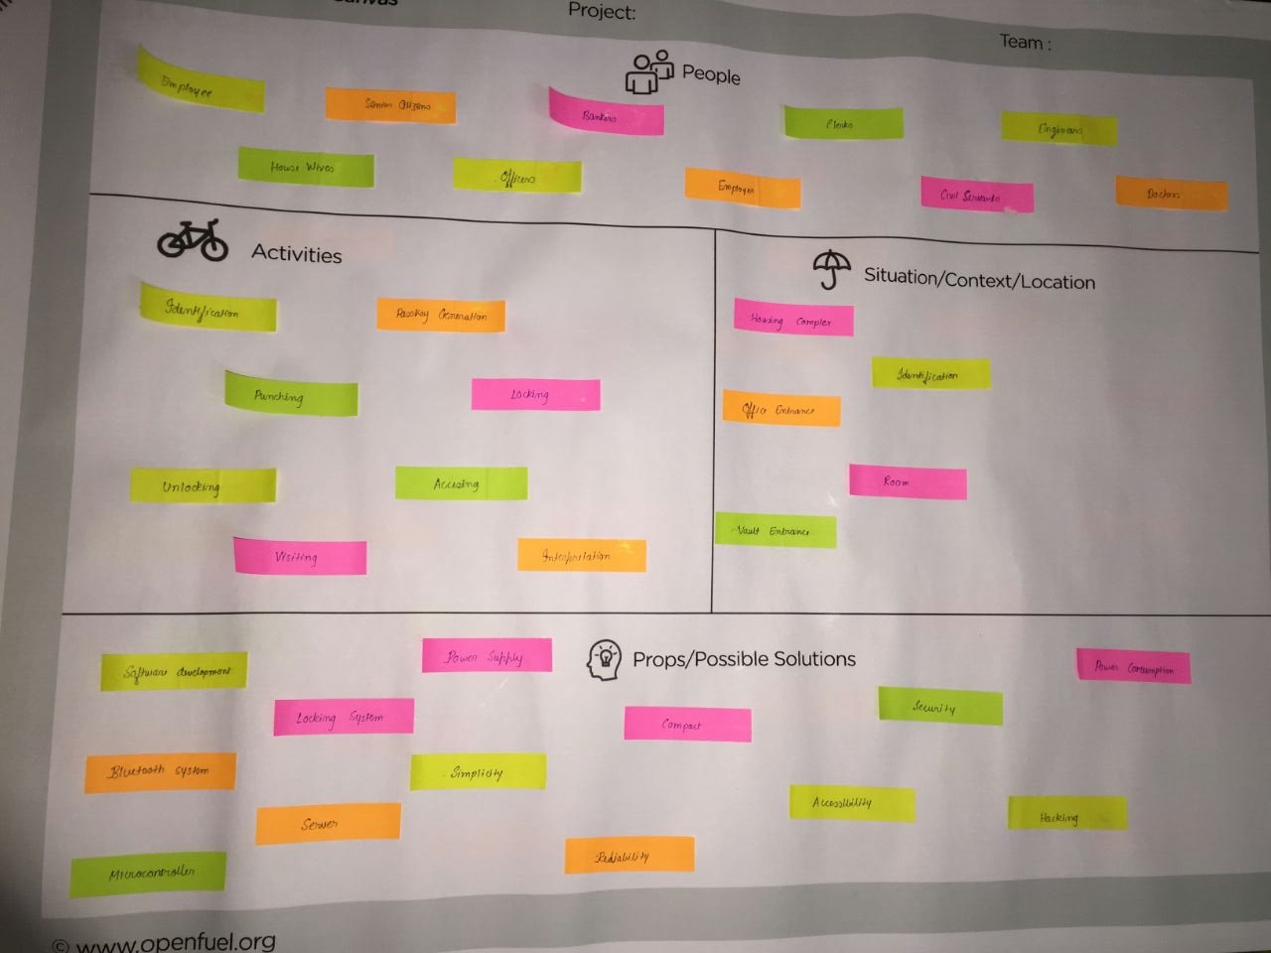

**PRODUCT DEVELOPMENT CANVAS:**

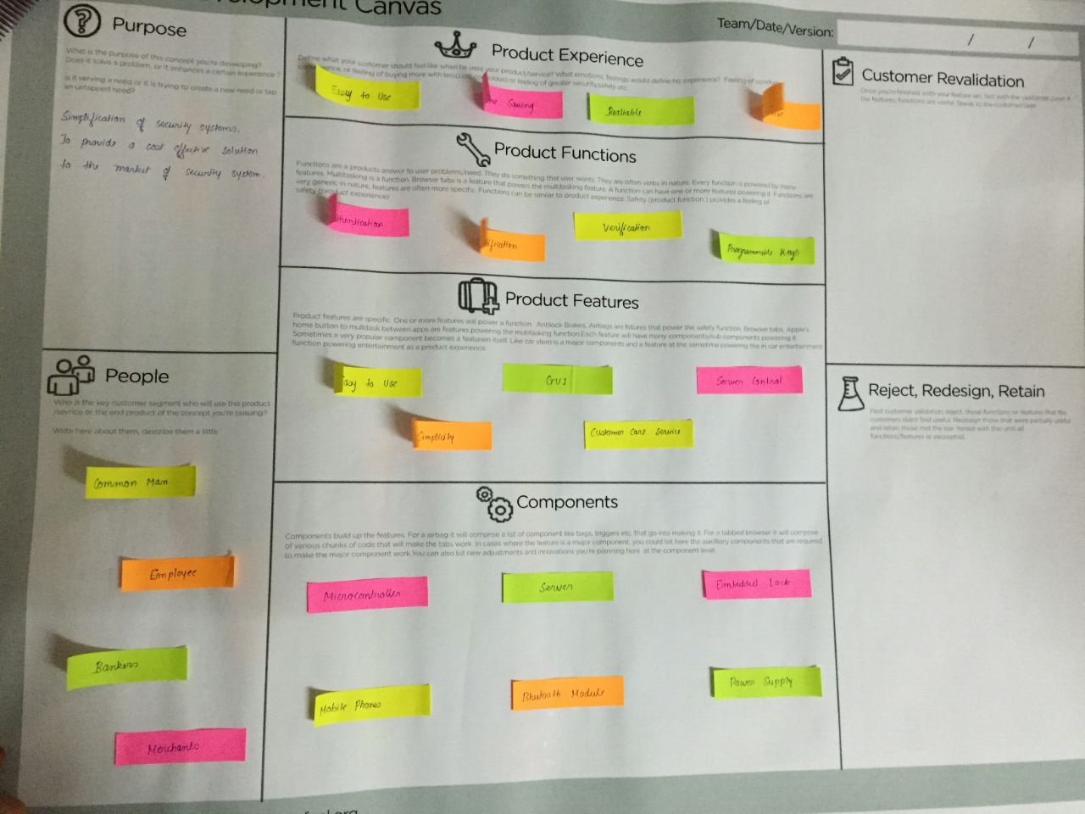

**Chapter:3 Feedback Analysis**

To ensure that we get an honest opinion about the credibility of product, we decided for some feedbacks on our product. For that we decided to visit one of the finest Biometric Security Systems in Vadodara , TIME SECURITY SYSTEMS.

The owner, MR. Tushar Joshi, a respected security consultant in the security field gave his thoughtful insight of the product.A wonderful critic and an equally capable guide, he gave his approval our product stating the Cost effectiveness and the compactness as our USP.

However , he does believe much can be worked upon to increase the efficiency and stability of our systems so that it is ready for the market and we ensure to work upon it.

**Kwik Lock:** kwik lock is a home automation system. It can also be used in the industry and offices. Our system provides revolutionary idea for the locking system which we are using from hundreds of years. Our system is basically designed on the idea of digital lock access system. Our system works on the phenomena of Bluetooth system. What we are thinking is providing a application to customer so he can lock and unlock the lock without using keys. We are sure that this will increase reliability. Now he can easily connect with many locks without using many keys but just using one mobile

**Chapter:4 Summary of Reaserch Papers**

**LITERATURE REVIEW:-**

**PAPER 1:-**

**DOOR-AUTOMATION SYSTEM USING BLUETOOTH-BASED ANDROID FOR MOBILE PHONE**

**AUTHORS:_ Lia Kamelia, Alfin Noorhassan S.R, Mada Sanjaya and W.S., Edi Mulyana Sunan Gunung Djati**

**ABSTRACT:-** Smart Home is the term commonly used to define a residence that uses a home controller to integrate the residence's various home automation systems. The most popular home controllers are those that are connected to a Windows based PC. In our research we presented a part of smart home technology which using Bluetooth in a mobile device, so it will more easy and efficient to use. It also based on Android and Arduino platform both of which are free open source software. In this paper, a system called door locks automation system using Bluetooth-based Android Smartphone is proposed and prototyped. First the hardware design and software development are described, then the design of a Bluetooth-based Smartphone application for lock/unlock the door are presented. The hardware design for door-lock system is the combination of android smart phone as the task master, Bluetooth module as command agent, Arduinomicrocontroller as controller center / data processing center, and solenoid as door lock output. All of the tests indicate that all goes according to the initial design of this research.

**PAPER 2:-**

**AUTOMATIC DOOR LOCK SYSTEM**

**AUTHORS:-Neelam Majgaonkar, Ruhina Hodekar, Priyanka Bandagale.**

**Abstract -** Our main objective is to utilize the different electronic parts available in the market and build an integrated home security system by using Bluetooth device and Microcontroller technology. This system gives service at low cost compared to the cost of the available security system. We want to make a system that will give 24 into 7 service By using registered password in this system we can unlock the door by which it increases the security level to prevent an unauthorized unlocking. If the user forgets the combination of password this system gives the flexibility to the user to change or reset the password. Security measure is very high as provided in two ways. First we have to enter password for blue-tooth connection and second is for unlocking the door in application. Both passwords can be changed as and when required. This automatic password based lock system will give user more secure and low cost way of locking-unlocking system.

**Index Terms -**Microcontroller, Stepper motor, Bluetooth device, Password.

**PAPER 3:-**

**SMART LOCK: A LOCKING SYSTEM USING BLUETOOTH TECHNOLOGY & CAMERA VERIFICATION**

**AUTHORS:-Bhalekar Pandurang, Jamgaonkar Dhanesh, Prof. Mrs. Shailaja Pede, Ghangale Akshay, Garge Rahul**

**Abstract:-**

The new generation is now full of smart people using smart technology. Smart devices makes life of a person easy and updated. There are hundreds of goods available today that allow us have power over the devices without human intervention, either by remote control; or even by voice command. So in ”Smart Lock” an ARM7 controller and Bluetooth module from the mobile device is used for smart lock system. The proposed system describes improvement of a security system that is integrated with an Android mobile phone device using Bluetooth as a wireless connection protocol. Android OS is currently the go ahead on mobile market share while Symbian OS was already discontinued. This proposed system allows a user to lock or unlock a door a short range from the door. The application was designed to allow the user to also check the status of the door. The mobile device requires a password to increase the security of the system. The hardware on the door uses a microcontroller to control a linear actuator that acts as the locking mechanism. The Bluetooth protocol was chosen as a communication method because it is already integrated into many Android devices and is secured through the protocol itself. It also fits well into the design requirements of the project for a short range, wireless connection method. The system is designed such that the motion of the user will be captured from the camera and the user will be detected and then only he will be given a key to lock or unlock. The system will be designed for security purposes. It will work as when bell rings at the door, it will act as a trigger to the camera and the camera will capture the video of the person standing in front of the door, that will be shown to the registered user who is away from home and then he will identify the person and can share the key with that person for a particular time period. This increases great security for homes and that too without human intervention. Keywords: Automation, ARM7 controller, bluetooth model, dc motors, camera.

**PAPER 4:-**

**OPTIMIZED LOCKING AND UNLOCKING A SYSTEM USING ARDUINO**

**AUTHORS:-Sedhumadhavan. , Saraladevi.**

**Abstract**: Smart Home Automation System playing a major role which helps in reducing a work by using some technologies. The proposed work is to send a signal to door from a Tablet or mobile devices by using wireless system. This allows the user to lock and unlock a door from inside or outside a house with a Wi-Fi range available. The ideal purpose of the work is, if the door is not locked in First floor or in any other floor, the user from ground floor they can open the door or unlock the door from mobile phone or Laptop, which makes a person to reduce its energy or save time. The major components of the system are Latest Arduino Board, Servo Motor and Wi-Fi (IEEE 802.11b/g/n) standard protocol for wireless communication which combines and forms an activity. The open source Software and Hardware with embedded device is used to give a complete task.

KEYWORDS: Arduino Uno Board, Servo Motor, Wi-Fi.

**PAPER 5:-**

**ANDROID-BASED HOME DOOR LOCKS APPLICATION VIA BLUETOOTH FOR DISABLED PEOPLE**

**AUTHORS:-N.H. Ismail, Zarina Tukiran,N.N. Shamsuddin.**

**Abstract**— This paper discusses about an ongoing project that serves the needs of people with physical disabilities at home. It uses the Bluetooth technology to establish communication between user’s Smartphone and controller board. The prototype support manual controlling and microcontroller controlling to lock and unlock home door. By connecting the circuit with a relay board and connection to the Arduino controller board it can be controlled by a Bluetooth available to provide remote access from tablet or smartphone. This paper addresses the development and the functionality of the Android-based application (Android app) to assist disabled people gain control of their living area.

Index Terms— Bluetooth, Arduino controller

**PAPER 6:-**

**SMART LIVING USING BLUETOOTH- BASED ANDROID SMARTPHONE**

**AUTHORS:- Ming Yan and Hao Shi**

**Abstract:-**

With the development of modern technology and Android Smartphone, Smart Living is gradually changing people’s life. Bluetooth technology, which aims to exchange data wirelessly in a short distance using short-wavelength radio transmissions, is providing a necessary technology to create convenience, intelligence and controllability. In this paper, a new Smart Living system called home lighting control system using Bluetooth-based Android Smartphone is proposed and prototyped. First Smartphone, Smart Living and Bluetooth technology are reviewed. Second the system architecture, communication protocol and hardware design are described. Then the design of a Bluetooth-based Smartphone application and the prototype are presented. It is shown that Android Smartphone can provide a platform to implement Bluetooth-based application for Smart Living.

**Chapter:6 DESIGN THINKING**

Design Thinking is a methodology used by designers to solve complex problems, and find desirable solutions for clients. Design Thinking draws upon logic, imagination, intuition, and systemic reasoning, to explore possibilities of what could be, and to create desired outcomes that benefit the end user (the customer). A design mind-set is not problem-focused; its solution focused, and action oriented. It involves both analysis and imagination.

**IMPORTANCE AND SOCIO-ECONOMIC RELEVANCE OF DESIGN THINKING**

It is used in technical systems, educational system, aesthetic system, social system, theories, models etc. It is an efficient way to cope up with new demands and existing problems in the society.

**LEARNING TOOLS**

Prior research, Analogy, Group discussion, Role playing, Art factual, Interaction, Interview

**TEAM BUILDING AND LOG BOOK EXERCISES**

We decided our team of three members based on mutual trust and everyone’s area of expertise.

We started our log book to keep a reference about project learning and results which may become necessary to provide a history of the design, monitor and control where we invest our time, learn and apply the best practices for our profession,regularly take time to learn from successes and failures

These are the things we noted down:

Customer needs or requirements, project objectives, meeting notes..

**ROUGH PROTOTYPE:**

**Description:**

The idea of this project is to comfort a person’s life by just simply changing the tedious need to carry a bunch of keys to a User Interface system which is very handy in nowadays. The android cell phone is the main aspect of our project. It is the device which will decide to let a person should be able to access the door lock. The system which is used to establish a connection between this is Bluetooth.

Many versions of Bluetooth are available. We are using Bluetooth LTE 4.1. This version of Bluetooth is very efficient in application where the connection between two entities is just apart few meters. It is also very efficient and power saving.

The tool or platform which we used to generate our android application is Android Studio.

**Tool Description**

Arduino Uno

Arduino is an open-source project that created microcontroller-based kits for building digital service and interactive objects that can sense and control physical devices. This system provides sets of digital and analogue I/O pins that can interface to various expansion board.

Key features of Arduino Uno

-An Open source design.

-An easy USB interface.

-Very convenient power management and built-in voltage regulation.

-An easy-to-find microcontroller brain.

-A 16mHz clock.

HC-05 Bluetooth module

HC-05 module is an easy to use Bluetooth SPP (Serial Port Protocol) module, designed for transparent wireless serial connection setup. It can be used in a Master or Slave configuration, making it a great solution for wireless communication.

Features of HC-05

-3.3 to 5 V I/O.

-Typical -80dBm sensitivity.

-Auto connect to the last device on power as default.

-Auto pairing PINCODE: “ 1234 “ as default

Android Studio

Android Studio is the official integrated development environment(IDE) for Android platform development.

Features of Android Studio:

-Instant Run

-Intelligent code editor

-Fast and feature-rich emulator

-Robust and flexible build system

-Designed for systems

-Optimized for all Android devices

**Specification:**

**Project Schematic:**

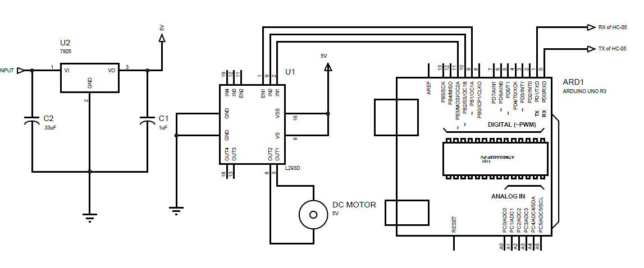

**Proteus View:**

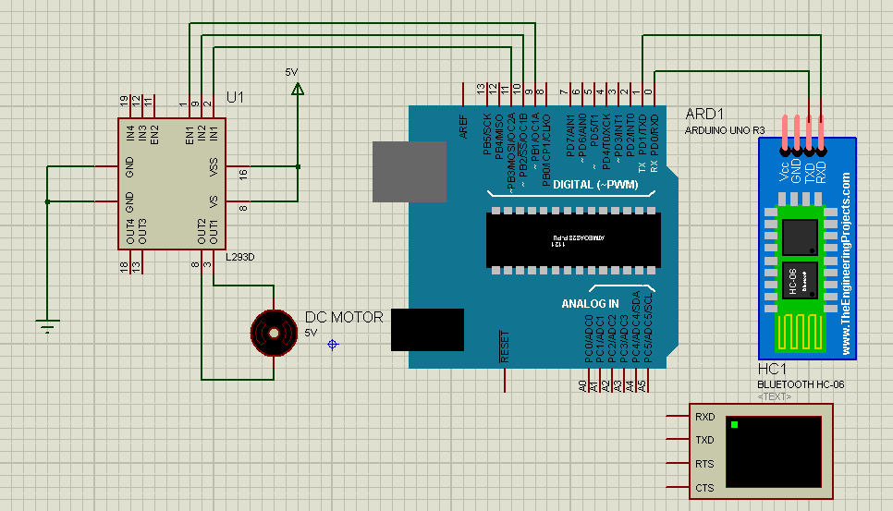

**Android Application:**

In order to make it more user friendly we developed a application on Java platform. The software which we used to connect all layers of our application is Android Studio which is a product of Google Inc.

You can download our application by accessing below link

<https://drive.google.com/open?id=0BxMvqtjxpXVFRnhTU2Z5bXBsT00>

**Arduino Code:**

We are using Arduino Uno Microcontroller. So we have written a program that will control our door. First it will compare the password entered by the User and it will decide to grant or deny the permission to access. It has two functions which are Opendoor and Closedoor.

You can download Arduino code by accessing below link.

<https://drive.google.com/open?id=0BxMvqtjxpXVFOGNBX0s4UC1kOTA>

You can also download schematic from below link.

<https://drive.google.com/open?id=0BxMvqtjxpXVFbUQ2SWltRF9PTms>

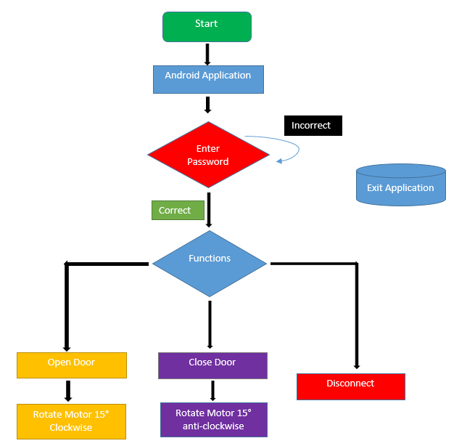

**Motor Mechanism:**

We are going to use a servo motor to control our door lock. We will modify it in a manner that it will only rotate only 15 degrees either clockwise or anti-clockwise. The image of our motor which is assembled on a CD Drive mechanism which is used to drive the lock is shown in below figure.

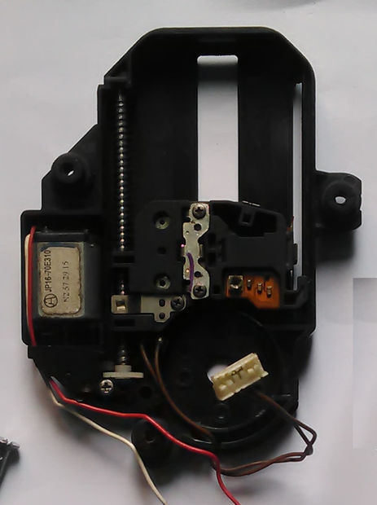

**Android Application Layouts:**

