# Create a Maven Project in STS

1. Open STS
2. Select File 🡪new🡪maven project

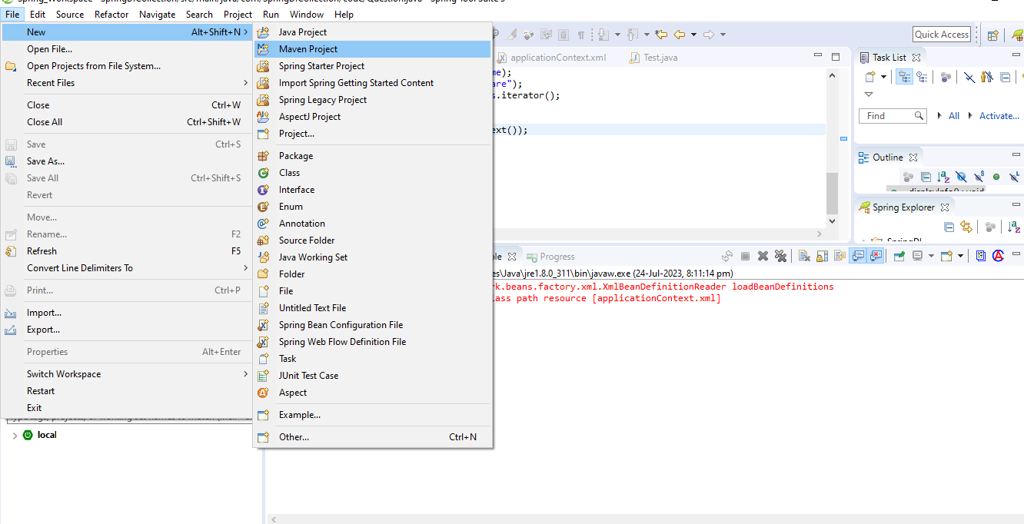

1. You will get below screen then please tick on the **Create Simple Project**

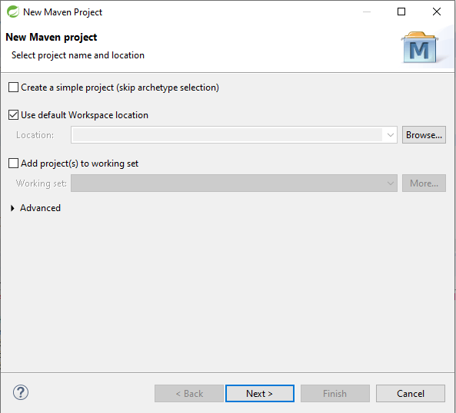

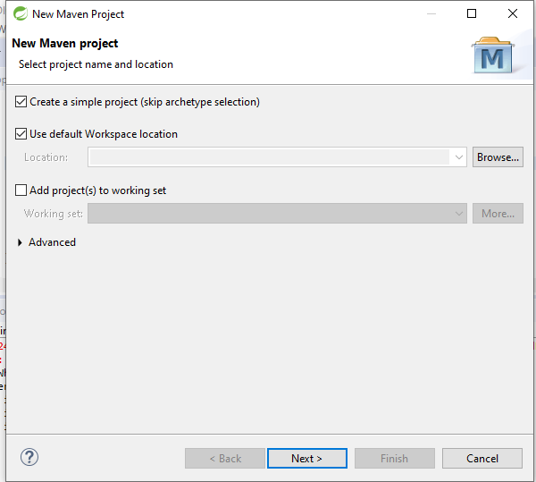

1. Give group id and artifact id and click on finish

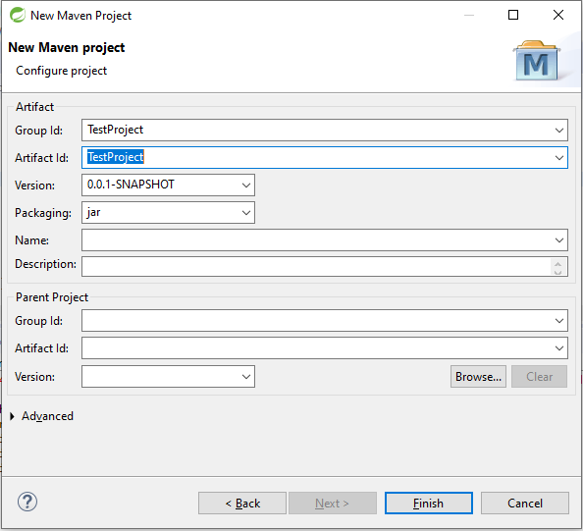

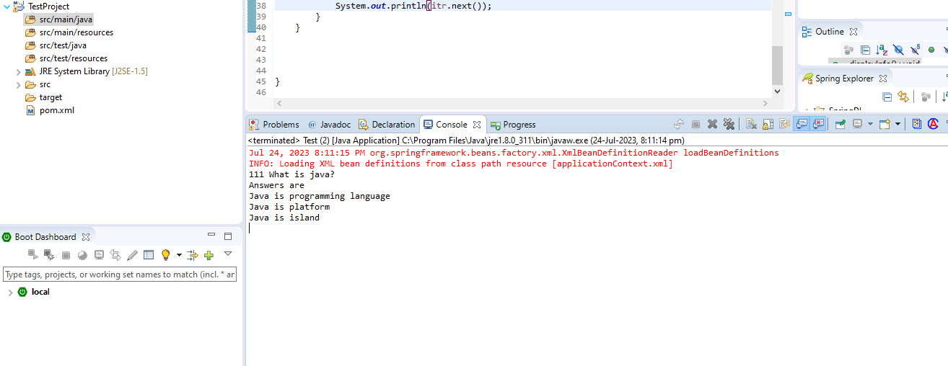

1. Create package in project

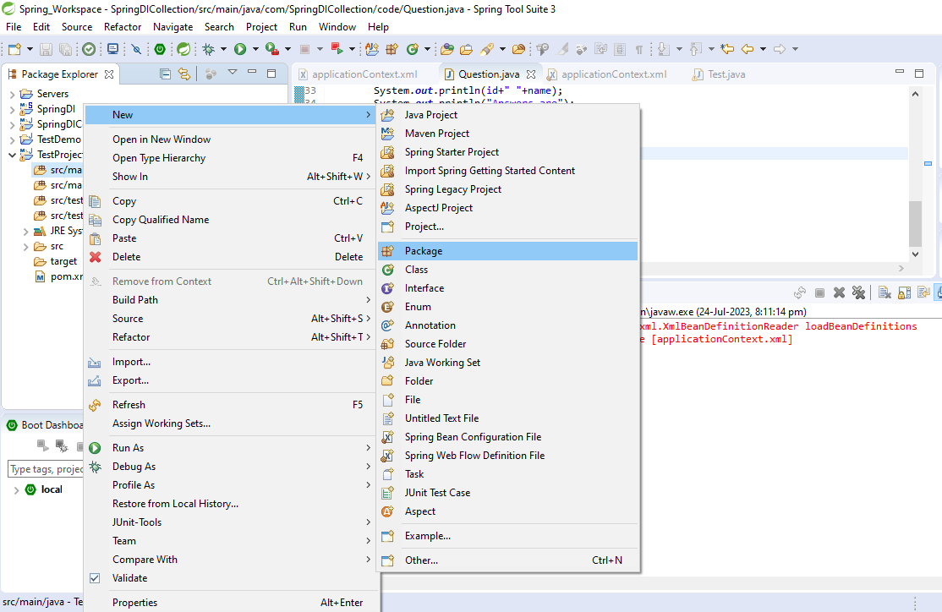

1. Create applicationContext.xml OR any file in the properties folder

