***TARGET CASE STUDY - using big query setup***

1. **Import the dataset and do usual exploratory analysis steps like checking the structure & characteristics of the dataset:**

***1.1 Data type of all columns in the "customers" table.***

***ANSWER :***

SELECT column_name, data_type

FROM`scaler-dsml-sql-407614.TargetSQL.INFORMATION_SCHEMA.COLUMNS`

WHERE table_name= "customers"

**SNAP :**

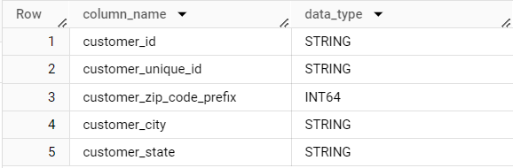

**1.2 Get the time range between which the orders were placed.**

**ANSWER :**

SELECT MIN(order_purchase_timestamp),

MAX(order_purchase_timestamp)

FROM`scaler-dsml-sql-407614.TargetSQL.orders`

**SNAP :**



**1.3 Count the Cities & States of customers who ordered during the given period.**

**ANSWER :**

SELECT COUNT(c.customer_city) AS count_city,

COUNT(c.customer_state) AS count_state

FROM`scaler-dsml-sql-407614.TargetSQL.orders`AS o

JOIN`scaler-dsml-sql-407614.TargetSQL.customers`AS c

ON o.customer_id = c.customer_id

**SNAP :**

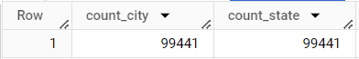

**2. In-depth Exploration:**

**2.1 Is there a growing trend in the no. of orders placed over the past years?**

**ANSWER :**

SELECT

EXTRACT(Month FROM o.order_purchase_timestamp)AS Month,

EXTRACT(Year FROM o.order_purchase_timestamp)AS Year,

COUNT(DISTINCT o.order_id) AS order_count

FROM`scaler-dsml-sql-407614.TargetSQL.orders`AS o

JOIN`scaler-dsml-sql-407614.TargetSQL.customers`AS c

ON o.customer_id = c.customer_id

GROUP BY Month, Year

ORDER BY Year, Month;

**SNAP :**

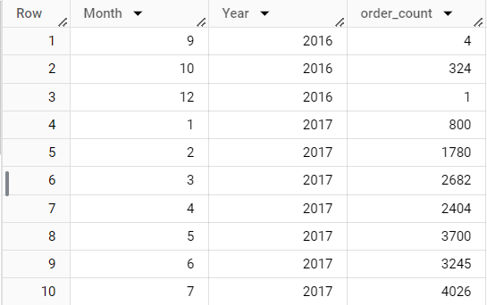

**2.2 Is there a growing trend in the no. of orders placed over the past years?**

**ANSWER :**

SELECT

EXTRACT(Month FROM order_purchase_timestamp)AS Month,

COUNT(DISTINCT order_id) AS order_count

FROM`scaler-dsml-sql-407614.TargetSQL.orders`

GROUP BY Month

ORDER BY Month;

**SNAP :**

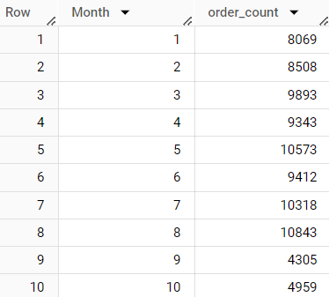

**2.3 During what time of the day, do the Brazilian customers mostly place their orders? (Dawn, Morning, Afternoon or Night)**

* + - **0-6 hrs : Dawn**
    - **7-12 hrs : Mornings**
    - **13-18 hrs : Afternoon**
    - **19-23 hrs : Night**

**ANSWER :**

SELECT

CASE

WHEN EXTRACT(Hour FROM o.order_purchase_timestamp)BETWEEN 0 AND 5 THEN 'Dawn'

WHEN EXTRACT(Hour FROM o.order_purchase_timestamp)BETWEEN 6 AND 11 THEN 'Morning'

WHEN EXTRACT(Hour FROM o.order_purchase_timestamp)BETWEEN 12 AND 17 THEN 'Afternoon'

WHEN EXTRACT(Hour FROM o.order_purchase_timestamp)BETWEEN 18 AND 23 THEN 'Night'

END AS Hour,

COUNT(o.order_id)AS order_count

FROM`scaler-dsml-sql-407614.TargetSQL.orders`AS o

JOIN`scaler-dsml-sql-407614.TargetSQL.customers`AS c

ON o.customer_id = c.customer_id

GROUP BY Hour

ORDER BY order_count DESC;

**SNAP :**

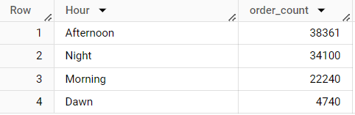

**3.Evolution of E-commerce orders in the Brazil region:**

**3.1 Get the month on month no. of orders placed in each state.**

**ANSWER :**

SELECT

c.customer_state,

EXTRACT(Month FROM o.order_purchase_timestamp)AS Month,

COUNT(o.order_purchase_timestamp)AS order_count

FROM`scaler-dsml-sql-407614.TargetSQL.orders`AS o

JOIN`scaler-dsml-sql-407614.TargetSQL.customers`AS c

ON o.customer_id = c.customer_id

GROUP BY c.customer_state, Month

ORDER BY c.customer_state, Month

**SNAP :**

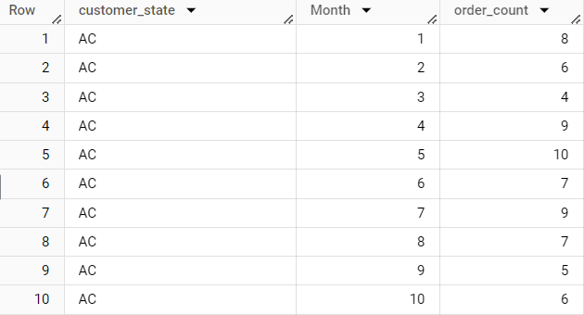

**3.2 How are the customers distributed across all the states?**

**ANSWER :**

SELECT

customer_state,

COUNT(customer_id) AS no_of_customers

FROM`scaler-dsml-sql-407614.TargetSQL.customers`

GROUP BY customer_state

ORDER BY customer_state;

**SNAP :**

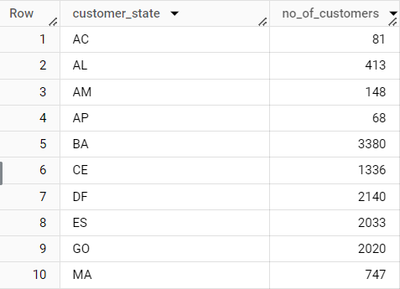

**4.Impact on Economy: Analyze the money movement by e-commerce by looking at order prices, freight and others.**

**4.1 Get the % increase in the cost of orders from year 2017 to 2018 (include months between Jan to Aug only).**

**You can use the "payment_value" column in the payments table to get the cost of orders.**

**ANSWER :**

SELECT

EXTRACT(MONTH FROM o.order_purchase_timestamp) AS month,

((SUM(CASE

WHEN EXTRACT(YEAR FROM o.order_purchase_timestamp)= 2018

AND

EXTRACT(MONTH FROM o.order_purchase_timestamp) BETWEEN 1 AND 8

THEN p.payment_value END)

-

SUM(CASE

WHEN EXTRACT(YEAR FROM o.order_purchase_timestamp)= 2017

AND

EXTRACT(MONTH FROM o.order_purchase_timestamp) BETWEEN 1 AND 8

THEN p.payment_value END))/

SUM(CASE WHEN EXTRACT(YEAR FROM o.order_purchase_timestamp)= 2017 AND

EXTRACT(MONTH FROM o.order_purchase_timestamp) BETWEEN 1 AND 8

THEN p.payment_value END)) * 100 AS percent_increase

FROM`scaler-dsml-sql-407614.TargetSQL.orders`AS o

JOIN`scaler-dsml-sql-407614.TargetSQL.payments`AS p

ON o.order_id = p.order_id

WHERE

EXTRACT(YEAR FROM o.order_purchase_timestamp)IN(2017, 2018)AND

EXTRACT(MONTH FROM o.order_purchase_timestamp)BETWEEN 1 AND 8

GROUP BY month

ORDER BY month;

**SNAP :**

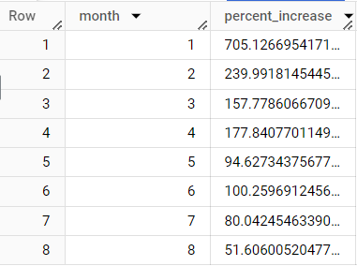

**4.2Calculate the Total & Average value of order price for each state. and**

**4.3Calculate the Total & Average value of order freight for each state.**

**ANSWER :**

SELECT

c.customer_state,

ROUND(AVG(i.price),2) AS mean_price,

ROUND(SUM(i.price),2) AS total_price,

ROUND(AVG(i.freight_value),2) AS mean_freight_value,

ROUND(SUM(i.freight_value),2) AS total_freight_value

FROM`scaler-dsml-sql-407614.TargetSQL.orders`AS o

JOIN`scaler-dsml-sql-407614.TargetSQL.order_items`AS i

ON o.order_id = i.order_id

JOIN`scaler-dsml-sql-407614.TargetSQL.customers`AS c

ON o.customer_id = c.customer_id

GROUP BY c.customer_state

**SNAP :**

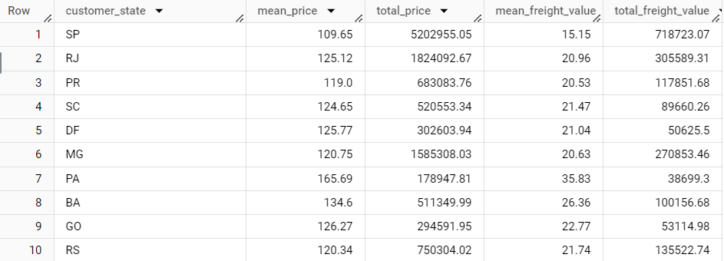

**5.Analysis based on sales, freight and delivery time.**

***5.1 Find the no. of days taken to deliver each order from the order’s purchase date as delivery time.  
Also, calculate the difference (in days) between the estimated & actual delivery date of an order.  
Do this in a single query.  
You can calculate the delivery time and the difference between the estimated & actual delivery date using the given formula:***

* + - ***time_to_deliver = order_delivered_customer_date - order_purchase_timestamp***
    - ***diff_estimated_delivery = order_delivered_customer_date - order_estimated_delivery_date***

**ANSWER :**

***SELECT***

***order_id,***

***DATE_DIFF(order_delivered_customer_date,order_purchase_timestamp,***

***DAY)***

***AS delivered_in_days,***

***DATE_DIFF(order_estimated_delivery_date,order_purchase_timestamp,***

***DAY)***

***AS estimated_delivery_in_days,***

***DATE_DIFF(order_estimated_delivery_date,***

***order_delivered_customer_date, DAY)***

***AS estimated_minus_actual_delivery_days***

***FROM`scaler-dsml-sql-407614.TargetSQL.orders`***

***WHERE***

***DATE_DIFF(order_delivered_customer_date,***

***order_purchase_timestamp, DAY)IS NOT NULL***

***ORDER BY delivered_in_days;***

**SNAP :**

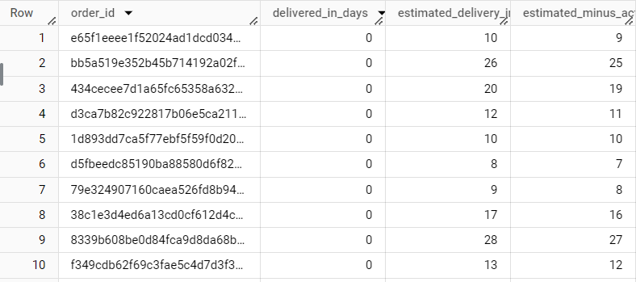

***5.2 Find out the top 5 states with the highest & lowest average freight value.***

***ANSWER :***

SELECT customer_state,

MAX(CASE WHEN ranking = "TOP"

THEN avg_freight END) AS top_avg_freight,

MAX(CASE WHEN ranking = "BOTTOM"

THEN avg_freight END) AS bottom_avg_freight

FROM((SELECT c.customer_state,

ROUND(AVG(i.freight_value),2) AS avg_freight,

"TOP" AS ranking

FROM`scaler-dsml-sql-407614.TargetSQL.orders`AS o

JOIN`scaler-dsml-sql-407614.TargetSQL.order_items`AS i

ON o.order_id = i.order_id

JOIN`scaler-dsml-sql-407614.TargetSQL.customers`AS c

ON o.customer_id = c.customer_id

GROUP BY c.customer_state

ORDER BY avg_freightDESC

LIMIT 5)

UNION DISTINCT

(SELECT c.customer_state,

ROUND(AVG(i.freight_value), 2) AS avg_freight,

"BOTTOM" AS ranking

FROM`scaler-dsml-sql-407614.TargetSQL.orders`AS o

JOIN`scaler-dsml-sql-407614.TargetSQL.order_items`AS i

ON o.order_id = i.order_id

JOIN`scaler-dsml-sql-407614.TargetSQL.customers`AS c

ON o.customer_id = c.customer_id

GROUP BY c.customer_state

ORDER BY avg_freight ASC

LIMIT5)) AS subquery

GROUP BY customer_state;

**SNAP :**

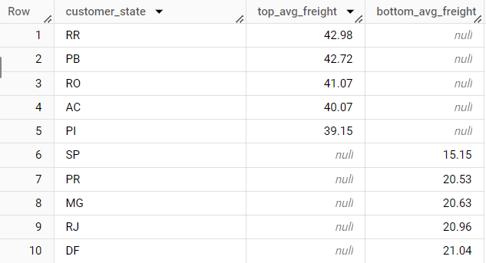

**5.3 Find out the top 5 states with the highest & lowest average delivery time.**

***ANSWER :***

SELECT customer_state,

MAX(CASE WHEN ranking = "TOP"

THEN avg_delivery_time END) AS top_avg_delivery_time,

MAX(CASE WHEN ranking = "BOTTOM"

THEN avg_delivery_time END) AS bottom_avg_delivery_time

FROM(

(SELECT c.customer_state,

ROUND(AVG(DATE_DIFF(o.order_delivered_customer_date, o.order_purchase_timestamp, DAY)), 2)AS avg_delivery_time,

"TOP"AS ranking

FROM`scaler-dsml-sql-407614.TargetSQL.orders`AS o

JOIN`scaler-dsml-sql-407614.TargetSQL.order_items`AS i

ON o.order_id = i.order_id

JOIN`scaler-dsml-sql-407614.TargetSQL.customers`AS c

ON o.customer_id = c.customer_id

GROUP BY c.customer_state

ORDER BY avg_delivery_time DESC LIMIT 5)

UNION DISTINCT

(SELECT c.customer_state,

ROUND(AVG(DATE_DIFF(o.order_delivered_customer_date, o.order_purchase_timestamp, DAY)), 2) AS avg_delivery_time,

"BOTTOM" AS ranking

FROM`scaler-dsml-sql-407614.TargetSQL.orders`AS o

JOIN`scaler-dsml-sql-407614.TargetSQL.order_items`AS i

ON o.order_id = i.order_id

JOIN`scaler-dsml-sql-407614.TargetSQL.customers`ASc

ON o.customer_id= c.customer_id

GROUP BY c.customer_state

ORDERBY avg_delivery_time ASC LIMIT 5))AS subquery

GROUP BY customer_state;

**SNAP :**

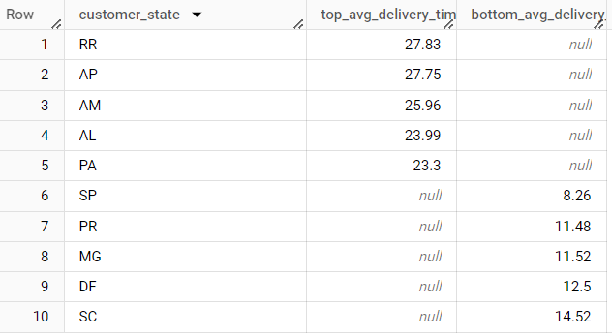

**5.4 Find out the top 5 states where the order delivery is really fast as compared to the estimated date of delivery.**

**You can use the difference between the averages of actual & estimated delivery date to figure out how fast the delivery was for each state.**

***ANSWER :***

SELECT customer_state,

MAX(CASE WHEN ranking = "TOP"

THEN diff_estimated_delivery END) AS top_diff_estimated_delivery,

MAX(CASE WHEN ranking = "BOTTOM"

THEN diff_estimated_delivery END) AS bottom_diff_estimated_delivery

FROM(

(SELECT

c.customer_state,

ROUND(AVG(DATE_DIFF(o.order_estimated_delivery_date, o.order_delivered_customer_date, DAY)), 2)

AS diff_estimated_delivery,

"TOP" AS ranking

FROM`scaler-dsml-sql-407614.TargetSQL.orders`AS o

JOIN`scaler-dsml-sql-407614.TargetSQL.order_items`AS i

ON o.order_id = i.order_id

JOIN`scaler-dsml-sql-407614.TargetSQL.customers`AS c

ONo.customer_id = c.customer_id

GROUP BY c.customer_state

ORDER BY diff_estimated_delivery DESC

LIMIT 5)

UNION DISTINCT

(SELECT

c.customer_state,

ROUND(AVG(DATE_DIFF(o.order_estimated_delivery_date, o.order_delivered_customer_date, DAY)), 2)

As diff_estimated_delivery,

"BOTTOM" AS ranking

FROM`scaler-dsml-sql-407614.TargetSQL.orders`AS o

JOIN`scaler-dsml-sql-407614.TargetSQL.order_items`AS i

ON o.order_id = i.order_id

JOIN`scaler-dsml-sql-407614.TargetSQL.customers`AS c

ON o.customer_id = c.customer_id

GROUP BY c.customer_state

ORDER BY diff_estimated_delivery ASC

LIMIT 5)) AS subquery

GROUP BY customer_state;

**SNAP :**

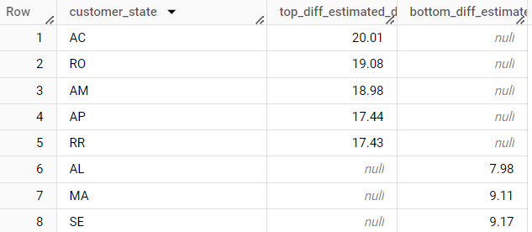

**6.Analysis based on the payments:**

**6.1 Find the month on month no. of orders placed using different payment types.**

**ANSWER :**

SELECT

p.payment_type,

EXTRACT(MONTH FROM o.order_purchase_timestamp)AS month,

COUNT(DISTINCT o.order_id) AS order_count

FROM`scaler-dsml-sql-407614.TargetSQL.orders`AS o

JOIN`scaler-dsml-sql-407614.TargetSQL.payments`AS p

ONo.order_id= p.order_id

GROUP BY p.payment_type, month

ORDER BY p.payment_type, month

**SNAP :**

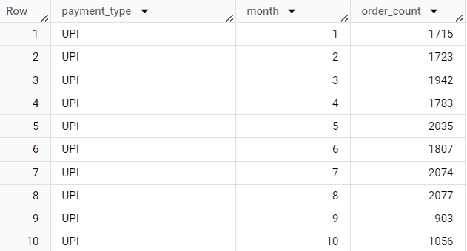

**6.2 Find the no. of orders placed on the basis of the payment installments that have been paid.**

**ANSWER :**

SELECT

p.payment_installments,

COUNT(o.order_id)AS order_count

FROM`scaler-dsml-sql-407614.TargetSQL.orders`AS o

JOIN`scaler-dsml-sql-407614.TargetSQL.payments`AS p

ON o.order_id = p.order_id

GROUP BY p.payment_installments

ORDER BY order_count DESC

**SNAP :**

