1. Mention different ways data is generated. (Write 5 points).

Ans:

1.Users

Ex:

Suppose you go on flipkart mobile app and save item.

This data needs to be saved.

2. Internals.

Ex: Generate invoice for item purchased.

3. Insights.

Ex: Recommendation given based on your search.

2. Comment about the different storage solutions.

Ans:

1. Dealing with read heavy system (Twitter, Instagram)

Caching -> Redis

1. Unstructured data can be store as blob storage or amazon s3
2. Elastic search -> Movie Recommendation system
3. Datawarehouse -> Big data

3. Mention the scenario in which we can go for relational database vs non-relational database.

Ans:

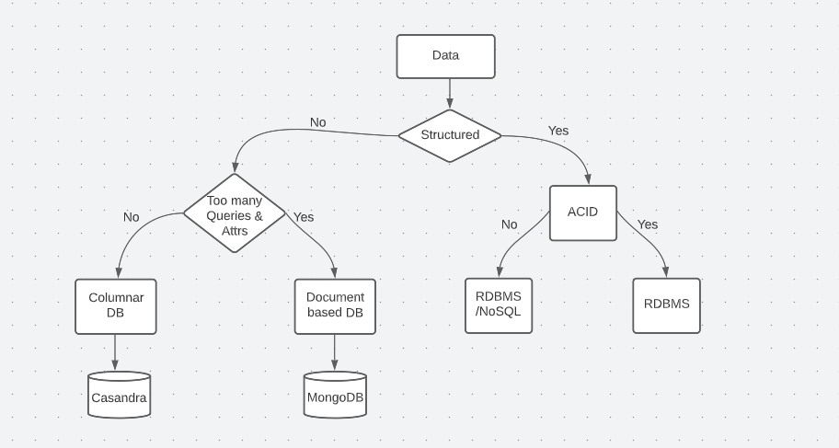

4. What is API?

Ans:

Application Programming Interface (API) is a software interface that allows two applications to interact with each other without any user intervention.

API is a collection of software functions and procedures. In simple terms, API means a software code that can be accessed or executed.

5. Mention the advantages of API.

Ans:

1. Platform Agnostic
2. Abstraction
3. Communication