**2) Baseline drift correction using dc notch filter**

Filter removes the DC part from the input signal. Filter is very narrow so it does not distort the signal.

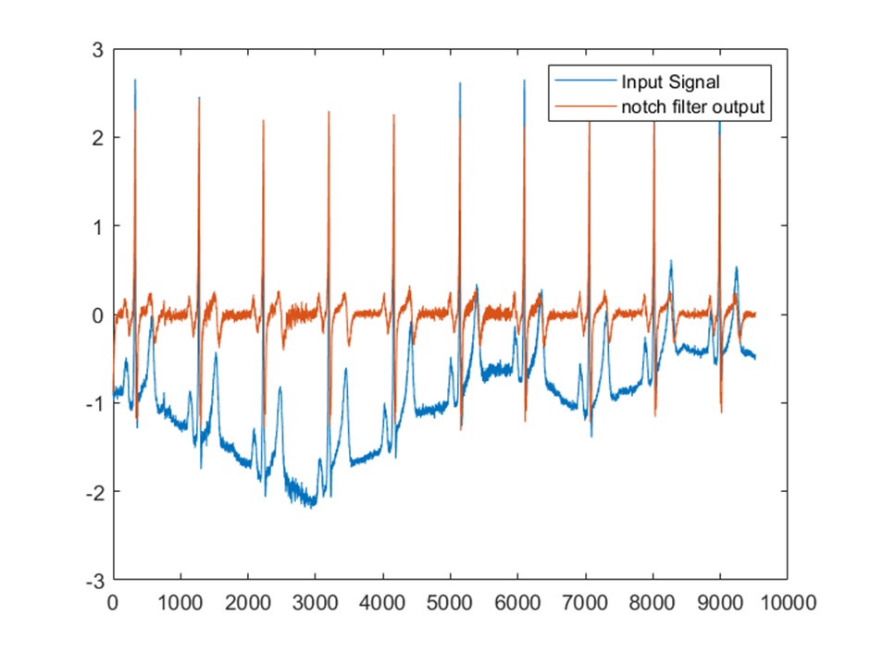

**3) 60 Hz notch filter for ECG signal**

FIR and IIR Filter both remove 60 Hz noise from signal. IIR filter out put matches closely with input, FIR filter out put delayed than input signal.

FIR filter has shorter impulse response than IIR filter.

