**1. Workflow of Git with Neat Diagram**

Git Workflow:  
1. Working Directory - Where files are created/modified.  
2. Staging Area - Where files are staged using 'git add'.  
3. Local Repository - Where files are committed using 'git commit'.  
4. Remote Repository - Where files are pushed using 'git push'.  
  
Basic Flow:  
Working Directory -> Staging Area -> Local Repository -> Remote Repository

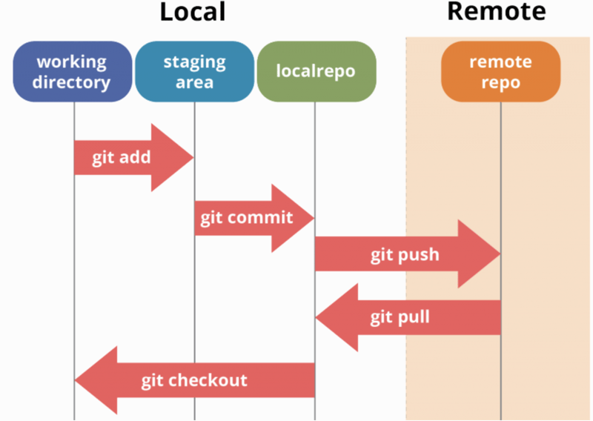

**2. What is Git and How to Stage a File with git add**

Git: Git is a distributed version control system that tracks changes in source code during software development.  
It allows multiple developers to work on a project simultaneously.  
  
To stage a file using git add:  
1. Create/Modify a file.  
2. Run: git add filename (to stage a specific file)  
 OR  
 git add . (to stage all changes)

**3. What is Git, GitHub, GitLab - Differences**

- Git: A distributed version control tool to manage source code history.  
- GitHub: A cloud-based hosting service for Git repositories, mainly used for open-source projects.  
- GitLab: Another cloud-hosting platform similar to GitHub, with additional DevOps tools and CI/CD integration.

**Differences:**

|  |  |  |  |
| --- | --- | --- | --- |
| **Feature** | **Git** | **GitHub** | **GitLab** |
| **Type** | Version Control | Repository Hosting | Repository Hosting |
| **Hosting** | No Hosting | Cloud Hosting | Cloud/Self Hosting |
| **Focus** | Tracking changes | Collaboration & Open Source | Collaboration & DevOps |

**4. How to Create a Tag and Push It**

To create a tag:  
git tag v1.0 -m "Version 1.0 Release"  
  
To push the tag:  
git push origin v1.0  
  
To push all tags:  
git push origin --tags

**5. Steps to Send Project from Local Repo to Remote Repo**

1. Initialize Repository:  
 git init  
  
2. Add Remote URL:  
 git remote add origin <remote_repo_url>  
  
3. Stage Files:  
 git add .  
  
4. Commit Files:  
 git commit -m "Initial commit"  
  
5. Push Files to Remote:  
 git push origin main (or master)

**6. What is Pull Request and Procedure**

Pull Request : A request to merge changes from one branch into another, typically used in collaborative development.  
  
Procedure:  
1. Fork the repository (if you don’t have write access).  
2. Clone the forked repo.  
3. Create a new branch and make changes.  
4. Commit and push changes to your branch.  
5. Open the repository on GitHub/GitLab and click "New Pull Request".  
6. Select branches and create the PR.  
7. Reviewer reviews and merges the PR.

**7. What is Fork and Why It is Necessary**

Fork: A copy of a repository in your own account, used to contribute to someone else's project.  
  
Why Fork is Necessary:  
- Provides a personal workspace to make changes.  
- Enables contributing to projects where you do not have direct write access.  
- Maintains separation between the original project and your changes until reviewed/merged.