

Where Problems meet solutions, and Skills turn into opportunities. Fix Lanka empowers both.

Created By
2nd year group IS_10
University Of Colombo School of Computing

Umesh Yapa
Nimesha Madushan
Dilanka Supun
Amalsha Kavindi

Table of Contents
Details of project supervisor, Co-supervisor, Advisors and Clients

1.Introduction
1.1 Domain description
1.2 Current system and limitations
1.3 Goals & Objectives
1.4 Process Re-Engineered
1.5 Assumptions
2. Project Feasibility
2.1 Technical Feasibility
2.2 Legal & Ethical Feasibility
2.3 Resource Feasibility
2.4 Schedule Feasibility
2.5 Social Feasibility
3. Requirements
3.1 Stakeholders / Actors
3.2 Functional Requirements
3.3 Non-Functional (Quality Attribute) Requirements
3.4 In-scope and Out-of-scope
3.5 Constraints and Limitations
4. Proposed System Architecture
4.1 Components and their Functionalities
4.2 Component Interactions
5. System Design Diagrams
5.1 Use Case Diagram
5.2 Activity Diagram
5.3 ER Diagram
5.4 Class Diagram
6. Completeness of the project
6.1 Functionalities completed
6.2 Functionalities yet to complete
6.3 Individual contribution of the team members

Details of Project Supervisor, Co-supervisor, Advisors, and Clients

Project Supervisor (Academic Staff of UCSC):
Name of the supervisor: Ms. J.G.S. Rupasinghe
Signature of the supervisor:
Date:

Project Co-Supervisor (Assigned by Course Coordinator):
Name of the co-supervisor: Ms. H.P.M. Jayathilaka
Signature of the supervisor:
Date:

- Introduction
Fix Lanka is a web-based platform designed to connect customers with reliable and verified repair service providers across Sri Lanka. The system aims to make it easier for people to find skilled professionals such as electricians, plumbers, and technicians through a single, trusted online platform.
It also helps service providers promote their work, manage bookings, and build trust through user reviews.
This project was developed by our group to address the growing need for a transparent and organized repair service system that benefits both customers and service providers.

  - Domain Description
Fix Lanka is a web-based service platform designed to connect customers with qualified repair service providers such as electricians, plumbers, technicians, and carpenters.
The platform aims to simplify the process of finding reliable repair professionals while ensuring trust, transparency, and timely service delivery.
In Sri Lanka, many individuals and companies struggle to find trustworthy repairers, often depending on word-of-mouth recommendations or unreliable social media advertisements. Similarly, repair professionals lack a centralized digital platform to promote their services, manage customer requests, and receive verified payments.
Fix Lanka bridges this gap by providing a centralized, transparent, and easy-to-use system where customers can book repair services, service providers can manage their business profiles, and admins/moderators can maintain system integrity through advertisement approvals, account management, and issue handling.

1.2 Current System & its Limitations
Currently, most people find repair services through social media groups, flyers, or local recommendations. These methods come with several problems:
- Lack of verification – No guarantee that the service provider is genuine or skilled.
- Poor communication – No proper platform for tracking requests or confirming job details
- Inconsistent pricing – Customers often face unexpected or unfair charges.
- Limited accountability – No proper reporting or review system for bad service.
- No digital management – Providers cannot easily promote, schedule, or manage their work online.
Fix Lanka addresses these issues by offering a digital marketplace for repair services with verified professionals, transparent job tracking, in-app chat, review systems, and proper admin/moderator oversight.

1.3 Goals and Objectives

System Goal
To develop a user-friendly and secure web-based platform that connects customers with trusted repair service providers, ensuring quality service delivery and transparent administration.

Objectives
- Enable customers to find and request repair services easily.
- Allow service providers to register, post service advertisements, and manage bookings.
- Provide moderators with tools to review ads, manage reports, and maintain content quality.
- Enable admins to manage users, send notifications, and monitor financial activities.
- Introduce a complaint-handling system for transparency and trust.
- Provide real-time notifications and activity logs for system interactions.

1.4 Process Re-Engineered
The system replaces manual workflows with automated processes such as:
Job request → approval → assignment → completion tracking
Advertisement submission → moderator review → admin override
Issue/report handling with structured validation

1.3 Assumptions
• All users must register with valid email and contact details.
• Service providers must be verified before publishing advertisements.
• The system requires a stable internet connection.
• Admin and Moderator actions are recorded for accountability.

- Project Feasibility

2.1 Technical Feasibility
Fix Lanka is developed using HTML, CSS, JavaScript, and PHP, with MySQL as the database.
All these technologies are open-source, lightweight, and supported by large online communities.
The project can be hosted on any cloud-based platform, making it accessible from any device with internet access.
Team members already possess fundamental knowledge in PHP and database management, making implementation technically feasible.

2.2 Legal & Ethical Feasibility
User data privacy and security are prioritized.
- Each user has role-based access (Customer, Provider, Admin, Moderator).
- Sensitive information is protected using authentication and password encryption.
- Data will never be shared with third parties.
- Service providers’ identities are verified to prevent fraud.
Hence, the system is legally and ethically feasible.

2.3 Resource Feasibility
The main resources required are:
- Human resources: A four-member development team with distributed roles (frontend, backend, database, documentation).
- Hardware: Personal laptops and smartphones for testing.
- Software: Open-source tools such as VS Code, XAMPP, and GitHub for version control.
- All resources are accessible and sufficient, ensuring project feasibility.

2.4 Schedule Feasibility
The development timeline runs from June to March, covering planning, design, development, and testing phases.
Tasks are equally divided among members with weekly progress reviews.
The total estimated team effort is 1000–1200 hours, ensuring the system can be developed on schedule.

2.5 Social Feasibility
Surveys among local users revealed that 90% of participants prefer an online repair service system to save time and ensure reliability.
Service providers also expressed interest in joining a verified platform for consistent job opportunities.
Therefore, Fix Lanka is socially feasible and beneficial for both service providers and customers.

Google form links- Click Here
Service providers - Click Here
Company - Click Here
Google form Results – Click Here

- Requirements

  - Stakeholders / Actors

Customer (User) –
• Registers and logs into the system.
• Searches and requests repair services.
• Views advertisements from service providers.
• Submits complaints or feedback.
• Receives notifications and updates from moderator.

Service Provider (Repairer/Company) –
• Registers and creates service advertisements.
• Manages job requests from customers.
• Updates service details and schedules.
• Communicates with customers through the system.

Moderator –
• Reviews and approves advertisements posted by service providers.
• Handles user complaints and reports.
• Bans or recovers user accounts when necessary.
• Monitors content to maintain platform standards.
• Sends alerts and notifications to all users.

Admin –
• Manages users and system data.
• Handling the accounts.
• Reviews financial and activity reports.
• Oversees overall system performance.
Guest Visitor –
• Can view basic service details and advertisements.
• Must register to request services or communicate.

  - Functional Requirements

The Fix Lanka system consists of several functional requirements that define how users, service providers, moderators, and administrators interact with the platform.
Each function ensures smooth operation, efficient communication, and transparency between all actors.

3.2.1 User Registration and Authentication
• The system must allow users to register with their name, email address, contact number, and password.
• Each registered user should be assigned a specific role such as Customer, Service Provider, Moderator, or Admin.
• The login process must validate user credentials securely and restrict access to unauthorized users.
• Users should be able to reset their passwords or recover their accounts through verified email addresses.

3.2.2 Advertisement Management
• Service Providers can create new advertisements describing their repair services, including service type, location, price, and availability.
• Moderators must review and approve advertisements before they are published on the platform to ensure they meet the content guidelines.
• Providers can update or delete their own advertisements, while moderators can reject or remove inappropriate ones.
• Only approved advertisements should be visible to customers and guests.

3.2.3 Service Request Management
• Customers can request repair services directly through advertisements or provider profiles.
• Service Providers should receive notifications for new requests and must have the option to accept or reject them.
• Once accepted, customers can track the service progress until completion.
• Both customers and providers can rate each other after service completion to maintain quality.

3.2.4 Complaint and Issue Handling
• Customers and Service Providers can submit complaints or reports about system misuse, inappropriate advertisements, or poor service.
• Complaints should include a description, date, and evidence (such as screenshots or text).
• Moderators can read, update, and resolve these complaints by changing their status (Pending, Resolved, Escalated, or Dismissed).
• Moderators can review complaint reports to ensure fairness and transparency.

3.2.5 User Account Management
• Admins and Moderators can view user profiles, update information, or ban/unban accounts based on user activity or complaints.
• Service Providers can update their profile details such as business name, contact number, or service category.
• Users can deactivate their accounts voluntarily if they wish to leave the platform.

3.2.6 Notification and Alert System
• The moderator can create and send notifications or system-wide alerts to all registered users.
• Notifications may include system updates, maintenance messages, or service reminders.
• All notifications should be stored in the database and viewable in each user’s dashboard.
• Users can mark notifications as read or delete them when no longer needed.

3.2.7 Financial and Activity Reports
• The admin should be able to generate and view system reports, including monthly revenue, pending withdrawals, and total transactions.
• Activity logs should automatically record every action performed by Admins and Moderators (e.g., “Moderator approved Ad #102” or “Admin banned User #321”).
• Reports and logs ensure transparency and can be exported for future auditing.

3.2.8 Chat and Communication System
• Customers and Service Providers can communicate through a built-in messaging system after a booking is confirmed.
• Chat messages should be stored securely and accessible only to the two participants.
• Moderators or Admins do not have access to chats but can receive complaints about misuse.

  - Non-Functional (Quality Attribute) Requirements

• Usability: Simple interface and clear navigation.
• Performance: Fast loading and smooth data retrieval.
• Security: Encrypted passwords and role-based access.
• Reliability: Regular backups and stable hosting.
• Maintainability: Modular design for easy updates.
• Scalability: Can support growing user base and services.

  - In-Scope and Out-of-Scope

In-Scope
The Fix Lanka system will cover all major functionalities related to connecting customers and service providers while maintaining proper administration and moderation of activities. The system will ensure reliability, security, and transparency in all user interactions.
The following functions are considered in-scope for the current project phase:
- User Registration and Authentication – Allowing customers, service providers, moderators, and admins to register, log in, and securely access their respective dashboards.
- Role-Based Access Control – Each user type will have different permissions. For example, customers can request services, while moderators can review ads and handle complaints.
- Service Advertisement Management – Service providers can create, edit, and delete advertisements for repair services. Moderators will review and approve these ads before publishing.
- Complaint and Report Handling – Users can submit complaints regarding poor service, fake ads, or inappropriate content. Moderators can view, update, and resolve them.
- Account Management – Admins and moderators can ban, recover, or permanently delete user accounts if necessary.
- Notification and Alert System – The admin can send notifications, warnings, or announcements to users or providers through the dashboard.
- Activity Log and Report Generation – All admin and moderator actions will be recorded in activity logs for accountability and transparency.
- Search and Filtering – Customers can search for repair services using filters like service type, provider location, or budget.
- Review and Rating System – Customers can rate and review service providers after service completion.
- Basic Chat and Communication Feature – Customers and service providers can exchange messages regarding bookings (moderators do not see chats).
- Dashboard Interfaces – Separate dashboards for Admin, Moderator, Service Provider, and Customer for organized task management.
- Responsive Web Design – The system will be accessible via desktop and tablet browsers, with mobile-friendly layouts.

Out-of-Scope
Some advanced functionalities will not be included in this version of the system but may be implemented in future updates. These include features that require external integration, automation, or advanced analytics.
- Payment Gateway Integration – The system will not include real online payment or withdrawal handling in this phase. Only financial reporting (manual data) will be included.
- Mobile Application – A dedicated mobile app version will not be developed at this stage. The system will be optimized for browsers only.
- Live Tracking of Service Providers – Real-time GPS tracking for repairers is not included in the current phase.
- Third-Party API Integrations – No integration with Google Maps, SMS gateways, or third-party notification services.
- AI-Based Matching System – Automatic service provider recommendation or matching algorithms are not implemented yet.
- Voice or Video Communication – Only text-based chat is available; video/audio call functions are out of scope.
- Multi-language Support – The current version supports English only.
- Advanced Analytics Dashboard – Detailed data visualization (graphs/charts) beyond basic financial and user reports is not implemented.
- Automated Complaint Escalation – Complaints are manually managed by moderators; no auto-escalation rules are applied.
- service Subscription Packages – Premium or paid advertising packages for providers are not included in this version.

  - Constraints and Limitations
• Internet connection required.
• Only verified service providers can post ads.
• Limited to desktop browsers for Phase

- Proposed System Architecture

  - Components and their Functionalities
Fix Lanka follows a Model–View–Controller (MVC) architecture:
- Models
• Manage data and database operations.
• Handle entities like User, Advertisement, Complaint, and Report.
- Views
• Display frontend user interfaces for all roles.
• Dynamically present content received from controllers.
- Controllers
• Process user inputs and requests.
• Validate data and trigger the correct model methods.
• Manage workflow between views and models.

4.2 Component Interactions
- User Interaction:
• Customers and Providers interact through the UI (views).
- Controller Processing:
• When a user performs an action (e.g., submit complaint), the controller validates input and interacts with models.
- Model Data Handling:
• The model fetches, inserts, or updates data in the database.
- Response Back to View:
• The controller sends processed results back to the view for display (e.g., “Ad approved successfully”).

- System Design Diagrams

5.1 Use Case Diagram
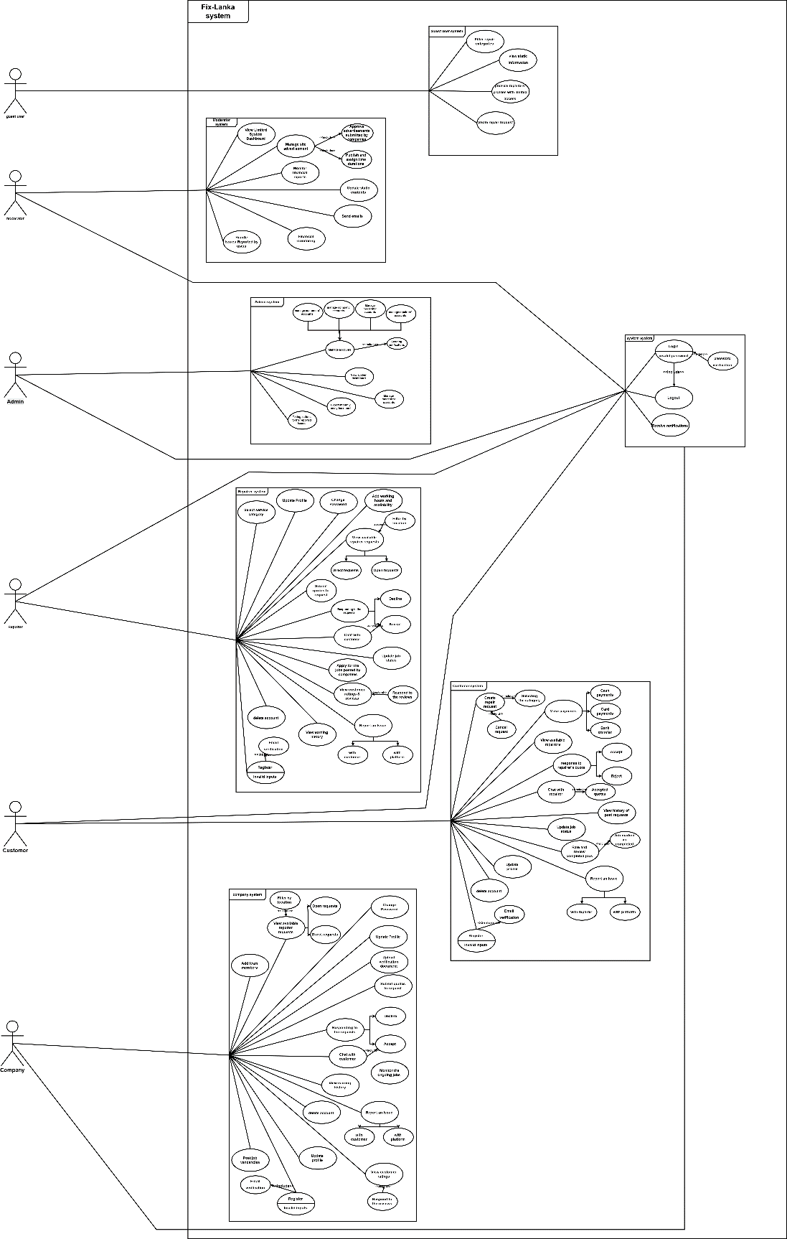

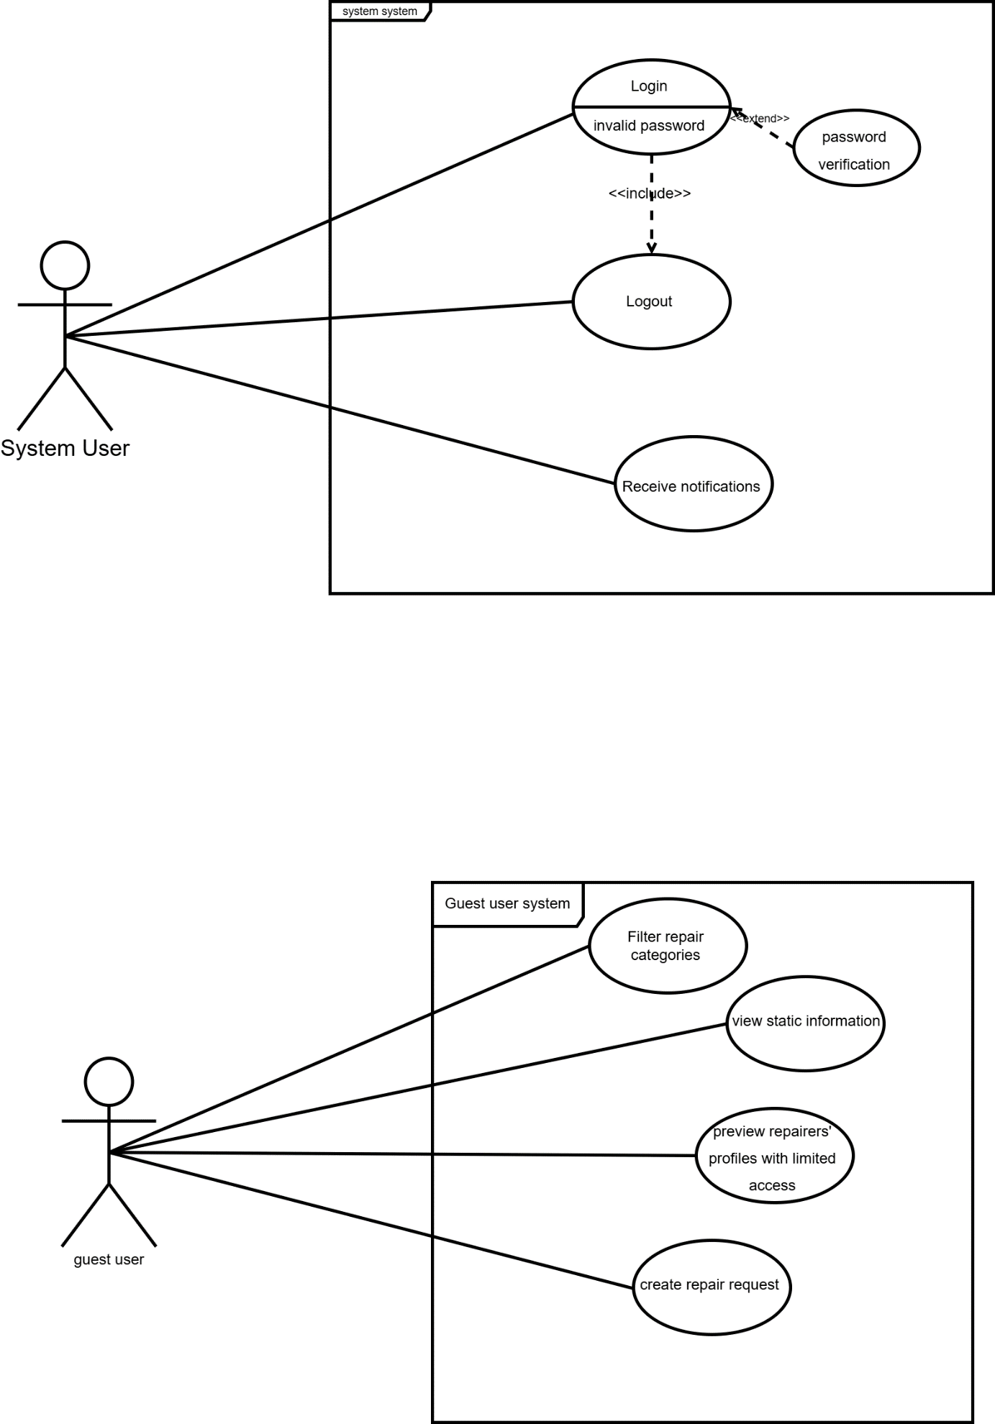
User & Guest User

Moderator & Admin
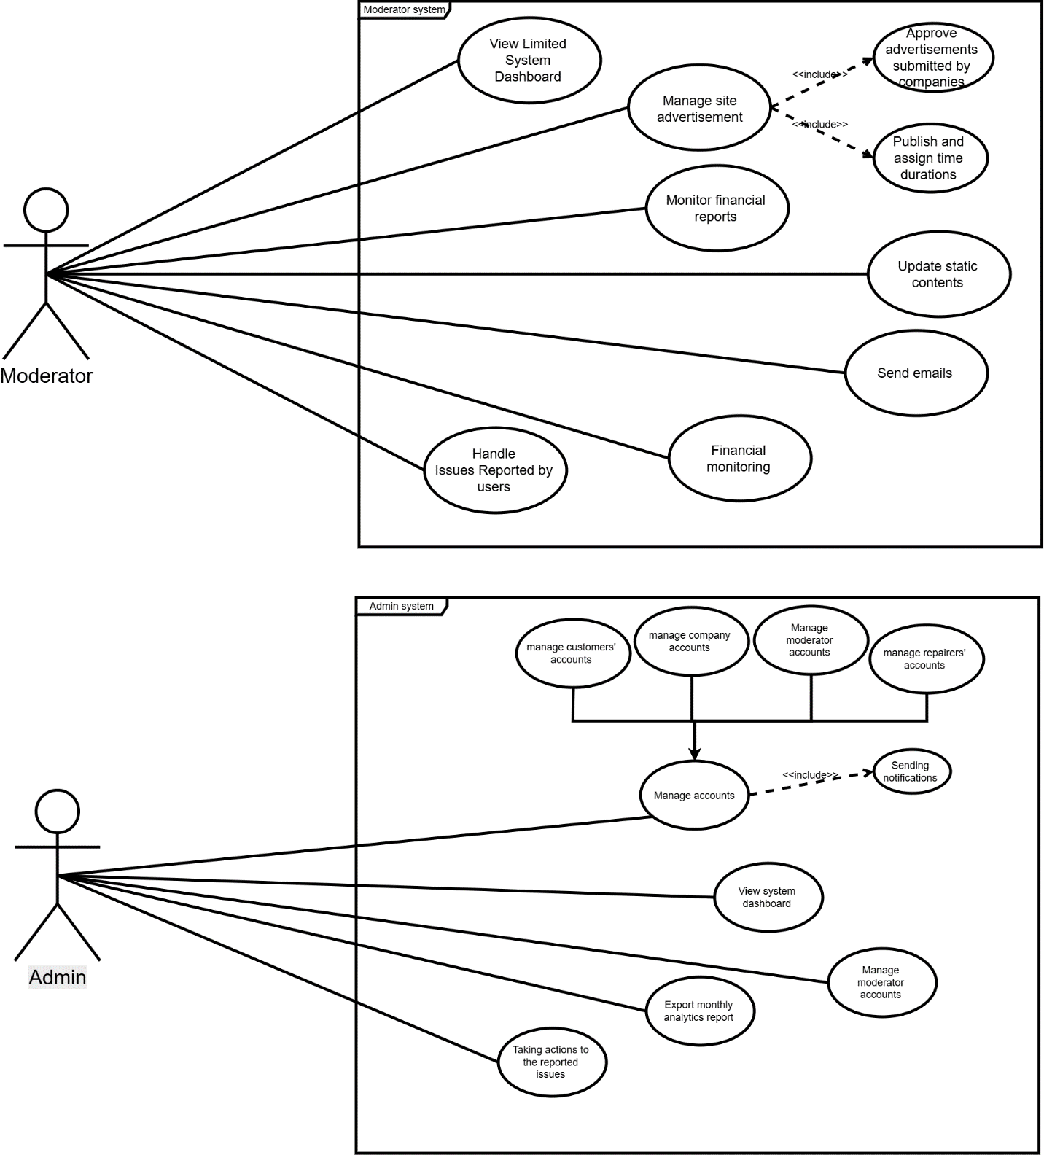

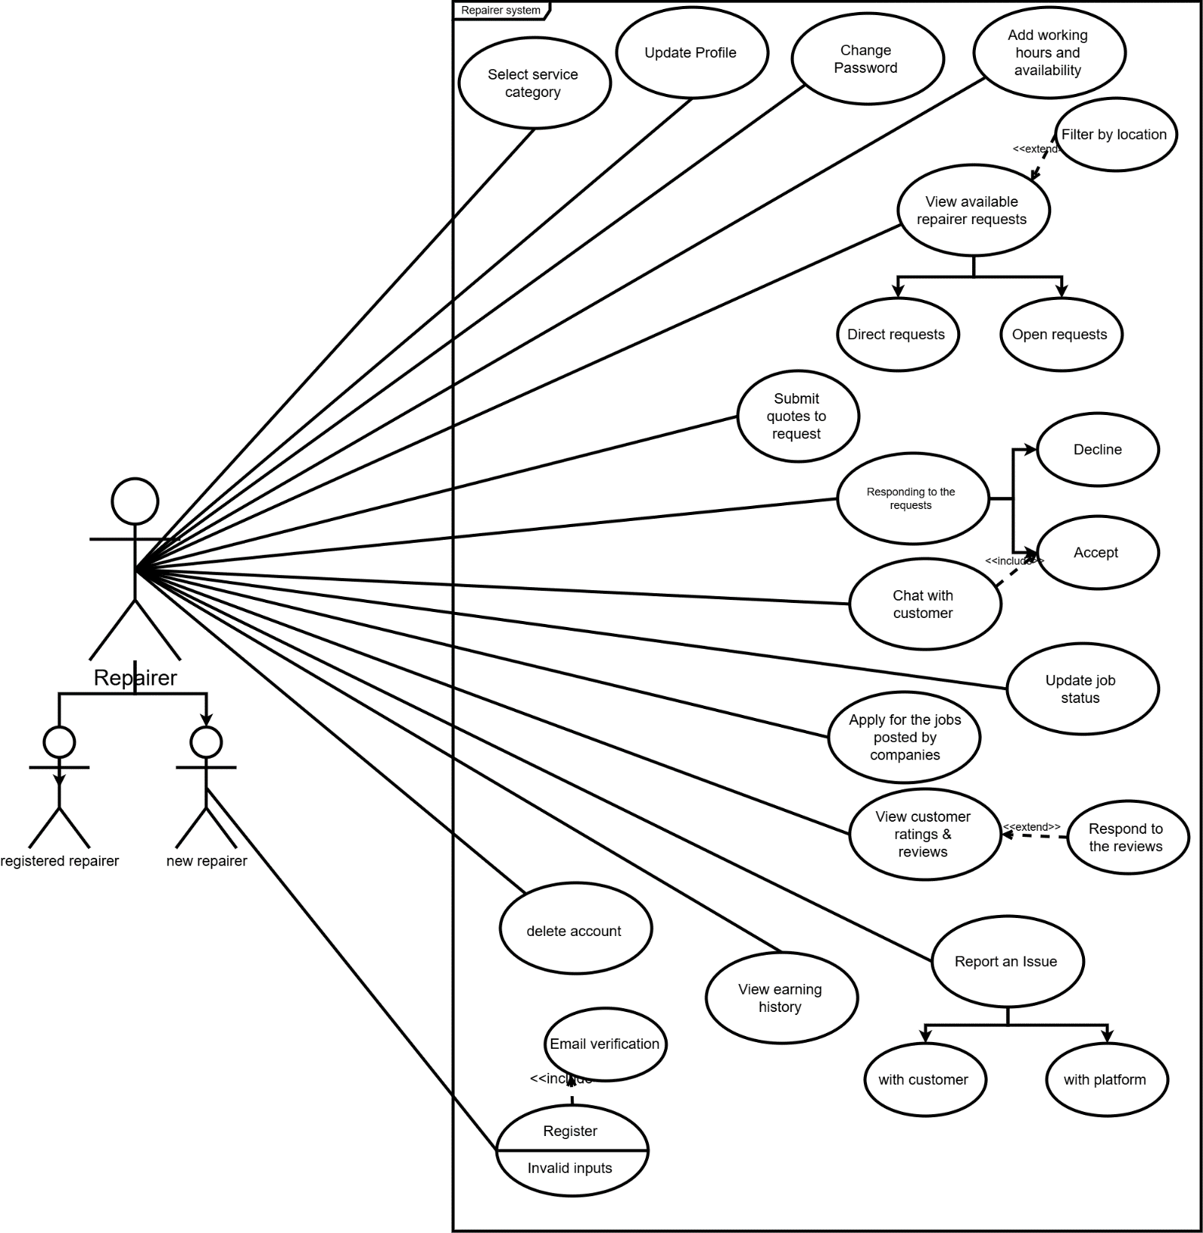
Repairer

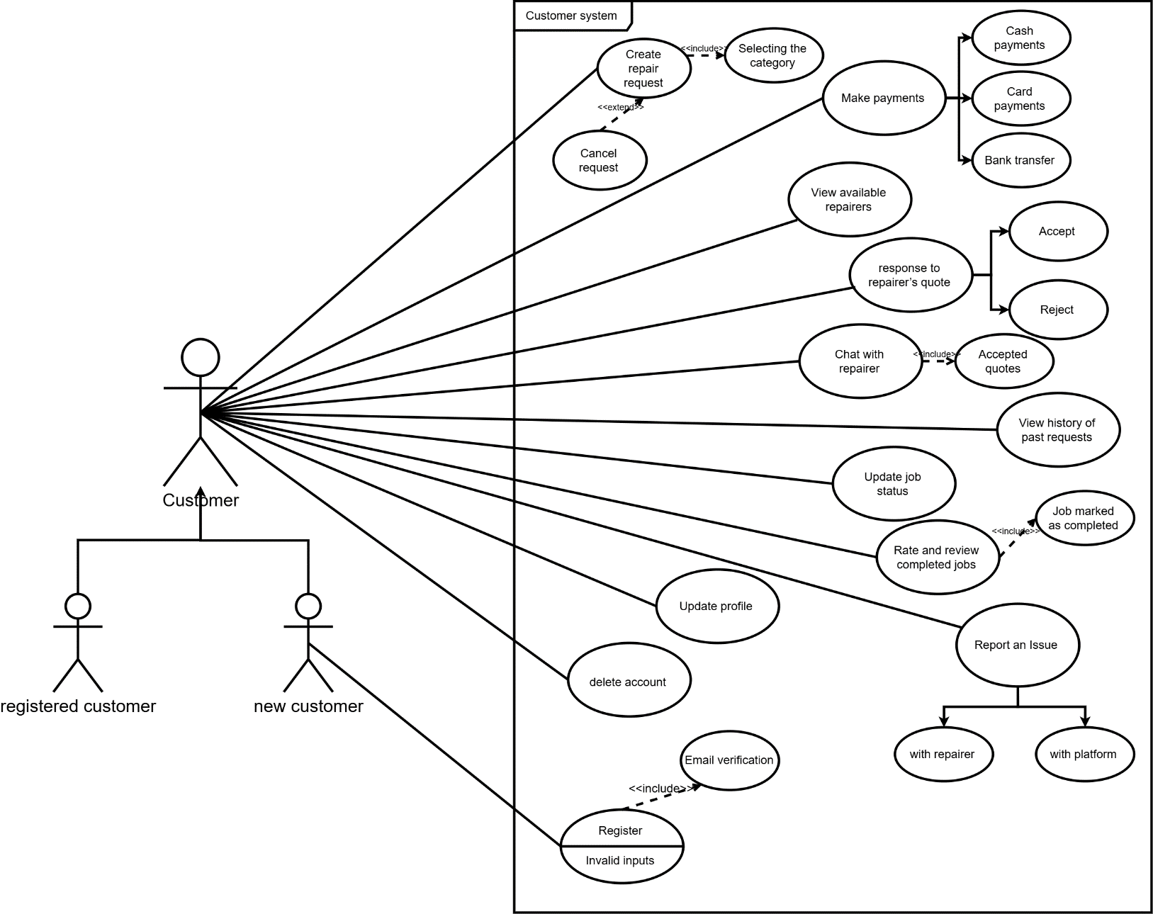
Customer

Company
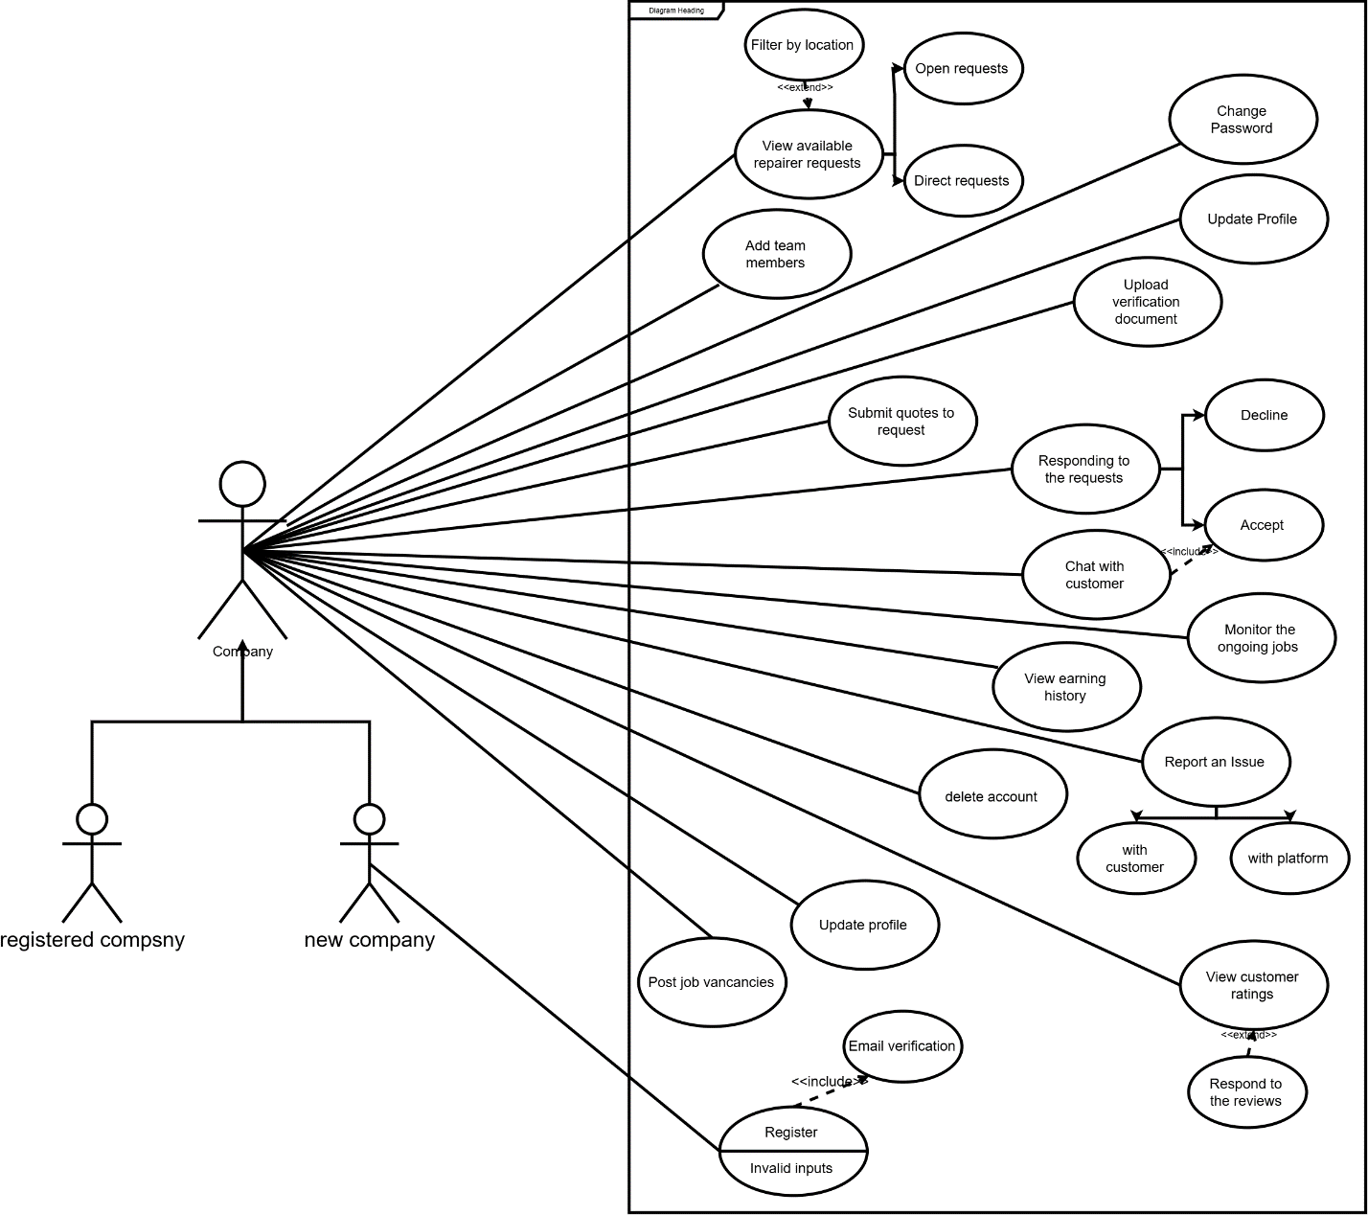

5.2 Activity Diagrams
Main Activity Diagram

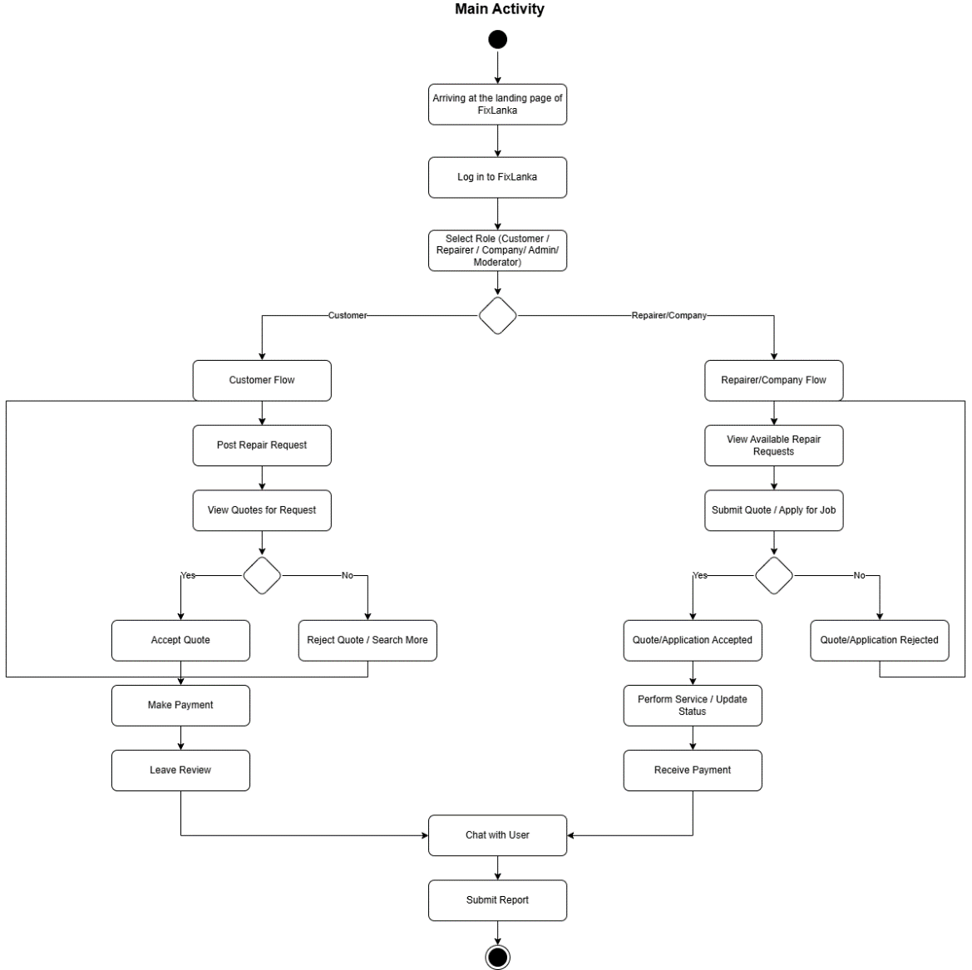

User Registration

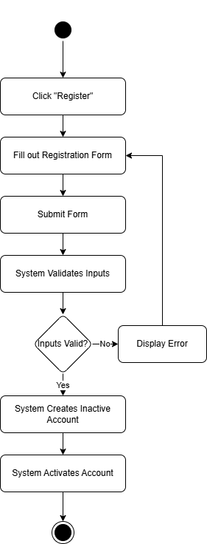

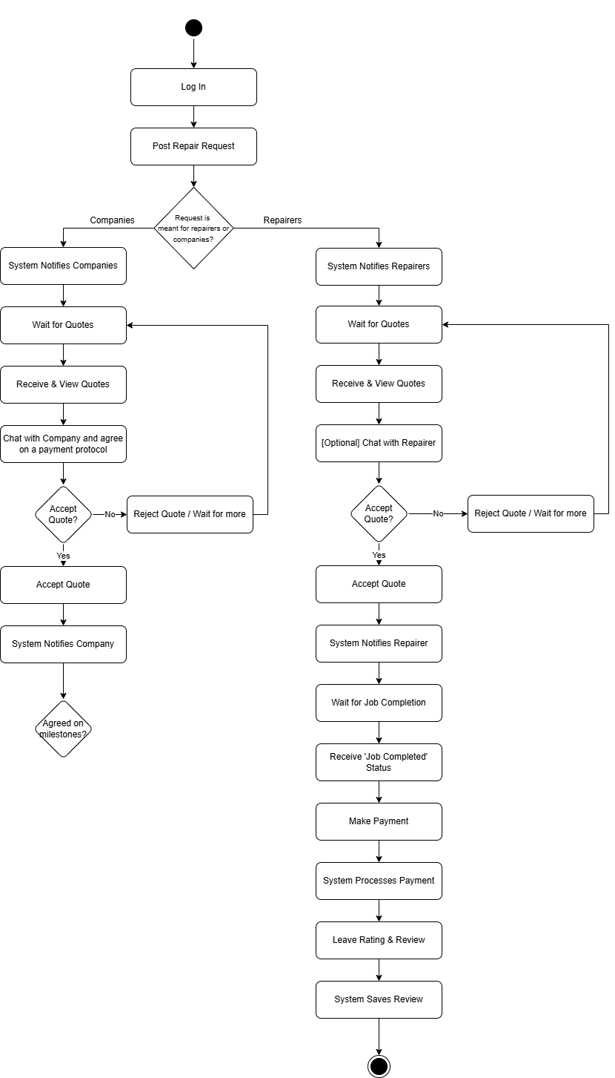
Customer: Ad Request

Repairer: Respond to Request
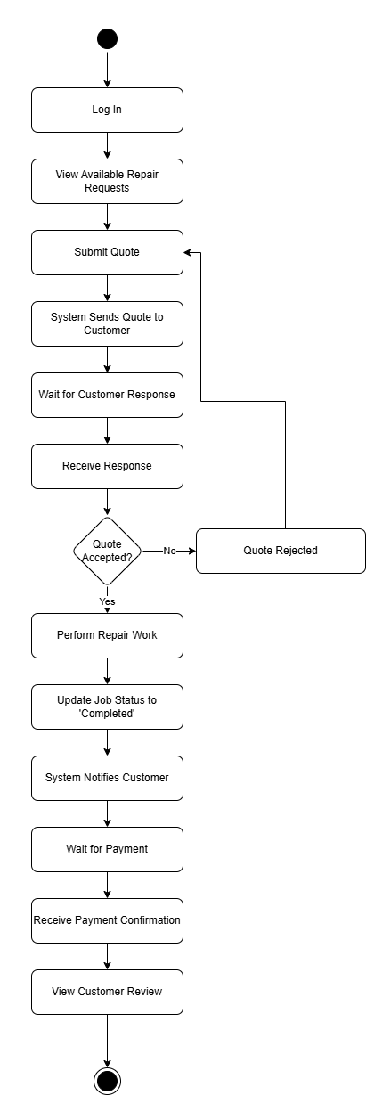

Moderator: Verified
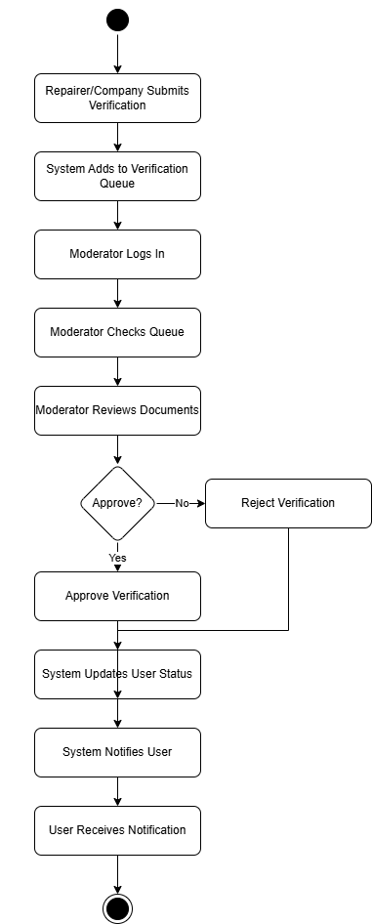

Admin: View Analytics
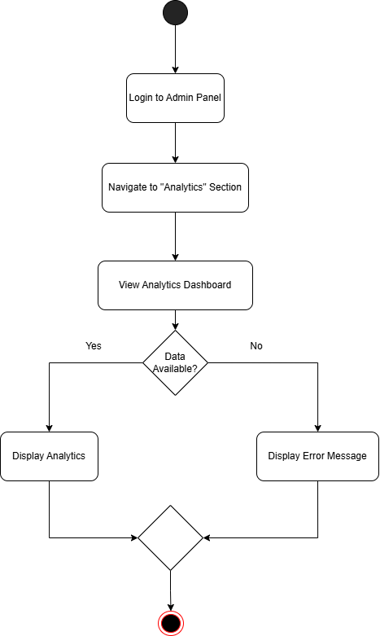

5.3 ER Diagram

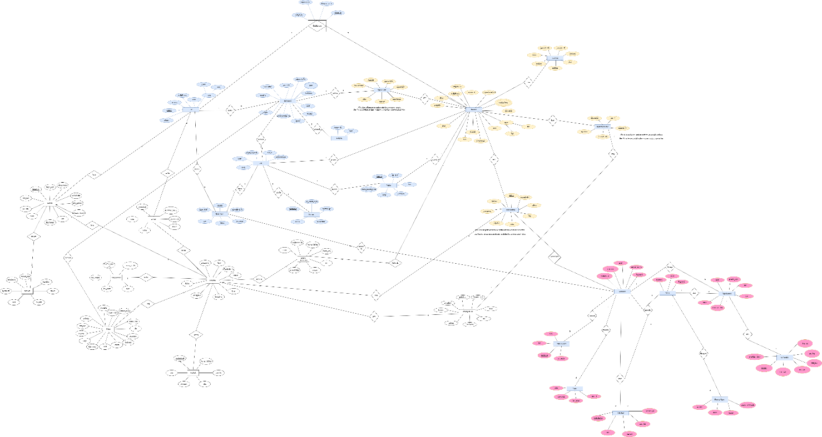

Link to the Diagram – Click Here

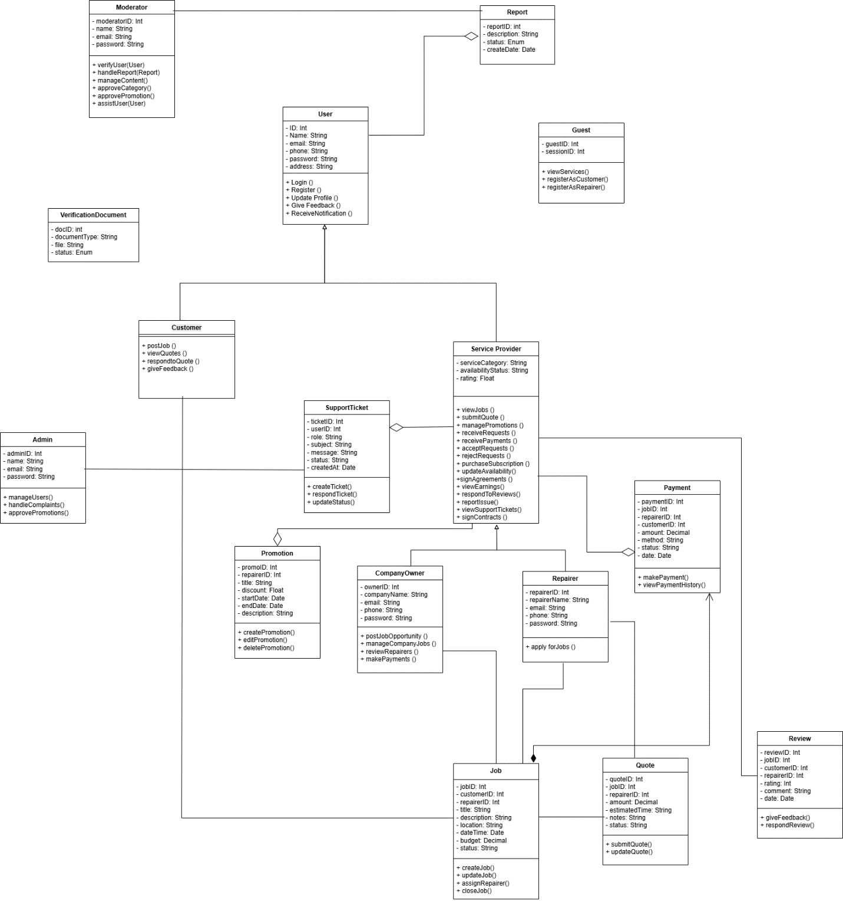
5.4 Class Diagram

Link to the Diagram – Click Here

- Completeness of the project

6.1 Functionalities Completed
We have successfully implemented the FixLanka platform with role-based functionalities. The system includes Admin, Moderator, Company, Repairer, and Client/User roles. Below are the completed features:

Client/User
1. Register
2. Login
3. Logout
4. Forgot Password
5. View available services and repair providers
6. Search and filter services
7. View service details
8. Create repair/service requests
9. Track request status
10. View request history
11. Schedule services
12. Cancel requests
13. Contact service providers
14. Submit complaints and reports
15. Receive notifications
16. View notifications
17. View profile
18. Edit profile
19. Deactivate account

Repairer
- Register
- Login and Logout
- Forgot Password
- View assigned jobs
- Accept or reject job requests
- Update job status (pending, ongoing, completed)
- Manage availability
- View job history
- Communicate with clients
- Receive notifications
- View profile
- Edit profile
- Deactivate account

Company
- Register
- Login and Logout
- Forgot Password
- Create and manage service/job postings
- Edit and update service details
- Delete service postings
- View service requests
- Manage repairers under company
- Assign jobs to repairers
- View analytics and reports
- Receive notifications
- View profile
- Edit profile
- Deactivate account

Moderator
- Login
- View pending advertisements
- Approve advertisements
- Reject advertisements
- Manage advertisement status
- Handle complaints and reports
- Monitor system activities
- Receive notifications
- View profile

Admin
- Login and Logout
- Forgot Password
- View dashboard summary
- Manage users (Client, Company, Repairer, Moderator)
- Add and manage moderators
- Activate/Deactivate user accounts
- View system-wide reports and analytics
- Handle complaints and issues
- View all advertisements
- Override advertisement decisions (approve/reject)
- Monitor moderator activities
- Send notifications to users
- Manage system settings
- View profile

Extra (Common Functionalities)
- Home page
- Role-based dashboards
- MVC architecture implementation
- Form validation (frontend & backend)
- Flash messages for actions
- Notification system
- Pagination
- Error handling and validation
- Activity tracking (recent activities)

6.2 Project Completion Status
We are pleased to state that nearly all core functionalities defined in the project proposal have been successfully completed.
The system has reached a fully integrated and stable state, with all modules connected and functioning under a unified MVC architecture.

Remaining work includes:
- Final system testing
- Minor UI refinements
- Documentation and presentation preparation

  - Each member's contribution
Throughout the working process it's happy to say that every member contributed at their best.
(L) - Low priority tasks.
(M) - Medium priority tasks.
(H) - High priority tasks.
Dilanka (23021179) | Nimesha (23020857) | Umesh (23020131) | Amalsha (23020474)
Company job posting system (H) | Repairer job acceptance & workflow (H) | User interface design (H) | Admin dashboard & control panel (H)
Add, edit, delete job postings (H) | Job status transition logic (H) | Login, register UI integration (M) | Advertisement review system (H)
Service update validation (M) | Job completion handling (M) | Client request submission UI (M) | Admin override functionality (H)
Backend form validation (H) | SQL query optimization (M) | View job listings (M) | Issue & report management (H)
Handle job posting errors (M) | Error handling & transaction safety (H) | UI consistency improvements (M) | User account moderation (H)
Database operations (CRUD) (H) | Repairer dashboard backend (M) | Form validation (frontend) (M) | Role-based access control (H)
Integration with repairer module (M) | Debugging job lifecycle issues (M) | UI-backend integration (H) | System monitoring features (M)
Fix backend edge cases (M) | Integration testing support (M) | Client dashboard UI (M) | Advertisement status validation (M)
Contributed to integration testing (M) | Contributed to debugging (M) | UI bug fixing (M) | Final system testing support (M)
Contributed to database merging (M) | Contributed to database merging (M) | Contributed to database merging (M) | Contributed to database merging (M)
Create dummy data for testing (L) | Create dummy data for testing (L) | UI enhancements (L) | Admin UI refinements (L)

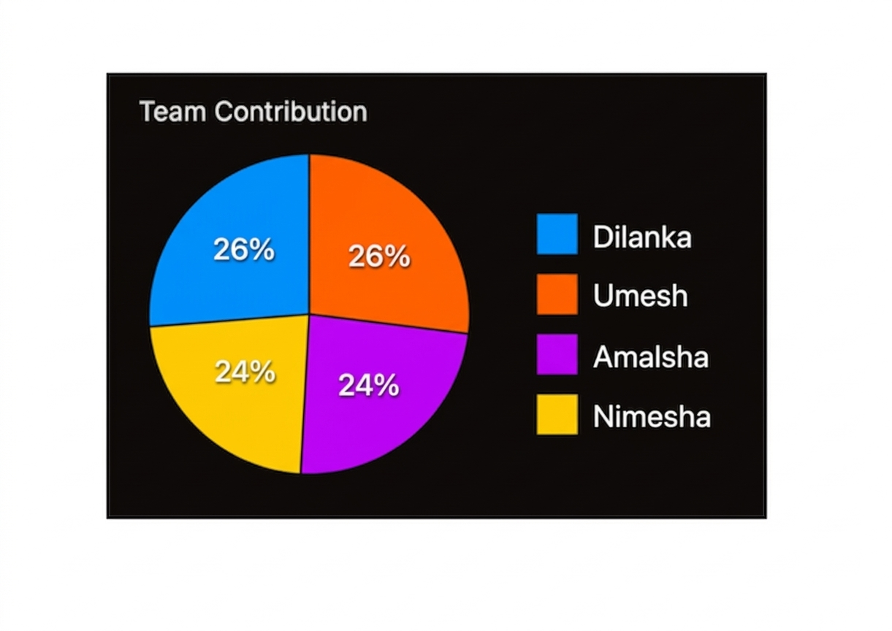

Test Cases of Amalsha (Moderator/Admin)
  - Moderator – Registration & Authentication

Scenario ID | Scenario Description | Test Case ID | Pre-Condition | Steps | Expected Result | Actual Result | Status
01 | Admin creates moderator account | 01 | Admin logged in | 1. Go to /admin/add-moderator  2. Enter Name, Email, Password  3. Click "Create" | Moderator account created in DB | Moderator account successfully inserted into users table with role=moderator. Credentials saved correctly. | Pass
 | Create moderator with duplicate email | 02 | Email already exists | Enter existing email → Submit | Error message shown | System displays “Email already exists” and prevents duplicate account creation. | Pass
 | Moderator logs in with valid credentials | 03 | Moderator account exists in DB with role="moderator" | 1. Go to /login  2. Enter moderator email/password  3. Click "Login" | Redirected to moderator dashboard Error message displayed | Moderator successfully authenticated. Session created with role=moderator and redirected to dashboard. | Pass
 | Moderator logs in with invalid credentials | 04 | None required | Enter wrong email/password → Login | Error message displayed | System shows “Invalid email or password” and prevents login. | Pass
 | Moderator resets forgotten password | 05 | Moderator email exists | 1. Go to /forgot-password  2. Enter email  3. Submit | Reset successful | Password updated in database and confirmation message displayed. | Pass
 | Moderator logs out of the system | 06 | Moderator logged in | Click "Logout" | Session destroyed | Session cleared and user redirected to login page. Unauthorized access blocked. | Pass

Moderator Advertisement Review Module
  - Advertisement Viewing

Scenario ID | Scenario Description | Test Case ID | Pre-Condition | Steps | Expected Result | Actual Result | Status
02 | View pending advertisements | 01 | Moderator logged in | Open review page | All pending ads displayed | Pending advertisements are successfully displayed on the review page. | Pass
 | View advertisement details | 02 | Ads available | Click “View” | Full advertisement details shown | Selected advertisement details are correctly displayed. | Pass
 | No advertisements available | 03 | No data in DB | Open page | Show “No advertisements” message | System displays “No advertisements available” message correctly. | Pass

3. Advertisement Approval / Rejection

Scenario ID | Scenario Description | Test Case ID | Pre-Condition | Steps | Expected Result | Actual Result | Status
03 | Approve advertisement | 01 | Ad status = Pending | Click “Approve” | Status updated to Approved | Advertisement status updated to “Approved” successfully in database. | Pass
 | Reject advertisement | 02 | Ad status = Pending | Click “Reject” | Status updated to Rejected | Advertisement status updated to “Rejected” successfully in database. | Pass
 | Approve already approved ad | 03 | Ad already approved | Try approve | Action blocked | System prevents approving an already approved advertisement. | Pass
 | Reject already rejected ad | 04 | Ad rejected | Try reject | Action blocked | System prevents rejecting an already rejected advertisement. | Pass
 | Missing action input | 05 | Ad pending | Submit without action | Validation error shown | System displays validation error when no action is selected. | Pass

- Data Consistency & Logging

Scenario ID | Scenario Description | Test Case ID | Pre-Condition | Steps | Expected Result | Actual Result | Status
04 | Same data as moderator | 01 | Ads reviewed | Compare tables | Data matches | Advertisement data remains consistent across all related tables. | Pass
 | Handle missing data | 02 | Data missing | Load page | Show error or empty state | System handles missing data by displaying appropriate empty/error state. | Pass

- Advertisement Reports Handling

Scenario ID | Scenario Description | Test Case ID | Pre-Condition | Steps | Expected Result | Actual Result | Status
05 | View reported advertisements | 01 | Reports exist | Open reports page | List of reported ads displayed | Reported advertisements are successfully retrieved and displayed. | Pass
 | Resolve report | 02 | Report exists | Click resolve | Report marked as resolved | Reported advertisements are successfully retrieved and displayed. | Pass
 | Remove reported ad | 03 | Reported ad exists | Delete ad | Ad removed from system | Reported advertisement is removed from system successfully. | Pass
 | Invalid report ID | 04 | Invalid ID | Try to resolve | Error handled | System handles invalid report ID without crashing. | Pass

- Notification System

Scenario ID | Scenario Description | Test Case ID | Pre-Condition | Steps | Expected Result | Actual Result | Status
06 | Send notification on ad approval | 01 | Ad approved | Perform approval | Notification sent to user | Notification is successfully sent to the user after advertisement approval. | Pass
 | Fetch recent notifications | 02 | Notifications exist | Open dashboard | Latest notifications displayed | Latest notifications are fetched and displayed correctly. | Pass
 | Mark notification as read | 03 | Unread notification exists | Click mark as read | Status updated | Notification status updated to “Read” successfully. | Pass
 | No notifications case | 04 | No notifications | Open page | “No notifications” shown | System displays “No notifications available” message correctly. | Pass

- Dashboard Activity Tracking

Scenario ID | Scenario Description | Test Case ID | Pre-Condition | Steps | Expected Result | Actual Result | Status
07 | Log activity on ad approval | 01 | Ad approved | Perform action | Activity logged with date/time | Advertisement approval action is logged with correct timestamp. | Pass
 | Display recent activities | 02 | Activities exist | Open dashboard | Activities displayed correctly | Recent activities are displayed accurately on the dashboard. | Pass
 | No activity case | 03 | No activity | Open dashboard | Empty state shown | System displays empty state when no activity is available. | Pass
 | Incorrect timestamp handling | 04 | Invalid data | Load dashboard | System handles gracefully | System handles invalid timestamp data without errors. | Pass

Admin
  - Admin – Registration & Authentication

Scenario ID | Scenario Description | Test Case ID | Pre-Condition | Steps | Expected Result Actual Result | Actual Result | Status
08 | Admin logs in with valid credentials | 01 | Admin account exists in DB with role="admin" | 1. Go to /login  2. Enter email: admin@fixit.lk  ,password: Admin@123  3. Click "Login" | Redirected to /admin-dashboard. Session created with user_id and role=admin | Redirected to Admin Dashboard. Session created with user_id=1 and role=admin. Dashboard modules loaded successfully. | Pass
 | Admin logs in with invalid credentials | 02 | None required | 1. Go to /login  2. Enter invalid email/password  3. Click "Login" | Error message shown. No session created | System displays “Invalid email or password”. No session created and user remains on login page. | Pass
 | Admin account already exists (no self-registration) | 03 | Admin role restricted | Try to access /register page | Access denied or hidden | System restricts access to admin registration page. Only system-created admin accounts allowed. | Pass
 | Admin resets forgotten password | 04 | Admin email exists in DB | 1. Go to /forgotpassword  2. Enter admin email  3. Click "Reset Password" | Password reset and success message shown | Password updated successfully in DB. Confirmation message displayed. Admin can log in with new password. | Pass
 | Admin logs out of the system | 05 | Admin logged in with active session | 1. Click "Logout" button | Session destroyed. Redirected to login | Session variables cleared successfully. Redirected to /login and protected routes blocked. | Pass

Admin Advertisement Management Module

  - View Advertisement

Scenario ID | Scenario Description | Test Case ID | Pre-Condition | Steps | Expected Result | Actual Result | Status
09 | View all advertisements | 01 | Admin logged in | Open page | All ads displayed | All advertisements are successfully displayed to admin. | Pass
 | View ad details | 02 | Ads exist | Click view | Details displayed | Selected advertisement details are correctly displayed. | Pass
 | No advertisements | 03 | No data | Load page | Empty message shown | System shows empty message when no advertisements exist. | Pass

  - Override Advertisement

Scenario ID | Scenario Description | Test Case ID | Pre-Condition | Steps | Expected Result | Actual Result | Status
10 | Override approved ad | 01 | Ad approved | Change status | Status updated successfully | Advertisement status successfully updated by admin override. | Pass
 | Override rejected ad | 02 | Ad rejected | Change status | Status updated | Rejected advertisement status successfully changed by admin. | Pass
 | Invalid override | 03 | Invalid state | Try override | Action blocked | System blocks invalid override operations correctly. | Pass
 | Override without permission | 04 | Unauthorized user | Try override | Access denied | Unauthorized user access is denied correctly. | Pass

  - Synchronization with Moderator

Scenario ID | Scenario Description | Test Case ID | Pre-Condition | Steps | Expected Result | Actual Result | Status
11 | Same data as moderator panel | 01 | Ad reviewed | Compare views | Data matches | Advertisement data is synchronized correctly between admin and moderator panels. | Pass
 | Missing data handling | 02 | Data missing | Load page | Graceful error | System handles missing data without affecting system stability. | Pass
 | Duplicate record prevention | 03 | Duplicate action | Submit twice | Only one update stored | Duplicate actions do not create multiple records in database. | Pass

- Issues & Reports Management

Scenario ID | Scenario Description | Test Case ID | Pre-Condition | Steps | Expected Result | Actual Result | Status
12 | View all user issues | 01 | Issues exist | Open issues page | List displayed correctly | All user issues are retrieved and displayed correctly. | Pass
 | View issue details | 02 | Issue exists | Click issue | Full details shown | Issue details are displayed accurately. | Pass
 | Update issue status | 03 | Issue exists | Change status (Pending → Resolved) | Status updated correctly | Issue status is updated successfully in the system. | Pass
 | Invalid issue ID | 04 | Invalid ID | Access issue | Error handled | System handles invalid issue ID properly without errors | Pass

- User / Account Moderation

Scenario ID | Scenario Description | Test Case ID | Pre-Condition | Steps | Expected Result | Actual Result | Status
13 | View all users | 01 | Users exist | Open user management | List displayed | User list is displayed correctly in admin panel. | Pass
 | Suspend user account | 02 | User exists | Click suspend | Account status updated | User account is successfully suspended. | Pass
 | Activate suspended account | 03 | Suspended user | Click activate | Account restored | Suspended user account is successfully reactivated. | Pass
 | Invalid user ID | 04 | Invalid ID | Try action | Error handled | System handles invalid user ID without system failure. | Pass

- Moderator Management

Scenario ID | Scenario Description | Test Case ID | Pre-Condition | Steps | Expected Result | Actual Result | Status
14 | Add moderator | 01 | Admin logged in | Fill form and submit | Moderator created successfully | New moderator is successfully added to the system. | Pass
 | Edit moderator details | 02 | Moderator exists | Update email/role | Details updated correctly | Moderator details are updated successfully. | Pass
 | Delete moderator | 03 | Moderator exists | Delete action | Moderator removed | Moderator is successfully deleted from the system. | Pass
 | Duplicate email | 04 | Email exists | Try to add | Validation error shown | System prevents adding moderator with duplicate email. | Pass

Test Cases of Nimesha (Repairer)

1. Repairer Registration & Authentication

Scenario ID | Scenario Description | Test Case ID | Pre-Condition | Steps | Expected Result | Actual Result | Status
15 | Register with valid details | 01 | Registration page loaded | Fill all fields correctly → Submit | Repairer registered successfully | Repairer account is successfully created and stored in the database. | Pass
 | Register with missing fields | 02 | Registration page loaded | Leave required fields empty → Submit | Validation errors displayed | System displays validation errors for all missing required fields. | Pass
 | Register with invalid email | 03 | Registration page loaded | Enter invalid email format → Submit | Error “Invalid email format” | System correctly detects invalid email format and displays error message. | Pass
 | Login with valid credentials | 04 | Account exists | Enter correct email & password | Redirect to dashboard | User is successfully authenticated and redirected to the repairer dashboard. | Pass
 | Login with incorrect password | 05 | Account exists | Enter wrong password | Error “Incorrect password | System displays “Incorrect password” error and prevents login. | Pass
 | Login with unregistered email | 06 | Login page loaded | Enter unregistered email | Error “User not found” | System displays “User not found” error for unregistered email. | Pass
 | Forgot password with valid email | 07 | Forgot password page | Enter unregistered email | Reset link sent | Password reset link is successfully sent to the entered email address. | Pass
 | Reset password with valid token | 08 | Reset link received | Enter new password | Password updated successfully | Password is successfully updated using valid reset token. | Pass

2. View Available Jobs

Scenario ID | Scenario Description | Test Case ID | Pre-Condition | Steps | Expected Result | Actual Result | Status
16 | View job list | 01 | Repairer logged in | Go to jobs page | Jobs displayed | Available jobs are successfully retrieved and displayed to the repairer. | Pass
 | View job details | 02 | Job exists | Click job | Full details shown | Selected job details are displayed correctly with full information. | Pass
 | No jobs available | 03 | No jobs exist | Open jobs page | “No jobs available” message | System displays “No jobs available” message when no jobs exist. | Pass

3. Job Request Handling

Scenario ID | Scenario Description | Test Case ID | Pre-Condition | Steps | Expected Result | Actual Result | Status
17 | Accept job request | 01 | Job assigned | Click “Accept” | Status becomes Accepted | Status updated correctly | Pass
 | Reject job request | 02 | Job assigned | Click “Reject” | Status becomes Rejected | Status updated correctly | Pass
 | View job details | 03 | Job exists | Click job | Full details displayed | Details displayed correctly | Pass

- Job Status Updates

Scenario ID | Scenario Description | Test Case ID | Pre-Condition | Steps | Expected Result | Actual Result | Status
18 | Actual Result | 01 | Job accepted | Click “Start” | Status = In Progress | Error shown | Pass
 | Complete job | 02 | Job in progress | Click “Complete” | Status = Completed | Status = Completed | Pass
 | Invalid status change | 03 | Job not accepted | Try to complete | Error shown | Error shown | Pass

- Schedule Management

Scenario ID | Scenario Description | Test Case ID | Pre-Condition | Steps | Expected Result | Actual Result | Status
19 | Add schedule | 01 | Logged in | Add date/time | Schedule saved | Schedule saved correctly | Pass
 | Overlapping schedule | 02 | Existing schedule | Add same time | Error shown | Conflict error displayed | Pass
 | Overlapping schedule | 03 | Schedule exists | Delete entry | Removed successfully | Removed correctly | Pass

- Earnings & Payments

Scenario ID | Scenario Description | Test Case ID | Pre-Condition | Steps | Expected Result | Actual Result | Status
20 | View earnings | 01 | Completed jobs exist | Open earnings page | Earnings displayed | Displayed correctly | Pass
 | No earnings | 02 | No jobs completed | Open page | Show zero/empty | Displayed correctly | Pass

- Notifications

Scenario ID | Scenario Description | Test Case ID | Pre-Condition | Steps | Expected Result | Actual Result | Status
21 | Receive notification | 01 | Action triggered | Perform action | Notification shown | Notification received | Pass
 | Mark as read | 02 | Unread exists | Click mark read | Marked as read | Updated correctly | Pass

- Profile Management

Scenario ID | Scenario Description | Scenario Description | Pre-Condition | Steps | Expected Result | Actual Result | Status
22 | Update profile | 01 | Logged in | Edit details | Updated successfully | Updated correctly | Pass
 | Invalid update | 02 | Logged in | Enter invalid data | Error shown | Error displayed | Pass

- Reviews & Ratings

Scenario ID | Scenario Description | Test Case ID | Pre-Condition | Steps | Expected Result | Actual Result | Status
23 | View reviews | 01 | Reviews exist | Open page | Reviews shown | Displayed correctly | Pass
 | No reviews | 02 | No reviews | Open page | Show empty | Displayed correctly | Pass

- Logout

Scenario ID | Scenario Description | Test Case ID | Pre-Condition | Steps | Expected Result | Actual Result | Status
24 | Logout | 01 | Logged in | Click logout | Redirect to login | Redirected correctly | Pass

- Security and Access Control

Scenario ID | Scenario Description | Test Case ID | Pre-Condition | Steps | Expected Result | Actual Result | Status
25 | Access without login | 01 | Not logged in | Open dashboard | Redirect to login | Redirected correctly | Pass
 | Unauthorized access | 02 | Logged in | Access restricted page | Access denied | Denied correctly | Pass

- Error Handling

Scenario ID | Scenario Description | Test Case ID | Pre-Condition | Steps | Expected Result | Actual Result | Status
26 | Database failure | 01 | Simulated error | Perform action | Error message | Error handled correctly | Pass
 | Server error | 02 | System issue | Perform action | Friendly error | Displayed correctly | Pass

Test Cases of Umesh (Client)
  - Registration & Authentication

Scenario ID | Scenario Description | Test Case ID | Pre-Condition | Steps | Expected Result | Actual Result | Status
27 | Client logs in with valid credentials | 01 | Client account exists in DB with role="client | 1. Go to /login  2. Enter email: user@client.lk  ,password:User@123  3. Click "Login" | Redirected to /client-dashboard. Session created with user_id and role=client | Redirected to Client Dashboard. Session created with user_id=10 and role=client. Dashboard loaded successfully. | Pass
 | Client logs in with invalid credentials | 02 | None required | 1. Go to /login  2. Enter wrong email/password  3. Click "Login" | Error message shown. No session created | System displays “Invalid email or password”. No session created and user remains on login page. | Pass
 | Client registers a new account | 03 | Email not already in DB | 1. Go to /signup  2. Enter Name, Email, Password  3. Select role "Client"  4. Click "Register" | Account created and redirected to login | Client account successfully inserted into users table with role=client. Redirected to login with “Registration successful” message. | Pass
 | Client registers with duplicate email | 04 | Email already exists in DB | Enter existing email → Submit | Error message shown | System prevents duplicate registration and displays “Email already exists” error. | Pass
 | Client registers with invalid email format | 05 | Signup page loaded | Enter invalid email → Submit | Validation error displayed | System validates email format and displays appropriate error message. | Pass
 | Client resets forgotten password | 06 | Client email exists in DB | 1. Go to /forgot-password  2. Enter email  3. Click "Reset Password" | Reset link sent / password updated | Password reset link sent successfully. Password updated in DB after reset. | Pass
 | Client resets password with invalid token | 07 | Invalid/expired token | Open reset link | Error message displayed | System displays “Invalid or expired token” and blocks password reset.
 | Client logs out of the system | 08 | Client logged in with active session | 1. Click "Logout" button | Session destroyed. Redirected to login | Session cleared successfully. Redirected to /login. Protected pages are inaccessible after logout. | Pass

  - Job Request & Quotation Management

Scenario ID | Scenario Description | Test Case ID | Pre-Condition | Steps | Expected Result | Actual Result | Status
28 | Post a new job request | 01 | User is logged in | 1. Navigate to "Post a Job"  2. Fill category, description, address, budget  3. Click "Post Job" | Job is created successfully and appears in "Jobs Posted" list with "Pending" status | Job requests successfully created with ID 456 and status set to "Pending" | Pass

  - View Received Quotations
Scenario ID | Scenario Description | Test Case ID | Pre-Condition | Steps | Expected Result | Actual Result | Status
29 | View received quotations | 01 | User has posted jobs with quotations | 1. Go to Job History  2. Click "Jobs Posted"  3. Click "View Quotations" | Modal displays all received quotations with provider details, price, and message | Quotation modal opened displaying 3 quotations from 2 repairers with correct details | Pass

  - Filter Quotes by Status

Scenario ID | Scenario Description | Test Case ID | Pre-Condition | Steps to Execute | Expected Result | Actual Result | Status
30 | Filter quotes by status | 01 | Quotes exist with different statuses | 1. Open "Quotes Received"  2. Select "Pending" filter | Only pending quotations are displayed | System correctly displays only 2 pending quotations while hiding others | Pass

  - Accept a Quotation

Scenario ID | Scenario Description | Test Case ID | Pre-Condition | Steps to Execute | Expected Result | Actual Result | Status
31 | Accept a quotation | 01 | User is viewing quotation details | 1.Open quotation  2. Click "Accept Quotation"  3. Confirm action | Quotation status updated to "Accepted" and collaboration panel is displayed | Quotation successfuly marked as "Accepted" and collaboration panel displayed correctly | Pass

  - Reject a Quotation

Scenario ID | Scenario Description | Test Case ID | Pre-Condition | Steps to Execute | Expected Result | Actual Result | Status
32 | Reject a quotation | 01 | User is viewing quotation details | 1. Open quotation  2. Click "Reject"  3. Confirm action | Quotation status updated to "Rejected" and UI reflects change | Quotation successfully marked as "Rejected" and cancel option displayed correctly | Pass

  - Price Negotiation

Scenario ID | Scenario Description | Test Case ID | Pre-Condition | Steps to Execute | Expected Result | Actual Result | Status
33 | Propose price negotiation | 01 | Quote status is "Pending" | 1. Open quotation  2. Click "Negotiate Price"  3. Enter new price and message  4. Submit | Proposal sent and quote marked as "Negotiation Ongoing" | Negotiation proposal successfully sent with updated price (LKR 8500) and history recorded | Pass

  - Cancel Accepted Quote

Scenario ID | Scenario Description | Test Case ID | Pre-Condition | Steps to Execute | Expected Result | Actual Result | Status
34 | Cancel accepted quotation | 01 | Quote status is "Accepted" | 1. Open accepted quotes  2. Click "Cancel Acceptance"  3. Confirm action | Quote reverts to "Pending" and collaboration is removed | Quote status successfully reverted to "Pending" and collaboration panel removed | Pass

  - View Completed Job Summary

Scenario ID | Scenario Description | Test Case ID | Pre-Condition | Steps to Execute | Expected Result | Actual Result | Status
35 | View completed quote summary | 01 | Quote status is "Completed" | 1. Open completed quotes  2. Click "View Summary" | System displays job summary with provider, price, and rating | Summary displayed with provider details, agreed price (LKR 12000), and rating (4.5 stars)  P | Pass

  - . Submit Job Review

Scenario ID | Scenario Description | Test Case ID | Pre-Condition | Steps to Execute | Expected Result | Actual Result | Status
36 | Submit job review | 01 | Job is completed | 1. Open completed job  2. Enter rating and review  3. Submit | Review saved successfully and cannot be edited | Review successfully saved with 5-star rating and confirmation message displayed | Pass

11. Send Direct Job Request

Scenario ID | Scenario Description | Test Case ID | Pre-Condition | Steps to Execute | Expected Result | Actual Result | Status
37 | Send direct job request | 01 | Provider profile available | 1.Open provider profile  2.Click "Request Job"  3.Fill details  4. Submit | Request sent and provider notified | Direct job requests successfully sent to selected provider and confirmation displayed | Pass

Test Cases of Dilanka (Company)

- Authentication

Scenario ID | Scenario Description | Test Case ID | Pre-Condition | Steps | Expected Result | Actual Result | Status
38 | Company logs in with valid  credentials | 01 | Company account exists in DB  with role="company | 1. Go to /login  2. Enter email:  techfix@company.lk, password: Fix@2024  3. Click "Login | Redirected to /company-dashboard.  Session created with user_id and  user_role=company | Redirected to Company Dashboard.Session held user_id=5,  user_role=company. All dashboard  widgets loaded. | Pass
 | Company logs in with invalid  credentials | 02 | None required | 1. Go to /login  2.Enter email:  wrong@email.com, password: wrongpass  3.Click "Login | Error message shown. User stays on  login page. No session created. | "Invalid email or password" displayed.  Form cleared. No session was created.  User remained on login page. | Pass
 | Compny registers a new  account | 03 | Email newcompany@lk.com not  already in DB | 1.Go to /signup  2.Enter Name: BuildFix  Co, Email: newcopany@lk.com,  Password: Build@123 3. Select role  "Company" 4. Click "Register | Account created in DB. Redirected to  login with success message. | Account for BuildFix Co inserted into  users table with role=company.  Redirected to login with "Registration  successful! | Pass
 | Company resets a forgotten  password | 04 | Account with email  techfix@company.lk exists in DB | 1. Go to /forgot-password 2. Enter email:  techfix@company.lk 3. Click "Reset  Password | Password reset in DB. Success  message shown | Password updated in DB. "Password  reset successful" displayed. User able to  log in with new credentials. | Pass
 | Company logs out of the  system | 05 | Company currently logged in  With active session | 1.Click "Logout" button in sidebar | Session destroyed. Redirected to  /login | $_SESSION cleared successfully.  Redirected to /login. Attempting to  access /company-dashboard redirected  back to login. | Pass

2. Dashboard

Scenario ID | Scenario Description | Test Case ID | Pre-Condition | Steps | Expected Result | Actual Result | Status
39 | Company views the main  dashboard | 01 | Company is logged in as  user_id=5 | 1. Navigate to /company-dashboard | Dashboard loads with widgets:  contracts, projects, repair requests,  payment summary | Dashboard loaded. Showed 4 active  contracts, 2 ongoing projects,  3 new  repair requests, LKR 45,000 in received  payments. | Pass

3. Repair Requests & Quotations

Scenario ID | Scenario Description | Test Case ID | Pre-Condition | Steps | Expected Result | Actual Result | Status
40 | Company views incoming  repair requests | 01 | Company logged in. 3 open  repair requests exist. | 1. Navigate to /company-repair-requests | List of open repair requests shown with  customer, location, service type. | 3 requests listed: "Water Pipe Repair  Colombo", "Electrical Fix – Kandy",  "Roof Leak – Galle". Dates and  customer info displayed correctly. | Pass
 | Company submits a  quotation for a repair request | 02 | Company logged in. Repair  request #REQ_041 is open | 1. Open repair request #REQ_041 2. Fill:  Amount=LKR 7,500, Notes="Includes parts  and labor" 3. Click "Submit Quotation" | Quotation saved. Request status =  "Quoted". Customer notified. | Quotation for LKR 7,500 stored in  quotations table. Request #REQ_041  status updated to "Quoted". Customer  dashboard reflected the new quotation. | Pass

4. Contracts

Scenario ID | Scenario Description | Test Case ID | Pre-Condition | Steps | Expected Result | Actual Result | Status
41 | Company views all its  contracts | 01 | Contracts exist for this company  in DB | 1. Navigate to /company-contracts | All contracts listed with status: Active,  Pending, Completed | 5 contracts displayed: 2 Active, 1  Pending approval, 2 Completed.  Amounts and dates were accurate. | Pass
 | Company creates a new  contract | 02 | Accepted quotation #QT_019  exists in DB | 1. Go to /company-contracts 2. Click  "Create Contract" 3. Select #QT_019, enter  Title="Plumbing Repair", Date=2026-05-01,  Amount=LKR 12,000 4. Click "Send to  Customer" | Contract saved. Status="Pending  Customer Approval". Customer  notified. | Contract "Plumbing Repair" saved with  contract_id=18. StatuPending.  Notification triggered. Contract appeared  In the contracts list. | Pass

5–9. Projects, Workforce, Payments, Reviews & Profile

Scenario ID | Scenario Description | Test Case ID | Pre-Condition | Steps | Expected Result | Actual Result | Status
42 | Company views all its  projects | 01 | Projects linked to this company  exist in DB | 1. Navigate to /company-projects | Active and completed projects listed  with progress and assigned repairer. | 3 projects shown: "Kitchen Renovation"  (70%), "HVAC Install" (Completed),  "Garden Wall" (Planning). All details  matched DB | Pass
 | Company views its assigned  workforce | 02 | Repairers are assigned to this  company | 1. Navigate to /company-workforce | Repairer list with name, specialty, and  availability displayed | 4 repairers: Kamal P. (Plumbing  Available), Amal S. (Electrical–Busy),  Ruwan D. (Carpentry–Available), Nimal  T. (Roofing–On Leave). | Pass
 | Company views its payment  history | 03 | At least 2 payment records exist  for this company | 1. Navigate to /company-payments | All payments listed with amount, date,  contract reference, and status. | 3 payments: LKR 12,000 (Received  2026-04-10), LKR 7,500 (Received  2026-04-02), LKR 3,000 (Pending 2026  04-17). Totals accurate.
 | Company views customer  reviews | 04 | 2 customers have submitted  reviews for this company. | 1. Navigate to /company-reviews | Reviews shown with star rating,  reviewer name, and comment. | ⭐⭐⭐⭐⭐  "Excellent, very  professional!" – Dilshan R. |  ⭐⭐⭐⭐  "Good work, completed on  time." – Saman K. Average: 4.5 stars. | Pass
 | Company views its own  profile | 05 | Company logged in as  user_id=5 | 1. Navigate to /company-profile | Profile loaded with name, reg. number,  address, contact, and services. | Profile: Name=TechFix Co,  Reg#=PV/00124, Address  45 Main St  Colombo 03, Phone=0112345678,  Services=Electrical, Plumbing. | Pass
 | Company updates its profile  information | 06 | Current phone number is  0112345678 | 1. Go to /company-profile 2. Change phone  to 0777654321 3. Click "Save Changes" | Profile updated in DB. Success  message shown. Change reflected  immediately. | Phone updated to 0777654321 in  companies table. "Profile updated  successfully" message shown. New  number reflected on screen instantly. | Pass

10–13. Settings, Advertisements, Support & Access Control

Scenario ID | Scenario Description | Test Case ID | Pre-Condition | Steps | Expected Result | Actual Result | Status
43 | Company updates account  settings | 01 | Company is logged in. | 1. Navigate to /company-settings 2. Enable  "Email Notifications" 3. Click "Save Settings" | Setting saved in DB. Confirmation  message shown. | email notifications=1 stored in  user settings for user_id=5. "Settings  saved successfully" displayed. Email  notifications activated | Pass
 | Company views its  advertisements | 02 | Company logged in. 2  advertisements exist in DB | 1. Navigate to /company-advertisements | Active and expired ads listed with title,  status, and dates | 2 ads shown: "Summer Discount 20%"  (Active–ends 2026-05-31, 1,240  impressions) and "Free Inspection Offer"  (Expired–ended 2026-03-01). | Pass
 | Company submits a support  ticket | 03 | Company is logged in. | 1. Navigate to /company-support 2. Enter  Subject: "Payment not processed",  Message: "Contract #18 payment not  received" 3. Click "Submit" | Ticket creed in DB. Confirmation  message shown. | Ticket #ST_0089 created with status  "Open". "Your ticket has been submitted.  Our team will respond within 24 hours."  displayed. | Pass
 | Unauthorized access to  company area is blocked | 04 | Browser has no active session  (not logged in). | 1. Clear browser cookies 2. Directly  navigate to /company-dashboard 3. Press  Enter | Access denied. Redirected to /login.  No company data exposed. | requireRole('company')check failed.  Session was empty. Immediately  redirected to /login. No company data  accessible to unauthorized user. | Pass

