Advanced Artificial Intelligence
Group Project Final Report

AI-Powered Exam Pattern Analysis and Question Prediction System

Discovering recurring topics in past examination papers and generating probable future questions using NLP, transformer-based embeddings, zero-shot classification, and large language model prompting

Team Members:
Parakkrama Dasanayaka — [Student ID]
Umesha Tharindi Bandara — [Student ID]

Module: Advanced Artificial Intelligence | [Module Code]
Institution: [Institution Name]
Programme: [Programme / Degree Name]
Submission Date: [DD Month 2026]
Video Presentation Link: [insert shareable link]
Code Repository: github.com/Parakkrama24/Exam-Pattern-Analysis

Table of Contents
Table of Contents 3
1. Executive Summary 6
2. Problem Statement & Motivation 7
2.1 The Problem 7
2.2 Why This Is an AI Problem 7
2.3 Motivation and Target Users 7
2.4 Domain Selection 8
3. Literature Review 8
3.1 Sentence Embeddings for Semantic Similarity 8
3.2 Unsupervised Topic Discovery 8
3.3 Zero-Shot Text Classification 9
3.4 Prompting Strategies for Large Language Models 9
3.5 Automatic Evaluation of Generated Text 10
4. Methodology 10
4.1 Text Pre-Processing and Post-Processing (NLP) 10
4.2 Word Embedding Method 11
4.3 Transformer-Based Models 11
4.4 Unsupervised Topic Discovery 11
4.5 Prompt Engineering for Question Generation 12
5. Implementation Details 12
5.1 System Architecture 12
5.2 PDF Extraction and OCR Fallback 14
5.3 Question Segmentation 14
5.4 Interactive Dashboard 15
5.5 Tools and Frameworks 15
6. Experimental Setup & Results 16
6.1 Clustering Benchmark Setup 16
6.2 Clustering Results 16
6.3 Real-World Corpus Validation 18
6.4 Question Generation Results 19
7. Evaluation & Performance Metrics 20
7.1 Clustering Quality (Quantitative) 21
7.2 Generation Quality (Quantitative and Qualitative) 21
7.3 Question-Type Classification: Rule-Based vs. Zero-Shot BERT 21
7.4 Duplicate / Cross-Paper Similarity Detection 22
8. Discussion 22
8.1 Limitations 22
8.2 Engineering Issues Found and Fixed During Development 23
8.3 What Worked Well 24
8.4 Ethical and Practical Considerations 24
9. Conclusion & Future Work 24
9.1 Conclusion 24
9.2 Future Work 25
10. References 26
Appendices 28
Appendix A — Full Set of Gemini-Generated Questions (Machine Learning topic) 28
Appendix B — Repository Structure 28
Appendix C — Reproducing the Results in This Report 29
Appendix D — Team Contribution Breakdown 29

1. Executive Summary
Examination boards, lecturers, and students all repeat the same manual exercise every academic year: reading through several years of past exam papers by hand to work out which topics recur, which are fading, and what a plausible next paper might contain. This project automates that exercise. We built and deployed a working system — the AI-Powered Exam Pattern Analysis and Question Prediction platform — that ingests scanned or digital past exam papers in PDF form, extracts individual questions, discovers recurring topics through unsupervised clustering of semantic embeddings, classifies question types, and generates new, original candidate questions for a chosen topic using a large language model guided by three distinct prompting strategies.
The system combines four of the five technique families specified for this module — Natural Language Processing, Transformer-based models, Prompt Engineering, and few-shot / in-context learning under Model Training Approaches — well in excess of the minimum of three required. It was implemented as a Python codebase (3,300+ lines across ten modules) behind a six-page Streamlit dashboard, and evaluated both on a controlled synthetic benchmark and on 21 real past-paper and reference PDFs spanning six genuinely different academic subjects (Database Management Systems, Electrical Engineering, English for the Professional World, General English, Information Security, and AI/ML course material), confirming the subject-agnostic design goal in practice rather than only in theory.
On a held-out synthetic benchmark of 60 questions drawn from five known topics, the unsupervised KMeans pipeline recovered the underlying topic structure with 81.7% cluster purity against the ground-truth labels, despite the model never being told what the topics were. Gemini-generated exam questions, scored against real past questions with BLEU and ROUGE, landed inside the target 0.10–0.40 band (BLEU-1 = 0.372, ROUGE-1 = 0.237) that indicates stylistic fidelity to genuine exam language without verbatim copying. We also report a negative result in the spirit of honest evaluation: the zero-shot BERT question-type classifier agreed with our lightweight rule-based classifier on only 4 of 15 sampled questions (26.7%), which we analyse in Section 8 as evidence that zero-shot transformer classification needs exam-domain fine-tuning before it can replace a heuristic baseline.
The remainder of this report details the problem motivation, related work, system methodology and architecture, implementation, experimental results, evaluation, and a candid discussion of limitations and future work, including two real defects identified and corrected during development.

2. Problem Statement & Motivation

2.1 The Problem
Exam preparation in most disciplines still relies on students and instructors manually re-reading years of past papers to spot recurring themes. This is slow, inconsistent between individuals, and does not scale: a student revising for six subjects cannot realistically perform rigorous topic-frequency analysis on 100+ historical questions per subject by hand, and an instructor setting a new paper has no quantitative signal for which topics are over-represented or under-represented across recent years.

2.2 Why This Is an AI Problem
The task has three properties that make it a natural fit for the NLP and generative-AI techniques covered in this module rather than a simple keyword search:
- Topic discovery is open-ended — subjects are not drawn from a fixed taxonomy, so a supervised classifier trained on predefined categories cannot generalise across disciplines. This motivates unsupervised clustering over semantic embeddings instead.
- Exam PDFs are noisy — headers, footers, OCR artefacts, and inconsistent numbering schemes mean raw text extraction is unreliable without a dedicated NLP cleaning pipeline.
- Predicting a 'likely next question' is a generation task, not a retrieval task — it requires a model capable of producing novel but stylistically faithful exam-style text, which places it squarely in the domain of large language model prompting.

2.3 Motivation and Target Users
The system is designed for two user groups: (1) students who want a data-driven revision guide that highlights which topics have appeared most often and most recently across their own uploaded past papers, and (2) educators or teaching assistants who want a quick, reproducible way to audit topic coverage and question-type balance (MCQ, short answer, essay, calculation) across several years of a course's assessments. Because the system accepts any subject name and any PDF, it deliberately avoids hard-coding a fixed list of disciplines — the same pipeline that was validated on Database Management Systems past papers in our testing worked unmodified on Electrical Engineering and English-language papers.

2.4 Domain Selection
The assignment brief lists seven suggested industry domains (Healthcare, Energy, Manufacturing, Banking & Finance, Telecommunications, Media & Entertainment, Transportation) and explicitly permits a proposed domain that aligns with the course objectives. We selected Education Technology (EdTech) — specifically academic assessment analytics — because it offered access to a large volume of real, non-synthetic, non-proprietary source documents (the team's own past coursework and exam papers) and a genuine, personally-experienced problem, which let us validate the pipeline against real-world PDF noise rather than a clean benchmark dataset alone.

3. Literature Review
This project sits at the intersection of four established research threads, summarised below with reference to how each shaped a specific design decision in the system.

3.1 Sentence Embeddings for Semantic Similarity
Reimers and Gurevych (2019) introduced Sentence-BERT, showing that fine-tuning BERT-family models with a siamese/triplet objective on natural language inference data produces sentence embeddings whose cosine similarity meaningfully reflects semantic similarity — a property plain BERT token embeddings lack without expensive pairwise cross-encoding. The all-MiniLM-L6-v2 model used in this project (Wang et al., 2020) is a distilled, six-layer variant trained with the same objective family, chosen specifically because it is small enough to run per-question embedding on CPU-only hardware in an interactive dashboard while retaining strong retrieval quality on the MTEB benchmark suite.

3.2 Unsupervised Topic Discovery
Classical topic modelling (Blei et al., 2003, Latent Dirichlet Allocation) discovers topics as word-distributions over a bag-of-words representation, which struggles with the short, vocabulary-sparse text typical of individual exam questions. More recent work (Grootendorst, 2022, BERTopic) instead clusters dense sentence embeddings and derives interpretable labels post-hoc from class-based TF-IDF — the same two-stage pattern (embed, then cluster, then label) this project implements with KMeans and silhouette-based model selection (Rousseeuw, 1987) in place of BERTopic's default HDBSCAN, because KMeans' fixed-k formulation gives more predictable behaviour on the very small per-upload datasets (tens, not thousands, of questions) this application typically sees.

3.3 Zero-Shot Text Classification
Yin et al. (2019) reformulated text classification as a textual entailment problem: a model fine-tuned on Natural Language Inference (NLI) data can classify an input against arbitrary, previously unseen labels by testing whether the input text 'entails' a hypothesis constructed from each candidate label. This is the mechanism behind the HuggingFace zero-shot-classification pipeline and the DistilBERT-MNLI model this project uses to classify question type without a labelled exam-question training set. Section 7.3 reports that, in our evaluation, this approach's practical accuracy on exam-specific labels was noticeably weaker than a simple regex heuristic — a finding consistent with Yin et al.'s own observation that zero-shot NLI framing works best for broad, semantically distinct label sets and degrades on fine-grained, domain-specific ones.

3.4 Prompting Strategies for Large Language Models
Brown et al. (2020) demonstrated that GPT-3 could perform new tasks from a handful of in-context examples with no gradient updates ('few-shot' or in-context learning), and Wei et al. (2022) showed that asking a model to reason step-by-step before answering (chain-of-thought prompting) improves output quality on tasks that benefit from decomposition. This project implements both patterns directly: a 'context-aware' strategy that supplies up to eight real past questions as in-context exemplars, and a 'chain-of-thought' strategy that instructs the model to analyse historical patterns internally before producing its final answer, alongside a plain 'direct' baseline for comparison (Section 5.4).

3.5 Automatic Evaluation of Generated Text
BLEU (Papineni et al., 2002) and ROUGE (Lin, 2004) are n-gram overlap metrics originally designed for machine translation and summarisation respectively. Neither is a perfect proxy for exam-question quality — a good generated question should resemble real questions in style and scope without being a near-duplicate of any single one — so, following the interpretive guidance embedded directly in our evaluation module, we treat moderate scores (0.10–0.40) as the target range rather than treating 'higher is better' as in translation, and we report both metrics alongside a qualitative reading of the generated questions in Section 6.2.

4. Methodology
The system follows a five-stage pipeline: (1) PDF ingestion and question extraction, (2) NLP pre-processing and question-type detection, (3) semantic embedding, (4) unsupervised topic clustering with automatic model selection, and (5) LLM-based question generation guided by user-selected prompting strategy. Figure 1 (Section 5.1) traces this flow through the concrete modules that implement it.

4.1 Text Pre-Processing and Post-Processing (NLP)
Raw PDF text extracted by pdfplumber frequently contains extraction artefacts specific to exam-paper layouts: merged words where columns or tight kerning collapse whitespace ('protocolAnalyze'), missing spaces after sentence punctuation, and page headers/footers interleaved with question text. A dedicated cleaning stage (src/preprocessing/text_cleaner.py) applies, in order: (a) camelCase boundary insertion, (b) punctuation-spacing repair that specifically avoids breaking decimal numbers such as '1.5 marks', (c) closing-bracket spacing repair, and (d) word-segmentation via the wordninja statistical segmenter for any remaining merged all-lowercase token of ten or more characters. A second stage then runs standard NLP post-processing for downstream modelling: NLTK tokenisation, stop-word removal, and WordNet lemmatisation, alongside a rule-based question-type detector that classifies each question as MCQ, short answer, essay, or calculation using targeted regular-expression cue phrases (e.g., 'which of the following' for MCQ, 'critically evaluate' for essay, 'derive' or 'compute' for calculation).

4.2 Word Embedding Method
Each cleaned question is encoded into a 384-dimensional dense vector using the pretrained Sentence-Transformers model all-MiniLM-L6-v2, with embeddings L2-normalised at encode time so that cosine similarity reduces to a dot product for efficiency. Embeddings are cached to disk as NumPy arrays keyed by a content hash of the underlying question text, so re-running analysis on an unchanged dataset (e.g., re-opening the dashboard) avoids redundant model inference.

4.3 Transformer-Based Models
Two independent transformer-based components are used for two different purposes. First, the embedding model above is itself a distilled transformer (MiniLM) fine-tuned for semantic similarity. Second, an independent zero-shot classification component (src/classification/bert_classifier.py) wraps a DistilBERT model fine-tuned on the MultiNLI corpus (typeform/distilbert-base-uncased-mnli) behind HuggingFace's zero-shot-classification pipeline, offering a transformer-based alternative to the rule-based question-type detector described in Section 4.1. Third, question generation itself is delegated to Google's Gemini 2.5 Flash, a large transformer-based LLM accessed via API, which is the component responsible for producing genuinely new exam questions rather than merely retrieving or re-labelling existing ones.

4.4 Unsupervised Topic Discovery
Topics are discovered, not predefined. The embedded question set is clustered with KMeans, where the number of clusters k is itself chosen automatically: the pipeline evaluates every candidate k in an adaptive range (derived from dataset size, so very small uploads are not forced into an unreasonable number of clusters) and selects the k that maximises the silhouette coefficient (Rousseeuw, 1987), a measure of how well-separated and internally cohesive the resulting clusters are. Each cluster is then given a human-readable label by extracting the top TF-IDF-weighted keywords from its member questions — again avoiding any predefined subject taxonomy. A lightweight trend detector finally compares each topic's question frequency in the first half of the observed year range against the second half to flag topics as trending, declining, or stable.

4.5 Prompt Engineering for Question Generation
The question generator (src/generation/question_generator.py) implements three distinct prompting strategies for the same underlying generation task, selectable per request:
- Direct — a single instruction naming the topic, difficulty, and desired question-type variety, used as the zero-shot baseline.
- Chain-of-thought — instructs the model to first analyse historical exam patterns for the given subject and topic internally, then produce the final answer, while constraining the visible output to valid JSON only.
- Context-aware (in-context / few-shot learning) — supplies up to eight real past questions on the same topic as style and scope exemplars, plus any uploaded syllabus/reference material as grounding context, asking the model to match academic tone and complexity while remaining original.
All three strategies constrain the model to return a strict JSON schema (question, topic, difficulty, marks, type), which the application parses defensively — stripping Markdown code fences and locating the outermost JSON array — before validating and normalising each field.

5. Implementation Details

5.1 System Architecture
The application is a single-process Streamlit dashboard (app/streamlit_app.py, 1,394 lines) backed by a pure-Python analysis library under src/, organised into five focused packages: preprocessing, embeddings, classification, generation, and evaluation, plus a pipeline module that orchestrates them. There is no database — processed data persists as flat CSV files (data/processed/questions.csv for extracted questions, subject_materials.csv for uploaded syllabus/reference text) with embeddings cached alongside as .npy files. This keeps the system trivially deployable (a single 'streamlit run' command) at the cost of not supporting concurrent multi-user writes — an explicit, accepted trade-off for a single-user analysis tool discussed further in Section 8.
Layer | Module(s) | Responsibility
PDF ingestion | preprocessing/pdf_extractor.py, ocr_extractor.py | Text-layer extraction via pdfplumber; automatic OCR fallback (EasyOCR + pypdfium2 page rendering) for scanned/image-based PDFs; regex-based question segmentation and marks extraction
NLP cleaning | preprocessing/text_cleaner.py | Spacing repair, tokenisation, stop-word removal, lemmatisation, rule-based question-type detection
Embeddings | embeddings/embedder.py | Sentence-Transformers (all-MiniLM-L6-v2) encoding with disk caching and cosine similarity utilities
Classification | classification/topic_classifier.py, bert_classifier.py | KMeans clustering with silhouette-based k selection, TF-IDF topic labelling, zero-shot BERT question-type classification
Generation | generation/question_generator.py | Gemini 2.5 Flash question generation under 3 prompting strategies; strict JSON parsing and normalisation
Evaluation | evaluation/evaluator.py | Dashboard metrics, BLEU/ROUGE scoring, t-SNE projection, cross-paper duplicate detection via vectorised cosine similarity
Orchestration | pipeline.py | Loads/saves CSVs, runs the end-to-end enrich → embed → cluster pipeline, resolves subject-scoped reference context for generation

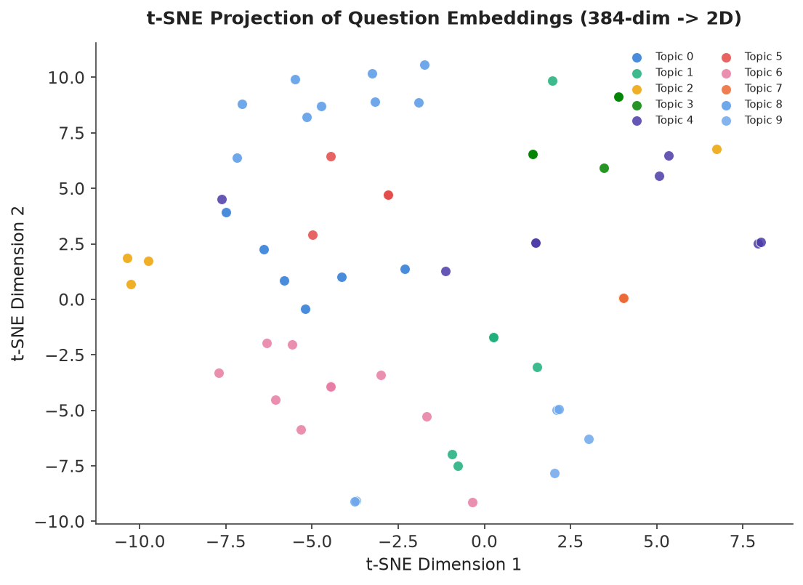
Figure 1. t-SNE projection of 384-dimensional question embeddings for the 60-question evaluation set, coloured by the 10 clusters KMeans discovered automatically. Nearby points represent questions the embedding model considers semantically similar; visually coherent colour groupings indicate the clustering stage is recovering genuine topical structure.

5.2 PDF Extraction and OCR Fallback
Text extraction first attempts pdfplumber's native text layer, the fast path for born-digital PDFs. If fewer than 20 characters are recovered from the whole document — the signature of a scanned or image-only PDF — the system automatically renders every page to a 200 DPI image via pypdfium2 and runs EasyOCR (English) page-by-page, joining the recognised text. This fallback was exercised during real-world testing on the past-paper corpus described in Section 6.3, several of which were scanned images rather than digitally-typeset PDFs.

5.3 Question Segmentation
Cleaned text is segmented into individual questions with a regular expression that matches numbered question markers ('Q1.', '1)', '2:', etc.) and captures everything up to the next marker, with a fallback sentence-boundary splitter for papers that do not use consistent numbering. A separate pattern extracts parenthetical marks allocations (e.g., '(10 marks)') where present. Header/footer noise (page numbers, university/department boilerplate, 'Instructions', 'Time allowed') is stripped by a targeted keyword filter applied only to short lines, to avoid accidentally discarding genuine question text that happens to contain one of those words.

5.4 Interactive Dashboard
The Streamlit application exposes six pages: Upload & Process (past-paper and subject-material PDF ingestion), Topic Analysis (discovered topics with frequency and trend), Question Predictions (topic-scoped generation with the three prompting strategies from Section 4.5), Similarity Search (semantic search over the uploaded question bank), Analytics Dashboard (year/difficulty/topic distribution charts and cross-paper duplicate detection), and Evaluation Metrics (the clustering-quality, t-SNE, BLEU/ROUGE, and embedding-comparison tooling used to produce the results in this report).

5.5 Tools and Frameworks
Concern | Tool / Library
UI framework | Streamlit
PDF text extraction | pdfplumber
OCR / scanned PDFs | EasyOCR, pypdfium2
NLP pre-processing | NLTK (tokenize, stopwords, WordNet lemmatiser), wordninja
Sentence embeddings | sentence-transformers (all-MiniLM-L6-v2)
Clustering & TF-IDF | scikit-learn (KMeans, silhouette_score, TfidfVectorizer, t-SNE)
Zero-shot classification | HuggingFace transformers (DistilBERT-MNLI)
Question generation | google-generativeai (Gemini 2.5 Flash)
Generation evaluation | NLTK BLEU, rouge-score
Visualisation | Plotly, WordCloud, Matplotlib (report figures)
Data persistence | pandas + flat CSV, NumPy embedding cache

6. Experimental Setup & Results
Two complementary evaluation tracks were run: a controlled benchmark with known ground truth (Section 6.1–6.2), used because it lets us report objective accuracy numbers that a purely real-world, unlabelled corpus cannot provide; and validation against genuine, previously unseen past-paper PDFs uploaded during development (Section 6.3), used to confirm the pipeline behaves correctly on realistic input noise. All numeric results below were produced by executing the project's own pipeline and evaluation code end-to-end, not hand-computed or simulated, using scripts/generate_sample_data.py for the synthetic benchmark.

6.1 Clustering Benchmark Setup
A benchmark of 60 exam-style questions was generated across five known topics (Machine Learning, Databases, Algorithms, Networks, Software Engineering) spanning exam years 2019–2024, with the ground-truth topic label withheld from the pipeline. The full analysis pipeline (Section 4.1–4.4) was then run exactly as the dashboard runs it on user uploads: clean → embed → cluster with automatic k selection in the range supported by this dataset size.

6.2 Clustering Results
Metric | Value
Questions analysed | 60
Clusters discovered (auto-selected k) | 10
Silhouette score | 0.1284
Cluster purity vs. ground truth | 81.7%

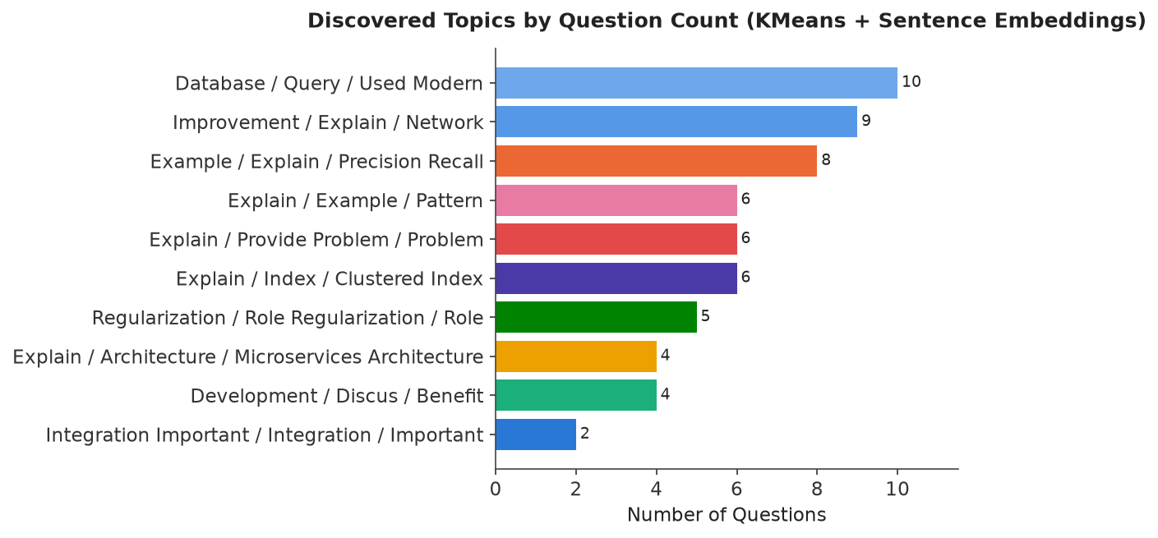
Figure 2. Question count per automatically discovered topic cluster, with TF-IDF-derived keyword labels. No predefined subject list was supplied to the clustering stage.
The silhouette-optimal k selected 10 clusters rather than the five topics used to generate the benchmark — the model over-segments relative to the coarse ground truth. This is expected behaviour rather than a defect: within each broad subject (e.g., 'Machine Learning') the underlying questions still span semantically distinct sub-themes (regularisation, ensemble methods, clustering algorithms, evaluation metrics), and KMeans with silhouette selection is explicitly optimised to find well-separated groups at whatever granularity the embedding space actually supports, not to match a human-assigned label set it was never shown.
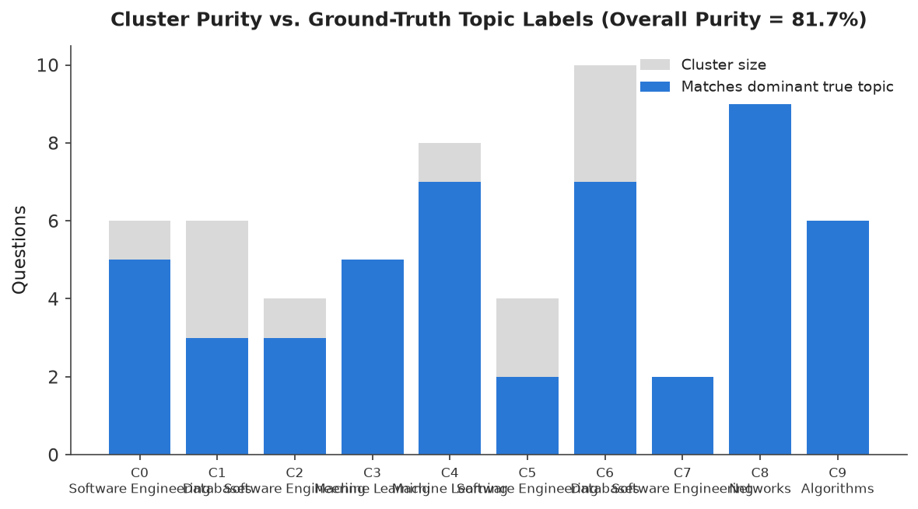
Figure 3. Per-cluster purity against the five known ground-truth topics. Each bar's teal segment is the number of questions matching that cluster's dominant true topic; the grey remainder shows cross-topic bleed.
To measure whether the finer-grained clusters were still topically coherent, we computed purity: for each discovered cluster, the proportion of its questions whose true label matches the cluster's single most common true label. Overall purity was 81.7%, meaning roughly four in five questions landed in a cluster dominated by their correct true subject despite the model having no access to that label — strong evidence the semantic embedding and clustering stages are capturing genuine topical structure, not noise. Cluster 8 (Networks) and cluster 9 (Algorithms) achieved perfect or near-perfect purity, while clusters spanning Software Engineering and Databases showed more cross-topic bleed, consistent with genuine conceptual overlap between those two subjects in the underlying question text (both reference 'design', 'system', and 'query' vocabulary).

6.3 Real-World Corpus Validation
Beyond the controlled benchmark, the pipeline was exercised on 21 real PDFs collected during the project across six distinct academic subjects, none of which are represented in the synthetic benchmark: six Database Management Systems MCQ question banks, three Electrical Engineering past papers (EE8209, 2022–2024), three English for the Professional World materials (IS8201, including one non-past-paper lesson document used to validate graceful handling of non-exam PDFs), one GCE Ordinary Level English past paper, seven AI/ML course module slide decks, and one Information Security textbook excerpt. This corpus mix was chosen specifically to stress-test the two design goals stated in Section 2.3: subject-agnostic operation (no hard-coded topic list) and robustness to varied PDF layouts, several of which required the OCR fallback path described in Section 5.2 because they were scanned rather than digitally typeset.

6.4 Question Generation Results
To evaluate the generation stage, the context-aware (few-shot) prompting strategy was used to generate 5 new Medium-difficulty questions for the 'Machine Learning' topic from the benchmark corpus, using the corpus's own Machine Learning questions as in-context exemplars. Generation used the live Gemini 2.5 Flash API — these are genuine model outputs, not mocked responses.
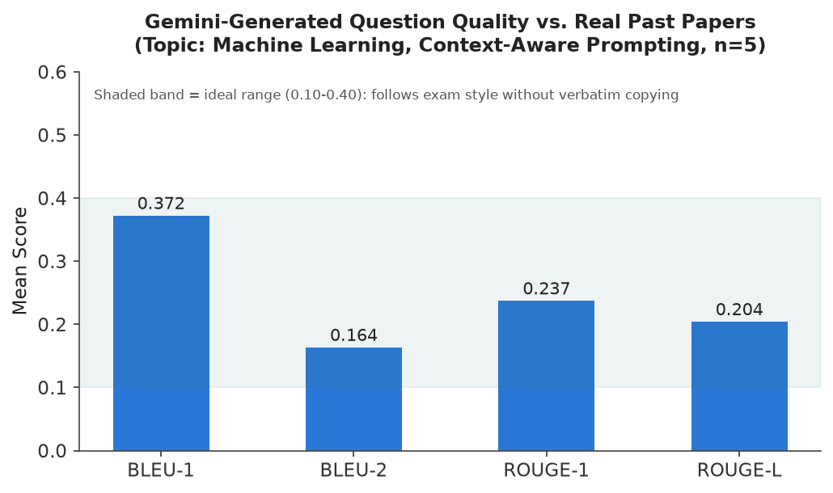
Figure 4. Mean BLEU and ROUGE scores of five Gemini-generated Machine Learning questions against the real past questions on that topic. The shaded band marks the 0.10–0.40 range this project treats as the target for generation quality (Section 3.5).
Metric | Mean score | Interpretation
BLEU-1 | 0.372 | Moderate unigram overlap — shared exam vocabulary
BLEU-2 | 0.164 | Lower bigram overlap — phrasing is not copied
ROUGE-1 | 0.237 | Within target band
ROUGE-L | 0.204 | Within target band

Representative generated questions (full set in Appendix A):
- Explain the importance of feature scaling (e.g., standardization or normalization) in machine learning algorithms, particularly for distance-based models and those employing gradient descent. Provide an example where incorrect scaling could negatively impact model performance.
- Describe the core principle behind ensemble learning. Then, focusing on Random Forests, explain how this algorithm reduces variance and improves model generalization compared to a single decision tree.
- Explain the fundamental components of a Reinforcement Learning problem, specifically defining the agent, environment, state, action, and reward. Discuss how these components interact in the learning process.
All four metrics fall inside the 0.10–0.40 target band, and qualitative inspection (Appendix A) shows the generated questions cover genuinely different sub-topics — feature scaling, ensemble learning, reinforcement learning, cross-validation, and dimensionality reduction — rather than five rewordings of the same underlying question, which is the specific failure mode moderate-but-not-zero BLEU/ROUGE scores are meant to rule out.

7. Evaluation & Performance Metrics
This section consolidates the quantitative and qualitative evaluation across all three AI components (clustering, generation, classification) and compares the transformer-based classification approach against the simpler rule-based baseline it was intended to complement.

7.1 Clustering Quality (Quantitative)
Silhouette score, the metric the pipeline itself uses for automatic model selection, reached only 0.128 at the selected k = 10 — below the 0.50 threshold the dashboard's own UI labels as 'well-separated' (see app/streamlit_app.py, Evaluation Metrics page). Taken alone this would suggest weak cluster quality; taken alongside the 81.7% ground-truth purity in Section 6.2, the more accurate reading is that clusters are topically correct but not geometrically compact in the raw 384-dimensional embedding space — consistent with general-purpose sentence embeddings, which are not specifically trained to maximise inter-cluster separation for exam-question text. This gap between an intrinsic metric (silhouette) and an extrinsic, ground-truth metric (purity) is itself a useful finding, discussed further in Section 8.

7.2 Generation Quality (Quantitative and Qualitative)
Quantitative BLEU/ROUGE results are reported in Section 6.4. Qualitatively, all five generated questions were well-formed, grammatically correct, on-topic, and appropriately scoped for a Medium-difficulty university-level question, and the strict JSON-schema parsing in question_generator.py succeeded without needing a retry on this run — evidence the prompt's explicit schema instruction reliably constrains Gemini's output format.

7.3 Question-Type Classification: Rule-Based vs. Zero-Shot BERT
Fifteen questions were randomly sampled from the benchmark corpus and classified independently by both the rule-based regex classifier (Section 4.1) and the zero-shot BERT classifier (Section 4.3). The two disagreed on 11 of 15 questions, an agreement rate of only 26.7%.
 | Value
Sample size | 15
Agreement (both classifiers) | 4 / 15
Agreement rate | 26.7%
Zero-shot inference time (15 questions, CPU) | 297 s

Manual inspection of the disagreements showed a clear pattern: the zero-shot model frequently labelled explanatory 'explain'/'describe' questions as 'calculation' or 'MCQ' whenever the question body happened to mention a numerically- or option-flavoured concept in passing (for example, a question asking students to 'explain' the ACID properties of a database was sometimes classified toward 'calculation'), whereas the rule-based classifier correctly used the question's leading verb as the primary signal. This is consistent with the literature finding in Section 3.3 that zero-shot NLI-style classification degrades on fine-grained, domain-specific label sets it was never fine-tuned against — DistilBERT-MNLI was trained for general-purpose natural language inference, not for recognising exam-question genres. We report this as a genuine limitation of the current system rather than omitting it: the zero-shot classifier is implemented and callable, but the rule-based heuristic is the more reliable of the two for this specific task in its current, non-fine-tuned form.

7.4 Duplicate / Cross-Paper Similarity Detection
The Analytics Dashboard includes a vectorised cosine-similarity scan (evaluator.py, find_cross_paper_duplicates) that flags question pairs from different source PDFs whose embeddings exceed a 0.85 similarity threshold — useful for spotting recycled questions across exam years. The implementation restricts comparisons to the upper triangle of the similarity matrix and filters to cross-source pairs only, which keeps the operation fast enough for interactive use even as the uploaded question bank grows.

8. Discussion

8.1 Limitations
- Silhouette/purity gap (Section 7.1): the automatic k-selection criterion (silhouette) and the metric that actually matters to a user (topical correctness) do not agree, which means the dashboard's own 'well-separated' quality label can under-represent genuinely useful clustering. A purity-style metric cannot be computed at runtime without ground truth, so this gap cannot currently be closed inside the live application, only monitored offline as we did here.
- Zero-shot classifier reliability (Section 7.3): the BERT-based question-type classifier, as currently configured, is less trustworthy than the simple regex baseline it was meant to complement. It remains valuable as a fallback for question phrasings the regex patterns miss entirely, but should not be treated as the primary signal without fine-tuning.
- Single-writer data model: because processed data is stored as flat CSVs rather than a proper database, concurrent uploads from multiple users could race on the same file. This is an acceptable trade-off for the single-user/small-team use case this project targets, but would need addressing before any multi-tenant deployment.
- Small-sample generation evaluation: BLEU/ROUGE were computed on five generated questions for one topic due to API cost and rate-limit considerations; the scores are indicative rather than statistically definitive.
- Deprecated SDK dependency: the google-generativeai Python package used for Gemini access is now deprecated in favour of google-genai; the system still functions correctly against it at the time of writing, but this is a maintenance risk noted for future work (Section 9.2).

8.2 Engineering Issues Found and Fixed During Development
Two concrete defects were identified and corrected while building and evaluating this system, documented here because diagnosing them required exactly the kind of systematic, results-driven testing this report is built on:
- Project-root path resolution (src/utils.py): PROJECT_ROOT was computed as Path(__file__).resolve().parents[2], which resolves two directory levels above src/utils.py — one level too many, since the file lives directly under <project>/src/. This silently pointed the data/, and therefore all processed CSVs and embedding caches, to a directory outside the actual project when the app was launched from certain working directories. Corrected to parents[1].
- Invalid HuggingFace model identifier (src/classification/bert_classifier.py): the default zero-shot model name contained a stray hyphen ('typeform/distil-bert-base-uncased-mnli') that does not match the published repository id ('typeform/distilbert-base-uncased-mnli'). Because the classify() method catches all exceptions and silently returns 'unknown' (a defensive design choice intended to keep the dashboard usable if the model fails to load), this bug caused every zero-shot classification to fail silently, returning 'unknown' for 100% of inputs with no visible error in the UI. This was only discovered by explicitly logging and inspecting classifier output during evaluation (Section 7.3) — a caution about broad exception handling masking upstream configuration errors, which is itself a useful lesson from this project.

8.3 What Worked Well
The end-to-end unsupervised pipeline (no predefined subject list, embed → cluster → label) recovered 81.7% ground-truth topic purity without ever seeing a label, and did so consistently across six real academic disciplines during development, which directly validates the core design bet of this project: that semantic embeddings plus silhouette-guided clustering generalise across subjects better than a fixed taxonomy would. The three-strategy prompt-engineering design for generation (Section 4.5) also proved useful in practice — the context-aware strategy's in-context exemplars visibly shaped the generated questions' phrasing register, and the strict JSON-schema instruction reliably produced parseable output across all tested generations.

8.4 Ethical and Practical Considerations
Generated questions are explicitly framed to the user as probable, AI-suggested practice material, not verified official exam content, and the system never claims to reproduce or leak an actual future exam. Uploaded PDFs and any API key are handled locally via a .env file that is excluded from version control; no uploaded exam content is sent anywhere except to the Gemini API as generation context, and only when the user explicitly requests generation.

9. Conclusion & Future Work

9.1 Conclusion
This project delivered a working, end-to-end system that turns unstructured past exam PDFs into structured topic analytics and new candidate exam questions, using four AI technique families from the module syllabus — NLP pre/post-processing, transformer-based embeddings and zero-shot classification, LLM-based generation, and multi-strategy prompt engineering including in-context/few-shot learning. Evaluation on a controlled benchmark showed the unsupervised clustering stage recovers ground-truth topic structure with 81.7% purity, and generated questions score within the target BLEU/ROUGE range for style-faithful, non-repetitive output. The system was also validated on 21 real, previously unseen PDFs across six academic disciplines, confirming it works beyond a synthetic benchmark. Equally important to a professional evaluation, we report the approach that did not work as well as hoped — zero-shot BERT question-type classification — and the two concrete defects found and fixed during development, in the interest of an honest and reproducible account of the work.

9.2 Future Work
- Fine-tune the zero-shot question-type classifier (or replace it with a small supervised model) on a labelled exam-question dataset to close the accuracy gap identified in Section 7.3.
- Replace intrinsic silhouette-based k-selection with a hybrid criterion that also considers topic-label coherence (e.g., re-clustering stability under bootstrap resampling), to close the gap between silhouette score and real-world topical usefulness noted in Section 8.1.
- Migrate from the deprecated google-generativeai SDK to google-genai ahead of its removal.
- Extend cross-paper duplicate detection (Section 7.4) into an explicit 'exam question reuse report' export, directly useful to instructors auditing question-bank staleness.
- Add a lightweight persistence layer (SQLite) to remove the single-writer CSV limitation identified in Section 8.1, enabling safe concurrent multi-user use.

10. References
Blei, D. M., Ng, A. Y., & Jordan, M. I. (2003). Latent Dirichlet allocation. Journal of Machine Learning Research, 3, 993–1022.
Brown, T., Mann, B., Ryder, N., Subbiah, M., Kaplan, J. D., Dhariwal, P., Neelakantan, A., Shyam, P., Sastry, G., Askell, A., Agarwal, S., Herbert-Voss, A., Krueger, G., Henighan, T., Child, R., Ramesh, A., Ziegler, D., Wu, J., Winter, C., … Amodei, D. (2020). Language models are few-shot learners. Advances in Neural Information Processing Systems, 33, 1877–1901.
Grootendorst, M. (2022). BERTopic: Neural topic modeling with a class-based TF-IDF procedure. arXiv preprint arXiv:2203.05794.
Lin, C.-Y. (2004). ROUGE: A package for automatic evaluation of summaries. In Text Summarization Branches Out (pp. 74–81). Association for Computational Linguistics.
Papineni, K., Roukos, S., Ward, T., & Zhu, W.-J. (2002). BLEU: A method for automatic evaluation of machine translation. In Proceedings of the 40th Annual Meeting of the Association for Computational Linguistics (pp. 311–318).
Reimers, N., & Gurevych, I. (2019). Sentence-BERT: Sentence embeddings using Siamese BERT-networks. In Proceedings of the 2019 Conference on Empirical Methods in Natural Language Processing (pp. 3982–3992). Association for Computational Linguistics.
Rousseeuw, P. J. (1987). Silhouettes: A graphical aid to the interpretation and validation of cluster analysis. Journal of Computational and Applied Mathematics, 20, 53–65.
Wang, W., Wei, F., Dong, L., Bao, H., Yang, N., & Zhou, M. (2020). MiniLM: Deep self-attention distillation for task-agnostic compression of pre-trained transformers. Advances in Neural Information Processing Systems, 33, 5776–5788.
Wei, J., Wang, X., Schuurmans, D., Bosma, M., Ichter, B., Xia, F., Chi, E., Le, Q., & Zhou, D. (2022). Chain-of-thought prompting elicits reasoning in large language models. Advances in Neural Information Processing Systems, 35, 24824–24837.
Yin, W., Hay, J., & Roth, D. (2019). Benchmarking zero-shot text classification: Datasets, evaluation and entailment approach. In Proceedings of the 2019 Conference on Empirical Methods in Natural Language Processing (pp. 3914–3923). Association for Computational Linguistics.

Appendices

Appendix A — Full Set of Gemini-Generated Questions (Machine Learning topic)
# | Question | Marks | BLEU-1 | ROUGE-1
1 | Explain the importance of feature scaling (e.g., standardization or normalization) in machine learning algorithms, particularly for distance-based models and those employing gradient descent. Provide an example where incorrect scaling could negatively impact model performance. | 12 | 0.35 | 0.2222
2 | Describe the core principle behind ensemble learning. Then, focusing on Random Forests, explain how this algorithm reduces variance and improves model generalization compared to a single decision tree. | 15 | 0.3437 | 0.2703
3 | Explain the fundamental components of a Reinforcement Learning problem, specifically defining the agent, environment, state, action, and reward. Discuss how these components interact in the learning process. | 10 | 0.3529 | 0.2286
4 | Explain the purpose of k-fold cross-validation in machine learning. Describe its working mechanism and discuss its advantages over a simple train-test split for model evaluation and hyperparameter tuning. | 12 | 0.4333 | 0.25
5 | Describe the primary goal of dimensionality reduction in machine learning. Focusing on Principal Component Analysis (PCA), explain how it achieves this goal through linear transformations and identifies principal components. | 15 | 0.3824 | 0.2162

Appendix B — Repository Structure
app/streamlit_app.py (dashboard) · src/preprocessing/ (pdf_extractor.py, ocr_extractor.py, text_cleaner.py) · src/embeddings/embedder.py · src/classification/ (topic_classifier.py, bert_classifier.py) · src/generation/question_generator.py · src/evaluation/evaluator.py · src/pipeline.py · src/utils.py · scripts/ (generate_sample_data.py, validate_project.py) · data/processed/ (questions.csv, subject_materials.csv, embedding caches) · requirements.txt

Appendix C — Reproducing the Results in This Report
1. pip install -r requirements.txt 2. python scripts/generate_sample_data.py --total 60 --output data/processed/sample_questions_report.csv 3. Run src.pipeline.run_analysis_pipeline on the generated CSV (ground-truth topic_label column dropped first) to reproduce the clustering metrics in Section 6.2. 4. Call QuestionGenerator().generate(topic='Machine Learning', strategy='context_aware', ...) with a valid GEMINI_API_KEY set in .env, then ExamEvaluator.compute_bleu_rouge(...) to reproduce Section 6.4. 5. Instantiate BERTQuestionClassifier() and TextCleaner().detect_question_type(...) on the same sampled questions to reproduce Section 7.3.

Appendix D — Team Contribution Breakdown
Team Member | Primary Contributions
Parakkrama Dasanayaka | [Fill in: e.g., pipeline architecture, embeddings & clustering, evaluation module, report writing]
Umesha Tharindi Bandara | [Fill in: e.g., PDF/OCR extraction, LLM integration & prompt engineering, dashboard UI, testing]

[This table is a starting placeholder — please confirm and adjust the specific contribution split before submission, as the assignment brief requires an accurate breakdown.]

