**Problem 1**

**Part A**

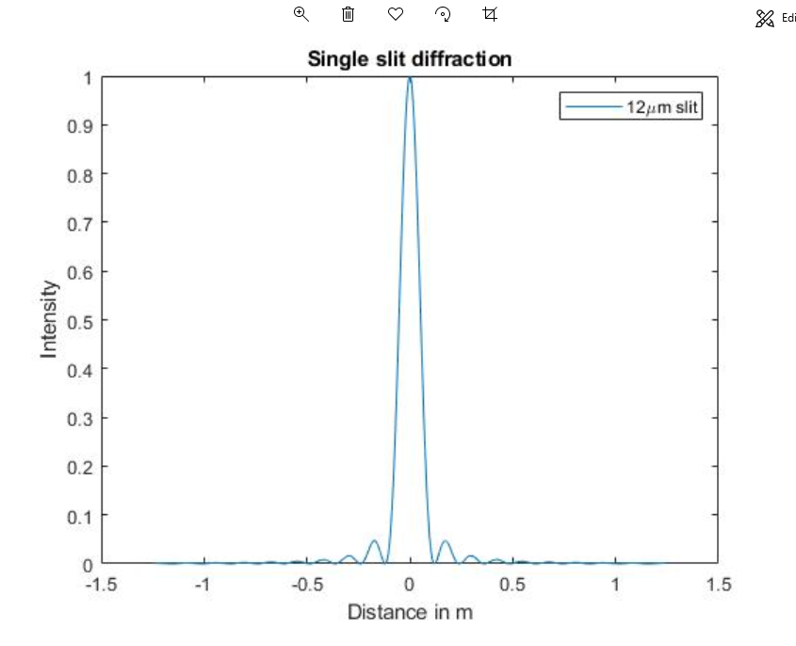

**Part B**

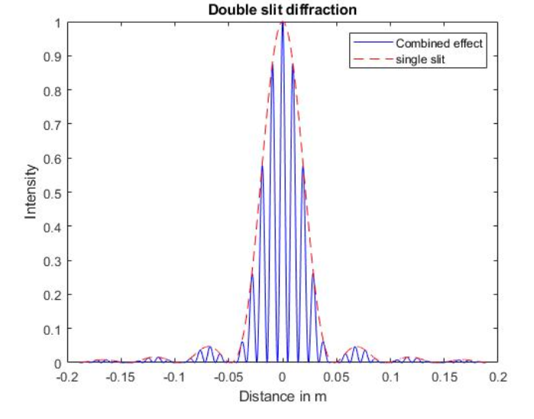

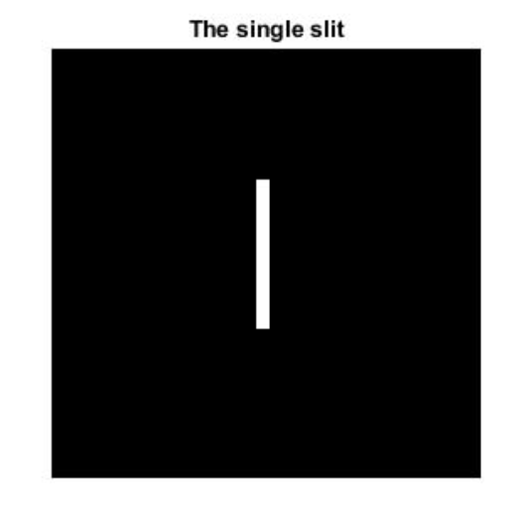 **Problem 2-Question 1**

According to this image, the black color was represented the 0 Bit number and the white slit was represented the 255 Bit number. Therefore, this image can be read as the Bit numbers matrix. Furthermore, some of the results were shown below.

0 0 0 0 0 0 0 0 0 0 0 0 0 0 0 0 0 0 0 0

0 0 0 0 0 0 0 0 0 0 0 0 0 0 0 0 0 0 0 0

0 0 0 0 0 0 0 0 0 0 0 0 0 0 0 0 0 0 0 0

0 0 255 255 255 255 255 255 255 255 0 0 0 0 0 0 0 0 0 0

0 0 255 255 255 255 255 255 255 255 0 0 0 0 0 0 0 0 0 0

0 0 255 255 255 255 255 255 255 255 0 0 0 0 0 0 0 0 0 0

0 0 255 255 255 255 255 255 255 255 0 0 0 0 0 0 0 0 0 0

0 0 255 255 255 255 255 255 255 255 0 0 0 0 0 0 0 0 0 0

0 0 255 255 255 255 255 255 255 255 0 0 0 0 0 0 0 0 0 0

0 0 255 255 255 255 255 255 255 255 0 0 0 0 0 0 0 0 0 0

0 0 255 255 255 255 255 255 255 255 0 0 0 0 0 0 0 0 0 0

0 0 255 255 255 255 255 255 255 255 0 0 0 0 0 0 0 0 0 0

0 0 255 255 255 255 255 255 255 255 0 0 0 0 0 0 0 0 0 0

0 0 255 255 255 255 255 255 255 255 0 0 0 0 0 0 0 0 0 0

0 0 255 255 255 255 255 255 255 255 0 0 0 0 0 0 0 0 0 0

0 0 255 255 255 255 255 255 255 255 0 0 0 0 0 0 0 0 0 0

0 0 255 255 255 255 255 255 255 255 0 0 0 0 0 0 0 0 0 0

0 0 255 255 255 255 255 255 255 255 0 0 0 0 0 0 0 0 0 0

0 0 255 255 255 255 255 255 255 255 0 0 0 0 0 0 0 0 0 0

0 0 255 255 255 255 255 255 255 255 0 0 0 0 0 0 0 0 0 0

0 0 255 255 255 255 255 255 255 255 0 0 0 0 0 0 0 0 0 0

0 0 255 255 255 255 255 255 255 255 0 0 0 0 0 0 0 0 0 0

0 0 255 255 255 255 255 255 255 255 0 0 0 0 0 0 0 0 0 0

0 0 255 255 255 255 255 255 255 255 0 0 0 0 0 0 0 0 0 0

0 0 255 255 255 255 255 255 255 255 0 0 0 0 0 0 0 0 0 0

0 0 255 255 255 255 255 255 255 255 0 0 0 0 0 0 0 0 0 0

0 0 255 255 255 255 255 255 255 255 0 0 0 0 0 0 0 0 0 0

0 0 255 255 255 255 255 255 255 255 0 0 0 0 0 0 0 0 0 0

0 0 255 255 255 255 255 255 255 255 0 0 0 0 0 0 0 0 0 0

0 0 255 255 255 255 255 255 255 255 0 0 0 0 0 0 0 0 0 0

0 0 255 255 255 255 255 255 255 255 0 0 0 0 0 0 0 0 0 0

**Problem 2-Question 2**

MATLAB syntaxes of “imshow”,”imread”, and ”imhist” can be used for extracting spectral information from a single slit image.

* imshow(filename) displays the image stored in the graphics file specified by filename.
* imread(filename) reads the image from the file specified by filename, inferring the format of the file from its contents. If filename is a multi-image file, then imread reads the first image in the file.
* imhist(filename) calculates the histogram for the intensity image I and displays a plot of the histogram. The number of bins in the histogram is determined by the image type.

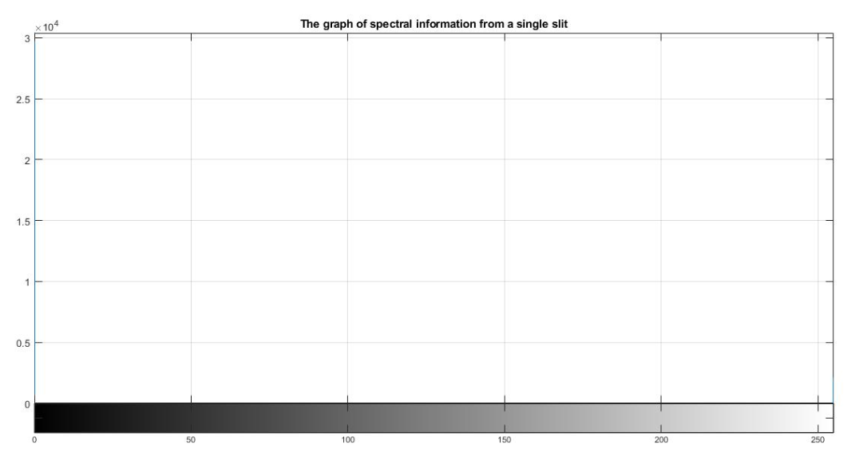

According to the graph of spectral information from a single slit which was identified that how it has spread the 0-bit number-black color to 255-bit number- white color.

**Problem 2-Question 3**

**Red spectrum**

**Green spectrum**

**Blue spectrum**

**Problem 2-Question 4**

MATLAB syntax of “fft(x)”, “abs(F)”, “rgb2gray”, “imread”, “imshow” can be used for Fourier transformations.

* fft(X) computes the discrete Fourier transform (DFT) of X using a fast Fourier transform (FFT) algorithm.
* abs(X) returns the absolute value of each element in array X.
* rgb2gray(RGB) converts the true color image RGB to the grayscale intensity image . The rgb2gray function converts RGB images to grayscale by eliminating the hue and saturation information while retaining the luminance. If it has Parallel Computing Toolbox™ installed, rgb2gray can be performed this conversion on a GPU.
* figure syntax creates a new figure window using default property values. The resulting figure is the current figure.

The Fast Fourier Transform (FFT) is the sampled Fourier Transform and therefore does not contain all frequencies forming an image, but only a set of samples which is large enough to fully describe the spatial domain image. The number of frequencies corresponds to the number of pixels in the spatial domain image, according to the above images in the Fourier domain and its log domain are the output of the transformation represents the image in the Fourier or frequency domain, while the input image is the spatial domain equivalent. In the Fourier domain image, each point represents each frequency contained in the spatial domain image.

**Problem 2-Question 5**

2D far-field of the center diffraction pattern for the single slit

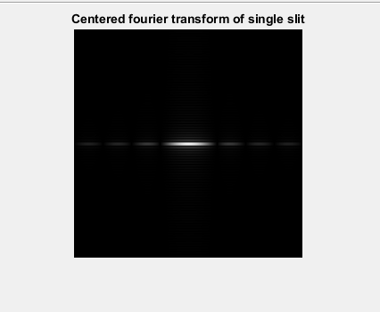

**Problem 2-Question 6**

The intensity pattern of a single slit with a horizontal cross-section of the lines

The intensity pattern of a single slit in a 1D plot

**Problem 2-Question 7**

According to the plot of a single slit, 1D diffraction pattern distance from the slit to the screen is greater than single slit width away from the slit. Therefore, the intensity is a function of angle. Diffraction is shown that each part of the slit can be thought of as an emitter of waves. The 1D single slit diffraction plot is shown that all the intensities interfere to produce the diffraction pattern. It has constructive interference and where spot meets through it has destructive interference.

The 2D diffraction pattern given by a rectangular aperture is shown in the problem2-question6 figure. There is a central peak, with a series of horizontal and vertical fringes. It is defined that dimensions of the central band are related to the dimensions of the slit by the same relationship as for a single slit so that the larger dimension in the diffracted image corresponds to the smaller dimension in the slit. The spacing of the fringes is also inversely proportional to the slit dimension. If the illuminating beam does not illuminate the whole length of the slit, the spacing of the vertical fringes is determined by the dimensions of the illuminating beam.

**Problem 2-Question 8**

**Green spectrum for the double slits**

**Blue spectrum for the double slits**

**Problem 2-Question 9**

The diffraction pattern of two slits of width that are separated by a distance between two slits in the interference pattern of two-point sources separated. The solid line with multiple peaks of various heights is the intensity observed on the plot. It is a product of the interference pattern of waves from separate slits and the diffraction of waves from within one slit.

According to the plot of double slits 2D diffraction pattern, Interference and diffraction effects operate simultaneously and generally produce minimum at different angles. This gives rise to a complicated pattern on the plot, in which some of the maximum interference from the two slits are missing if the maximum of the interference is in the same direction as the minimum of the diffraction. Close examination of the double-slit diffraction pattern shows that there are very fine horizontal diffraction fringes above and the main spot, as well as the more obvious horizontal fringes.