**Exp.No: 10**

**Date:18.9.25 Storage Virtualization**

**AIM**

To implement storage virtualization using Logical Volume Management (LVM)

**THEORY:**

**Storage Virtualization using LVM**

Storage virtualization allows flexible management of storage independent of physical disks. Using Logical Volume Management (LVM) in Linux, one or more physical disks (PVs) are combined into a Volume Group (VG), from which Logical Volumes (LVs) are created. These LVs can be resized, extended, formatted, and mounted like normal disks, providing efficient and easy-to-manage storage.

**PROCEDURE:**

**Storage Extension Steps:**

**Step 1: Add Additional Storage to VM**

1. In VirtualBox, select your VM and click **Settings**
2. Go to **Storage**
3. Click on **Controller: SATA**
4. Click the **Add Hard Disk** icon (+ symbol)

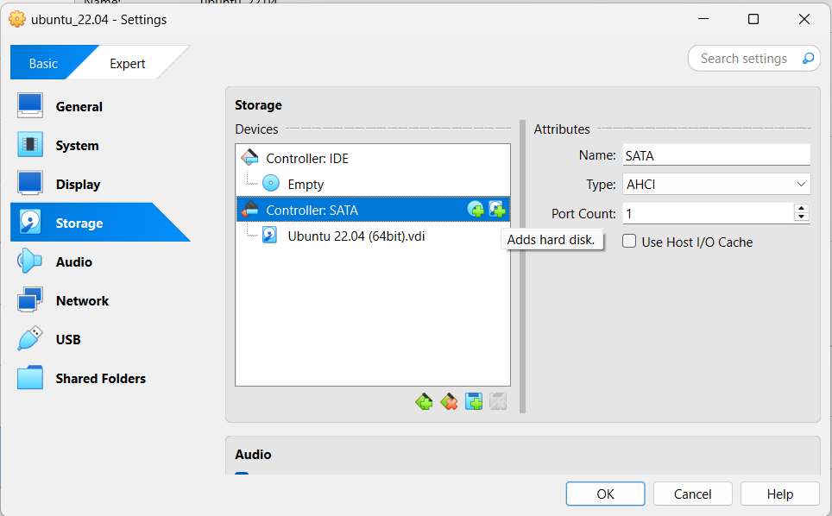

1. Choose **Create new disk** > Allot size > Click Finish

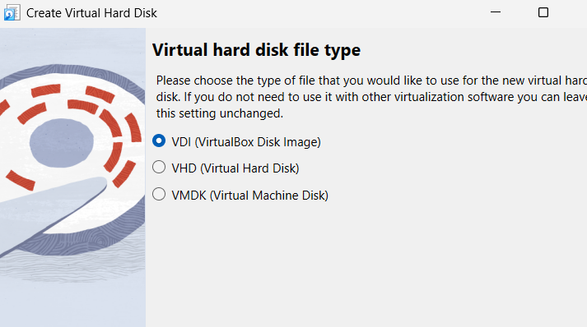 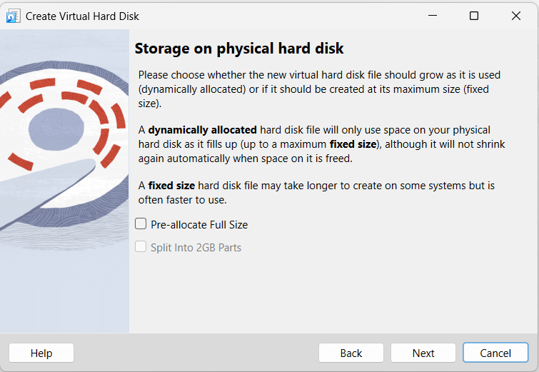

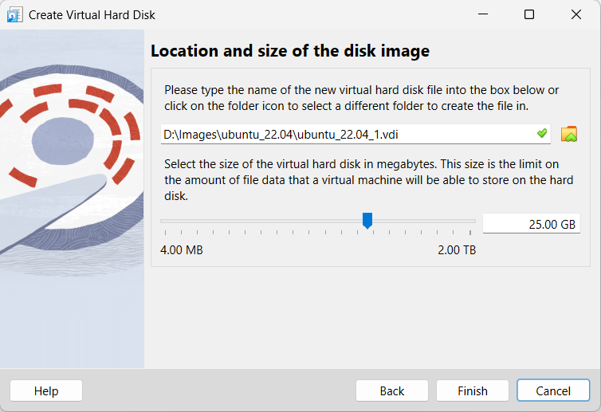 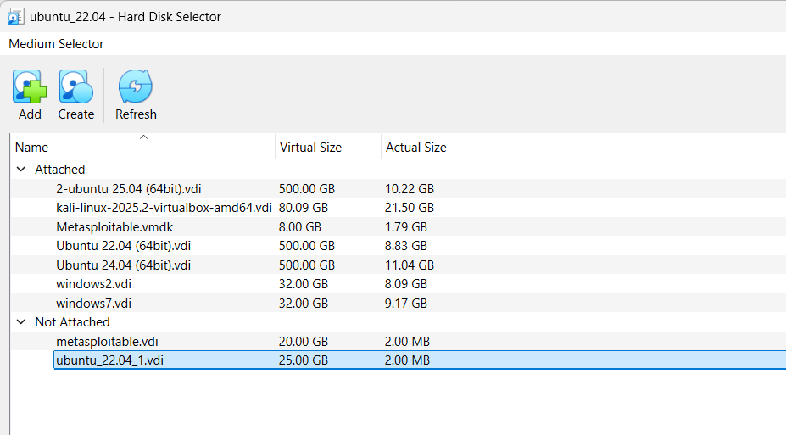

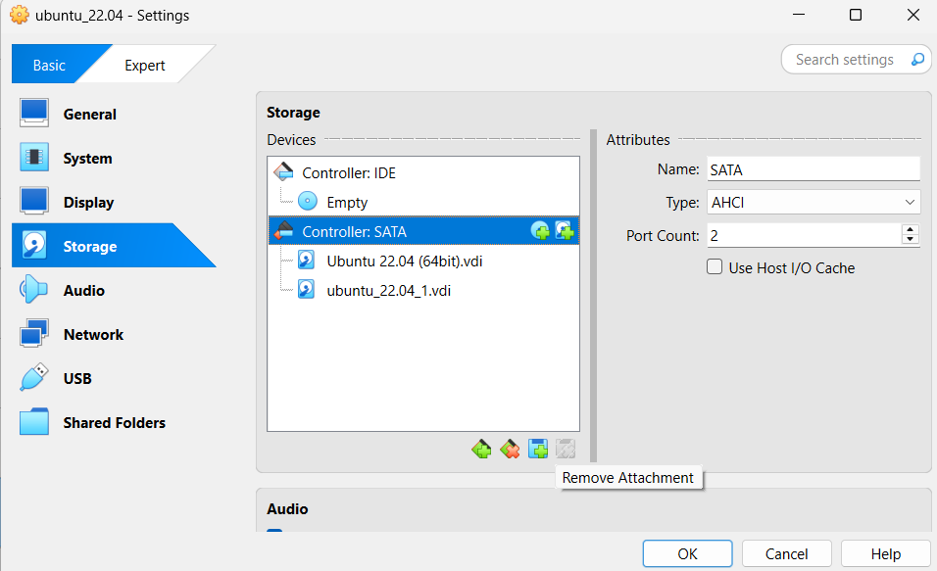

**Step 2: Boot VM and Execute Commands**

After adding the disk, boot your Ubuntu VM and open Terminal:

1. Switch to root user

sudo -s

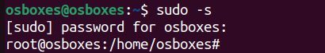

1. List all disks and partitions

fdisk -l

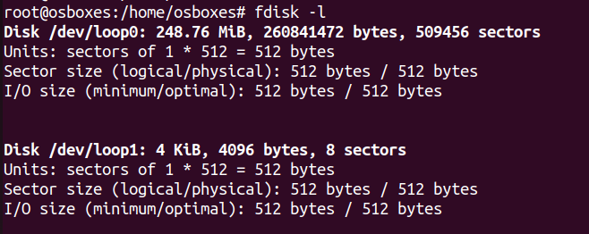

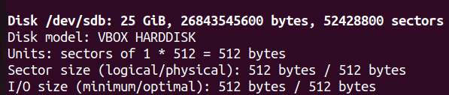

1. Display physical volumes

pvdisplay

1. Display volume groups

vgdisplay

1. Display logical volumes

Lvdisplay

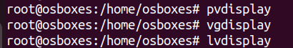

1. Create physical volume

pvcreate /dev/sdb

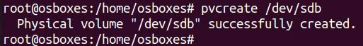

1. Create LVM on the new disk

vgcreate demo-vg /dev/sdb



lvcreate -L 10G -n demo-lv demo-vg



1. Create filesystem and mount

mkfs.ext4 /dev/demo-vg/demo-lv

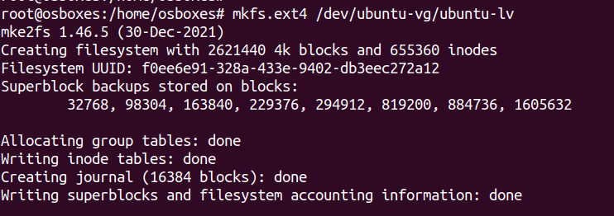

mkdir /mnt/lvm-demo



mount /dev/demo-vg/demo-lv /mnt/lvm-demo



1. Resize logical volume (adjust size as needed)

lvresize --size +12G ubuntu-vg/ubuntu-lv # Common LV name



1. Check current disk usage

df -h

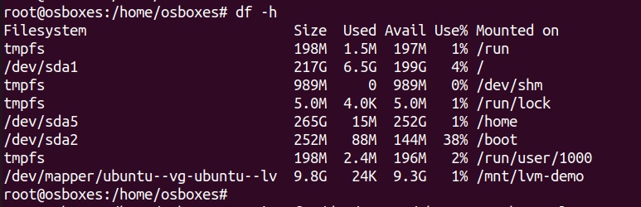

1. Resize filesystem

resize2fs /dev/mapper/ubuntu-vg-ubuntu-lv

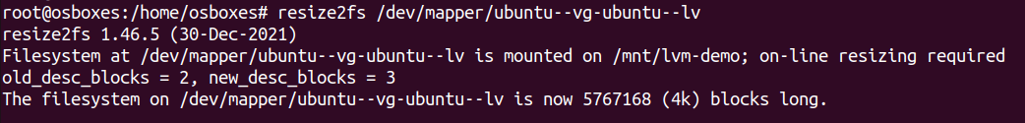

1. Verify the extension

df -h

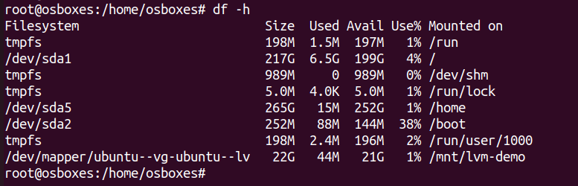

**RESULT:**

Thus, the storage virtualization was implemented using LVM.