Software Requirements Specification (SRS)

Structural Authority Mapping System (OrgMap)

1. Introduction

1.1 Purpose
The purpose of this document is to outline the requirements for the Structural Authority Mapping System (OrgMap), a MERN-stack web application designed for interactive organizational charting and authority management.

1.2 Scope
OrgMap allows users to visualize, manage, and modify organizational hierarchies using a “Figma-like” infinite canvas. It supports complex reporting structures (multiple managers), automated node-locking, and seamless data synchronization between a canvas and a hierarchical list.

2. Technical Stack
- Frontend: React.js, Tailwind CSS (Dark Mode), React Flow (Canvas Engine).
- Backend: Node.js, Express.js.
- Database: MongoDB (Mongoose for Schema).
- Media: Cloudinary (Image Uploads).
- Tools: React Flow for node-edge management.

3. Core Features & Functional Requirements

3.1 Main Screen (Playground Canvas)
- Infinite Canvas: A drag-and-pan workspace similar to Figma or Photoshop.
- Interactive Nodes:
  - Circular avatars/nodes representing individuals.
  - Name and designated role displayed below the node.
  - Hover State: Tooltip displaying a brief bio, contact info, and current project.
  - PFP Hover: Displays an “Edit” button for modifying user details.
- Vertical Spanning Tree (PRIORITY):
  - Orientation: Vertical Spanning Tree layout (Top-to-Bottom flow).
  - Connections: Straight, technical connection lines between parents and subordinates.
  - Auto-Locking System: If a node is dragged near another node, it automatically “locks in” as a subordinate.
  - Multi-Parent Support: Supports complex reporting lines (Direct Acyclic Graph).

3.2 Sidebars

3.2.1 Primary Left Sidebar (The Toolbox)
- Integrated Design: Uses the specific ‘OrgMap Technical’ left sidebar design.
- People Section: Search bar, role-based categories (Managers, Seniors, Interns), expandable person info, and drag handles.
- Action Zone: ‘Add Person’ button, ‘Import from Excel’ (with cloud icon), and ‘Projects’ management (Create New, Recent, Share).

3.2.2 Right Sidebar (Hierarchy Manager)
- Collapsible Panel: Multi-level hierarchical list representation of the canvas.
- Bi-directional Sync: Drag-to-reorder in the list updates the canvas structure instantly.

4. Implementation Roadmap
Phase | Milestone | Deliverables
Phase 1 | Frontend & Connection | Core UI shell (Dark Mode), React Flow initialization (Vertical Spanning), and API connectivity.
Phase 2 | Core Drag-and-Drop (PRIORITY) | Infinite canvas dragging, straight-line connections, and the Auto-Locking system.
Phase 3 | Logic & Integration | Backend relationship mapping, multi-parent support, and Cloudinary PFP uploads.
Phase 4 | Integrated Sidebars | Full Left Sidebar (Toolbox) and Right Sidebar (Sync Manager) implementation.
Phase 5 | Batch Tools & Polish | Excel import processing and high-fidelity glassmorphic animations.

5. Design & Workflow
- User drags a person from the Left Sidebar onto the Canvas.
- User positions the node vertically relative to a parent; the Auto-Locking system draws a straight connection line.
- The Right Sidebar list reflects the new hierarchy position.

Appendix: Final Design Mockup
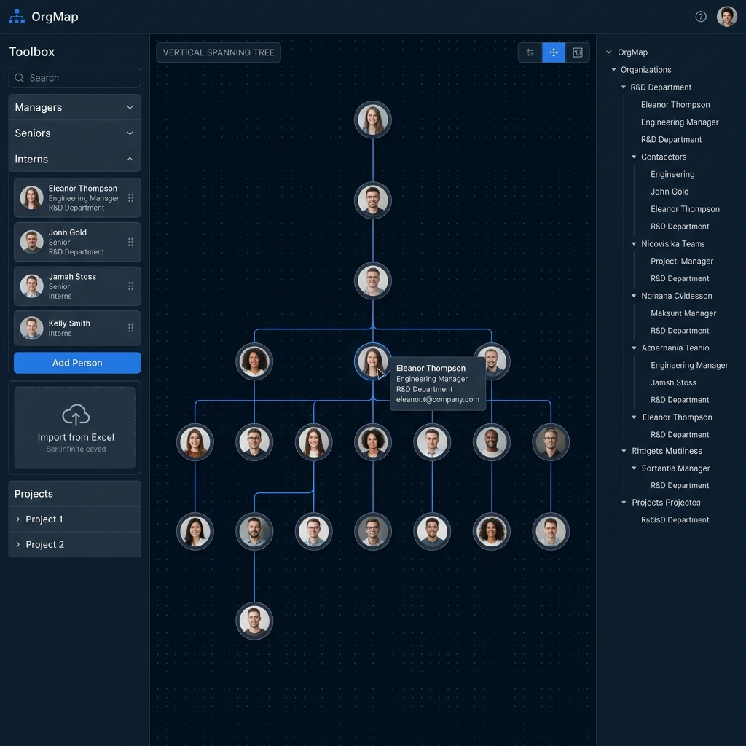
OrgMap Final Vertical Spanning Tree Design

