Software Requirements Specification (SRS)

Structural Authority Mapping System (OrgMap)

1. Introduction

1.1 Purpose
The purpose of this document is to outline the requirements for the Structural Authority Mapping System (OrgMap), a MERN-stack web application designed for interactive organizational charting and authority management.

1.2 Scope
OrgMap allows users to visualize, manage, and modify organizational hierarchies using a “Figma-like” infinite canvas. It supports complex reporting structures (multiple managers), automated node-locking, and seamless data synchronization between a canvas and a hierarchical list.

2. Technical Stack
- Frontend: React.js, Tailwind CSS (Dark Mode), React Flow (Canvas Engine).
- Backend: Node.js, Express.js.
- Database: MongoDB (Mongoose for Schema).
- Media: Cloudinary (Image Uploads).
- Tools: React Flow for node-edge management.

3. Core Features & Functional Requirements

3.1 Main Screen (Playground Canvas)
- Infinite Canvas: A drag-and-pan workspace (playground mat) similar to design tools like Figma or Photoshop.
- Interactive Nodes:
  - Circular avatars/nodes representing individuals.
  - Name and designated role displayed below the node.
  - Hover State: Tooltip displaying a brief bio, contact info, and current project.
  - PFP Hover: Displays an “Edit” button for modifying user details.
- Drag-and-Drop Workflow (PRIORITY):
  - Free-floating nodes can be dragged and dropped anywhere on the mat.
  - Auto-Locking System: If a node is dragged near another node, it automatically “locks in” as a subordinate, creating a visual connection.
  - Multi-Parent Support: A single person can report to multiple managers (DAG structure).

3.2 Sidebars

3.2.1 Left Sidebar (The Toolbox)
- People Section:
  - Search bar for quick filtering.
  - Categorized dropdowns (Managers, Seniors, Interns, etc.).
  - Drag-to-Canvas capability: Dragging a name from the list onto the mat creates a new node.
- Import Section:
  - “Import from Excel” feature to batch-add people to the database.
- Projects Section:
  - Switch between different project hierarchies.
  - Create New, Open Recent, and Share Project buttons.

3.2.2 Right Sidebar (Hierarchy Manager)
- Collapsible Panel: Stays visible but can be toggled to minimize.
- Multi-Level List: A tree-view list representing the structure on the canvas.
- Synchronization: Changes in the list (e.g., reordering via drag) reflect on the canvas connections instantly, and vice versa.
- Action Buttons: “Edit” and “Create New” at the bottom.

4. Updated Phases of Implementation
Phase | Milestone | Deliverables
Phase 1 | Frontend & Connection | Build core UI components (Dark Mode), initial React Flow setup, and basic Express server connectivity.
Phase 2 | Core Drag-and-Drop (PRIORITY) | Implement infinite canvas dragging, custom node interactions, and the Auto-Locking system for node relationships.
Phase 3 | Hierarchy Logic & Sync | Backend relationship mapping (MongoDB), multi-parent support, and bi-directional sync between sidebar list and canvas.
Phase 4 | Integrated Sidebars | Full implementation of Left Sidebar (Toolbox) and Right Sidebar (Hierarchy Manager) UI/UX.
Phase 5 | Cloudinary & Batch Tools | Cloudinary image upload integration and Excel import batch processing.
Phase 6 | Polish & Optimization | Performance tuning for large hierarchies, hover micro-animations, and glassmorphic UI refinement.

5. Design & Workflow
- User Interaction: User drags a person from the Left Sidebar onto the Canvas.
- Persistence: A POST request is sent to MongoDB. The new node appears as a floating element.
- Logic: User drags Node B near Node A. React Flow detects collision/proximity and updates the edges state.
- Sync: The Right Sidebar hierarchy list refreshes to show Node B under Node A.

Appendix: Design Mockups
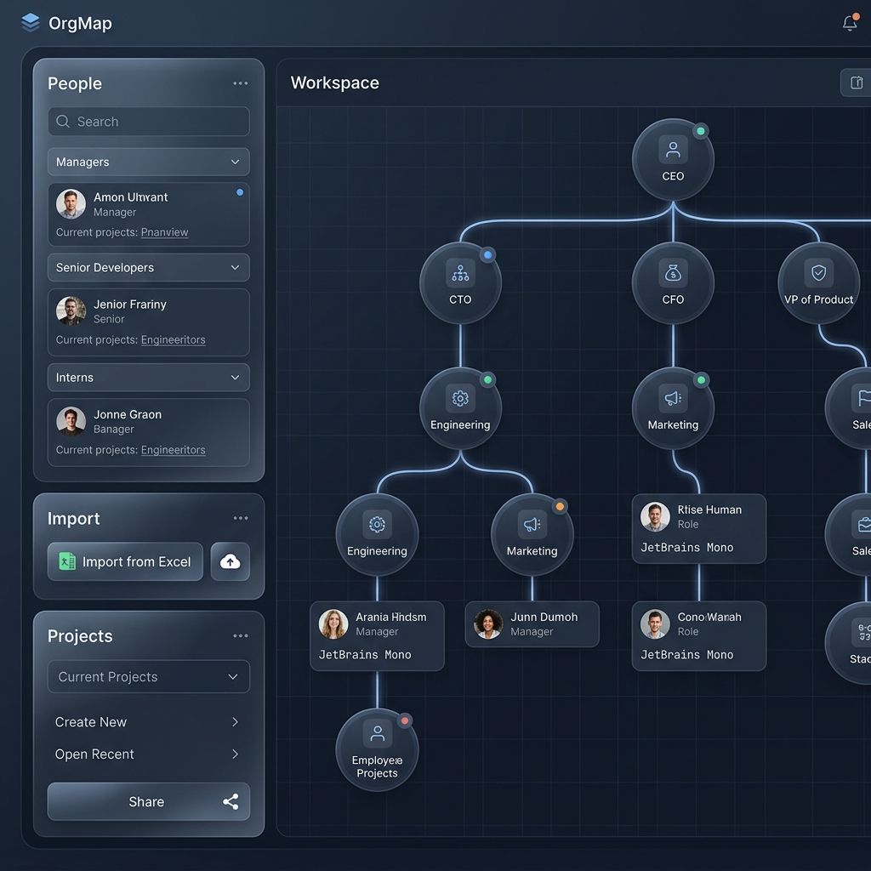
OrgMap Primary Interface Design Mockup

