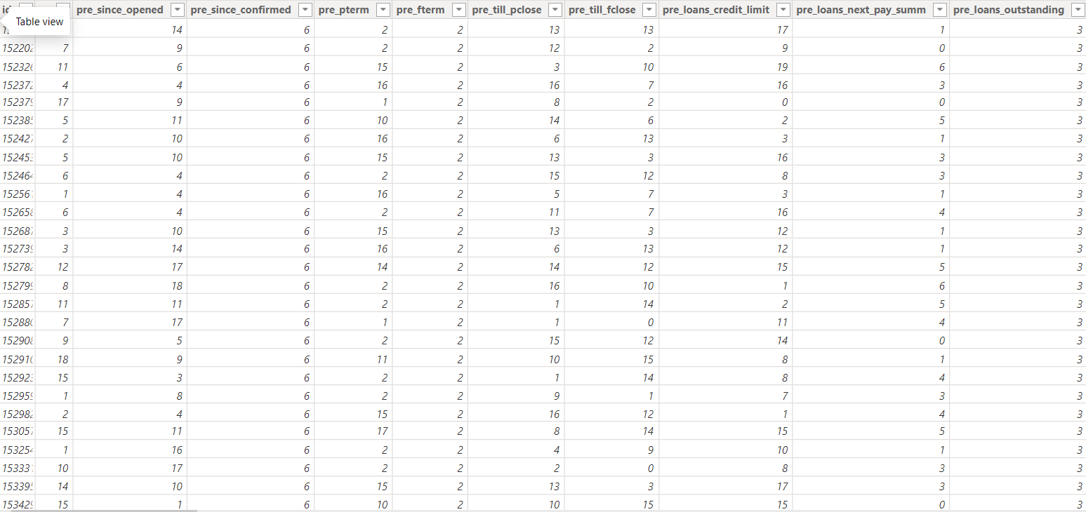
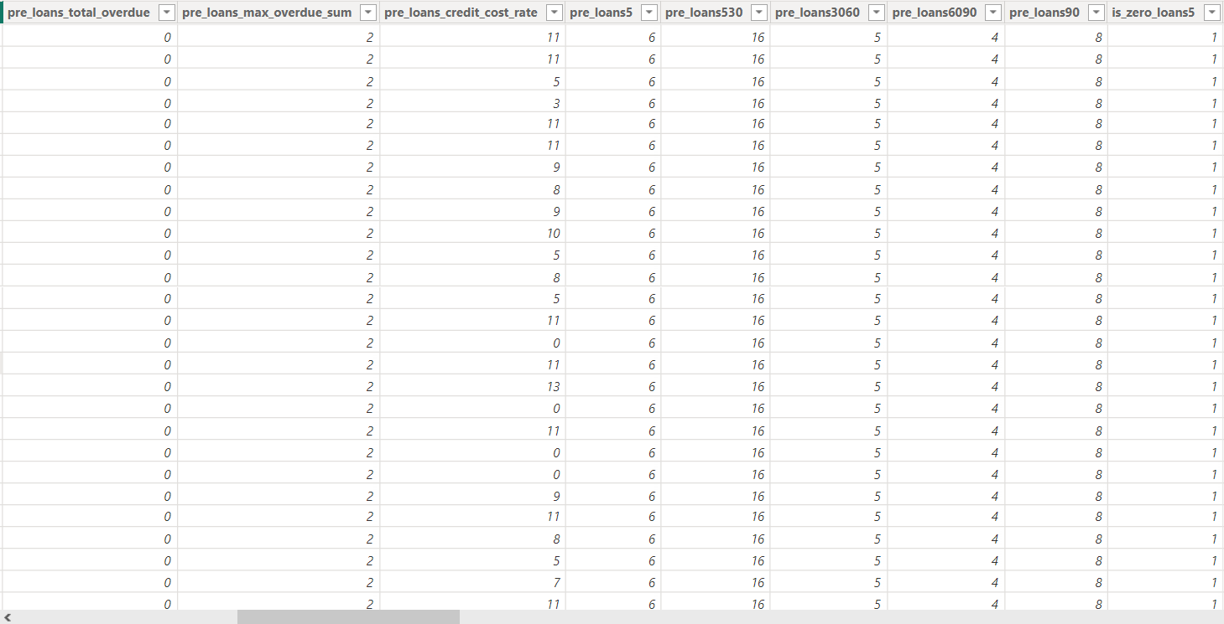
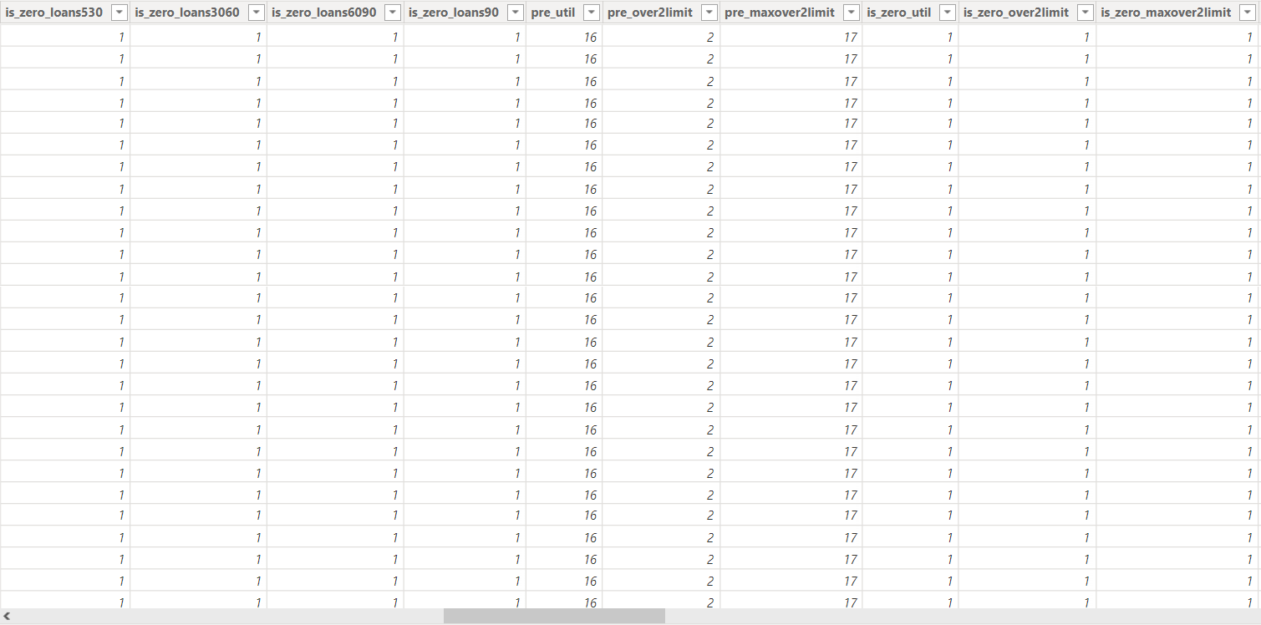
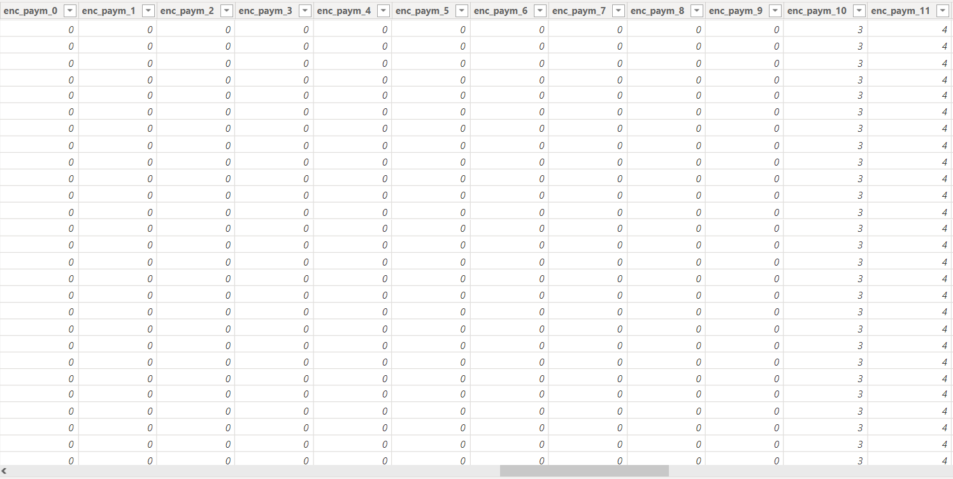
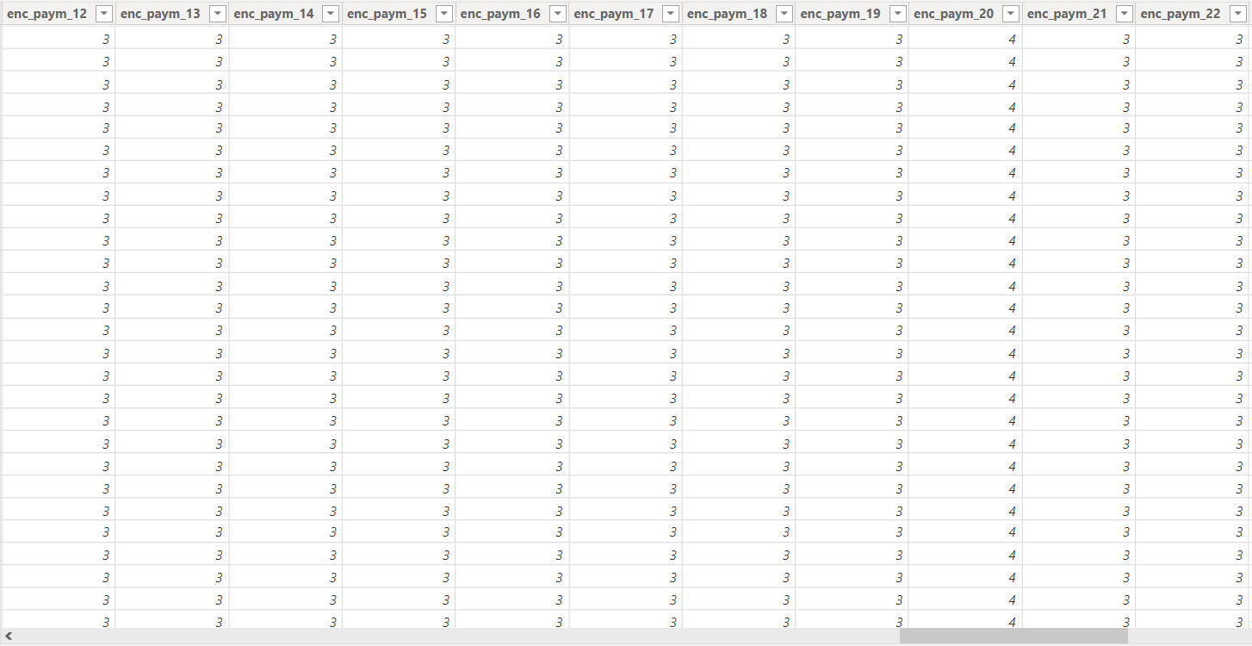
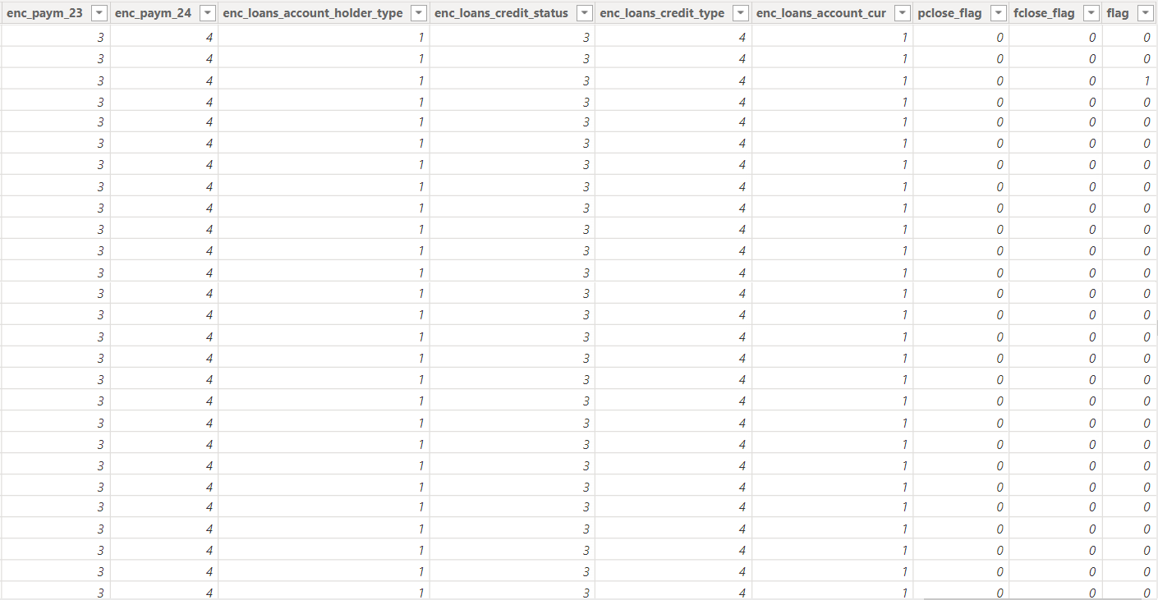
Important information about the structure of the dataset and features:

1) id - Application ID. Applications are numbered so that the higher number corresponds to the later application date.

2) rn - Serial number of the loan product in the credit history. A higher number corresponds to a product with a later opening date.

3) pre_since_opened - Days from the date of opening the loan to the date of data collection (binarized*)

4) pre_since_confirmed - Days from the date of confirmation of loan information to the date of data collection (binarized*)

5) pre_pterm - Planned number of days from the loan opening date to the closing date (binarized*)

6) pre_fterm - Actual number of days from the loan opening date to the closing date (binarized*)

7) pre_till_pclose - Planned number of days from the date of data collection to the loan closing date (binarized*)

8) pre_till_fclose - Actual number of days from the date of data collection to the loan closing date (binarized*)

9) pre_loans_credit_limit - Credit limit (binarized*)

10) pre_loans_next_pay_summ - The amount of the next loan payment (binarized*)

11) pre_loans_outstanding - Remaining outstanding loan amount (binarized*)

12) pre_loans_total_overdue - Current overdue debt (binarized*)

13) pre_loans_max_overdue_sum - Maximum overdue debt (binarized*)

14) pre_loans_credit_cost_rate - Total cost of the loan (binarized*)

15) pre_loans5 - Number of overdues up to 5 days (binarized*)

16) pre_loans530 - Number of overdues from 5 to 30 days (binarized*)

17) pre_loans3060 - Number of overdues from 30 to 60 days (binarized*)

18) pre_loans6090 - Number of overdues from 60 to 90 days (binarized*)

19) pre_loans90 - Number of overdues by more than 90 days (binarized*)

20) is_zero_loans_5 - Flag: no overdue payments up to 5 days

21) is_zero_loans_530 - Flag: no overdue from 5 to 30 days

22) is_zero_loans_3060 - Flag: no overdue from 30 to 60 days

23) is_zero_loans_6090 - Flag: no overdue from 60 to 90 days

24) is_zero_loans90 - Flag: no overdue for more than 90 days

25) pre_util - Ratio of the remaining unpaid loan amount to the credit limit (binarized*)

26) pre_over2limit - Ratio of current overdue debt to credit limit (binarized*)

27) pre_maxover2limit - Ratio of maximum overdue debt to credit limit (binarized*)

28) is_zero_util - Flag: the ratio of the remaining unpaid loan amount to the credit limit is 0

29) is_zero_over2limit - Flag: the ratio of the current overdue debt to the credit limit is 0

30) is_zero_maxover2limit - Flag: the ratio of the maximum overdue debt to the credit limit is 0

31) enc_paym_{0..N} - Statuses of monthly payments for the last N months (coded**)

32) enc_loans_account_holder_type - Loan relationship type (coded**)

33) enc_loans_credit_status - Loan status (encoded**)

34) enc_loans_account_cur - Loan currency (encoded**)

35) enc_loans_credit_type - Loan type (encoded**)

36) pclose_flag - Flag: the planned number of days from the loan opening date to the closing date is not defined

37) fclose_flag - Flag: the actual number of days from the loan opening date to the closing date is not defined

* the field value range is divided into N non-overlapping intervals, each interval is randomly assigned a unique number from 0 to N-1, the field value is replaced by the number of the interval to which it belongs

** each unique field value is randomly assigned a unique number from 0 to K, the field value is replaced by the number of this value

