Signed up for scrumdo account and logged in as arf62.

Trying to create a story.

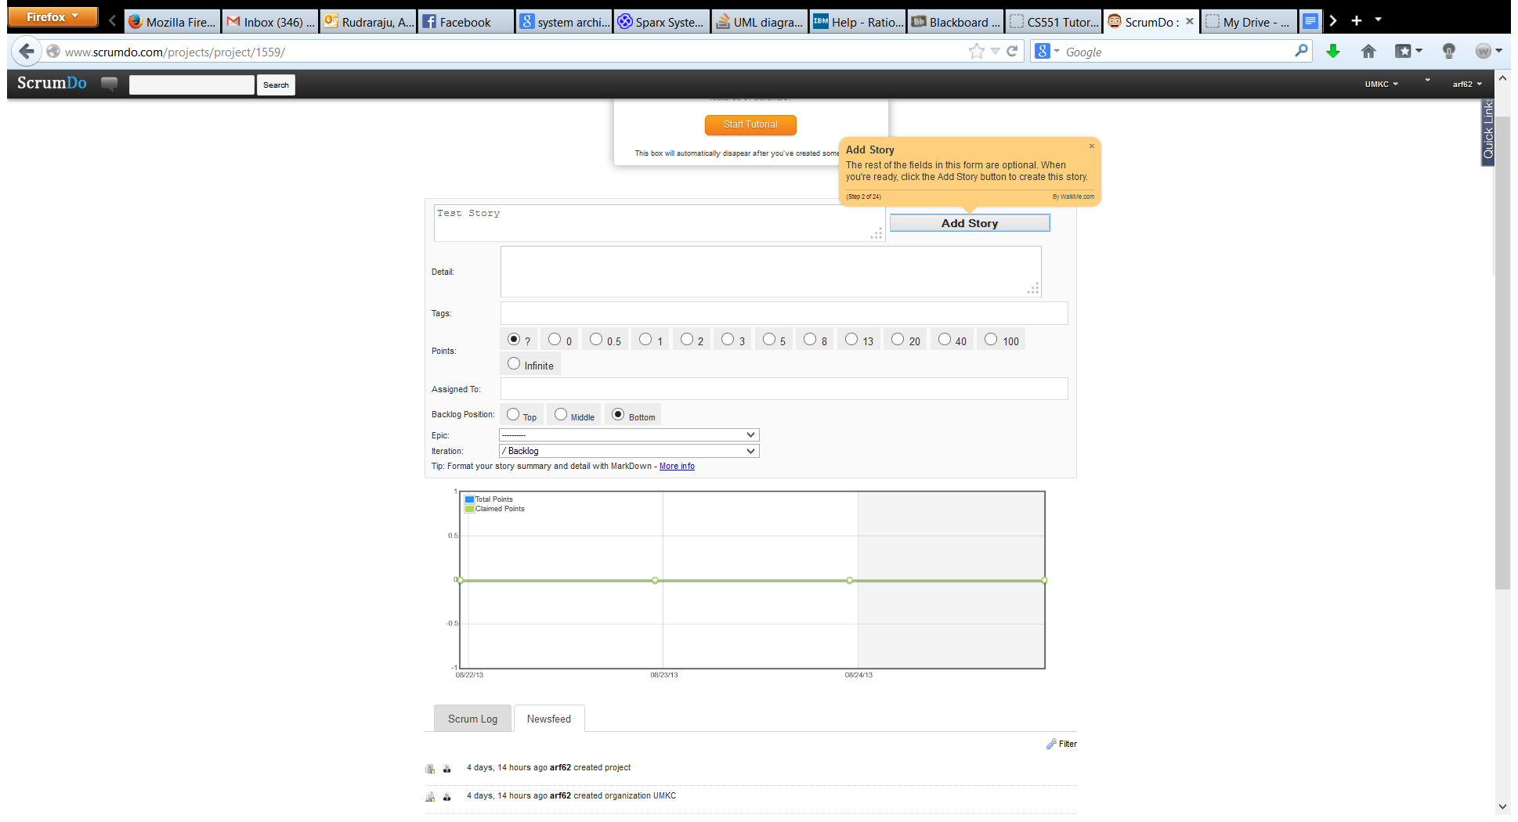

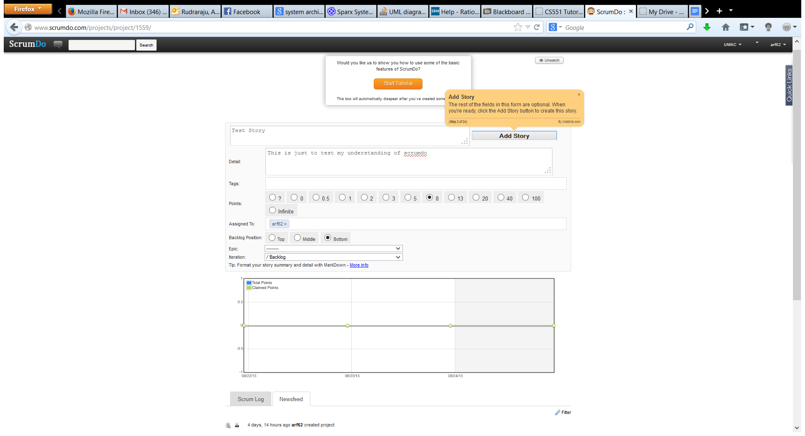

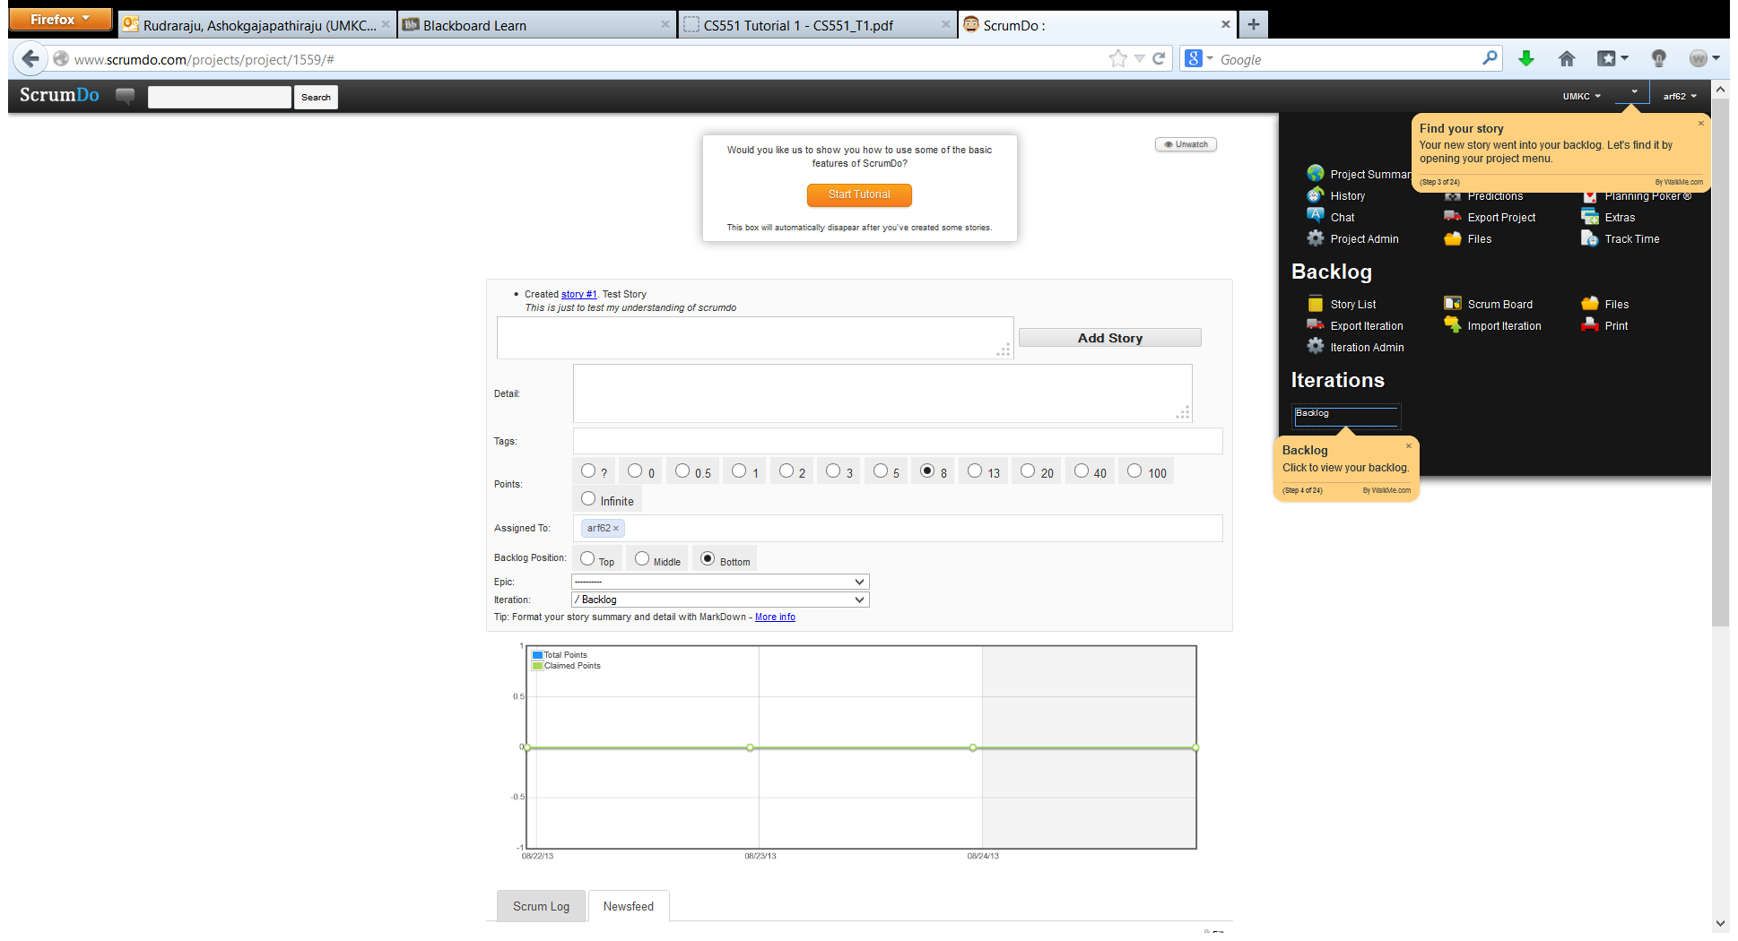

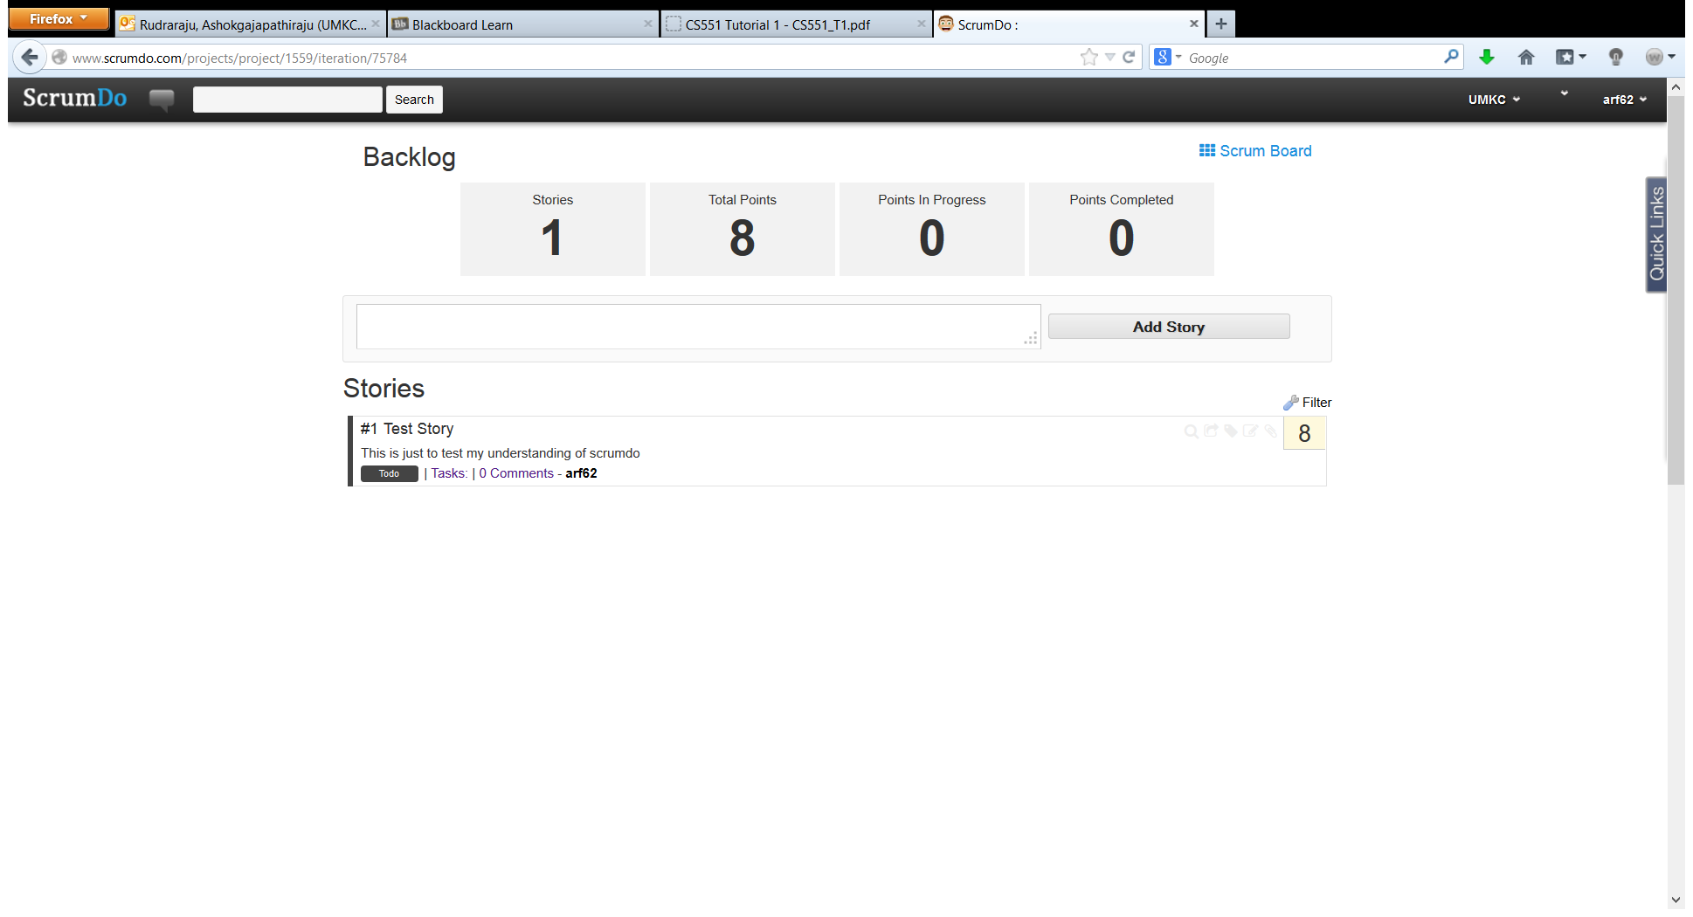

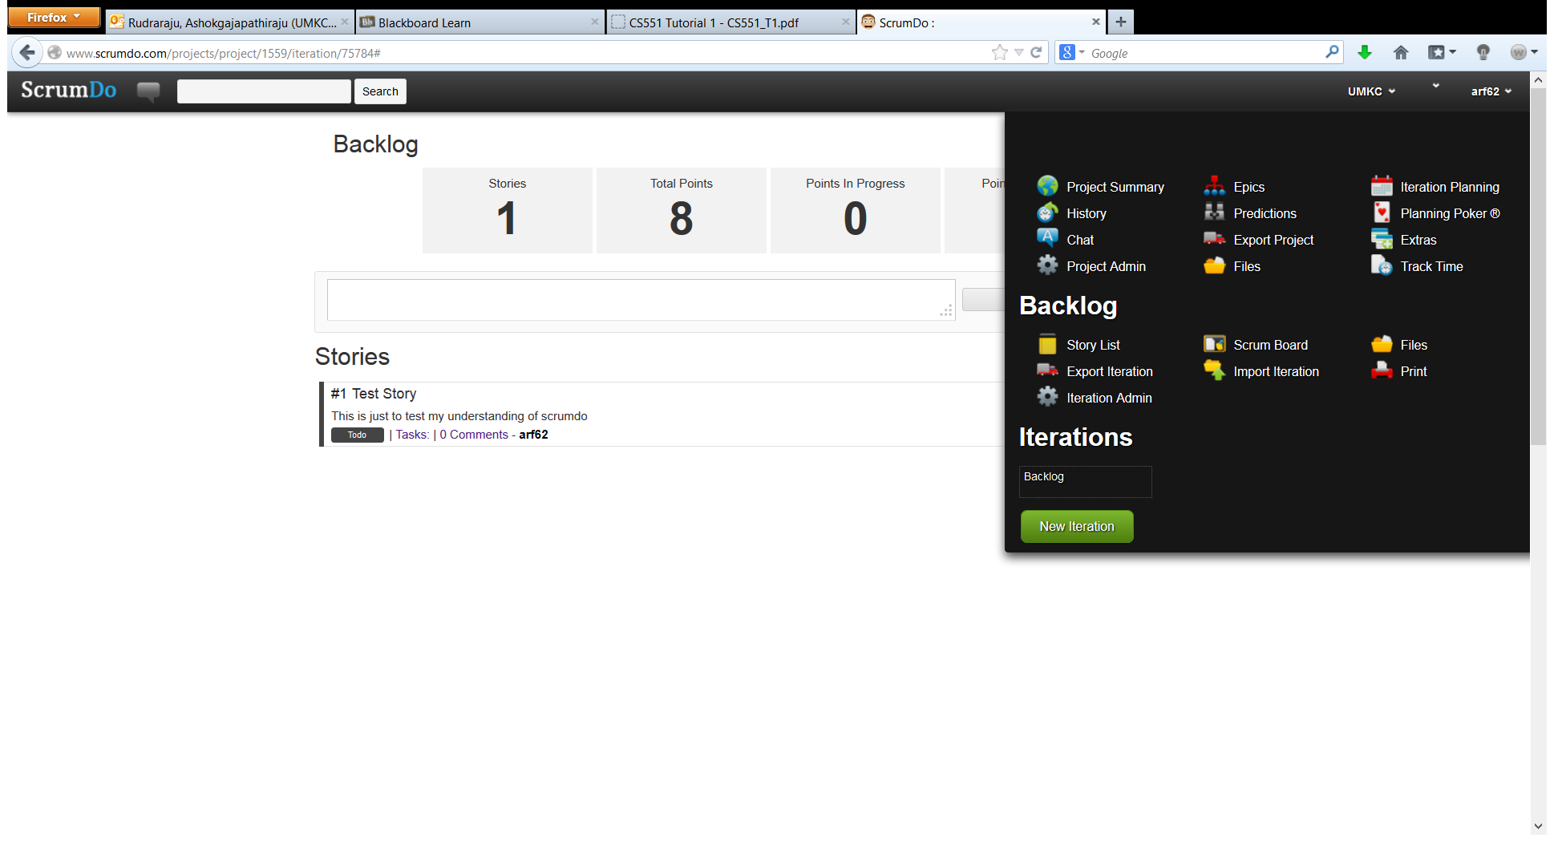

Trying to create an iteration in the above screen shot.

The following screen shot shows the newly created Iteration.

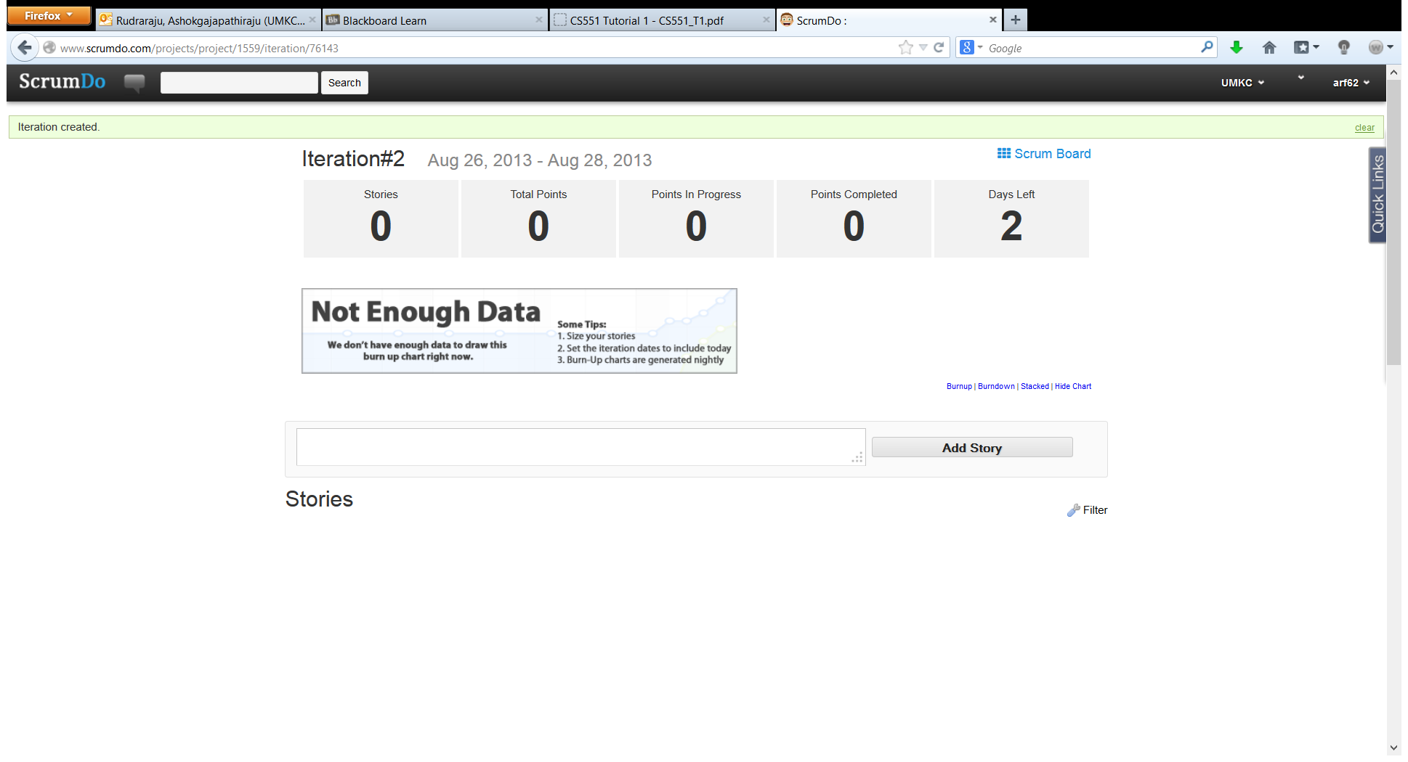

In the following screen shot ,learning to use the Iteration planning service.

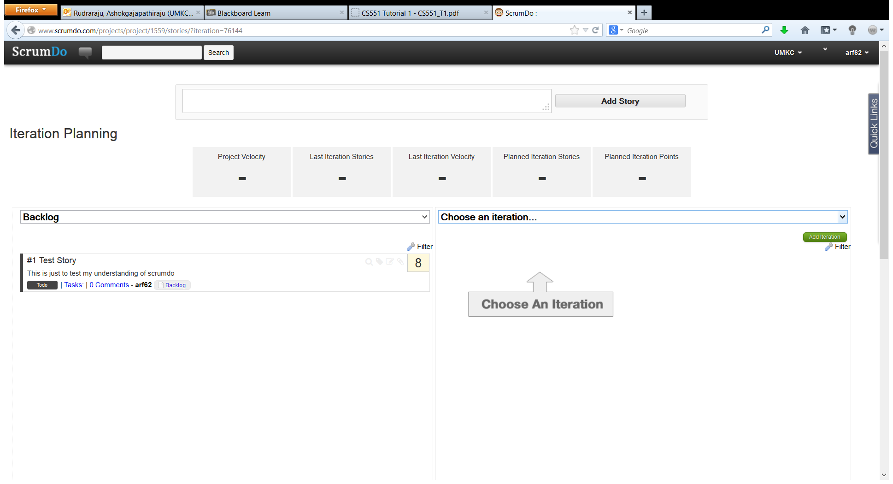

In the following scree shot, created an epic story and added a sub story under it.

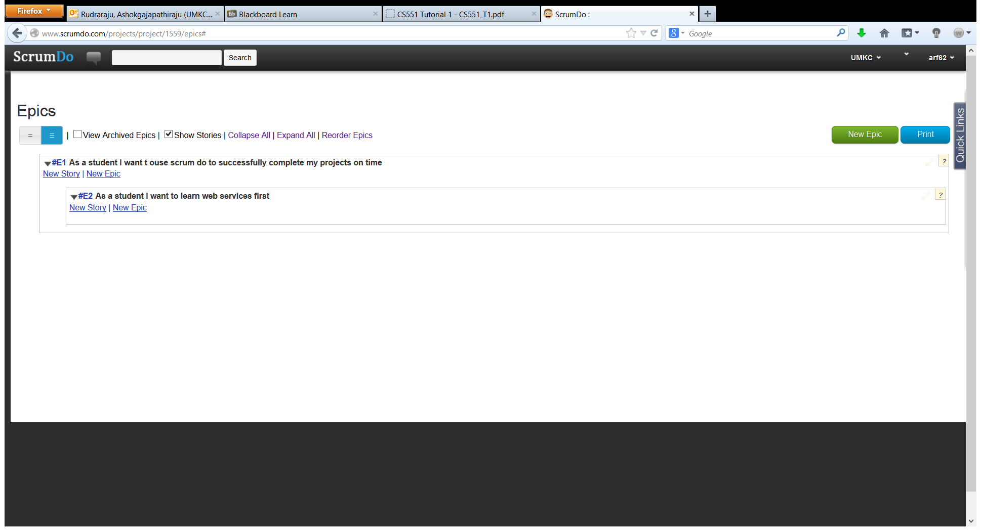

The following screen shot shows the status of the tasks in the Iteration#2 in the scrum board.

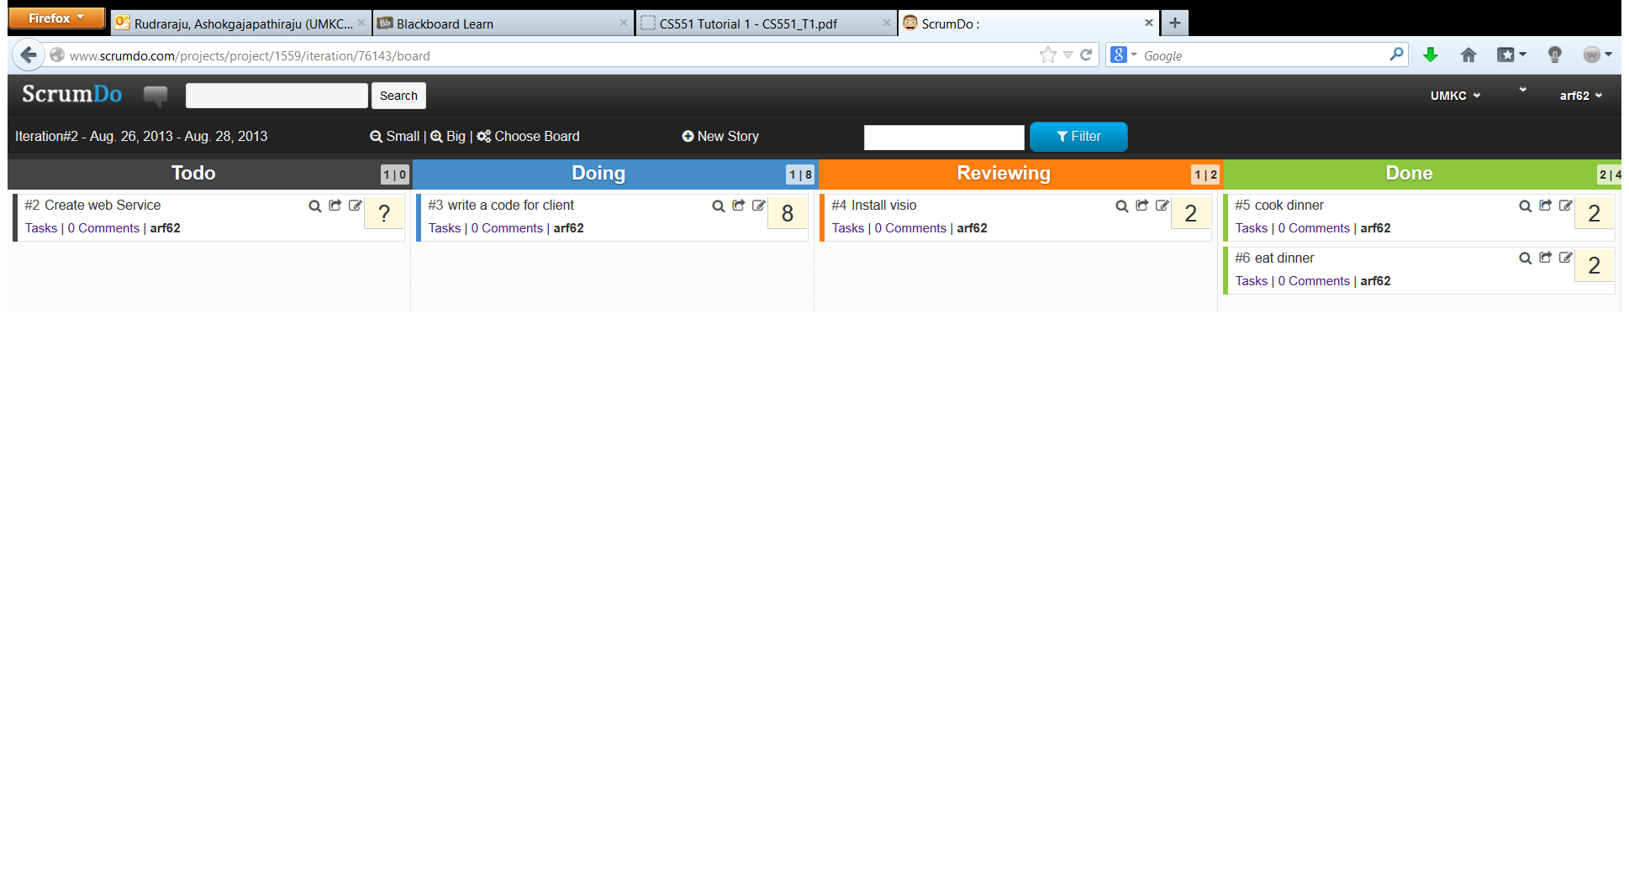

The following screen shot shows the over all status of my account arf62.

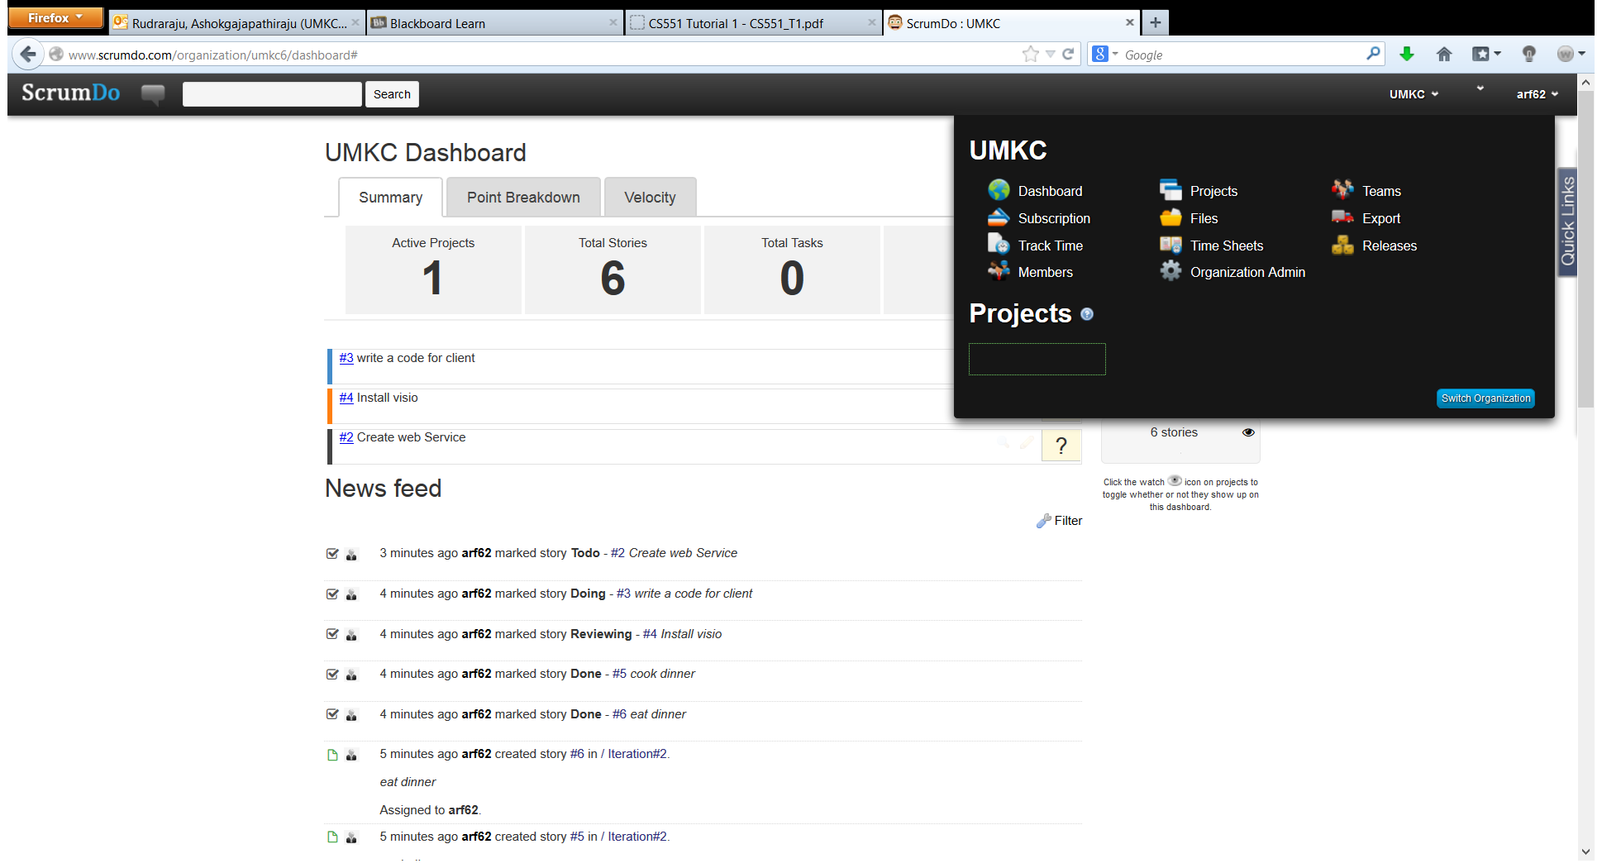

In thefollowing screen shot trying to create a new team.

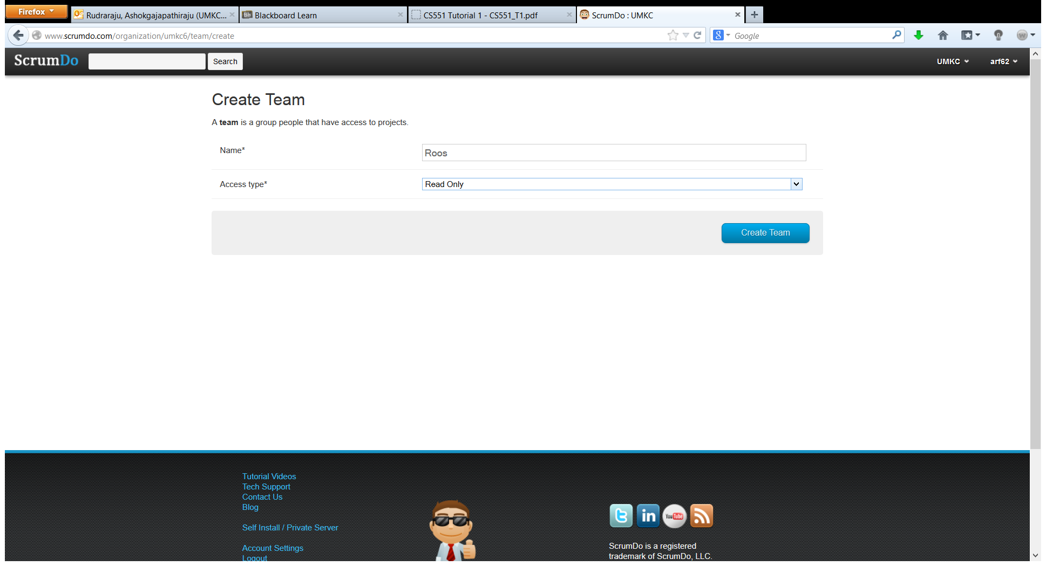

Successfully created a new team.

